

**Module Code & Module Title**

**CS6P05NI Final Year Project**

**Assessment Weightage & Type**

**40% Final Project Report**

**Year and Semester**

**2021-22 Autumn**

**Student Name: Abhishek Rokaya**

**London Met ID: 19030695**

**College ID: NP01CP4A190164**

**Internal Supervisor: Mohit Sharma**

**External Supervisor: Ankit Tandukar**

**Assignment Due Date: 27th April 2022**

**Assignment Submission Date: 27th April 2022**

**Word Count:**

*I confirm that I understand my coursework needs to be submitted online via Google Classroom under the relevant module page before the deadline in order for my assignment to be accepted and marked. I am fully aware that late submissions will be treated as non-submission and a marks of zero will be awarded.*

**Abstract**

Table of Contents

1. Introduction 1

1.1 Project Description 1

1.2 Problem Scenario 1

1.3 Project as a Solution 2

1.4 Aims and Objectives 4

1.5 Structure of the report 4

1.5.1 Background 4

1.5.2 Development 4

1.5.3 Testing and Analysis 5

1.5.4 Conclusion 5

2. Background 6

2.1 About the end users 6

2.1.1 Discussion with client 6

2.1.2 End Users 7

2.2 Understanding the solution 8

2.3 Similar Projects 10

2.4 Comparisons 13

2.5 Critical evaluation of the comparisons 14

3. Development 15

3.1 Considered Methodologies 15

3.2 Selected Methodology 17

3.3 Phases of Methodology 18

3.4 Survey 20

3.4.1 Pre-Survey Results 20

3.4.2 Post-Survey Results 21

3.5 Requirement Analysis 22

3.5.1 Feature Requirements 22

3.5.2 Hardware and Software Requirements 22

3.6 Design 23

3.6.1 Overall Use Case Diagram 24

3.6.2 Functional UML Diagrams 25

3.7 Implementation 57

3.7.1 System Architecture 57

3.7.2 Database Implementation 59

4. Testing and analysis 61

4.1 Test Plan 61

4.1.1 Black Box Testing, Test Plan 61

4.1.2 White Box Testing, Test Plan 62

4.1.3 Integration Testing, Test Plan 63

4.1.4 System Testing, Test Plan 63

4.1.5 Client Evaluation Testing, Test Plan 64

4.2 Black Box Testing 65

4.3 White Box Testing 81

4.4 Integration Testing 92

4.5 System Testing 126

4.6 Client Evaluation Testing 127

4.7 Critical Analysis 128

5. Conclusion 129

5.1 Legal, Social and Ethical Issues 130

5.1.1 Legal Issues 130

5.1.2 Social Issues 130

5.1.3 Ethical Issues 130

5.2 Advantages 131

5.3 Limitations 132

5.4 Future Work 132

6. Reference 133

7. Appendix 135

7.1 Appendix A: Background 135

7.1.2 Discussion with client 135

7.2 Appendix B: Development 137

7.2.1 Considered Methodologies 137

7.2.2 Selected Methodology 140

7.3 Appendix C: Pre-Survey 142

7.3.1 Pre-Survey Form 142

7.3.2 Sample of filled pre-survey forms 146

7.3.3 Pre-Survey Result 155

7.4 Appendix D: Post-Survey 160

7.4.1 Post-Survey Form 160

7.4.2 Sample of Filled Post-Survey Forms 163

7.4.3 Post-Survey Result 169

7.5 Appendix E: Sample Codes 173

7.5.1 Sample code of the UI 173

7.5.2 Sample code for the Automation Script 174

7.6 Appendix F: Designs 175

7.6.1 Functional UML Diagrams 177

7.6.2 Gantt Chart 246

7.6.3 Work Breakdown Structure 247

7.6.4 Algorithms and Flowcharts 248

7.6.5 ER Diagram Creation Process 252

7.6.6 Creation of Use Case Diagram 259

7.6.7 Class Diagram 262

7.6.8 Software Requirement Specification (SRS) 263

7.6.9 Wireframes 285

7.7 Appendix G: Testing 308

7.7.1 Black Box Testing 308

7.7.2 White Box Testing 324

7.8 Appendix H: Screenshots of the System 347

7.9 Appendix I: User Feedback 381

7.9.1 User Feedback Form 381

7.9.2 Sample of Filed User Feedback Forms 381

7.10 Appendix J: Future Work 381

7.10.1 Readings for future work 381

**List of Figures**

Figure 1: Survey of problem 2

Figure 2: Survey of solution 1 3

Figure 3: Survey of solution 2 3

Figure 4: Client Role Permission 6

Figure 5: Client's Requirements 7

Figure 6: Dent-inn 10

Figure 7: DentaLife 11

Figure 8: Kumari Dental Care 12

Figure 9: Overall Use Case Diagram 24

Figure 10: Use Case Diagram – User Registration 25

Figure 11: Collaboration Diagram – User Registration 26

Figure 12: Activity Diagram – User Registration 27

Figure 13: Sequence Diagram – User Registration 28

Figure 14: Use Case Diagram – User Login 29

Figure 15: Collaboration Diagram – User Login 29

Figure 16: Activity Diagram – User Login 30

Figure 17: Sequence Diagram – User Login 31

Figure 18: Use Case Diagram – User View Profile 32

Figure 19: Collaboration Diagram – User View Profile 32

Figure 20: Activity Diagram – User View Profile 33

Figure 21: Sequence Diagram – User View Profile 34

Figure 22: Use Case Diagram – User Edit Profile 35

Figure 23: Collaboration Diagram – User Edit Profile 35

Figure 24: Activity Diagram – User Edit Profile 36

Figure 25: Sequence Diagram – User Edit Profile 37

Figure 26: Use Case Diagram – User Book Appointment 38

Figure 27: Collaboration Diagram – User Book Appointment 39

Figure 28: Activity Diagram – User Book Appointment 40

Figure 29: Sequence Diagram – User Book Appointment 41

Figure 30: Use Case Diagram – User View Appointment 42

Figure 31: Collaboration Diagram – User View Appointment 42

Figure 32: Activity Diagram – User View Appointment 43

Figure 33: Sequence Diagram – User View Appointment 44

Figure 34: Use Case Diagram – User Cancel Appointment 45

Figure 35: Collaboration Diagram – User Cancel Appointment 45

Figure 36: Activity Diagram – User Cancel Appointment 46

Figure 37: Sequence Diagram – User Cancel Appointment 47

Figure 38: Use Case Diagram – User View Doctor 48

Figure 39: Collaboration Diagram – User View Doctor 48

Figure 40: Activity Diagram – User View Doctor 49

Figure 41: Sequence Diagram – User View Doctor 50

Figure 42: Use Case Diagram – User View Report 51

Figure 43: Collaboration Diagram – User View Report 51

Figure 44: Activity Diagram – User View Report 52

Figure 45: Sequence Diagram – User View Report 53

Figure 46: Use Case Diagram – User View Services 54

Figure 47: Collaboration Diagram – User View Services 54

Figure 48: Activity Diagram – User View Services 55

Figure 49: Sequence Diagram – User View Services 56

Figure 50: System Architecture (AskPython, 2022) 58

Figure 51: Database Implementation Code – 1 59

Figure 52: Database Implementation Code - 2 59

Figure 53: Database Implementation Code – 3 60

Figure 54: Database Implementation Code – 4 60

Figure 55: Black Box Test 1 (Unsuccessful) 65

Figure 56: Black Box Test 1 - Error Code 66

Figure 57: Black Box Test 1 - Fixed Code 66

Figure 58: Black Box Test 1 (Successful) 67

Figure 59: Black Box Test 2 (Unsuccessful) - 1 68

Figure 60: Black Box Test 2 (Unsuccessful) - 2 69

Figure 61: Black Box Test 2 (Unsuccessful) – 3 69

Figure 62: Black Box Test 2 - Error Code 70

Figure 63: Black Box Test 2 - Fixed Code 70

Figure 64: Black Box Test 2 (Successful) - 1 71

Figure 65: Black Box Test 2 (Successful) - 2 72

Figure 66: Black Box Test 3 (Unsuccessful) 73

Figure 67: Black Box Test 3 - Error Code 74

Figure 68: Black Box Test 3 - Fixed Code 74

Figure 69: Black Box Test 3 (Successful) 75

Figure 70: Black Box Test 4 (Unsuccessful) - 1 76

Figure 71: Black Box Test 4 (Unsuccessful) – 2 77

Figure 72: Black Box Test 4 - Error Code 77

Figure 73: Black Box Test 4 - Fixed Code 78

Figure 74: Black Box Test 4 (Successful) - 1 79

Figure 75: Black Box Test 4 (Successful) - 2 80

Figure 76: White Box Test 1 - 1 81

Figure 77: White Box Test 1 - 2 82

Figure 78: White Box Test 1 - 3 82

Figure 79: White Box Test 2 - 1 83

Figure 80: White Box Test 2 - 2 84

Figure 81: White Box Test 2 - 3 84

Figure 82: White Box Test 3 - 1 85

Figure 83: White Box Test 3 - 2 86

Figure 84: White Box Test 4 - 1 87

Figure 85: White Box Test 4 - 2 88

Figure 86: White Box Test 4 - 3 88

Figure 87: White Box Test 5 - 1 89

Figure 88: White Box Test 5 – 2 90

Figure 89: White Box Test 5 – 3 90

Figure 90: Integration Test 1 - 1 92

Figure 91: Integration Test 1 - 2 93

Figure 92: Integration Test 1 - 3 93

Figure 93: Integration Test 1 – 4 94

Figure 94: Integration Test 1 - 5 94

Figure 95: Integration Test 1 - Database Before 95

Figure 96: Integration Test 1 - Database After 95

Figure 97: Integration Test 2 - 1 96

Figure 98: Integration Test 2 – 2 97

Figure 99: Integration Test 2 - 3 97

Figure 100: Integration Test 2 - Database Before 98

Figure 101: Integration Test 2 - Database After 98

Figure 102: Integration Test 3 - 1 99

Figure 103: Integration Test 3 – 2 100

Figure 104: Integration Test 3 – 3 100

Figure 105: Integration Test 3 – 4 101

Figure 106: Integration Test 3 – 5 101

Figure 107: Integration Test 3 - Database Before 102

Figure 108: Integration Test 3 - Database After 102

Figure 109: Integration Test 4 – 1 103

Figure 110: Integration Test 4 – 2 104

Figure 111: Integration Test 4 - 3 104

Figure 112: Integration Test 4 - Database Before 105

Figure 113: Integration Test 4 - Database After 105

Figure 114: Integration Test 5 - 1 106

Figure 115: Integration Test 5 - 2 107

Figure 116: Integration Test 5 - 3 107

Figure 117: Integration Test 5 - Database Before 108

Figure 118: Integration Test 5 - Database After 108

Figure 119: Integration Test 6 - 1 109

Figure 120: Integration Test 6 – 2 110

Figure 121: Integration Test 6 - 3 110

Figure 122: Integration Test 6 - 4 111

Figure 123: Integration Test 6 - 5 111

Figure 124: Integration Test 6 - Database Before 112

Figure 125: Integration Test 6 - Database After 112

Figure 126: Integration Test 7 - 1 113

Figure 127: Integration Test 7 – 2 114

Figure 128: Integration Test 7 – 3 114

Figure 129: Integration Test 7 - Database Before 115

Figure 130: Integration Test 7 - Database After 115

Figure 131: Integration Test 8 – 1 116

Figure 132: Integration Test 8 - 2 117

Figure 133: Integration Test 8 - 3 117

Figure 134: Integration Test 8 - Database before 118

Figure 135: Integration Test 8 - Database After 118

Figure 136: Integration Test 9 - 1 119

Figure 137: Integration Test 9 – 2 120

Figure 138: Integration Test 9 - 3 120

Figure 139: Integration Test 9 - 4 121

Figure 140: Integration Test 9 – 5 121

Figure 141: Integration Test 9 - Database Before 122

Figure 142: Integration Test 9 - Database After 122

Figure 143: Integration Test 10 - 1 123

Figure 144: Integration Test 10 – 2 124

Figure 145: Integration Test 10 - 3 124

Figure 146: Integration Test 10 - Database Before 125

Figure 147: Integration Test 10 - Database After 125

Figure 148: System Testing 1 126

Figure 149: RUP Methodology (TestBytes, 2019) 137

Figure 150: Prototype Methodology (Martin, 2021) 138

Figure 151: Incremental Methodology (GeeksForGeeks, 2019) 139

Figure 152: Pre-Survey Form - 1 142

Figure 153: Pre-Survey Form - 2 143

Figure 154: Pre-Survey Form - 3 143

Figure 155: Pre-Survey Form - 4 144

Figure 156: Pre-Survey Form - 5 144

Figure 157: Pre-Survey Form - 6 145

Figure 158: Sample 1 of pre-survey form - 1 146

Figure 159: Sample 1 of pre-survey form - 2 146

Figure 160: Sample 1 of pre-survey form - 3 147

Figure 161: Sample 1 of pre-survey form - 4 147

Figure 162: Sample 1 of pre-survey form - 5 148

Figure 163: Sample 2 of pre-survey form - 1 149

Figure 164: Sample 2 of pre-survey form - 2 149

Figure 165: Sample 2 of pre-survey form - 3 150

Figure 166: Sample 2 of pre-survey form - 4 150

Figure 167: Sample 2 of pre-survey form - 5 151

Figure 168: Sample 3 of pre-survey form - 1 152

Figure 169: Sample 3 of pre-survey form - 2 152

Figure 170: Sample 3 of pre-survey form - 3 153

Figure 171: Sample 3 of pre-survey form - 4 153

Figure 172: Sample 3 of pre-survey form - 5 154

Figure 173: Pre-Survey Result – 1 155

Figure 174: Pre-Survey Result - 2 155

Figure 175: Pre-Survey Result – 3 156

Figure 176: Pre-Survey Result - 4 156

Figure 177: Pre-Survey Result - 5 157

Figure 178: Pre-Survey Result - 6 157

Figure 179: Pre-Survey Result - 7 158

Figure 180: Pre-Survey Result - 8 159

Figure 181: Post-Survey Form - 1 160

Figure 182: Post-Survey Form - 2 161

Figure 183: Post-Survey Form - 3 161

Figure 184: Post-Survey Form - 4 162

Figure 185: Post-Survey Form - 5 162

Figure 186: Sample 1 of post-survey form - 1 163

Figure 187: Sample 1 of post-survey form - 2 163

Figure 188: Sample 1 of post-survey form - 3 164

Figure 189: Sample 1 of post-survey form - 4 164

Figure 190: Sample 2 of post-survey form - 1 165

Figure 191: Sample 2 of post-survey form - 2 165

Figure 192: Sample 2 of post-survey form - 3 166

Figure 193: Sample 2 of post-survey form - 4 166

Figure 194: Sample 3 of post-survey form - 1 167

Figure 195: Sample 3 of post-survey form - 2 167

Figure 196: Sample 3 of post-survey form - 3 168

Figure 197: Sample 3 of post-survey form - 4 168

Figure 198: Post-Survey Result – 1 169

Figure 199: Post-Survey Result - 2 169

Figure 200: Post-Survey Result - 3 170

Figure 201: Post-Survey Result - 4 170

Figure 202: Post-Survey Result - 5 171

Figure 203: Post-Survey Result - 6 171

Figure 204: Post-Survey Result - 7 172

Figure 205: Use Case Diagram – Admin Login 177

Figure 206: Collaboration Diagram – Admin Login 178

Figure 207: Activity Diagram – Admin Login 179

Figure 208: Sequence Diagram – Admin Login 180

Figure 209: Use Case Diagram – Admin View Users 181

Figure 210: Collaboration Diagram – Admin View Users 181

Figure 211: Activity Diagram – Admin View Users 182

Figure 212: Sequence Diagram – Admin View Users 183

Figure 213: Use Case Diagram – Admin Delete Users 184

Figure 214: Collaboration Diagram – Admin Delete Users 184

Figure 215: Activity Diagram – Admin Delete Users 185

Figure 216: Sequence Diagram – Admin Delete Users 186

Figure 217: Use Case Diagram – Admin View Doctors 187

Figure 218: Collaboration Diagram – Admin View Doctors 187

Figure 219: Activity Diagram – Admin View Doctors 188

Figure 220: Sequence Diagram – Admin View Doctors 189

Figure 221: Use Case Diagram – Admin Add Doctors 190

Figure 222: Collaboration Diagram – Admin Add Doctors 190

Figure 223: Activity Diagram – Admin Add Doctors 191

Figure 224: Sequence Diagram – Admin Add Doctors 192

Figure 225: Use Case Diagram – Admin Delete Doctors 193

Figure 226: Collaboration Diagram – Admin Delete Doctors 194

Figure 227: Activity Diagram – Admin Delete Doctors 195

Figure 228: Sequence Diagram – Admin Delete Doctors 196

Figure 229: Use Case Diagram – Admin Edit Doctors 197

Figure 230: Collaboration Diagram – Admin Edit Doctors 197

Figure 231: Activity Diagram – Admin Edit Doctors 198

Figure 232: Sequence Diagram – Admin Edit Doctors 199

Figure 233: Use Case Diagram – Admin Add Report 200

Figure 234: Collaboration Diagram – Admin Add Report 201

Figure 235: Activity Diagram – Admin Add Report 202

Figure 236: Sequence Diagram – Admin Add Report 203

Figure 237: Use Case Diagram – Admin Delete Report 204

Figure 238: Collaboration Diagram – Admin Delete Report 205

Figure 239: Activity Diagram – Admin Delete Report 206

Figure 240: Sequence Diagram – Admin Delete Report 207

Figure 241: Use Case Diagram – Admin Edit Report 208

Figure 242: Collaboration Diagram – Admin Edit Report 208

Figure 243: Activity Diagram – Admin Edit Report 209

Figure 244: Sequence Diagram – Admin Edit Report 210

Figure 245: Use Case Diagram – Admin View Reports 211

Figure 246: Collaboration Diagram – Admin View Reports 211

Figure 247: Activity Diagram – Admin View Reports 212

Figure 248: Sequence Diagram – Admin View Reports 213

Figure 249: Use Case Diagram – Admin Book Appointment 214

Figure 250: Collaboration Diagram – Admin Book Appointment 214

Figure 251: Activity Diagram – Admin Book Appointment 215

Figure 252: Sequence Diagram – Admin Book Appointment 216

Figure 253: Use Case Diagram – Admin View Appointments 217

Figure 254: Collaboration Diagram – Admin View Appointments 217

Figure 255: Activity Diagram – Admin View Appointments 218

Figure 256: Sequence Diagram – Admin View Appointments 219

Figure 257: Use Case Diagram – Admin Cancel Appointment 220

Figure 258: Collaboration Diagram – Admin Cancel Appointment 220

Figure 259: Activity Diagram – Admin Cancel Appointment 221

Figure 260: Sequence Diagram – Admin Cancel Appointment 222

Figure 261: Use Case Diagram – Admin Approve Appointment 223

Figure 262: Collaboration Diagram – Admin Approve Appointment 223

Figure 263: Activity Diagram – Admin Approve Appointment 224

Figure 264: Sequence Diagram – Admin Approve Appointment 225

Figure 265: Use Case Diagram – Admin Reject Appointment 226

Figure 266: Collaboration Diagram – Admin Reject Appointment 226

Figure 267: Activity Diagram – Admin Reject Appointment 227

Figure 268: Sequence Diagram – Admin Reject Appointment 228

Figure 269: Use Case Diagram – Admin Finish Appointment 229

Figure 270: Collaboration Diagram – Admin Finish Appointment 229

Figure 271: Activity Diagram – Admin Finish Appointment 230

Figure 272: Sequence Diagram – Admin Finish Appointment 231

Figure 273: Use Case Diagram – Admin View Services 232

Figure 274: Collaboration Diagram – Admin View Services 232

Figure 275: Activity Diagram – Admin View Services 233

Figure 276: Sequence Diagram – Admin View Services 234

Figure 277: Use Case Diagram – Admin Add Services 235

Figure 278: Collaboration Diagram – Admin Add Services 235

Figure 279: Activity Diagram – Admin Add Services 236

Figure 280: Sequence Diagram – Admin Add Services 237

Figure 281: Use Case Diagram – Admin Delete Services 238

Figure 282: Collaboration Diagram – Admin Delete Services 239

Figure 283: Activity Diagram – Admin Delete Services 240

Figure 284: Sequence Diagram – Admin Delete Services 241

Figure 285: Use Case Diagram – Admin Edit Service 242

Figure 286: Collaboration Diagram – Admin Edit Service 242

Figure 287: Activity Diagram – Admin Edit Service 243

Figure 288: Sequence Diagram – Admin Edit Service 244

Figure 289: Gantt chart 246

Figure 290: Work Breakdown Structure 247

Figure 291: Bubble Sort Algorithm 248

Figure 292: Flowchart of the overall system 251

Figure 293: User-patientUser Relation 252

Figure 294: patientUser-Appointment Relation 253

Figure 295: Report-Appointment Relation 253

Figure 296: Doctor-Appointment Relation 253

Figure 297: Service-Appointment Relation 254

Figure 298: Final ERD: 257

Figure 299: Rectangle which represents System 259

Figure 300: Human stick figure which represents Actor 259

Figure 301: Oval which represents Use Case 260

Figure 302: Solid line which represents the relation between actor and use case 260

Figure 303: Include Relation 260

Figure 304: Extend Relation 260

Figure 305: Generalisation Relation 261

Figure 306: Class Diagram 262

Figure 307: System Perspective Diagram 265

Figure 308: Overall Use Case of the System 266

Figure 309: UI of Home Page 1 277

Figure 310: UI of Home Page 2 278

Figure 311: UI of Home Page 3 278

Figure 312: UI of Home Page 4 279

Figure 313: UI of Home Page 5 279

Figure 314: UI of Home Page 6 280

Figure 315: UI of Home Page 7 280

Figure 316: UI of Home Page 8 281

Figure 317: UI of Home Page 9 281

Figure 318: Wireframe - Home Page 285

Figure 319: Wireframe - User Registration 286

Figure 320: Wireframe - User Login 287

Figure 321: Wireframe - Admin Login 288

Figure 322: Wireframe - User Dashboard 289

Figure 323: Wireframe - User View Appointment 290

Figure 324: Wireframe - User Book Appointment 291

Figure 325: Wireframe - User View Doctor 292

Figure 326: Wireframe - User View Report 293

Figure 327: Wireframe - User View Service 294

Figure 328: Wireframe - User View Profile 295

Figure 329: Wireframe - User Edit Profile 296

Figure 330: Wireframe - Admin Dashboard 297

Figure 331: Wireframe - Admin View Appointment 298

Figure 332: Wireframe - Admin Approve Appointment 299

Figure 333: Wireframe - Admin Book Appointment 300

Figure 334: Wireframe - Admin View Doctor 301

Figure 335: Wireframe - Admin Add Doctor 302

Figure 336: Wireframe - Admin View Report 303

Figure 337: Wireframe - Admin Add Report 304

Figure 338: Wireframe - Admin View Service 305

Figure 339: Wireframe - Admin Add Service 306

Figure 340: Wireframe - Admin View Users 307

Figure 341: Black Box Test 5 (Unsuccessful) 308

Figure 342: Black Box Test 5 - Error Code 309

Figure 343: Black Box Test 5 - Fixed Code 309

Figure 344: Black Box Test 5 (Successful) 310

Figure 345: Black Box Test 6 (Unsuccessful) - 1 311

Figure 346: Black Box Test 6 (Unsuccessful) - 2 312

Figure 347: Black Box Test 6 (Unsuccessful) – 3 312

Figure 348: Black Box Test 6 - Error Code 313

Figure 349: Black Box Test 6 - Fixed Code 313

Figure 350: Black Box Test 6 (Successful) - 1 314

Figure 351: Black Box Test 6 (Successful) – 2 315

Figure 352: Black Box Test 6 (Successful) - 3 315

Figure 353: Black Box Test 7 (Unsuccessful) 316

Figure 354: Black Box Test 7 - Error Code 317

Figure 355: Black Box Test 7 - Fixed Code 317

Figure 356: Black Box Test 7 (Successful) 318

Figure 357: Black Box Test 8 (Unsuccessful) - 1 319

Figure 358: Black Box Test 8 (Unsuccessful) – 2 320

Figure 359: Black Box Test 8 - Error Code 320

Figure 360: Black Box Test 8 - Fixed Code 320

Figure 361: Black Box Test 8 (Successful) - 1 321

Figure 362: Black Box Test 8 (Successful) - 2 322

Figure 363: Black Box Test 8 - Database before 322

Figure 364: Black Box Test 8 - Database after 322

Figure 365: White Box Test 6 - 1 324

Figure 366: White Box Test 6 – 2 325

Figure 367: White Box Test 6 - 3 325

Figure 368: White Box Test 7 326

Figure 369: White Box Test 8 - 1 327

Figure 370: White Box Test 8 – 2 328

Figure 371: White Box Test 8 - 3 328

Figure 372: White Box Test 9 - 1 329

Figure 373: White Box Test 9 - 2 330

Figure 374: White Box Test 10 - 1 331

Figure 375: White Box Test 10 - 2 332

Figure 376: White Box Test 11 333

Figure 377: White Box Test 12 - 1 334

Figure 378: White Box Test 12 – 2 335

Figure 379: White Box Test 12 - 3 335

Figure 380: White Box Test 13 - 1 336

Figure 381: White Box Test 13 – 2 337

Figure 382: White Box Test 13 - 3 337

Figure 383: White Box Test 14 - 1 338

Figure 384: White Box Test 14 – 2 339

Figure 385: White Box Test 14 – 3 339

Figure 386: White Box Test 15 - 1 340

Figure 387: White Box Test 15 – 2 341

Figure 388: White Box Test 15 – 3 341

Figure 389: White Box Test 16 - 1 342

Figure 390: White Box Test 16 - 2 343

Figure 391: White Box Test 16 - 3 343

Figure 392: White Box Test 17 - 1 344

Figure 393: White Box Test 17 - 2 345

Figure 394: White Box Test 17 - 3 345

**List of Tables**

Table 1: Analysis of Similar Project 13

Table 2: High Level Use Case – User Registration 25

Table 3: High Level Use Case – User Login 28

Table 4: High Level Use Case – User View Profile 31

Table 5: High Level Use Case – User Edit Profile 34

Table 6: High Level Use Case – User Book Appointment 38

Table 7: High Level Use Case – User View Appointment 42

Table 8: High Level Use Case – User Cancel Appointment 44

Table 9: High Level Use Case – User View Doctors 47

Table 10: High Level Use Case – User View Report 50

Table 11: High Level Use Case – User View Services 53

Table 12: Black Box Testing Test Plan 61

Table 13: White Box Testing Test Plan 62

Table 14: Integration Testing Test Plan 63

Table 36: System Testing Test Plan 63

Table 16: Black Box Test 1 (Unsuccessful) 65

Table 17: Black Box Test 1 (Successful) 67

Table 18: Black Box Test 2 (Unsuccessful) 68

Table 19: Black Box Test 2 (Successful) 71

Table 20: Black Box Test 3 (Unsuccessful) 73

Table 21: Black Box Test 3 (Successful) 75

Table 22: Black Box Test 4 (Unsuccessful) 76

Table 23: Black Box Test 4 (Successful) 79

Table 53: White Box Test 1 81

Table 54: White Box Test 2 83

Table 55: White Box Test 3 85

Table 56: White Box Test 4 87

Table 57: White Box Test 5 89

Table 70: Integration Test 1 92

Table 71: Integration Test 2 96

Table 72: Integration Test 3 99

Table 73: Integration Test 4 103

Table 74: Integration Test 5 106

Table 75: Integration Test 6 109

Table 76: Integration Test 7 113

Table 77: Integration Test 8 116

Table 78: Integration Test 9 119

Table 79: Integration Test 10 123

Table 80: System Testing 1 126

Table 60: High Level Use Case – Admin Login 177

Table 61: High Level Use Case – Admin View Users 180

Table 62: High Level Use Case – Admin Delete Users 183

Table 63: High Level Use Case – Admin View Doctors 186

Table 64: High Level Use Case – Admin Add Doctors 189

Table 65: High Level Use Case – Admin Delete Doctors 193

Table 66: High Level Use Case – Admin Edit Doctors 196

Table 67: High Level Use Case – Admin Add Report 200

Table 68: High Level Use Case – Admin Delete Report 204

Table 69: High Level Use Case – Admin Edit Report 207

Table 70: High Level Use Case – Admin View Reports 211

Table 23: High Level Use Case – Admin Book Appointment 213

Table 24: High Level Use Case – Admin View Appointments 217

Table 25: High Level Use Case – Admin Cancel Appointment 219

Table 26: High Level Use Case – Admin Approve Appointment 222

Table 27: High Level Use Case – Admin Reject Appointment 225

Table 28: High Level Use Case – Admin Finish Appointment 228

Table 77: High Level Use Case – Admin View Services 231

Table 78: High Level Use Case – Admin Add Services 234

Table 31: High Level Use Case – Admin Delete Services 238

Table 80: High Level Use Case – Admin Edit Services 241

Table 81: User Attributes 254

Table 82: patientUser Attributes 255

Table 83: Doctor Attribute 255

Table 84: Service Attribute 256

Table 85: Appointment attribute 256

Table 86: Report attribute 257

Table 87: Functional Requirement 1 270

Table 88: Functional Requirement 2 271

Table 89: Functional Requirement 3 272

Table 90: Functional Requirement 4 273

Table 91: Functional Requirement 5 274

Table 92: Functional Requirement 6 275

Table 93: Functional Requirement 7 276

Table 94: Performance Requirement 283

Table 95: Safety Requirement 283

Table 96: Other Software Quality Attributes 284

Table 24: Black Box Test 5 (Unsuccessful) 308

Table 25: Black Box Test 5 (Successful) 310

Table 26: Black Box Test 6 (Unsuccessful) 311

Table 27: Black Box Test 6 (Successful) 314

Table 28: Black Box Test 7 (Unsuccessful) 316

Table 50: Black Box Test 7 (Successful) 318

Table 30: Black Box Test 8 (Unsuccessful) 319

Table 31: Black Box Test 8 (Successful) 321

Table 58: White Box Test 6 324

Table 59: White Box Test 7 326

Table 60: White Box Test 8 327

Table 61: White Box Test 9 329

Table 62: White Box Test 10 331

Table 63: White Box Test 11 333

Table 64: White Box Test 12 334

Table 65: White Box Test 13 336

Table 66: White Box Test 14 338

Table 67: White Box Test 15 340

Table 68: White Box Test 16 342

Table 69: White Box Test 17 344

**Table of Abbreviation**

|  |  |
| --- | --- |
| IT | Information Technology |
| ERD | Entity Relation Diagram |
| UML |  |
| RUP |  |
|  |  |

# 1. Introduction

## 1.1 Project Description

Dental hygiene is the practice of keeping the mouth clean, and it is often regarded as the most effective method of preventing cavities (dental caries), gingivitis, periodontitis, and other dental problems. It also aids in the prevention of foul breath (halitosis). Regular dental visit is necessary since it helps to keep our teeth and gums healthy. It is recommended that we visit a dental clinic at least once every six months.

A good dental care is necessary if we face any problems related to our teeth and gums. If not treated properly, we may face various difficulties like constant tooth pain, not being able to eat properly and many more. There are millions of people who face daily dental related problems in their lives all over the world. In Nepal, there is no proper facility to get an appointment for our dental check-up. There are thousands of people who visit dental clinics in Nepal every single day. But due to lack of proper resources, people have to wait for hours and hours even if they have a slight problem just to consult with a doctor.

Time is a precious thing and we should not waste it waiting in line for hours. So keeping that in mind, this project is a dental application/management system which lets users to book an appointment for their dental requirements. This will help save people a lot of time and is convenient as well.

## 1.2 Problem Scenario

People who have a tight schedule don't have enough time to wait in long line for their dental check-up. Sometimes there is no guarantee if their turn will come or not. It is very hectic for people to wait in long lines for a few minutes of consultation as well. Especially now, in times of Covid, it is very risky to stay in crowds as well. Here, the clinics still use old paper style report so there is very high chance that the report will get lost or misplaced. So, if in case, the patient goes to a new dentist, there is a chance that he/she might have to check their whole teeth again to see what had happened.

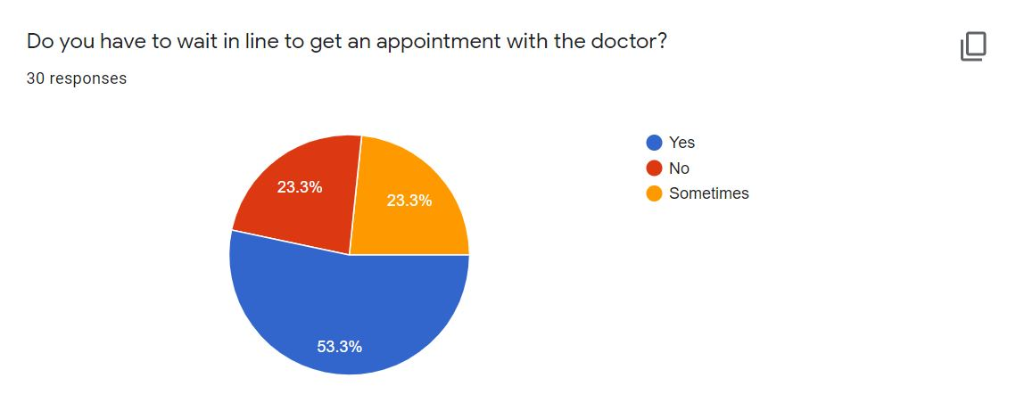

Figure 1: Survey of problem

According to a survey done, it was found that over 50% had to wait in long lines to get an appointment with the doctor whereas around 23% sometimes had to wait in lines.

## 

## 1.3 Project as a Solution

This Dental Appointment System is important for the country as technology grows fast in the world. The goal of developing this project is to provide better solutions to the problems faced by patients. This website will allow customers to schedule an appointment for their dental check-up from home or from the office. In the present situation, there is no such appointment system available in Nepal. Patients find it difficult to book an appointment for their dental check-up. Either they must wait a very long line in crowd or must call some known doctors to schedule an appointment. Patients can also view their reports in their profile, so they will never lose their dental record and it will be much easier to access it in future if the patients face any problems.

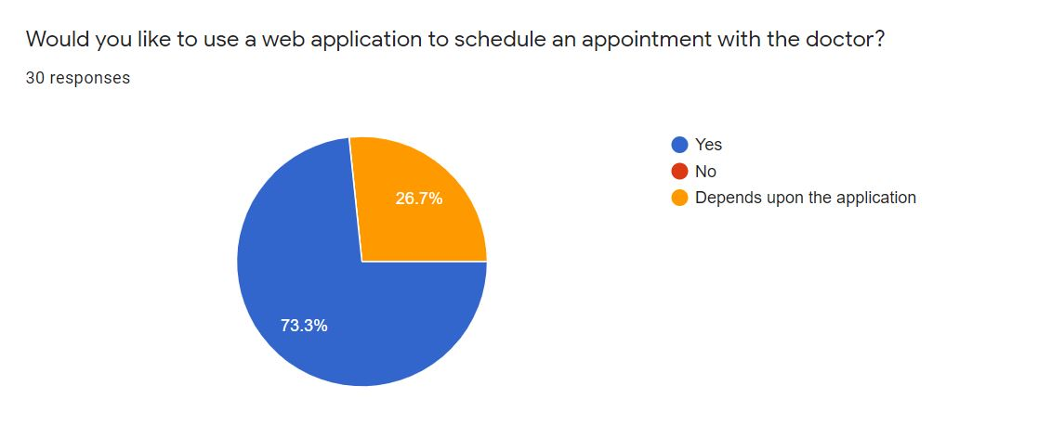

Figure 2: Survey of solution 1

According to the pie chart, it shows that over 70% of them would like to use a web based application to schedule an appointment with the doctor whereas the rest would like to use it depending upon the application.

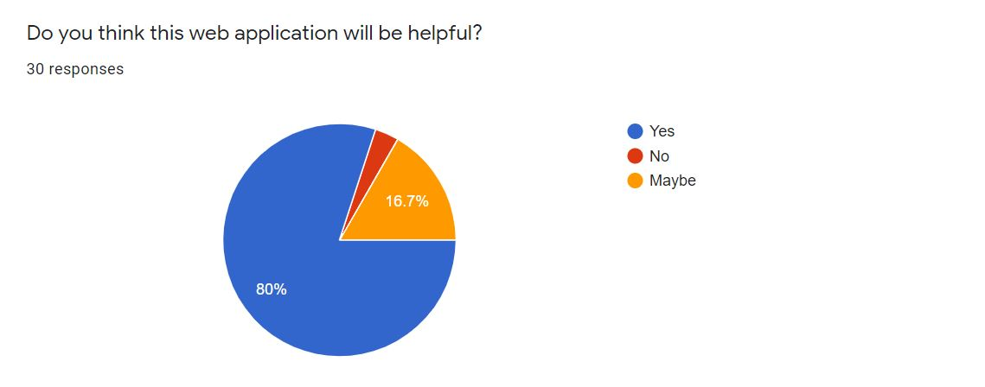

Figure 3: Survey of solution 2

According to the above pie chart of the survey, it was found that 80% of the people thought this web application will be useful whereas 16.7% thought it might be helpful.

At the end of this project, a prototype will be created that will provide a solution to the problem found. This system would be a web-based system where an overall online registration process and appointments will be carried out. Finally, the proposed system would save time for the patients.

## 1.4 Aims and Objectives

The primary aim of this project is to create a user-friendly web application that allows users to schedule a dental check-up appointment and save time rather than going to the clinic and waiting in line.

The following objectives are pursued in order to achieve this aim:

* To learn about the Python and its Django Framework along with it features.
* To use a relational database to comprehend and implement a database management system in the real world.
* To create a web application that allows to people book an appointment for their dental check-up.
* To work on the project using incremental methodology.
* Make the UI as user-friendly and interactive as possible.

## 1.5 Structure of the report

### 1.5.1 Background

* About end user
* Understanding the solution
* Similar Projects
* Comparisons

### 1.5.2 Development

* Considered Methodologies
* Selected Methodology
* Phases of methodology
* Survey Results
  + Pre-Survey Results
  + Post-Survey Results
* Requirement Analysis
* Design
* Implementation

### 1.5.3 Testing and Analysis

* Test Plan
  + Unit Testing, Test plan
  + System Testing, Test Plan
* Unit Testing
* System Testing
* Critical Analysis

### 1.5.4 Conclusion

* Legal, Social and Ethical Issues
  + Legal Issues
  + Social Issues
  + Ethical Issues
* Advantages
* Limitations
* Future Work

# 2. Background

## 2.1 About the end users

### 2.1.1 Discussion with client

Click here to see the summary of the discussion with the client.

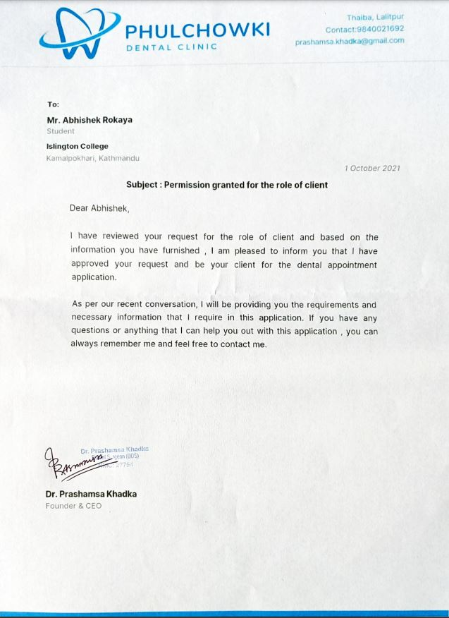

Figure 4: Client Role Permission

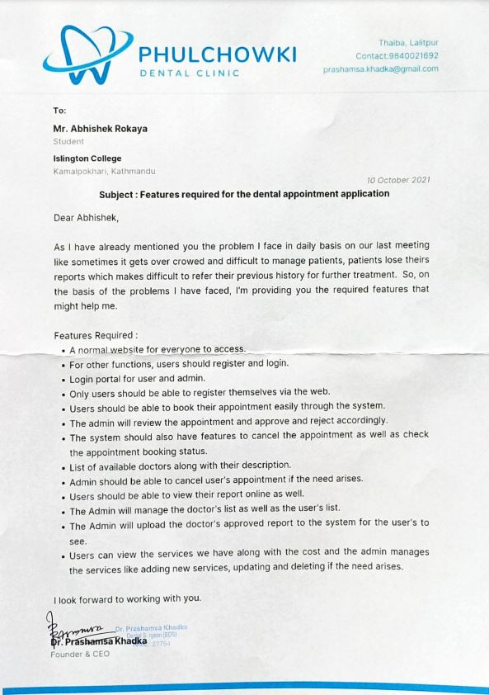

Figure 5: Client's Requirements

### 2.1.2 End Users

The end users for the application will be multiple people who wants to book a dental appointment. The targeted users are the general public looking for an easier way to schedule a dental appointment with the doctor.

## 2.2 Understanding the solution

**2.2.1 Overview of the system**

The system is web-based application named "Dental Appointment System" for "Phulchowki Dental Clinic" located in Thaiba, Lalitpur. The main objective of the application is to provide an online platform for users to book their dental appointment based on their time and convenience. It is a simple application in which user can also view their reports of their appointment visit and select their desired doctors and services.

**2.2.2 Technology**

**Django Python Framework:**

For my project, I have decided to use the Django Python Framework. The reason I chose this framework is because it has better CDN connectivity and content management. It also has a faster processing. Django uses the MTV architecture due to which the transmission over the internet is easier and faster.

**HTML, CSS, JavaScript and Bootstrap**

For the frontend of the web application, I have decided to use HTML, CSS, JavaScript and Bootstrap, which is the framework of CSS.

**SQLite3**

For the database, I have decided to use SQLite to store the database. Django uses SQLite database by default so it is easier to use this database than others which is why I chose this.

**Visual Studio Code IDE:**

The IDEs that I will be using to develop the application is Visual Studio Code. Microsoft's Visual Studio Code (often known as VS Code) is a free open source text editor. Windows, Linux, and macOS are all supported by VS Code. Although the editor is minimal, it contains several strong capabilities that have helped VS Code become one of the most popular development environment tools in recent years.

**Hardware Requirements**

For the project to run, it doesn't need any high-end hardware device. Just a normal working device with a proper internet connection will work fine.

## 2.3 Similar Projects

**2.3.1 Dent-inn**

Dent-inn is a dental clinic located at Durbar-marg of Kathmandu, Nepal. The application is a web based application. In this application, you can fill out an online appointment form. The form requires name, phone, email, date, time, preferred doctor and message. However, you cannot select a particular service from the appointment from itself. There is also a section where you can view the in house doctors. In this application, you do not need register as a user. Anyone can just visit the website and book an appointment. There is no section for uploading report meaning you can only book an appointment for your dental check-up and nothing more.

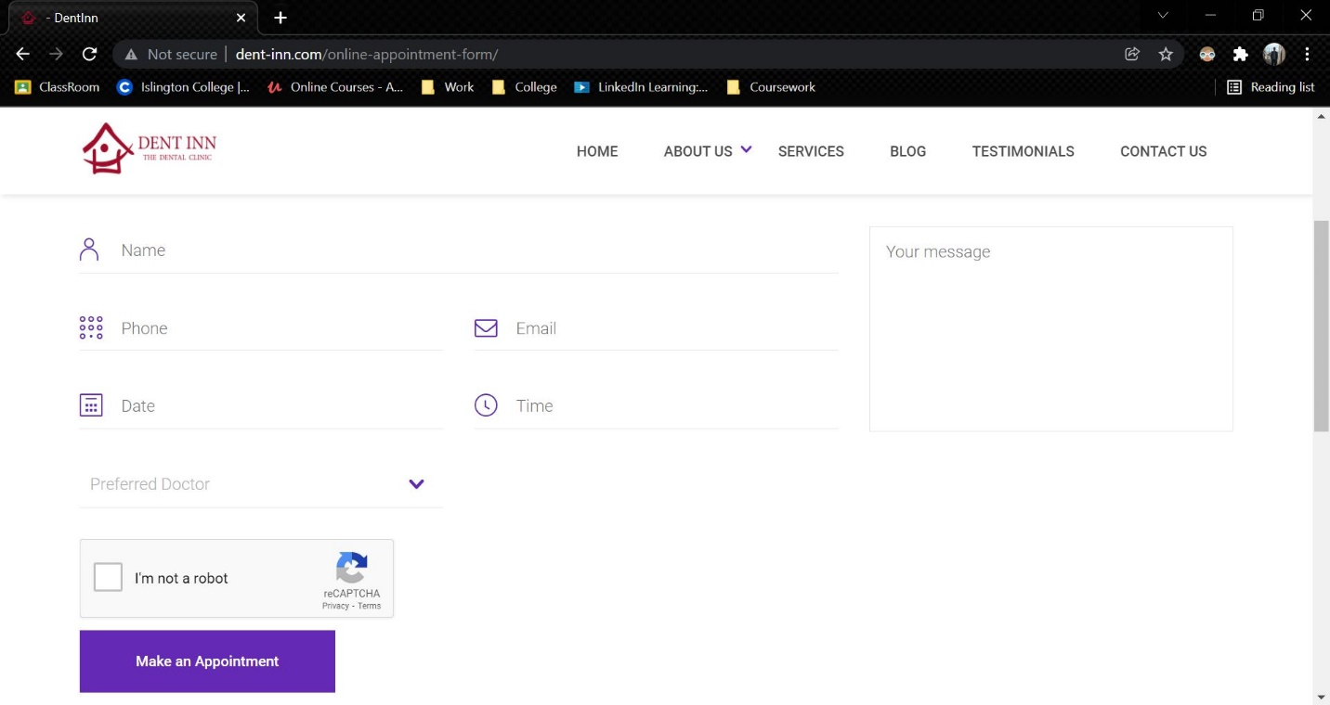

Figure 6: Dent-inn

Link to the website: <http://www.dent-inn.com/>

**2.3.2 DentaLife**

DentaLife is also a dental clinic located at Jamal, Kathmandu. Although the website is similar to Dent-inn, the appointment section of this web is quite different. It used google forms in order to collect the appointment details. This web uses no backend.

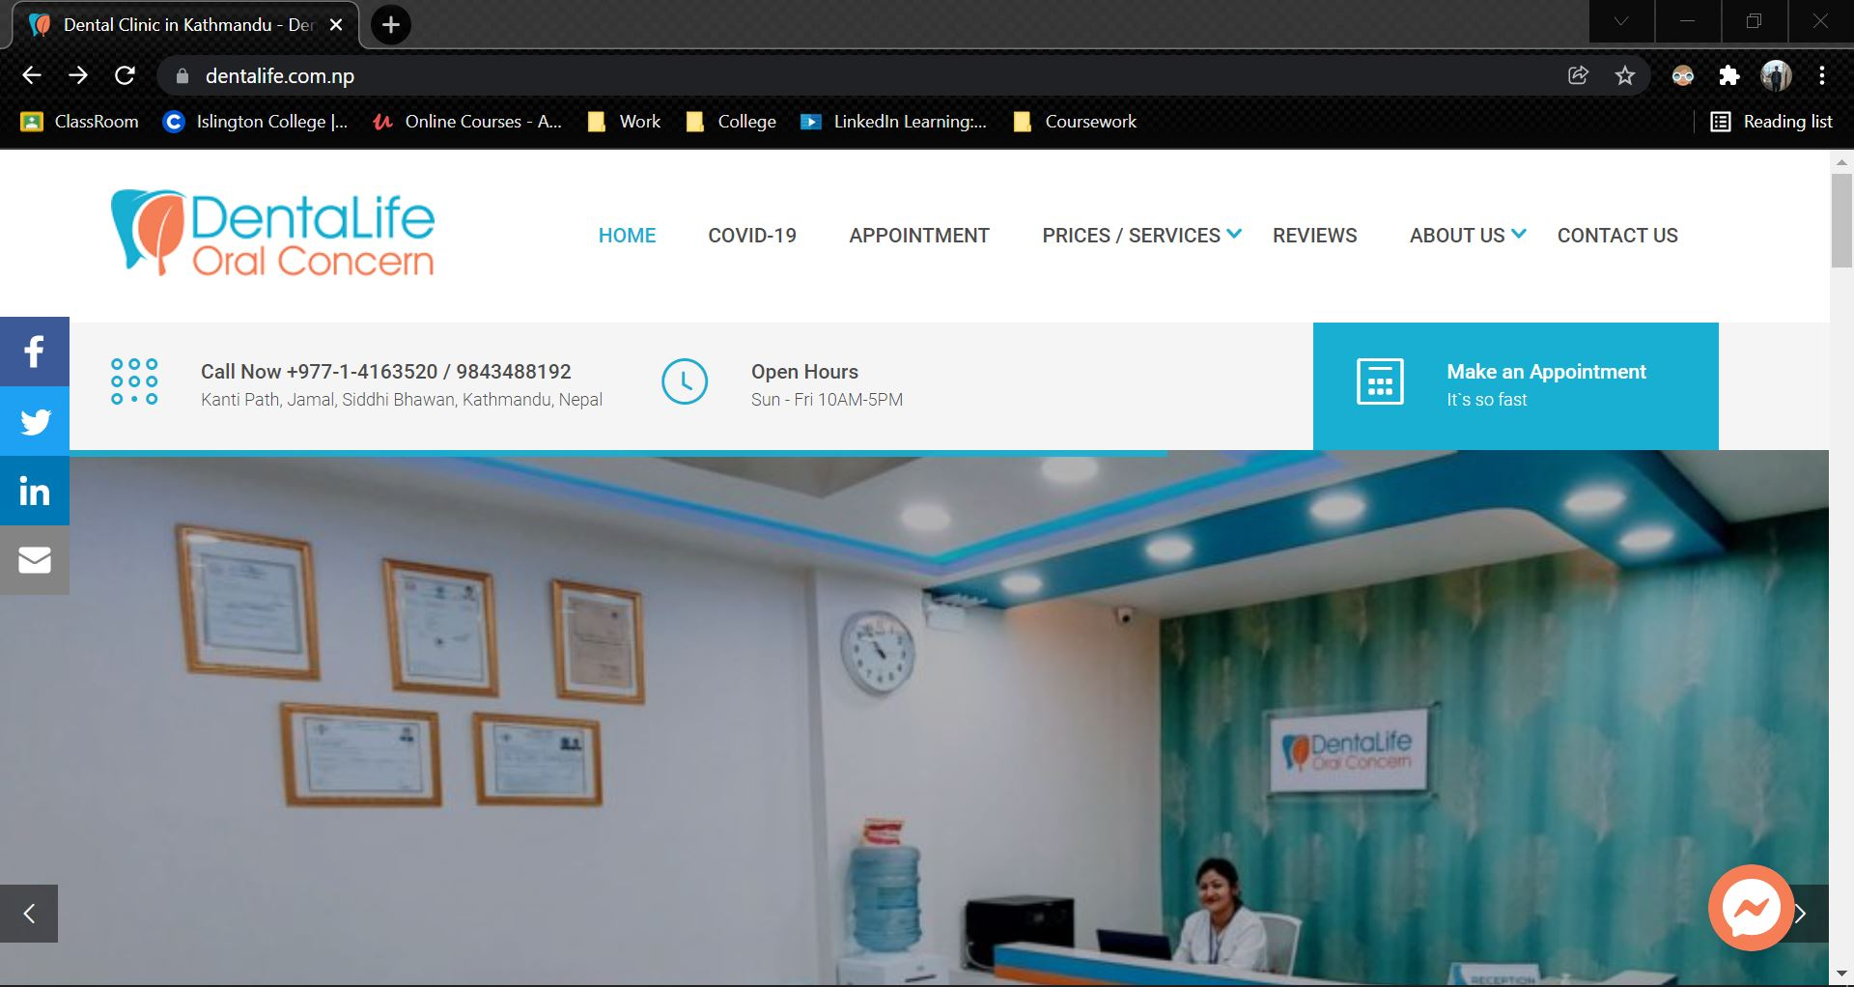

Figure 7: DentaLife

Link to the website: <https://dentalife.com.np/>

**2.3.3 Kumari Dental Care**

Kumari Dental Care is a dental clinic located at Jhamsikhel, Lalitpur. It is also a web based application where any user can book an appointment. In this web application, the first name, last name, email, needs and message. In this clinic, only one doctor is present. There is no login and register feature here as well. There is no report option here as well, meaning user will only use this website once for their appointment.

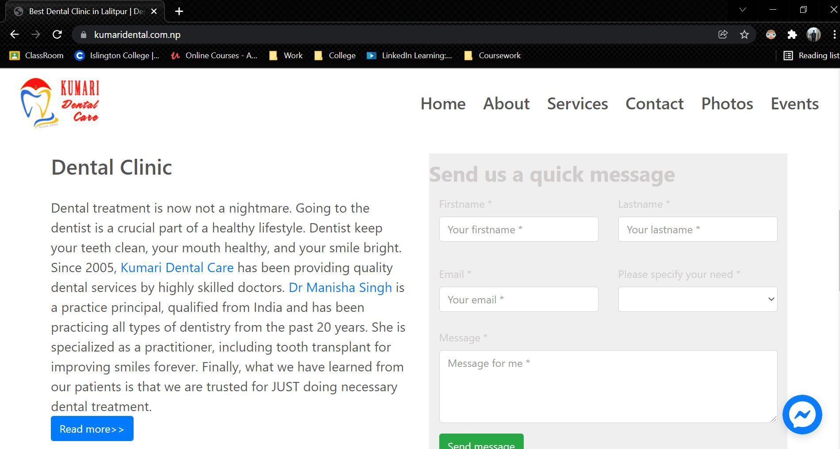

Figure 8: Kumari Dental Care

Link to the website: <https://kumaridental.com.np/index.html>

## 2.4 Comparisons

The table below shows the comparison of different web based applications for the online appointment booking system.

|  |  |  |  |  |  |
| --- | --- | --- | --- | --- | --- |
| S.No | **Features** | Dent-inn | DentaLife | Kumari Dental | My System |
| 1. | Online Appointment Booking Module | ✓ | ✓ | ✓ | ✓ |
| 2. | Doctor Selection | ✓ | ✓ | 🗶 | ✓ |
| 3. | Service Selection | 🗶 | 🗶 | ✓ | ✓ |
| 4. | View Report | 🗶 | 🗶 | 🗶 | ✓ |
| 5. | View Doctors | ✓ | 🗶 | ✓ | ✓ |
| 6. | Login | 🗶 | 🗶 | 🗶 | ✓ |
| 7. | Register | 🗶 | 🗶 | 🗶 | ✓ |
| 8. | Day and Time Selection | ✓ | ✓ | ✓ | ✓ |
| 9. | Description | ✓ | ✓ | ✓ | ✓ |

Table 1: Analysis of Similar Project

## 2.5 Critical evaluation of the comparisons

Comparing the systems, it is found that none of the other similar system have a login or register feature. 2 out 3 website uses Google form as their appointment booking system to collect the user's data. 2 out of 3 website also had the option to select which doctor they wanted to select to get an appointment with. Only one of the three website had the option to select what service the user wanted to get. Others used the description field to write what they wanted. All of the website does have the date and time selection with a place for extra description of their appointment. However, it appears none of the similar websites have the feature to view their report of the visit. All of the similar system focuses only on gaining patient for the appointment and does not seem to care afterwards. However, in my system, we keep track of every visits of the users along with their reports of every visit. In my system, we also show the details of the doctors with the qualification along with the price of the service. This system is very much transparent compared to others and it is for free meaning users do not have to pay any price to use this system.

# 3. Development

## 3.1 Considered Methodologies

**3.1.1 RUP Methodology**

**Justification for considering the methodology:**

* The development process can be done back and forth
* End users have the ability to provide continuous feedback.
* This model focuses on the quality of the software with accurate documentation.

**Reason for not selecting this methodology**

* It relies strongly on expert and skilled team members.
* The process of development is far too complicated and disorderly.
* The focus on integration throughout development may have an impact on testing and other quality assurance phases.

Click here to see more about RUP Methodology.

**3.1.2 Prototype Methodology**

**Justification for considering the methodology:**

* There is room for improvement, which implies that new requirements may be addressed quickly.
* It aids both developers and users in gaining a better understanding of the system.
* The integration needs are well defined, and the deployment channels are chosen early on.
* It has the ability to actively include users in the development process.

**Reason for not selecting this methodology**

* Because to the constantly changing client needs, it has weak documentation.
* The system's complexity may rise as a result.
* There may be an excessive amount of variety in requirements.

Click here to view more about Prototype Methodology.

## 3.2 Selected Methodology

**Incremental Methodology**

Reason for selecting this methodology:

* Produces usable software rapidly and early in the software development life cycle.
* This model is more adaptable, making changes to scope and needs less costly.
* A smaller iteration makes testing and debugging easier.
* Customers can respond to each built in this model.

Click here to see the detailed reason to select this methodology.

## 3.3 Phases of Methodology

There are 4 phases involves in the Incremental model and they are enumerated below:

**3.3.1 Requirement Analysis:**

The first stage in the incremental model is to analyse the product's problem situation and identify the specifications. The functional requirements of the system are understood by the requirement analysis team. This procedure is essential for designing apps utilizing the incremental model. All of the system's criteria are obtained during this procedure through study of publications, books, and web sites, as well as surveys and interviews with end users.

The requirements for my system were acquired through a survey and analysed based on how the end user would want to utilize the program and what features they desired.

**3.3.2 Design and Development:**

Following the collection of all specifications, the major functions and features to be employed in the software are determined. Risks are identified during this phase, as are the instruments that will be used. During this phase, wireframes, use case diagrams, collaboration diagrams, sequence diagrams, and class diagrams are also created. The functionality of the system and the development technique have been successfully designed.

After analysing the requirements, the general design of the project began with the creation of the system's wireframes. Following the creation of the wireframe, the class diagram and use cases for the overall system were established. Following the creation of the class diagram, the ERD for the system's database was created, and the system's code/development was initiated.

**3.3.3 Testing:**

After developing the system's functionality, it is tested in this phase to ensure that the developed system is fully functional and error-free. This phase assesses the consistency of all existing functionalities as well as the addition of new features. A variety of testing methods are utilized to test the activity of each task.

Following the end of the system's development, different forms of testing were performed, including unit testing, system testing, Blackbox testing, and Whitebox testing.

**3.3.4 Implementation:**

When the testing phase is finished, the project goes on to the implementation phase. It includes both the final coding developed during the development phase and the testing of the functionality during the testing phase. After this phase is completed, the number of working products is improved and updated all the way to the final system product. This phase reviews and discusses the entire system, as well as the features and modifications that will be required in future iterations.

After testing is completed, the system's final coding is accomplished, and the focus shifts to enhancing the system, fixing errors, and adding new features.

## 3.4 Survey

### 3.4.1 Pre-Survey Results

A survey was conducted during the requirement analysis phase where details about the scenario people face and what might make the application better was recorded. A total of 30 people filled out the survey and the details that was gathered are as follows:

1. 43.3% of them have their dental check-up in over a year, 26.7% of them in a year, 26.7% in every 6 months and 3.3% in every 3 months.
2. 53.3% have to wait in line to get an appointment, 23.3% sometime have to wait in line and 23.3% of them doesn't have to wait in line.
3. 86.7% have never used an online appointment booking system whereas 13.3% have.
4. 73.3% said they would like to use a web based application to schedule an appointment with the doctor whereas the remaining 26.7% said it would depend on the application.
5. 80% thinks this application will be helpful, 16.7% thinks the application might be helpful whereas 3.3% thought it will not be helpful.
6. 76.7% thinks having an online report will be useful whereas 23.3% thinks it might be useful.

Link to the survey: <https://forms.gle/x1DkhUFqgoDTmZ886>

Click here to see the pre-survey results and responses

### 3.4.2 Post-Survey Results

After the completion of the development phase, another survey was conducted which recorded the response of people to how the system was. A total of 55 people filled out the survey and the results that was gathered are as follows:

1. 74.5% of the total people rated 5 star for the UI of the application. 23.6% rated it as 4 star and 1.8% rated it as 3 star.
2. 87.3% of the total people rated 5 star for the functionality of the system whereas the rest 12.7% rated it as 4 star.
3. 49.1% of them liked viewing the report function the most among others. 40% liked the Booking of Appointment most whereas the rest 10.9% liked the browsing of doctor the most.
4. 100% of the people saw themselves as using this application.
5. 100% of the people would recommend this application to others.
6. Most of the people would like to see payment and chat system in the future.

Link to the survey: https://forms.gle/Y7jvWTMVgvhn8wCr7

Click here to see the post-survey results and responses

## 3.5 Requirement Analysis

### 3.5.1 Feature Requirements

**3.5.1.1 Functional**

* User can register and login in the system.
* User can schedule an appointment for their booking.
* User can cancel their booking.
* Admin can approve, reject or cancel the user's appointment.
* Admin can add report of the finished appointment.
* Admin can add, update and delete the doctors and services.

**3.5.1.2 Non-Functional**

* User can view their report of their finished appointment.
* User can view the list of doctors along with their details.
* User can view the services available along with the cost and description.

**3.5.1.3 Usable**

* There is a navigation bar available in the side for users to switch pages.
* Unregistered users can send their queries through contact form in home page.
* User can search and sort their appointment and report list.
* User can download a pdf of their report.

### 3.5.2 Hardware and Software Requirements

Since this project is a web application, there are no required hardware requirements for loading or accessing it. The following are some of the requirements for operating this web application:

* Good and stable Internet Connection.
* Any working laptop or computer.
* Web Browsers like Google Chrome, Microsoft Edge, etc.

Click here to see the SRS Document of this project.

## 3.6 Design

For the design part of the project, UML Diagrams, ER Diagram and Class Diagrams are created. Use Case Diagram, Collaboration Diagram, Activity Diagram and Sequence Diagrams are created for each of the function of the system. However, an overall use case diagram is also created for the overall system. ER Diagram and Class Diagram is also created for the overall system. The designs are given below:

Click here to see the description of the designs.

Click here to see the Gantt chart.

Click here to see the Work Breakdown Structure.

Click here to see the algorithm and the flowchart.

Click here to see the Final ERD and its creation.

Click here to see the Class Diagram.

Click here to see the wireframes.

Click here to see the functional UML Diagrams of the admin side.

### 3.6.1 Overall Use Case Diagram

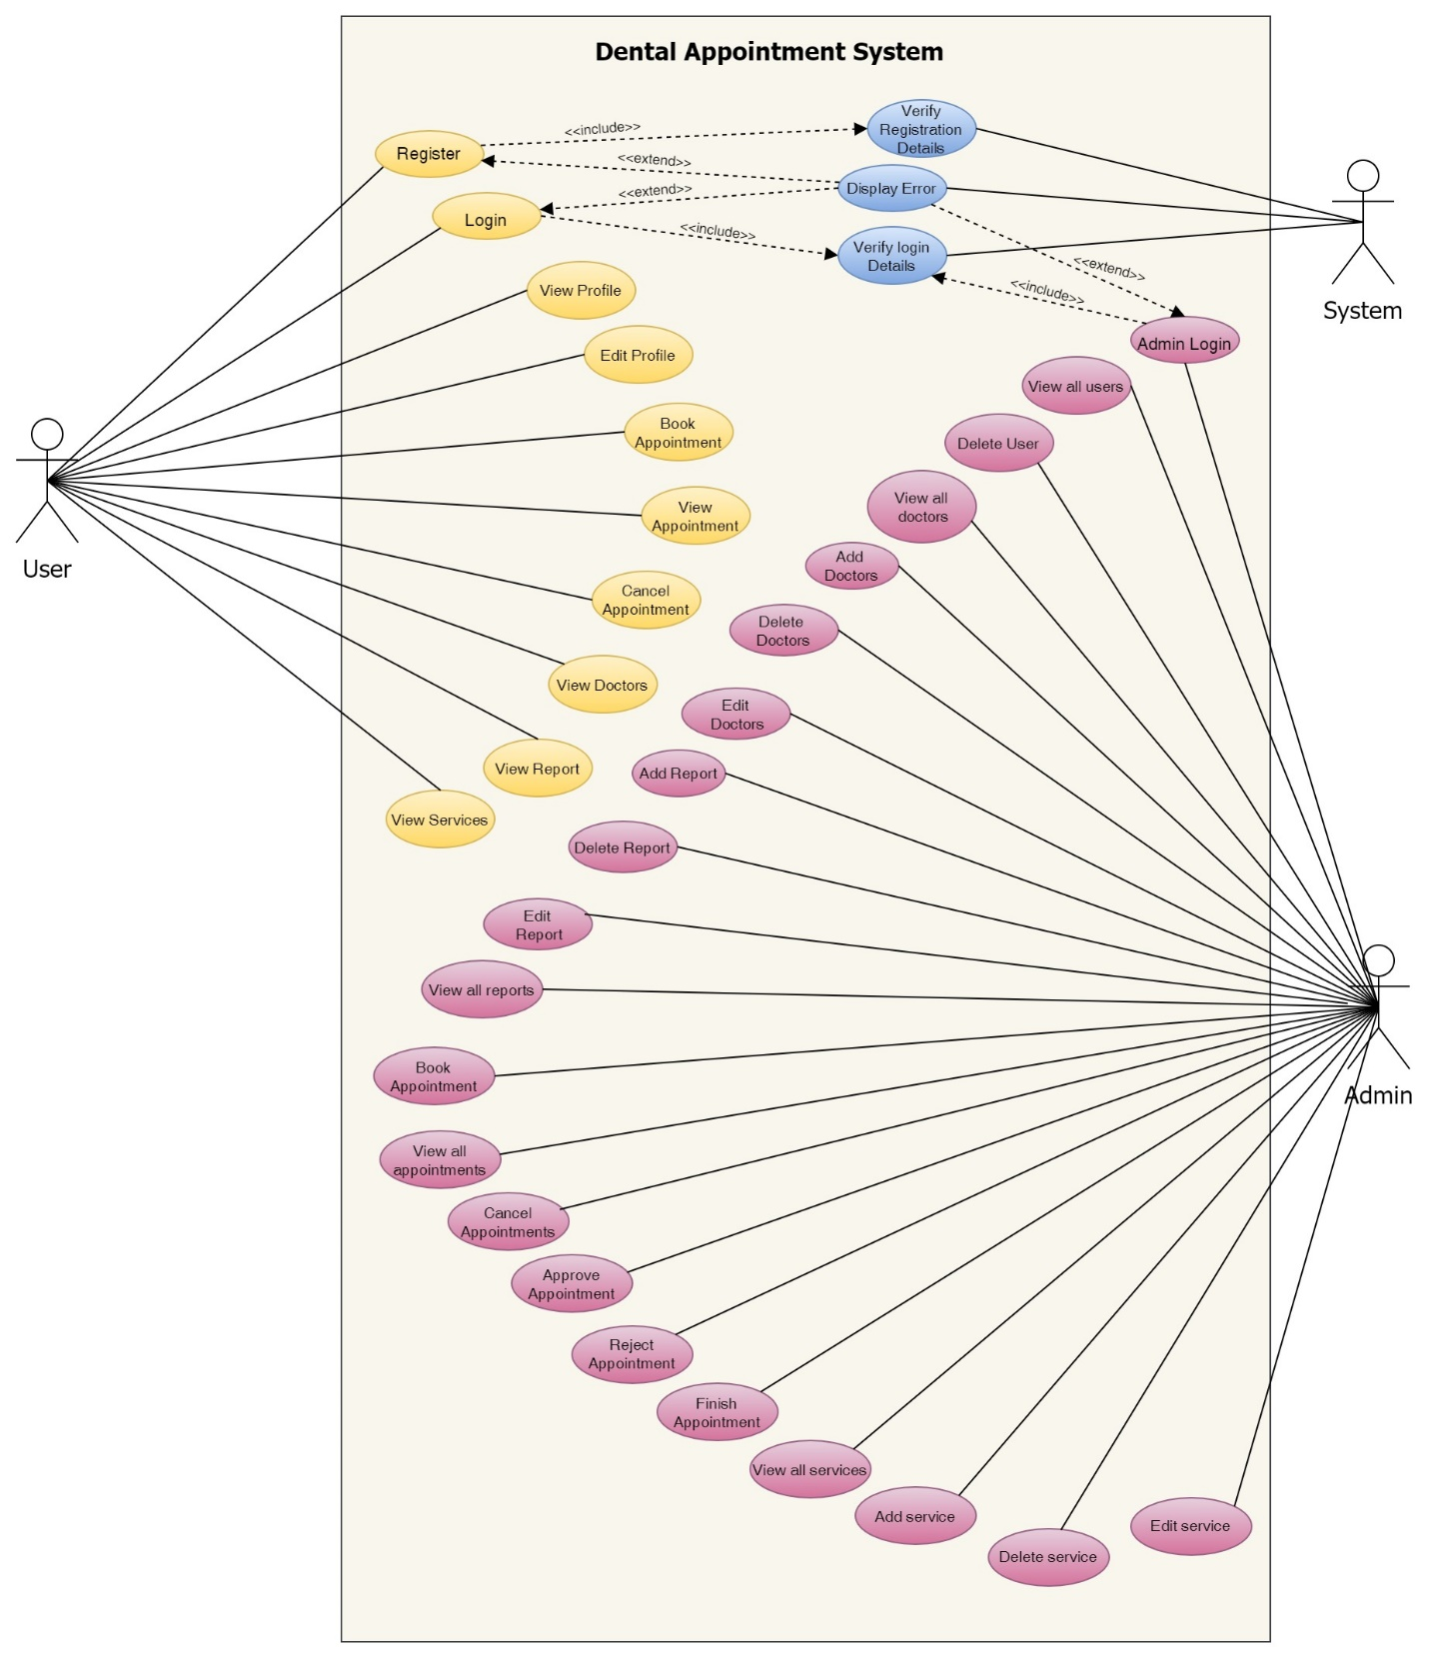

Figure 9: Overall Use Case Diagram

Click here to view the creation of Use Case Diagram.

### 3.6.2 Functional UML Diagrams

**User**

1. Register to the system

**High Level Use Case Description**

|  |  |
| --- | --- |
| **Use Case:** | Register |
| **Actor:** | User |
| **Description:** | New users that are not registered in the system register into system. The registration is then verified by the system. |

Table 2: High Level Use Case – User Registration

**Use Case Diagram**

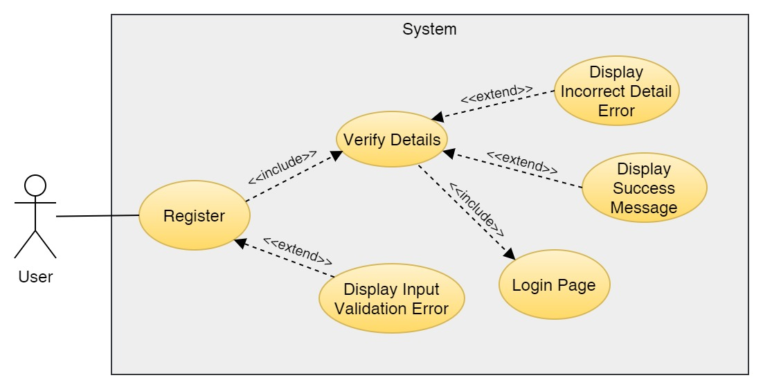

Figure 10: Use Case Diagram – User Registration

**Collaboration Diagram**

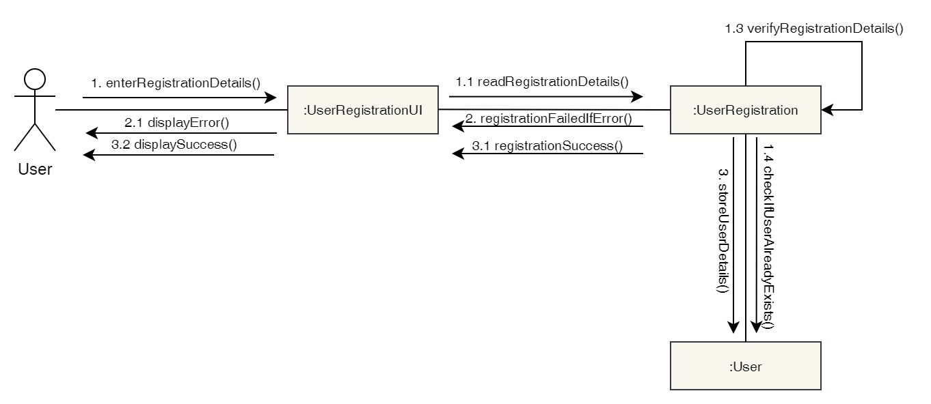

Figure 11: Collaboration Diagram – User Registration

**Activity Diagram**

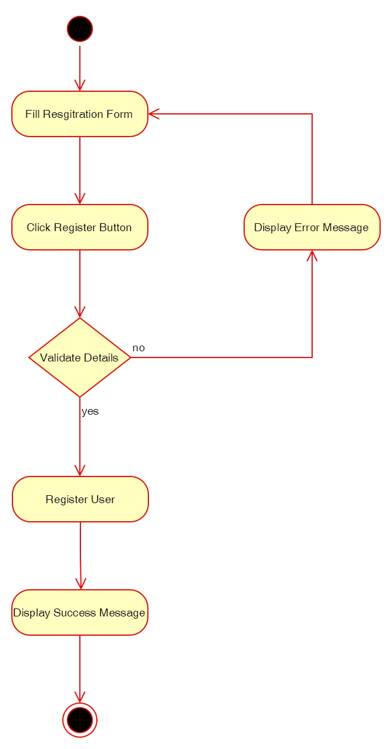

Figure 12: Activity Diagram – User Registration

**Sequence Diagram**

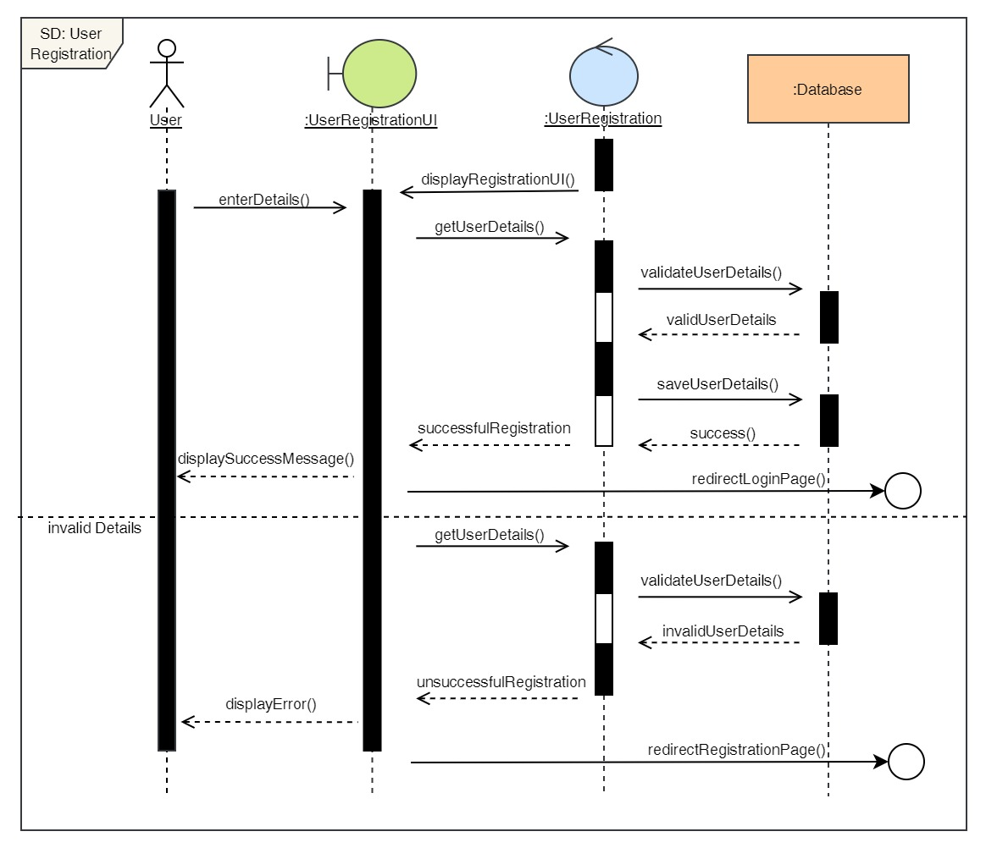

Figure 13: Sequence Diagram – User Registration

2. Login to the system

**High Level Use Case Description**

|  |  |
| --- | --- |
| **Use Case:** | Login |
| **Actor:** | User |
| **Description:** | In order to use the system and use its features, the user must log in to the system. The login details is then verified by the system. |

Table 3: High Level Use Case – User Login

**Use Case Diagram**

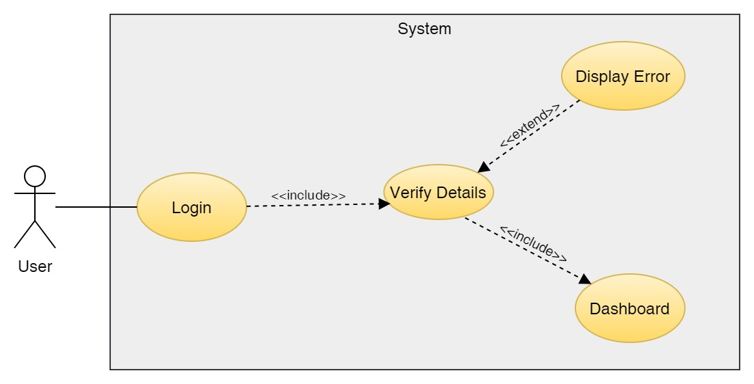

Figure 14: Use Case Diagram – User Login

**Collaboration Diagram**

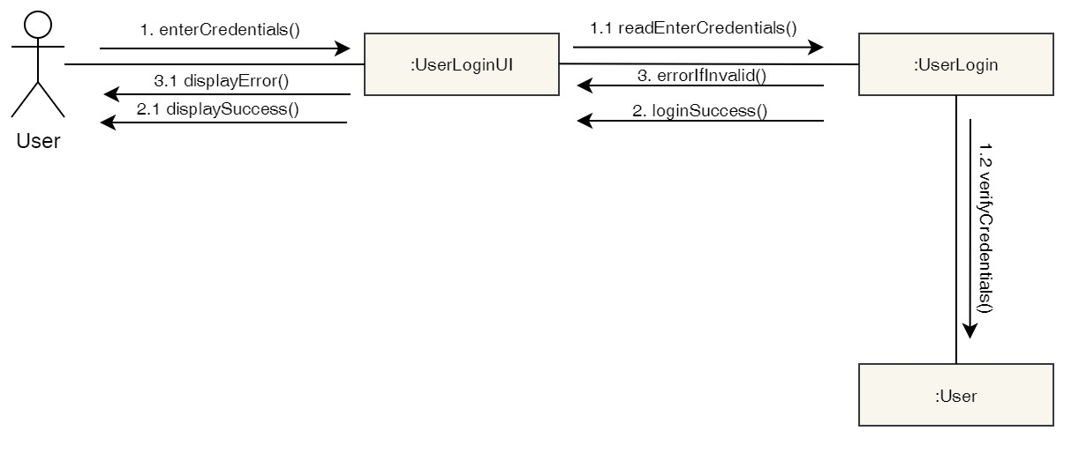

Figure 15: Collaboration Diagram – User Login

**Activity Diagram**

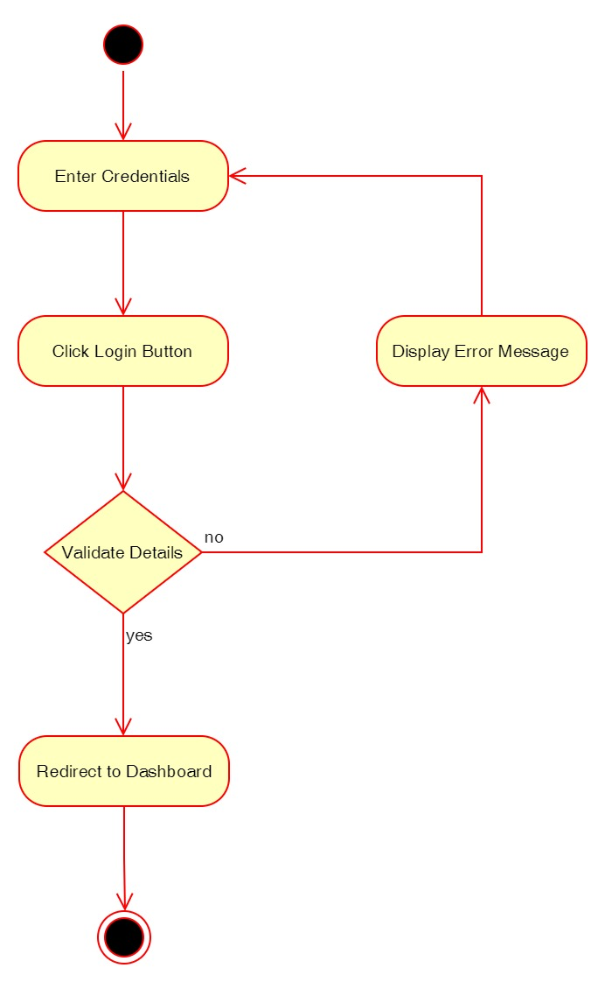

Figure 16: Activity Diagram – User Login

**Sequence Diagram**

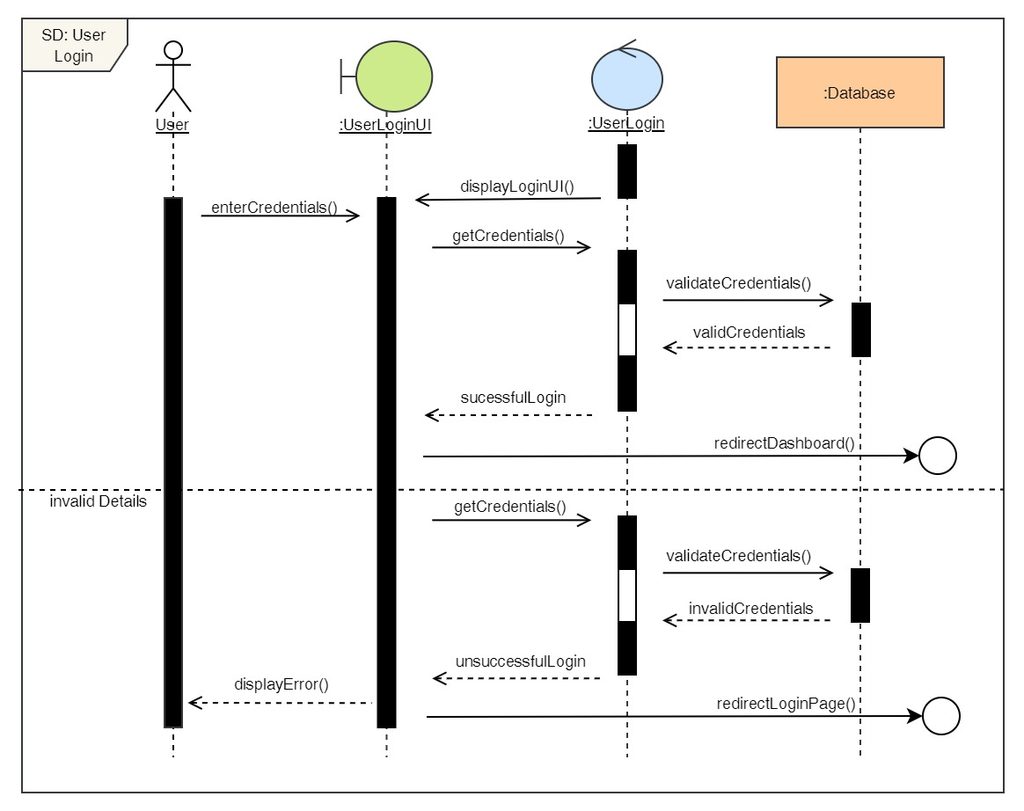

Figure 17: Sequence Diagram – User Login

3. View Profile

**High Level Use Case Description**

|  |  |
| --- | --- |
| **Use Case:** | View Profile |
| **Actor:** | User |
| **Description:** | The user can view their profile where they can see their details which they input. |

Table 4: High Level Use Case – User View Profile

**Use Case Diagram**

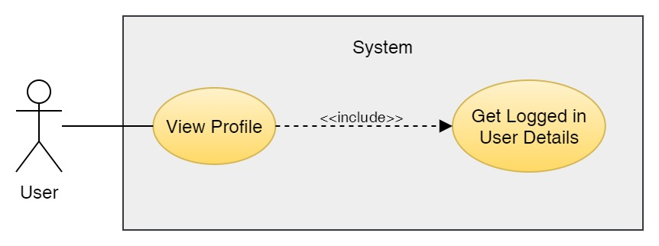

Figure 18: Use Case Diagram – User View Profile

**Collaboration Diagram**

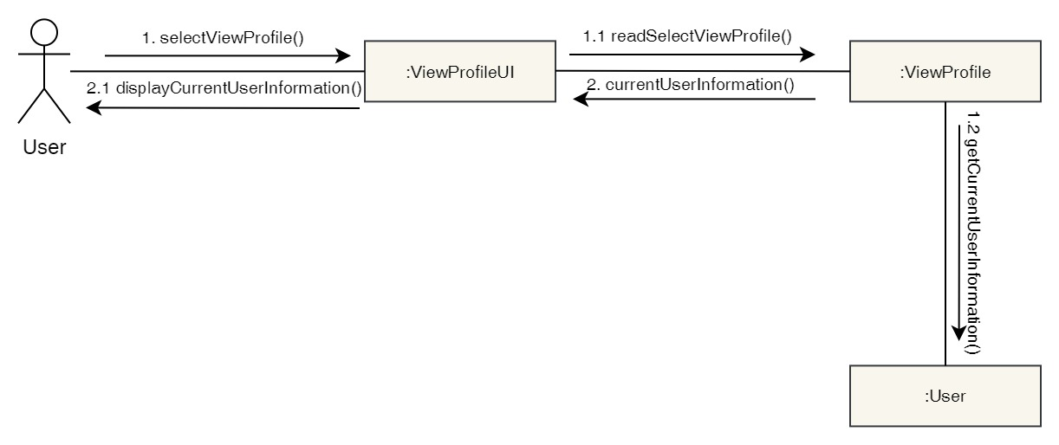

Figure 19: Collaboration Diagram – User View Profile

**Activity Diagram**

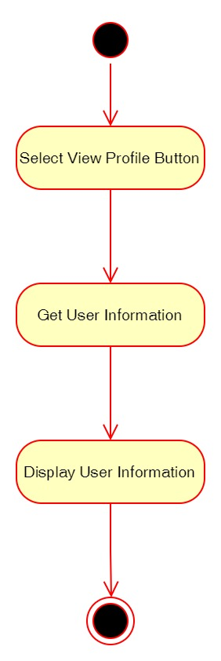

Figure 20: Activity Diagram – User View Profile

**Sequence Diagram**

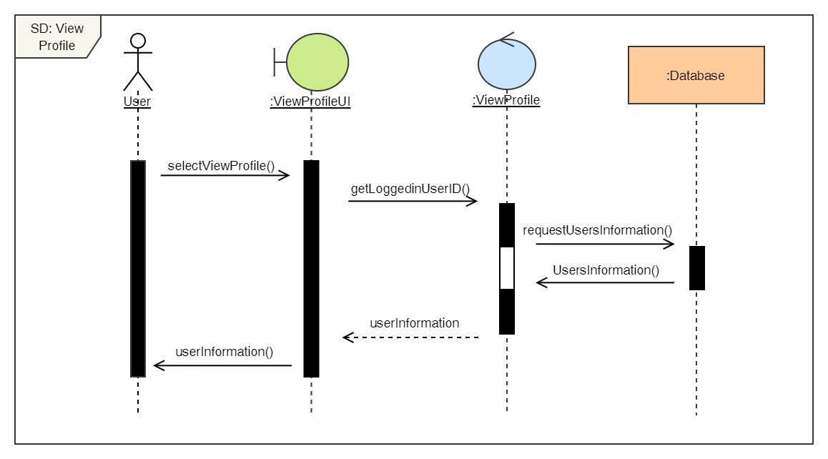

Figure 21: Sequence Diagram – User View Profile

4. Edit Profile

**High Level Use Case Description**

|  |  |
| --- | --- |
| **Use Case:** | Edit Profile |
| **Actor:** | User |
| **Description:** | The user can update their profile details if they have changed anything from what they previously entered. |

Table 5: High Level Use Case – User Edit Profile

**Use Case Diagram**

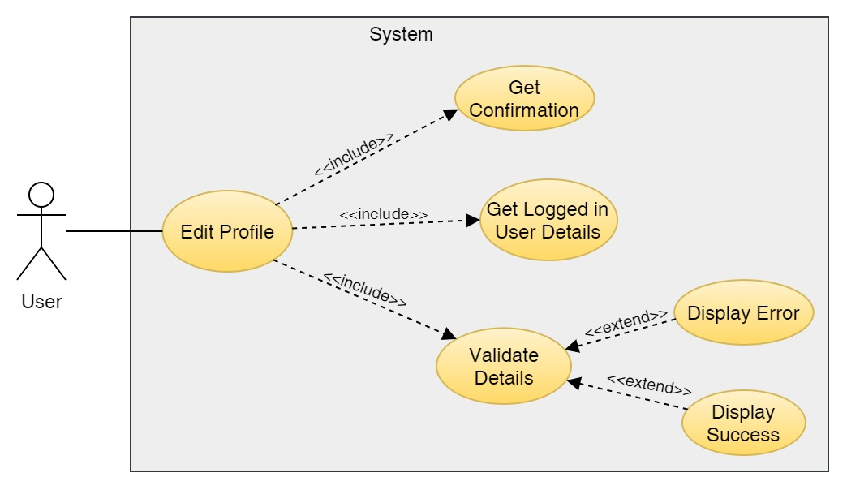

Figure 22: Use Case Diagram – User Edit Profile

**Collaboration Diagram**

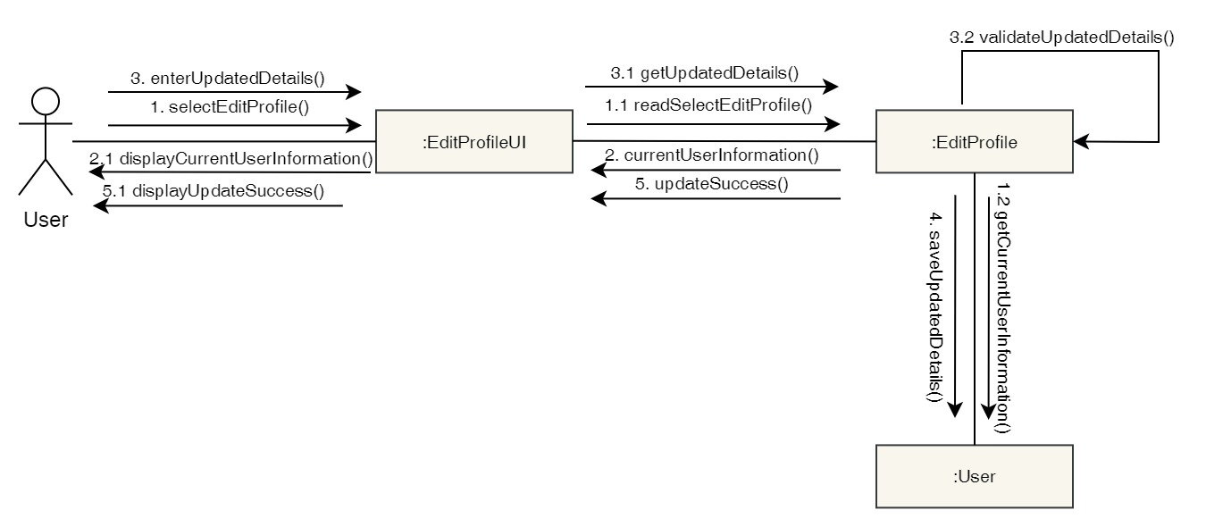

Figure 23: Collaboration Diagram – User Edit Profile

**Activity Diagram**

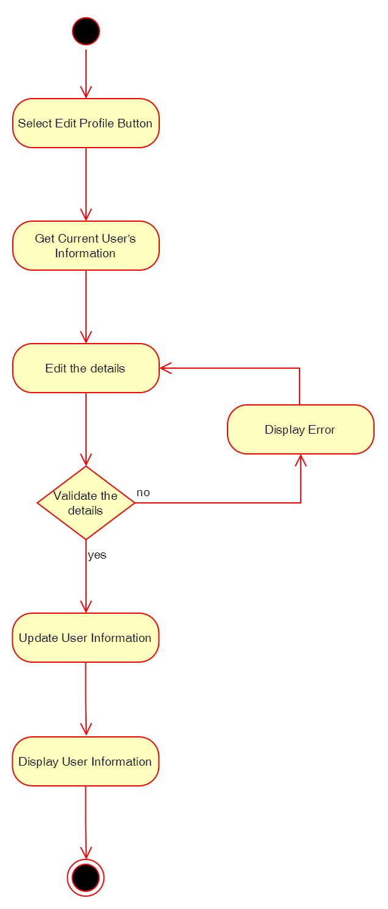

Figure 24: Activity Diagram – User Edit Profile

**Sequence Diagram**

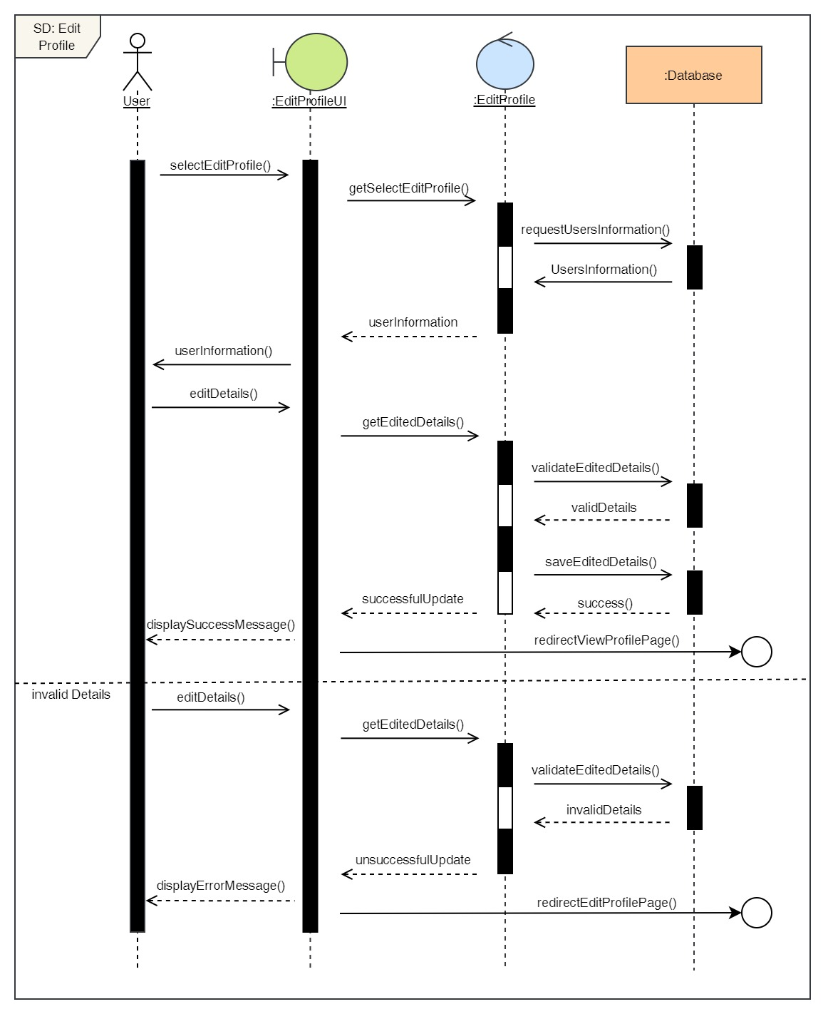

Figure 25: Sequence Diagram – User Edit Profile

5. Book a Dental Appointment

**High Level Use Case Description**

|  |  |
| --- | --- |
| **Use Case:** | Book Appointment |
| **Actor:** | User |
| **Description:** | User can book appointment for any dental services by selecting the desired date, time, doctor and service. |

Table 6: High Level Use Case – User Book Appointment

**Use Case Diagram**

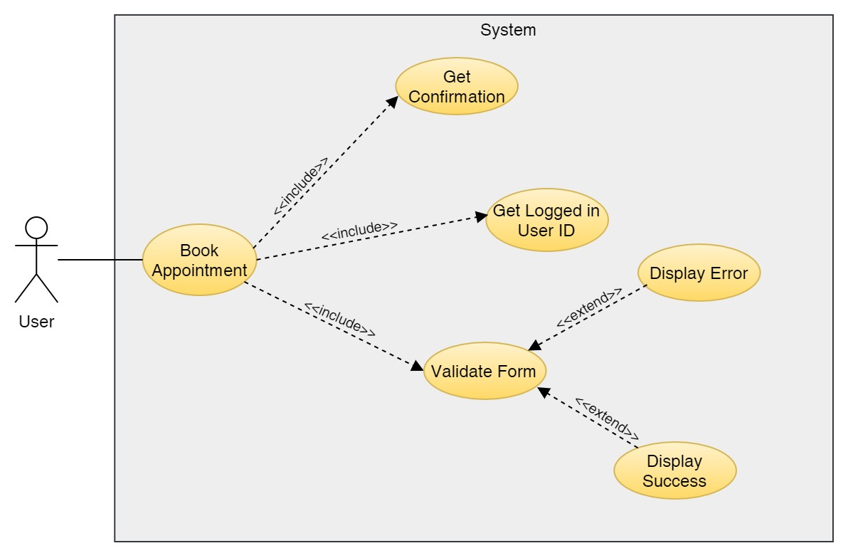

Figure 26: Use Case Diagram – User Book Appointment

**Collaboration Diagram**

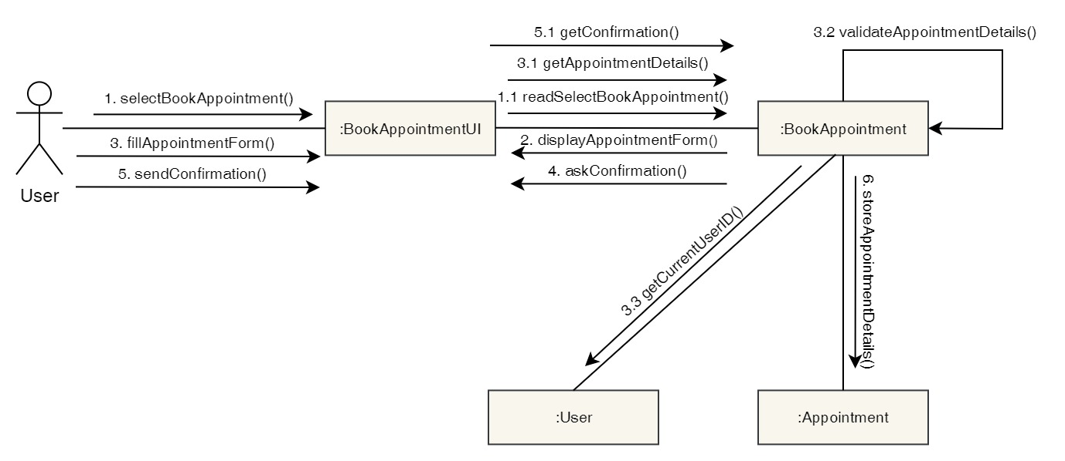

Figure 27: Collaboration Diagram – User Book Appointment

**Activity Diagram**

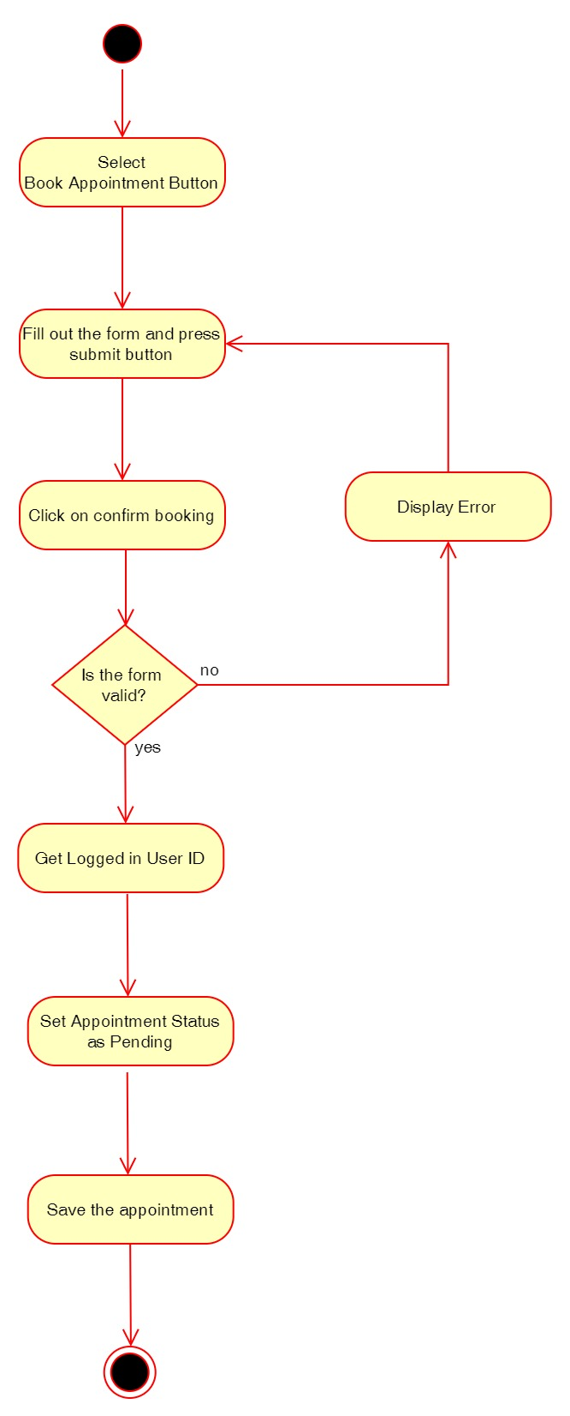

Figure 28: Activity Diagram – User Book Appointment

**Sequence Diagram**

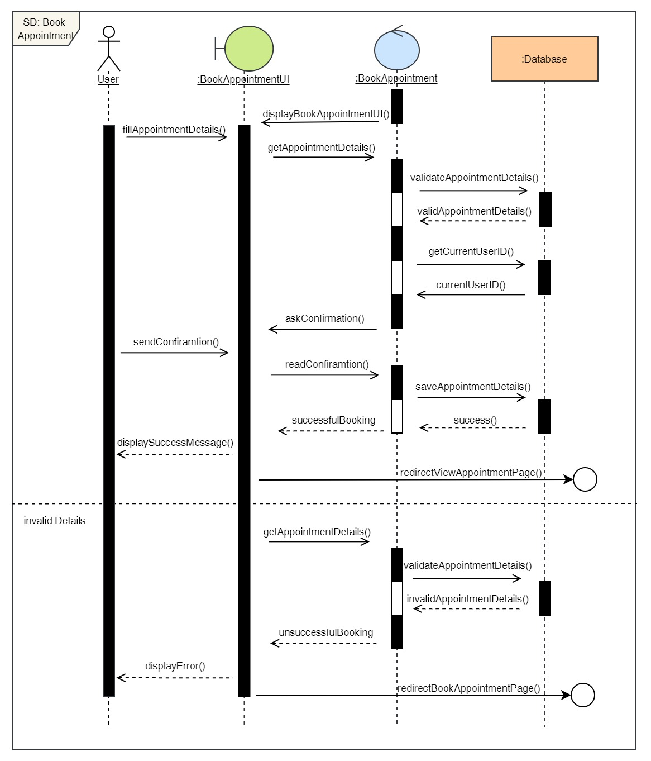

Figure 29: Sequence Diagram – User Book Appointment

6. View Appointment

**High Level Use Case Description**

|  |  |
| --- | --- |
| **Use Case:** | View Appointment |
| **Actor:** | User |
| **Description:** | Users can view their current appointments as well as their appointments history. |

Table 7: High Level Use Case – User View Appointment

**Use Case Diagram**

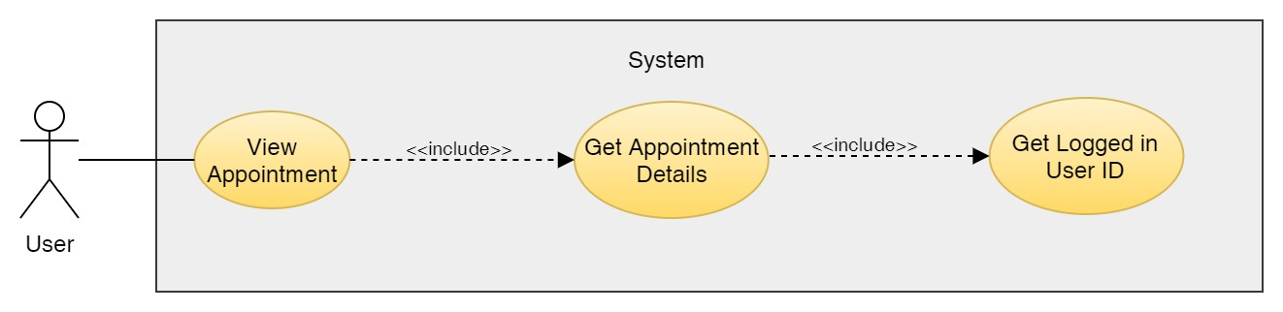

Figure 30: Use Case Diagram – User View Appointment

**Collaboration Diagram**

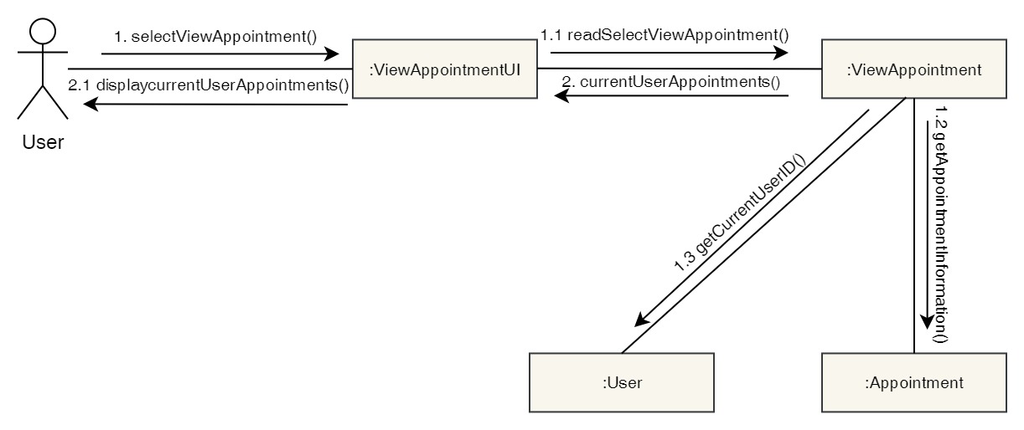

Figure 31: Collaboration Diagram – User View Appointment

**Activity Diagram**

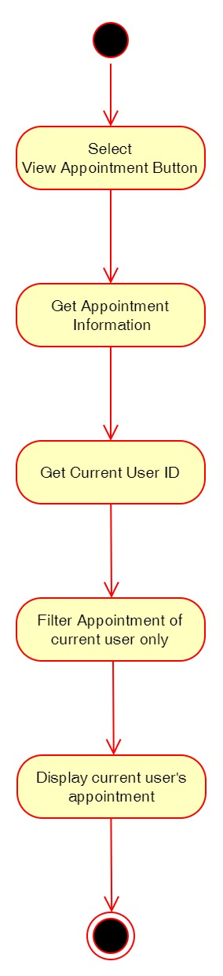

Figure 32: Activity Diagram – User View Appointment

**Sequence Diagram**

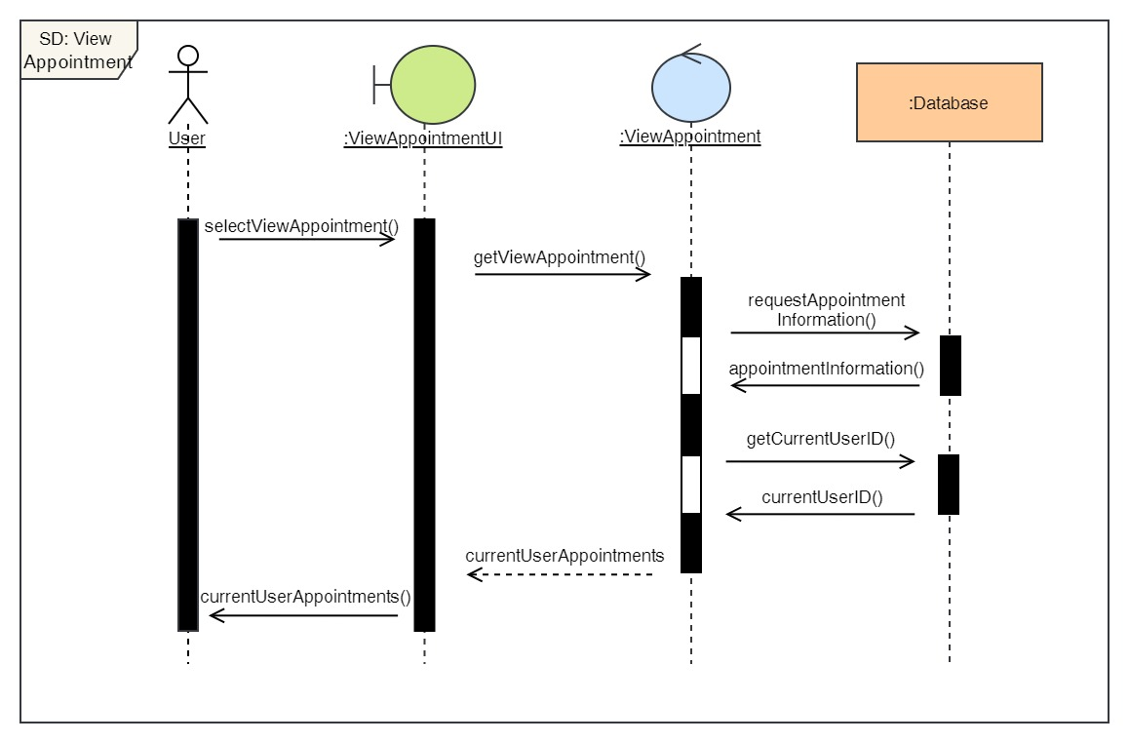

Figure 33: Sequence Diagram – User View Appointment

7. Cancel Appointment

**High Level Use Case Description**

|  |  |
| --- | --- |
| **Use Case:** | Cancel Appointment |
| **Actor:** | User |
| **Description:** | The user can cancel their pending appointment or the appointment that has been confirmed. |

Table 8: High Level Use Case – User Cancel Appointment

**Use Case Diagram**

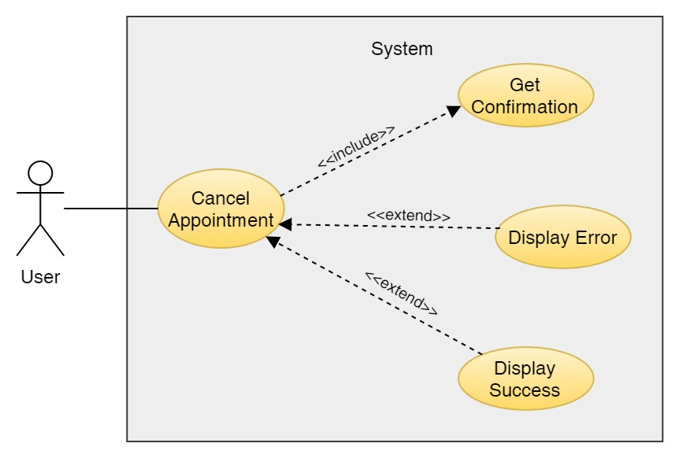

Figure 34: Use Case Diagram – User Cancel Appointment

**Collaboration Diagram**

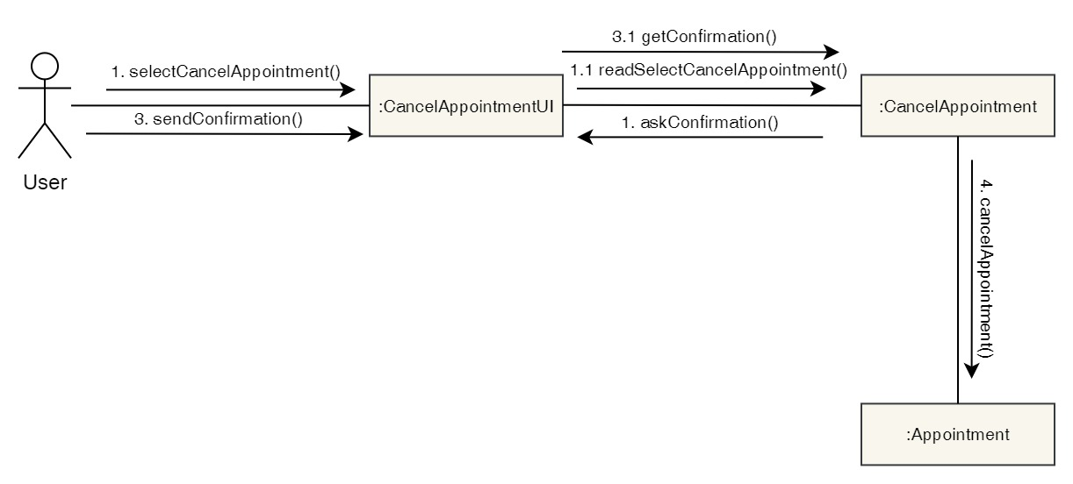

Figure 35: Collaboration Diagram – User Cancel Appointment

**Activity Diagram**

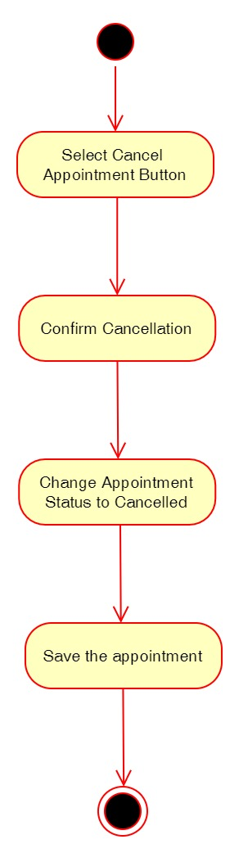

Figure 36: Activity Diagram – User Cancel Appointment

**Sequence Diagram**

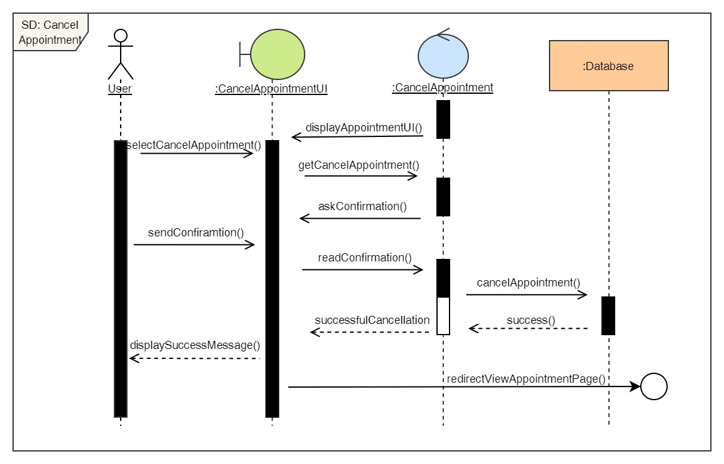

Figure 37: Sequence Diagram – User Cancel Appointment

8. View available doctors

**High Level Use Case Description**

|  |  |
| --- | --- |
| **Use Case:** | View Doctors |
| **Actor:** | User |
| **Description:** | Users can view doctors that are available at the clinic and read their description and see their qualification as well. |

Table 9: High Level Use Case – User View Doctors

**Use Case Diagram**

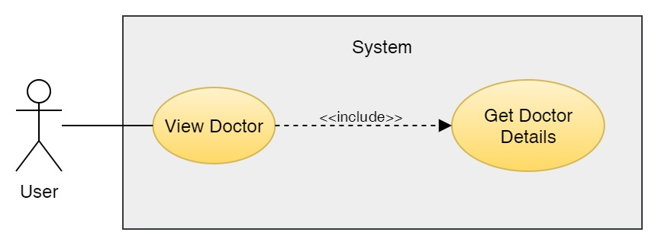

Figure 38: Use Case Diagram – User View Doctor

**Collaboration Diagram**

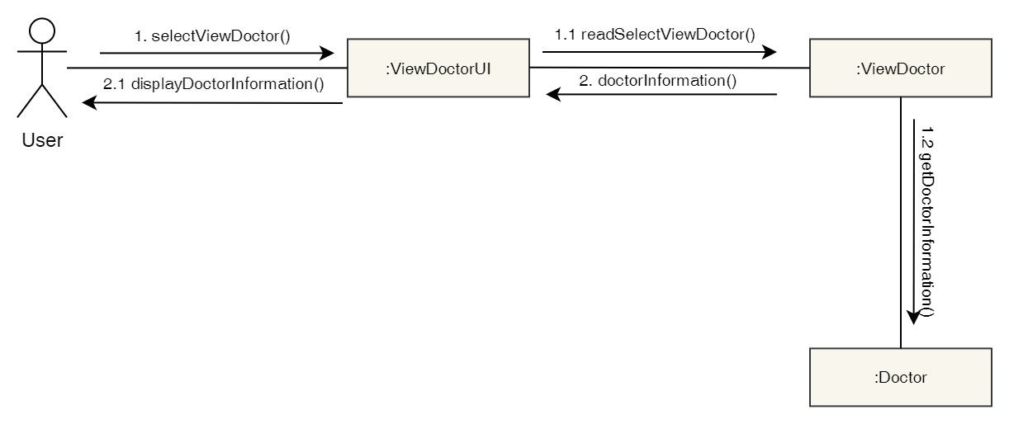

Figure 39: Collaboration Diagram – User View Doctor

**Activity Diagram**

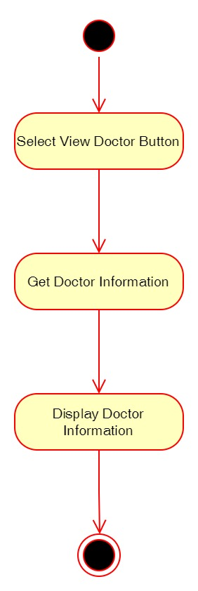

Figure 40: Activity Diagram – User View Doctor

**Sequence Diagram**

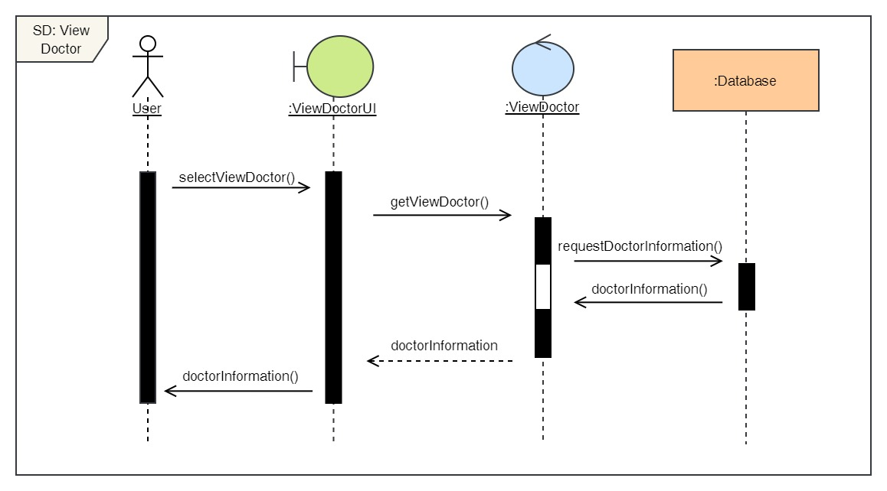

Figure 41: Sequence Diagram – User View Doctor

9. View report

**High Level Use Case Description**

|  |  |
| --- | --- |
| **Use Case:** | View Report |
| **Actor:** | User |
| **Description:** | Users can view report about their visit to the clinic. They can download it as well. |

Table 10: High Level Use Case – User View Report

**Use Case Diagram**

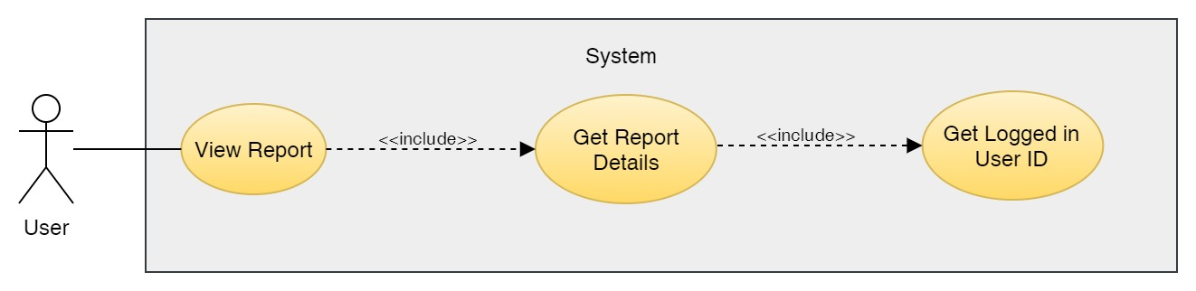

Figure 42: Use Case Diagram – User View Report

**Collaboration Diagram**

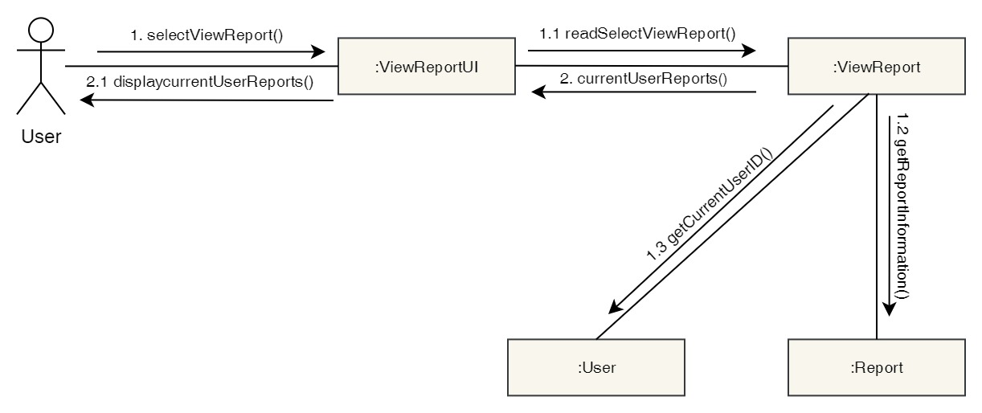

Figure 43: Collaboration Diagram – User View Report

**Activity Diagram**

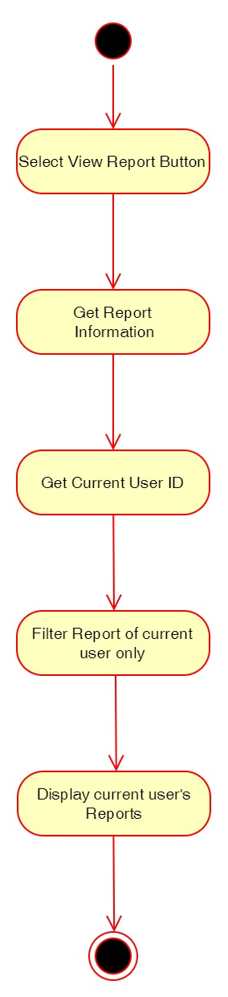

Figure 44: Activity Diagram – User View Report

**Sequence Diagram**

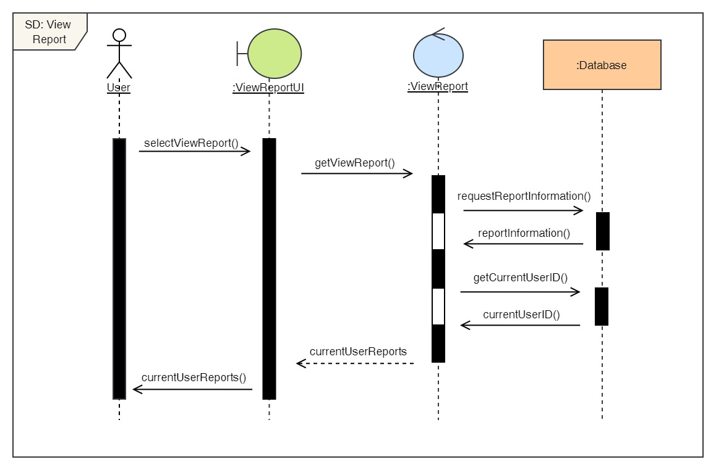

Figure 45: Sequence Diagram – User View Report

10. View services

**High Level Use Case Description**

|  |  |
| --- | --- |
| **Use Case:** | View Services |
| **Actor:** | User |
| **Description:** | Users can view the list of services available along with the cost of it and description. |

Table 11: High Level Use Case – User View Services

**Use Case Diagram**

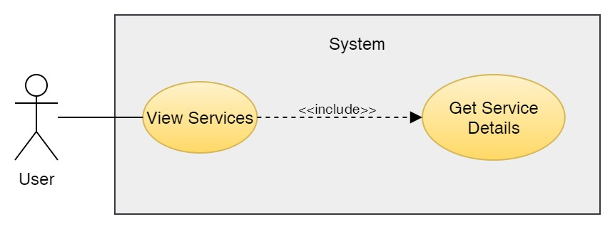

Figure 46: Use Case Diagram – User View Services

**Collaboration Diagram**

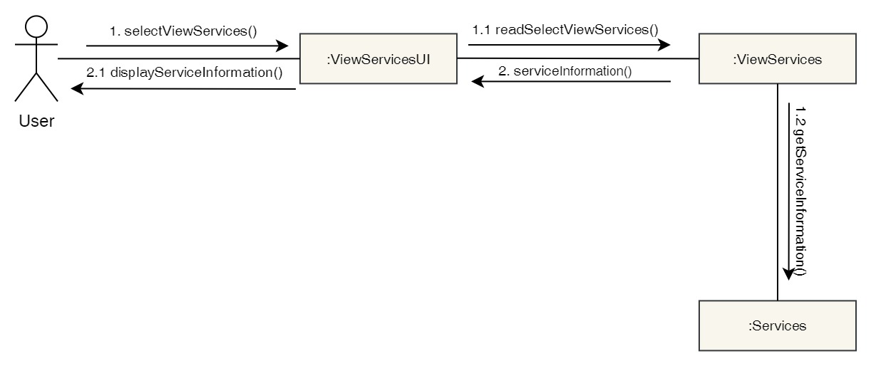

Figure 47: Collaboration Diagram – User View Services

**Activity Diagram**

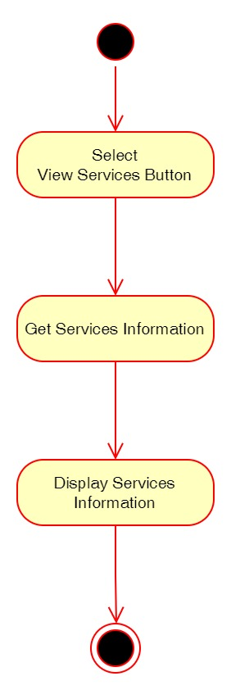

Figure 48: Activity Diagram – User View Services

**Sequence Diagram**

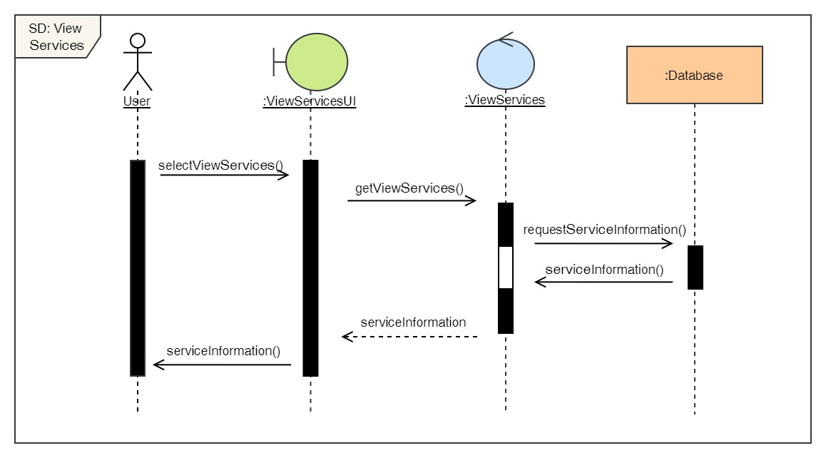

Figure 49: Sequence Diagram – User View Services

Click here to view the rest of the functional UML diagrams of the admin side.

## 3.7 Implementation

### 3.7.1 System Architecture

A system architecture is a conceptual model that describes a system's structure and behaviour. This project is done on Django Framework which is based on MVT (Model-View-Template) Architecture. MVT is a web application development software design pattern. It has three major components, which are listed as follows:

**Model**: The model is going to be your data's interface. It is in charge of data management. The database (SQLite3) represents the logical data structure that underpins the whole program.

**View**: It is the user interface that we see in our browser when we render a website. HTML/CSS/JavaScript/Bootstrap are used to represent it.

**Template:** It is made up of both static sections of the desired HTML output and specific syntax that describes how dynamic information will be included.

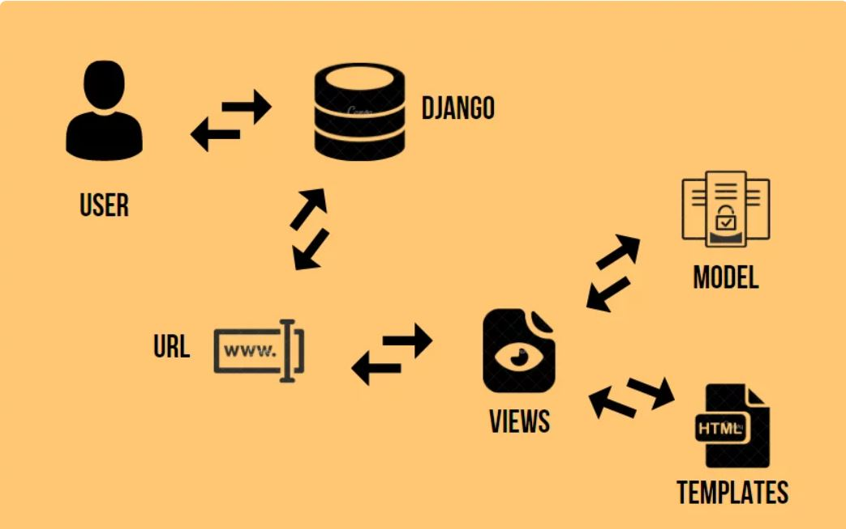

Figure 50: System Architecture (AskPython, 2022)

In the above image, we can see the control flow of the MVT Architecture in Django. The user first sends a URL request for a resource to Django. Then the Django framework searches up the URL resource. If the URL path points to a certain View, that View is called. After that, the View will communicate with the Model and obtain the necessary data from the database. The View then returns to the user with an appropriate template and the obtained data. In this way, the MVT Architecture works in Django Framework.

### 3.7.2 Database Implementation

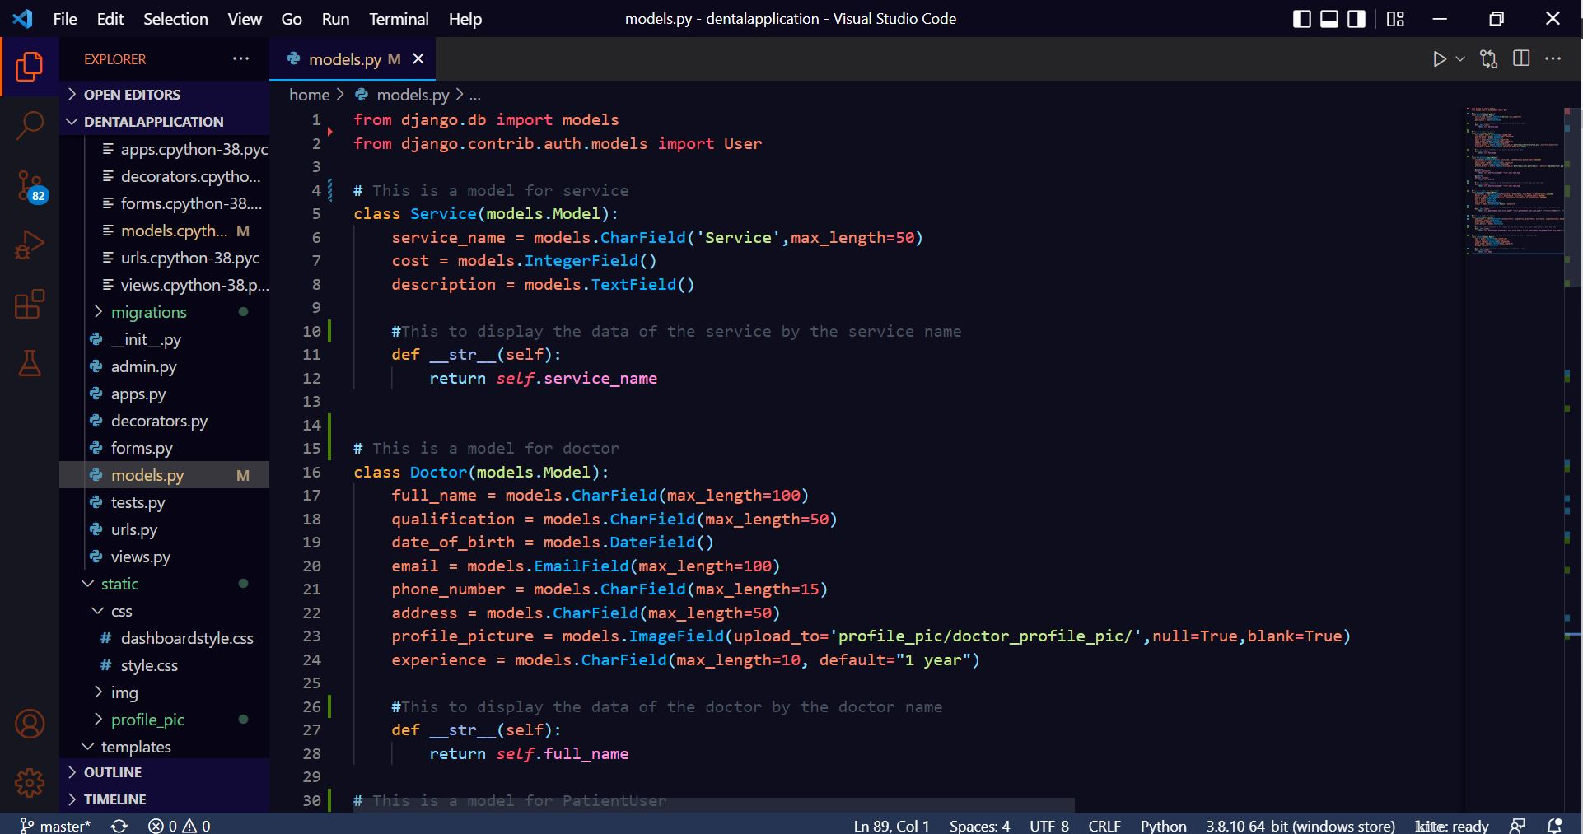

Figure 51: Database Implementation Code – 1

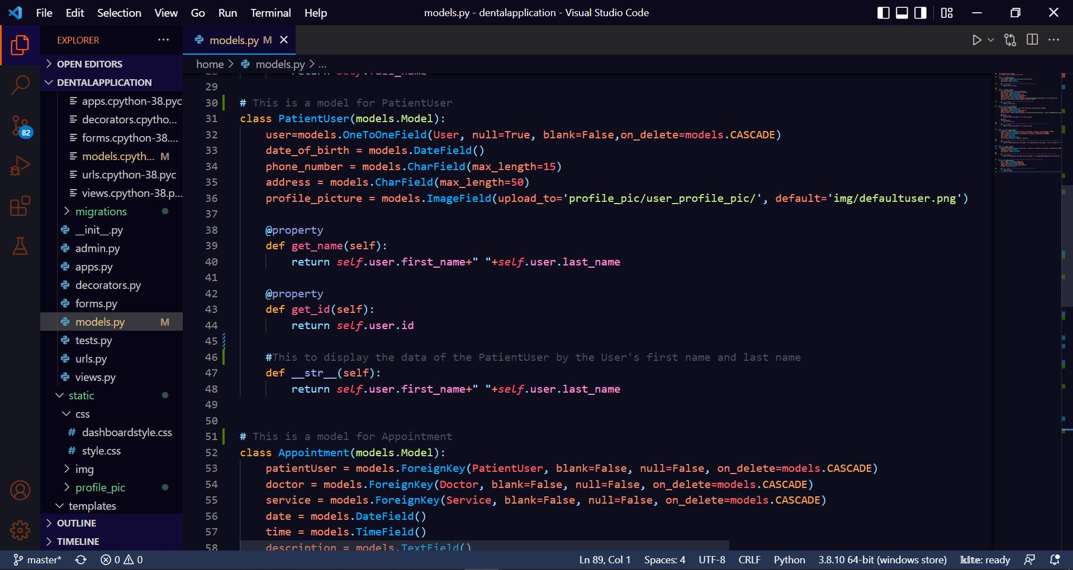

Figure 52: Database Implementation Code - 2

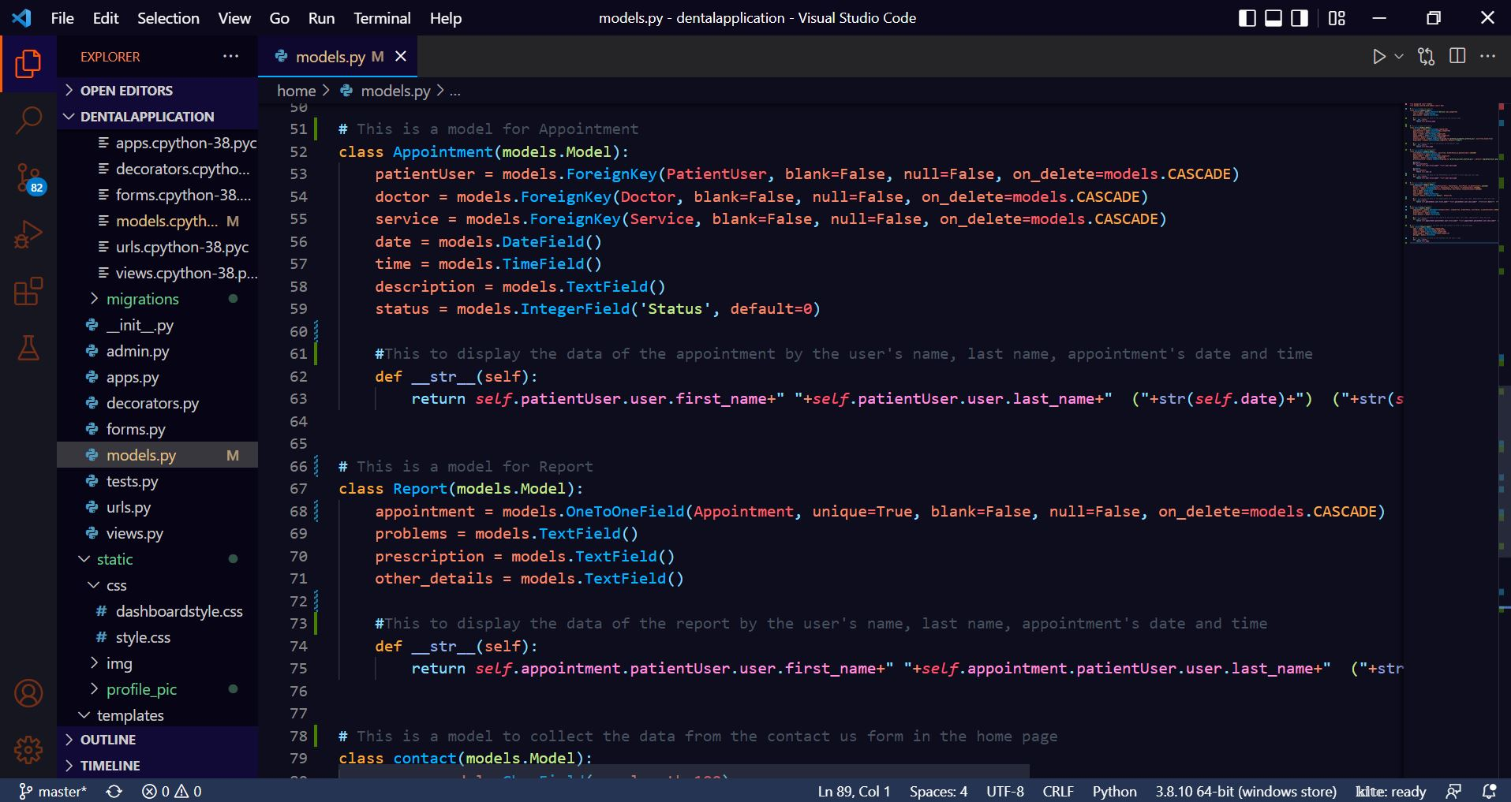

Figure 53: Database Implementation Code – 3

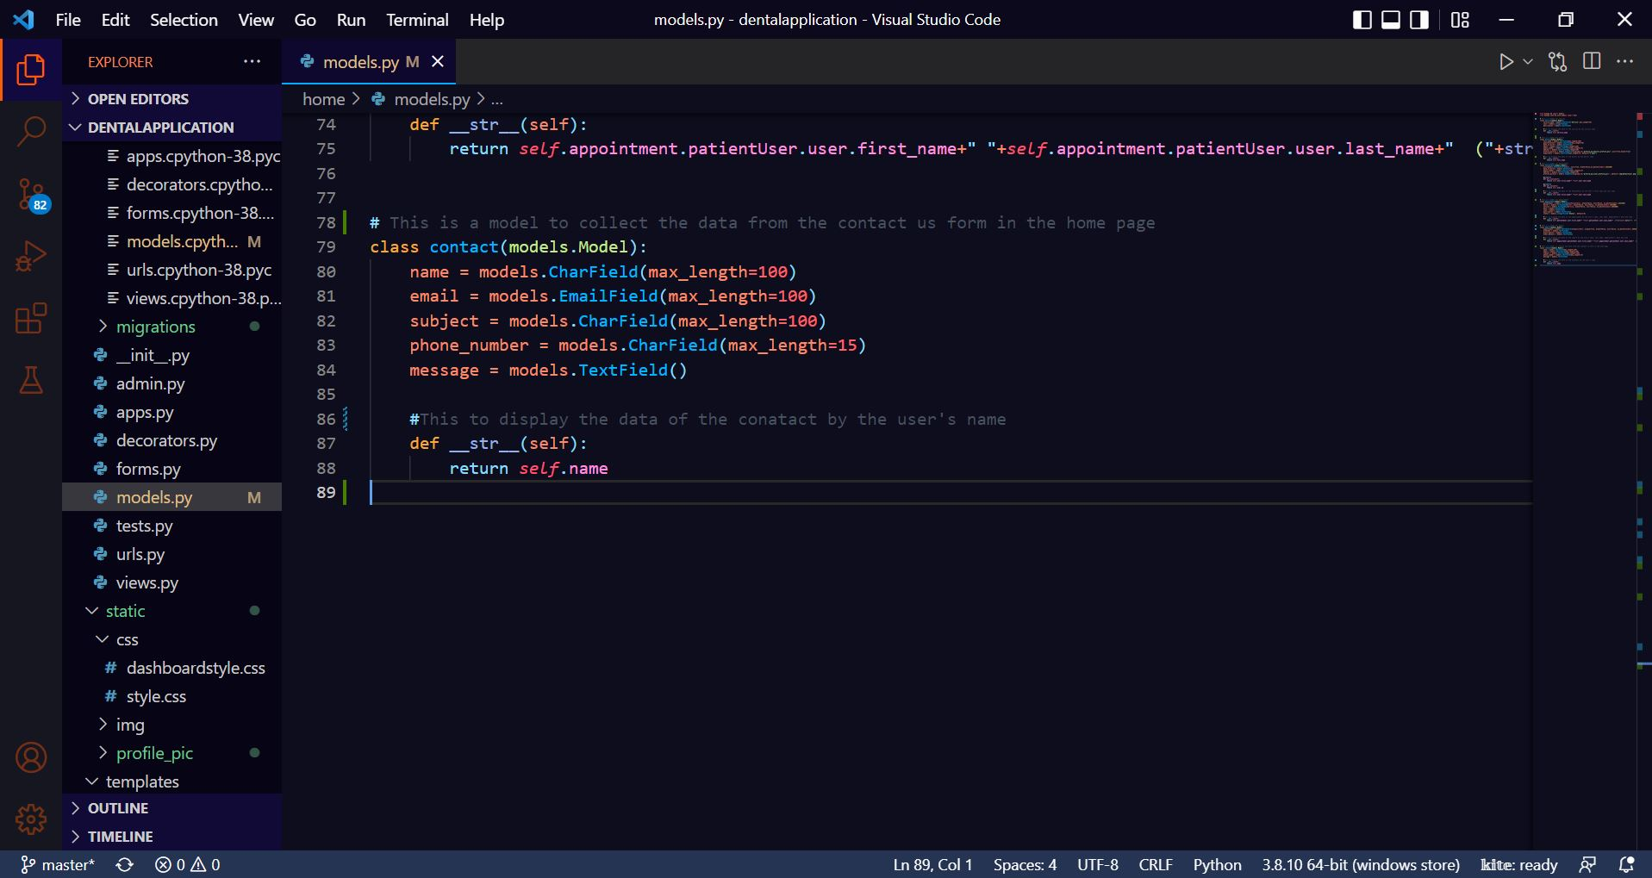

Figure 54: Database Implementation Code – 4

# 4. Testing and analysis

Software Testing is a method to check whether the actual software product matches expected requirements and to ensure that software product is Defect free. (Hamilton, 2022) Any software developer's ultimate goal is to create apps that are fast, stable, and simple to use. Each application must be properly tested in order to achieve this goal.

## 4.1 Test Plan

There are 5 types of testing that are done for this application. They are as follows:

### 4.1.1 Black Box Testing, Test Plan

Black Box Testing is a software testing method in which the functionalities of software applications are tested without having knowledge of internal code structure, implementation details and internal paths. (Hamilton, 2022) It majorly focuses on the input and output of software applications and is totally driven by software requirements and specifications.

|  |  |
| --- | --- |
| Test Cases | Objectives |
| Test Case 1 | To view user's profile picture in the sidebar. |
| Test Case 2 | To book an appointment by the user. |
| Test Case 3 | To view user's appointment by user. |
| Test Case 4 | To check if we can access admin page without logging in. |
| Test Case 5 | To view user's report by the user. |
| Test Case 6 | To book an appointment outside the clinic time. |
| Test Case 7 | To view pending appointment by the admin. |
| Test Case 8 | To delete user from the system by the admin. |

Table 12: Black Box Testing Test Plan

### 4.1.2 White Box Testing, Test Plan

White box testing is an approach that allows testers to inspect and verify the inner workings of a software system—its code, infrastructure, and integrations with external systems. (Imperva, 2022) In a modern Continuous Integration/Continuous Delivery (CI/CD) development pipeline, white box testing is an important aspect of automated build operations.

|  |  |
| --- | --- |
| Test Cases | Objectives |
| Test Case 1 | To register user. |
| Test Case 2 | To log in user. |
| Test Case 3 | To enter invalid login details. |
| Test Case 4 | To log in admin. |
| Test Case 5 | To cancel appointment by user. |
| Test Case 6 | To view doctor by user. |
| Test Case 7 | To view service by user. |
| Test Case 8 | To download the report in pdf by the user. |
| Test Case 9 | To sort the appointment according to the date. |
| Test Case 10 | To search the report. |
| Test Case 11 | To view user's profile. |
| Test Case 12 | To logout. |
| Test Case 13 | To approve appointment of the user by the admin. |
| Test Case 14 | To reject appointment of the user by the admin. |
| Test Case 15 | To cancel the confirmed appointment of the user by the admin. |
| Test Case 16 | To finish the appointment of the user by the admin. |
| Test Case 17 | To add another report of the same appointment. |

Table 13: White Box Testing Test Plan

### 4.1.3 Integration Testing, Test Plan

Integration testing is a type of software testing in which the different units, modules or components of a software application are tested as a combined entity. (Awati, 2022)

|  |  |
| --- | --- |
| Test Cases | Objectives |
| Test Case 1 | To update the user profile by the user. |
| Test Case 2 | To add report by the admin. |
| Test Case 3 | To update the report details by the admin. |
| Test Case 4 | To delete the report by the admin. |
| Test Case 5 | To add service by the admin. |
| Test Case 6 | To update the service details by the admin. |
| Test Case 7 | To delete the service by the admin. |
| Test Case 8 | To add doctor by the admin. |
| Test Case 9 | To update the doctor details by the admin. |
| Test Case 10 | To delete the doctor by the admin |

Table 14: Integration Testing Test Plan

### 4.1.4 System Testing, Test Plan

System Testing is a type of software testing that is performed on a complete integrated system to evaluate the compliance of the system with the corresponding requirements. (Pankaj, 2019) As majority of the tests will be performed in the black box, white box, and integration testing, system testing is performed to determine whether or not the system is operational.

|  |  |
| --- | --- |
| Test Cases | Objectives |
| Test Case 1 | To run the system from VS Code. |

Table 36: System Testing Test Plan

### 4.1.5 Client Evaluation Testing, Test Plan

Client evaluation testing is a type of testing done by the client to ensure that the software system is working properly before it is deployed to the production environment. After all other testing has been completed, it is done in the last step of testing.

Link to client evaluation testing form:

## 4.2 Black Box Testing

|  |  |
| --- | --- |
| **Test No.1** | |
| Objective | To view user's profile picture in the sidebar. |
| Action | The user logged in and the 'View Services' button was pressed. |
| Expected Output | The profile picture of the user would be shown in the sidebar. |
| Actual Output | The profile picture of the user was not shown in the sidebar. |
| Result | The test was unsuccessful. |

Table 16: Black Box Test 1 (Unsuccessful)

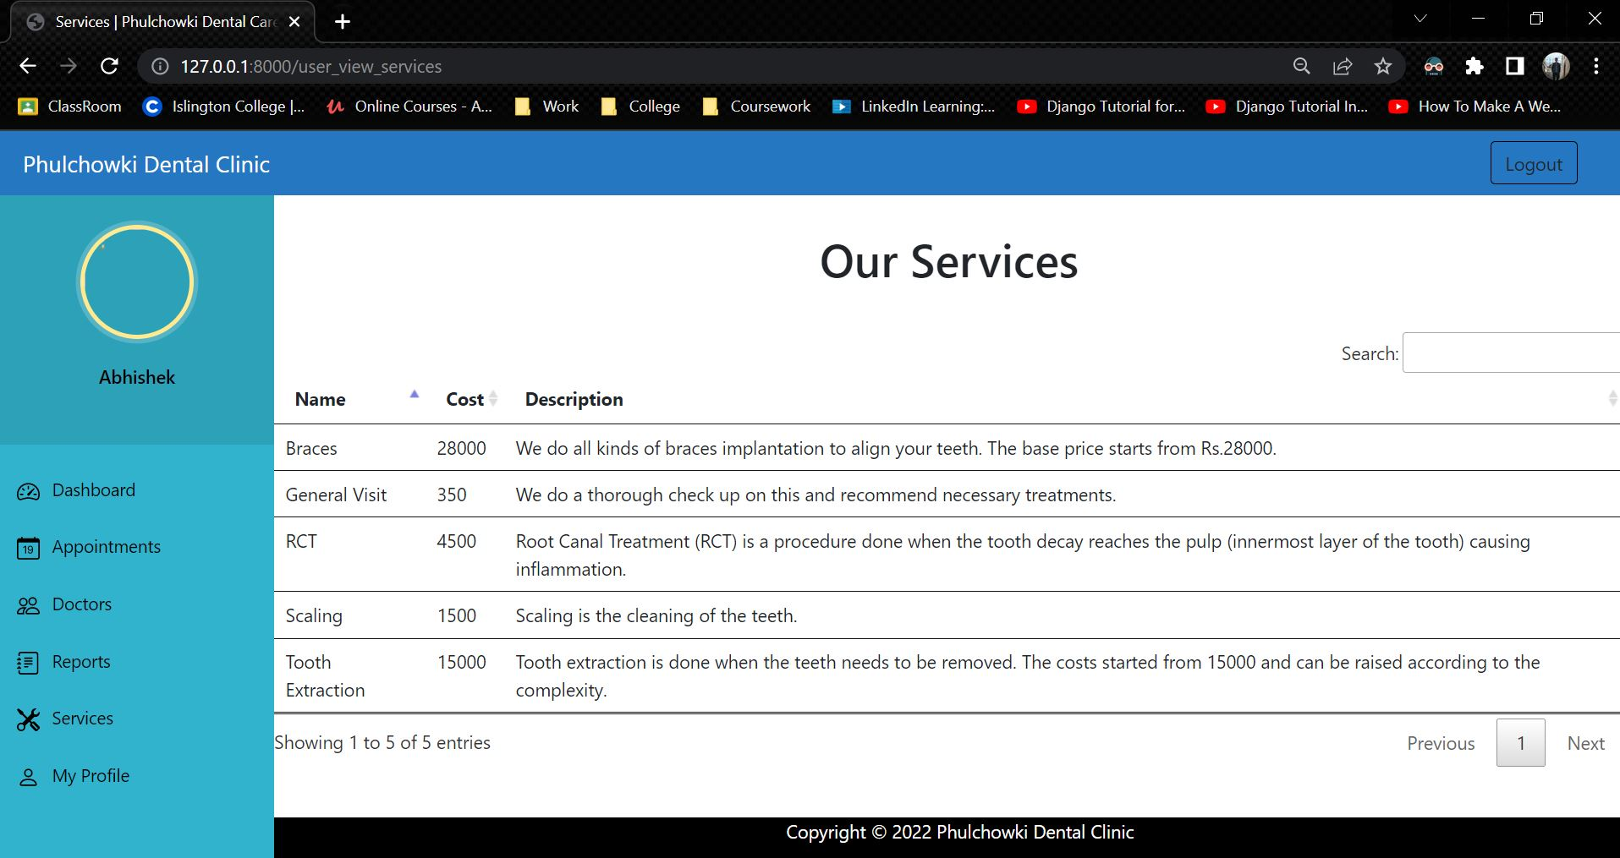

Figure 55: Black Box Test 1 (Unsuccessful)

**Code that caused the error:**

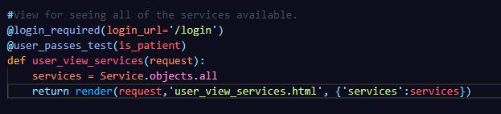

Figure 56: Black Box Test 1 - Error Code

**Fixing the code:**

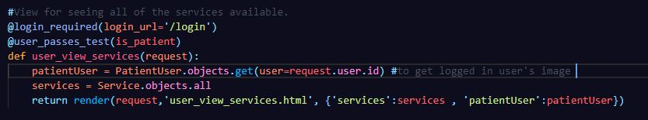

Figure 57: Black Box Test 1 - Fixed Code

|  |  |
| --- | --- |
| **Test No.1** | |
| Objective | To view user's profile picture in the sidebar. |
| Action | The user logged in and the 'View Services' button was pressed. |
| Expected Output | The profile picture of the user would be shown in the sidebar. |
| Actual Output | The profile picture of the user was not shown in the sidebar. |
| Result | The test was successful. |
| Cause of Error | The current user's ID wasn’t |

Table 17: Black Box Test 1 (Successful)

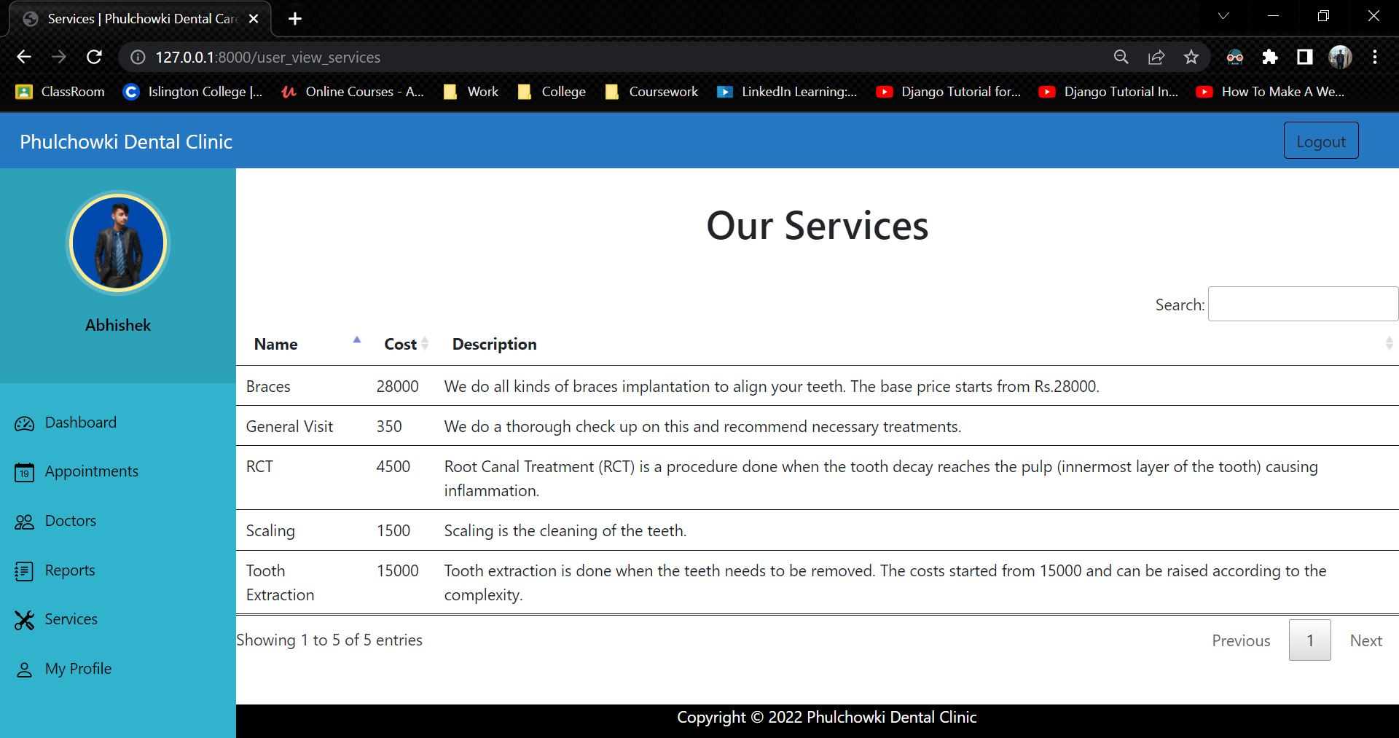

Figure 58: Black Box Test 1 (Successful)

|  |  |
| --- | --- |
| **Test No.2** | |
| Objective | To book an appointment by the user. |
| Action | The booking form is filled and submitted by the user. |
| Expected Output | The booking would be done. |
| Actual Output | The booking was not done. |
| Result | The test was unsuccessful. |

Table 18: Black Box Test 2 (Unsuccessful)

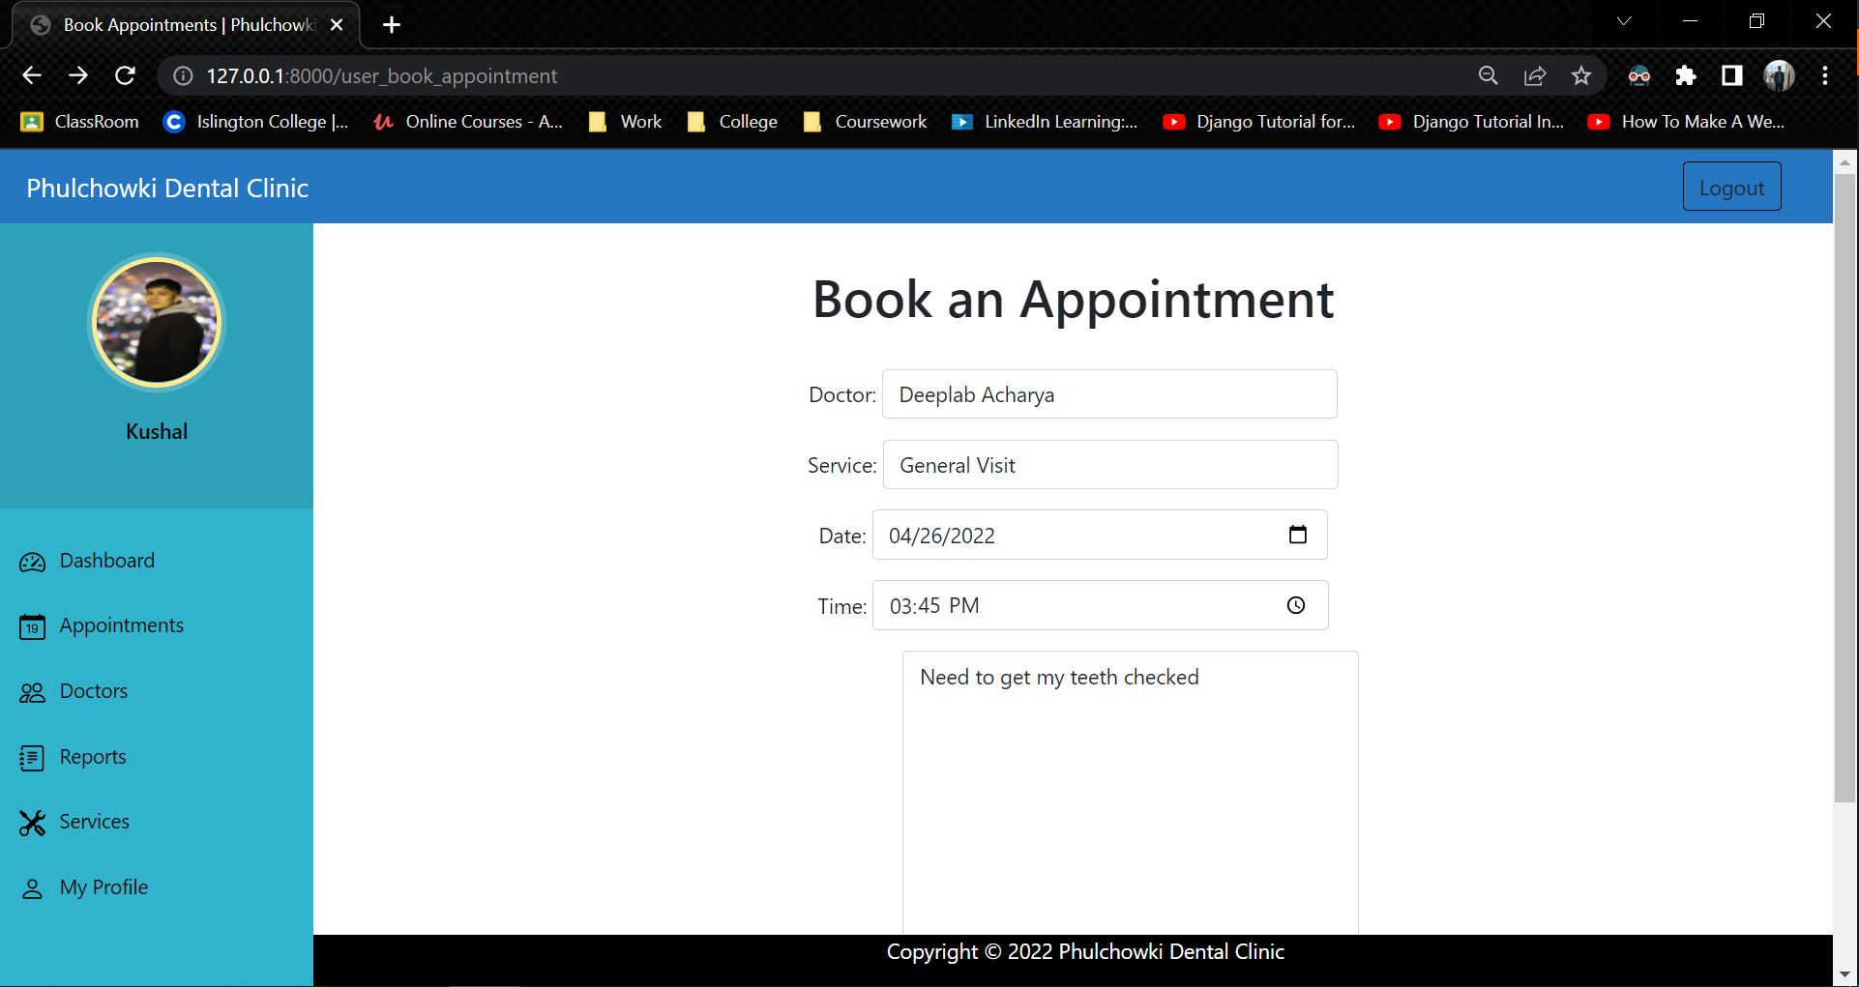

Figure 59: Black Box Test 2 (Unsuccessful) - 1

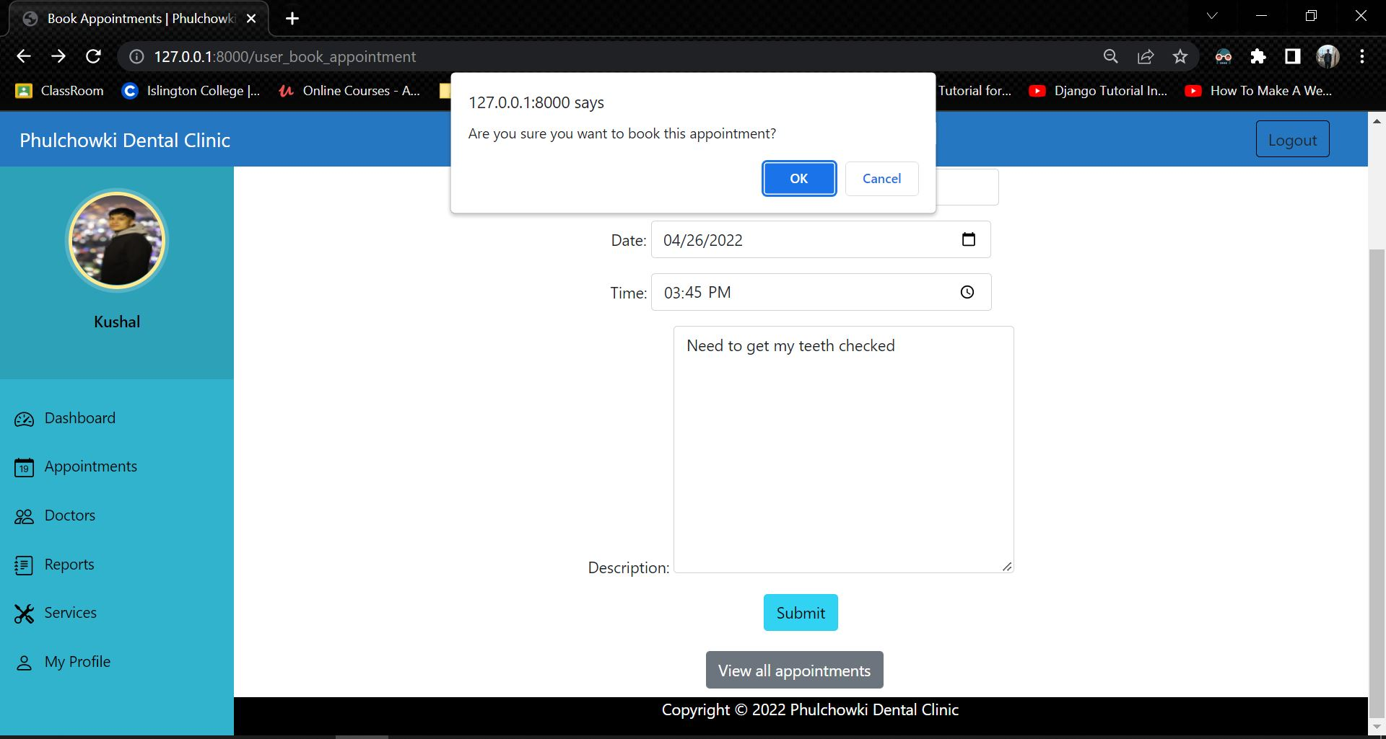

Figure 60: Black Box Test 2 (Unsuccessful) - 2

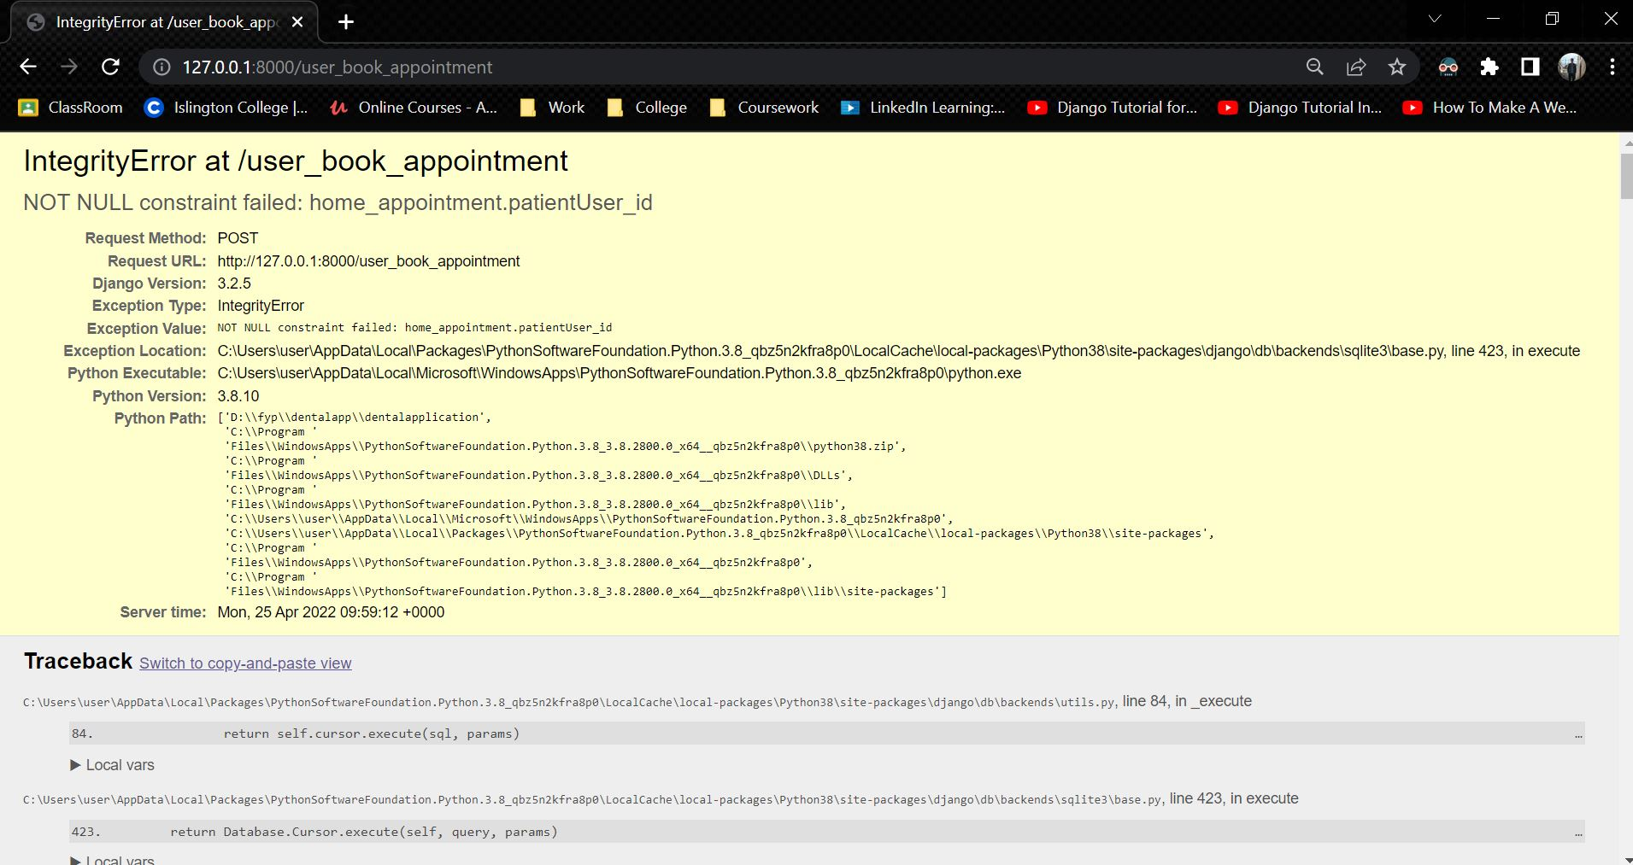

Figure 61: Black Box Test 2 (Unsuccessful) – 3

**Code that caused the error:**

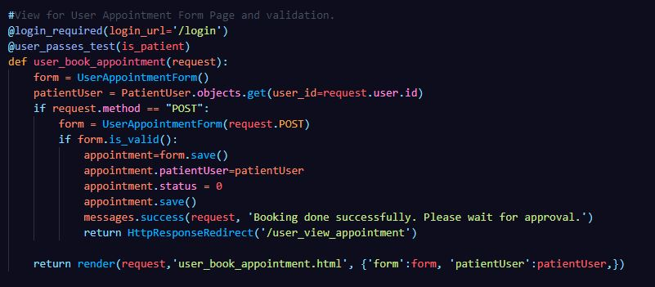

Figure 62: Black Box Test 2 - Error Code

**Fixing the code:**

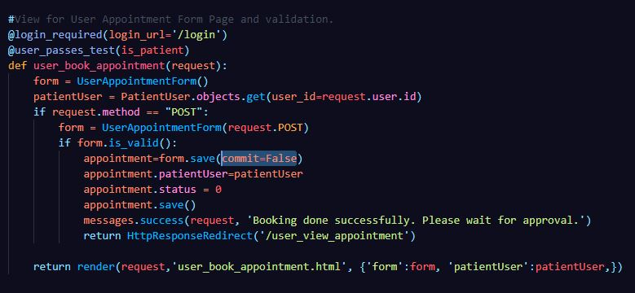

Figure 63: Black Box Test 2 - Fixed Code

|  |  |
| --- | --- |
| **Test No.2** | |
| Objective | To book an appointment by the user. |
| Action | The booking form is filled and submitted by the user. |
| Expected Output | The booking would be done. |
| Actual Output | The booking was done. |
| Result | The test was successful. |
| Cause of Error | The form was saved before getting the current user ID. |

Table 19: Black Box Test 2 (Successful)

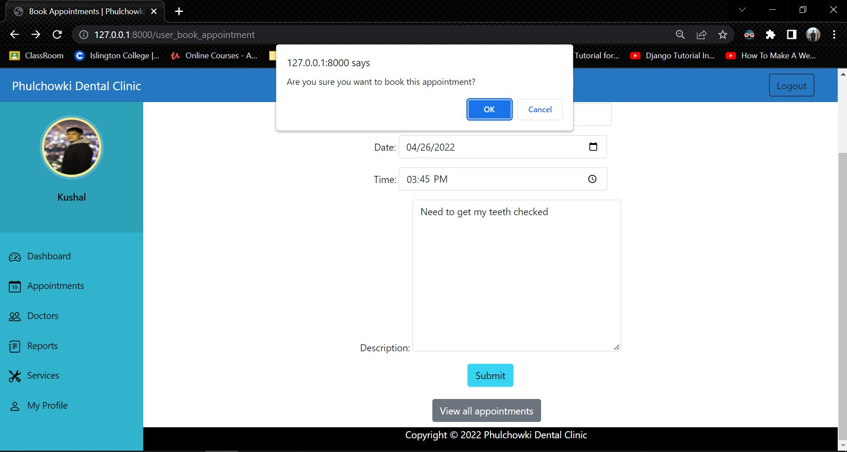

Figure 64: Black Box Test 2 (Successful) - 1

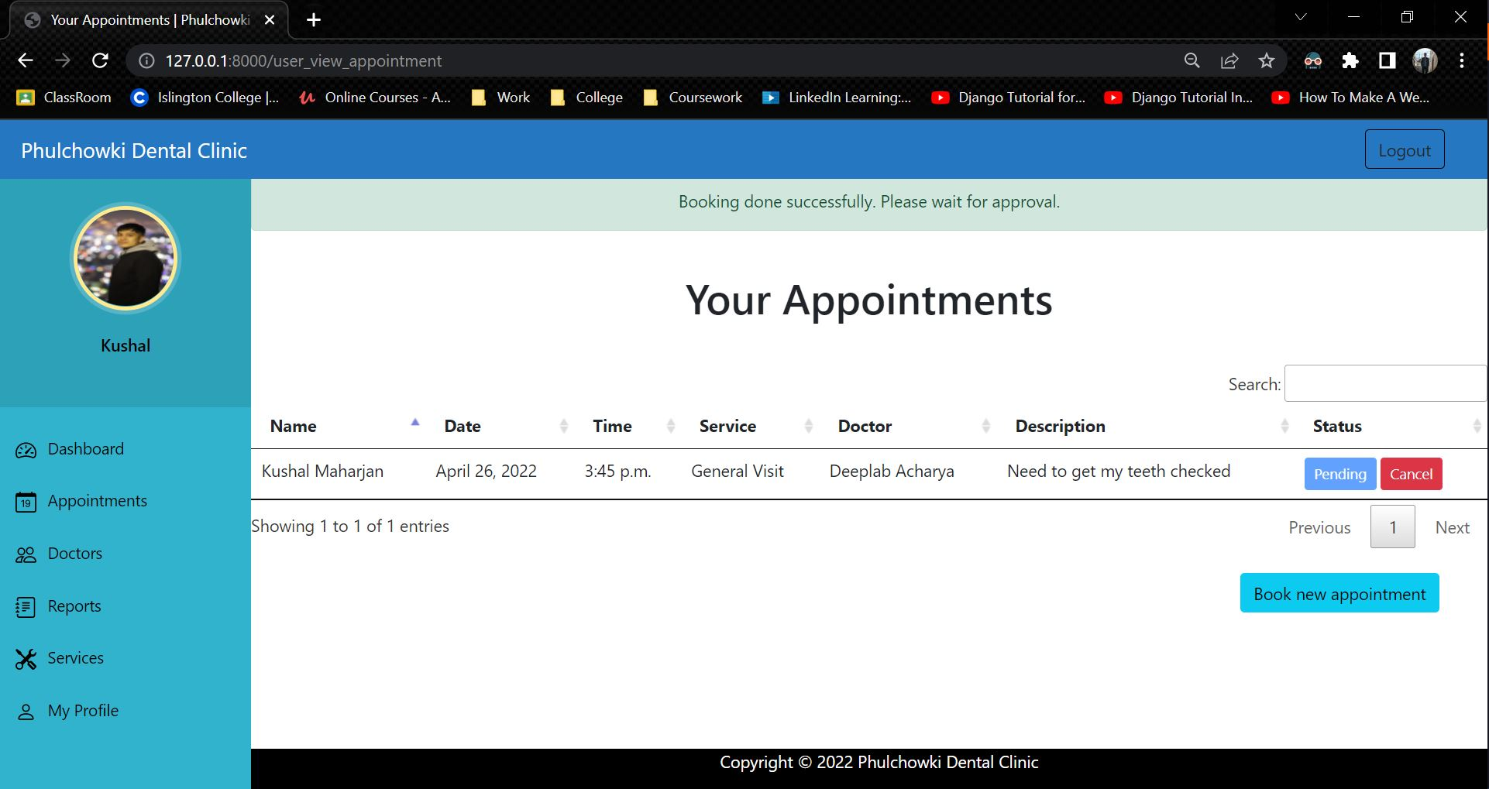

Figure 65: Black Box Test 2 (Successful) - 2

|  |  |
| --- | --- |
| **Test No.3** | |
| Objective | To view user's appointment by user. |
| Action | The view appointment button in the sidebar was clicked. |
| Expected Output | The list of user's appointment would be shown. |
| Actual Output | The list of user's appointment was not shown. |
| Result | The test was unsuccessful. |

Table 20: Black Box Test 3 (Unsuccessful)

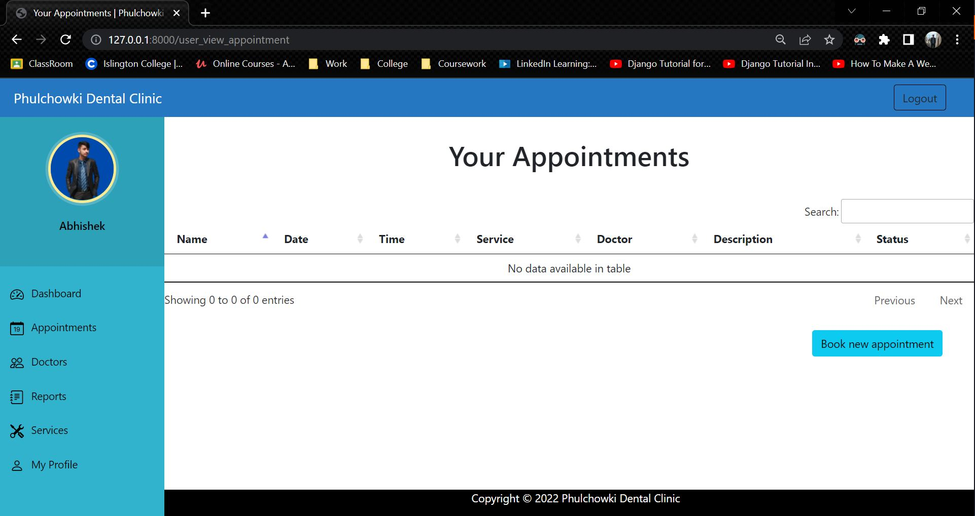

Figure 66: Black Box Test 3 (Unsuccessful)

**Code that caused the error:**

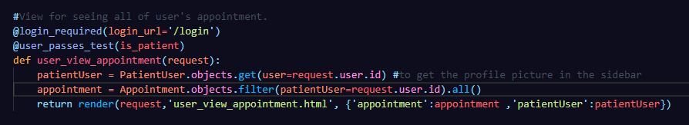

Figure 67: Black Box Test 3 - Error Code

**Fixing the code:**

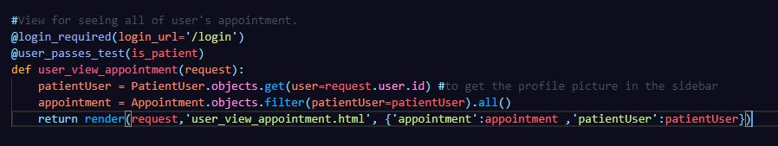

Figure 68: Black Box Test 3 - Fixed Code

|  |  |
| --- | --- |
| **Test No.3** | |
| Objective | To view user's appointment by user. |
| Action | The view appointment button in the sidebar was clicked. |
| Expected Output | The list of user's appointment would be shown. |
| Actual Output | The list of user's appointment was shown. |
| Result | The test was successful. |
| Cause of Error | The filter query was wrong so it didn’t display anything. |

Table 21: Black Box Test 3 (Successful)

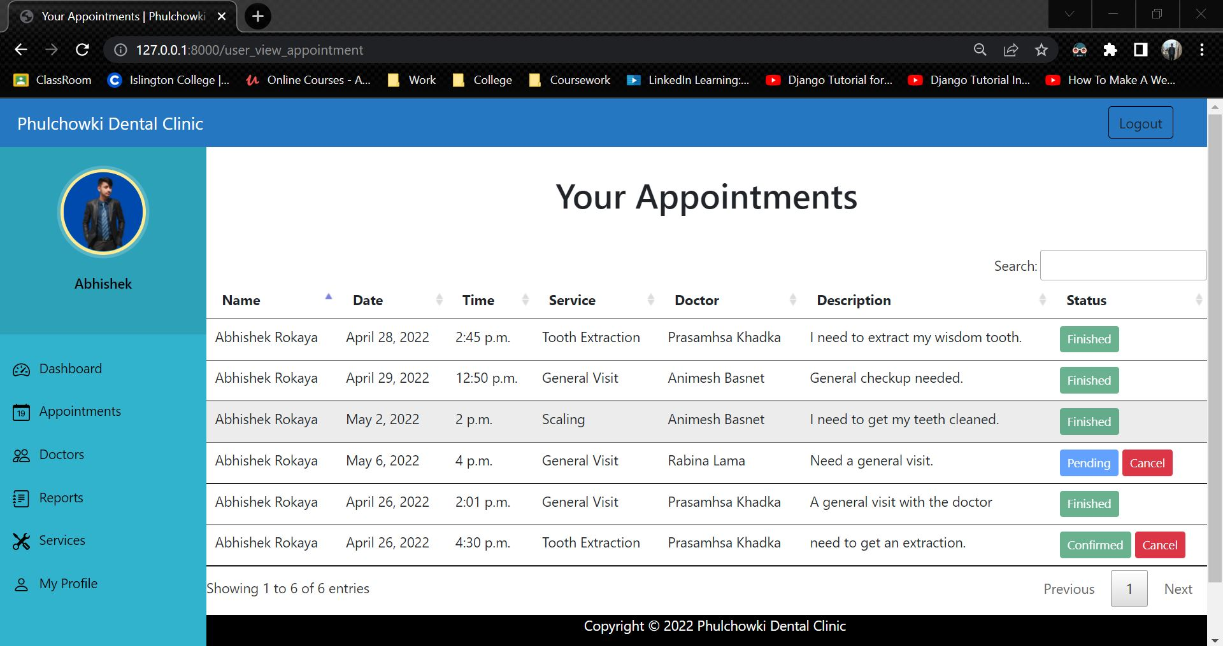

Figure 69: Black Box Test 3 (Successful)

|  |  |
| --- | --- |
| **Test No.4** | |
| Objective | To check if we can access admin page without logging in. |
| Action | The path to admin dashboard page was entered while not being logged in. |
| Expected Output | The admin login page would be shown. |
| Actual Output | The admin dashboard page was shown. |
| Result | The test was unsuccessful. |

Table 22: Black Box Test 4 (Unsuccessful)

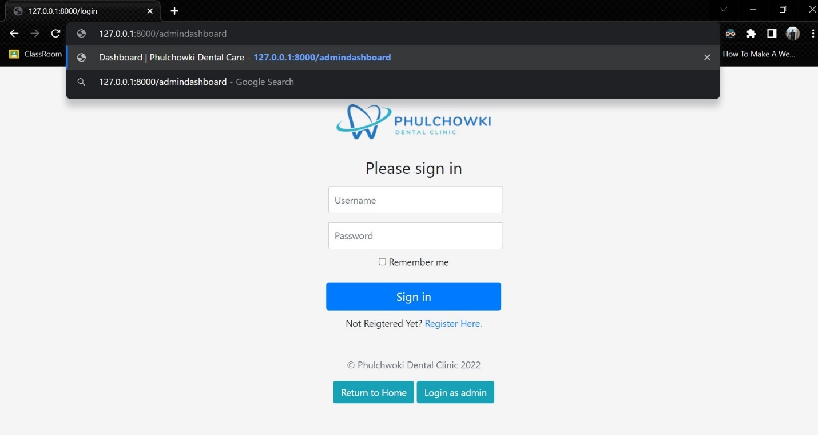

Figure 70: Black Box Test 4 (Unsuccessful) - 1

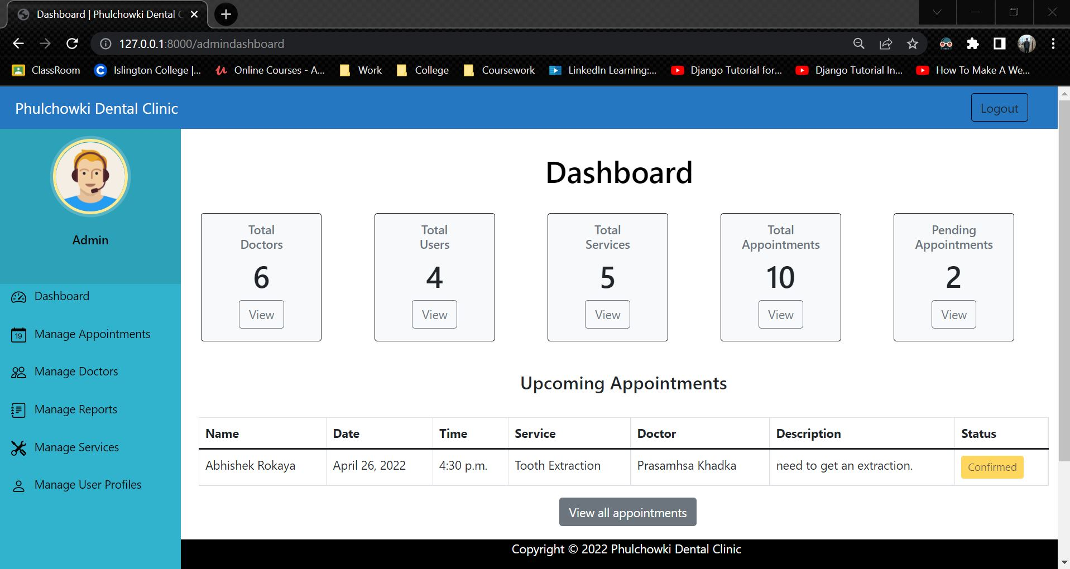

Figure 71: Black Box Test 4 (Unsuccessful) – 2

**Code that caused the error:**

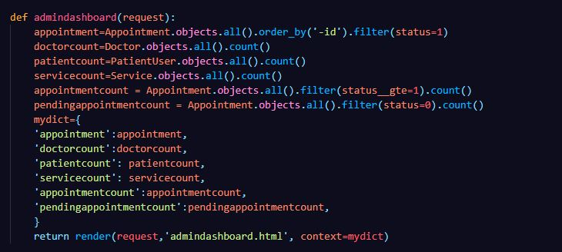

Figure 72: Black Box Test 4 - Error Code

**Fixing the code:**

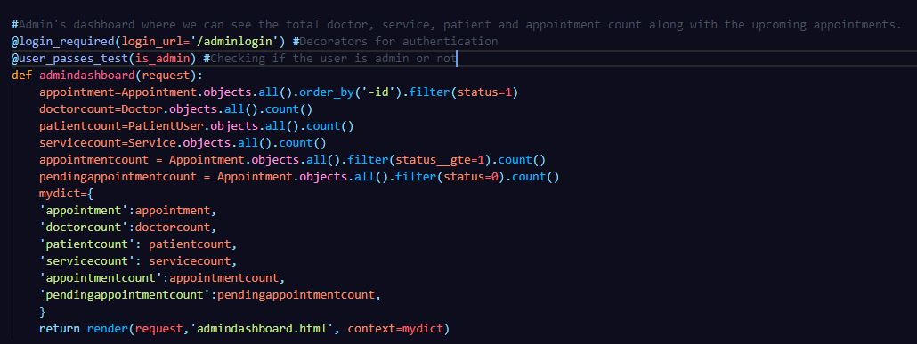

Figure 73: Black Box Test 4 - Fixed Code

|  |  |
| --- | --- |
| **Test No.4** | |
| Objective | To check if we can access admin page without logging in. |
| Action | The path to admin dashboard page was entered while not being logged in. |
| Expected Output | The admin login page would be shown. |
| Actual Output | The admin login page was shown. |
| Result | The test was successful. |
| Cause of Error | The decorators was not declared in the code. |

Table 23: Black Box Test 4 (Successful)



Figure 74: Black Box Test 4 (Successful) - 1

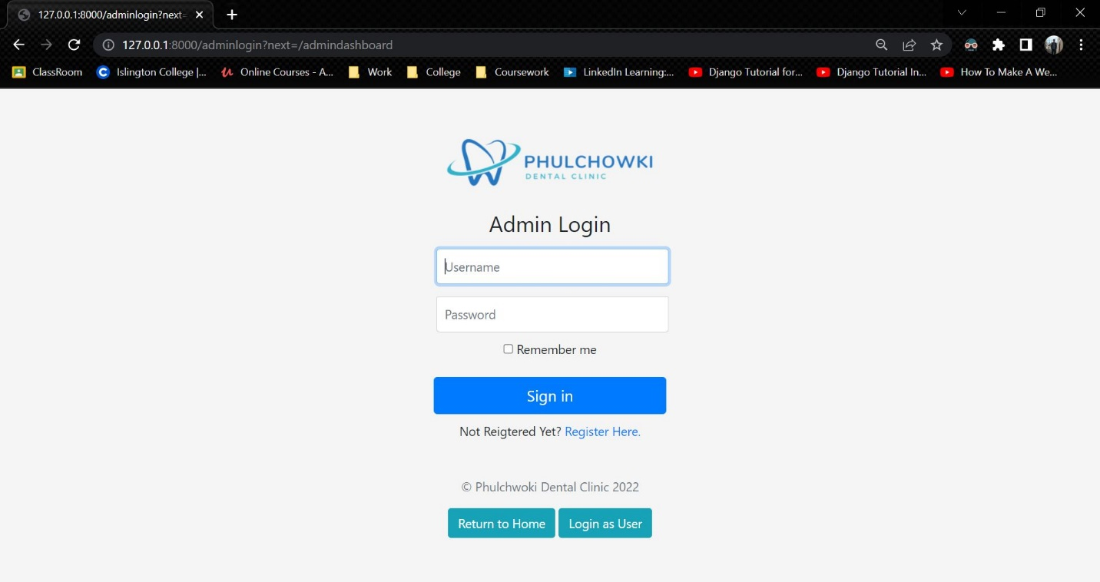

Figure 75: Black Box Test 4 (Successful) - 2

The rest of the black box testing is continued here. Click here to see the rest of it.

## 4.3 White Box Testing

|  |  |
| --- | --- |
| **Test No.1** | |
| Objective | To register user. |
| Action | The 'register' button was clicked and the user details were filled and the form was submitted. |
| Expected Output | The user would be registered to the system. |
| Actual Output | The user was registered to the system. |
| Result | The test was successful. |

Table 53: White Box Test 1

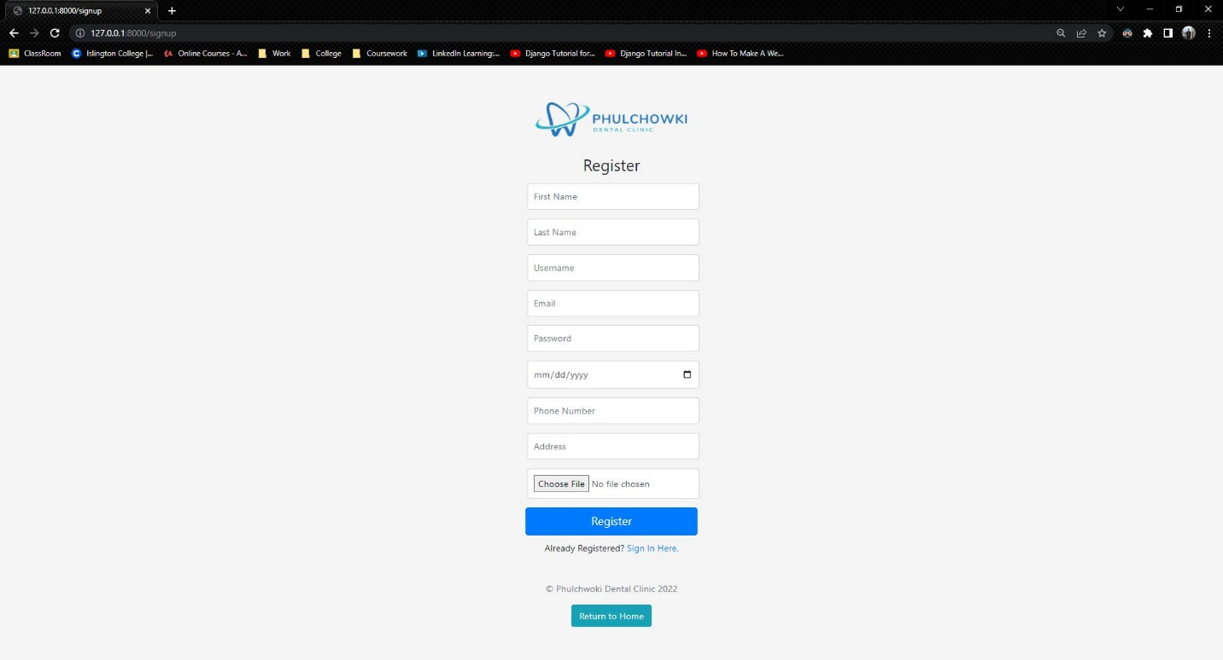

Figure 76: White Box Test 1 - 1

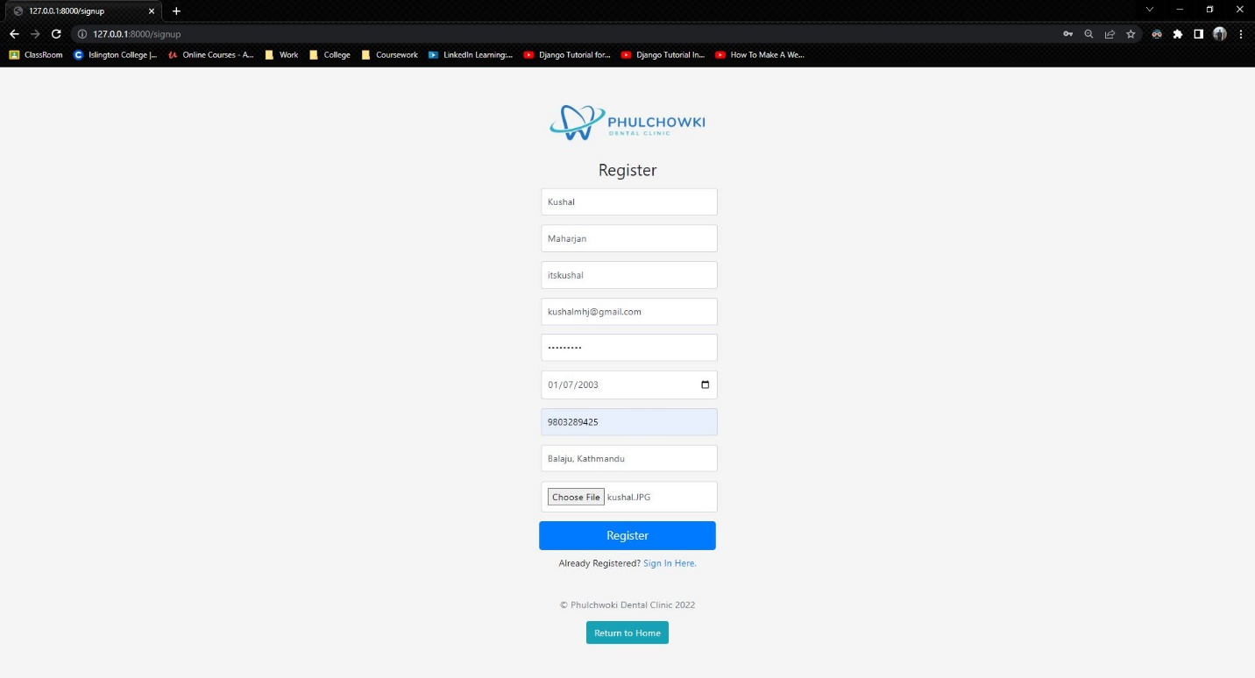

Figure 77: White Box Test 1 - 2

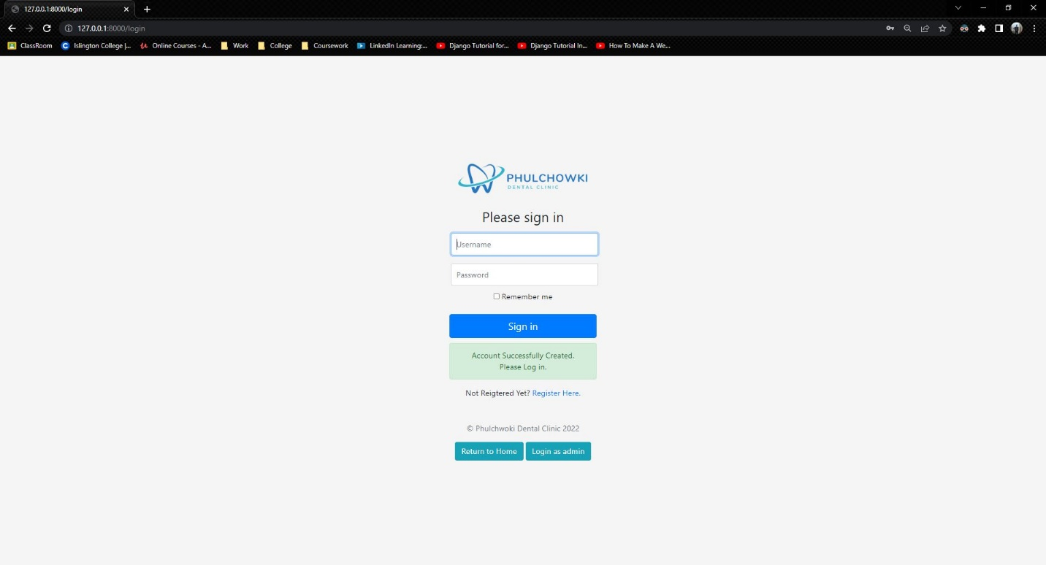

Figure 78: White Box Test 1 - 3

|  |  |
| --- | --- |
| **Test No.2** | |
| Objective | To log in user. |
| Action | The 'login' button was clicked and the user credentials were filled and the 'Sign in' button was clicked. |
| Expected Output | The user would be logged in and redirected to the dashboard. |
| Actual Output | The user was logged in and redirected to the dashboard. |
| Result | The test was successful. |

Table 54: White Box Test 2

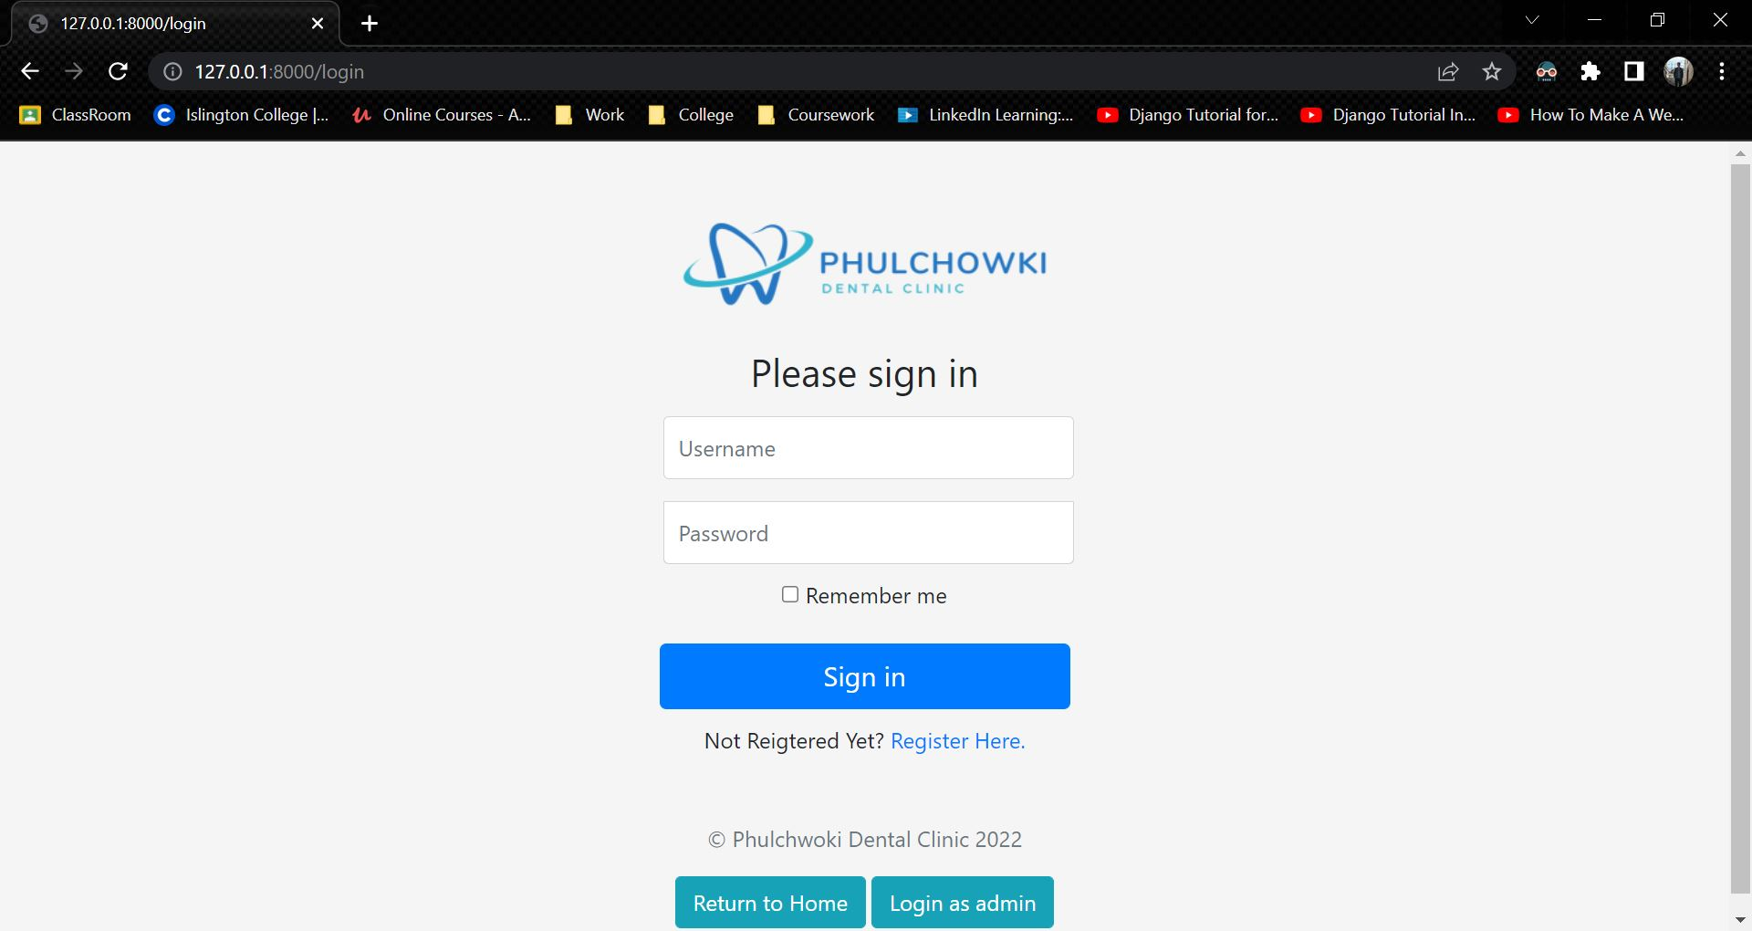

Figure 79: White Box Test 2 - 1

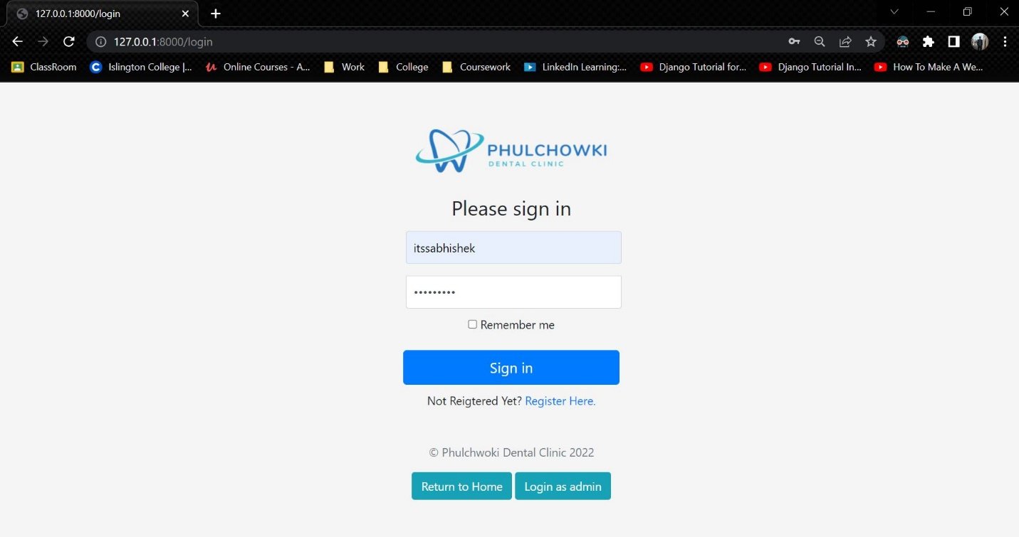

Figure 80: White Box Test 2 - 2

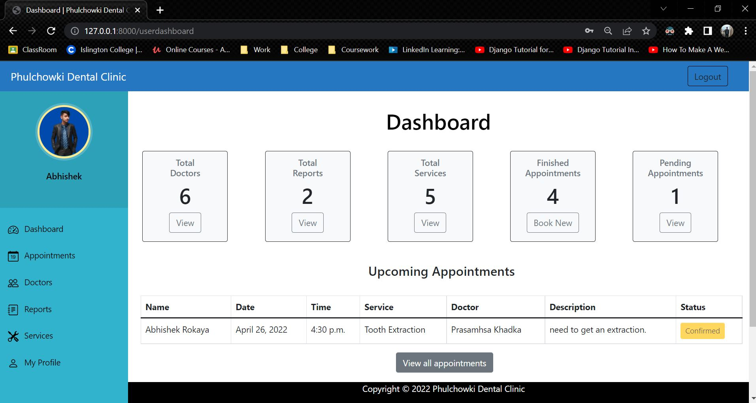

Figure 81: White Box Test 2 - 3

|  |  |
| --- | --- |
| **Test No.3** | |
| Objective | To enter invalid login details. |
| Action | The 'login' button was clicked and the user credentials were filled and the 'Sign in' button was clicked. |
| Expected Output | An error showing 'Invalid Credentials' would be displayed. |
| Actual Output | An error showing 'Invalid Credentials' was displayed. |
| Result | The test was successful. |

Table 55: White Box Test 3

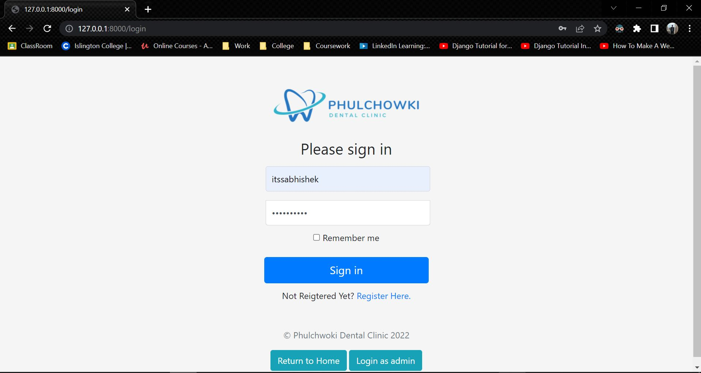

Figure 82: White Box Test 3 - 1

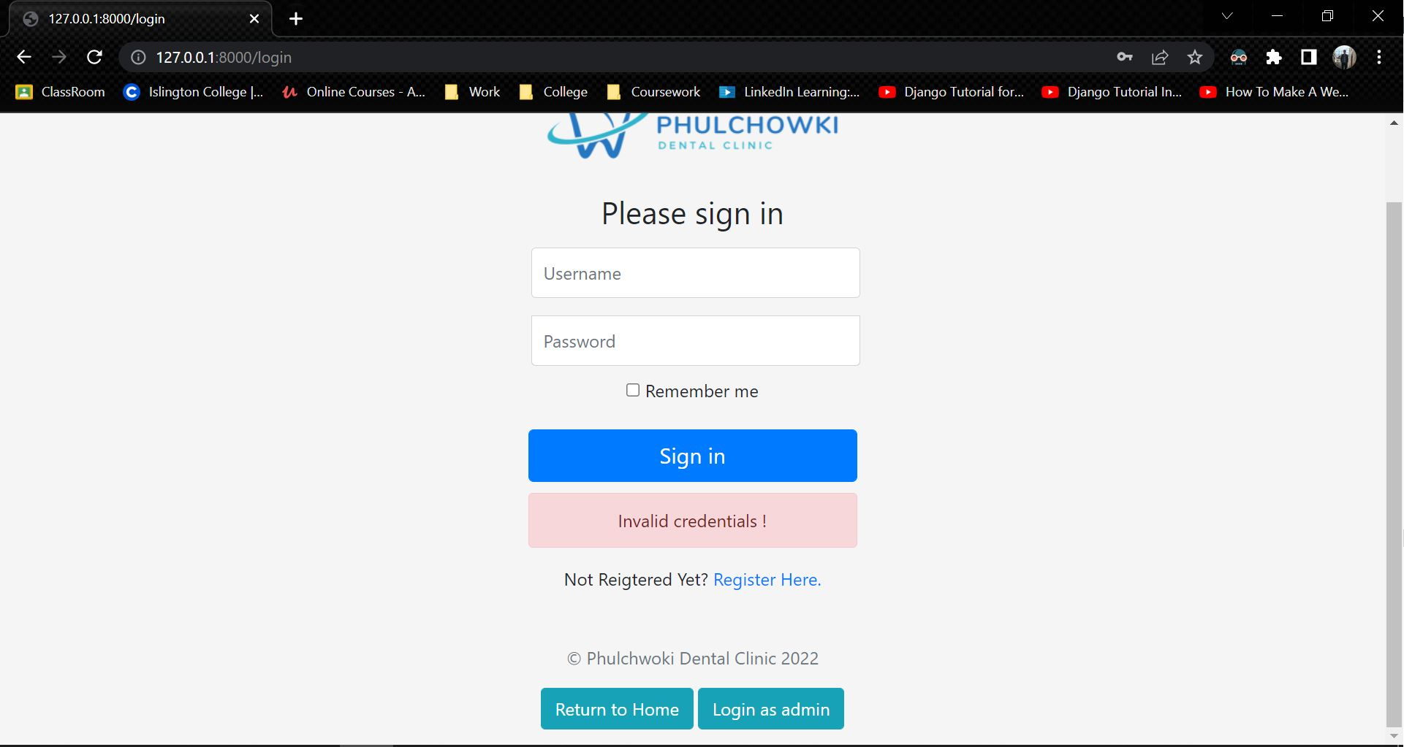

Figure 83: White Box Test 3 - 2

|  |  |
| --- | --- |
| **Test No.4** | |
| Objective | To log in admin. |
| Action | The 'admin login' button was clicked and the admin credentials were filled and the 'Sign in' button was clicked. |
| Expected Output | The admin would be logged in and redirected to the admin dashboard. |
| Actual Output | The admin was logged in and redirected to the dashboard. |
| Result | The test was successful. |

Table 56: White Box Test 4

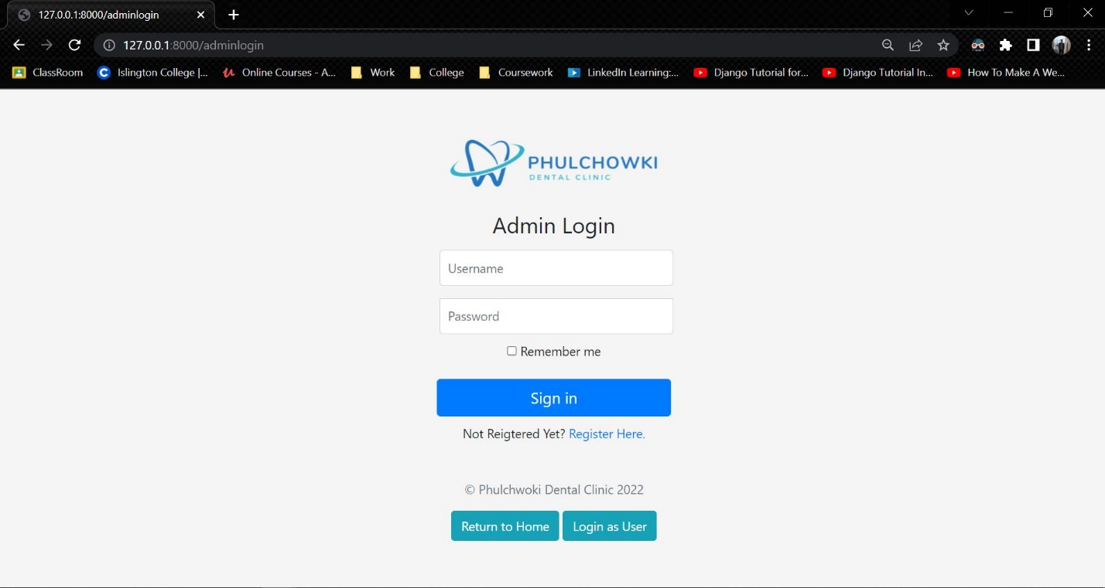

Figure 84: White Box Test 4 - 1

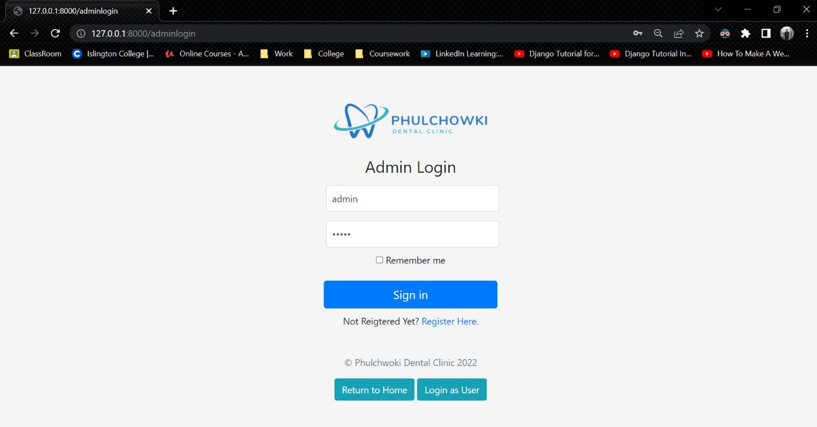

Figure 85: White Box Test 4 - 2

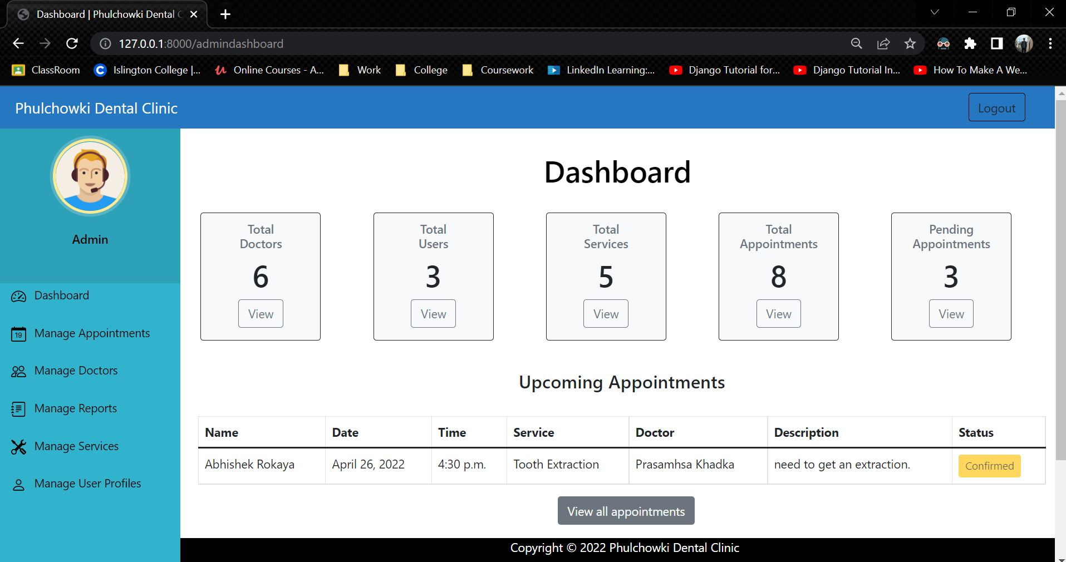

Figure 86: White Box Test 4 - 3

|  |  |
| --- | --- |
| **Test No.5** | |
| Objective | To cancel appointment by user. |
| Action | The 'cancel' button was clicked and the confirmation was clicked. |
| Expected Output | The appointment would be cancelled. |
| Actual Output | The appointment was cancelled. |
| Result | The test was successful. |

Table 57: White Box Test 5

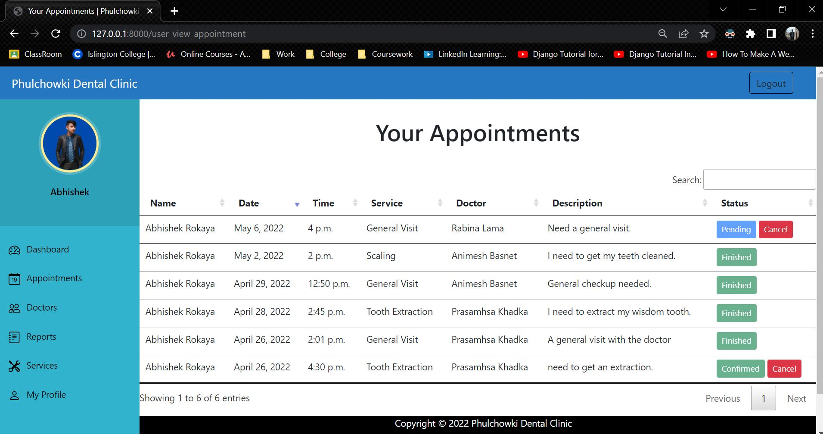

Figure 87: White Box Test 5 - 1

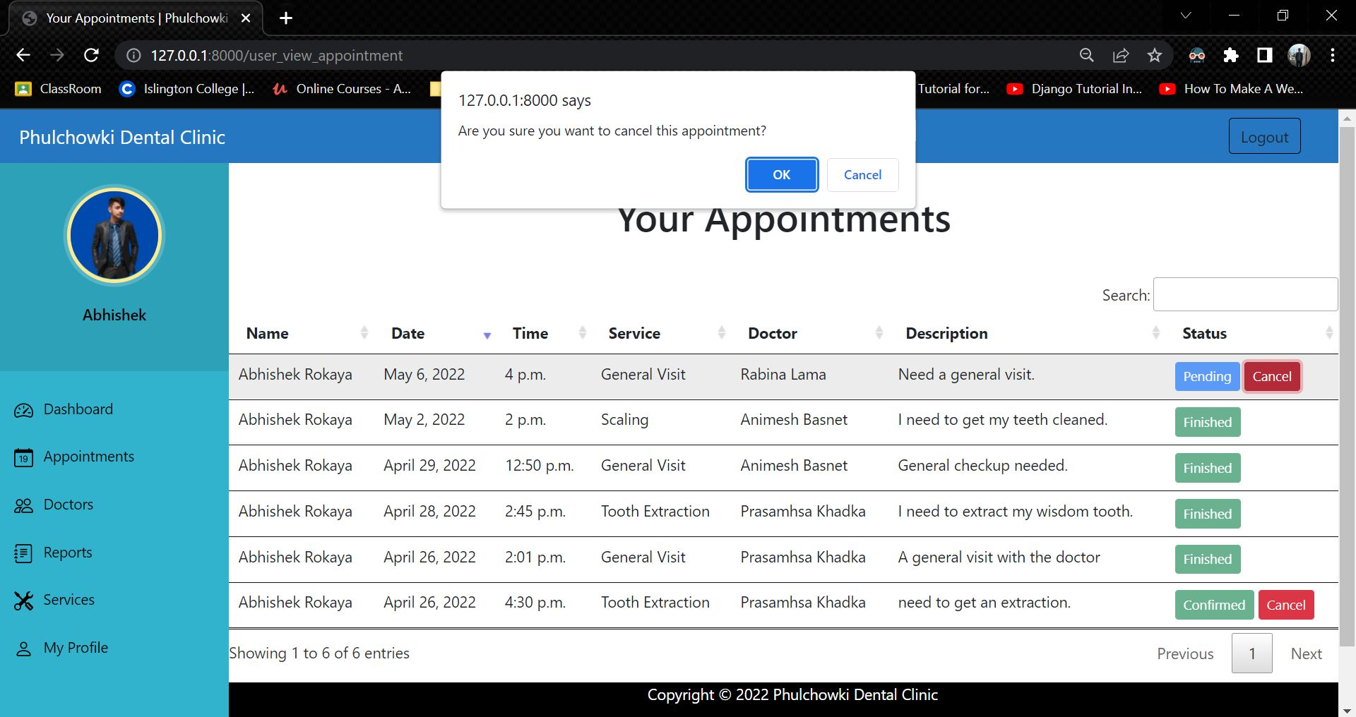

Figure 88: White Box Test 5 – 2

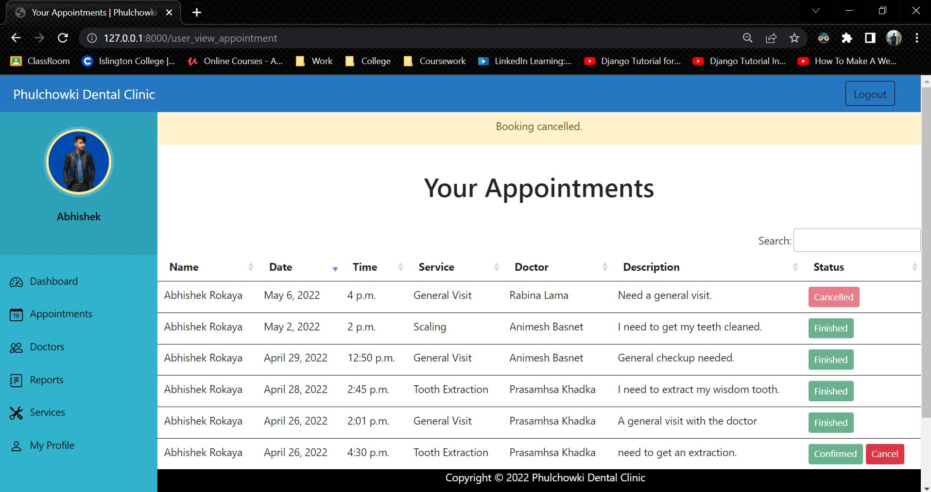

Figure 89: White Box Test 5 – 3

The rest of the white box testing is continued here. Click here to see the rest of it.

## 4.4 Integration Testing

|  |  |
| --- | --- |
| **Test No.1** | |
| Objective | To update user's profile by the user. |
| Action | The 'Edit Profile' button was clicked, then the necessary information were updated and the 'update' button was clicked. |
| Expected Output | The data would be updated. |
| Actual Output | The data was updated. |
| Result | The test was successful. |

Table 70: Integration Test 1

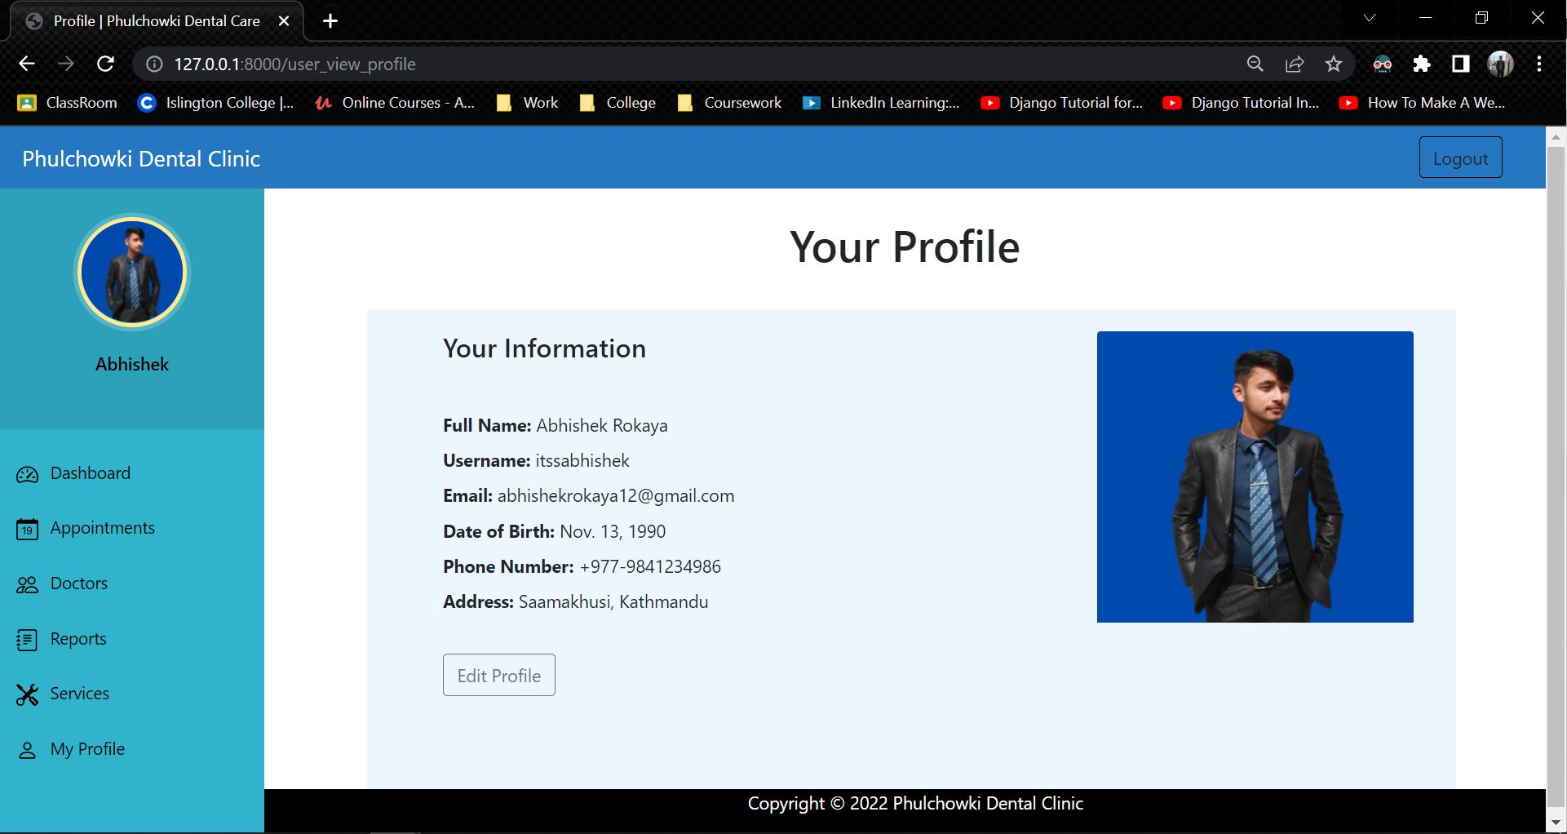

Figure 90: Integration Test 1 - 1

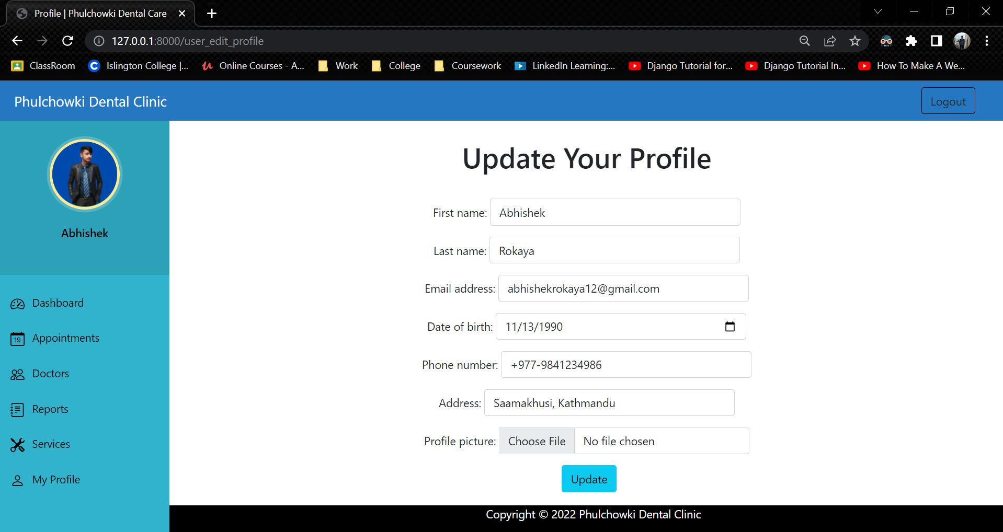

Figure 91: Integration Test 1 - 2

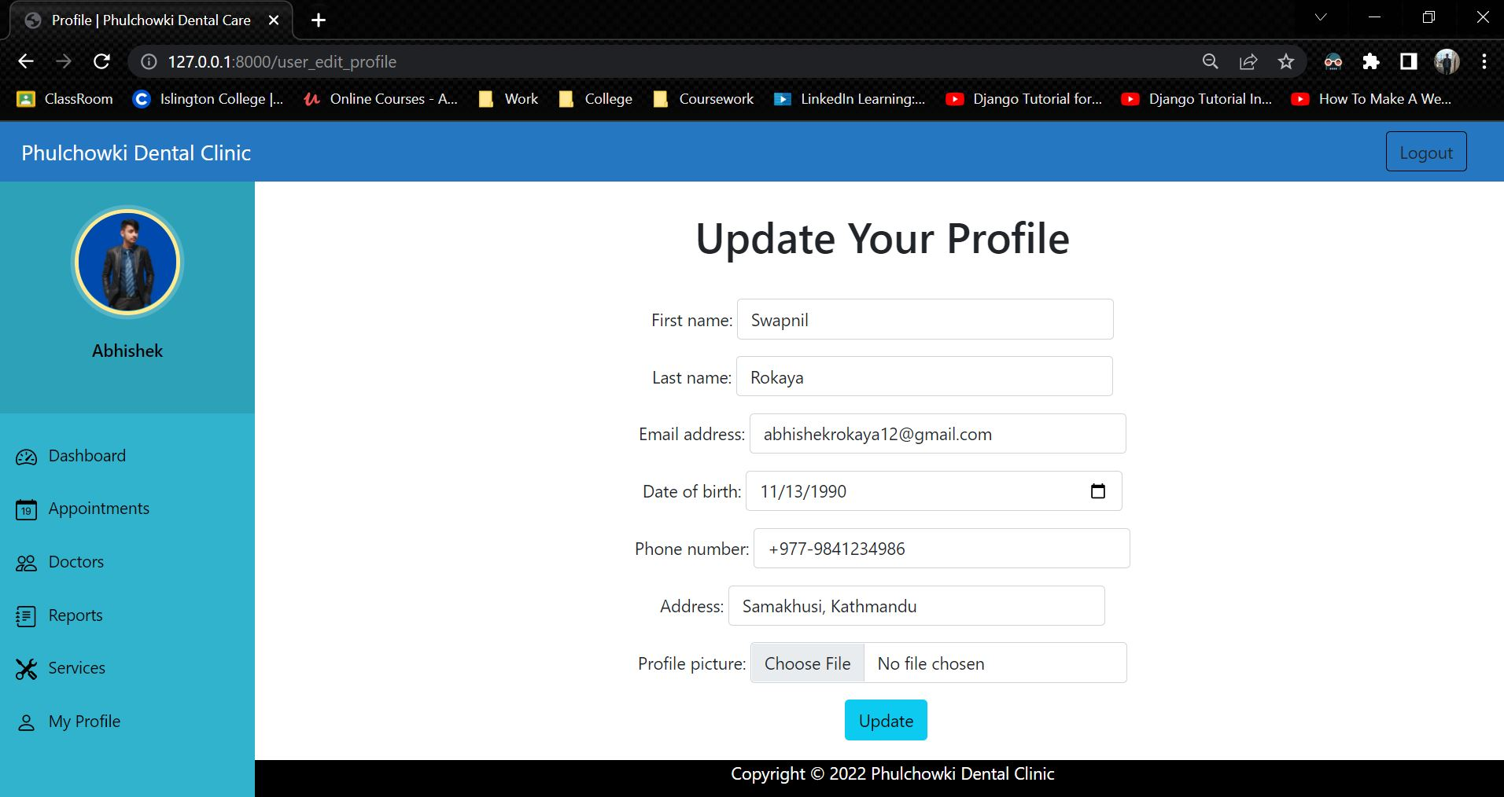

Figure 92: Integration Test 1 - 3

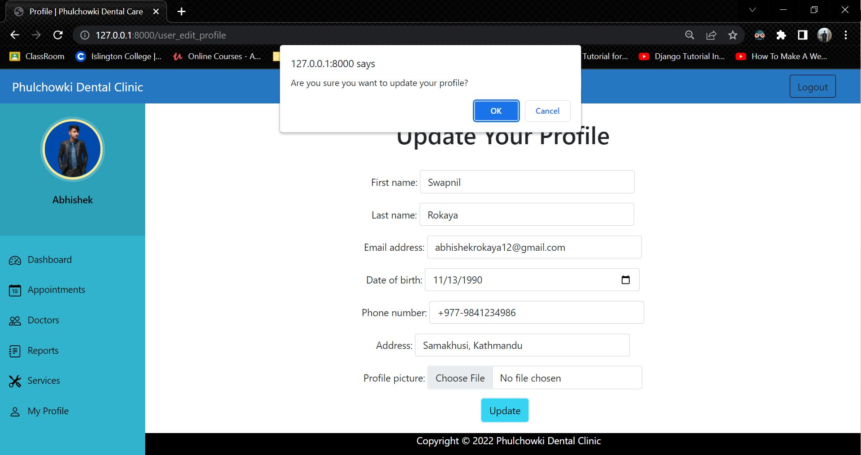

Figure 93: Integration Test 1 – 4

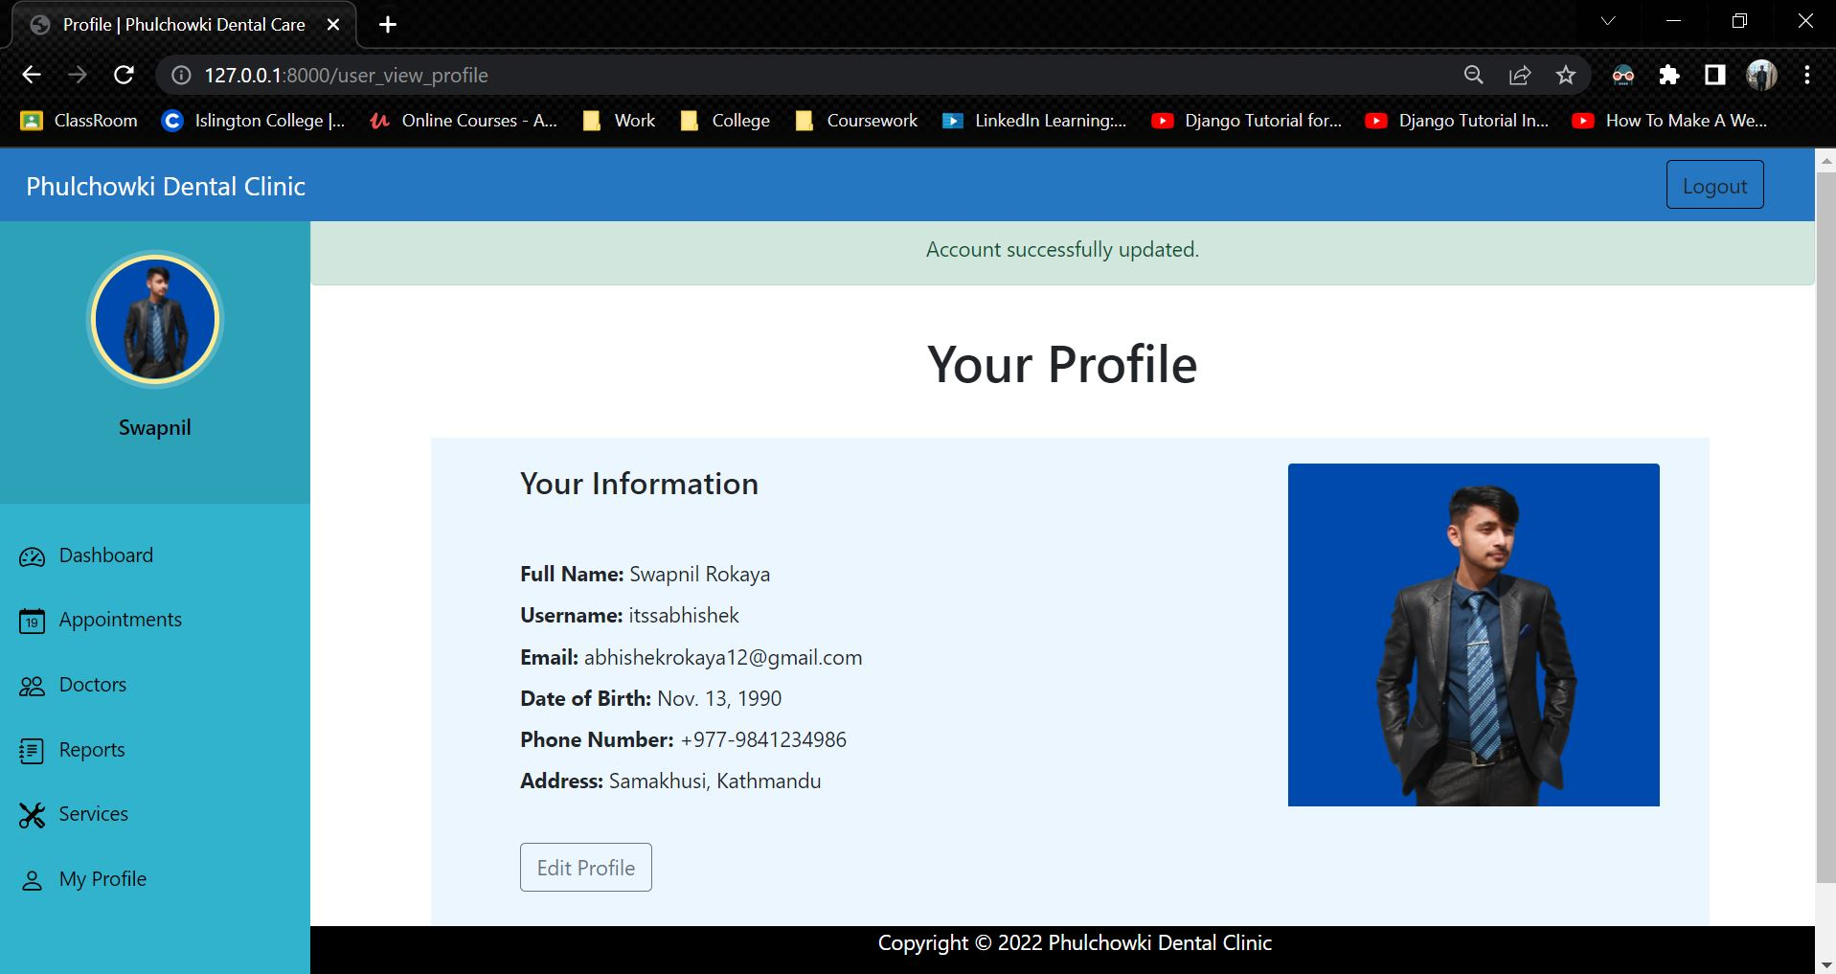

Figure 94: Integration Test 1 - 5

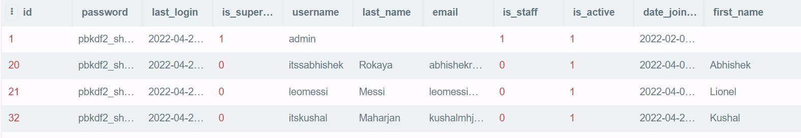

Figure 95: Integration Test 1 - Database Before

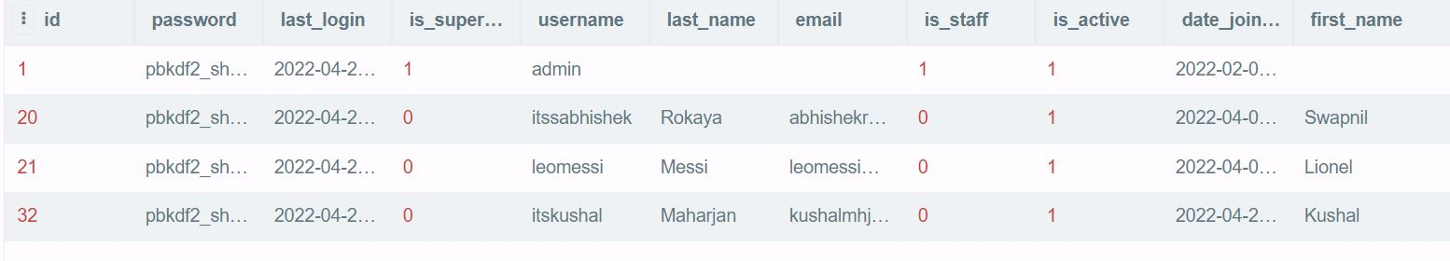

Figure 96: Integration Test 1 - Database After

|  |  |
| --- | --- |
| **Test No.2** | |
| Objective | To add report by the admin. |
| Action | The 'Add report' button was clicked, then the necessary information were added and the submit button was clicked. |
| Expected Output | The report would be added. |
| Actual Output | The report was added. |
| Result | The test was successful. |

Table 71: Integration Test 2

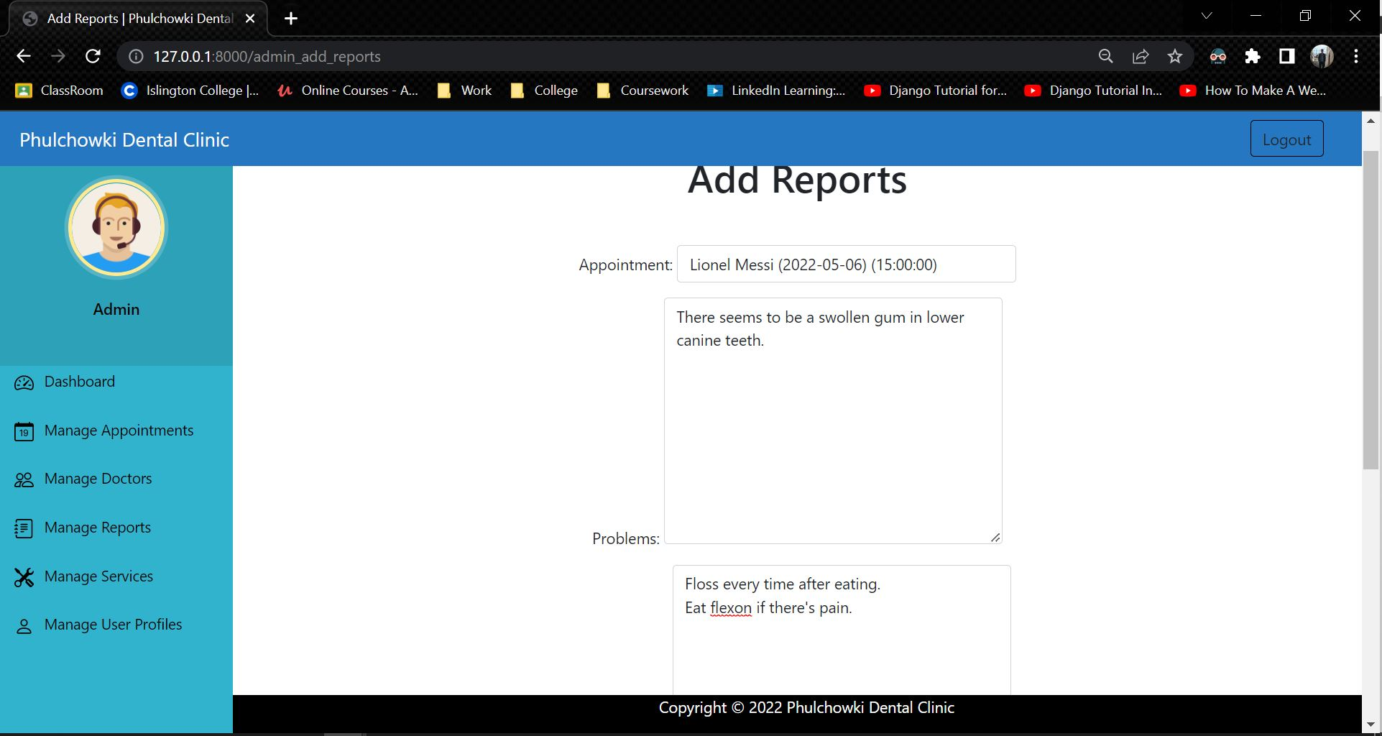

Figure 97: Integration Test 2 - 1

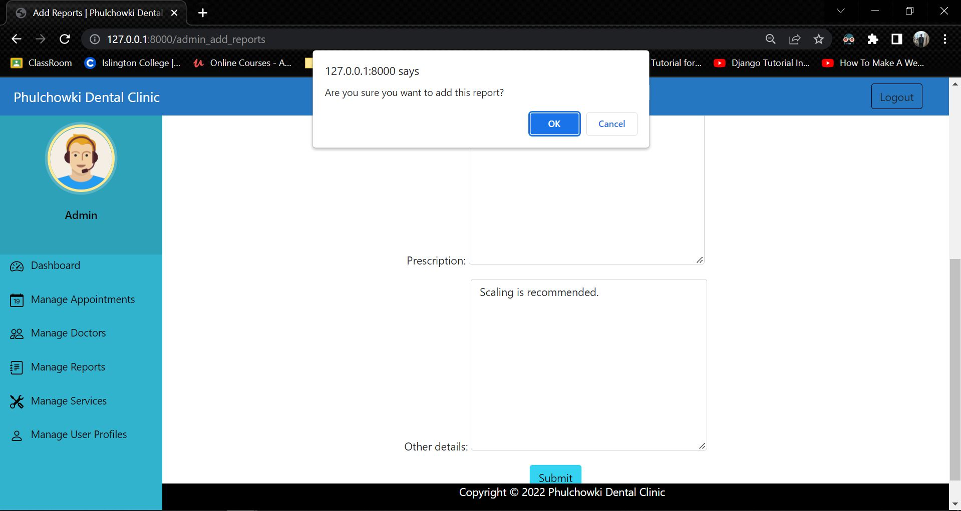

Figure 98: Integration Test 2 – 2

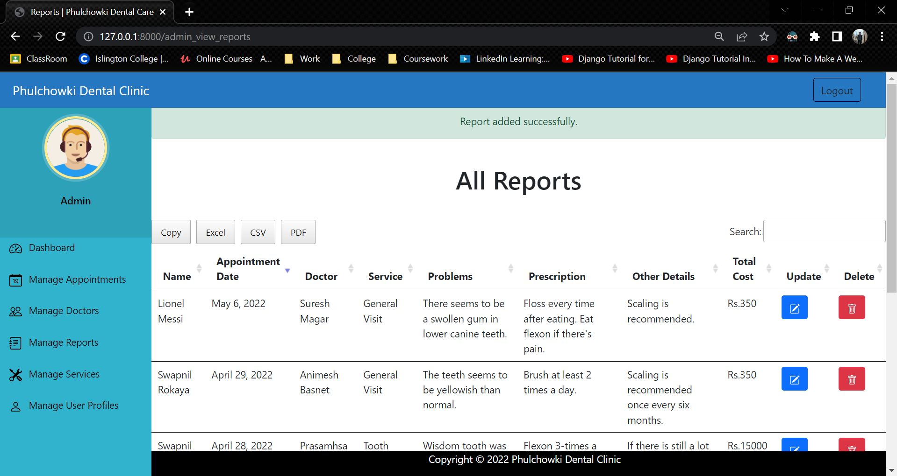

Figure 99: Integration Test 2 - 3

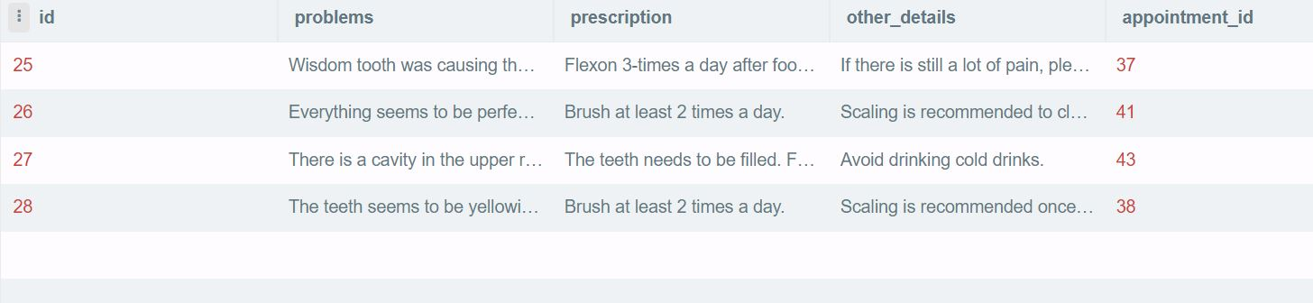

Figure 100: Integration Test 2 - Database Before

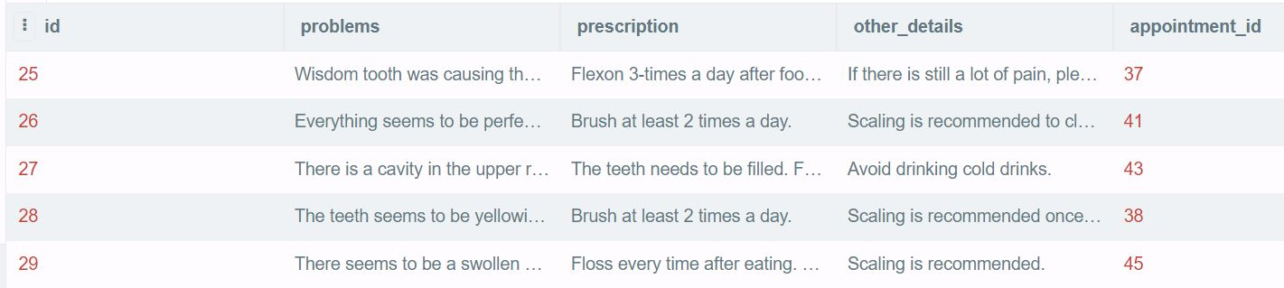

Figure 101: Integration Test 2 - Database After

|  |  |
| --- | --- |
| **Test No.3** | |
| Objective | To update the report details by the admin. |
| Action | The 'Update' button was clicked, then the necessary information were updated and the 'submit' button was clicked. |
| Expected Output | The report would be updated. |
| Actual Output | The report was updated. |
| Result | The test was successful. |

Table 72: Integration Test 3

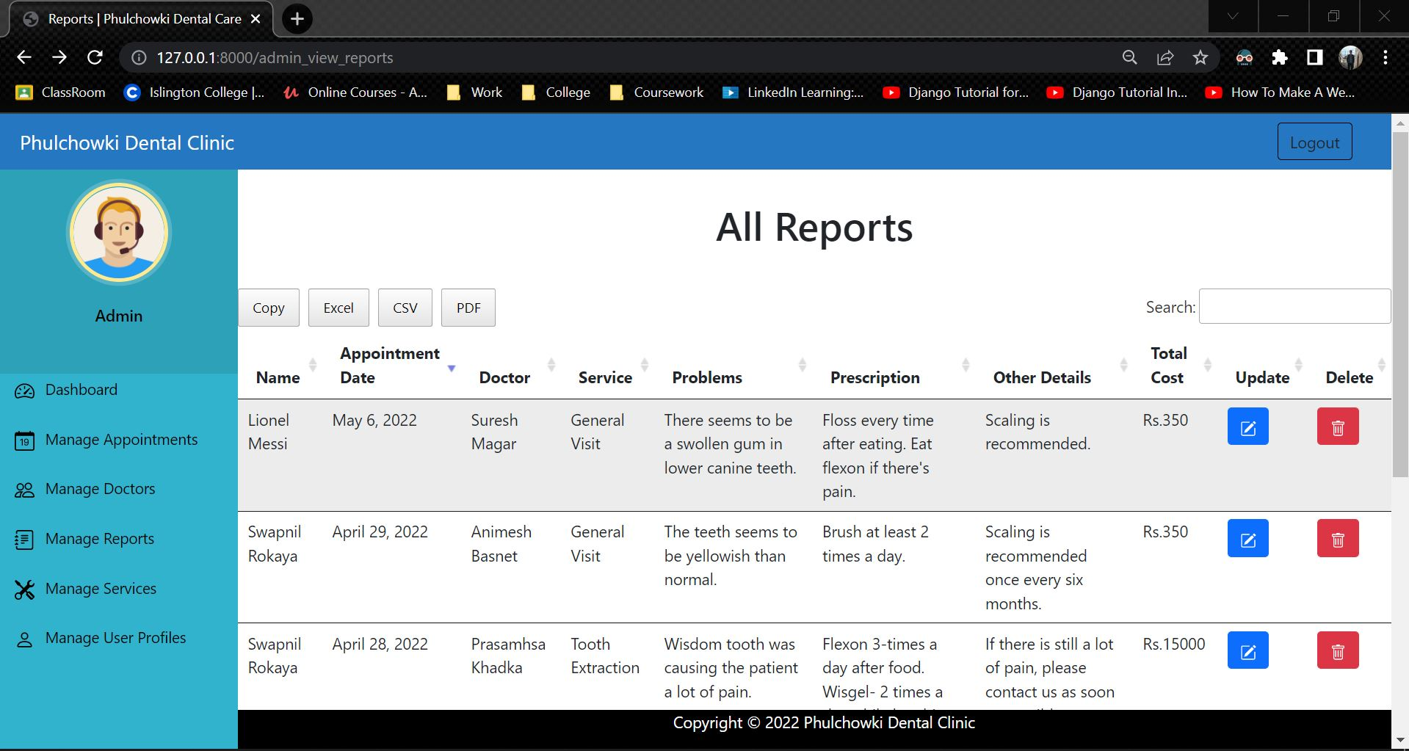

Figure 102: Integration Test 3 - 1

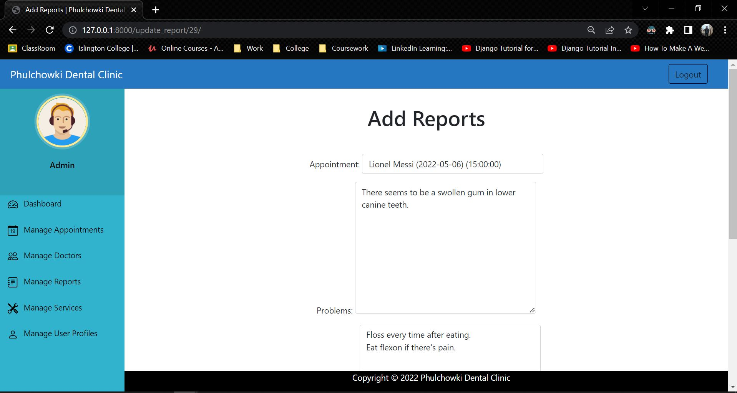

Figure 103: Integration Test 3 – 2

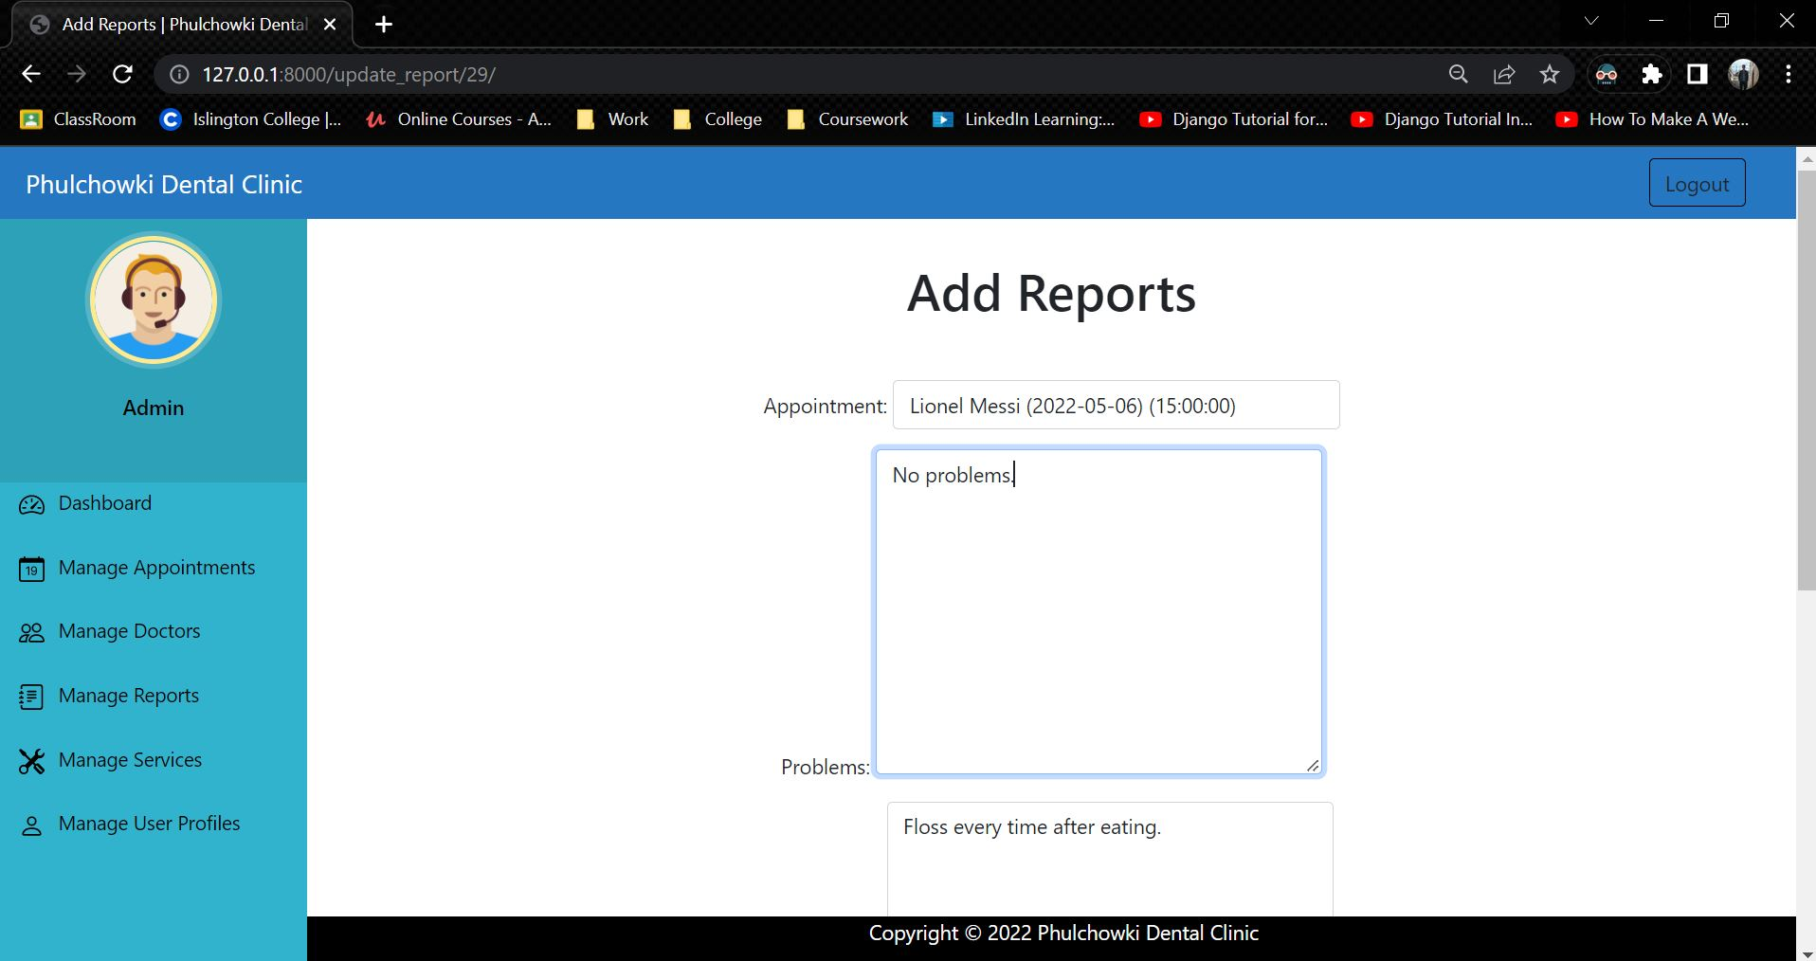

Figure 104: Integration Test 3 – 3

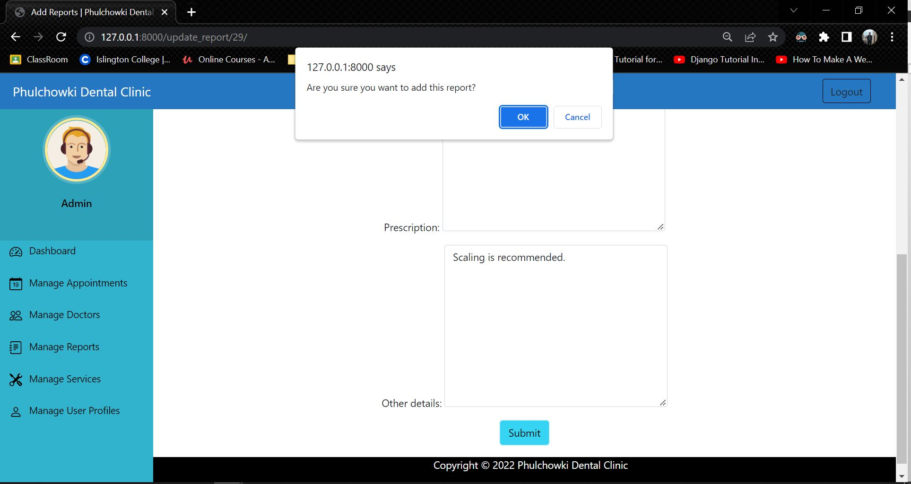

Figure 105: Integration Test 3 – 4

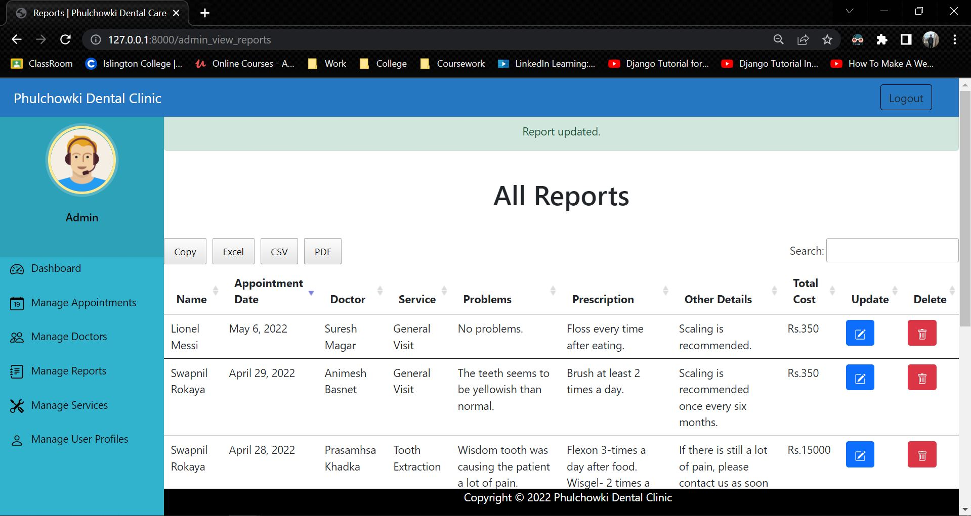

Figure 106: Integration Test 3 – 5

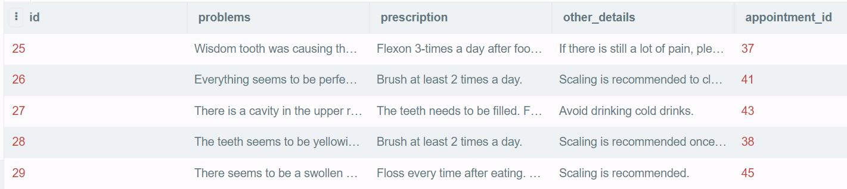

Figure 107: Integration Test 3 - Database Before

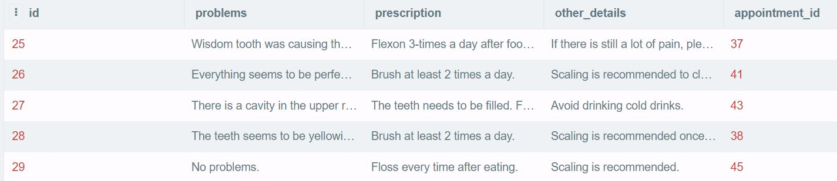

Figure 108: Integration Test 3 - Database After

|  |  |
| --- | --- |
| **Test No.4** | |
| Objective | To delete the report by the admin. |
| Action | The 'Delete' button was clicked, then the confirm button was clicked. |
| Expected Output | The report would be deleted. |
| Actual Output | The report was deleted. |
| Result | The test was successful. |

Table 73: Integration Test 4

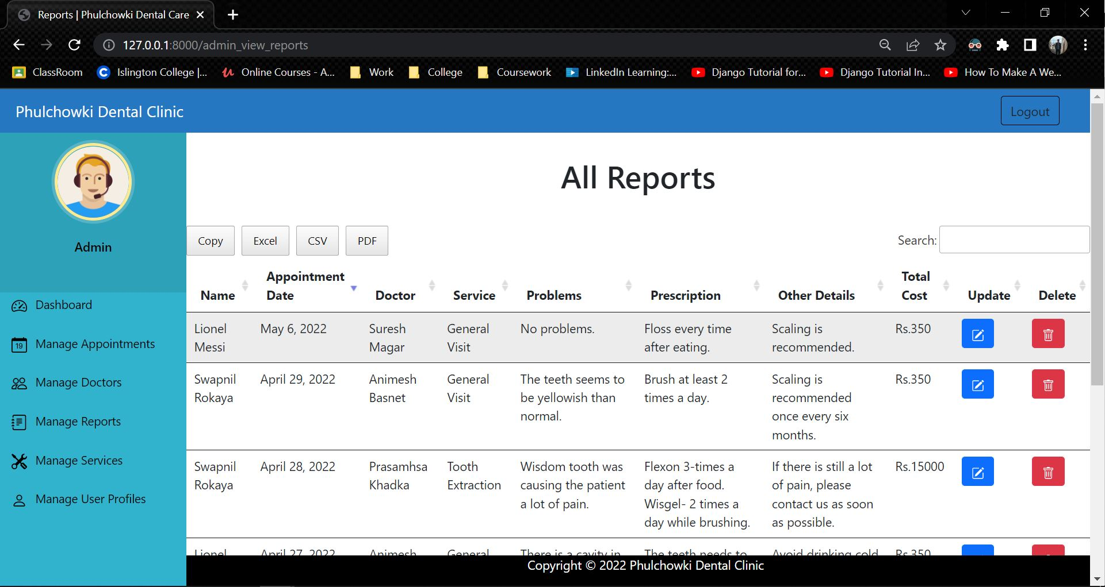

Figure 109: Integration Test 4 – 1

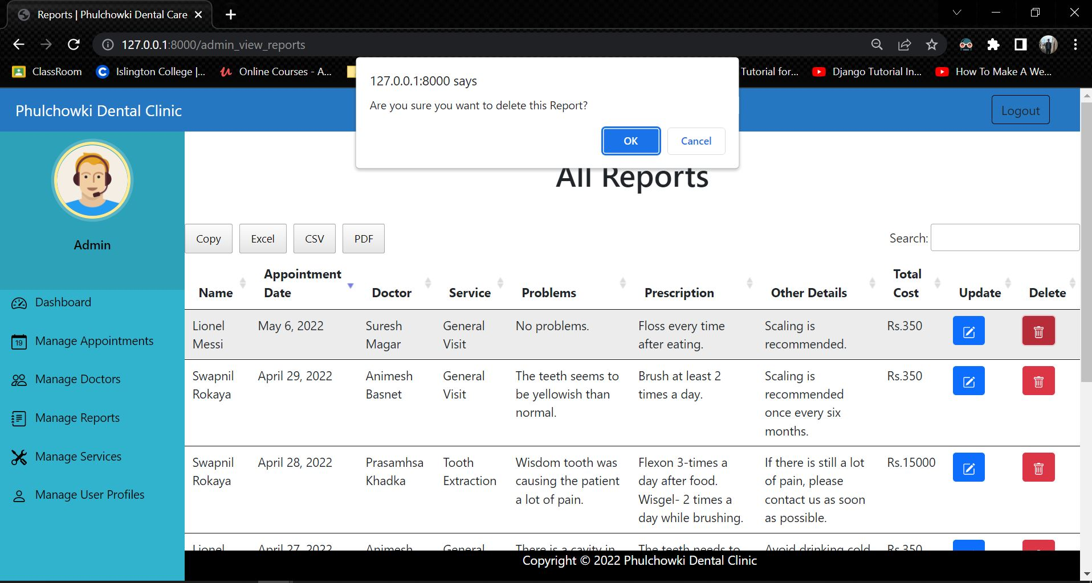

Figure 110: Integration Test 4 – 2

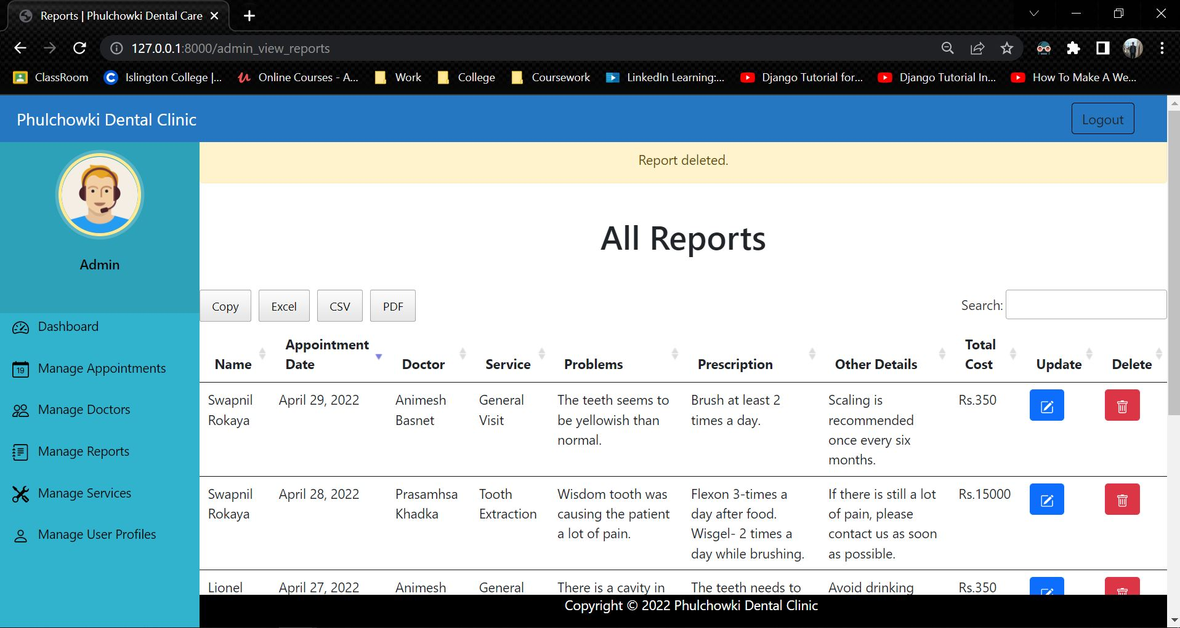

Figure 111: Integration Test 4 - 3

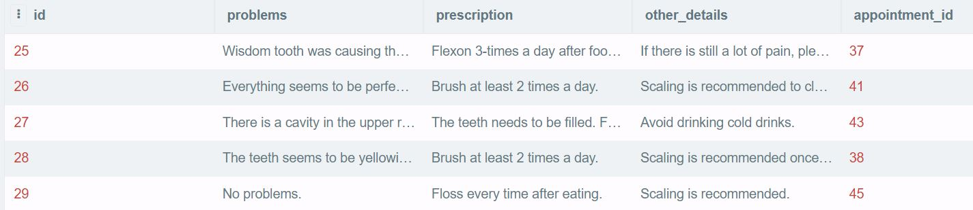

Figure 112: Integration Test 4 - Database Before

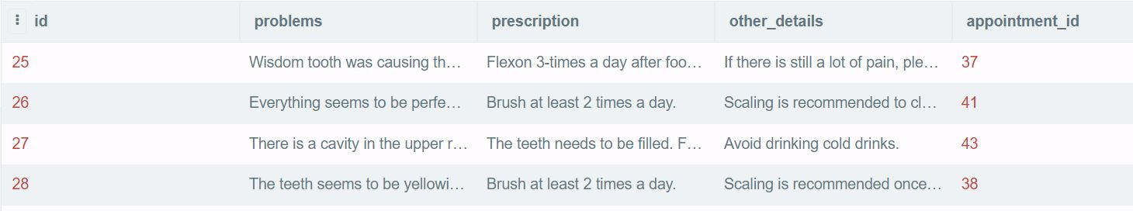

Figure 113: Integration Test 4 - Database After

|  |  |
| --- | --- |
| **Test No.5** | |
| Objective | To add service by the admin. |
| Action | The 'Add Service' button was clicked, then the necessary information were added and the submit button was clicked. |
| Expected Output | The service would be added. |
| Actual Output | The service was added. |
| Result | The test was successful. |

Table 74: Integration Test 5

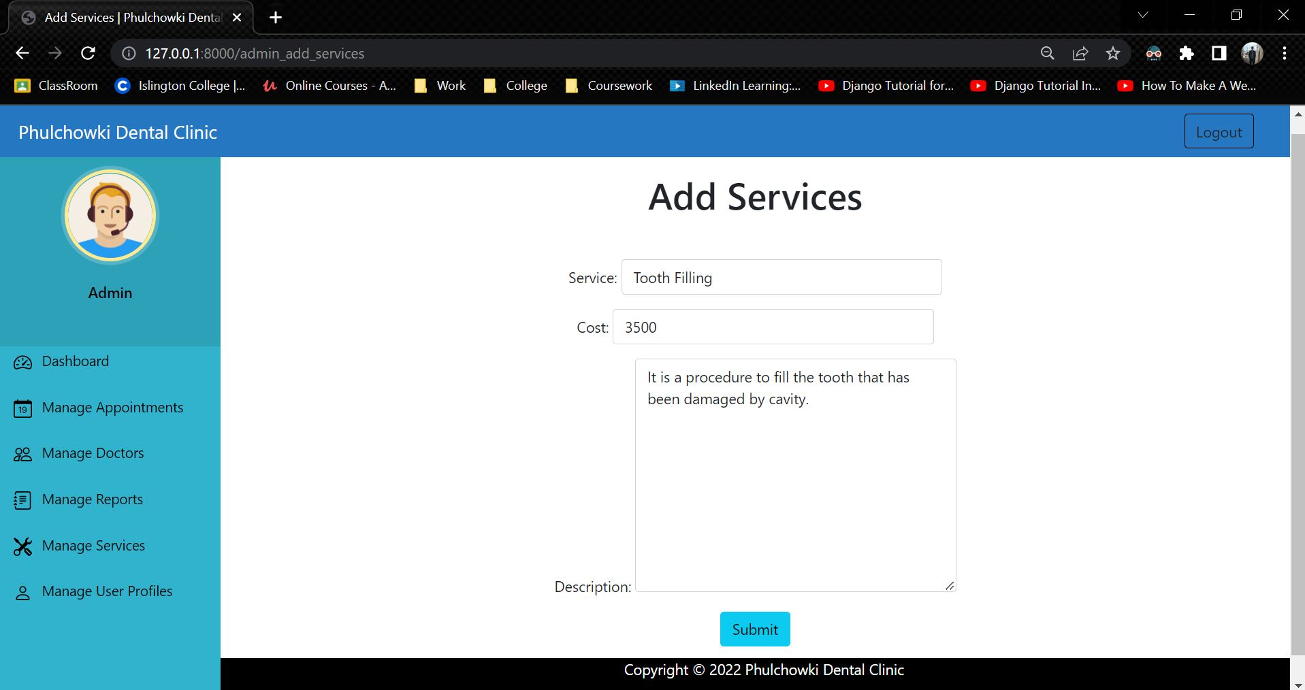

Figure 114: Integration Test 5 - 1

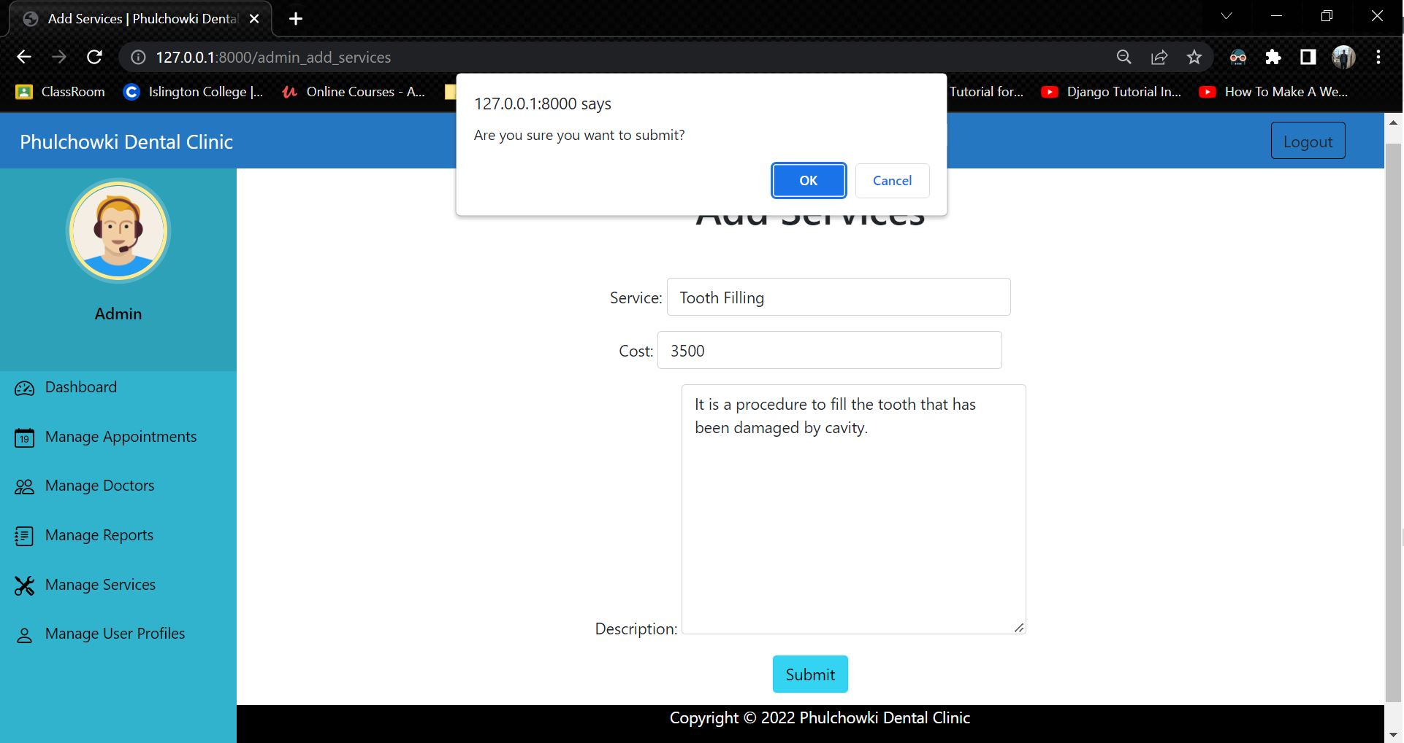

Figure 115: Integration Test 5 - 2

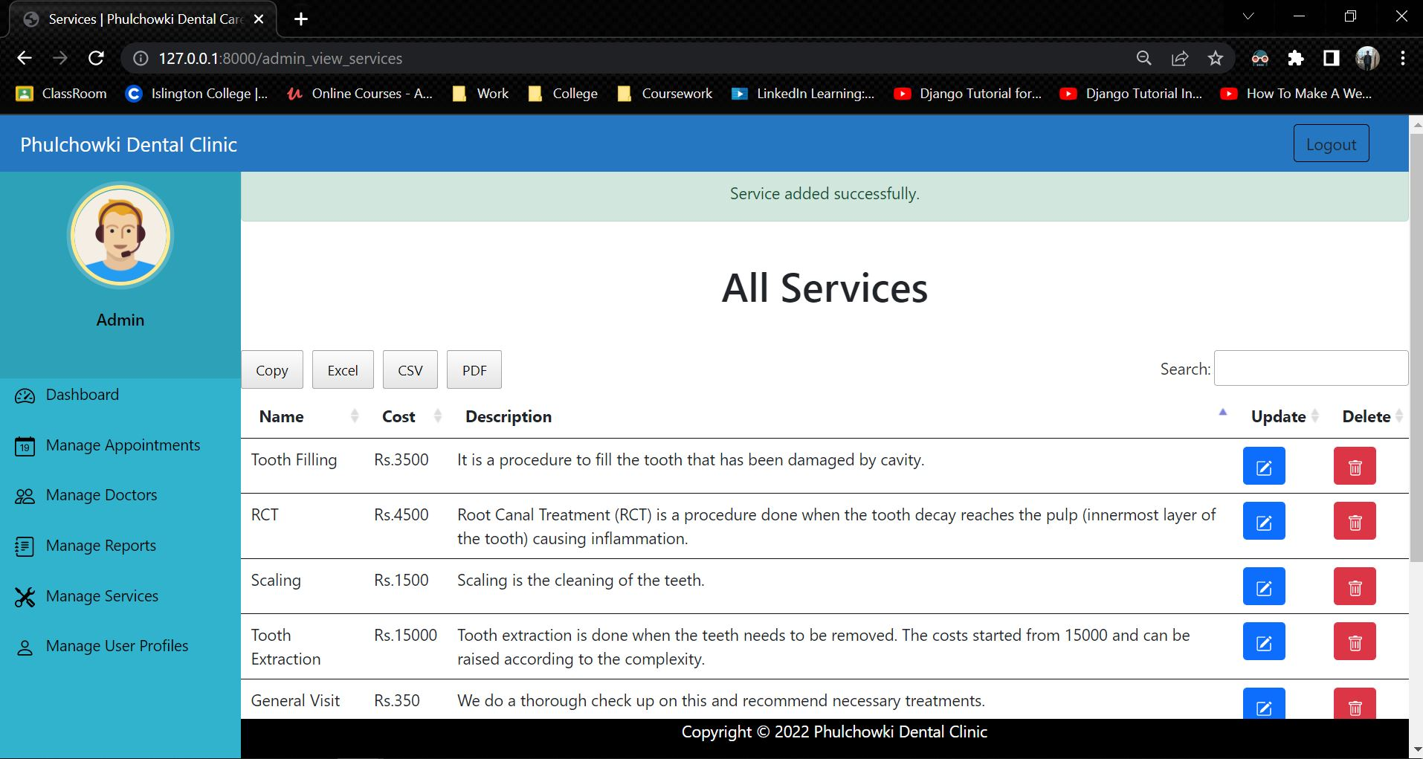

Figure 116: Integration Test 5 - 3

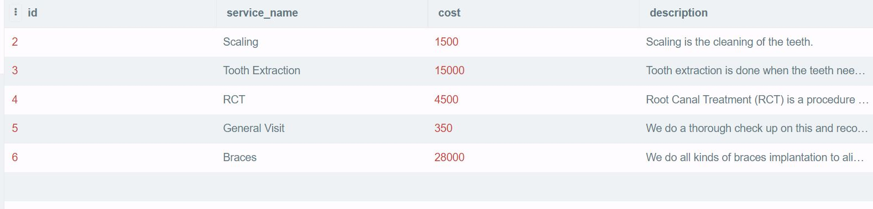

Figure 117: Integration Test 5 - Database Before

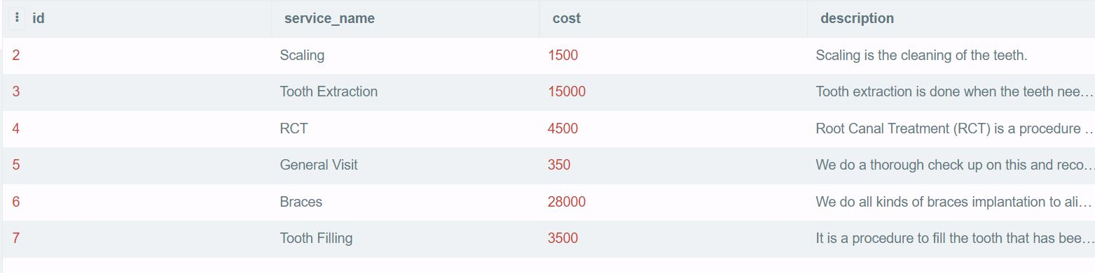

Figure 118: Integration Test 5 - Database After

|  |  |
| --- | --- |
| **Test No.6** | |
| Objective | To update the service details by the admin. |
| Action | The 'Update' button was clicked, then the necessary information were updated and the 'submit' button was clicked. |
| Expected Output | The service would be updated. |
| Actual Output | The service was updated. |
| Result | The test was successful. |

Table 75: Integration Test 6

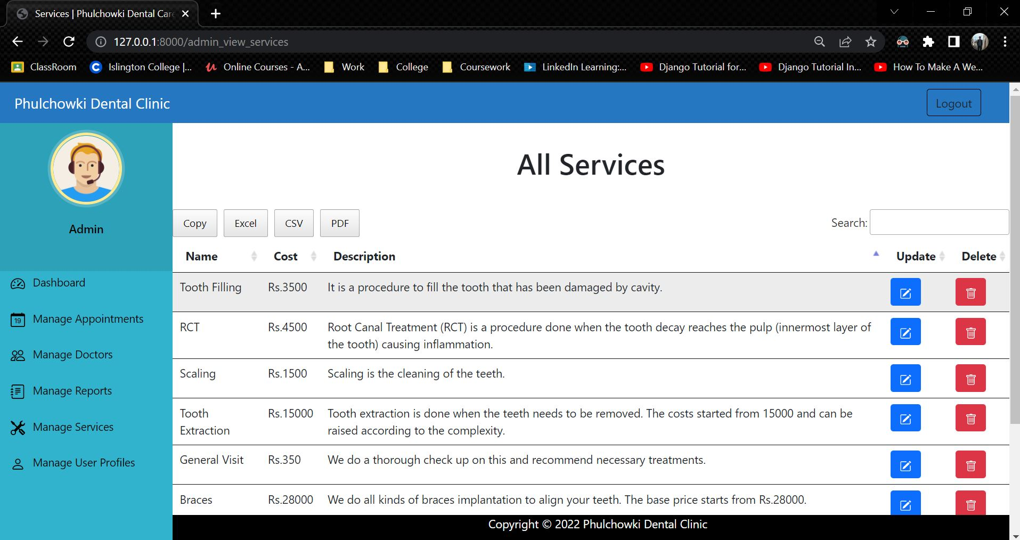

Figure 119: Integration Test 6 - 1

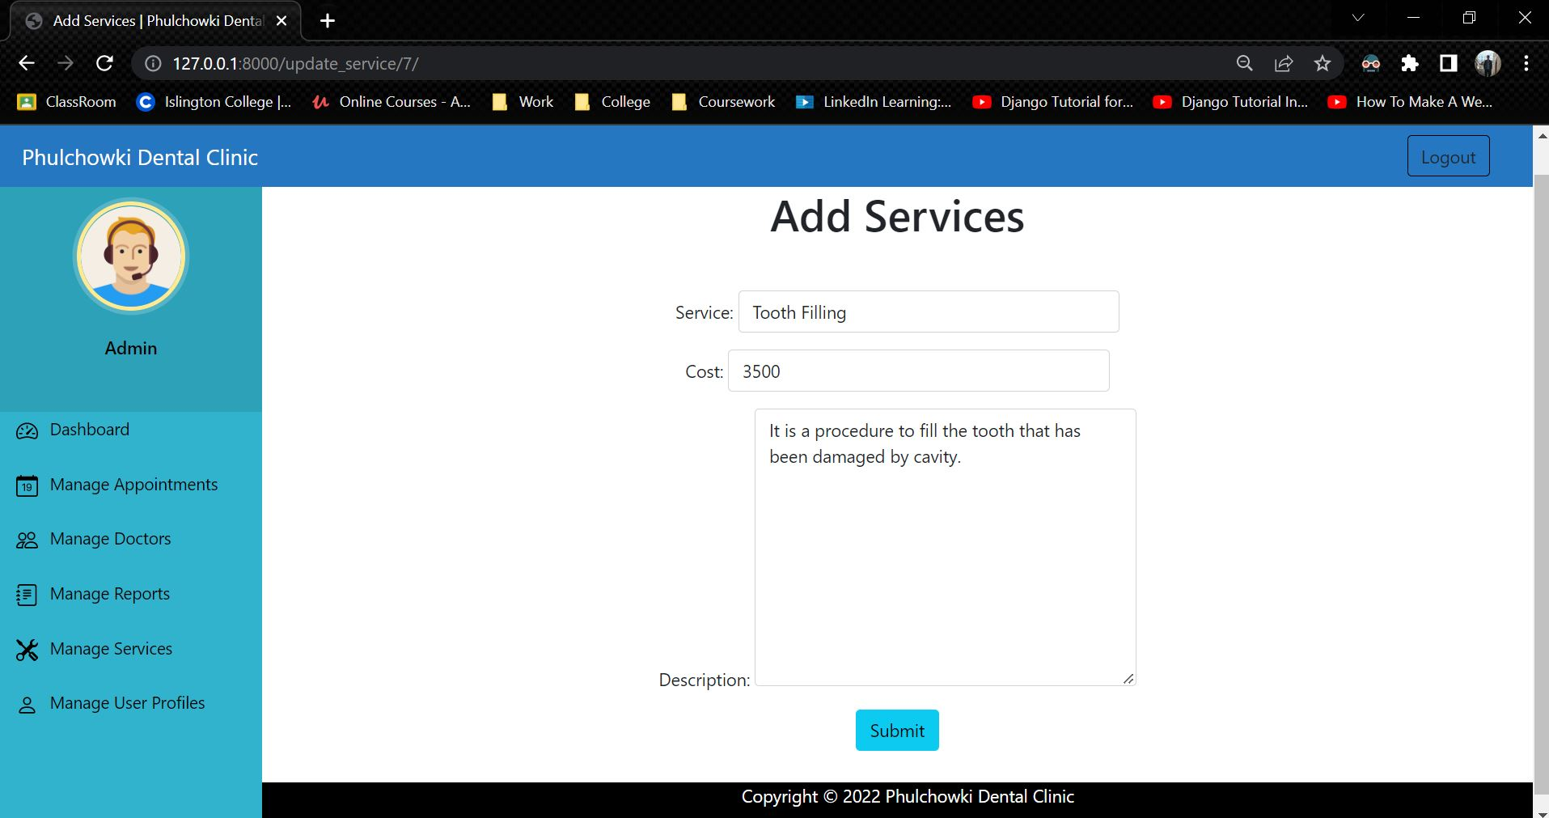

Figure 120: Integration Test 6 – 2

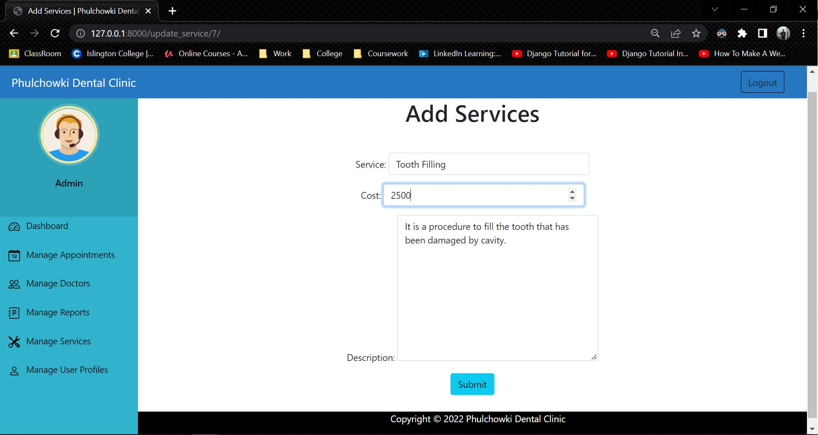

Figure 121: Integration Test 6 - 3

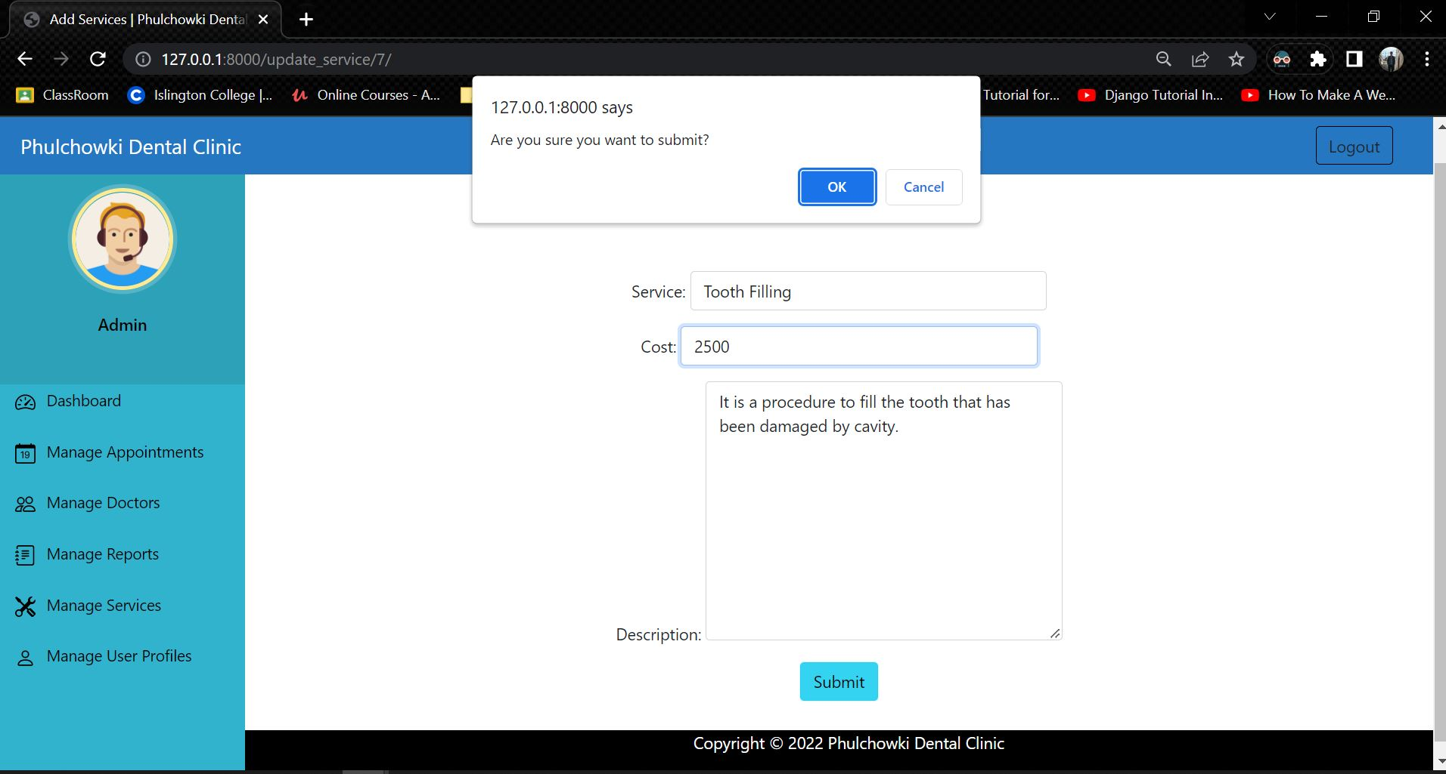

Figure 122: Integration Test 6 - 4

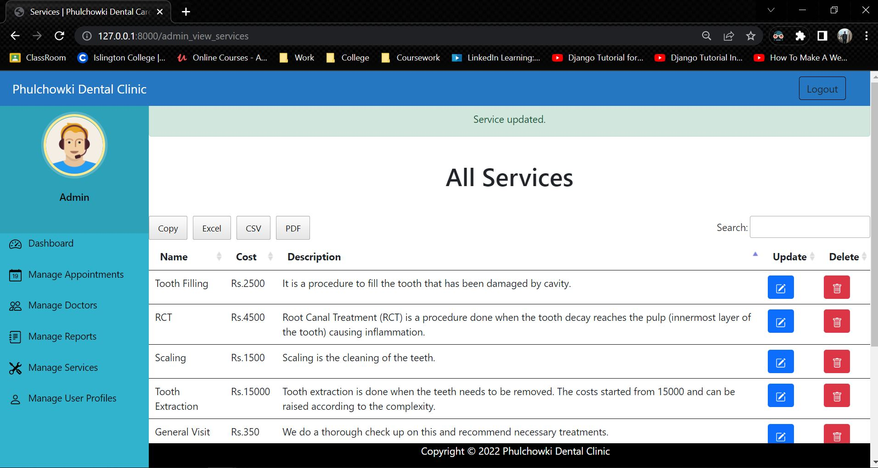

Figure 123: Integration Test 6 - 5

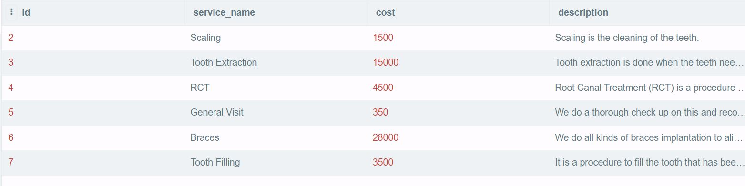

Figure 124: Integration Test 6 - Database Before

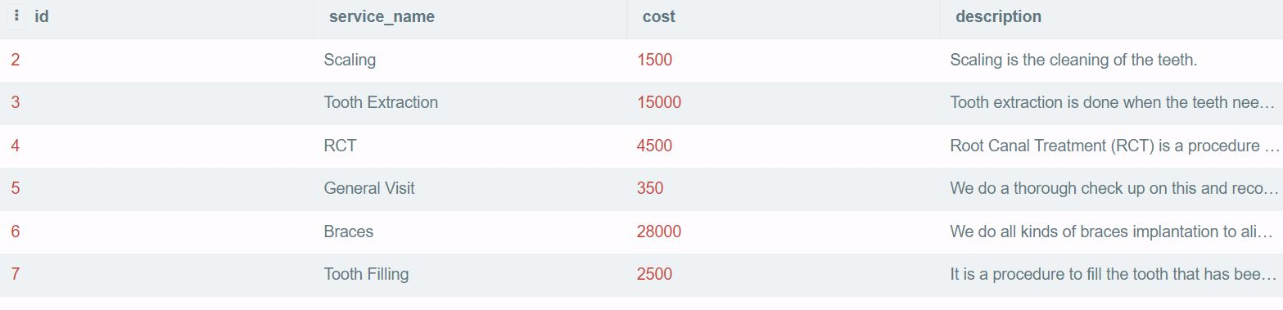

Figure 125: Integration Test 6 - Database After

|  |  |
| --- | --- |
| **Test No.7** | |
| Objective | To delete the service by the admin. |
| Action | The 'Delete' button was clicked, then the confirm button was clicked. |
| Expected Output | The service would be deleted. |
| Actual Output | The service was deleted. |
| Result | The test was successful. |

Table 76: Integration Test 7

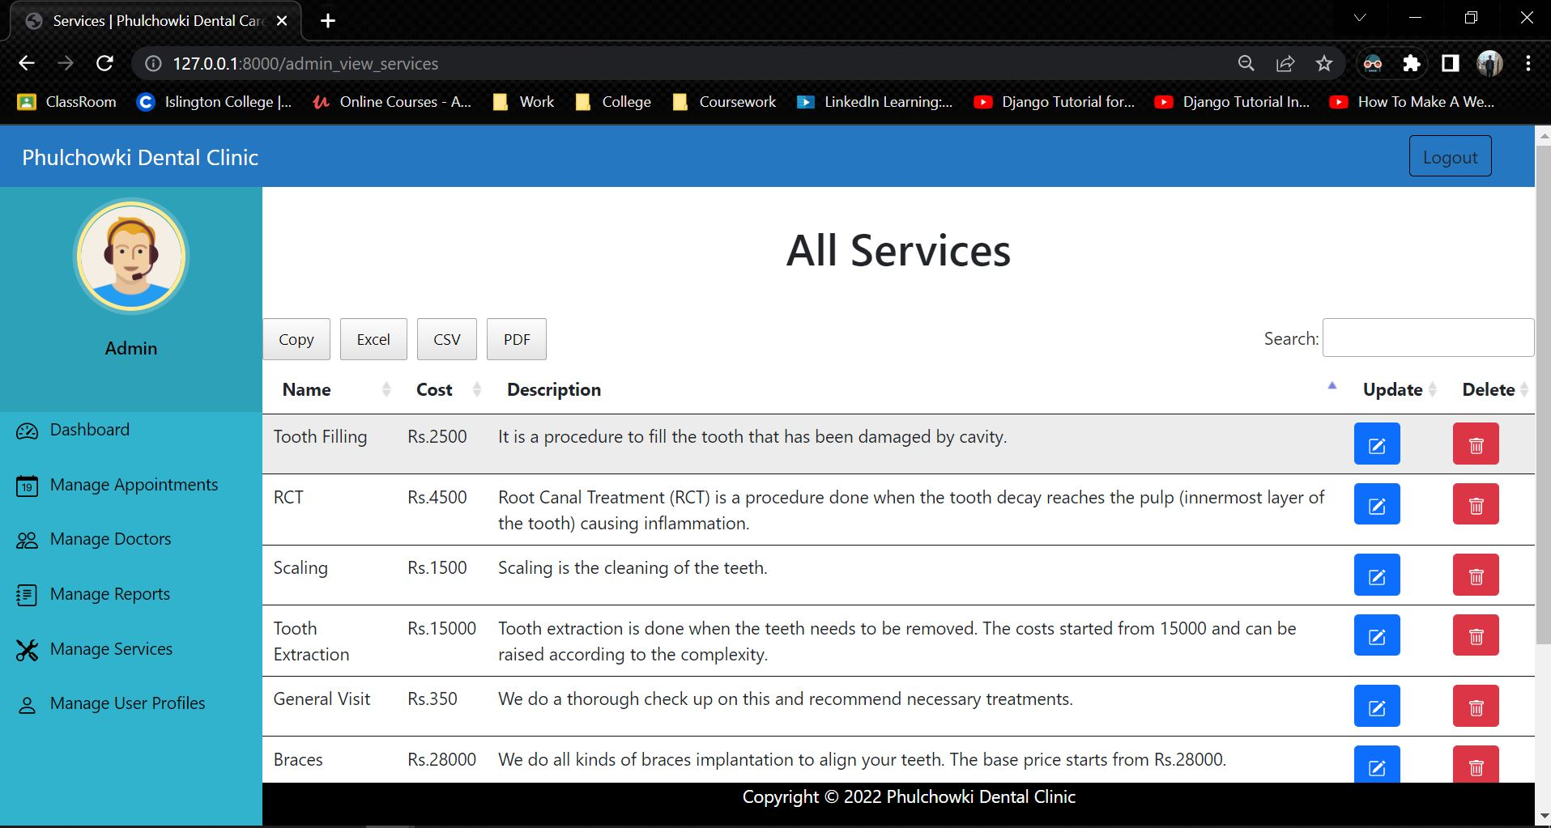

Figure 126: Integration Test 7 - 1

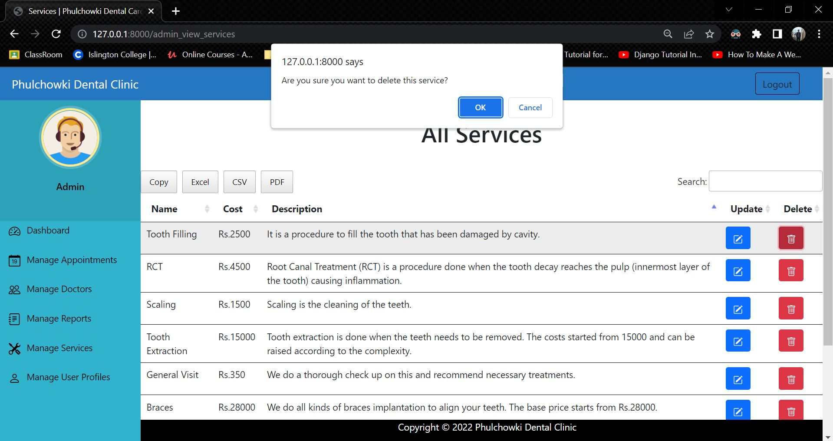

Figure 127: Integration Test 7 – 2

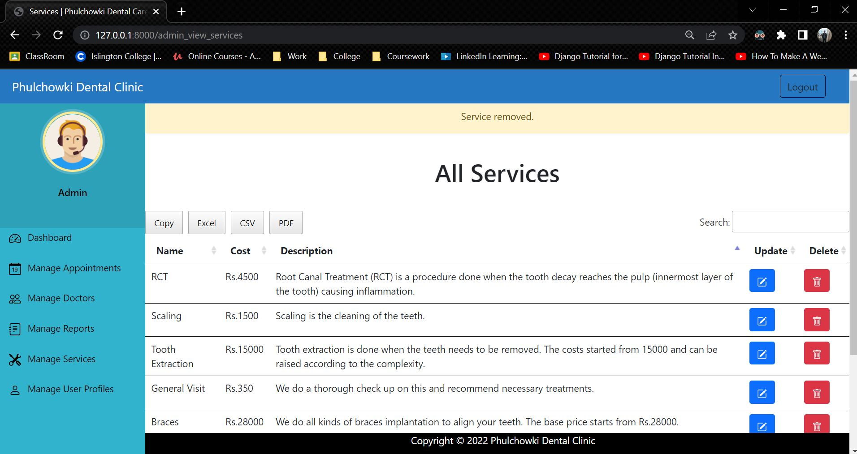

Figure 128: Integration Test 7 – 3

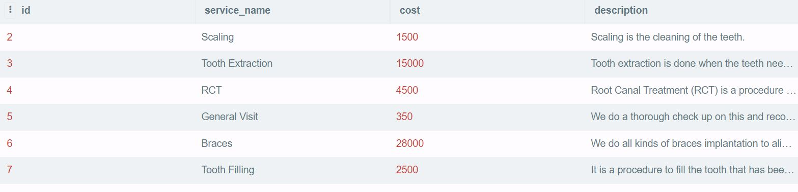

Figure 129: Integration Test 7 - Database Before

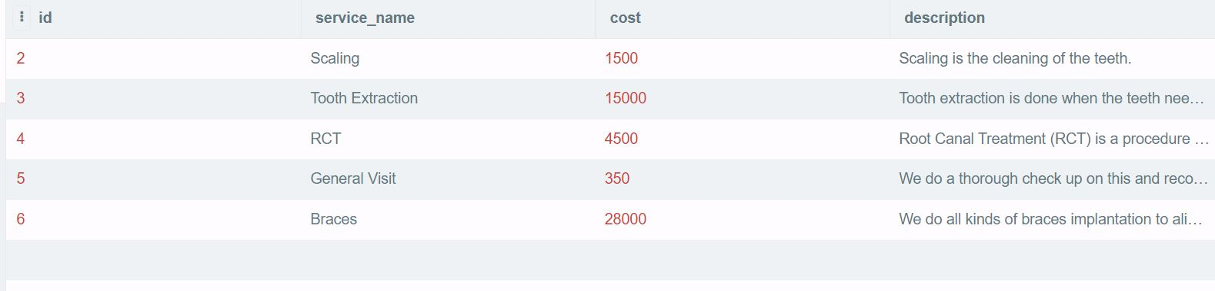

Figure 130: Integration Test 7 - Database After

|  |  |
| --- | --- |
| **Test No.8** | |
| Objective | To add doctor by the admin. |
| Action | The 'Add Doctor' button was clicked, then the necessary information were added and the submit button was clicked. |
| Expected Output | The doctor would be added. |
| Actual Output | The doctor was added. |
| Result | The test was successful. |

Table 77: Integration Test 8

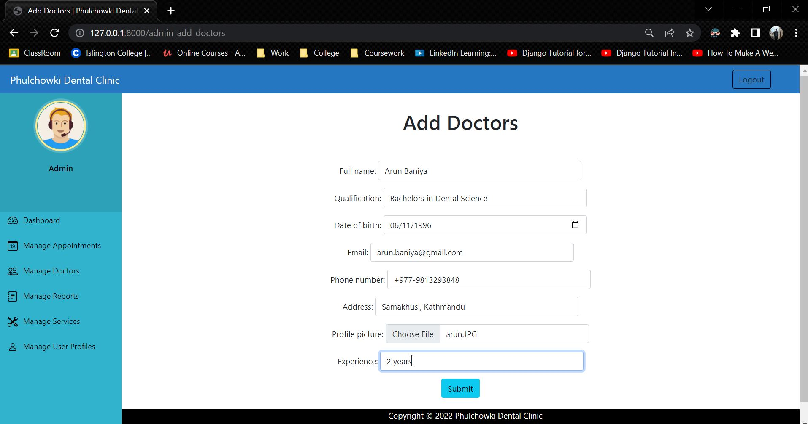

Figure 131: Integration Test 8 – 1

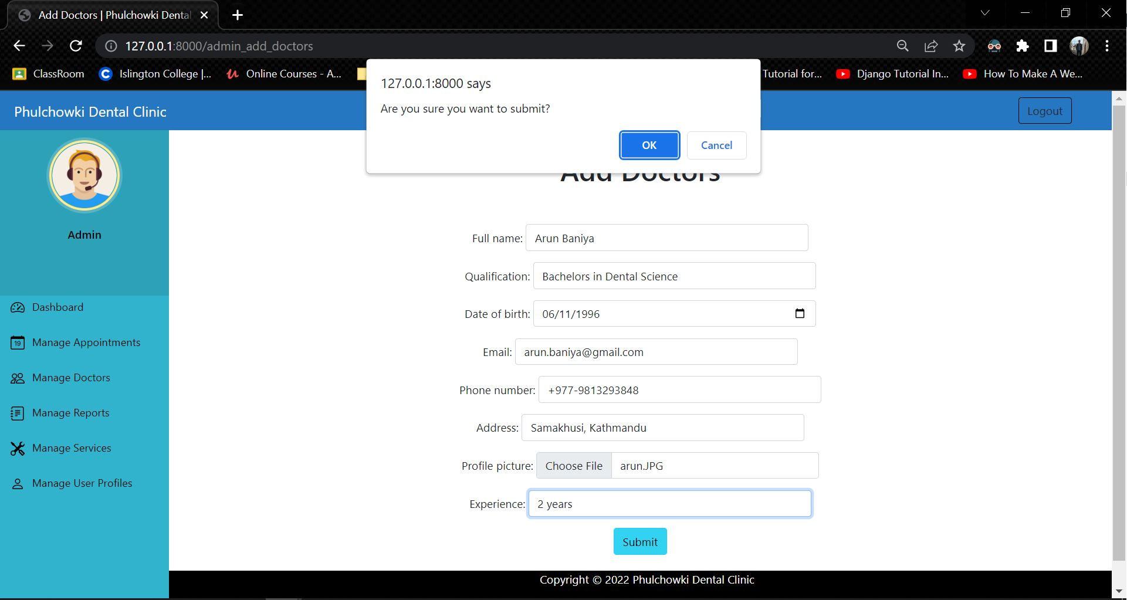

Figure 132: Integration Test 8 - 2

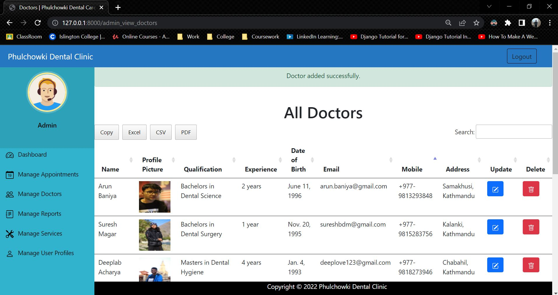

Figure 133: Integration Test 8 - 3

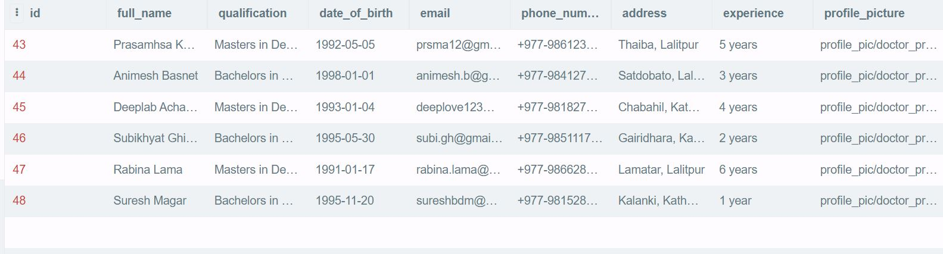

Figure 134: Integration Test 8 - Database before

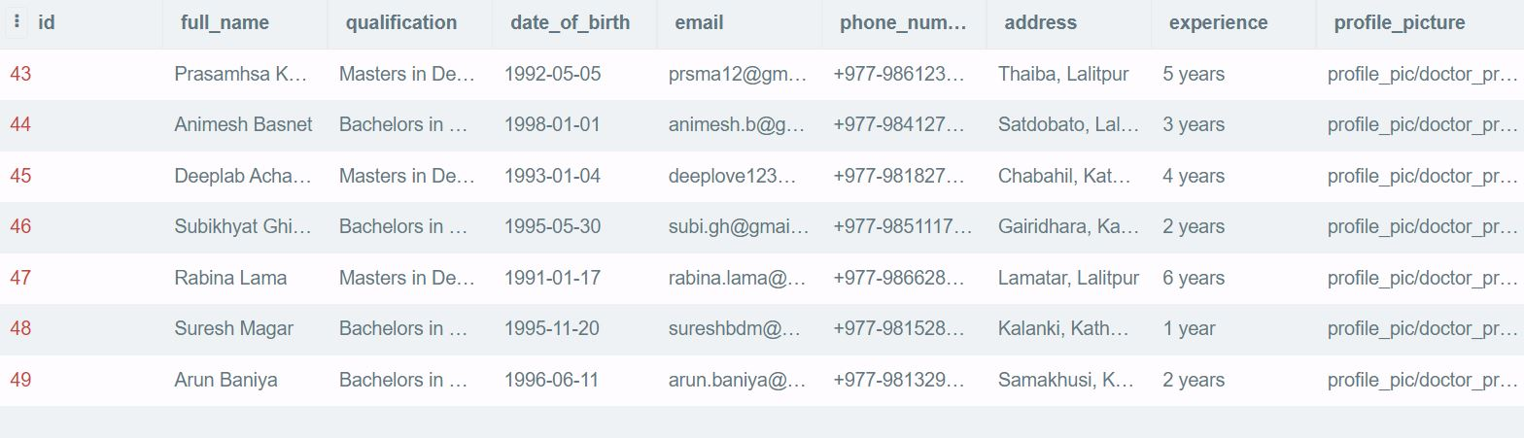

Figure 135: Integration Test 8 - Database After

|  |  |
| --- | --- |
| **Test No.9** | |
| Objective | To update the doctor's details by the admin. |
| Action | The 'Update' button was clicked, then the necessary information were updated and the 'submit' button was clicked. |
| Expected Output | The doctor would be updated. |
| Actual Output | The doctor was updated. |
| Result | The test was successful. |

Table 78: Integration Test 9

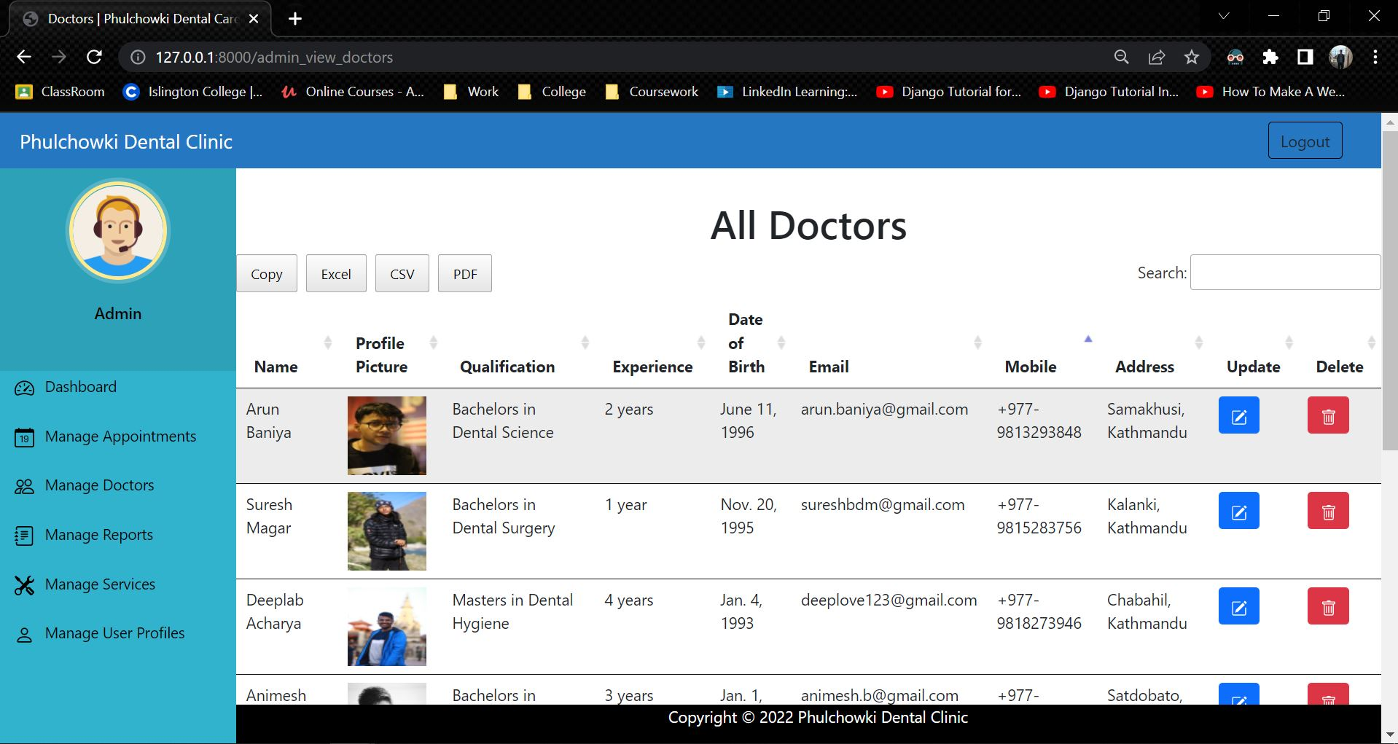

Figure 136: Integration Test 9 - 1

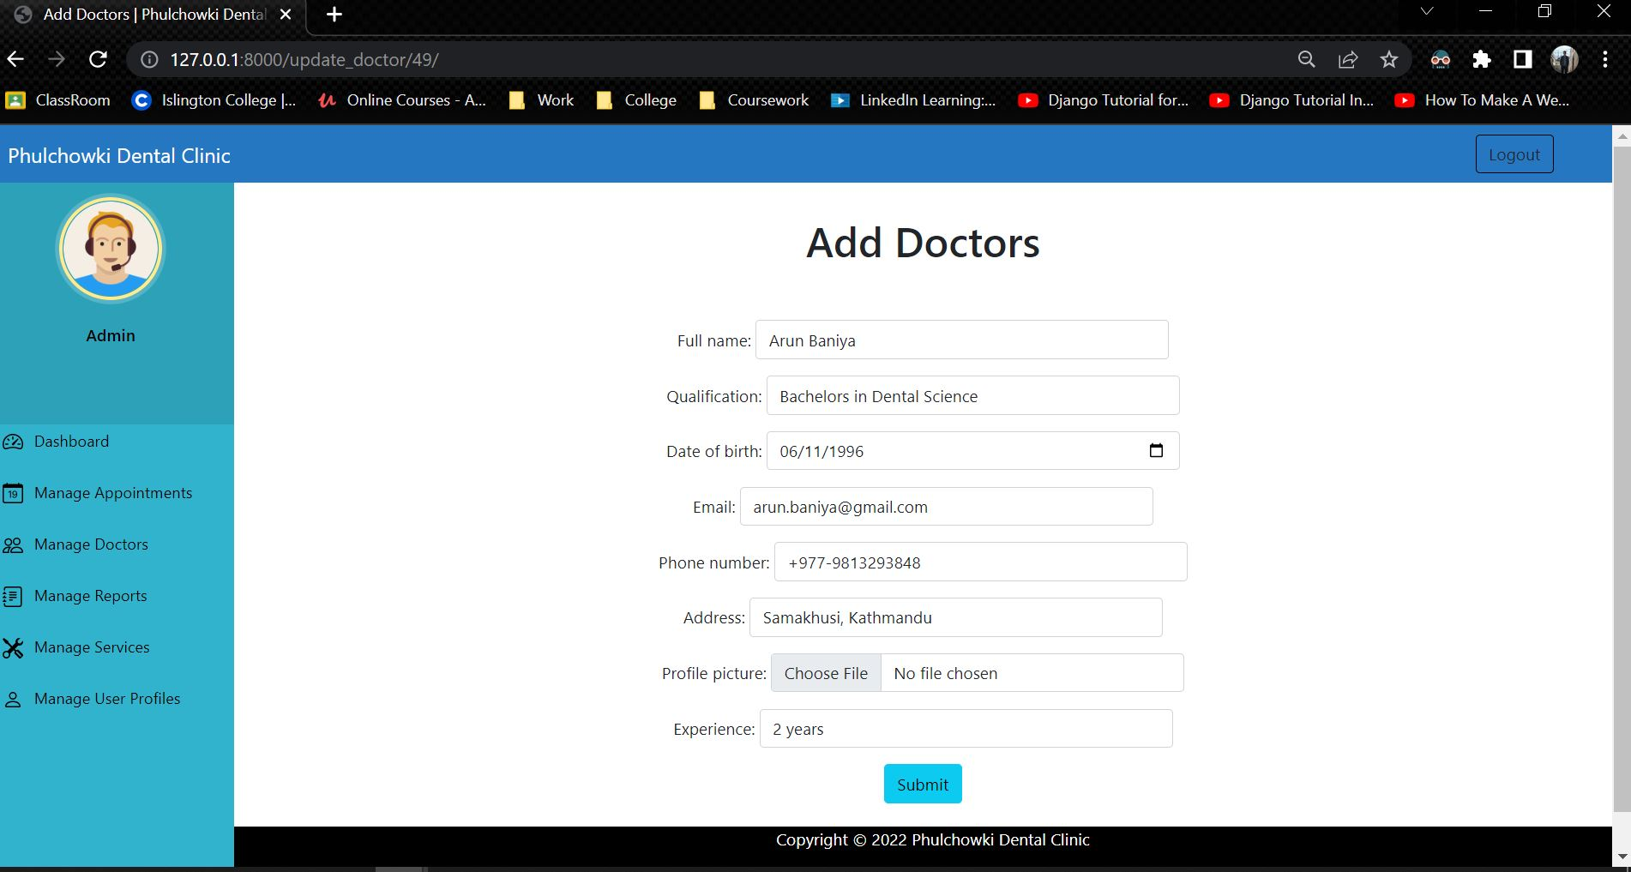

Figure 137: Integration Test 9 – 2

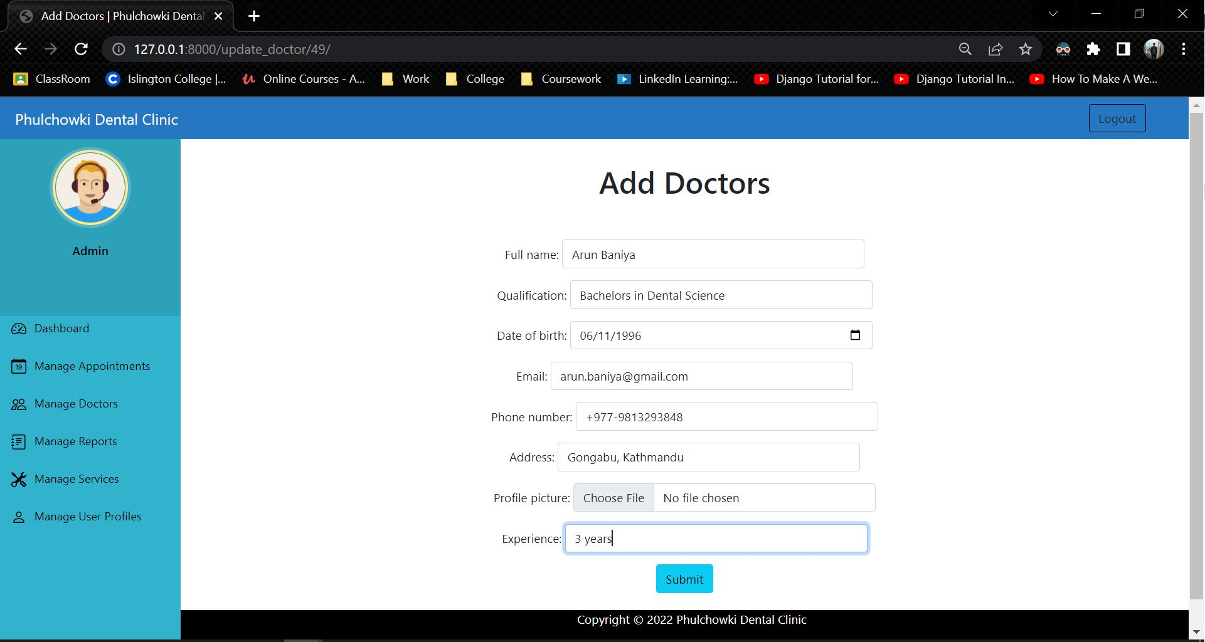

Figure 138: Integration Test 9 - 3

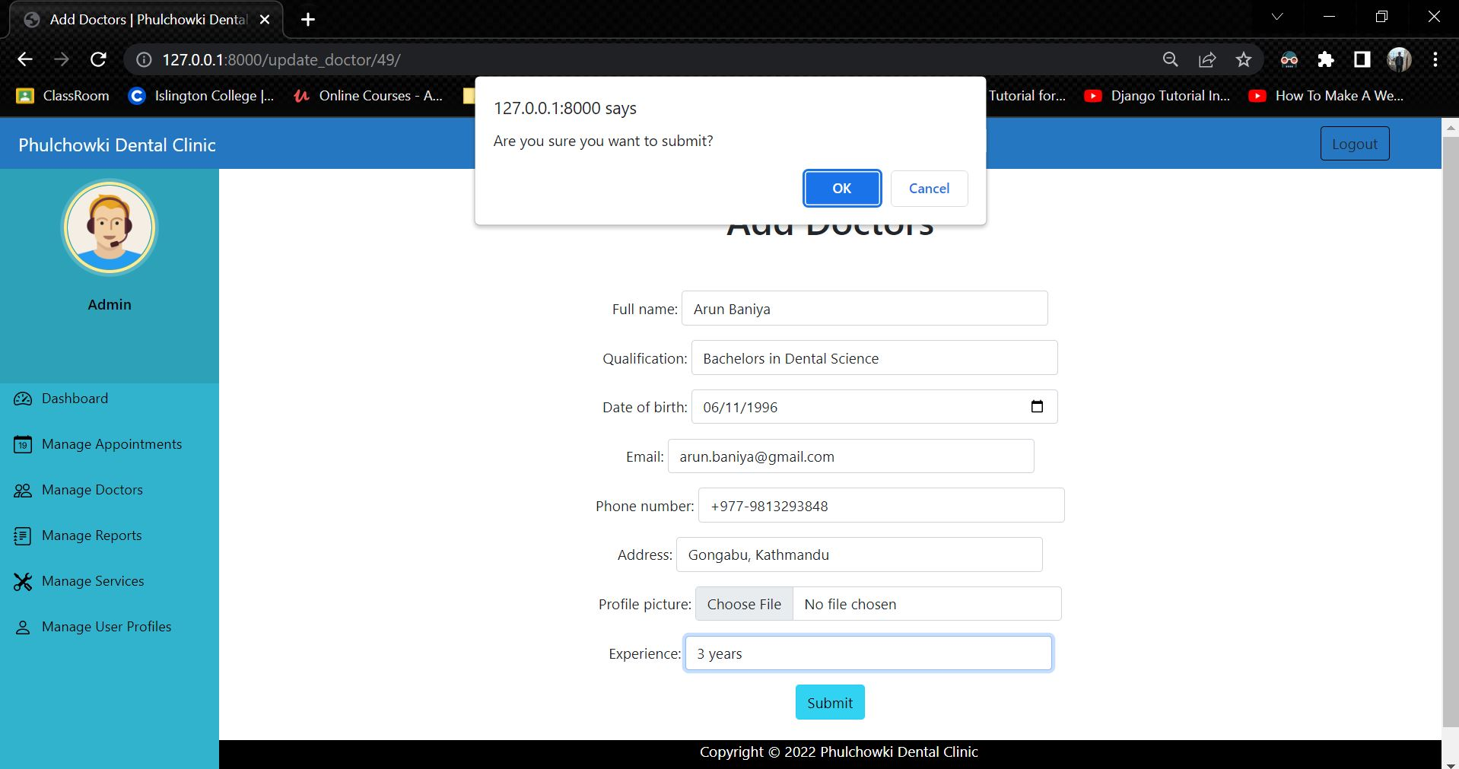

Figure 139: Integration Test 9 - 4

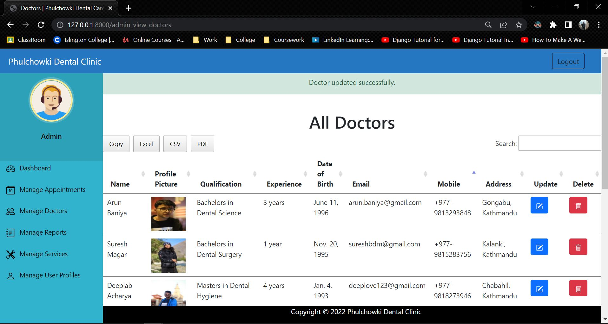

Figure 140: Integration Test 9 – 5

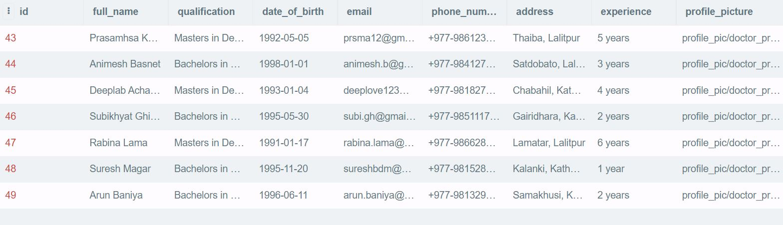

Figure 141: Integration Test 9 - Database Before

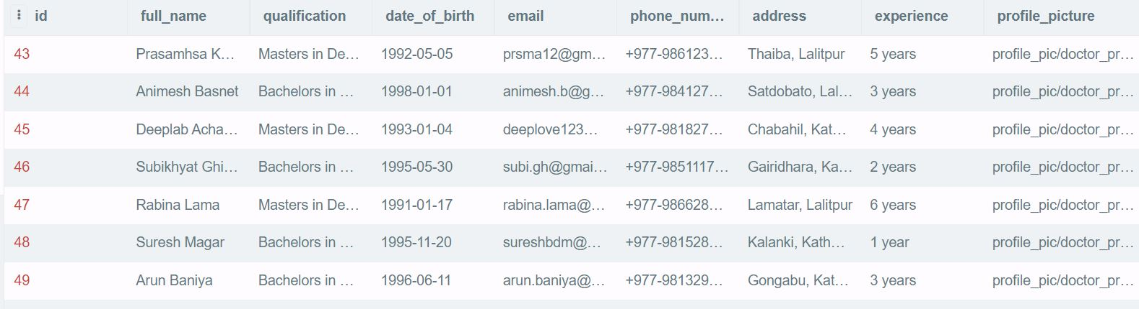

Figure 142: Integration Test 9 - Database After

|  |  |
| --- | --- |
| **Test No.10** | |
| Objective | To delete the doctor by the admin. |
| Action | The 'Delete' button was clicked, then the confirm button was clicked. |
| Expected Output | The doctor would be deleted. |
| Actual Output | The doctor was deleted. |
| Result | The test was successful. |

Table 79: Integration Test 10

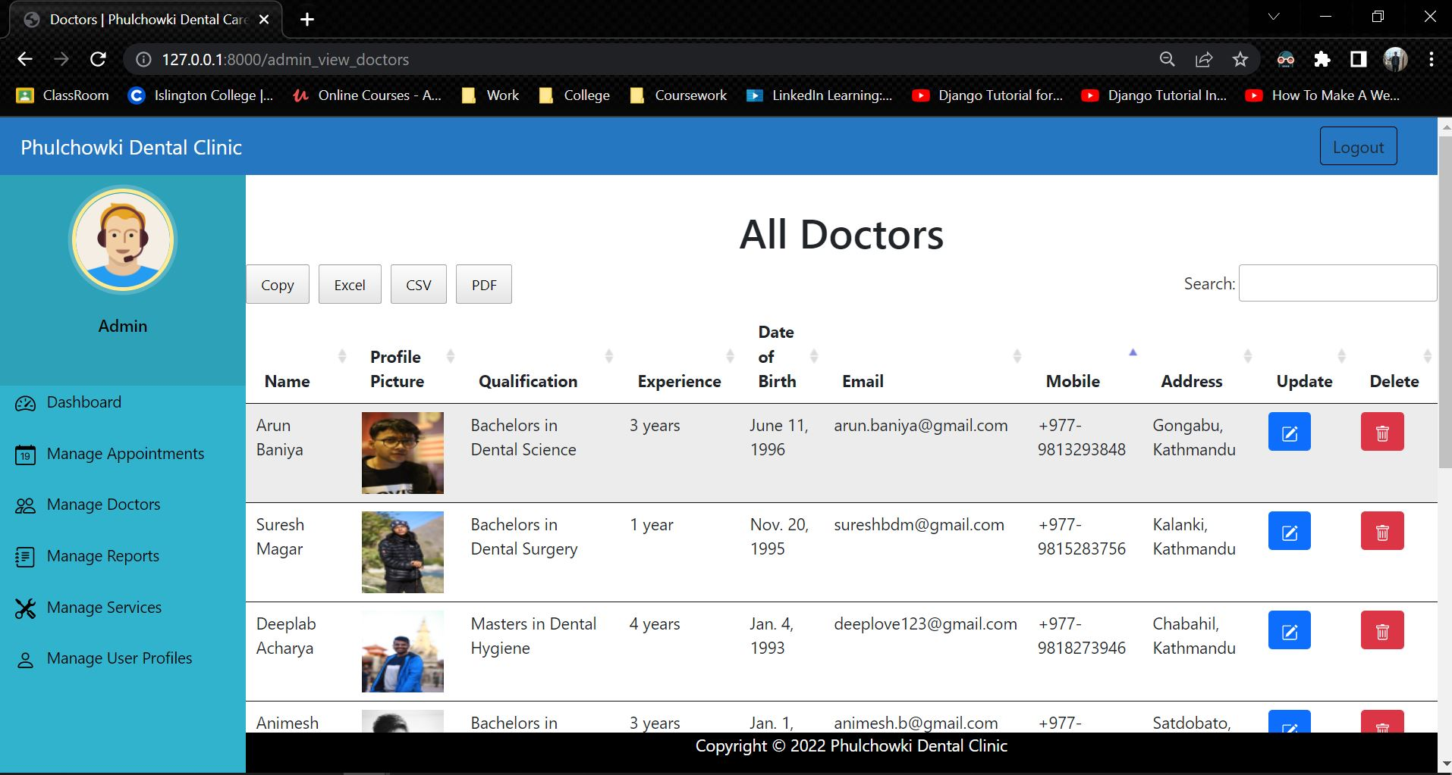

Figure 143: Integration Test 10 - 1

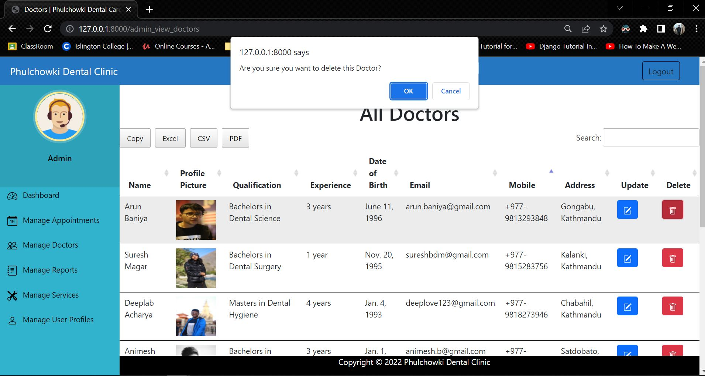

Figure 144: Integration Test 10 – 2

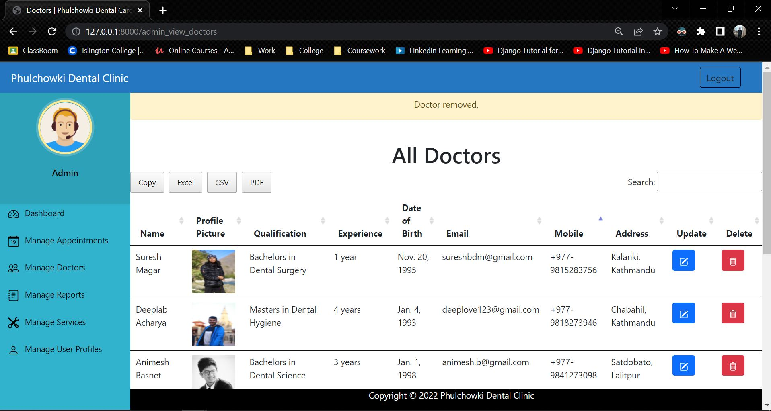

Figure 145: Integration Test 10 - 3

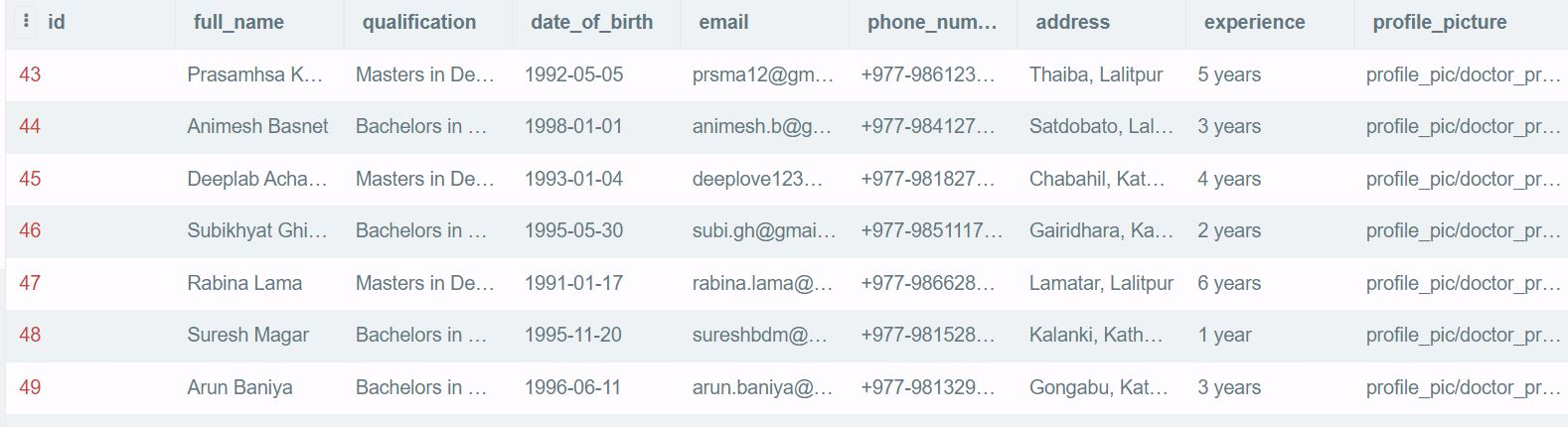

Figure 146: Integration Test 10 - Database Before

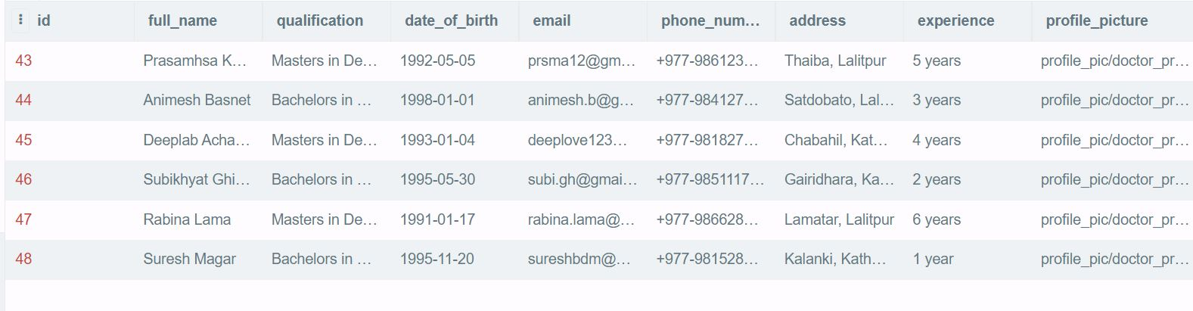

Figure 147: Integration Test 10 - Database After

## 4.5 System Testing

|  |  |
| --- | --- |
| **Test No.1** | |
| Objective | To run the system from VS Code. |
| Action | The command 'python manage.py runserver' was entered in the terminal. |
| Expected Output | The system would run. |
| Actual Output | The system ran successfully. |
| Result | The test was successful. |

Table 80: System Testing 1

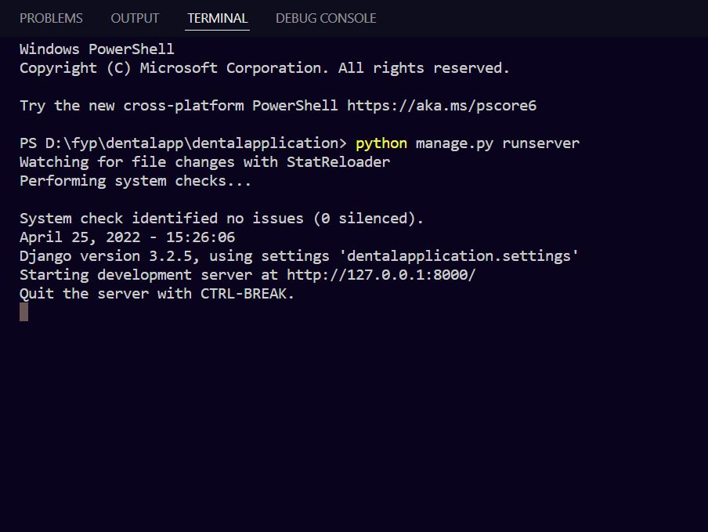

Figure 148: System Testing 1

## 4.6 Client Evaluation Testing

## 4.7 Critical Analysis

# 5. Conclusion

The following project included a variety of tasks and obstacles that involved relentless determination and a large number of errors to be dealt with when working. Both our internal and external supervisors offered invaluable guidance and assistance, and the provided instructions made the task simple to complete. However, in order to achieve correct output with good presentation, the rational solution of the problems, as well as the project documents, had to be carried out in a well-mannered manner.

The following project is web-based dental appointment system, which required knowledge of a variety of Front-end, Backend and Database concepts. This project helped me gain knowledge on variety of topics like HTML, Bootstrap, Python, Django, MVT Architecture, Database, Incremental Methodology and many more. There were a number of obstacles while doing this coursework. However, with the help of our supervisors, all of the doubts and misunderstandings were cleared leading to the completion of this project. This project helped in gaining knowledge of how real life applications are made. The project also had a client for whom the project was made. The interaction with the client made me one step closer to the real life software developer. Finally, a detailed report was made covering all of the topic from scratch to testing the application.

To summarize, this project was created after extensive research, hard work and dedication. Since the project had to be done alone, it was quiet challenging but with the help of resources available in the internet and the guidance of the supervisors, the final year project was finally completed.

## 5.1 Legal, Social and Ethical Issues

### 5.1.1 Legal Issues

Legal issues are those that are connected to a country's legislation, and breaching such laws leads to legal action, the decision of which is made by the court of justice itself. This project as a whole does not violate any laws that might result in legal consequence. The documentation lists all of the materials and resources utilized in the creation of this project, and they are all available online. The Dental Appointment System application is a straightforward online appointment system for user's dental issues. The data contained in this application, which includes all of the users' personal information, should not be used for personal purposes. This application ensures the confidentiality and privacy of the user's information. As a consequence, no legal difficulties arose throughout the creation of this application.

### 5.1.2 Social Issues

Social issues are those that influence individuals or groups of individuals living in a society. This project as a whole does not raise any kind of social issues in the society. This web application does not reflect or appear to represent any type of discrimination because it is accessible to persons of all caste, religion and ethnicity. Since every people can face dental issues and might need a dental check-up, anyone can use this application. As a result, this project has no negative consequences for society and is accessible to everyone.

### 5.1.3 Ethical Issues

Ethical issues are those that involve deciding whether a certain task is proper or incorrect. There are no such ethical issues that are being raised in this project. The entire project was created by me, and the code was not taken from the internet. Because this is a server-based application with sensitive information kept in a database, there are ethical concerns regarding the appointment system leaking and exploiting the user's data. The privacy and information of users will be maintained, and the data will not be made public or exploited.

## 5.2 Advantages

There are several advantages that the dental appointment system provides. Some of them are listed below:

* This application helps user to easily book their dental appointment.
* The user can update their profile accordingly as well.
* Users can view the details and the qualification of the doctors available and avoid any kind of uncertainty.
* User can select the doctor they want to for their appointment.
* User can view the list of services available in the clinic along with their prices and description. This makes it easy for user to manage their costs accordingly.
* The user can cancel their appointment any time before their appointment if the need arises.
* People can avoid the crowd and avoid staying in lines which saves a significant amount of time and resource. Especially in times of Covid, it helps avoid crowd and reduces the possibility of transmissions of viruses.
* User can view their report of their visit online as well. This avoids user to ever lose their report again which makes it easier for their next dental check-up anywhere in the world.
* User can search their appointment and reports and sort them accordingly as well.

## 5.3 Limitations

Every applications have their advantages and limitations. Similarly, this application also has its limitations in addition to the advantages above. The limitations of the application are as follows:

* The application only works when connected to the internet.
* There is no payment system integrated in to the application.
* Email verification is not implemented in the system.
* The application is only limited to one clinic i.e. Phulchowki Dental Clinic.

## 5.4 Future Work

The features and functions in the application is done as per the requirements of the client. However, this application can be scaled further and new features can be added to it. Some of the features that can be added to make this application even better is listed as follows:

* Payment system to confirm the booking.
* Chat-bot to address simple issues of the users.
* Chat system with the doctor so that user can avoid simple confusions.
* Email verification system.
* Notification system to remind user of their appointment status.

# 6. Reference

AskPython, 2022. *AskPython.* [Online]   
Available at: https://www.askpython.com/django/django-mvt-architecture  
[Accessed 12 4 2022].

Awati, R., 2022. *TechTarget.* [Online]   
Available at: https://www.techtarget.com/searchsoftwarequality/definition/integration-testing  
[Accessed 13 4 2022].

Gantt.com, 2022. *Gantt.com.* [Online]   
Available at: https://www.gantt.com/  
[Accessed 12 4 2022].

GeeksForGeeks, 2019. *GeeksForGeeks.* [Online]   
Available at: https://www.geeksforgeeks.org/software-engineering-incremental-process-model/  
[Accessed 10 12 2021].

Ghahrai, A., 2016. *DevQA.* [Online]   
Available at: https://devqa.io/software-development-methodologies/  
[Accessed 11 12 2021].

Guilizzoni, P., 2022. *Balsamiq.* [Online]   
Available at: https://balsamiq.com/learn/articles/what-are-wireframes/  
[Accessed 12 4 2022].

Hamilton, T., 2022. *guru99.* [Online]   
Available at: https://www.guru99.com/software-testing-introduction-importance.html  
[Accessed 13 4 2022].

Hamilton, T., 2022. *Guru99.* [Online]   
Available at: https://www.guru99.com/black-box-testing.html  
[Accessed 14 4 2022].

Imperva, 2022. *Imperva.* [Online]   
Available at: https://www.imperva.com/learn/application-security/white-box-testing/  
[Accessed 13 4 2022].

Lewis, S., 2019. *TechTarget.* [Online]   
Available at: https://www.techtarget.com/searchsoftwarequality/definition/collaboration-diagram  
[Accessed 11 4 2022].

Lucid, 2022. *LucidChart.* [Online]   
Available at: https://www.lucidchart.com/blog/types-of-UML-diagrams  
[Accessed 11 4 2022].

Martin, M., 2021. *Guru99.* [Online]   
Available at: https://www.guru99.com/software-engineering-prototyping-model.html  
[Accessed 10 12 2021].

Mukherjee, P., 2021. *GeeksForGeeks.* [Online]   
Available at: https://www.geeksforgeeks.org/what-is-a-flowchart-and-its-types/  
[Accessed 13 4 2022].

Organ, C., 2022. *Forbes.* [Online]   
Available at: https://www.forbes.com/advisor/business/what-is-work-breakdown-structure/#:~:text=A%20work%20breakdown%20structure%2C%20or,deliverables%20into%20a%20single%20tool.  
[Accessed 12 4 2022].

Pankaj, P., 2019. *GeeksForGeeks.* [Online]   
Available at: https://www.geeksforgeeks.org/system-testing/  
[Accessed 14 4 2022].

Paradigm, V., 2022. *Visual Paradigm.* [Online]   
Available at: https://www.visual-paradigm.com/guide/uml-unified-modeling-language/what-is-activity-diagram/  
[Accessed 11 4 2022].

Paradigm, V., 2022. *Visual Paradigm.* [Online]   
Available at: https://www.visual-paradigm.com/guide/uml-unified-modeling-language/what-is-class-diagram/  
[Accessed 12 4 2022].

Paradigm, V., 2022. *Visual Paradigm.* [Online]   
Available at: https://www.visual-paradigm.com/guide/uml-unified-modeling-language/what-is-sequence-diagram/  
[Accessed 12 4 2022].

Peterson, R., 2022. *guru99.* [Online]   
Available at: https://www.guru99.com/er-diagram-tutorial-dbms.html  
[Accessed 12 4 2022].

Programiz, 2022. *Programiz.* [Online]   
Available at: https://www.programiz.com/dsa/algorithm  
[Accessed 13 4 2022].

Raman, 2019. *GeeksForGeeks.* [Online]   
Available at: https://www.geeksforgeeks.org/software-engineering-work-breakdown-structure/  
[Accessed 12 4 2022].

TechTarget, 2020. *TechTarget.* [Online]   
Available at: https://www.techtarget.com/whatis/definition/use-case-diagram  
[Accessed 11 4 2022].

TestBytes, 2019. *TestBytes.* [Online]   
Available at: https://www.testbytes.net/blog/rational-unified-process/  
[Accessed 10 12 2021].

TutorialsPoint, 2022. *TutorialsPoint.* [Online]   
Available at: https://www.tutorialspoint.com/data_structures_algorithms/bubble_sort_algorithm.htm  
[Accessed 13 4 2022].

# 7. Appendix

## 7.1 Appendix A: Background

### 7.1.2 Discussion with client

Phulchowki Dental Clinic is a dental clinic located at Thaiba, Lalitpur. The founder and Managing Director of the clinic, Dr. Prashamsa Khadka has agreed to be the client for this project as she, including other staff, found this project very useful, feasible and effective.

According to Dr. Prashamsa Khadka, Founder and Managing Director of Phulchowki Dental Clinic, the following issues were identified during the discussion and meeting:

**Problem:**

According to her, there wasn't any system to book an appointment. People either had to call or wait in line. The lines were very long and sometimes very crowded as well. Especially in time of covid, it was very hard to even maintain social distance which increased the risk of transmission. She also stated that the records were written manually in a paper which made it very hard to access the records. Patients used to lose their reports frequently which made them difficult to have access to their previous history. So she had been looking for such system to implement.

**Solution:**

This system will allow users to book the appointment. Users can view the list of available doctors and select their desired doctors for their desired services. The system allows them to book, cancel and check the booking status. The report can also be uploaded which makes it easier for both patient and doctors.

**Client's Requirements:**

* Users should have their profile.
* Users should be able to book their appointment easily through the system.
* The system should also have features to cancel the appointment as well as check the appointment booking status.
* List of available doctors along with their description.
* Admin should be able to cancel user's appointment if the need arises.
* User should be able to view their report online as well.
* The Admin will manage the doctor's list and well as the user's list.
* The Admin will upload the doctor's approved report to the system for the user's to see.

Click here to see the client's letter.

## 7.2 Appendix B: Development

### 7.2.1 Considered Methodologies

**1. RUP Methodology**

The Rational Unified Process (RUP) is an approach for developing agile software. The project life cycle is divided into four phases by RUP. All six main development disciplines are practiced at each phase: business modelling, requirements, analysis and design, implementation, testing, and deployment. RUP provides a systematic way to build this type of system, focusing on the production of an executable architecture in the early stages of the project, that is, before committing resources on a large scale. (TestBytes, 2019)

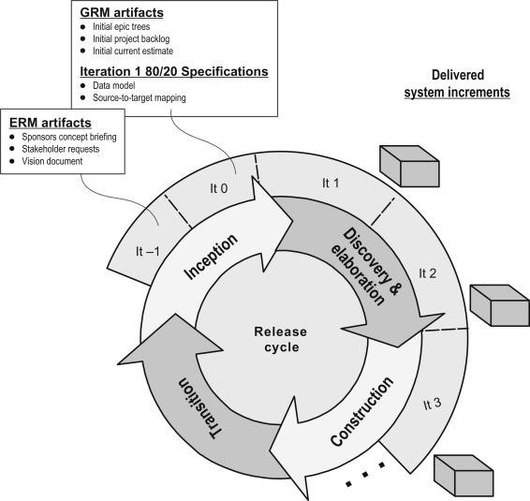

Figure 149: RUP Methodology (TestBytes, 2019)

Click here to view the justification and reason for not selecting this methodology.

**2. Prototype Methodology**

Prototype Model is a software development model in which prototype is built, tested, and reworked until an acceptable prototype is achieved. (Martin, 2021) It also serves as a foundation for the creation of the final system or software. It's best used in situations where the project's requirements aren't fully understood. It is an iterative, trial-and-error process that occurs between the developer and the client.

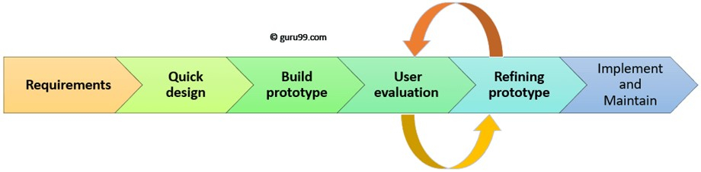

Figure 150: Prototype Methodology (Martin, 2021)

Click here to view the justification and reason for not selecting this methodology.

**3. Incremental Methodology**

In Incremental Methodology, first a simple working system is constructed and supplied to the customer, with only a few basic features. Over many successive iterations successive versions are implemented and delivered to the customer until the desired system is realised. (Mall, 2014) The following diagram shows the incremental development model:

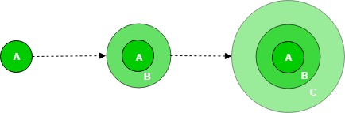

Figure 151: Incremental Methodology (GeeksForGeeks, 2019)

The product is broken down into multiple parts, each of which is designed and constructed independently (termed as builds). When all of the components have been completed, they are delivered to the client. This allows for partial product usage while avoiding a lengthy development process. It also necessitates a significant upfront financial investment, with the long wait time eliminated. This model of development also helps ease the traumatic effect of introducing completely new system all at once.

(Ghahrai, 2016)

Click here to view a brief reason to select this methodology.

### 7.2.2 Selected Methodology

Continued from here.

**Incremental Methodology**

There are various types of software development methodology. Some are designed for large, high-investment projects, while others are designed for smaller ones. While developing a software, the research on a methodology should be done properly and chosen in a very conscious way. I chose the Incremental Model methodology for my project. The incremental model is a software development technique in which the model is defined, implemented, and tested one step at a time until the product is complete. It consists of both development and maintenance. When a product meets all of its specifications, it is said to be done. This model combines the elements of the waterfall model with the iterative philosophy of prototyping. (Ghahrai, 2016)

**Reason to select this methodology over prototype and RUP methodology**

The system is created in prototypes, which are utilized as a model for inspection, feedback collection, and improvement for the next prototype, according to the prototype approach. During the early stages, these prototypes aren't given much attention and are built quickly with the purpose of being discarded. Because this is a tiny project, prototype technique necessitates a high level of client/end-user participation and contact, which is not physically practical. It's tough to create prototypes rapidly, because each module may take different expertise to construct, with some modules reliant on others. The prior prototypes, on the other hand, are discarded and unusable. Making prototypes for each iteration takes a long time.

In RUP Methodology, the development process is way too complex and disorganized. Since this project is to be done alone, it was better to avoid such development project. The team members also are needed to be expert to develop the software. This was not possible in the given scenario. While adding new features, there might only be more confusion and cause lots of issues during the testing phase so I chose incremental methodology over this methodology.

All things considered, we can conclude that increments was the preferable choice based on the approaches discussed above. The incremental method starts early in the development process with a first release of software and gradually enhances it. It's similar to prototyping, except instead of resuming development, it improves on what's already been done. This strategy breaks the project into minor iterations that can be handled as sub-projects and is suitable for developing a web application. Several iterations can be made to improve the web application's functions and features, as well as additions to functions in future iterations with updated versioning. It entails both development and maintenance at the same time. It's perfect since each module or component may be created independently, resulting in a better product at the end of each iteration. It is easier to estimate the project's risk because testing and debugging the program is easier in each iteration. Testing is also done in a separate step for each iteration in this manner.

## 7.3 Appendix C: Pre-Survey

**Survey Link**: <https://forms.gle/kWVfupLMvfYjMeEs5>

**Pre-Survey for Dental Appointment System**

**Project Name**: Dental Appointment System

**Description of Project**: Dental Appointment System is an online appointment system that helps people to save their time by scheduling an appointment for their dental check-up using a web application. This project is all about reducing the problem that people face when they have to get a dental appointment.

### 7.3.1 Pre-Survey Form

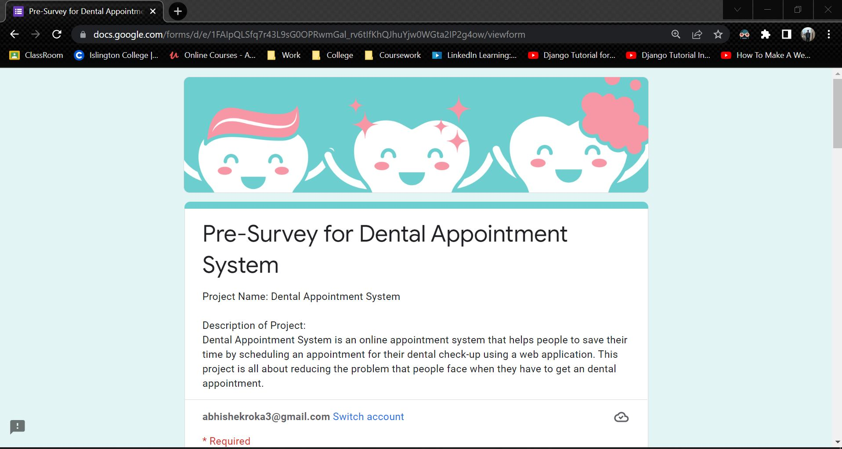

Figure 152: Pre-Survey Form - 1

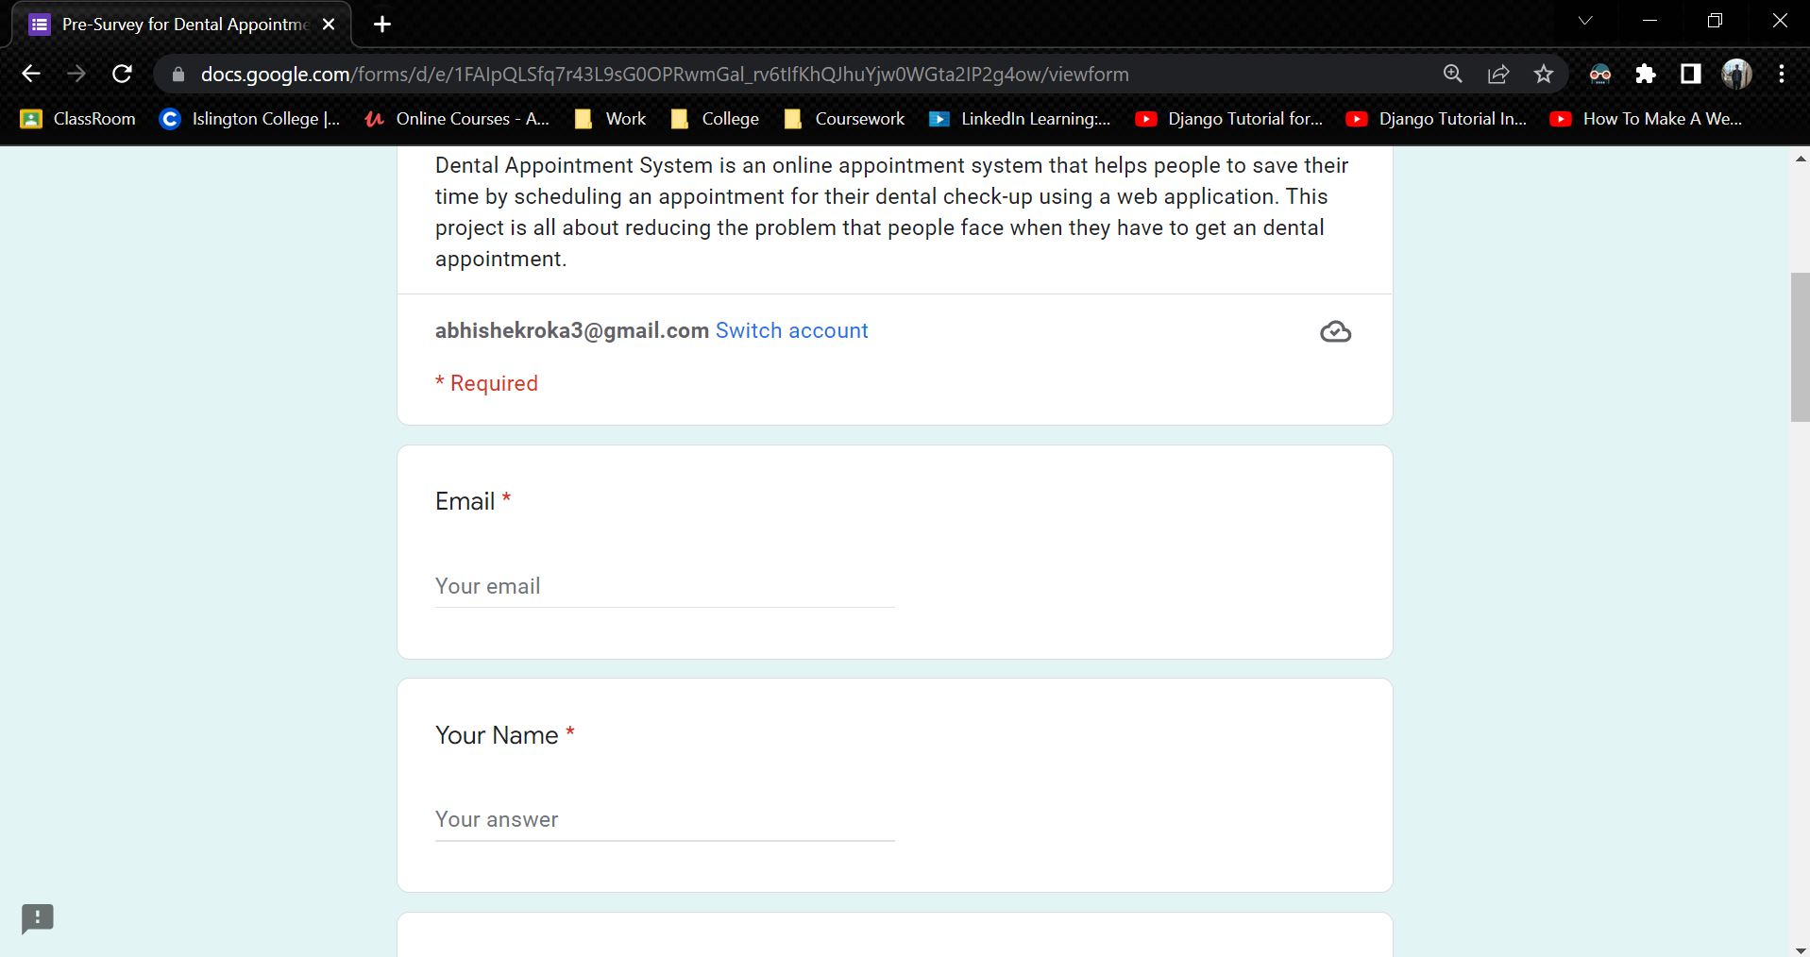

Figure 153: Pre-Survey Form - 2

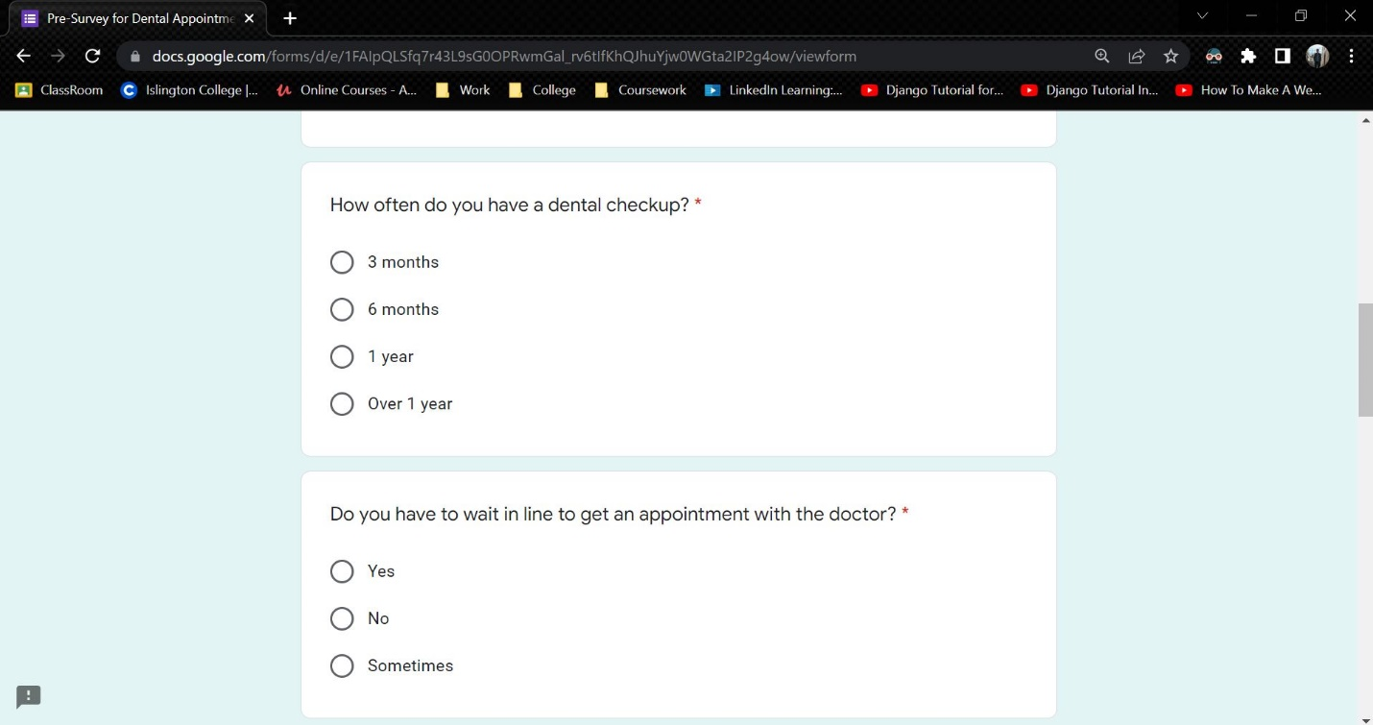

Figure 154: Pre-Survey Form - 3

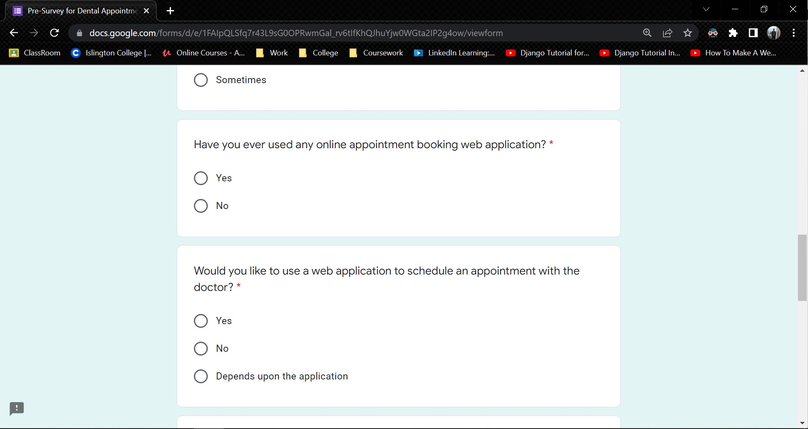

Figure 155: Pre-Survey Form - 4

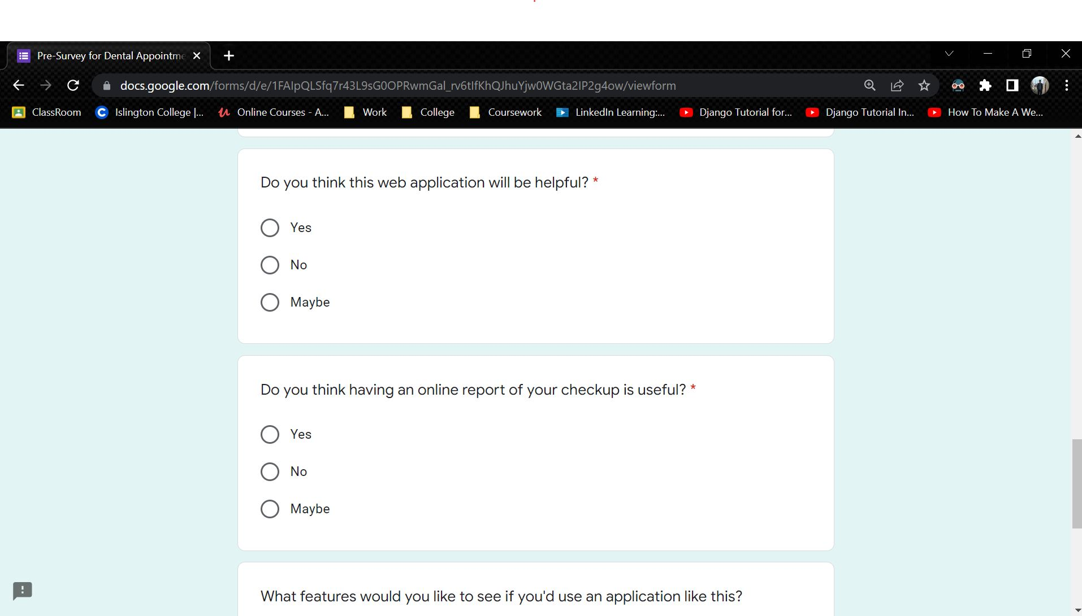

Figure 156: Pre-Survey Form - 5

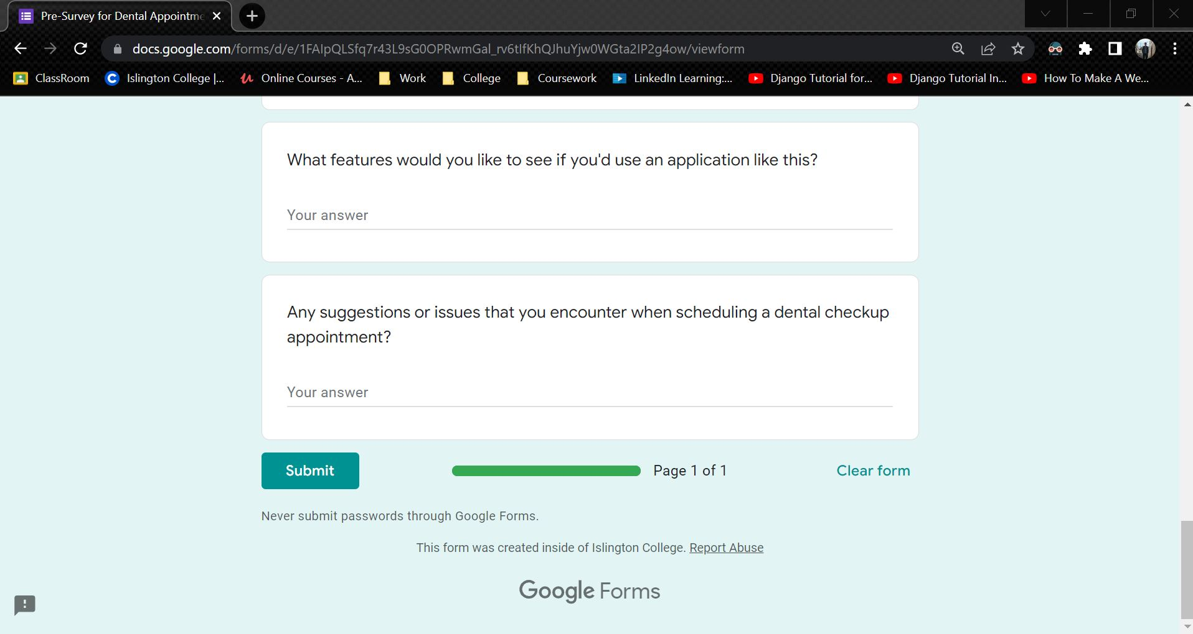

Figure 157: Pre-Survey Form - 6

### 7.3.2 Sample of filled pre-survey forms

**Sample 1**

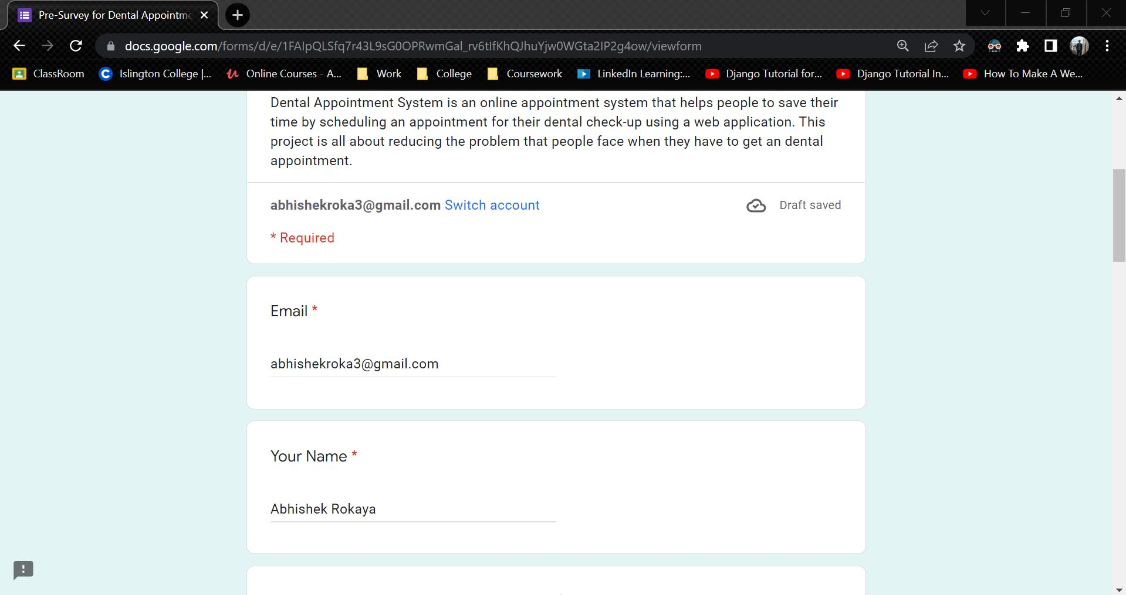

Figure 158: Sample 1 of pre-survey form - 1

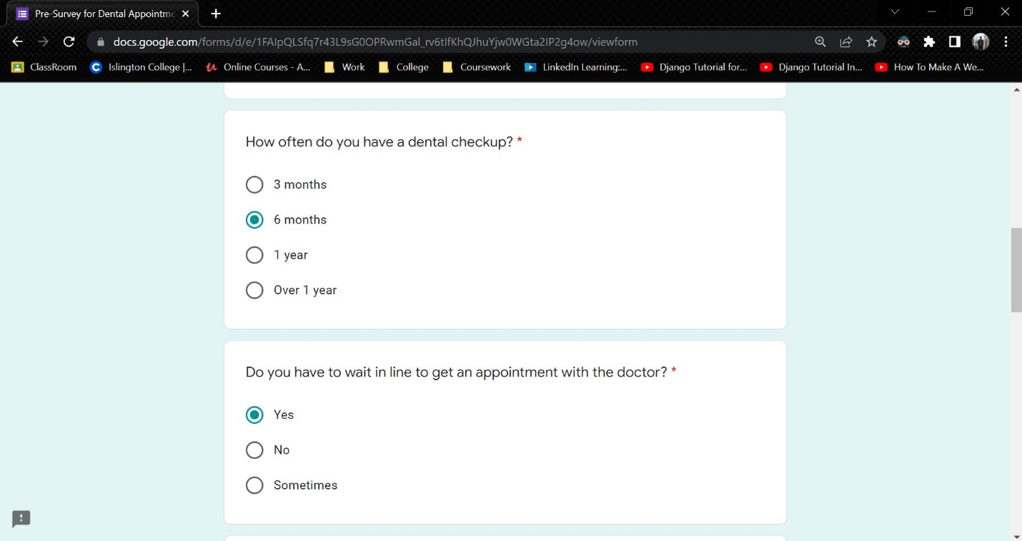

Figure 159: Sample 1 of pre-survey form - 2

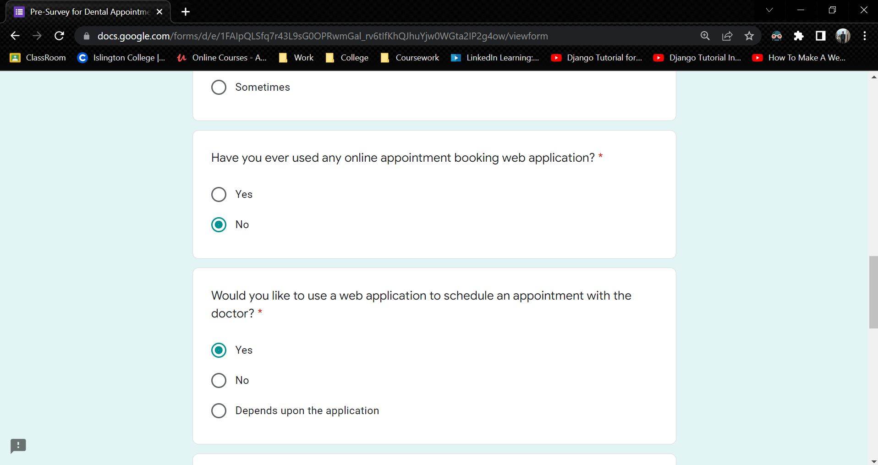

Figure 160: Sample 1 of pre-survey form - 3

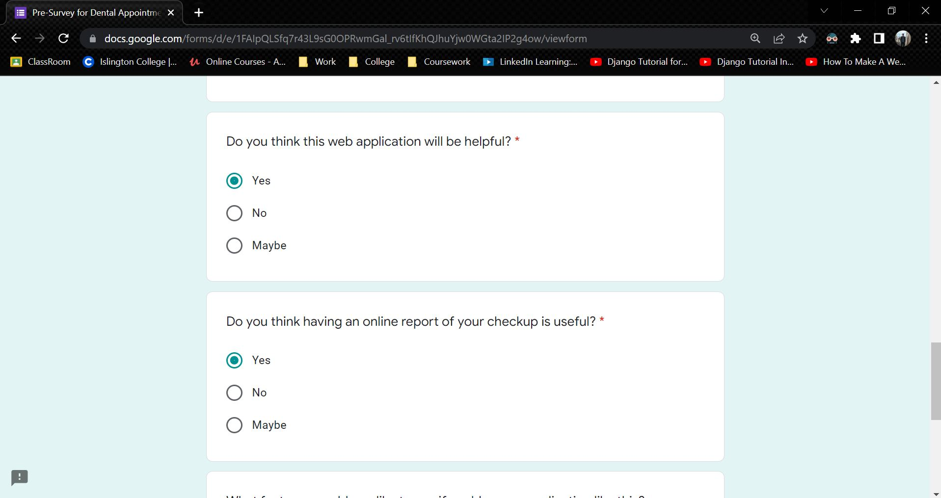

Figure 161: Sample 1 of pre-survey form - 4

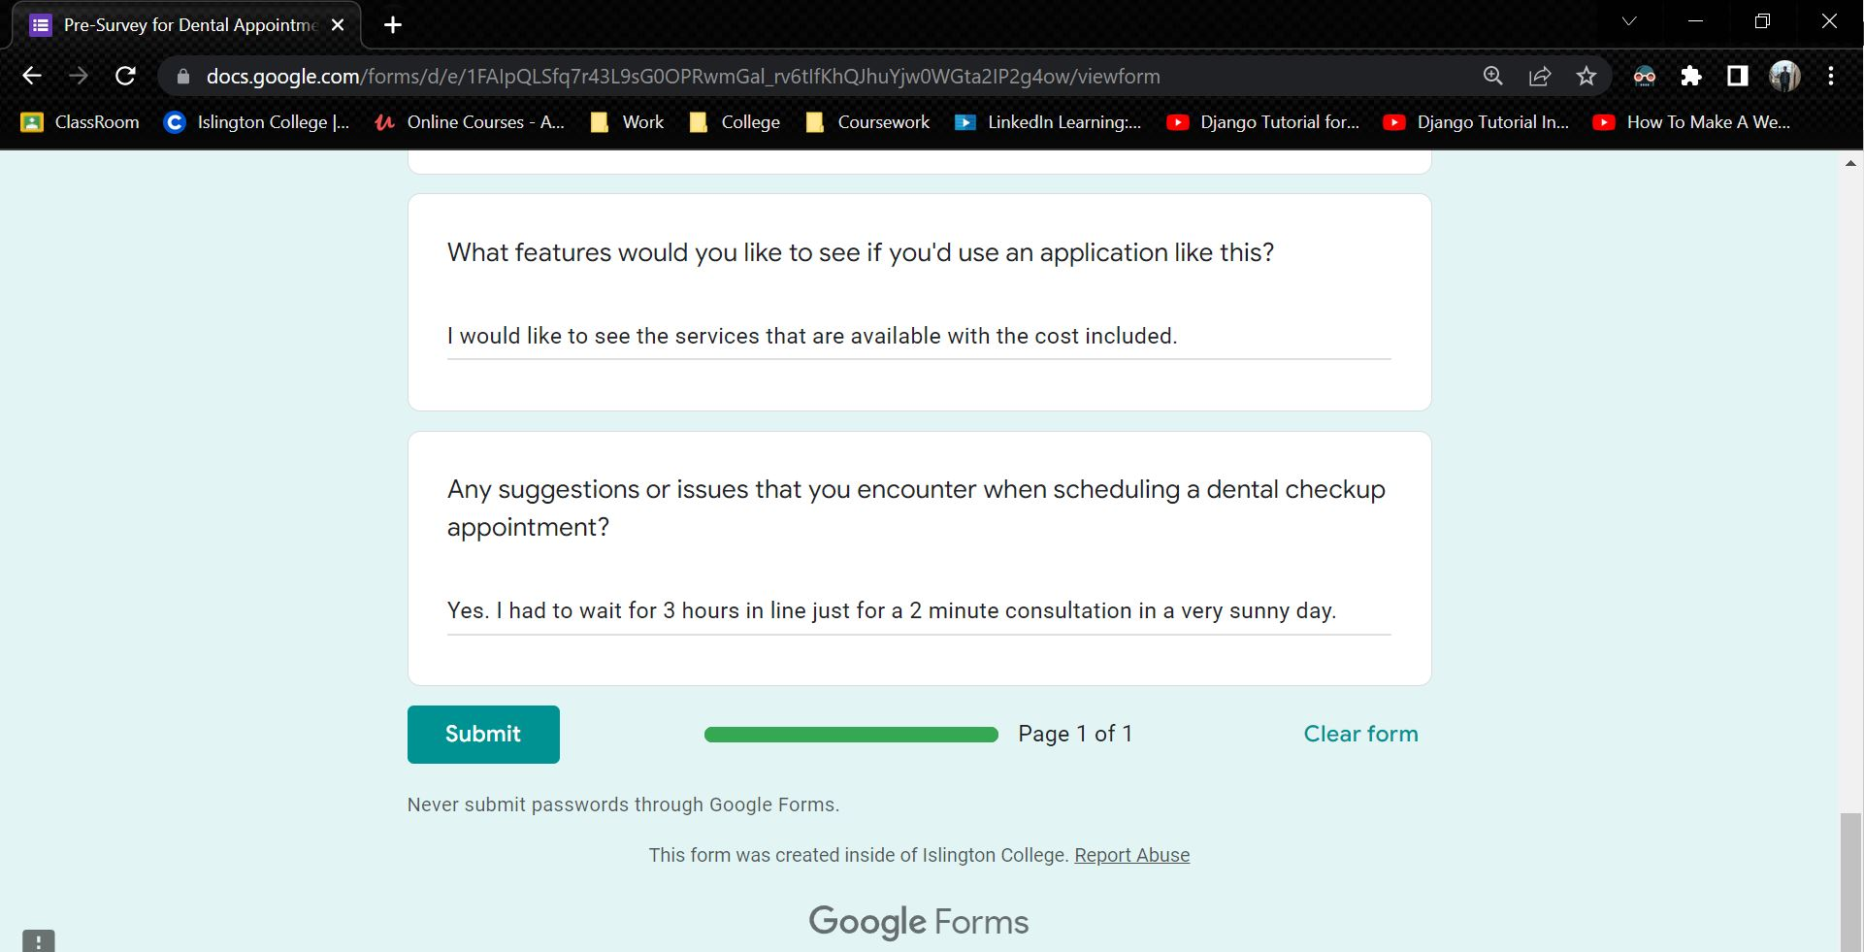

Figure 162: Sample 1 of pre-survey form - 5

**Sample 2**

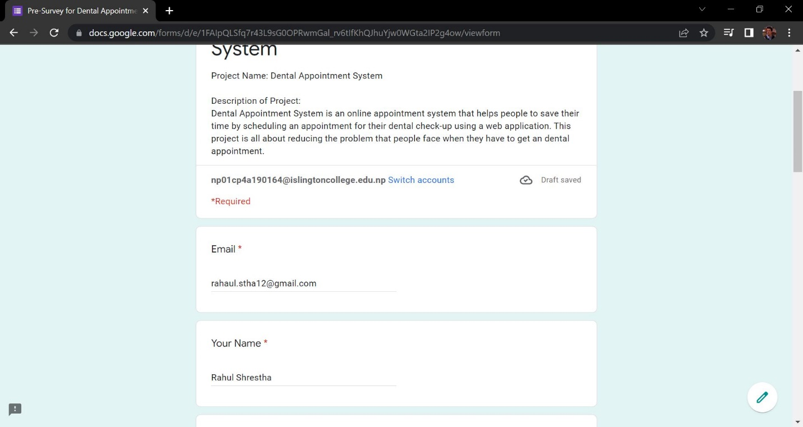

Figure 163: Sample 2 of pre-survey form - 1

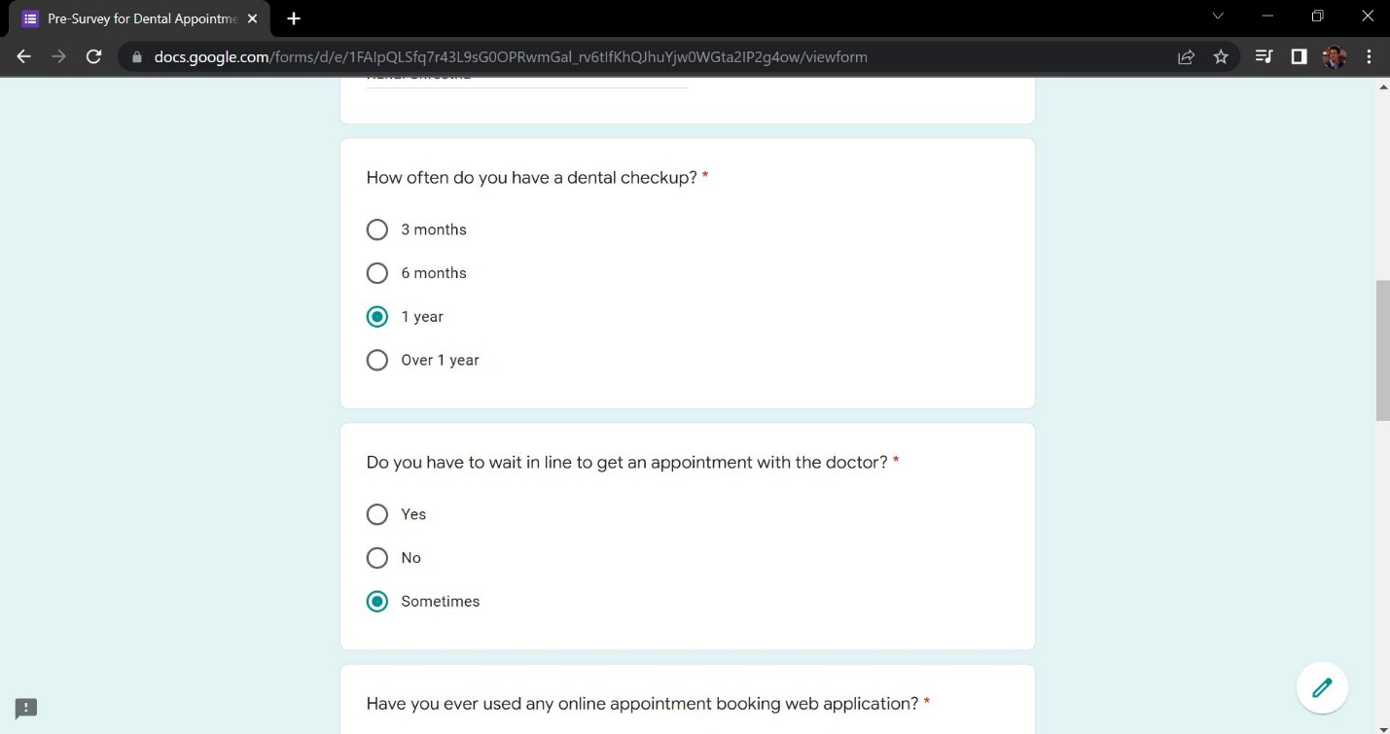

Figure 164: Sample 2 of pre-survey form - 2

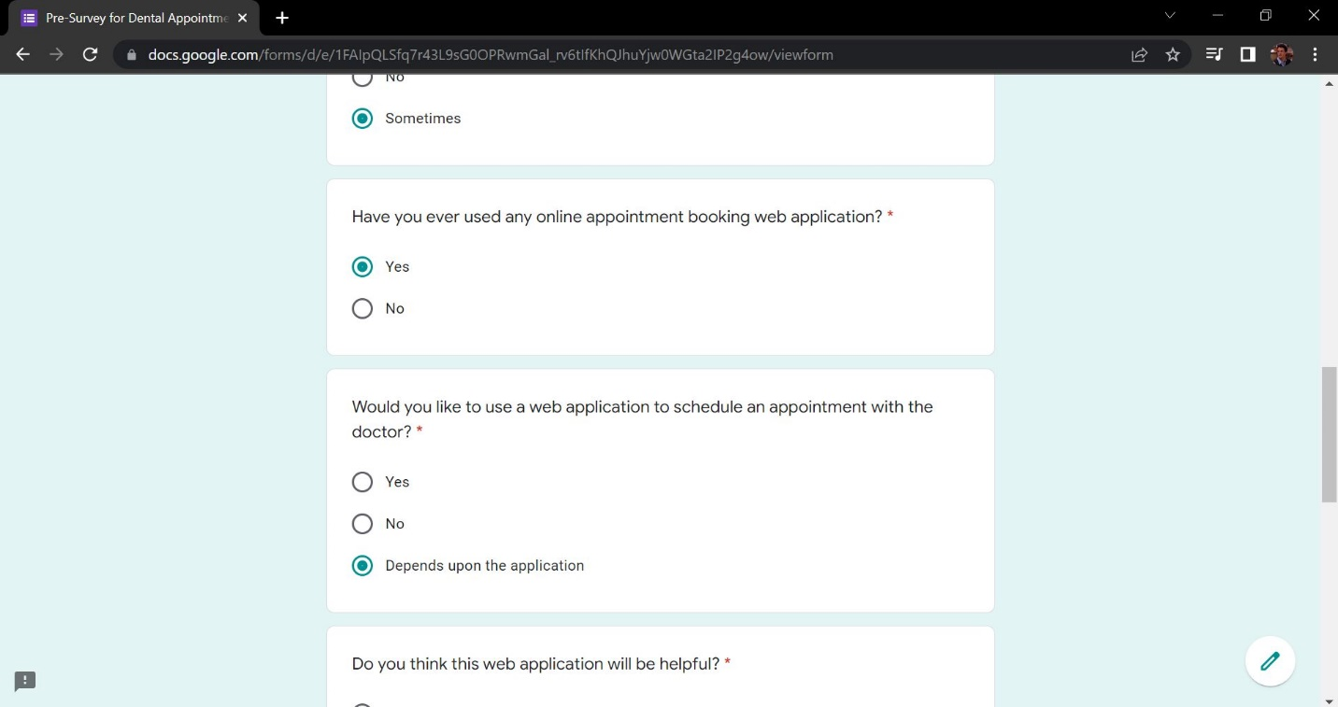

Figure 165: Sample 2 of pre-survey form - 3

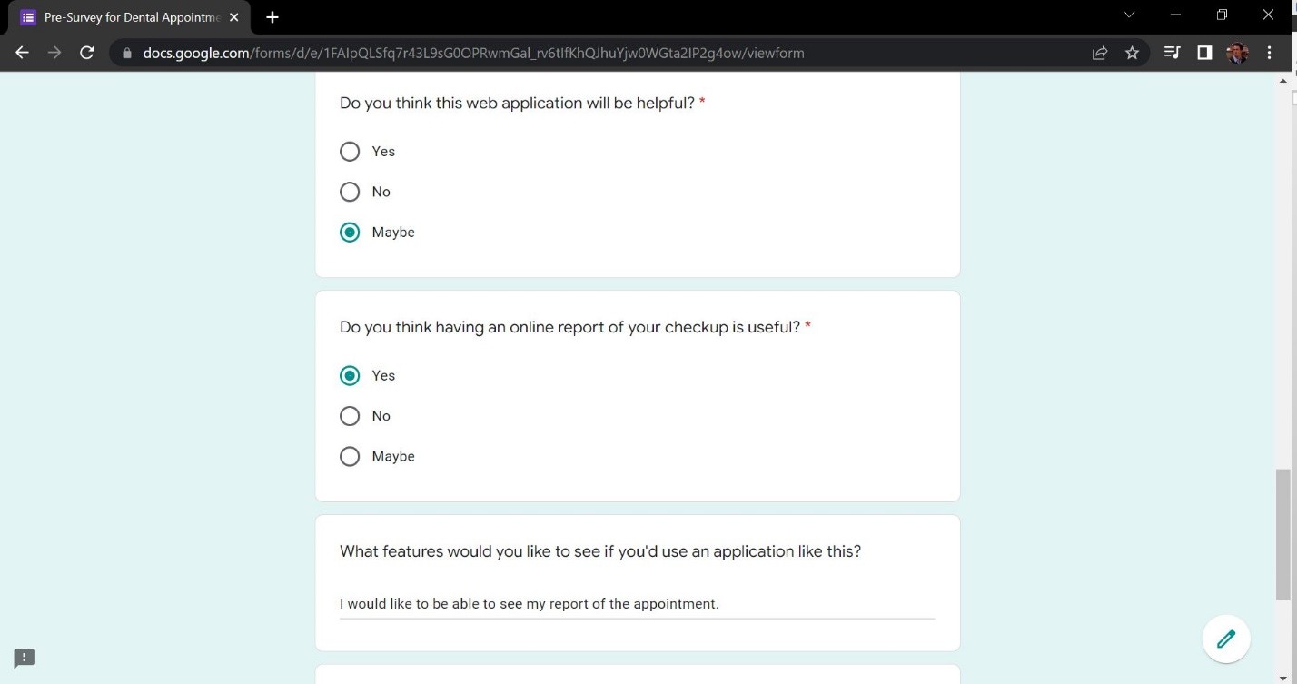

Figure 166: Sample 2 of pre-survey form - 4

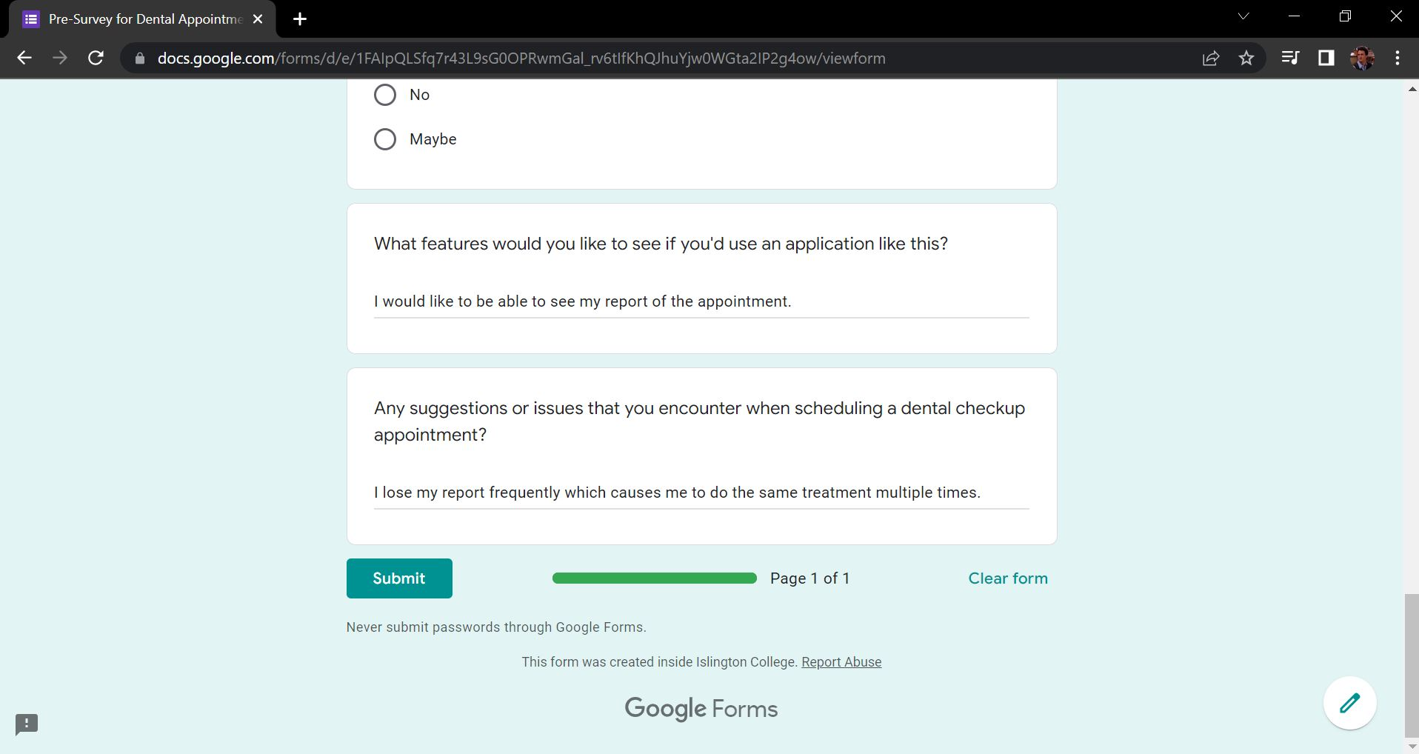

Figure 167: Sample 2 of pre-survey form - 5

**Sample 3**

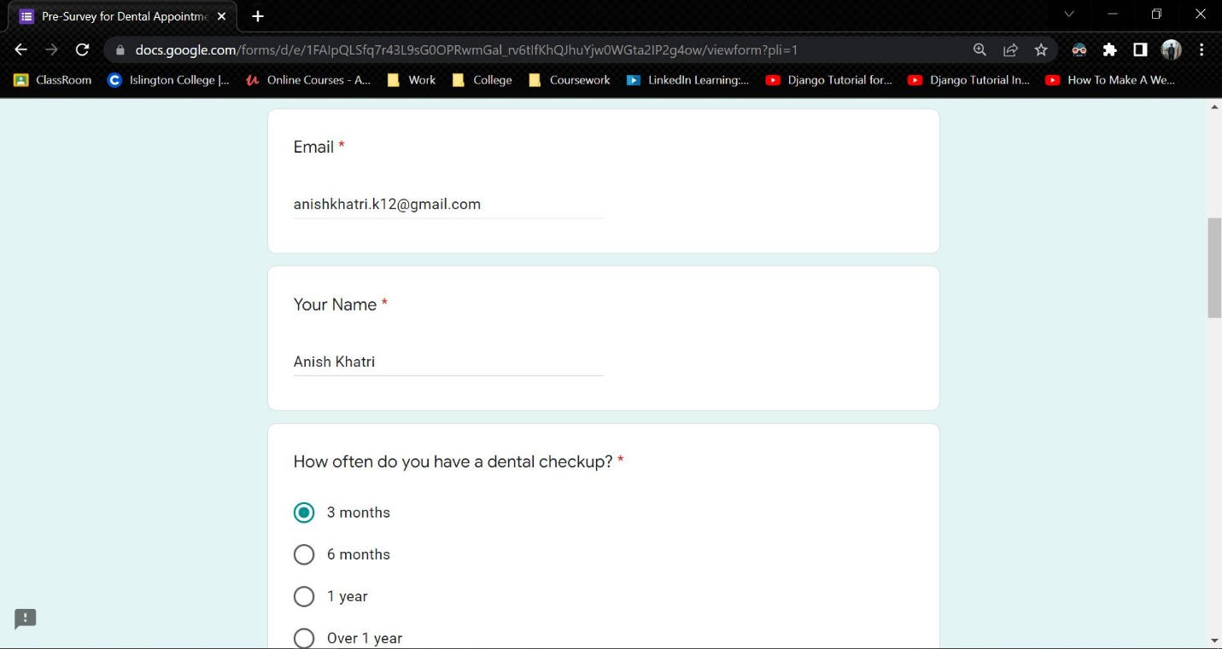

Figure 168: Sample 3 of pre-survey form - 1

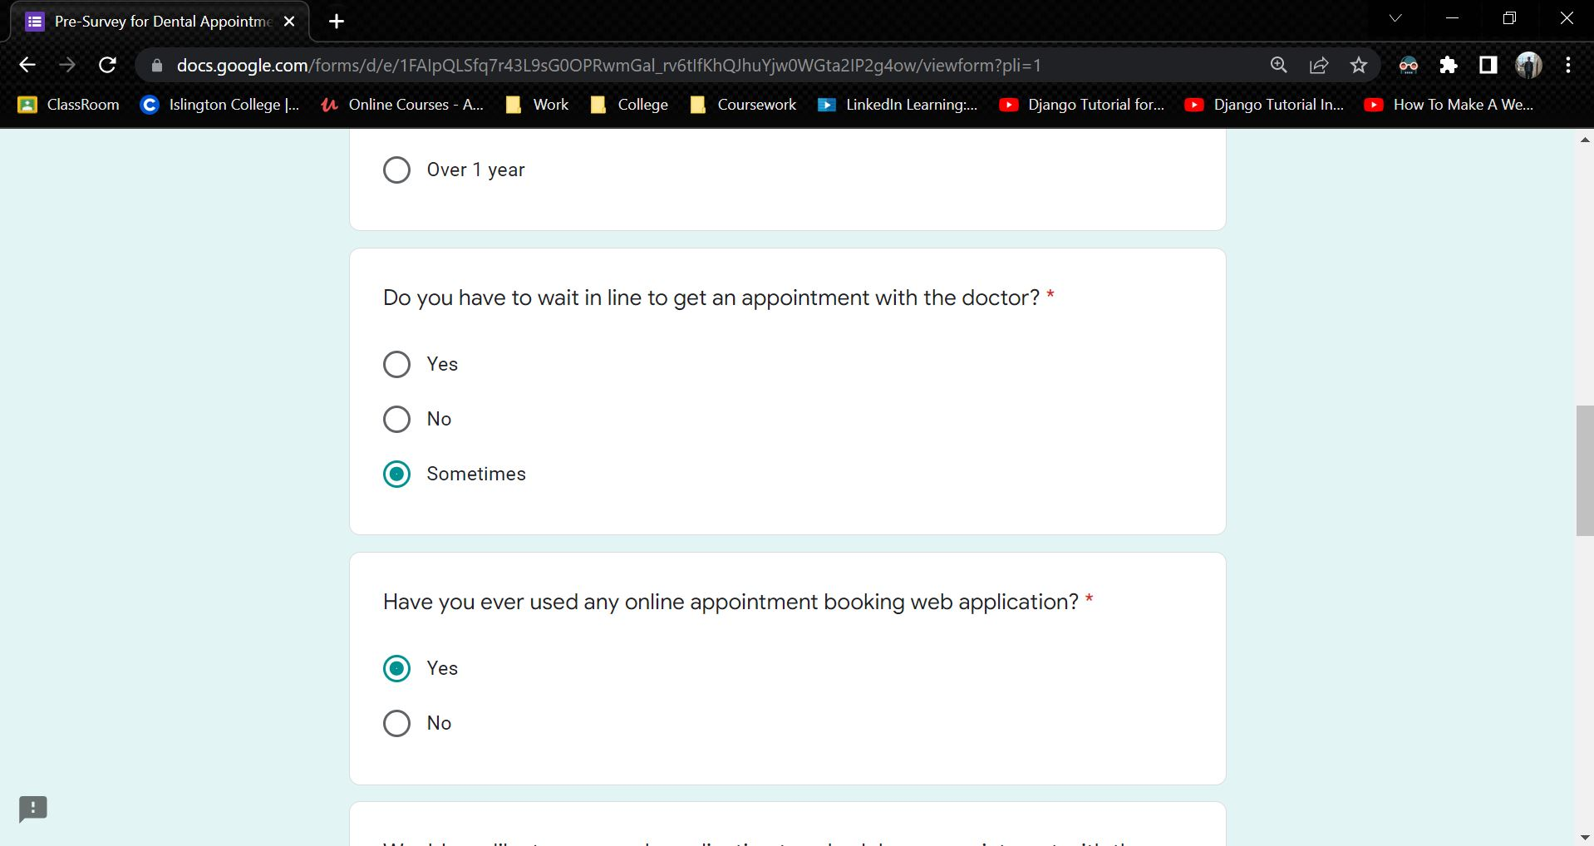

Figure 169: Sample 3 of pre-survey form - 2

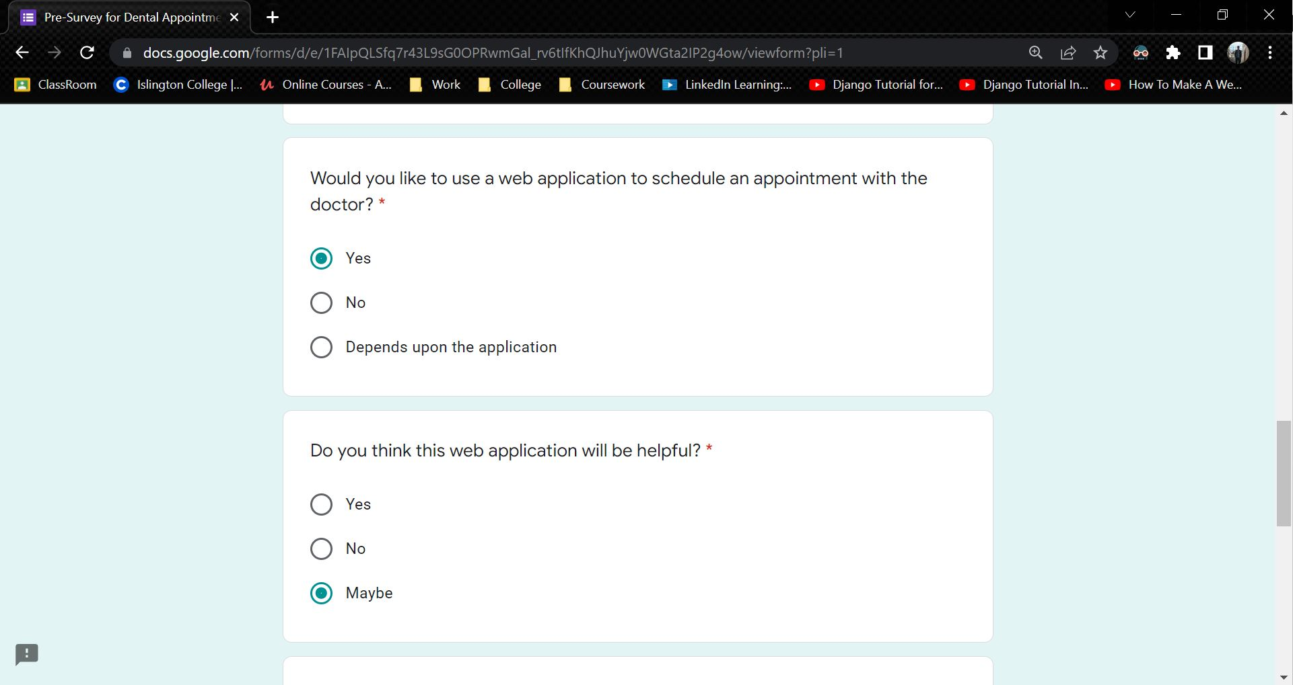

Figure 170: Sample 3 of pre-survey form - 3

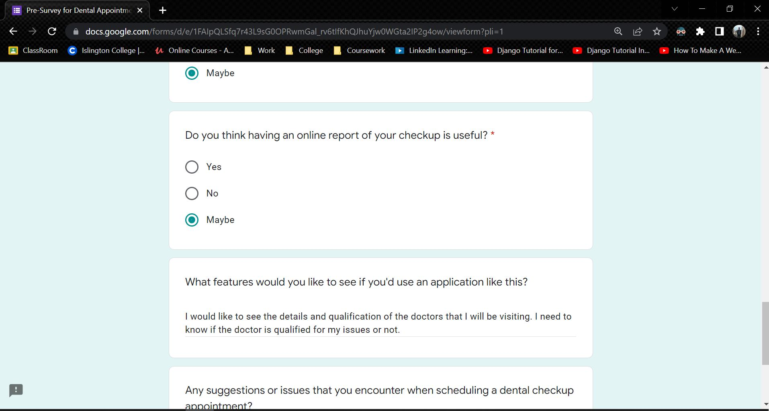

Figure 171: Sample 3 of pre-survey form - 4

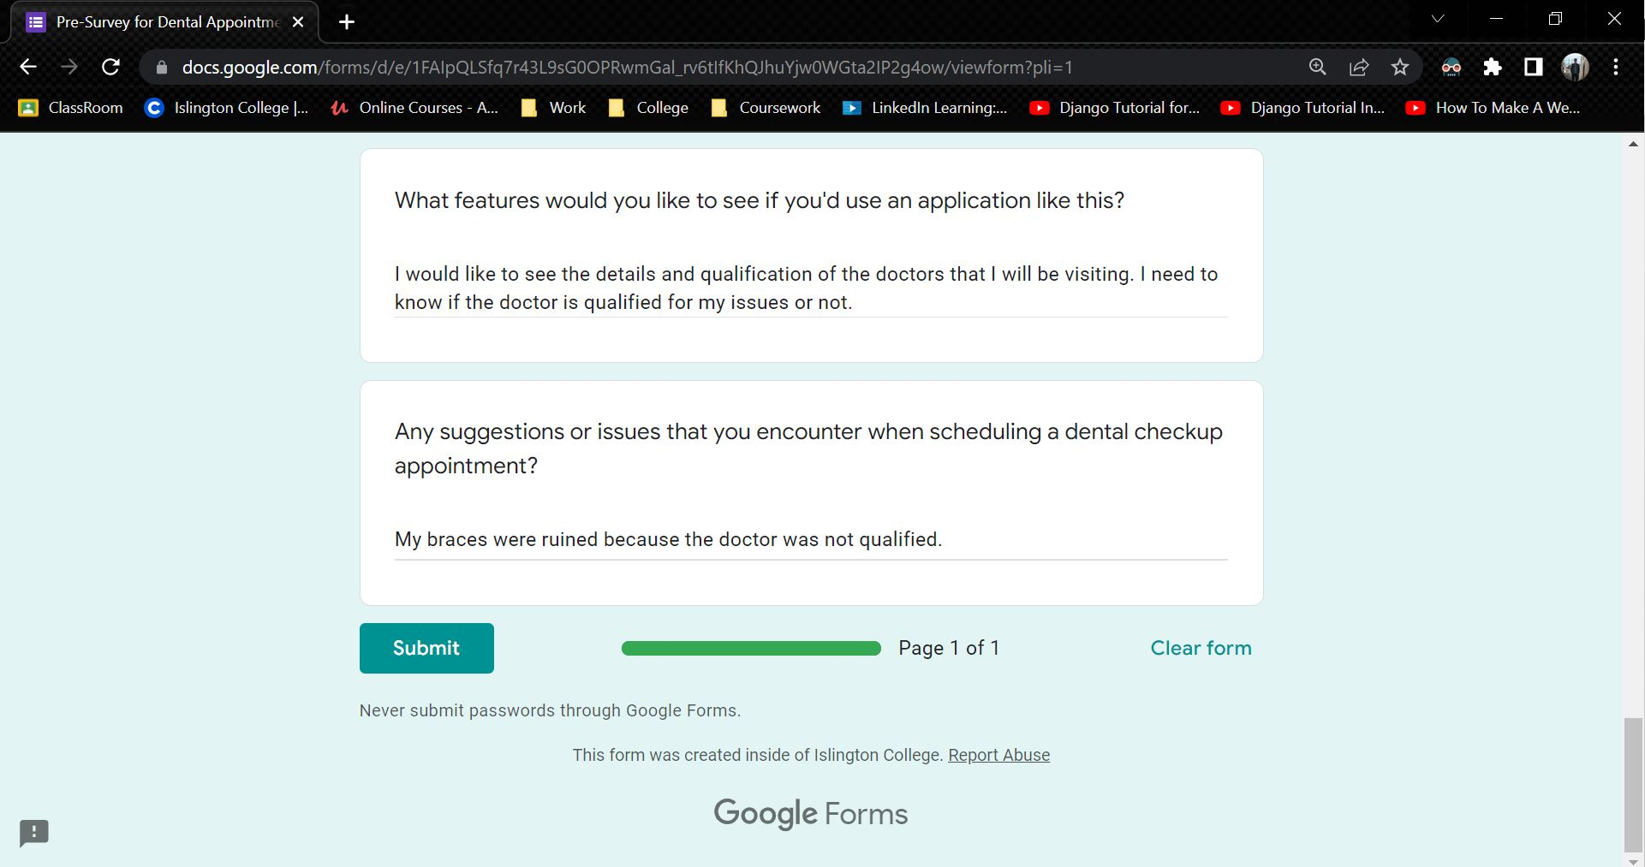

Figure 172: Sample 3 of pre-survey form - 5

### 7.3.3 Pre-Survey Result

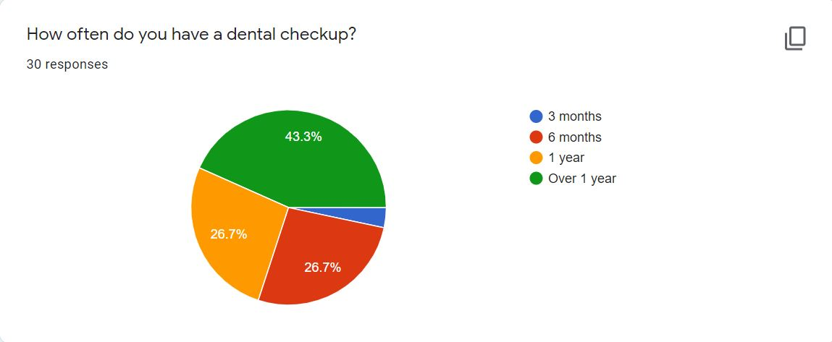

Figure 173: Pre-Survey Result – 1



Figure 174: Pre-Survey Result - 2

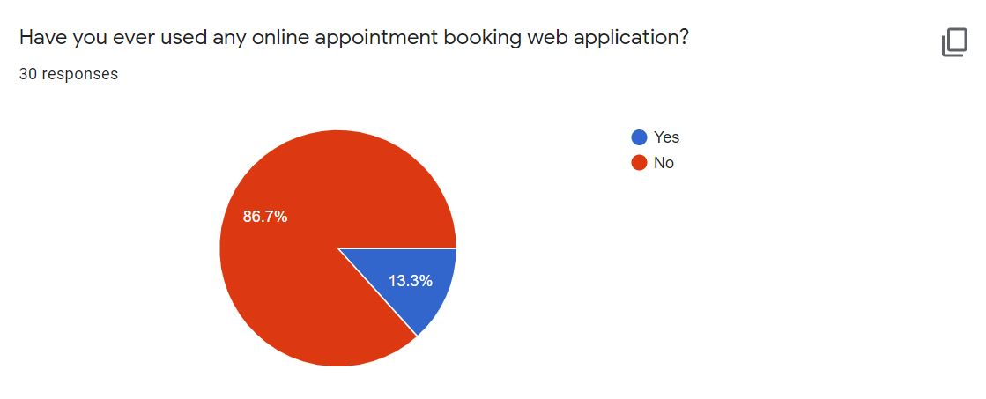

Figure 175: Pre-Survey Result – 3



Figure 176: Pre-Survey Result - 4



Figure 177: Pre-Survey Result - 5

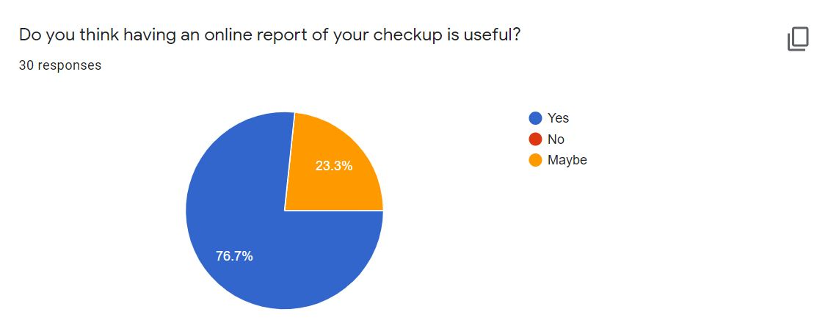

Figure 178: Pre-Survey Result - 6

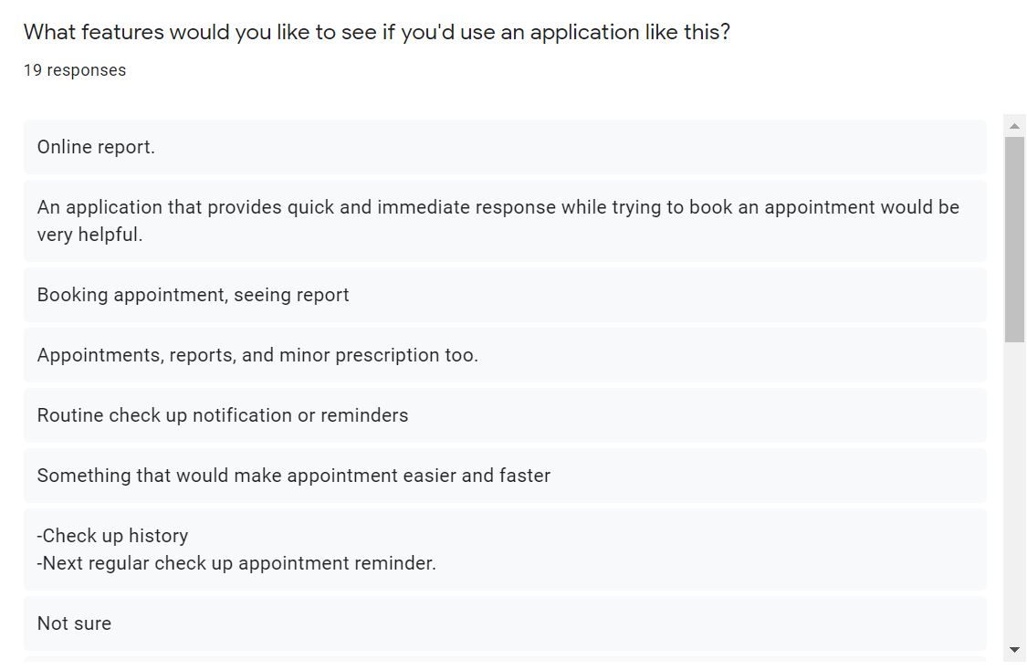

Figure 179: Pre-Survey Result - 7

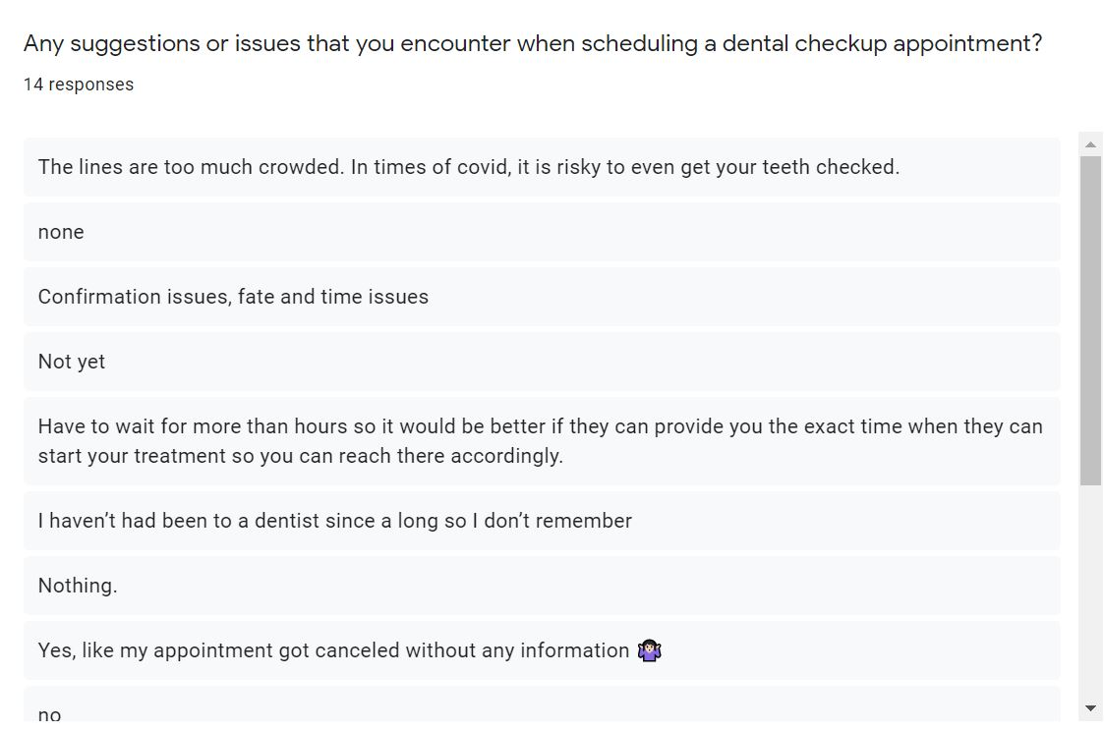

Figure 180: Pre-Survey Result - 8

## 7.4 Appendix D: Post-Survey

**Survey Link**: <https://forms.gle/jkz5EsW85t98Qohf9>

**Post-Survey for Dental Appointment System**

**Project Name**: Dental Appointment System

**Description of Project**: Dental Appointment System is an online appointment system that helps people to save their time by scheduling an appointment for their dental check-up using a web application. This project is all about reducing the problem that people face when they have to get a dental appointment.

### 7.4.1 Post-Survey Form

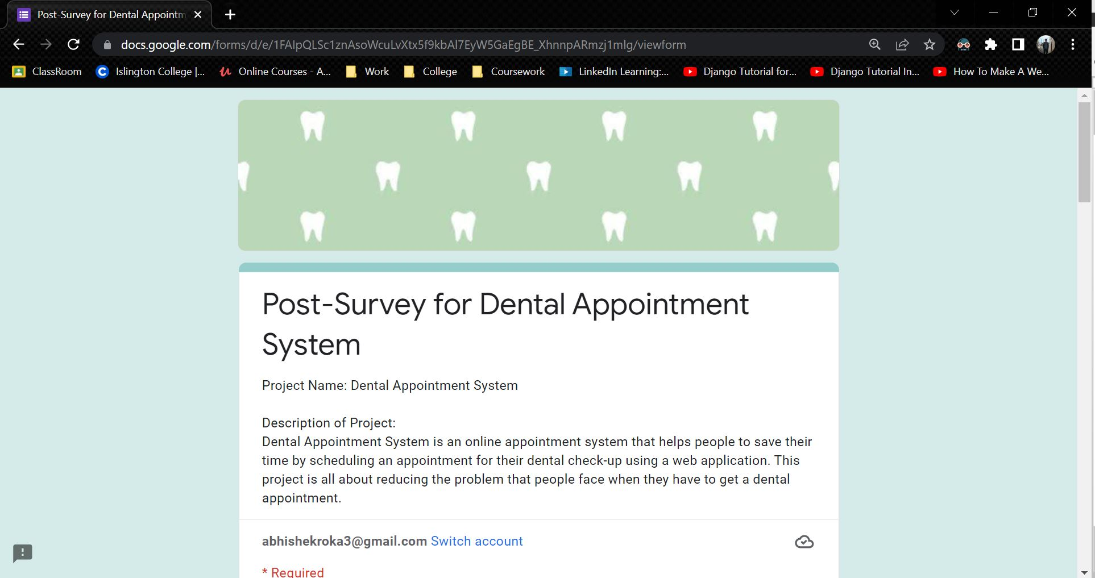

Figure 181: Post-Survey Form - 1

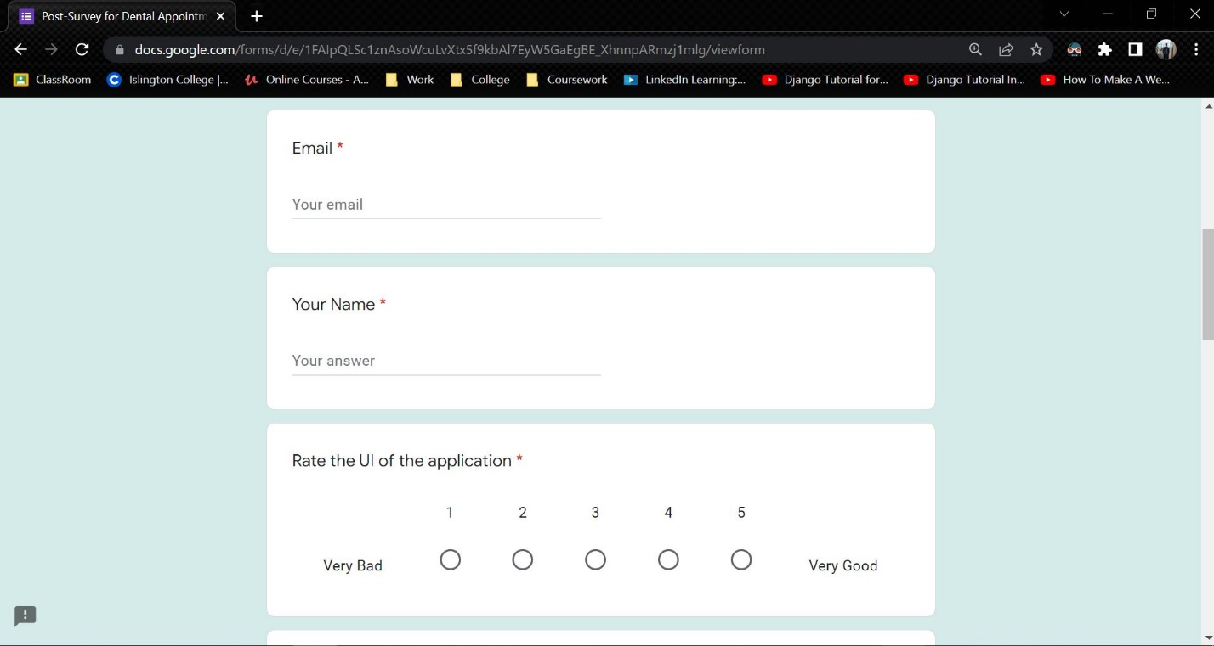

Figure 182: Post-Survey Form - 2

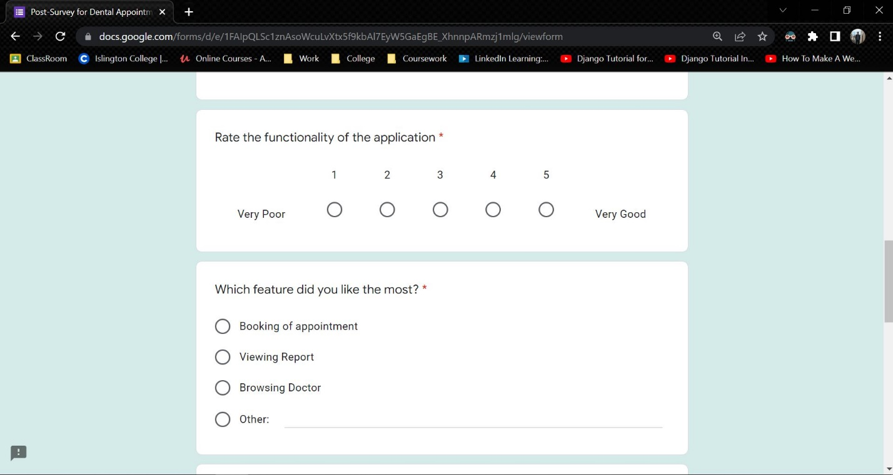

Figure 183: Post-Survey Form - 3

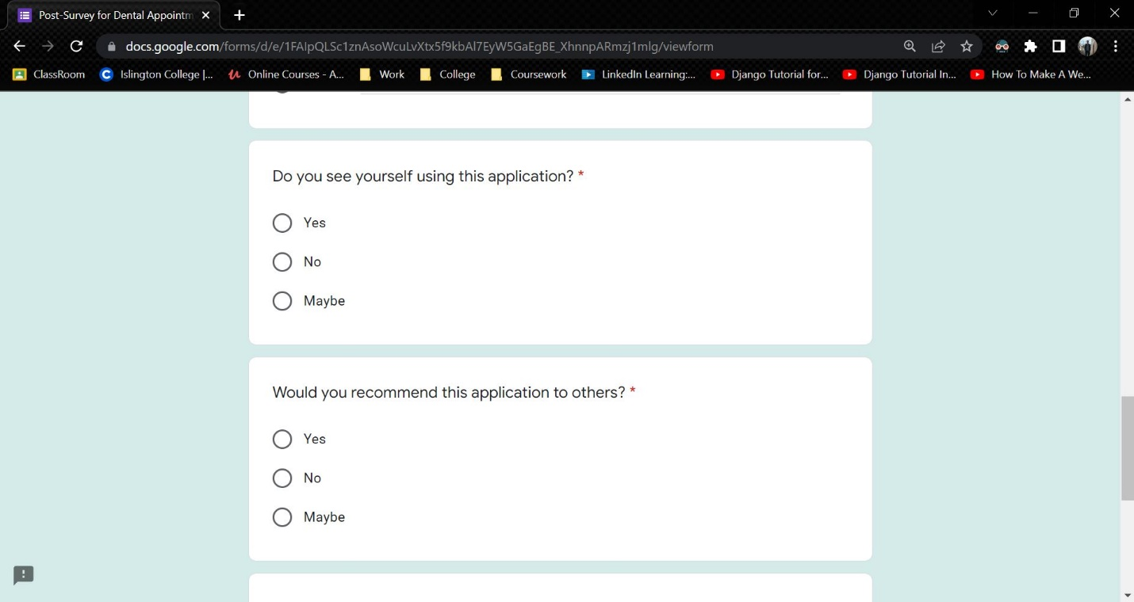

Figure 184: Post-Survey Form - 4

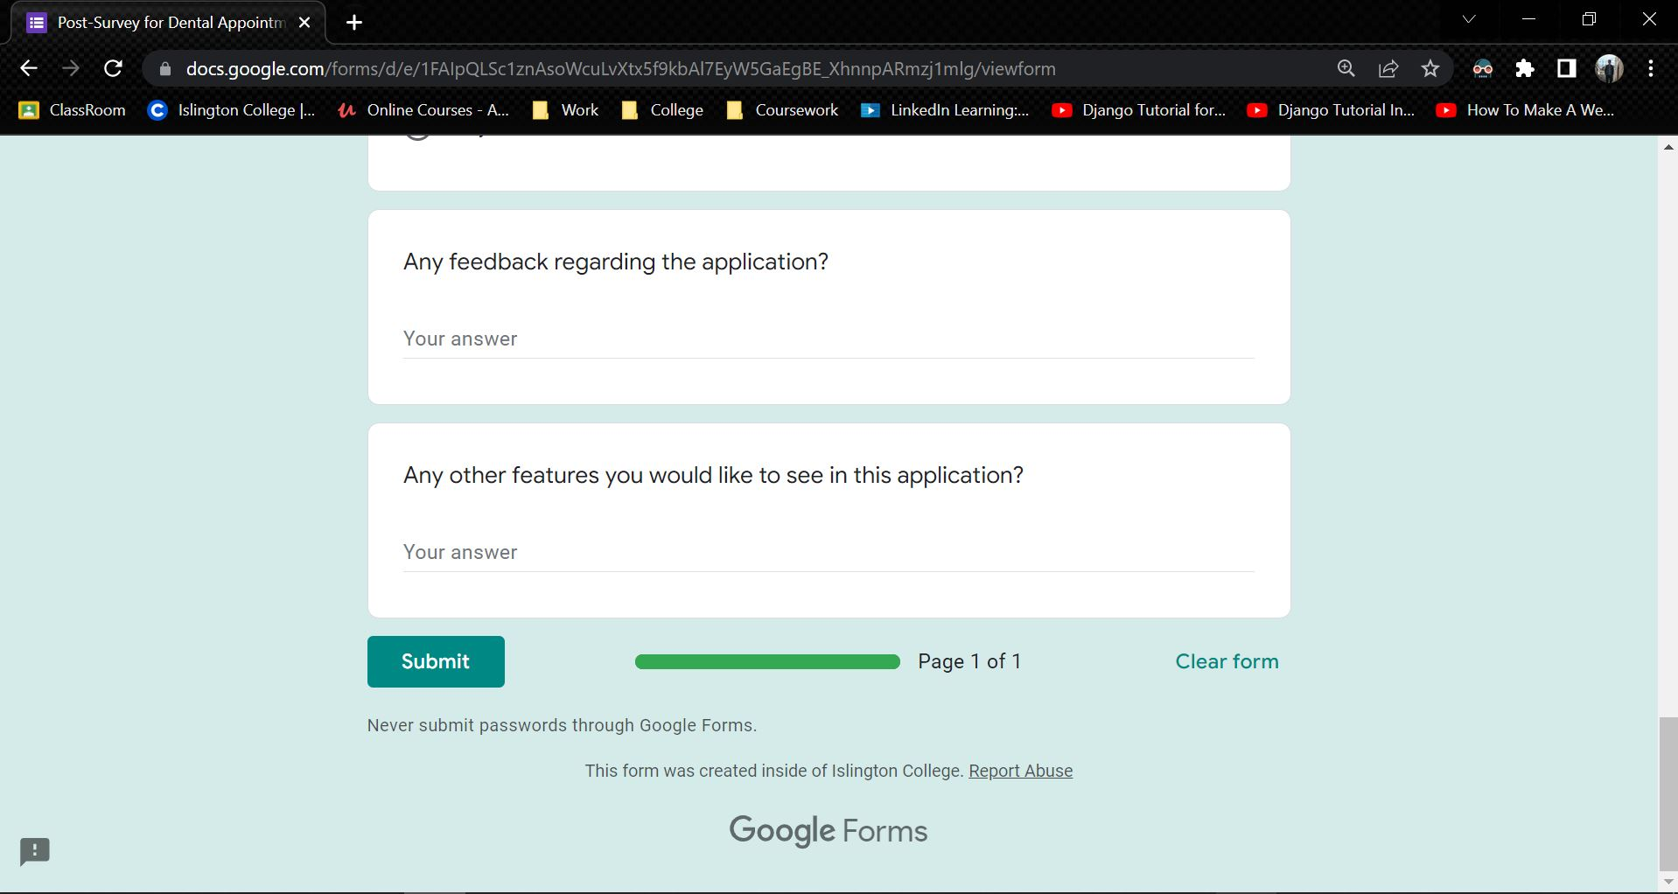

Figure 185: Post-Survey Form - 5

### 7.4.2 Sample of Filled Post-Survey Forms

**Sample 1**

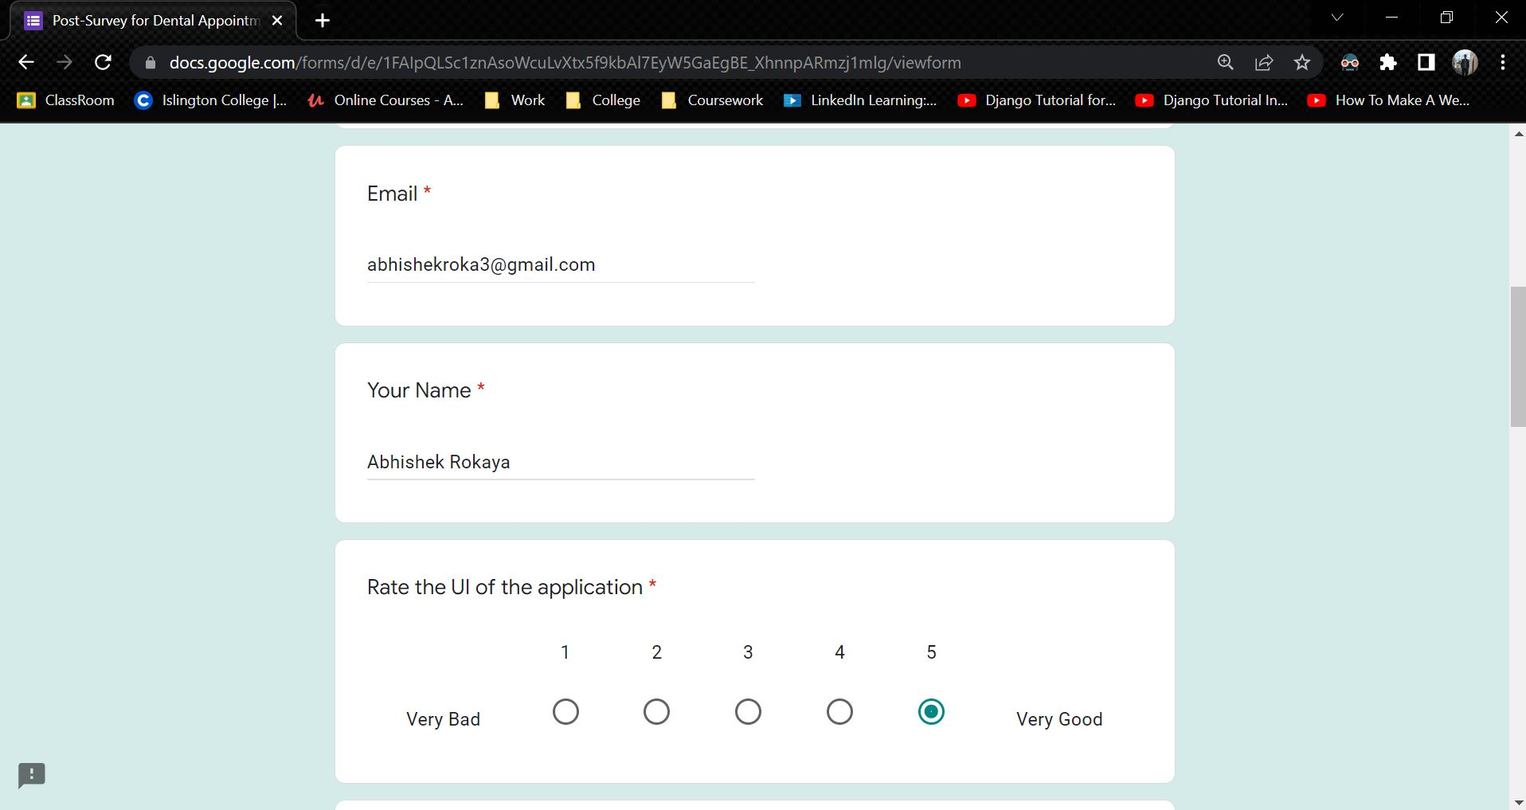

Figure 186: Sample 1 of post-survey form - 1

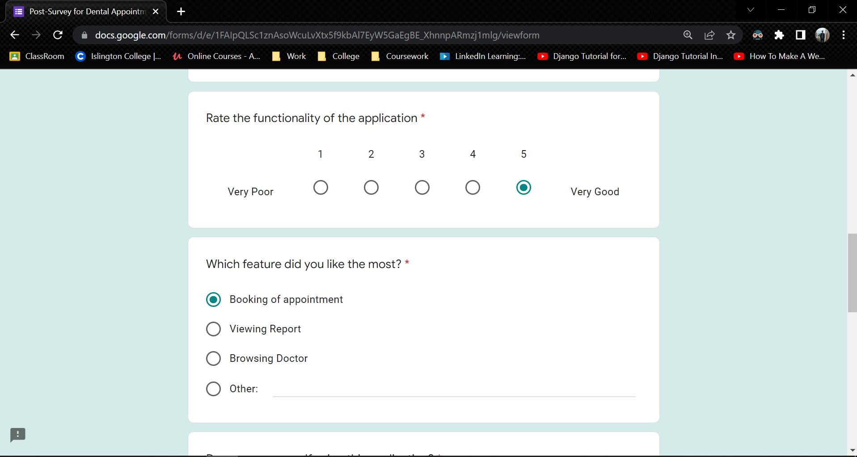

Figure 187: Sample 1 of post-survey form - 2

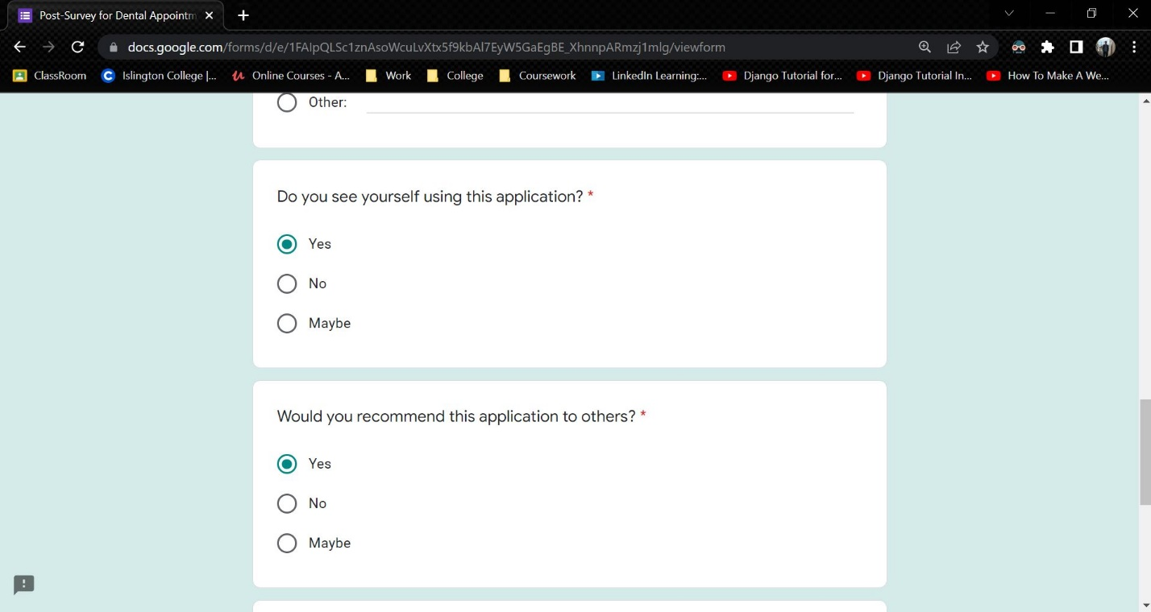

Figure 188: Sample 1 of post-survey form - 3

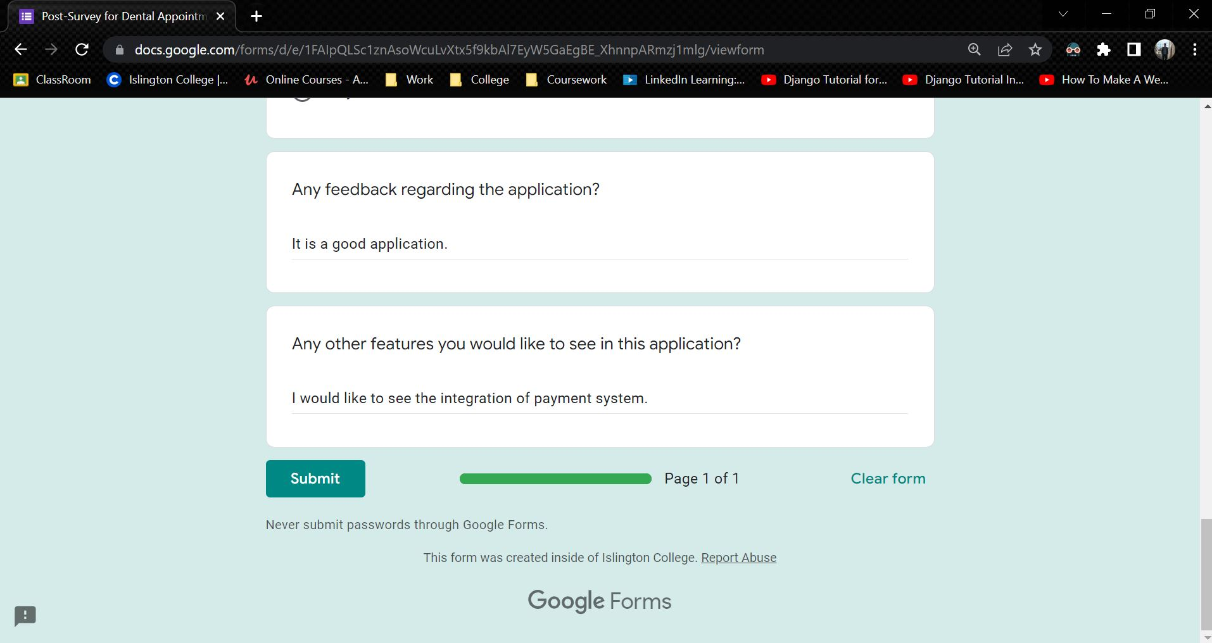

Figure 189: Sample 1 of post-survey form - 4

**Sample 2**

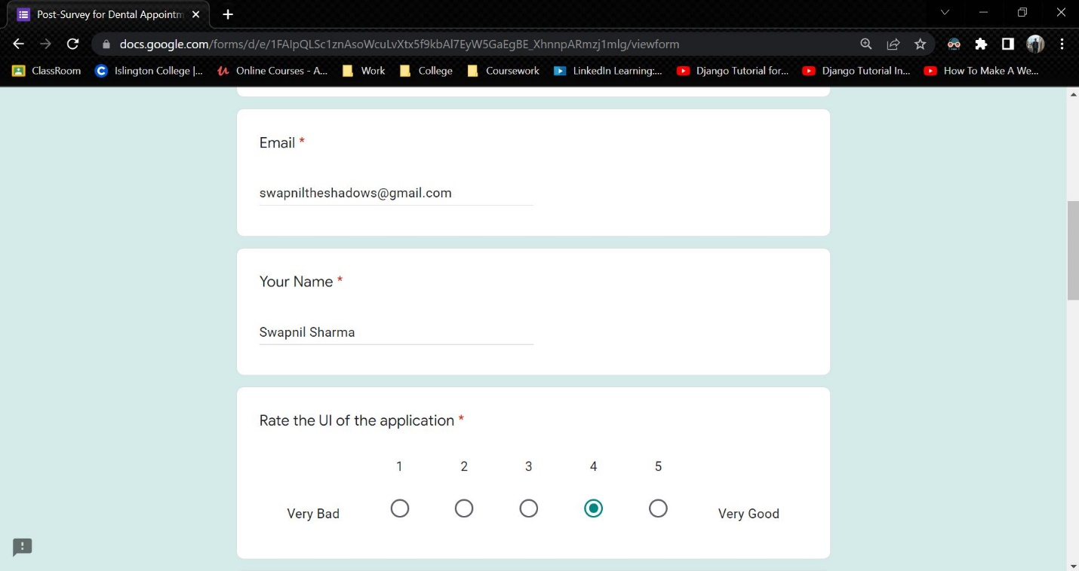

Figure 190: Sample 2 of post-survey form - 1

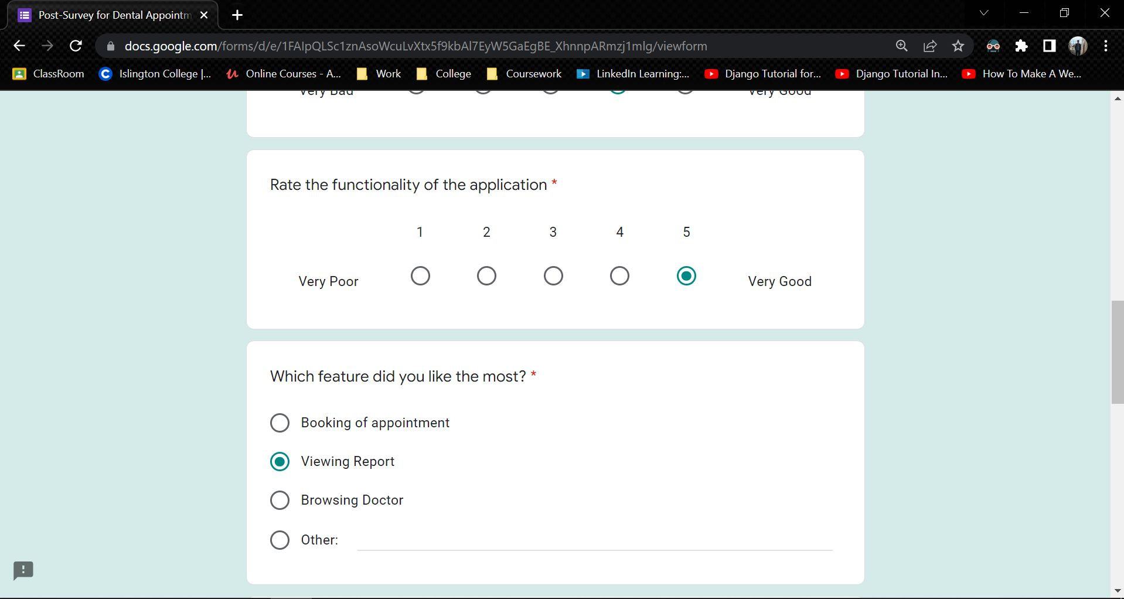

Figure 191: Sample 2 of post-survey form - 2

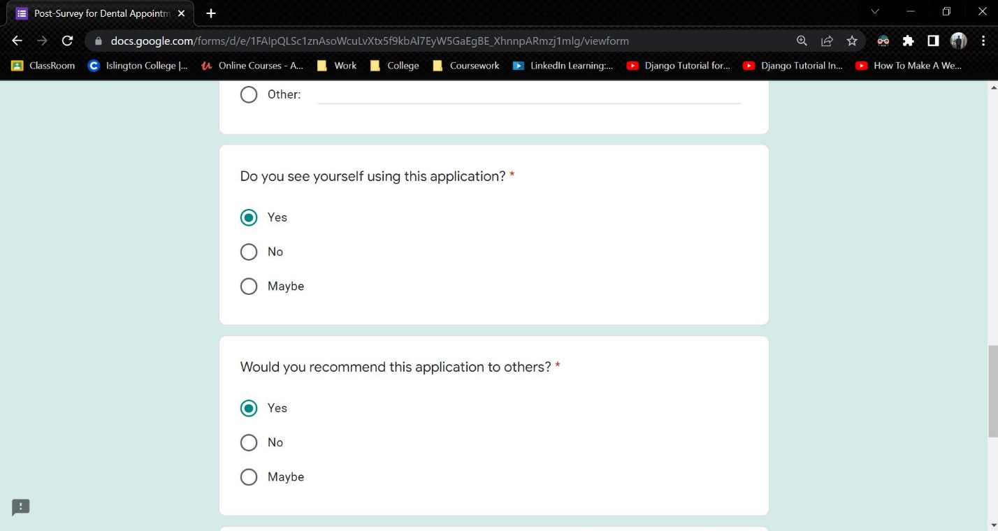

Figure 192: Sample 2 of post-survey form - 3

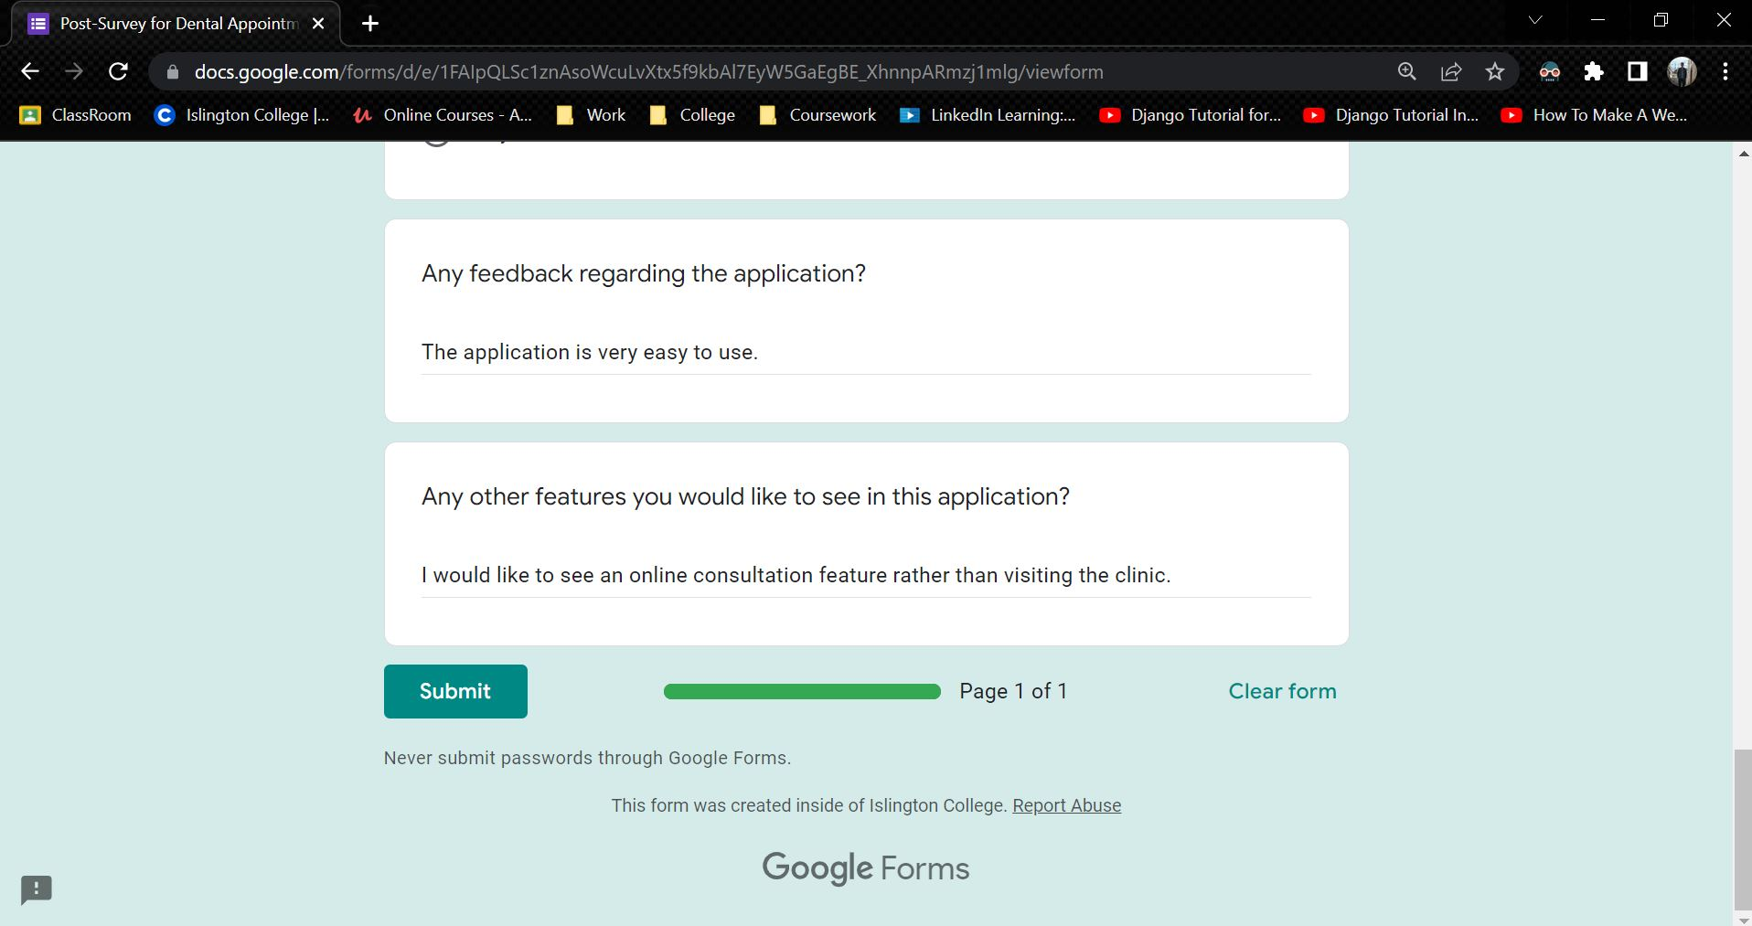

Figure 193: Sample 2 of post-survey form - 4

**Sample 3**

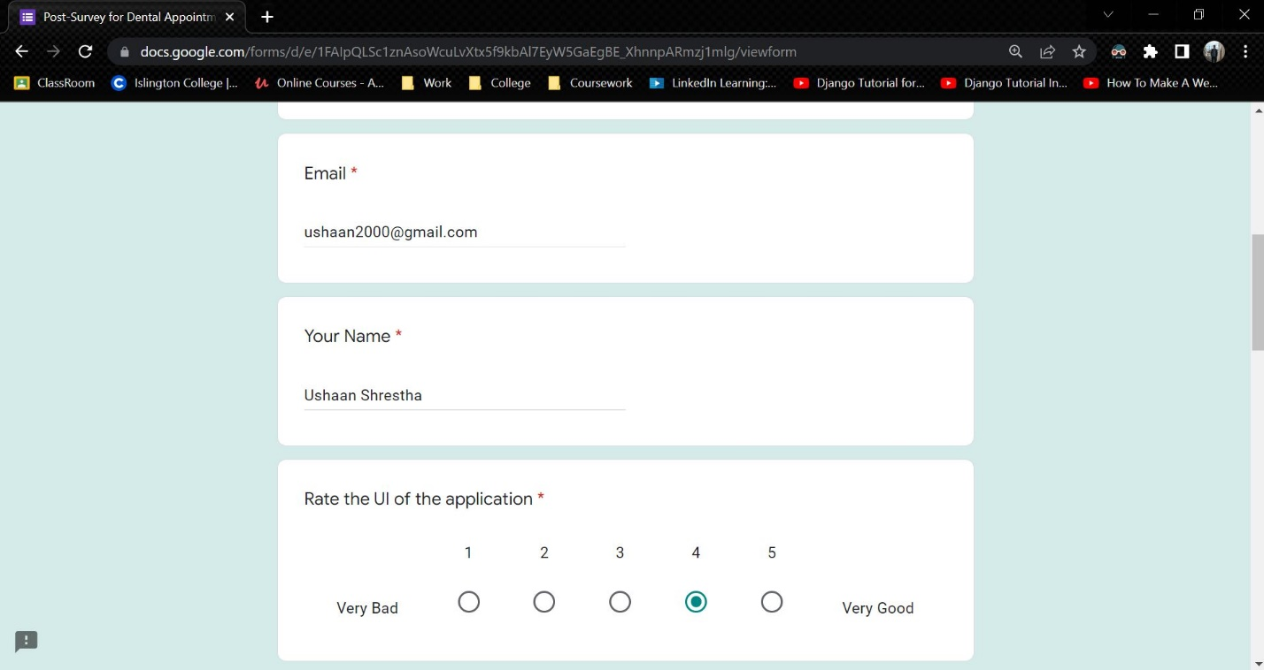

Figure 194: Sample 3 of post-survey form - 1

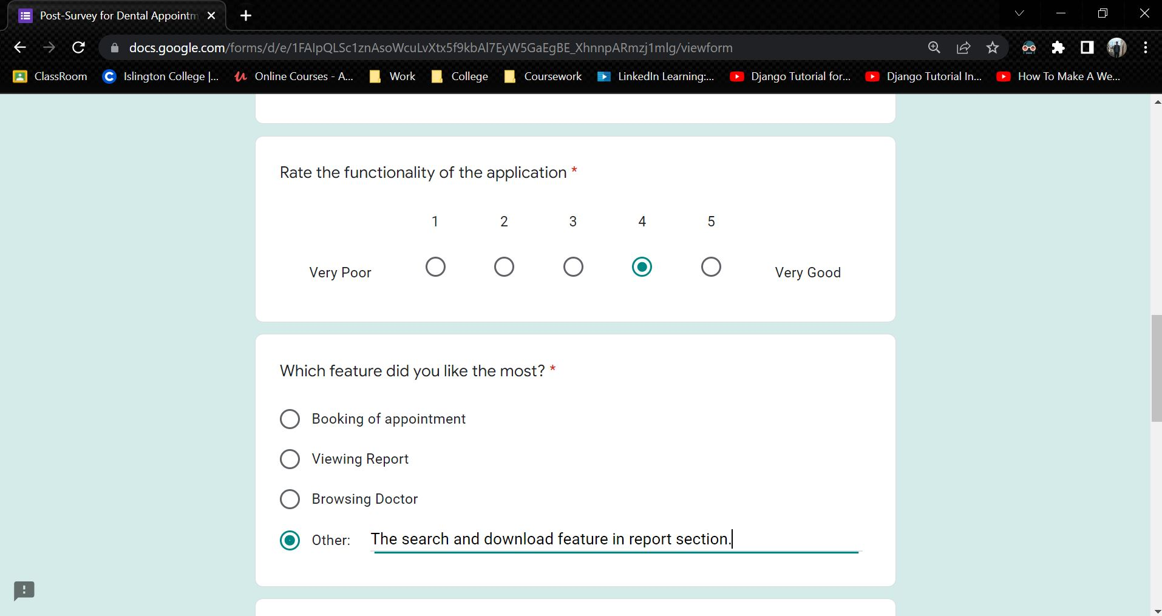

Figure 195: Sample 3 of post-survey form - 2

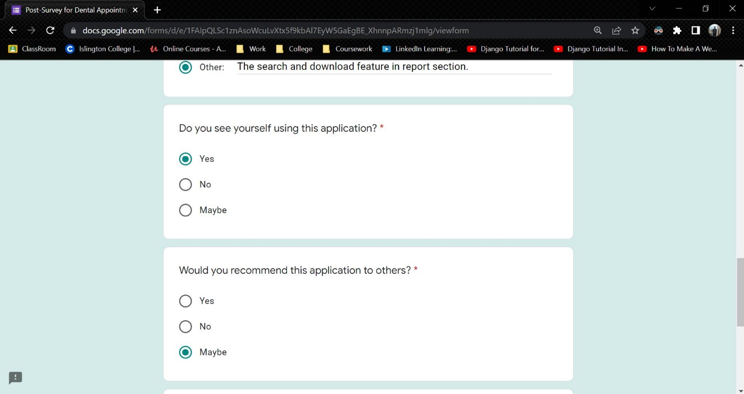

Figure 196: Sample 3 of post-survey form - 3

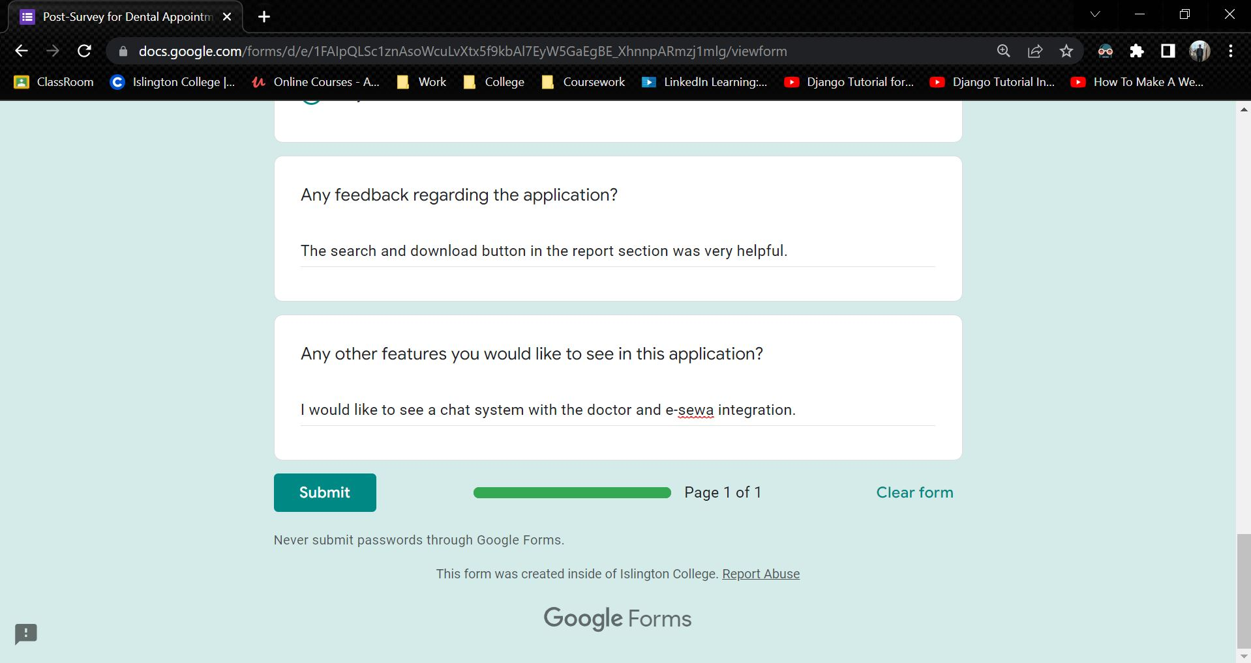

Figure 197: Sample 3 of post-survey form - 4

### 7.4.3 Post-Survey Result

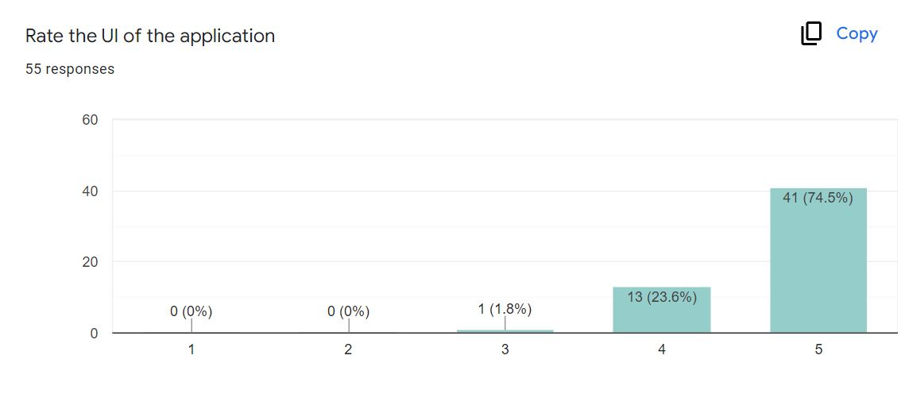

Figure 198: Post-Survey Result – 1

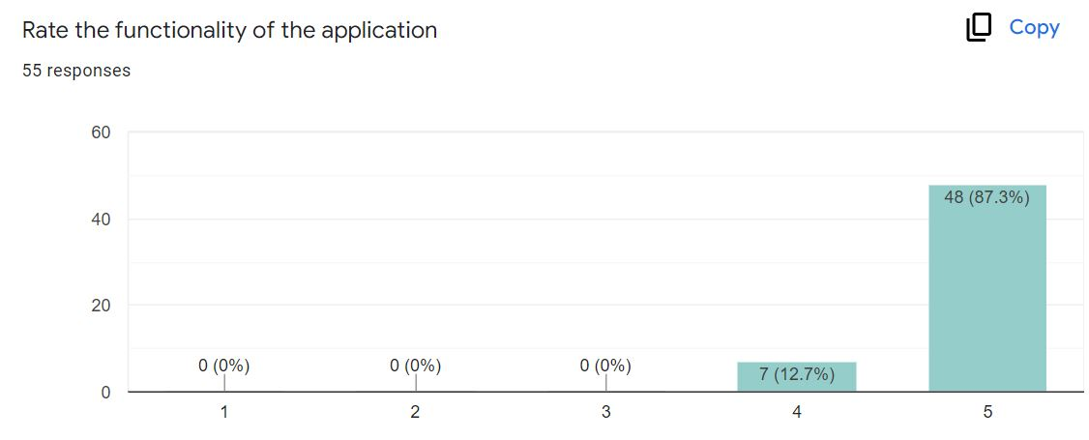

Figure 199: Post-Survey Result - 2

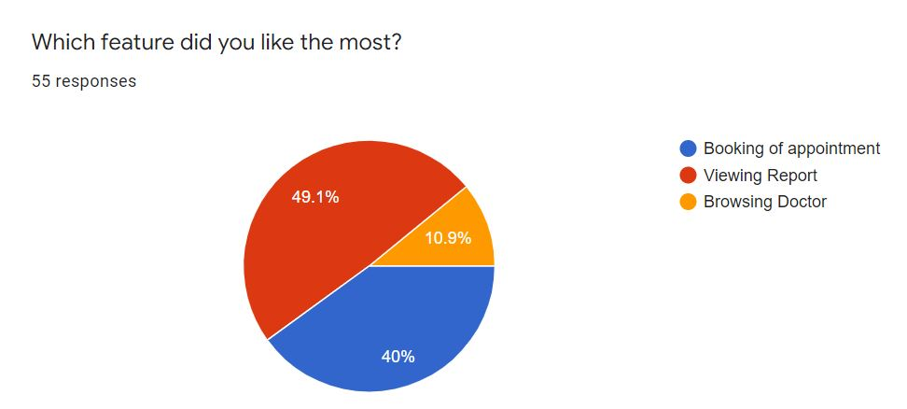

Figure 200: Post-Survey Result - 3

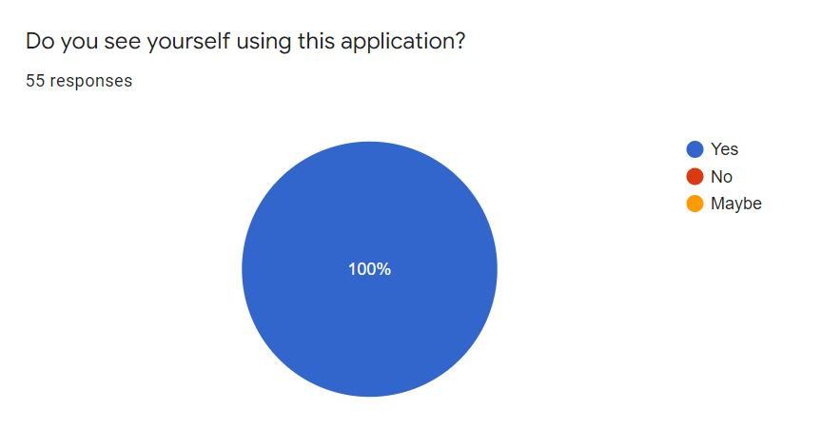

Figure 201: Post-Survey Result - 4

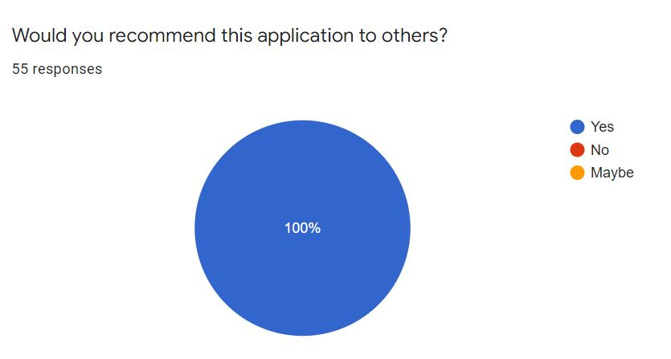

Figure 202: Post-Survey Result - 5

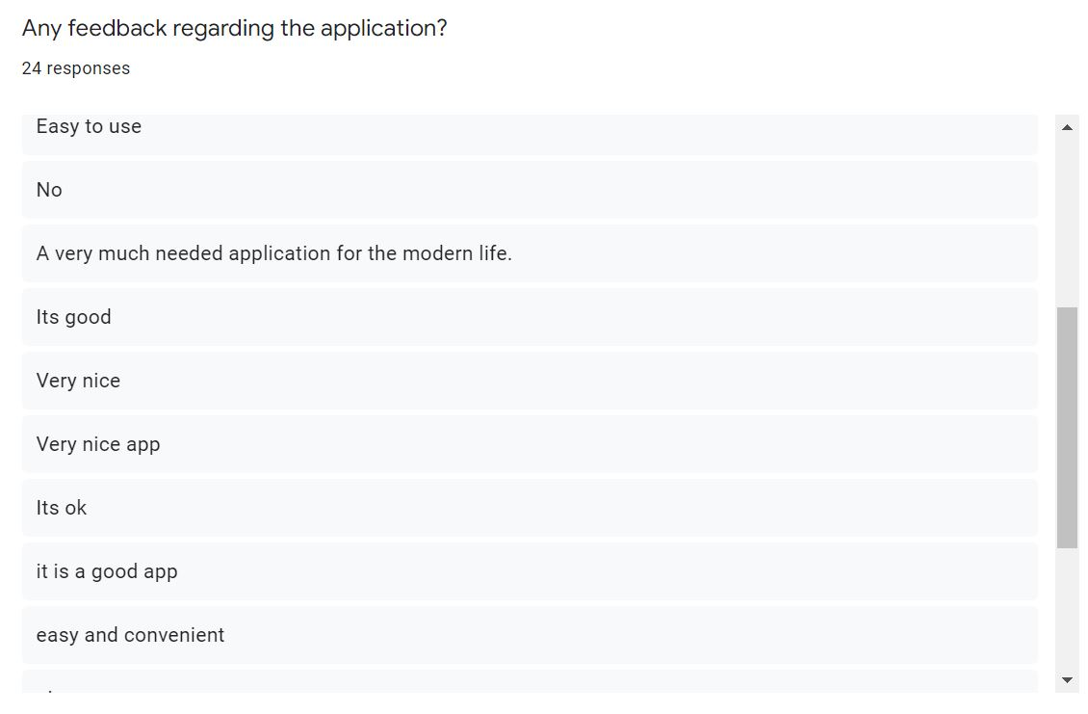

Figure 203: Post-Survey Result - 6

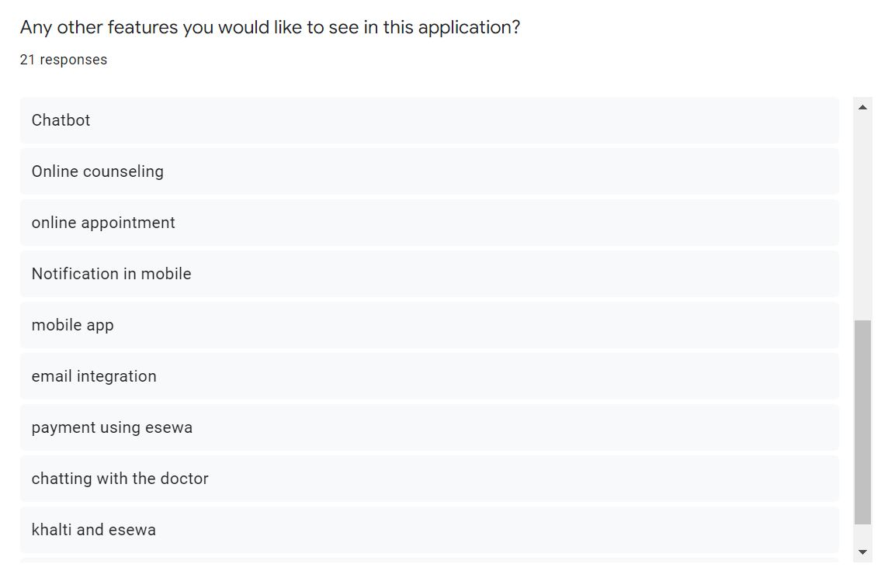

Figure 204: Post-Survey Result - 7

## 7.5 Appendix E: Sample Codes

### 7.5.1 Sample code of the UI

### 7.5.2 Sample code for the Automation Script

## 7.6 Appendix F: Designs

Continued from here.

UML, which stands for Unified Modelling Language, is a way to visually represent the architecture, design, and implementation of complex software systems. (Lucid, 2022) There are thousands of lines of code in an application, and it's tough to keep track of the links and hierarchies inside a software system when developing code. The software system is divided into components and subcomponents using UML diagrams.

**Use Case Diagram:** A use case diagram is a way to summarize details of a system and the users within that system. (TechTarget, 2020) It is often depicted as a graphical representation of the interactions between various parts in a system. Use case diagrams define the events in a system and how they flow, but they do not describe how those events are implemented.

**Collaboration Diagram:** A collaboration diagram, also known as a communication diagram, is an illustration of the relationships and interactions among software objects in the Unified Modelling Language (UML). (Lewis, 2019) These diagrams may be used to depict the dynamic behaviour of a certain use case as well as identify the role of each component.

**Activity Diagram:** Another significant behavioural diagram in UML diagram is the activity diagram, which is used to explain dynamic characteristics of the system. Activity diagram is essentially an advanced version of flow chart that modelling the flow from one activity to another activity. (Paradigm, 2022)

**Sequence Diagram:** UML Sequence Diagrams are interaction diagrams that show how processes are performed. They document the interaction of items in the context of a collaborative effort. Sequence Diagrams are time focused, and they graphically express the sequence of the interaction by utilizing the vertical axis of the diagram to indicate time, what messages are conveyed, and when. (Paradigm, 2022)

**Class Diagram:** In software engineering, a class diagram in the Unified Modelling Language (UML) is a type of static structure diagram that describes the structure of a system by showing the system's classes, their attributes, operations (or methods), and the relationships among objects. (Paradigm, 2022)

**ER Diagram:** ER Diagram stands for Entity Relationship Diagram, also known as ERD is a diagram that displays the relationship of entity sets stored in a database. (Peterson, 2022) In other words, ER diagrams aid in the explanation of database logical structure. Entities, attributes, and relationships are the three main elements around which ER diagrams are built.

### 7.6.1 Functional UML Diagrams

Click Here to see User side Functional UML Diagram

**Admin**

11. Login to the system

**High Level Use Case Description**

|  |  |
| --- | --- |
| **Use Case:** | Admin Login |
| **Actor:** | Admin |
| **Description:** | In order to use the admin side system and its features, the admin must log in to the system. The login details is then verified by the system. |

Table 60: High Level Use Case – Admin Login

**Use Case Diagram**

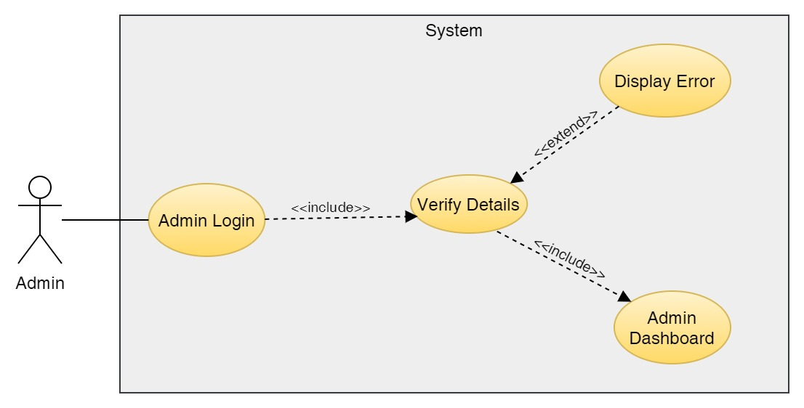

Figure 205: Use Case Diagram – Admin Login

**Collaboration Diagram**

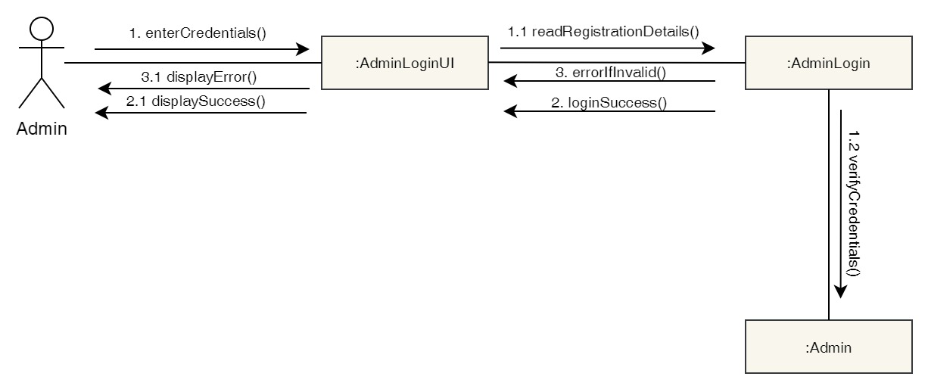

Figure 206: Collaboration Diagram – Admin Login

**Activity Diagram**

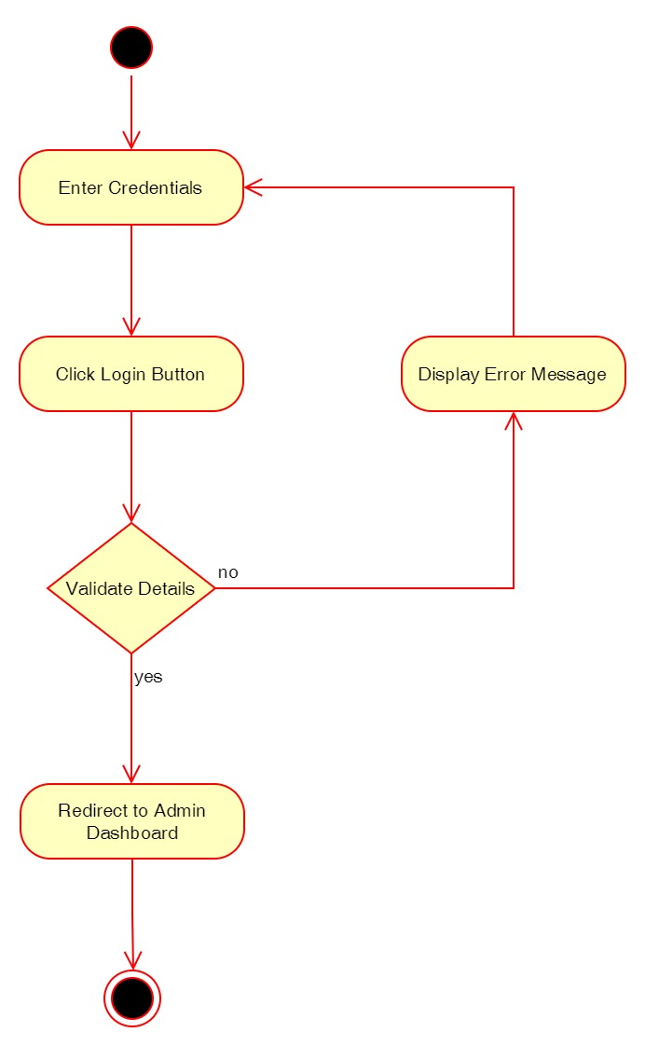

Figure 207: Activity Diagram – Admin Login

**Sequence Diagram**

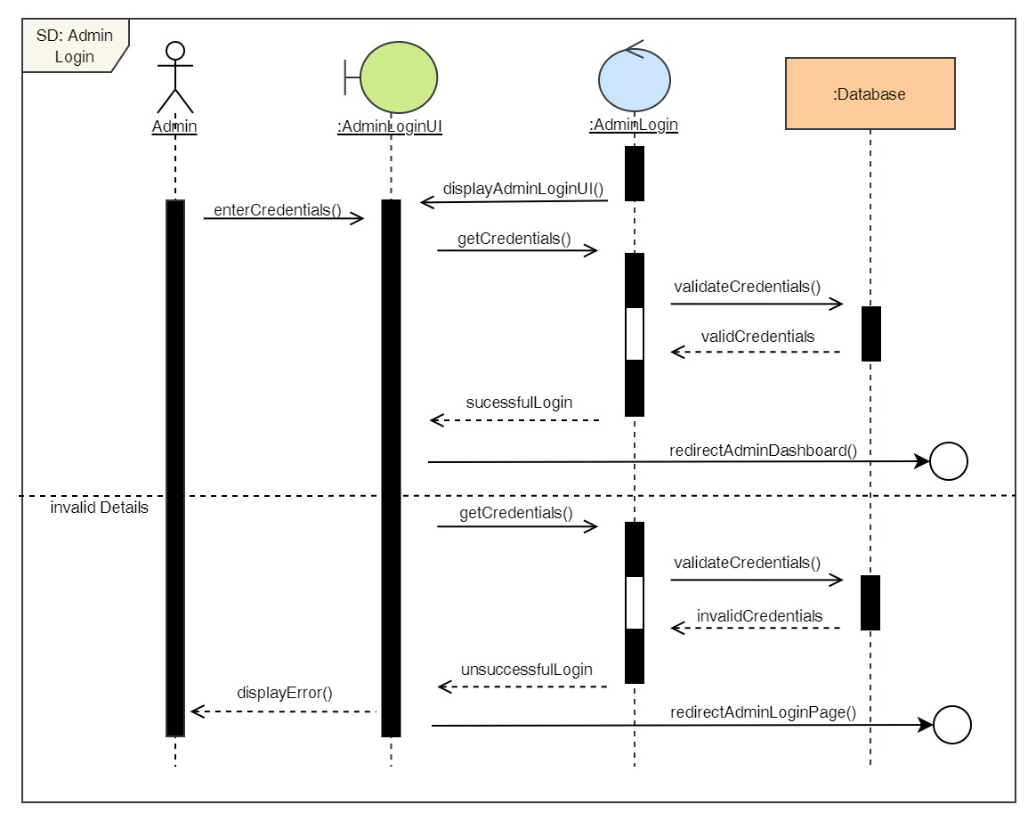

Figure 208: Sequence Diagram – Admin Login

12. View all users

**High Level Use Case Description**

|  |  |
| --- | --- |
| **Use Case:** | View all users |
| **Actor:** | Admin |
| **Description:** | Admin can view all the user that are registered to the system. |

Table 61: High Level Use Case – Admin View Users

**Use Case Diagram**

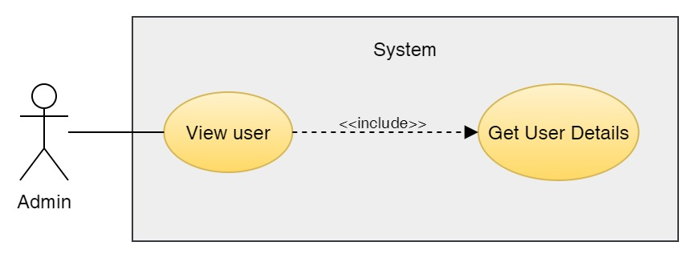

Figure 209: Use Case Diagram – Admin View Users

**Collaboration Diagram**

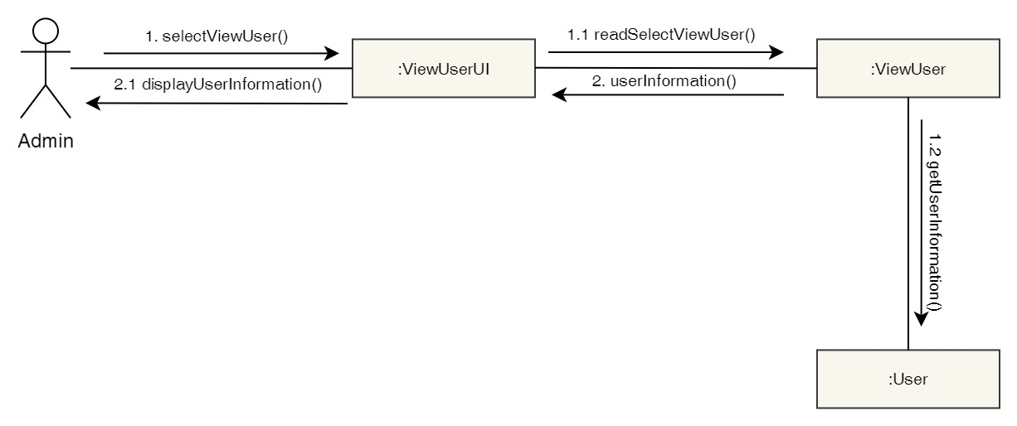

Figure 210: Collaboration Diagram – Admin View Users

**Activity Diagram**

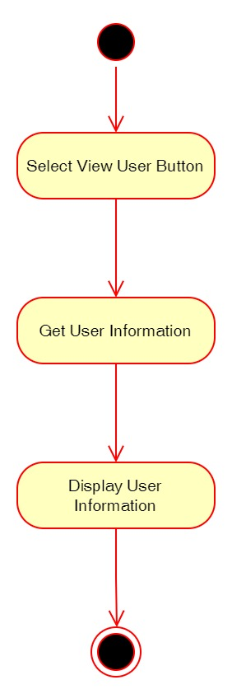

Figure 211: Activity Diagram – Admin View Users

**Sequence Diagram**

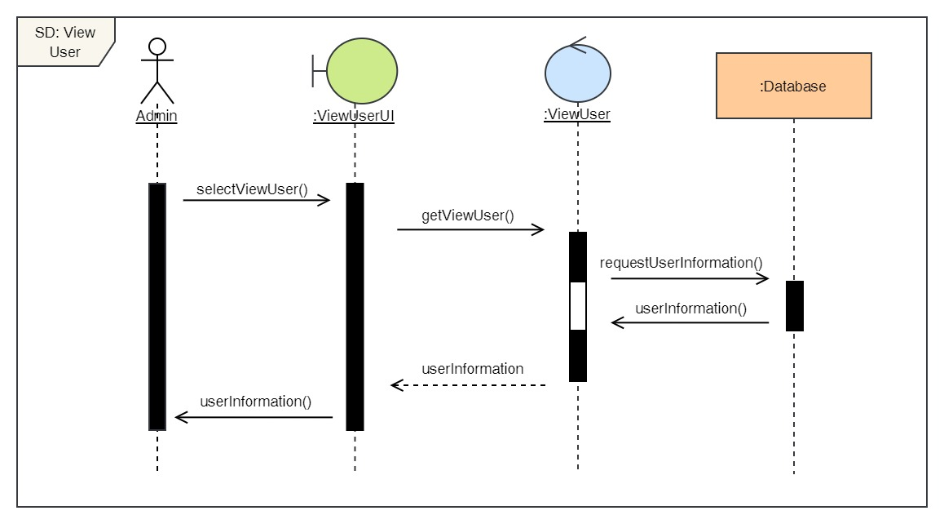

Figure 212: Sequence Diagram – Admin View Users

13. Delete users

**High Level Use Case Description**

|  |  |
| --- | --- |
| **Use Case:** | De-Register User |
| **Actor:** | Admin |
| **Description:** | Admin can delete existing users from the system. |

Table 62: High Level Use Case – Admin Delete Users

**Use Case Diagram**

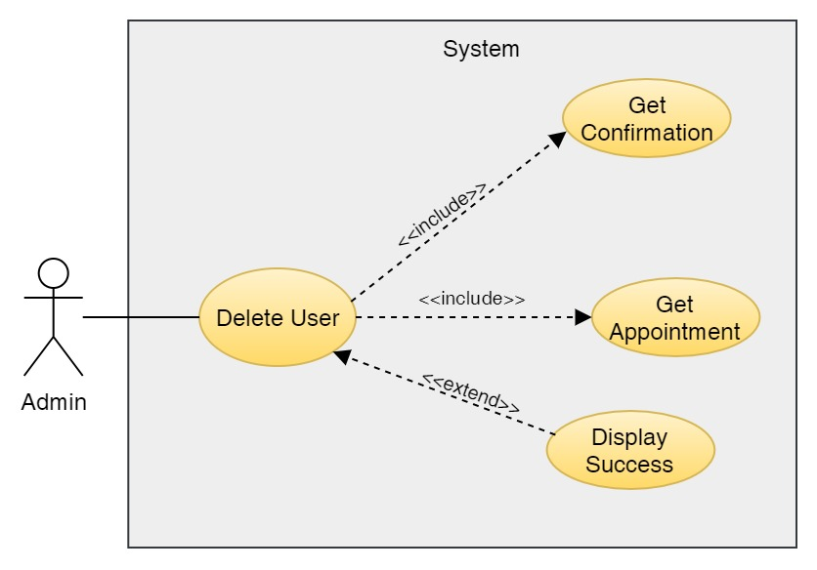

Figure 213: Use Case Diagram – Admin Delete Users

**Collaboration Diagram**

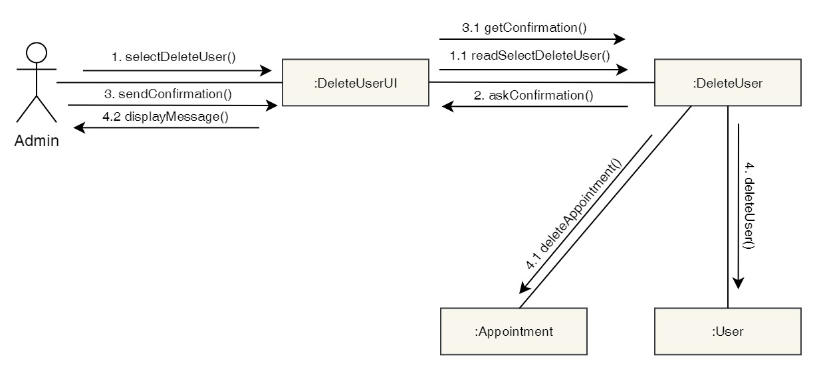

Figure 214: Collaboration Diagram – Admin Delete Users

**Activity Diagram**

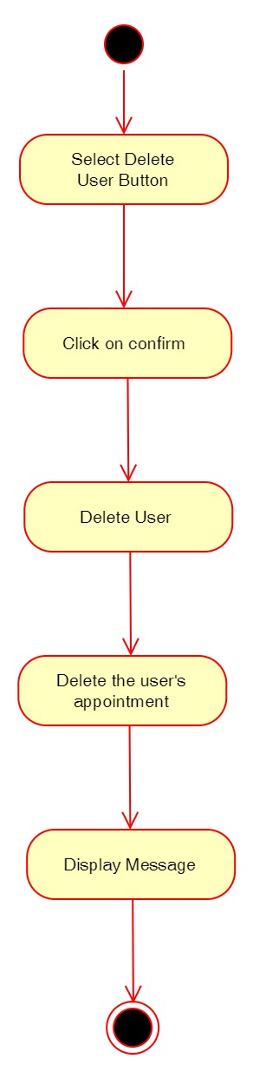

Figure 215: Activity Diagram – Admin Delete Users

**Sequence Diagram**

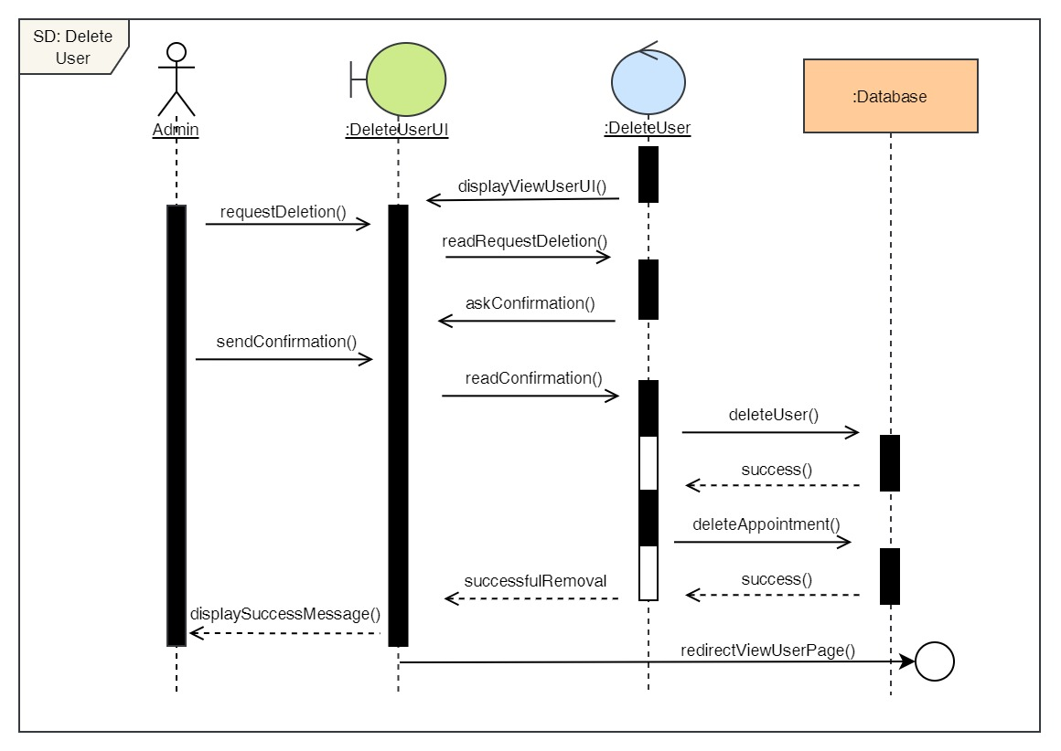

Figure 216: Sequence Diagram – Admin Delete Users

14. View all doctors

**High Level Use Case Description**

|  |  |
| --- | --- |
| **Use Case:** | View doctors |
| **Actor:** | Admin |
| **Description:** | Admin can view all the existing doctors in the system. |

Table 63: High Level Use Case – Admin View Doctors

**Use Case Diagram**

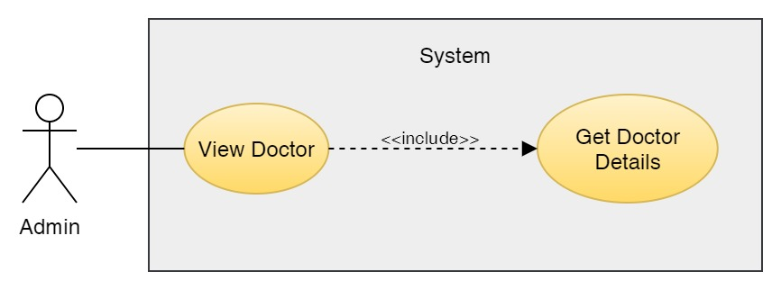

Figure 217: Use Case Diagram – Admin View Doctors

**Collaboration Diagram**

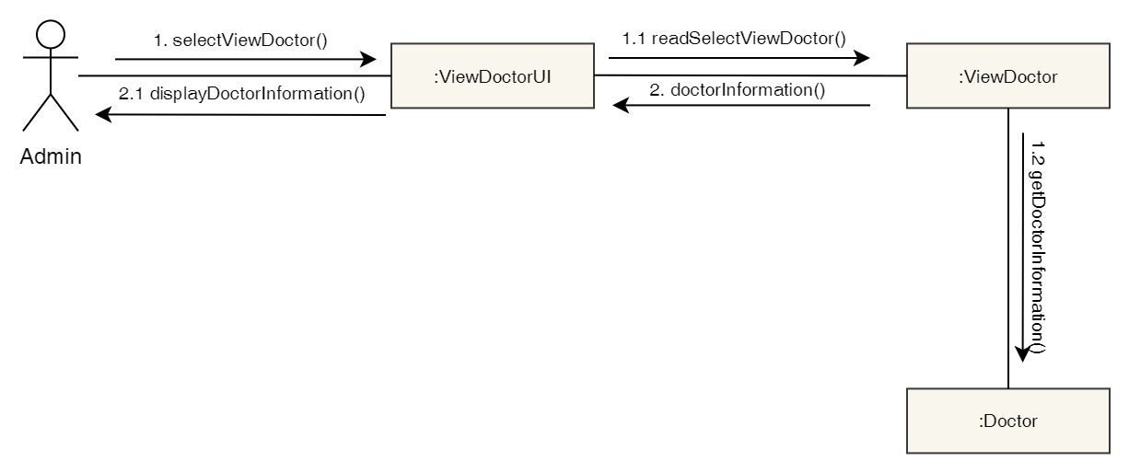

Figure 218: Collaboration Diagram – Admin View Doctors

**Activity Diagram**



Figure 219: Activity Diagram – Admin View Doctors

**Sequence Diagram**

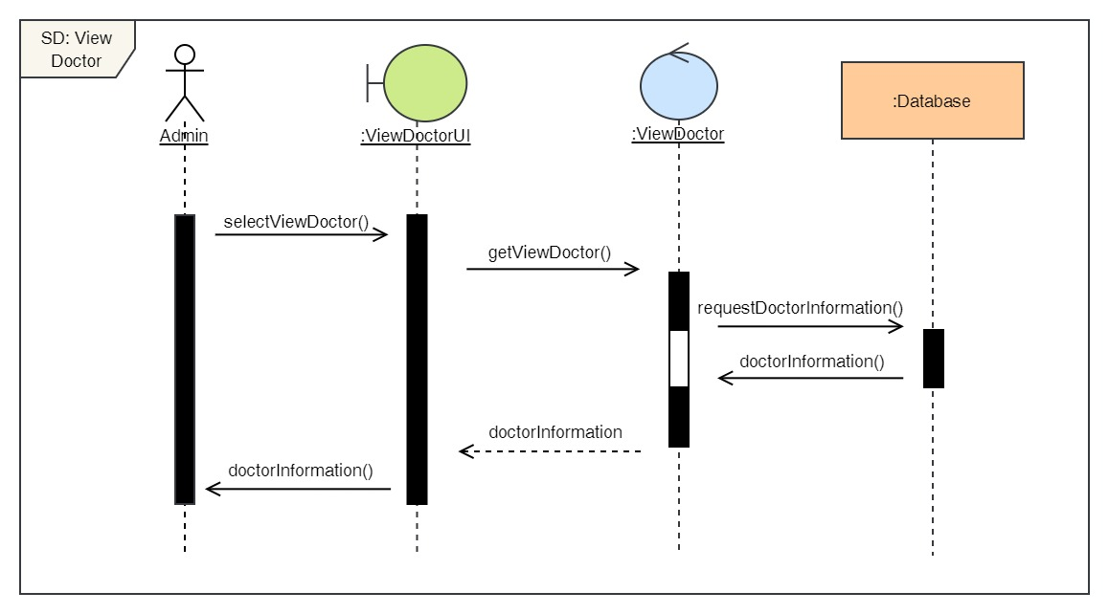

Figure 220: Sequence Diagram – Admin View Doctors

15. Add new doctors

**High Level Use Case Description**

|  |  |
| --- | --- |
| **Use Case:** | Add Doctors |
| **Actor:** | Admin |
| **Description:** | Admin can add new doctors to the system along with their description. |

Table 64: High Level Use Case – Admin Add Doctors

**Use Case Diagram**

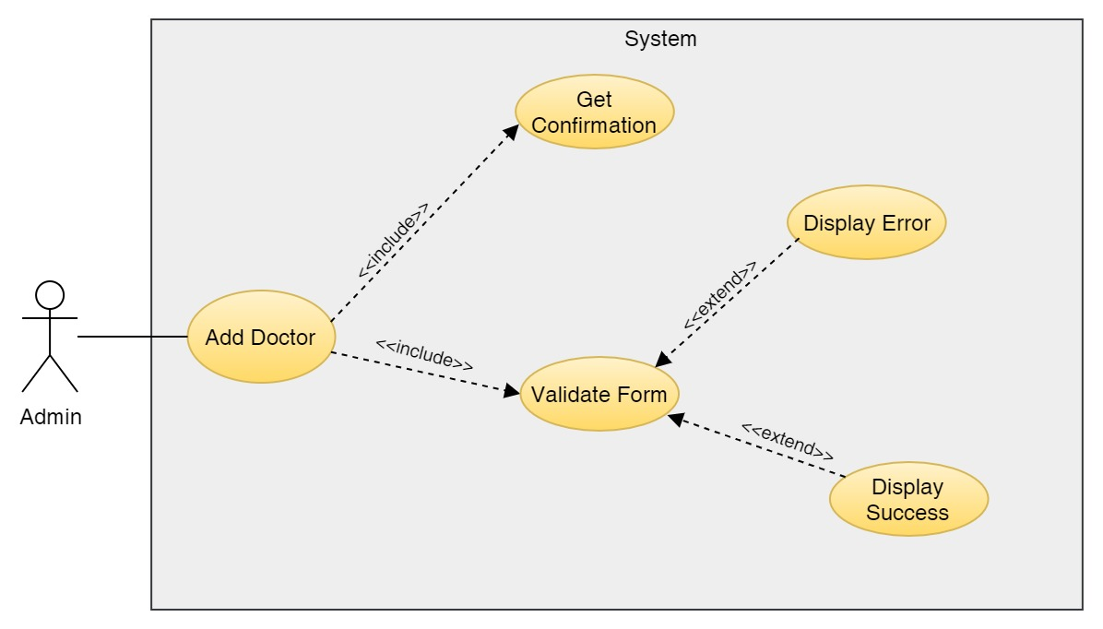

Figure 221: Use Case Diagram – Admin Add Doctors

**Collaboration Diagram**

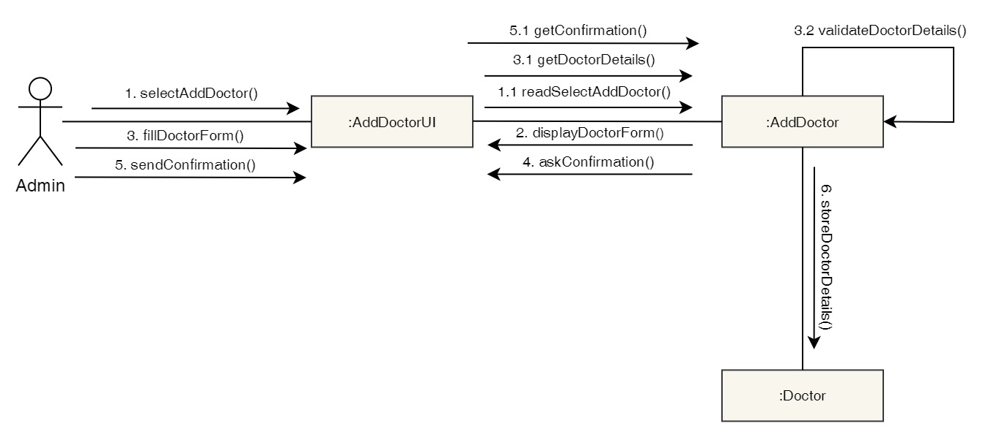

Figure 222: Collaboration Diagram – Admin Add Doctors

**Activity Diagram**

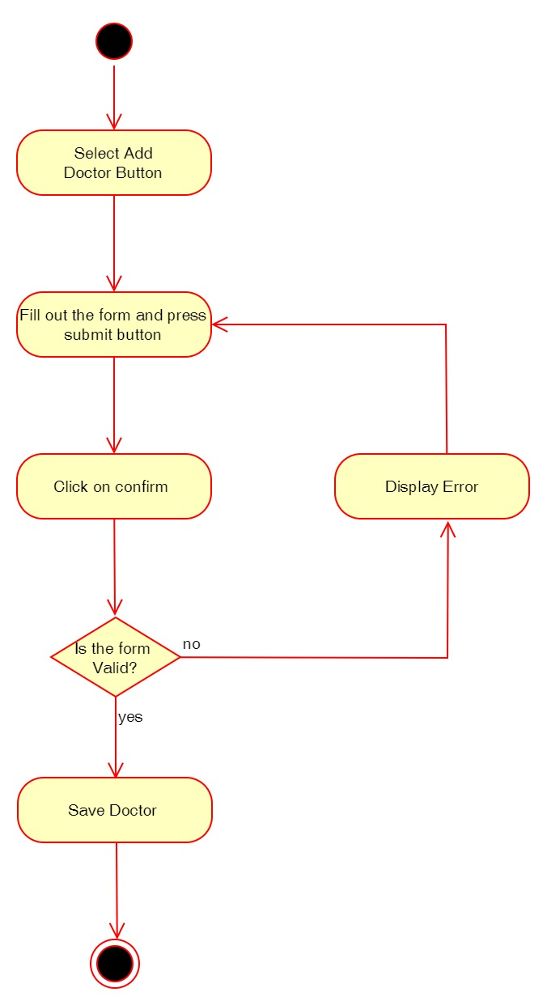

Figure 223: Activity Diagram – Admin Add Doctors

**Sequence Diagram**

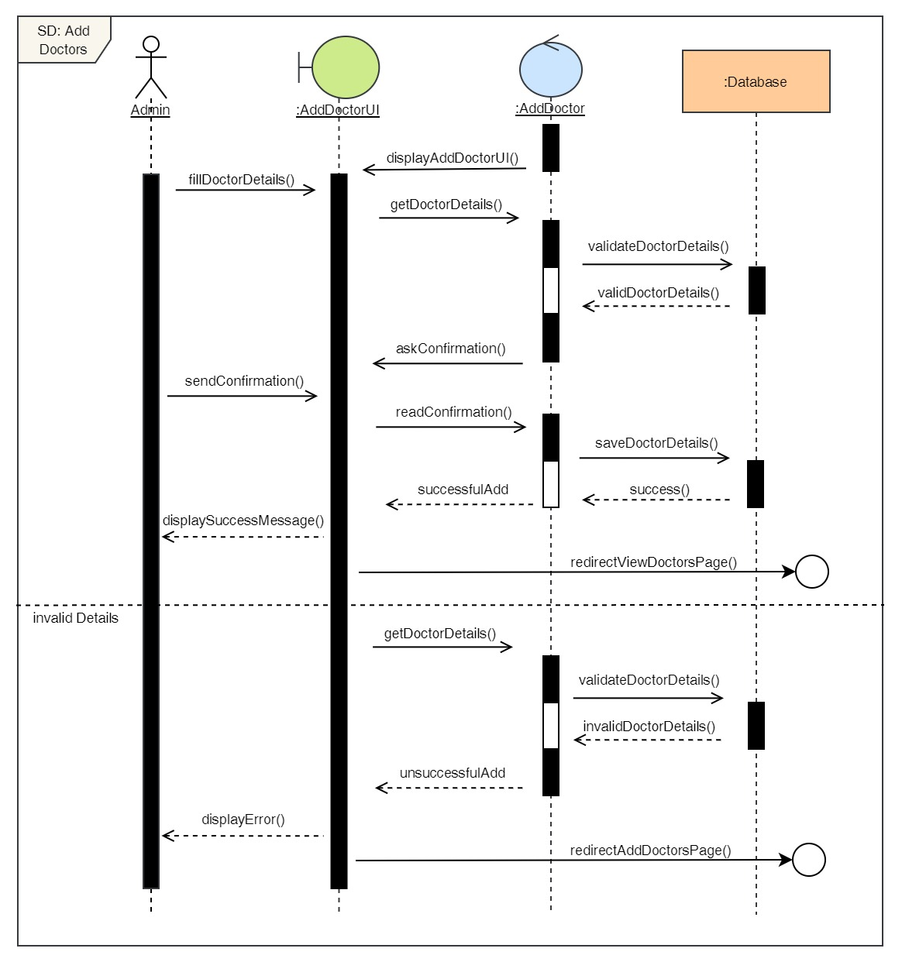

Figure 224: Sequence Diagram – Admin Add Doctors

16. Delete doctors

**High Level Use Case Description**

|  |  |
| --- | --- |
| **Use Case:** | Delete Doctors |
| **Actor:** | Admin |
| **Description:** | Admin can remove existing doctors from the system if the doctor is no longer working in the clinic. |

Table 65: High Level Use Case – Admin Delete Doctors

**Use Case Diagram**

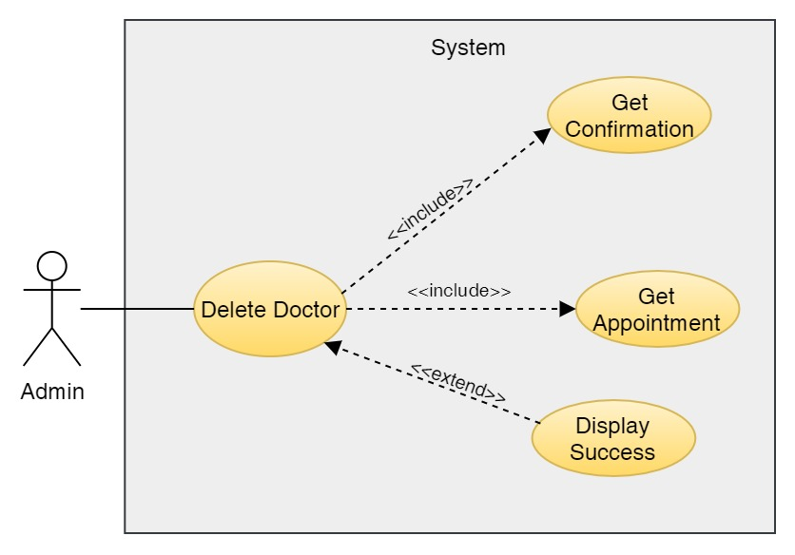

Figure 225: Use Case Diagram – Admin Delete Doctors

**Collaboration Diagram**

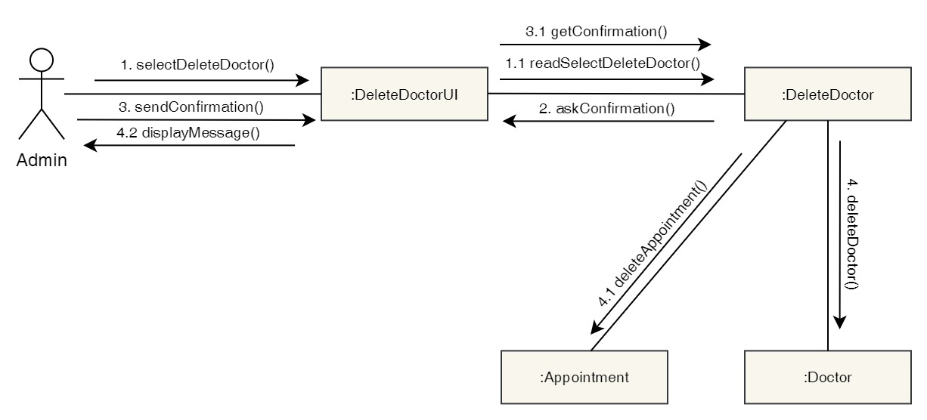

Figure 226: Collaboration Diagram – Admin Delete Doctors

**Activity Diagram**

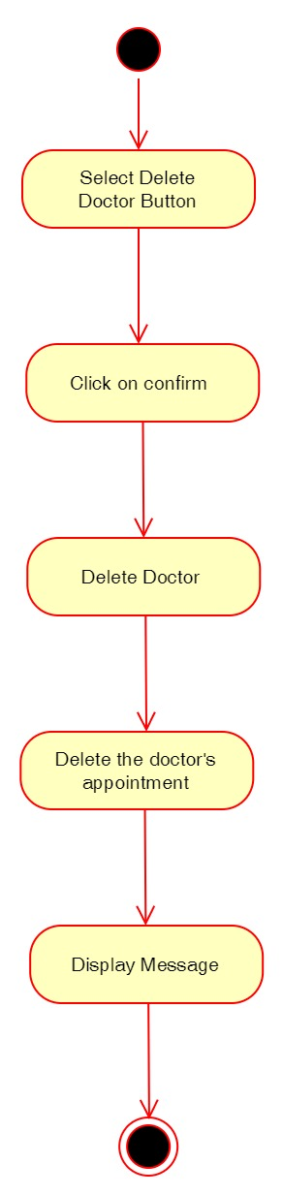

Figure 227: Activity Diagram – Admin Delete Doctors

**Sequence Diagram**

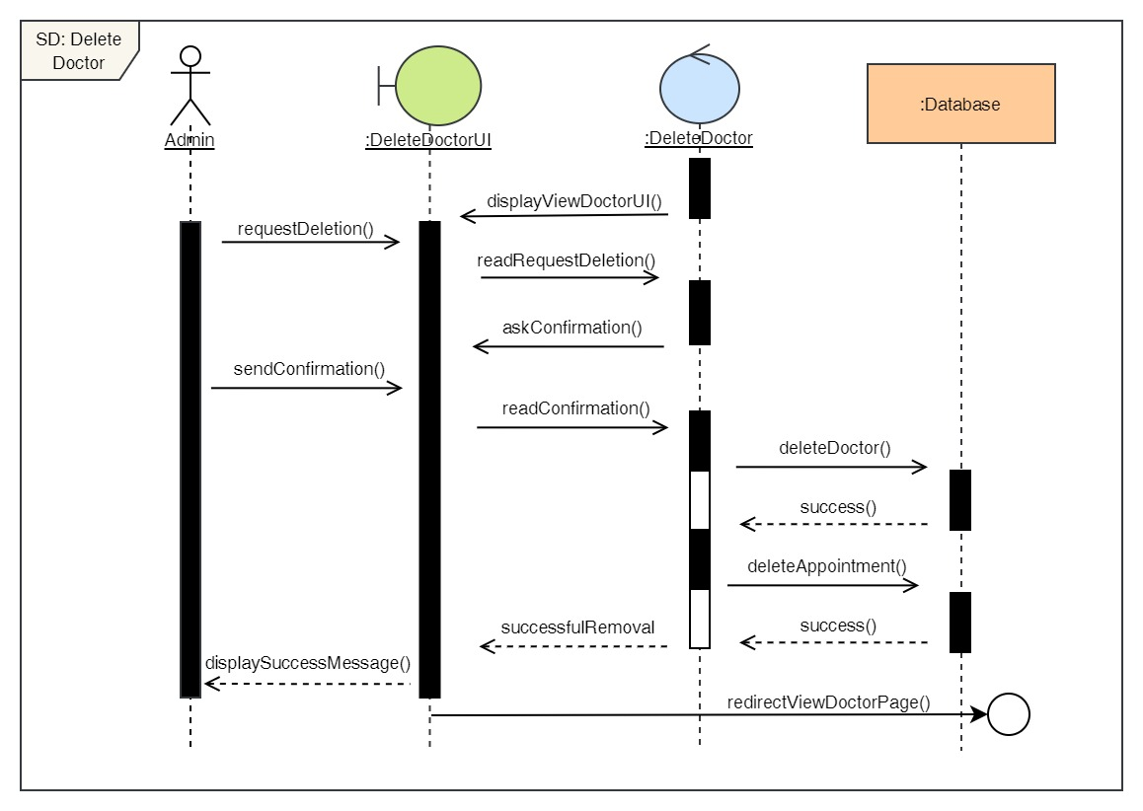

Figure 228: Sequence Diagram – Admin Delete Doctors

17. Edit doctors

**High Level Use Case Description**

|  |  |
| --- | --- |
| **Use Case:** | Edit Doctors |
| **Actor:** | Admin |
| **Description:** | Admin can update the details of the existing doctors in the system. |

Table 66: High Level Use Case – Admin Edit Doctors

**Use Case Diagram**

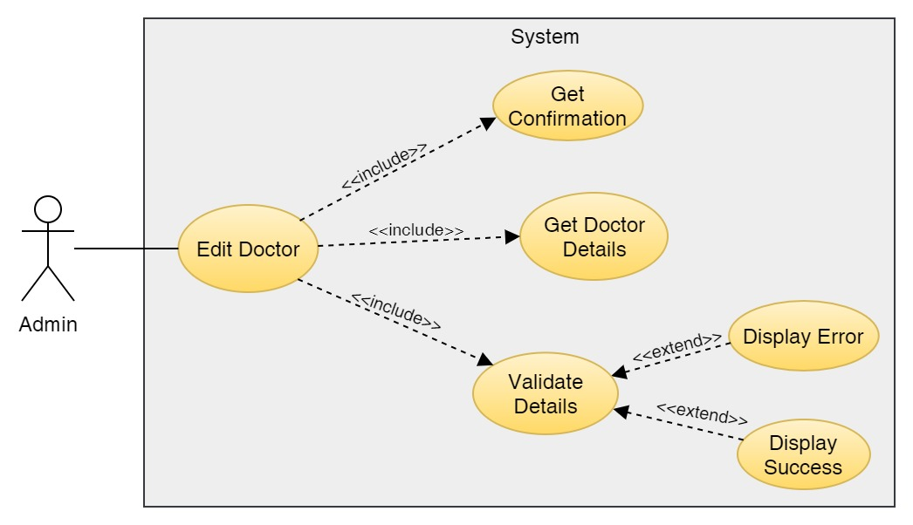

Figure 229: Use Case Diagram – Admin Edit Doctors

**Collaboration Diagram**

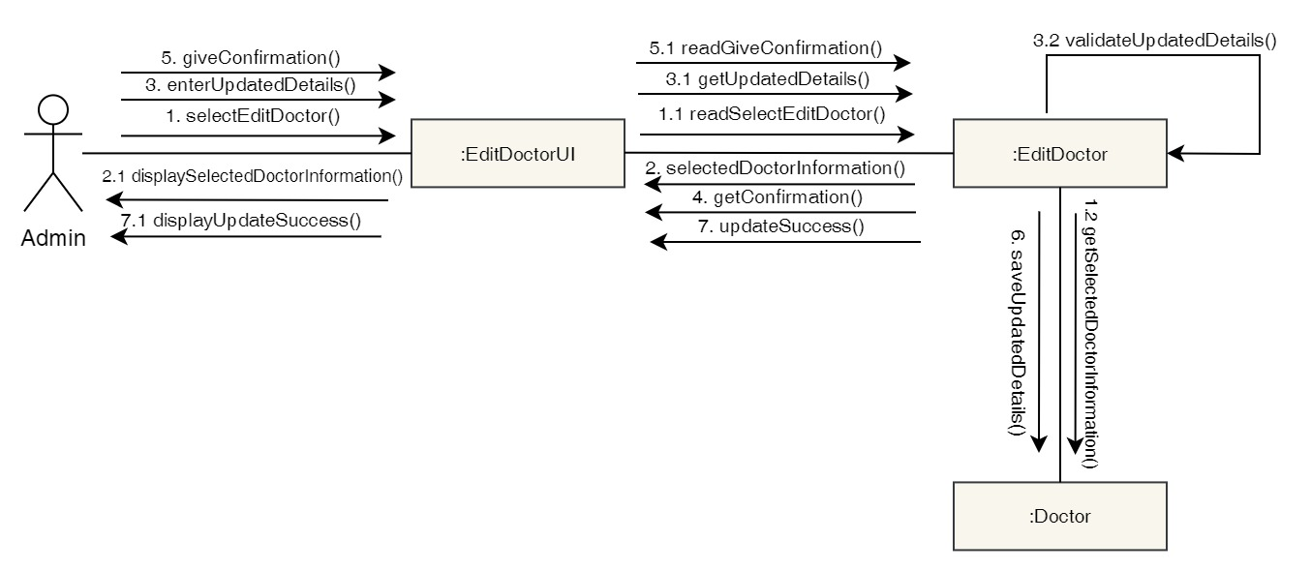

Figure 230: Collaboration Diagram – Admin Edit Doctors

**Activity Diagram**

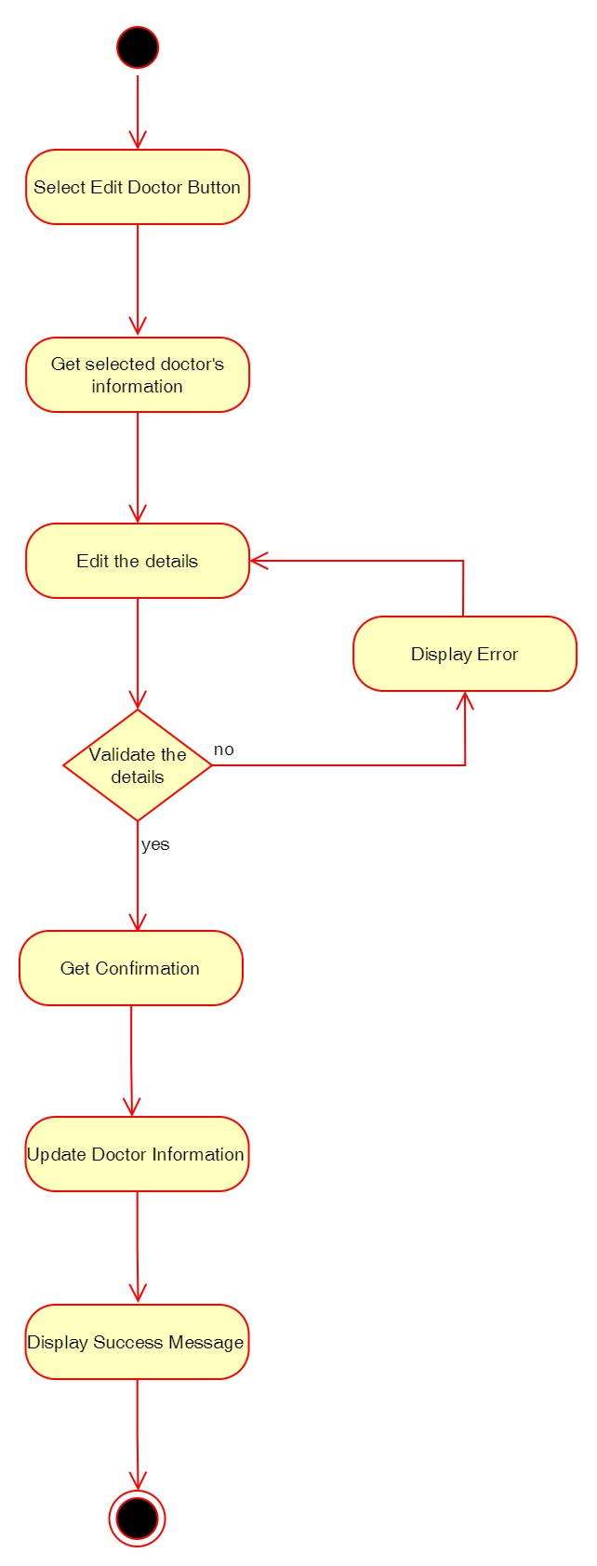

Figure 231: Activity Diagram – Admin Edit Doctors

**Sequence Diagram**

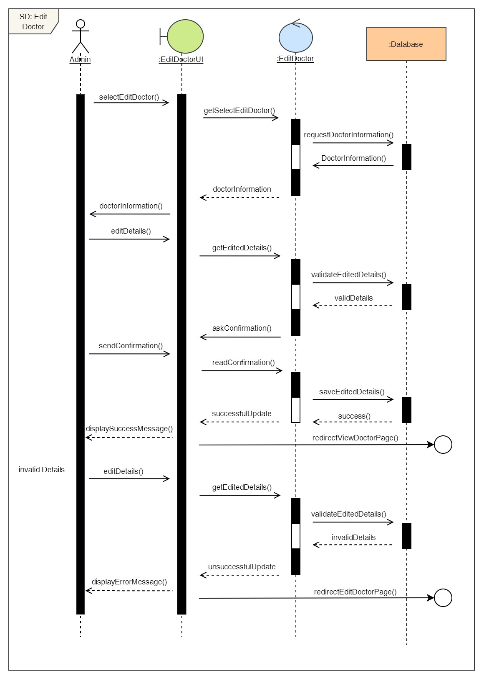

Figure 232: Sequence Diagram – Admin Edit Doctors

18. Add Report

**High Level Use Case Description**

|  |  |
| --- | --- |
| **Use Case:** | Add Report |
| **Actor:** | Admin |
| **Description:** | Admin can add reports of the appointments that has been completed. |

Table 67: High Level Use Case – Admin Add Report

**Use Case Diagram**

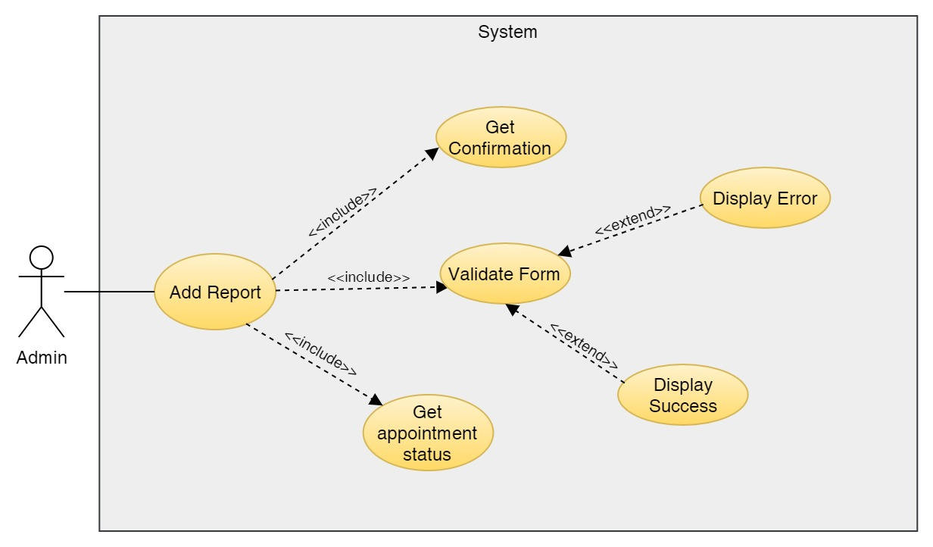

Figure 233: Use Case Diagram – Admin Add Report

**Collaboration Diagram**

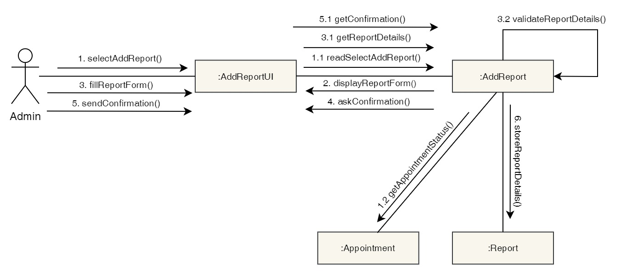

Figure 234: Collaboration Diagram – Admin Add Report

**Activity Diagram**

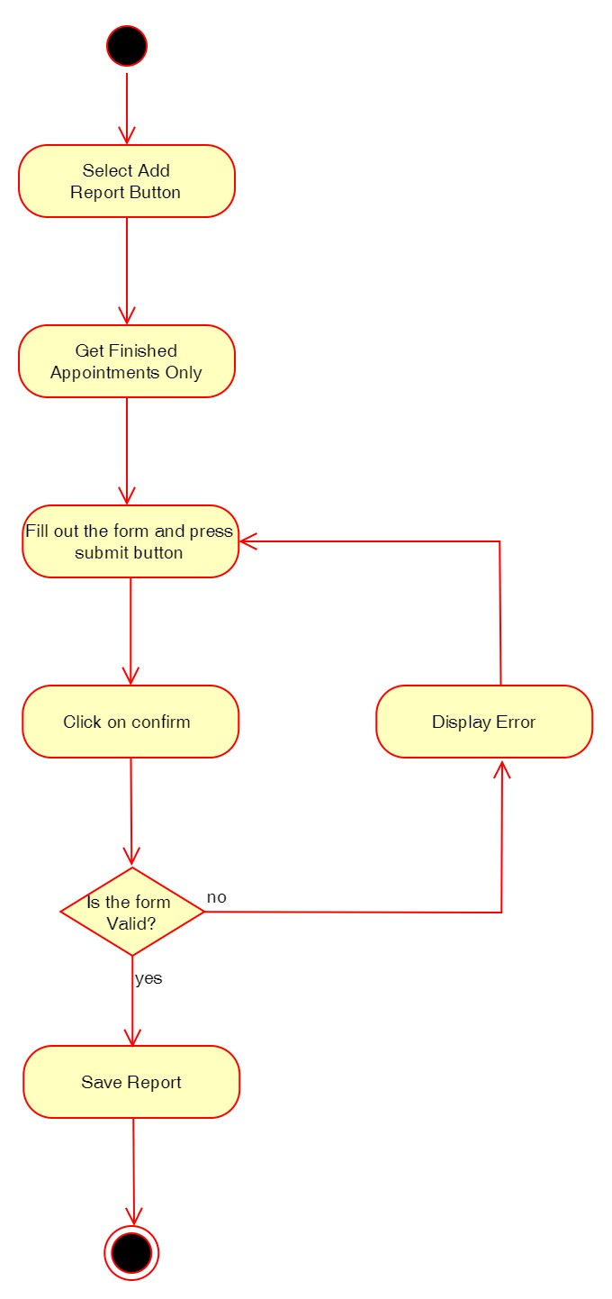

Figure 235: Activity Diagram – Admin Add Report

**Sequence Diagram**

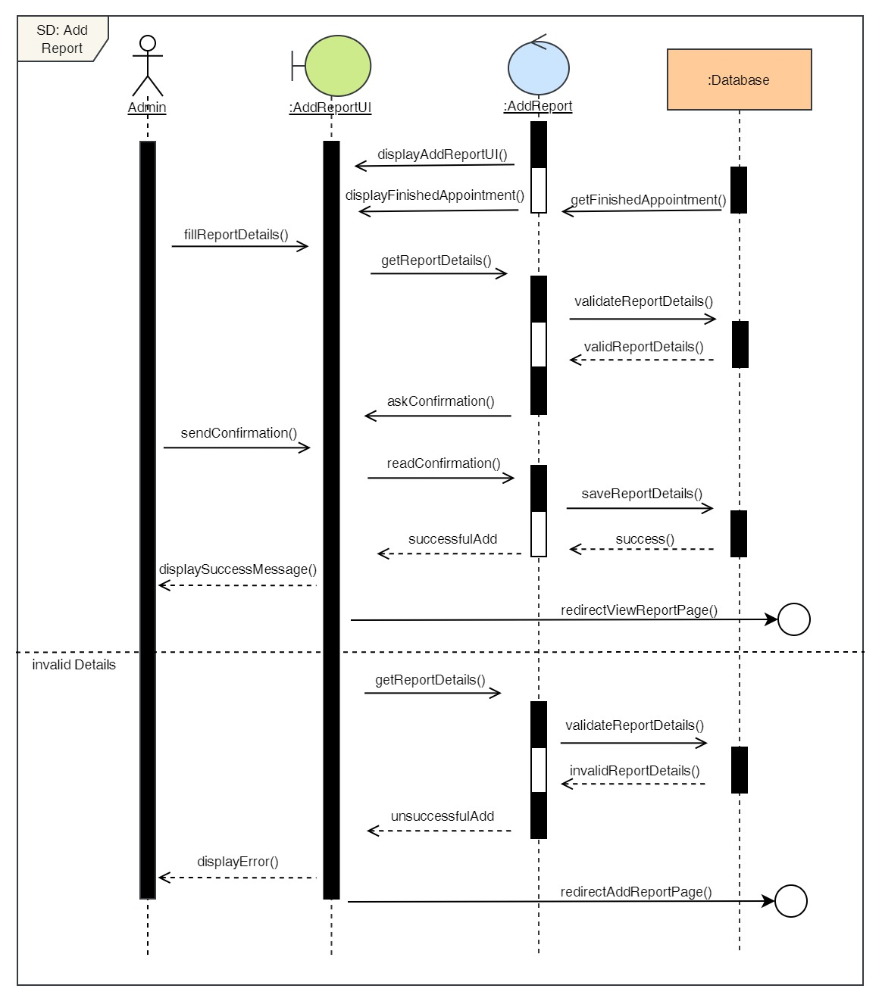

Figure 236: Sequence Diagram – Admin Add Report

19. Delete Report

**High Level Use Case Description**

|  |  |
| --- | --- |
| **Use Case:** | Delete Report |
| **Actor:** | Admin |
| **Description:** | Admin can add remove existing reports from the system. |

Table 68: High Level Use Case – Admin Delete Report

**Use Case Diagram**

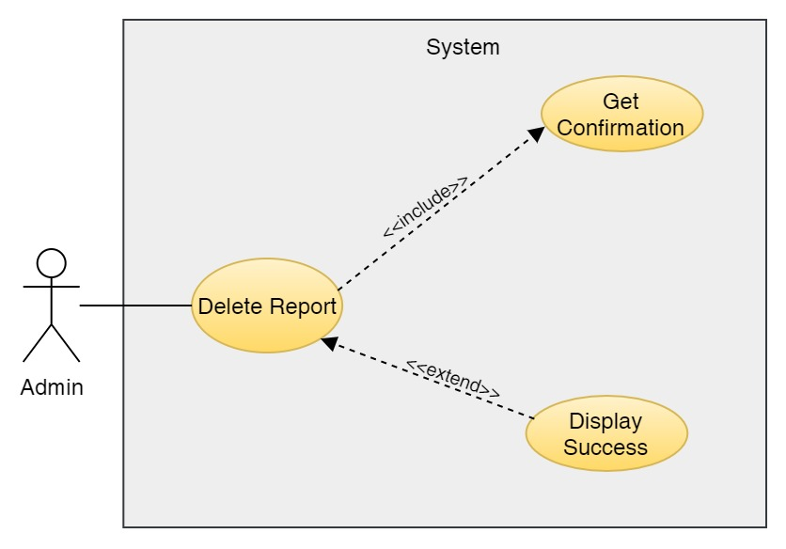

Figure 237: Use Case Diagram – Admin Delete Report

**Collaboration Diagram**

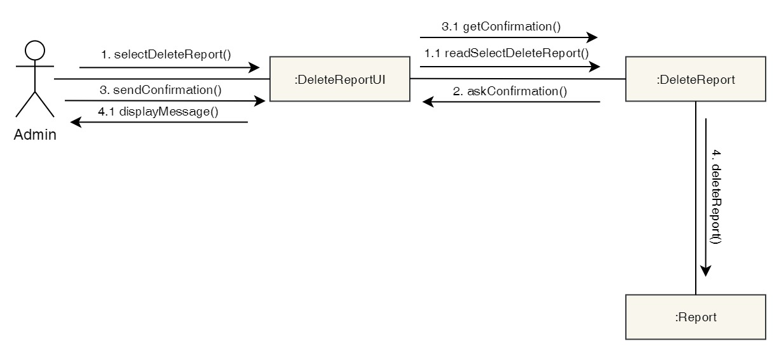

Figure 238: Collaboration Diagram – Admin Delete Report

**Activity Diagram**

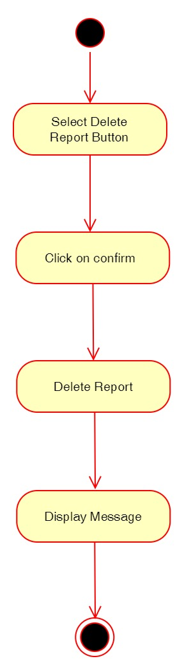

Figure 239: Activity Diagram – Admin Delete Report

**Sequence Diagram**

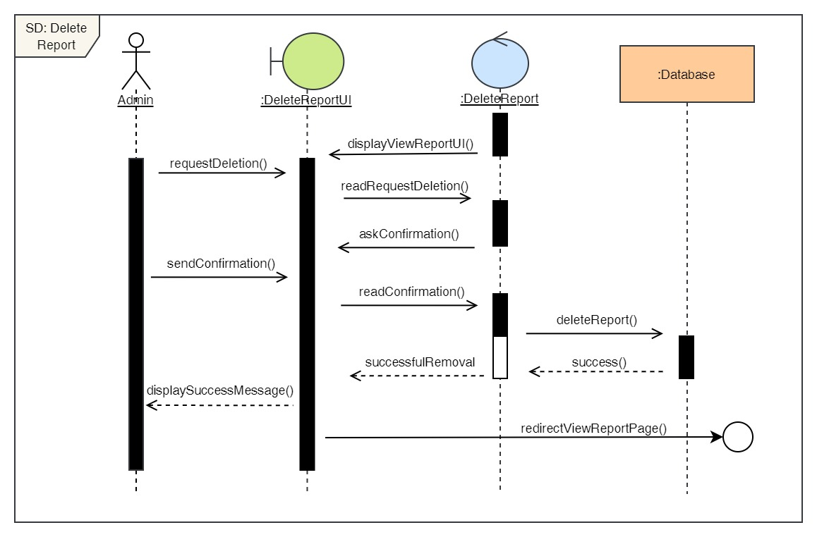

Figure 240: Sequence Diagram – Admin Delete Report

20. Edit reports

**High Level Use Case Description**

|  |  |
| --- | --- |
| **Use Case:** | Edit Reports |
| **Actor:** | Admin |
| **Description:** | Admin can update the details of the existing reports in the system. |

Table 69: High Level Use Case – Admin Edit Report

**Use Case Diagram**

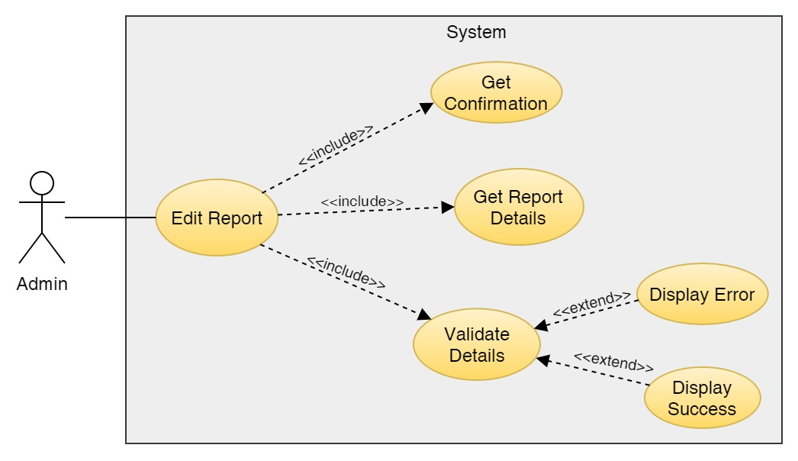

Figure 241: Use Case Diagram – Admin Edit Report

**Collaboration Diagram**

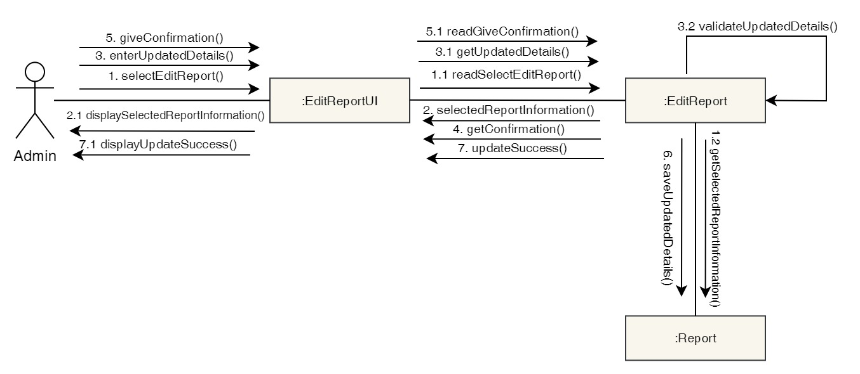

Figure 242: Collaboration Diagram – Admin Edit Report

**Activity Diagram**

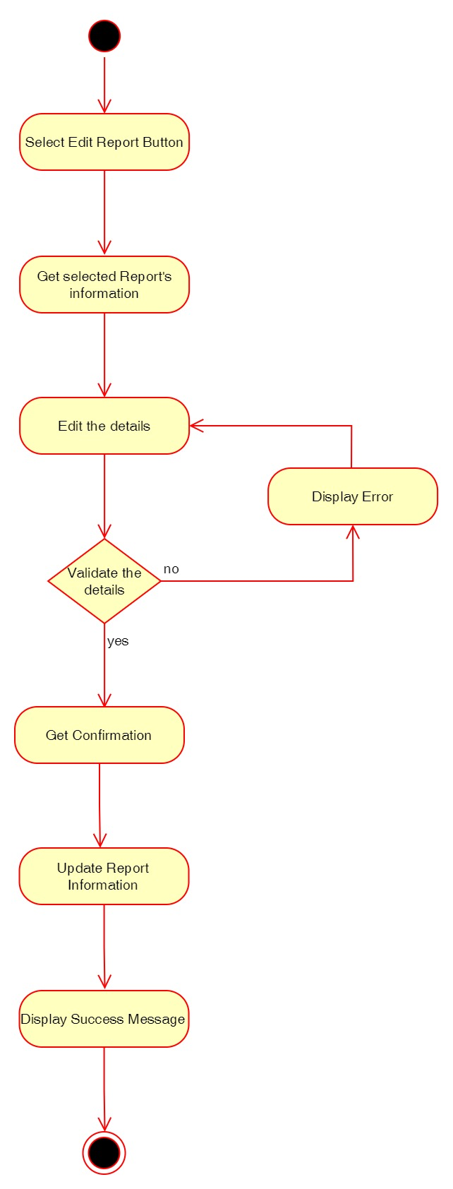

Figure 243: Activity Diagram – Admin Edit Report

**Sequence Diagram**

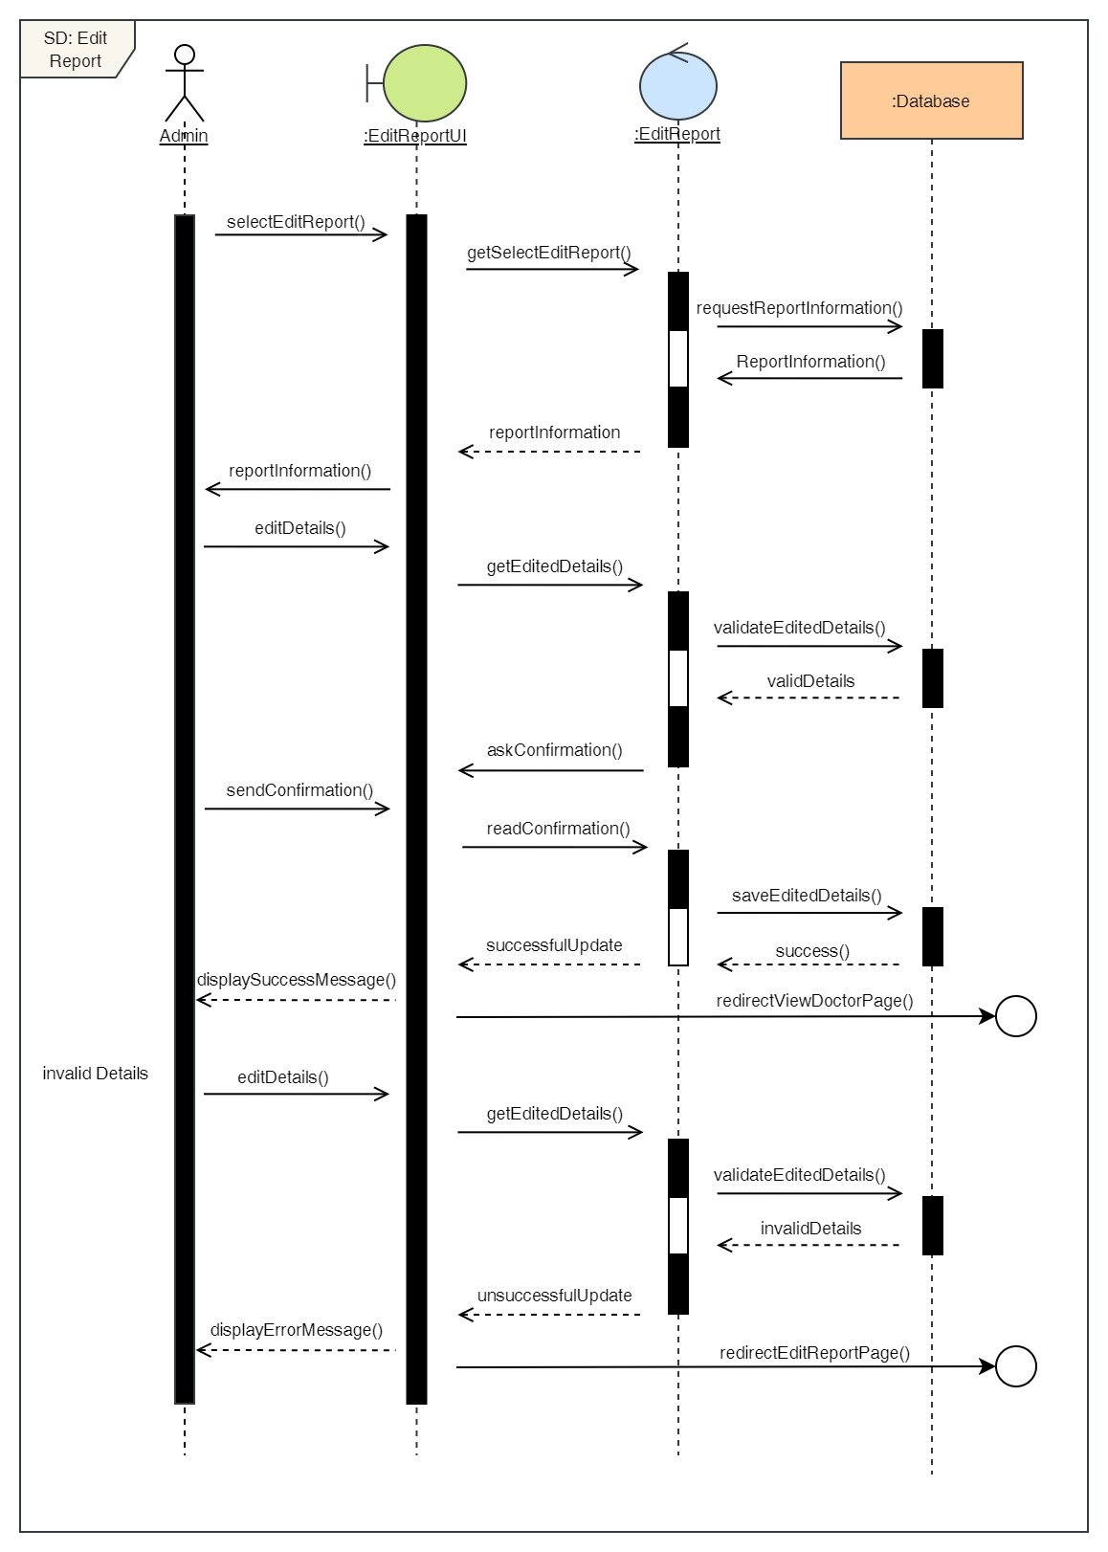

Figure 244: Sequence Diagram – Admin Edit Report

21. View all reports

**High Level Use Case Description**

|  |  |
| --- | --- |
| **Use Case:** | View Reports |
| **Actor:** | Admin |
| **Description:** | Admin can view all the reports of all the users stored in the system. |

Table 70: High Level Use Case – Admin View Reports

**Use Case Diagram**

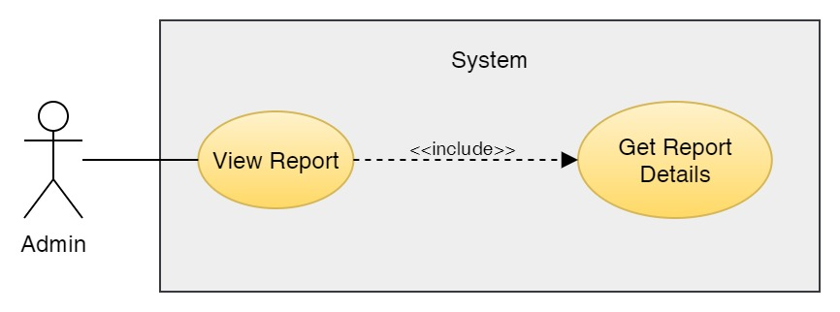

Figure 245: Use Case Diagram – Admin View Reports

**Collaboration Diagram**

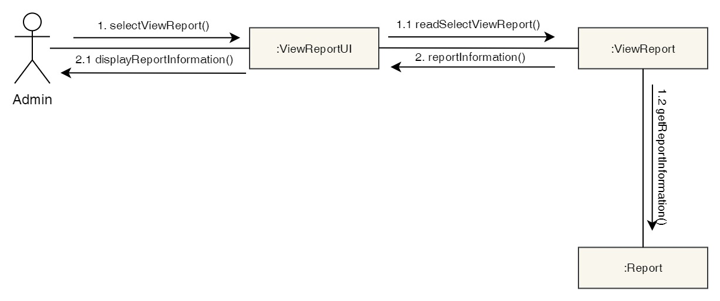

Figure 246: Collaboration Diagram – Admin View Reports

**Activity Diagram**

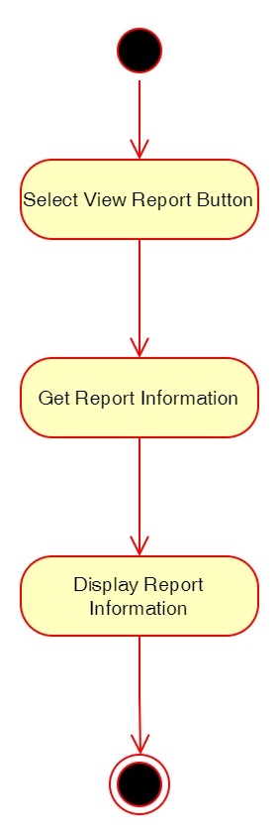

Figure 247: Activity Diagram – Admin View Reports

**Sequence Diagram**

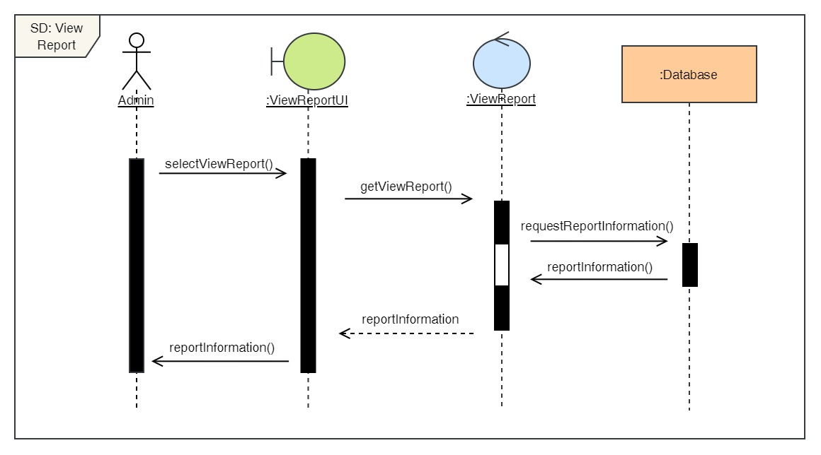

Figure 248: Sequence Diagram – Admin View Reports

22. Book a Dental Appointment

**High Level Use Case Description**

|  |  |
| --- | --- |
| **Use Case:** | Book Appointment |
| **Actor:** | Admin |
| **Description:** | Admin can book appointment for any user and any dental services by selecting the desired date, time, doctor and service. |

Table 23: High Level Use Case – Admin Book Appointment

**Use Case Diagram**

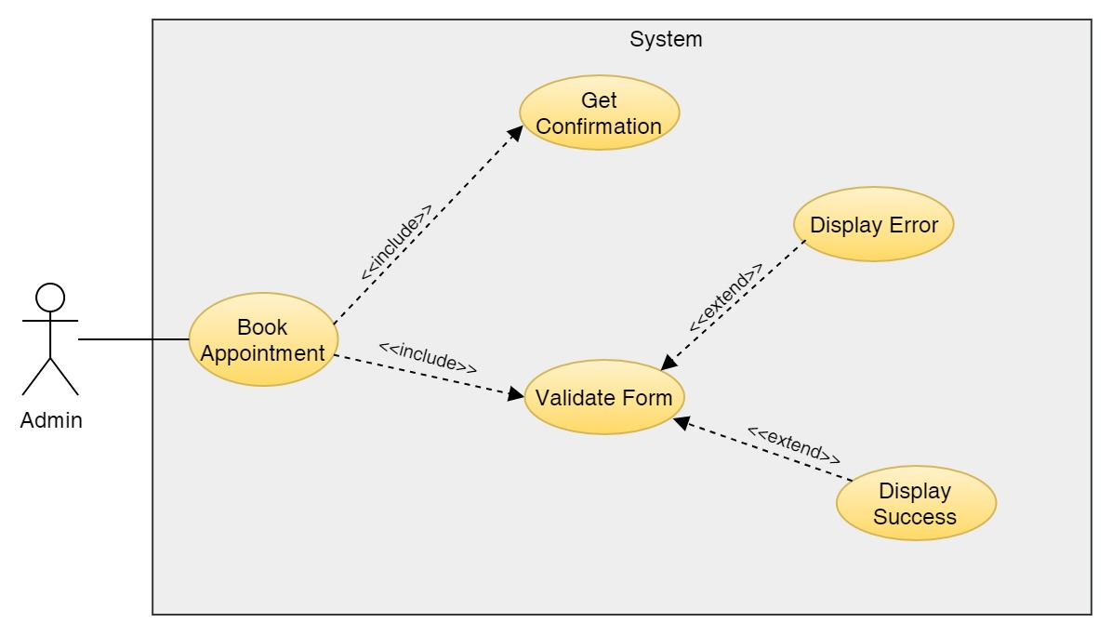

Figure 249: Use Case Diagram – Admin Book Appointment

**Collaboration Diagram**

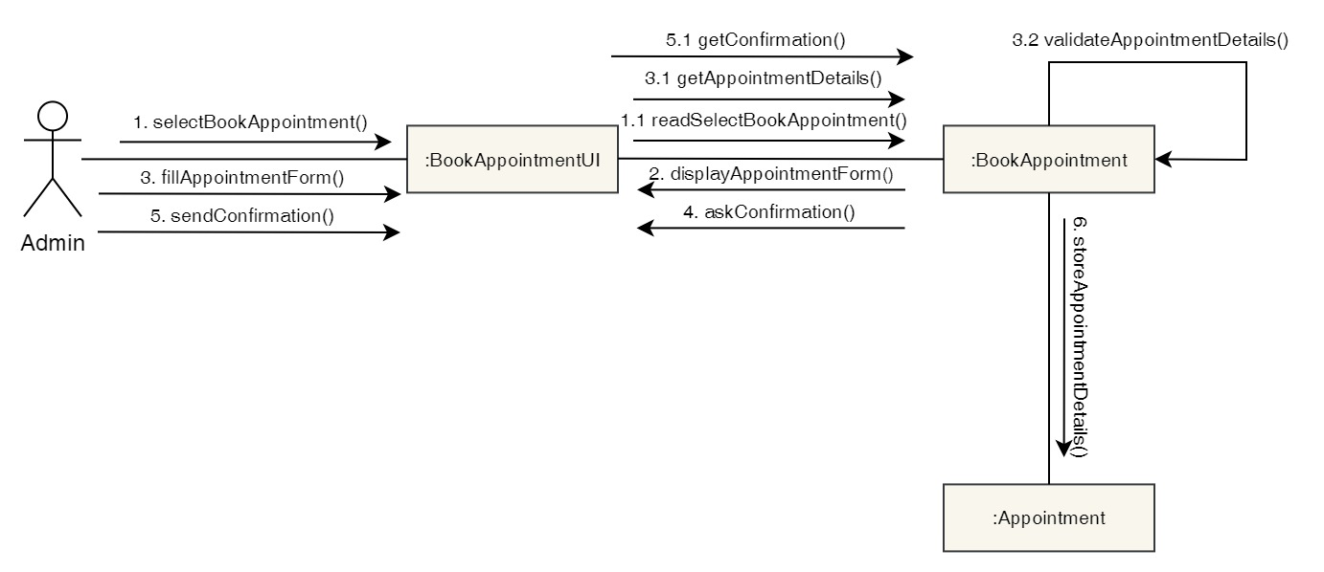

Figure 250: Collaboration Diagram – Admin Book Appointment

**Activity Diagram**

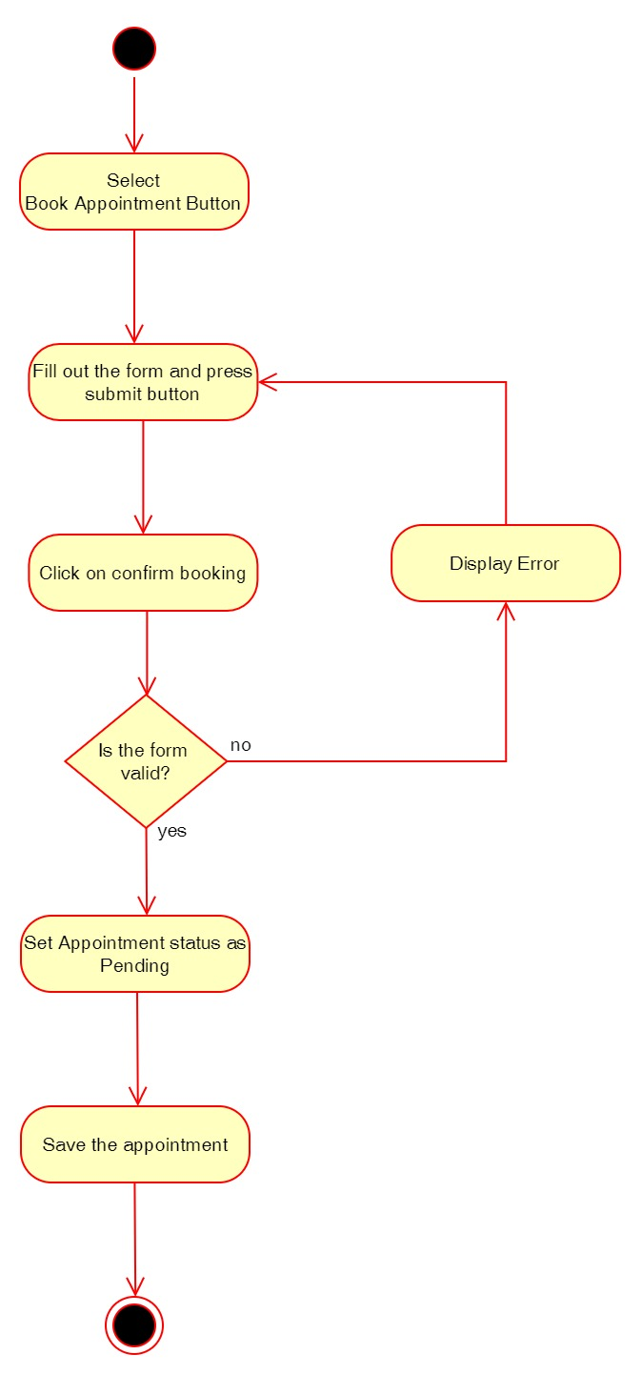

Figure 251: Activity Diagram – Admin Book Appointment

**Sequence Diagram**

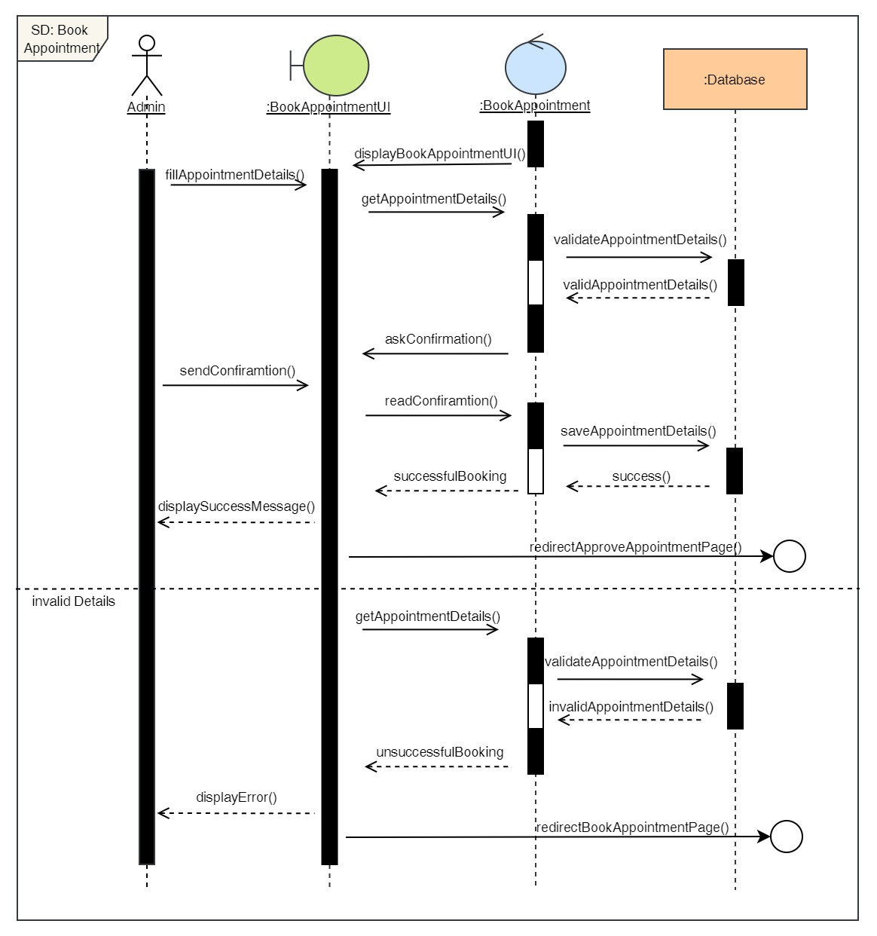

Figure 252: Sequence Diagram – Admin Book Appointment

23. View all appointments

**High Level Use Case Description**

|  |  |
| --- | --- |
| **Use Case:** | View all appointments |
| **Actor:** | Admin |
| **Description:** | Admin can view all the appointments the users have made from the system that is not pending. |

Table 24: High Level Use Case – Admin View Appointments

**Use Case Diagram**

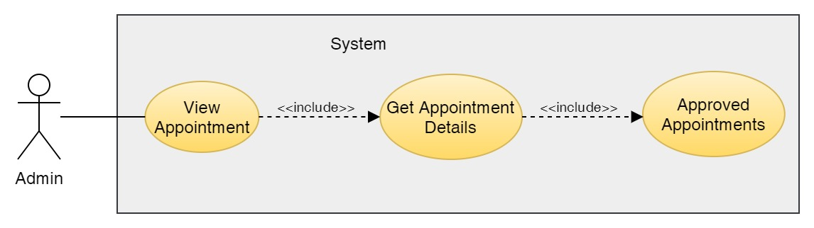

Figure 253: Use Case Diagram – Admin View Appointments

**Collaboration Diagram**

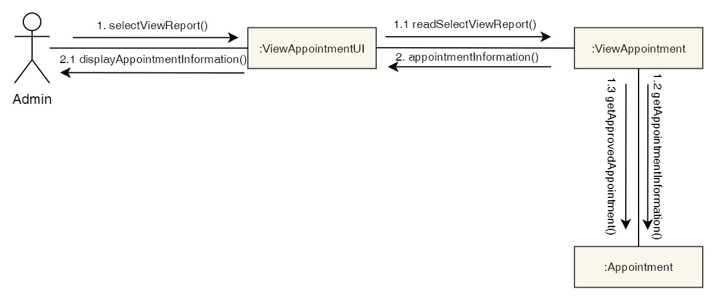

Figure 254: Collaboration Diagram – Admin View Appointments

**Activity Diagram**

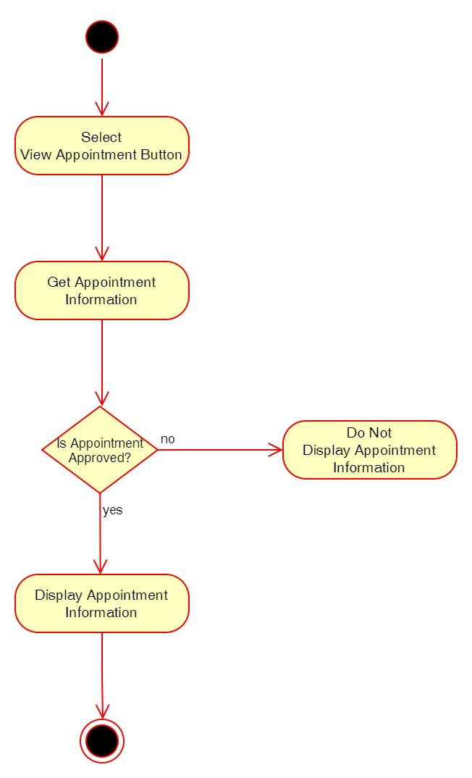

Figure 255: Activity Diagram – Admin View Appointments

**Sequence Diagram**

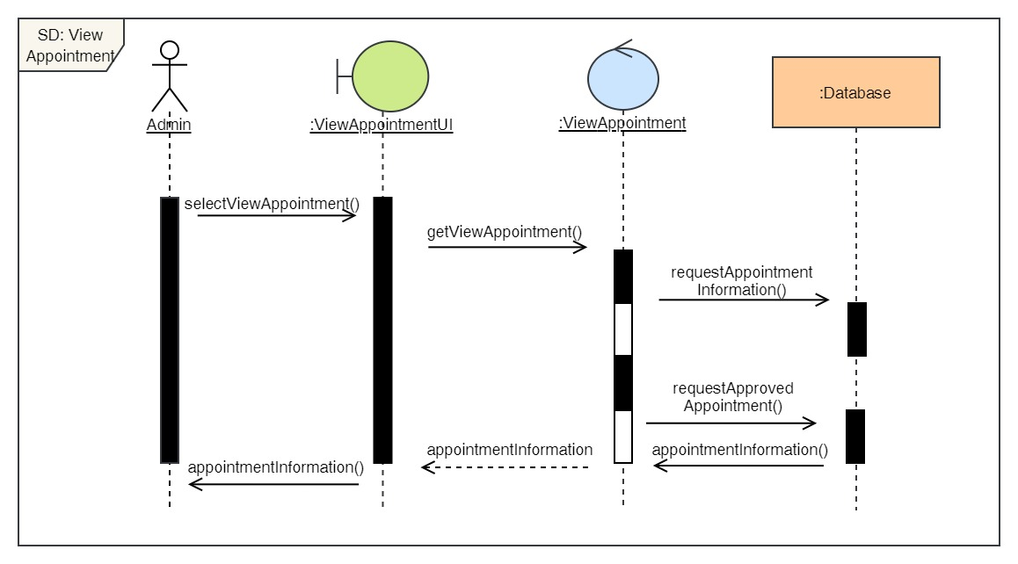

Figure 256: Sequence Diagram – Admin View Appointments

24. Cancel Appointment

**High Level Use Case Description**

|  |  |
| --- | --- |
| **Use Case:** | Cancel Appointment |
| **Actor:** | Admin |
| **Description:** | The admin can cancel appointment of the user's that has already been confirmed. |

Table 25: High Level Use Case – Admin Cancel Appointment

**Use Case Diagram**

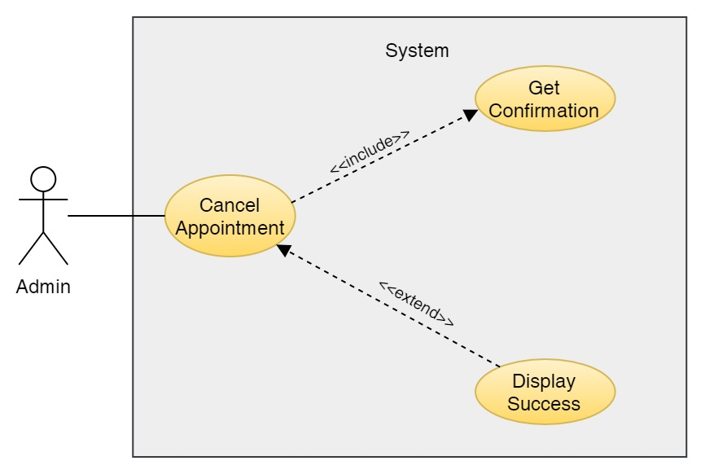

Figure 257: Use Case Diagram – Admin Cancel Appointment

**Collaboration Diagram**

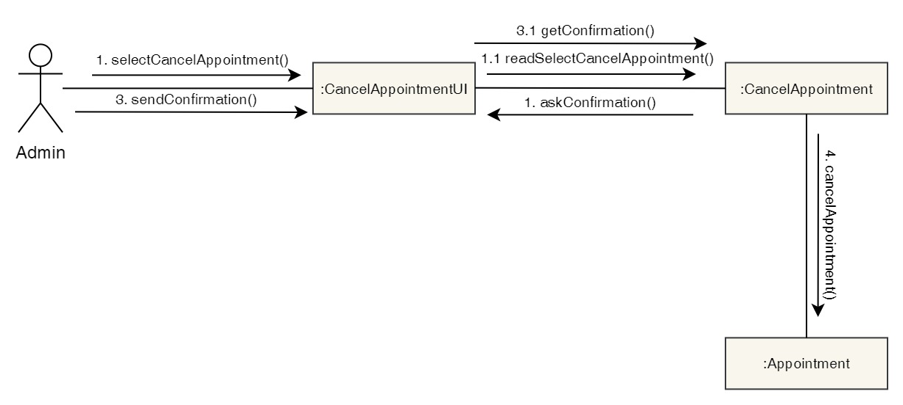

Figure 258: Collaboration Diagram – Admin Cancel Appointment

**Activity Diagram**



Figure 259: Activity Diagram – Admin Cancel Appointment

**Sequence Diagram**

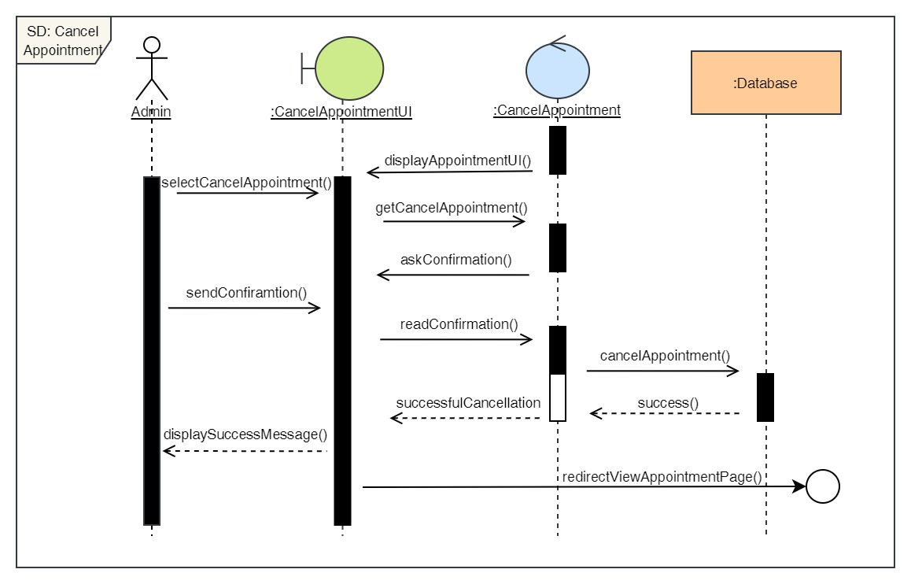

Figure 260: Sequence Diagram – Admin Cancel Appointment

25. Approve Appointment

**High Level Use Case Description**

|  |  |
| --- | --- |
| **Use Case:** | Approve Appointment |
| **Actor:** | Admin |
| **Description:** | When a user books an appointment, it gets in pending stage. The admin then approves the pending appointment and changes the status of the appointment from pending to confirmed. |

Table 26: High Level Use Case – Admin Approve Appointment

**Use Case Diagram**

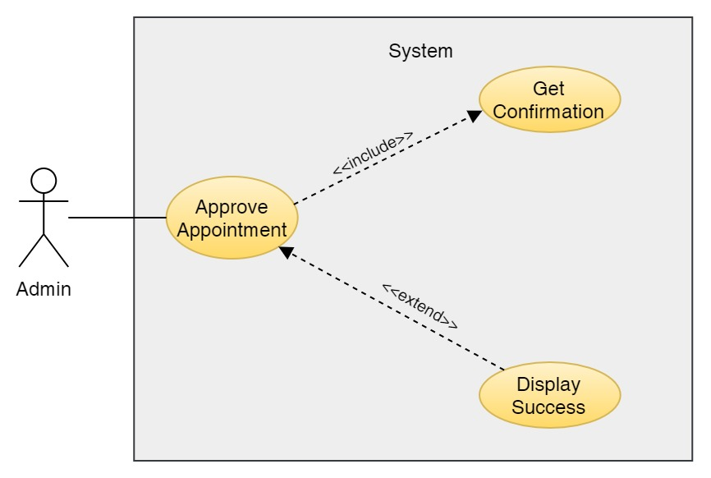

Figure 261: Use Case Diagram – Admin Approve Appointment

**Collaboration Diagram**

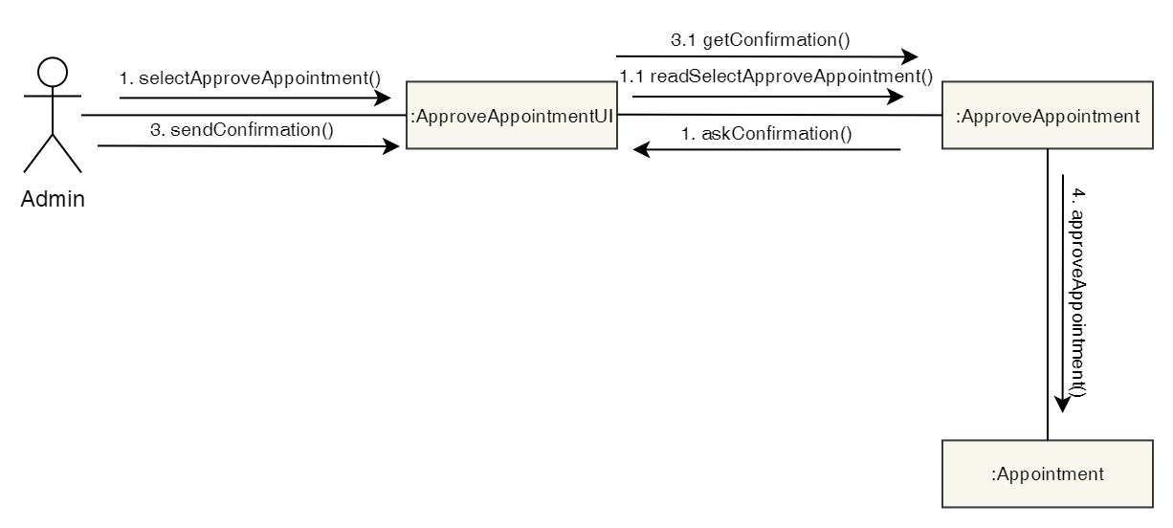

Figure 262: Collaboration Diagram – Admin Approve Appointment

**Activity Diagram**

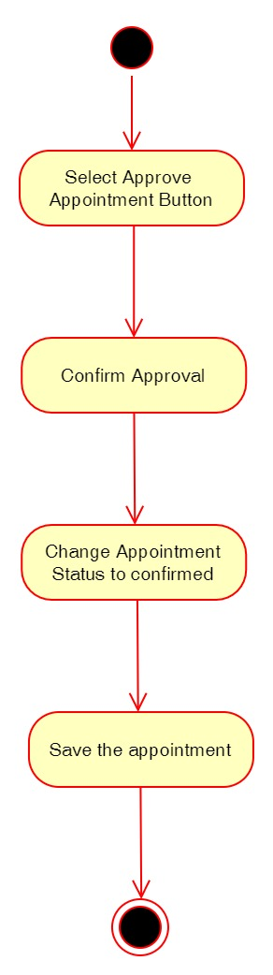

Figure 263: Activity Diagram – Admin Approve Appointment

**Sequence Diagram**

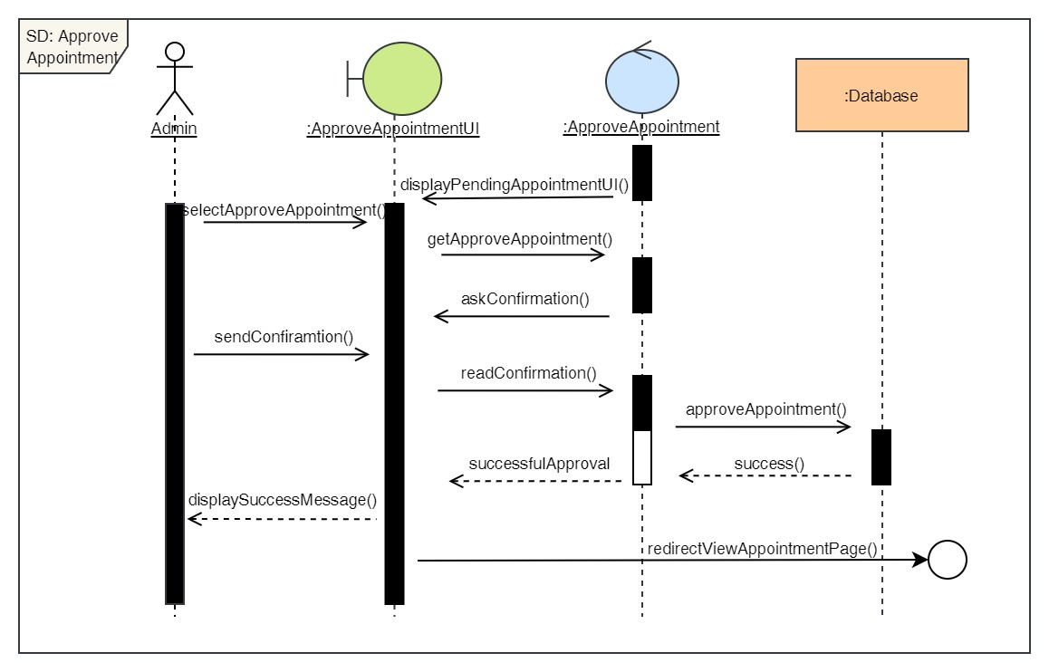

Figure 264: Sequence Diagram – Admin Approve Appointment

26. Reject Appointment

**High Level Use Case Description**

|  |  |
| --- | --- |
| **Use Case:** | Reject Appointment |
| **Actor:** | Admin |
| **Description:** | When a user books an appointment, it gets in pending stage. The admin then rejects the pending appointment if the appointment does not have enough information and changes the status of the appointment from pending to rejected. |

Table 27: High Level Use Case – Admin Reject Appointment

**Use Case Diagram**

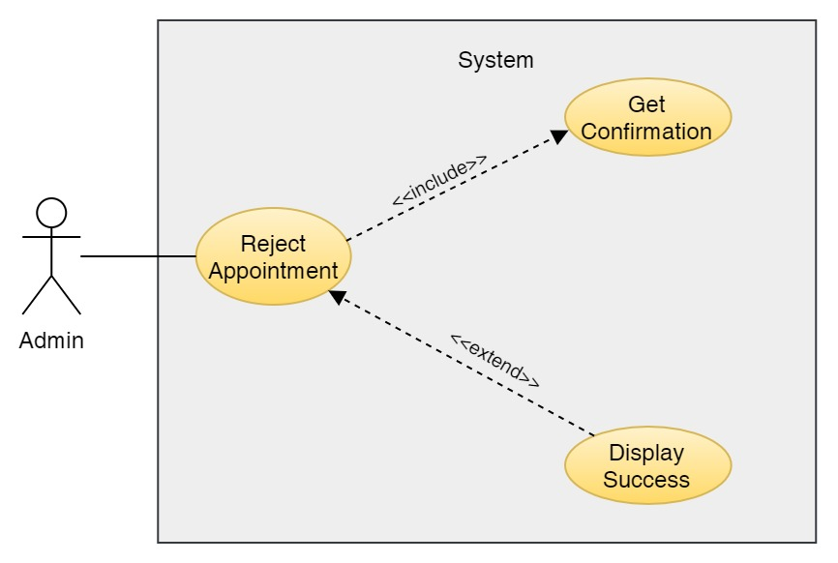

Figure 265: Use Case Diagram – Admin Reject Appointment

**Collaboration Diagram**

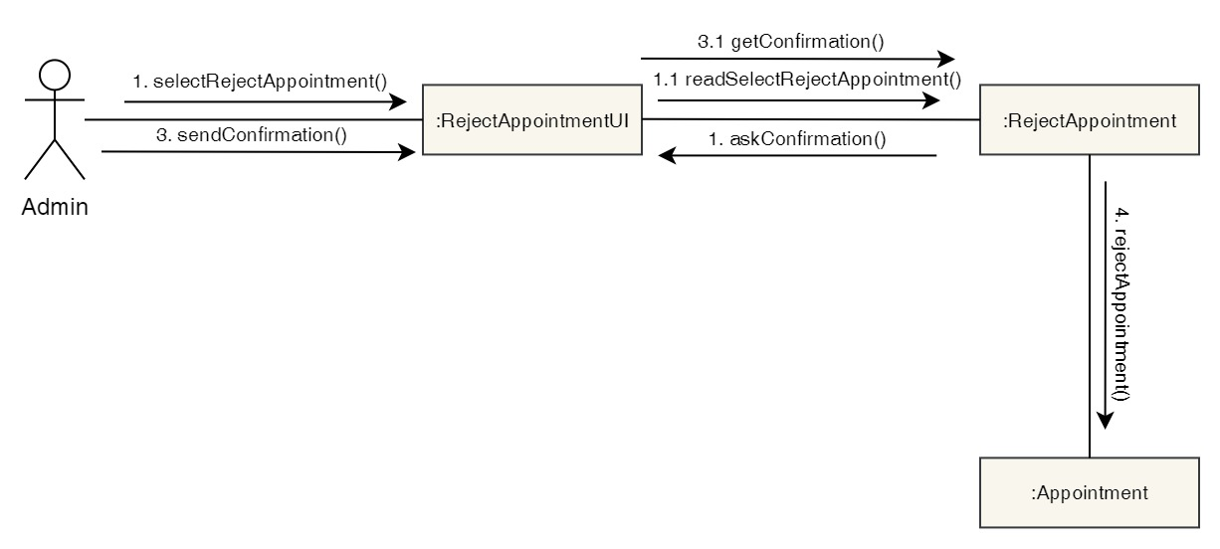

Figure 266: Collaboration Diagram – Admin Reject Appointment

**Activity Diagram**

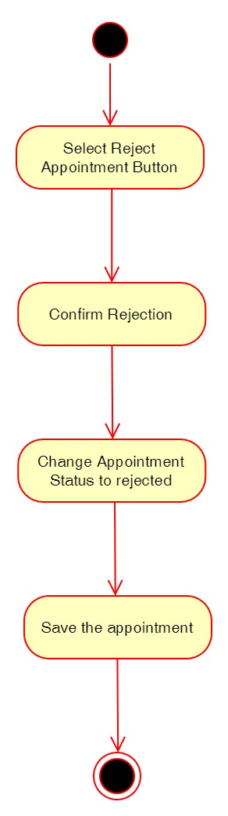

Figure 267: Activity Diagram – Admin Reject Appointment

**Sequence Diagram**

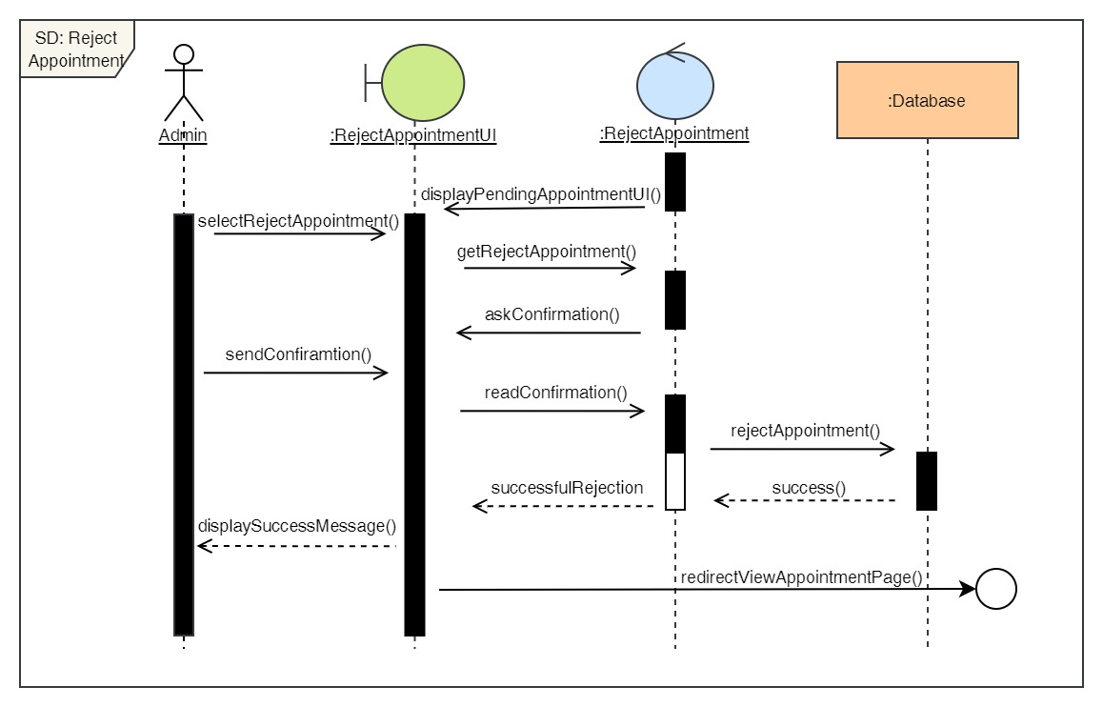

Figure 268: Sequence Diagram – Admin Reject Appointment

27. Finish Appointment

**High Level Use Case Description**

|  |  |
| --- | --- |
| **Use Case:** | Finish Appointment |
| **Actor:** | Admin |
| **Description:** | After the appointment is confirmed, it is in confirmed stage. After the user visits the clinic for their appointment and the appointment is completed, the admin changes the appointment status from confirmed to finished. |

Table 28: High Level Use Case – Admin Finish Appointment

**Use Case Diagram**

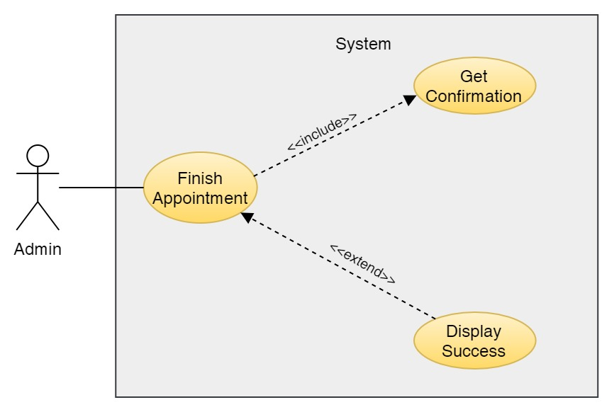

Figure 269: Use Case Diagram – Admin Finish Appointment

**Collaboration Diagram**

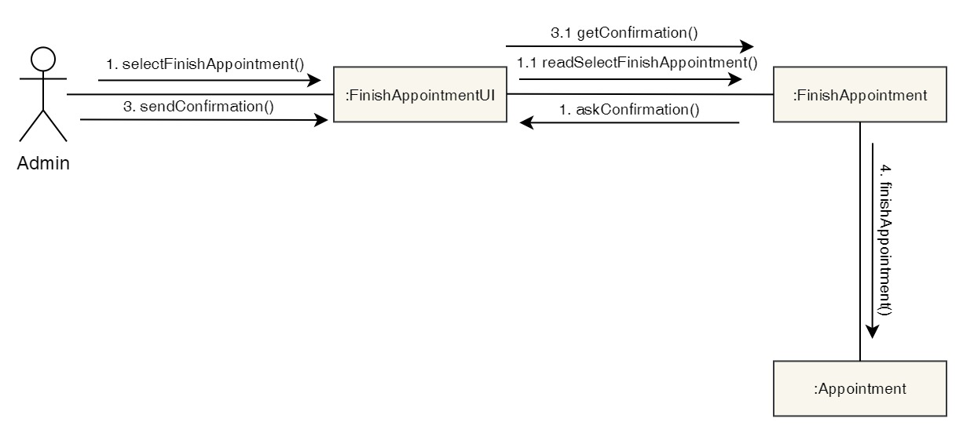

Figure 270: Collaboration Diagram – Admin Finish Appointment

**Activity Diagram**

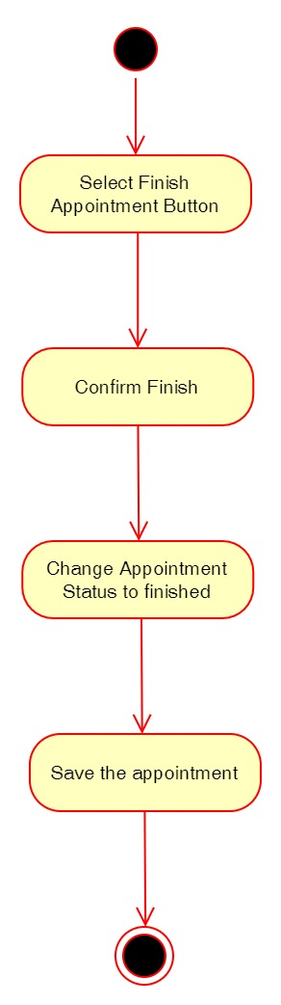

Figure 271: Activity Diagram – Admin Finish Appointment

**Sequence Diagram**

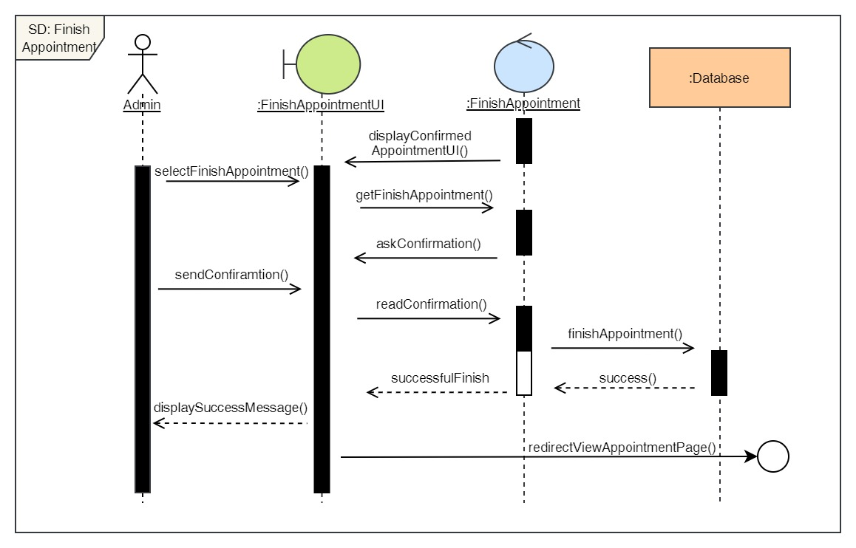

Figure 272: Sequence Diagram – Admin Finish Appointment

28. View all services

**High Level Use Case Description**

|  |  |
| --- | --- |
| **Use Case:** | View Services |
| **Actor:** | Admin |
| **Description:** | Admin can view the list of all the services available along with the cost of it and description. |

Table 77: High Level Use Case – Admin View Services

**Use Case Diagram**

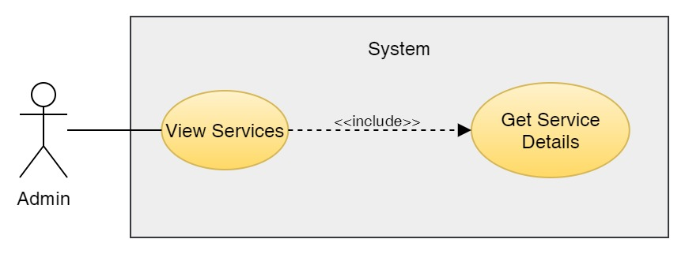

Figure 273: Use Case Diagram – Admin View Services

**Collaboration Diagram**

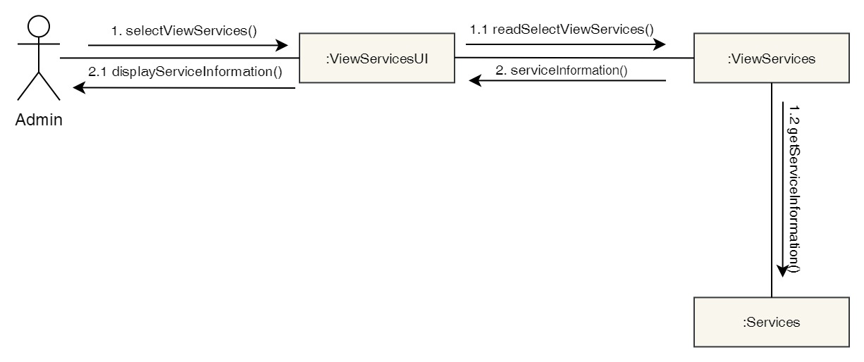

Figure 274: Collaboration Diagram – Admin View Services

**Activity Diagram**



Figure 275: Activity Diagram – Admin View Services

**Sequence Diagram**

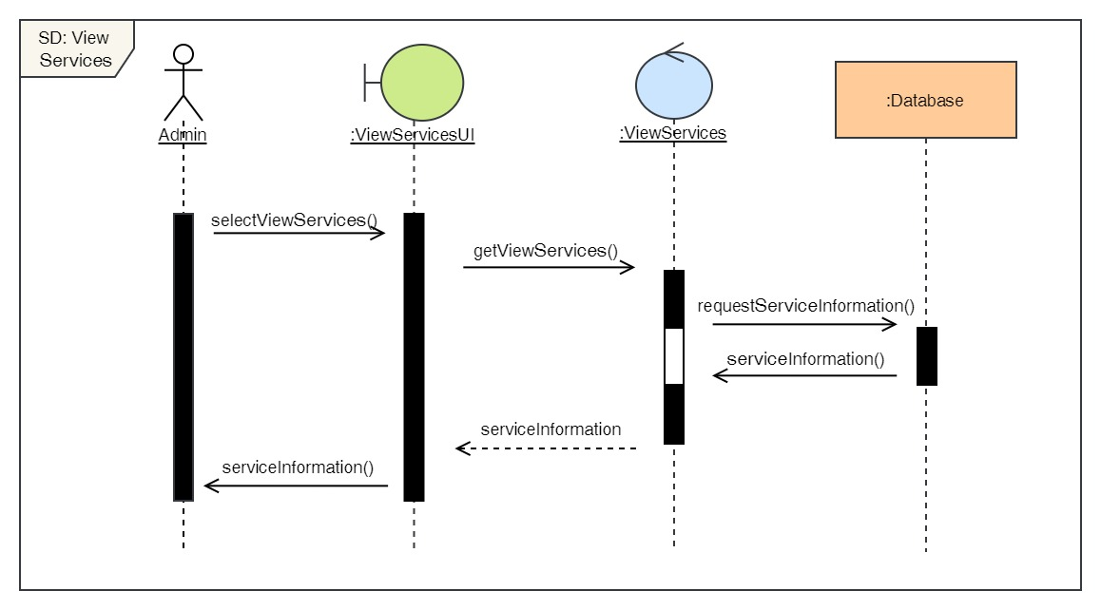

Figure 276: Sequence Diagram – Admin View Services

29. Add services

**High Level Use Case Description**

|  |  |
| --- | --- |
| **Use Case:** | Add services |
| **Actor:** | Admin |
| **Description:** | Admin can add new services in the system. |

Table 78: High Level Use Case – Admin Add Services

**Use Case Diagram**

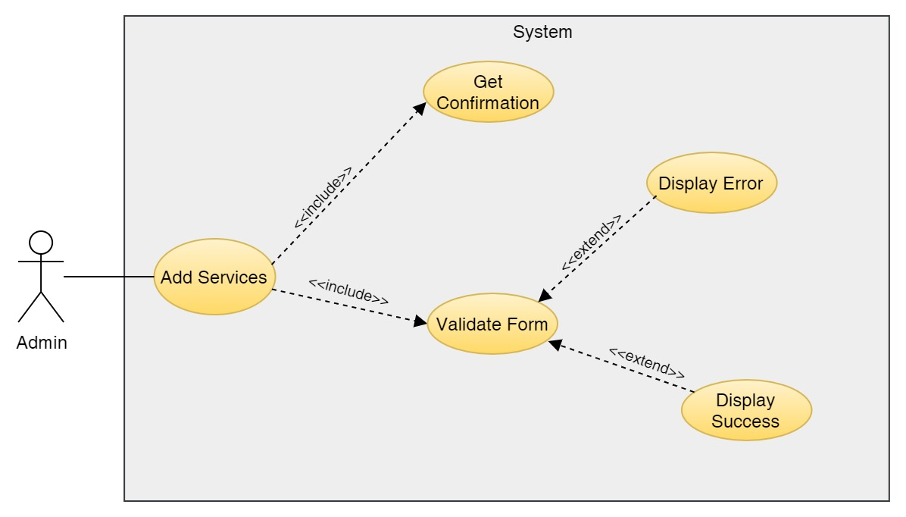

Figure 277: Use Case Diagram – Admin Add Services

**Collaboration Diagram**

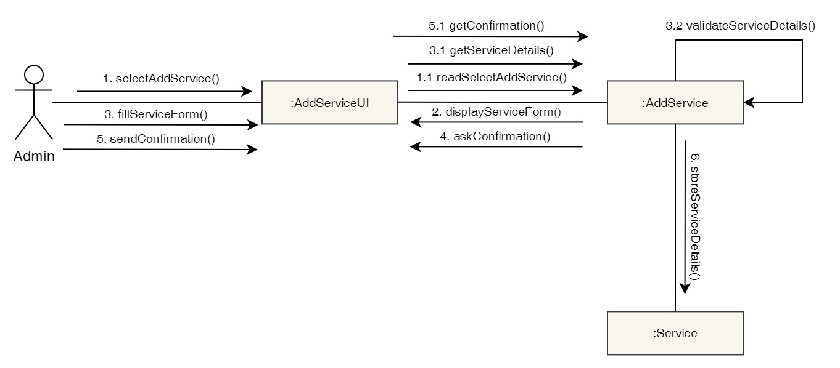

Figure 278: Collaboration Diagram – Admin Add Services

**Activity Diagram**

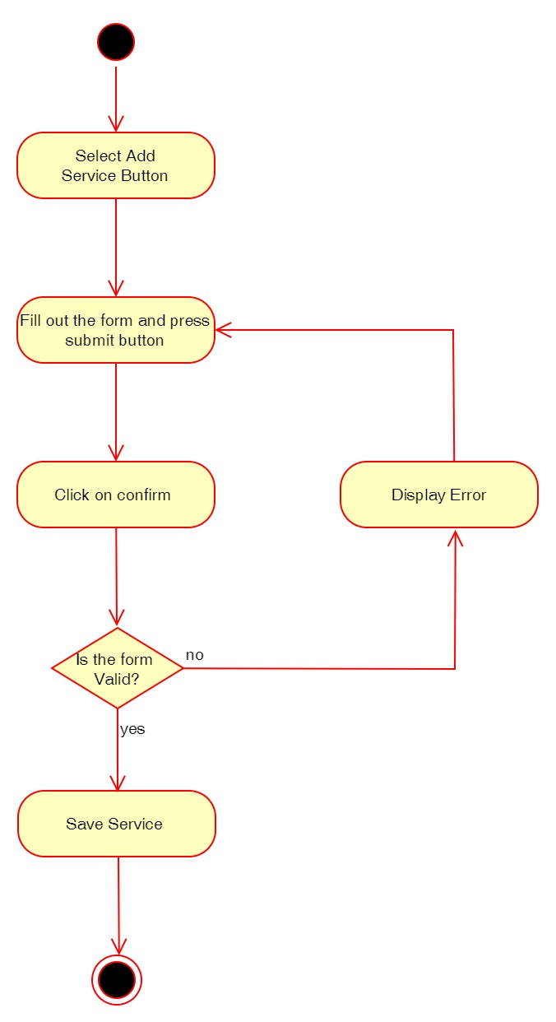

Figure 279: Activity Diagram – Admin Add Services

**Sequence Diagram**

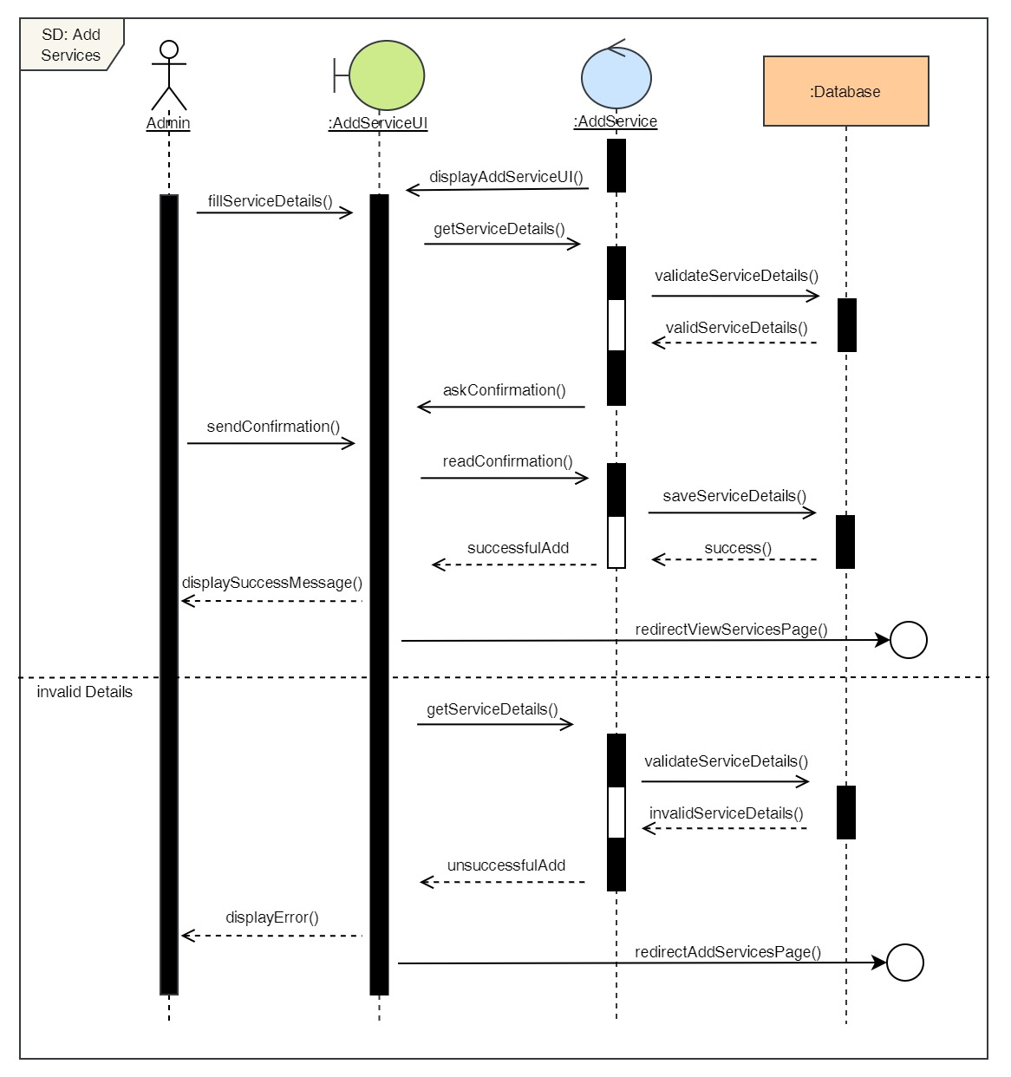

Figure 280: Sequence Diagram – Admin Add Services

30. Delete services

**High Level Use Case Description**

|  |  |
| --- | --- |
| **Use Case:** | Delete services |
| **Actor:** | Admin |
| **Description:** | Admin can add remove existing services from the system. |

Table 31: High Level Use Case – Admin Delete Services

**Use Case Diagram**

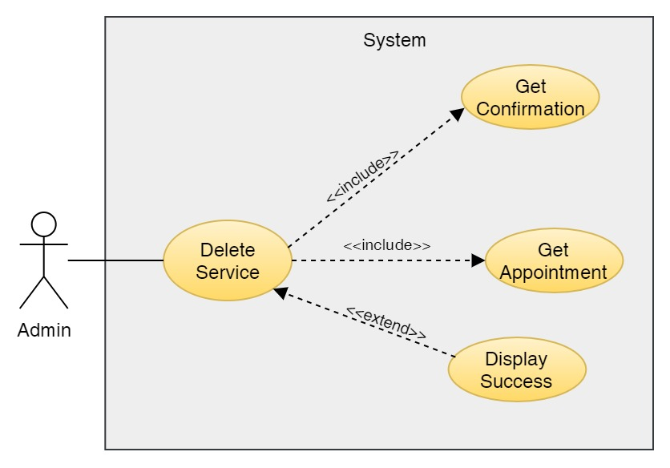

Figure 281: Use Case Diagram – Admin Delete Services

**Collaboration Diagram**

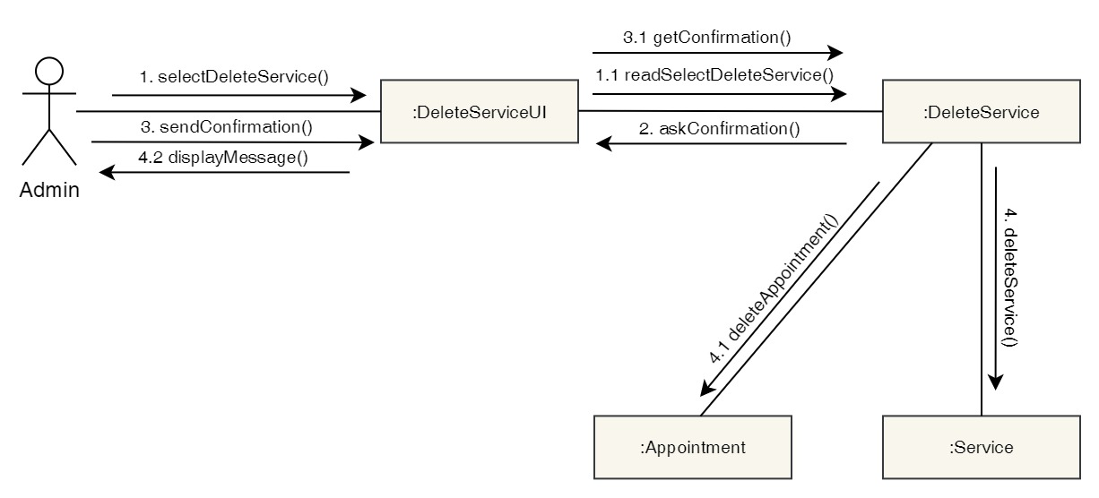

Figure 282: Collaboration Diagram – Admin Delete Services

**Activity Diagram**

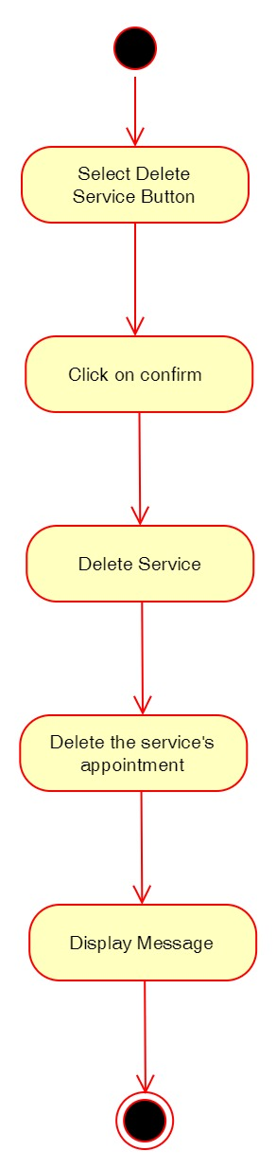

Figure 283: Activity Diagram – Admin Delete Services

**Sequence Diagram**

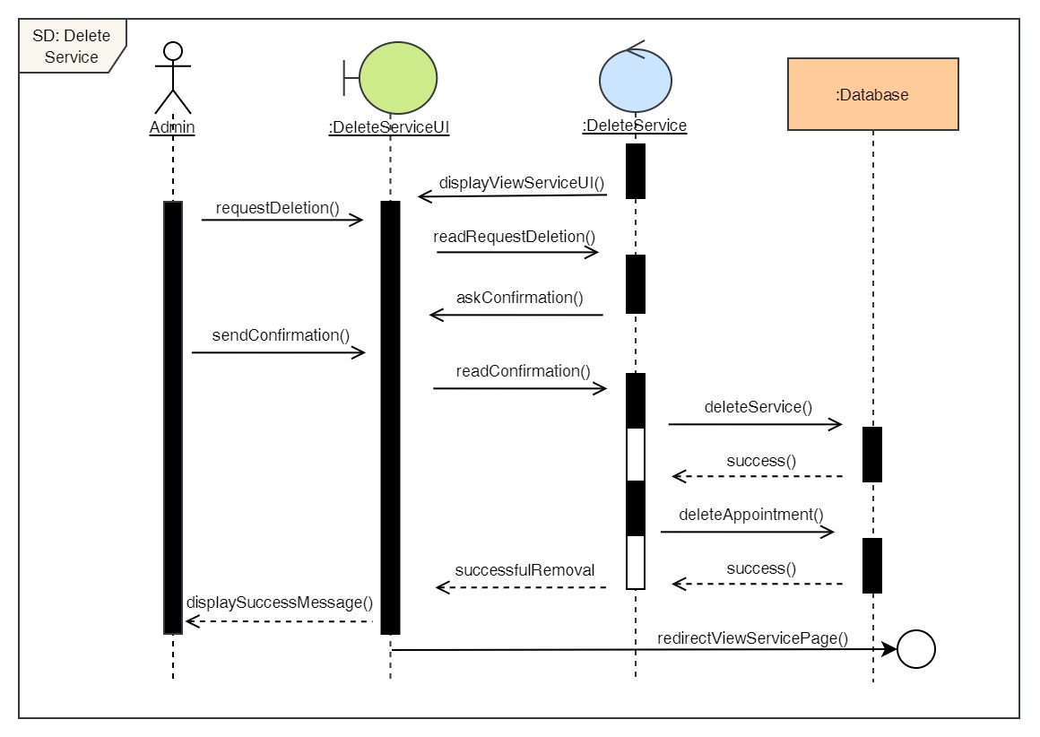

Figure 284: Sequence Diagram – Admin Delete Services

31. Edit services

**High Level Use Case Description**

|  |  |
| --- | --- |
| **Use Case:** | Edit services |
| **Actor:** | Admin |
| **Description:** | Admin can update the details of the existing services in the system. |

Table 80: High Level Use Case – Admin Edit Services

**Use Case Diagram**

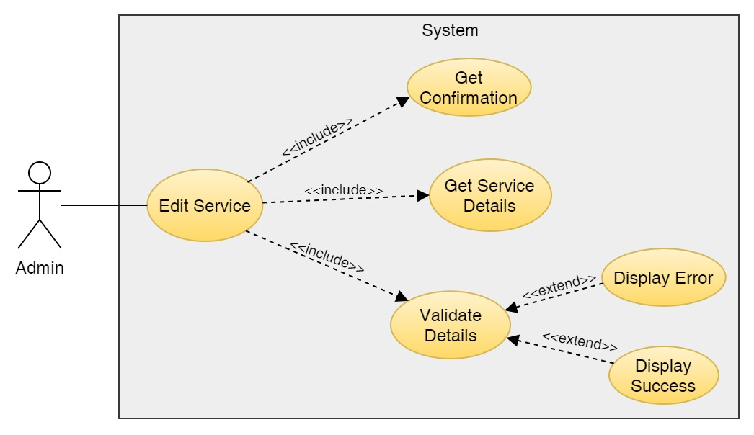

Figure 285: Use Case Diagram – Admin Edit Service

**Collaboration Diagram**

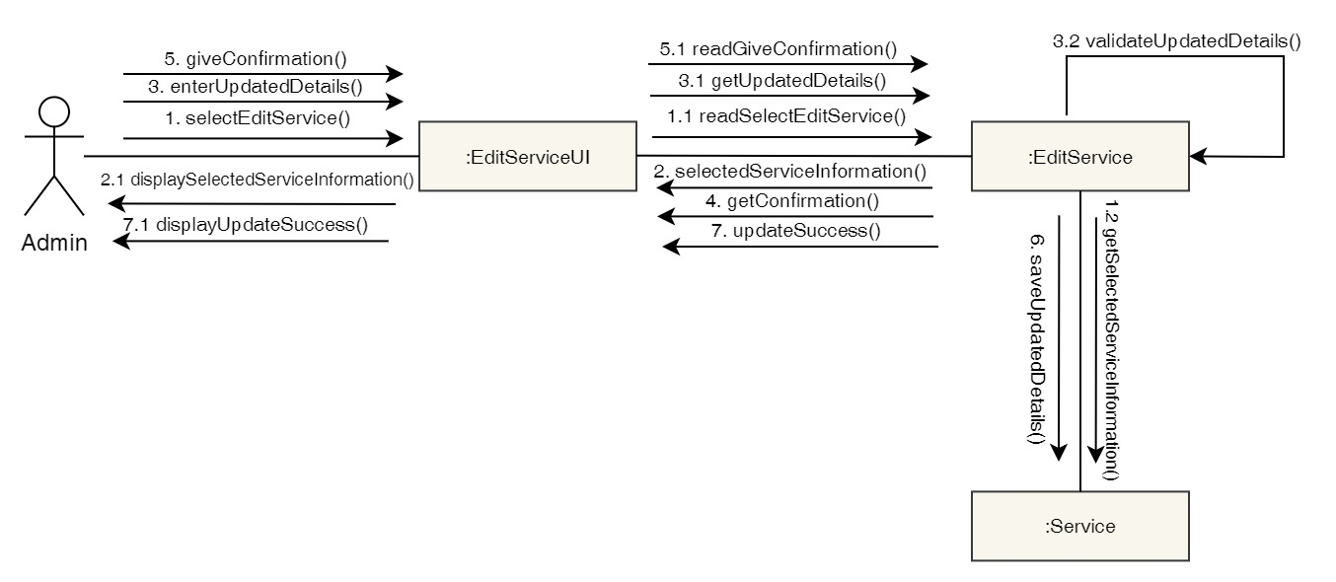

Figure 286: Collaboration Diagram – Admin Edit Service

**Activity Diagram**

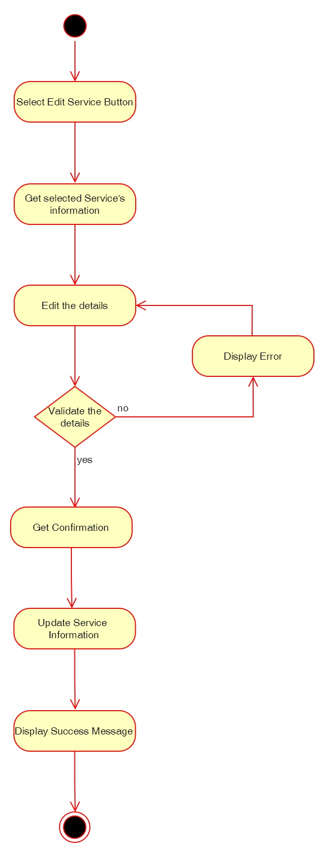

Figure 287: Activity Diagram – Admin Edit Service

**Sequence Diagram**

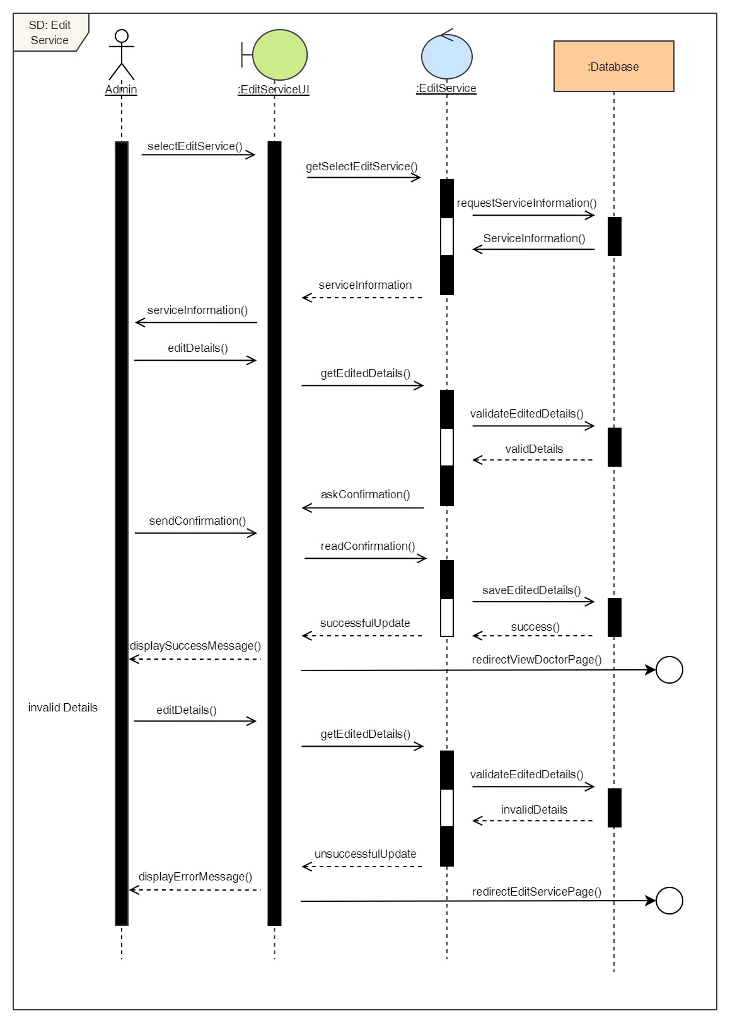

Figure 288: Sequence Diagram – Admin Edit Service

Click here to view the user side functional UML Diagrams.

Click here to view the overall Use Case Diagram.

### 7.6.2 Gantt Chart

A Gantt chart, commonly used in project management, is one of the most popular and useful ways of showing activities (tasks or events) displayed against time. (Gantt.com, 2022) The revised Gantt chart for the following Dental Appointment System is given below:

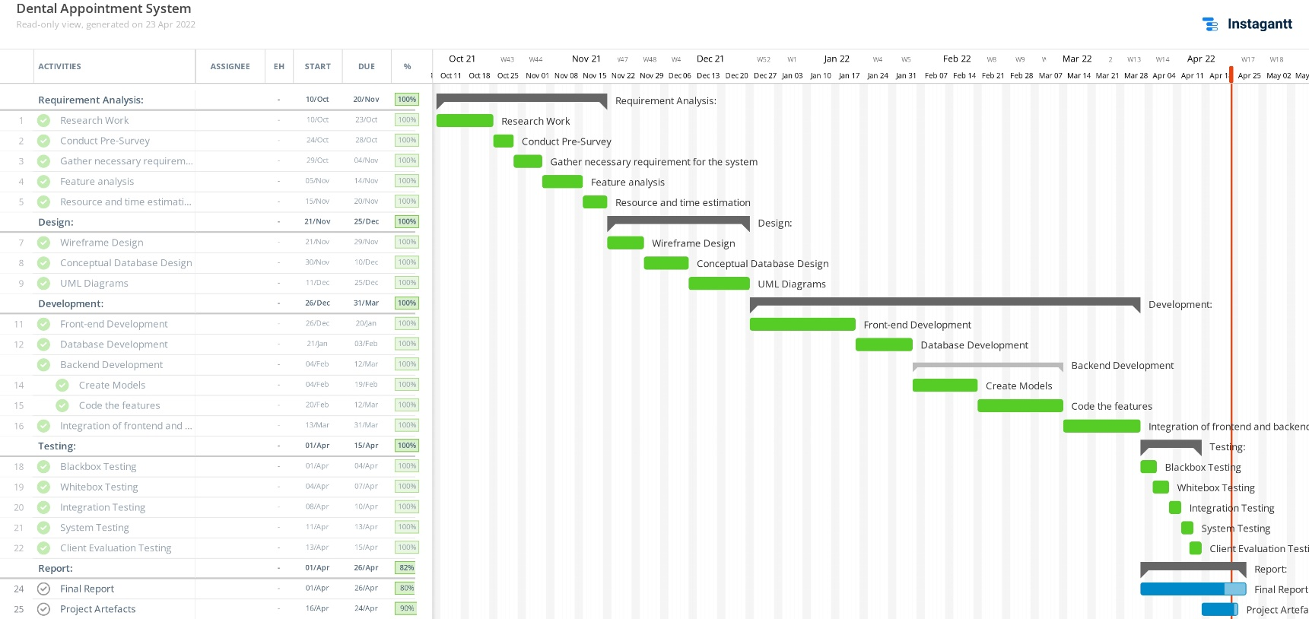

Figure 289: Gantt chart

Here, we can see the tasks according to the methodology. The Requirement Analysis, Design, Development and Testing are the four phases of the incremental methodology. The development portion has already been completed and the report part is still ongoing while the Gantt chart was created.

### 7.6.3 Work Breakdown Structure

A work breakdown structure, or WBS, is a project management tool that takes a step-by-step approach to complete large projects with several moving pieces. (Organ, 2022) A Work Breakdown Structure entails breaking down a huge, complicated project into smaller, more manageable, and self-contained jobs. The Project name is used to designate the root of this tree (structure). Each node is recursively divided into smaller sub-activities for the purpose of developing a work breakdown structure, until the activities become undividable and autonomous at the leaf level. It follows a Top-Down strategy. (Raman, 2019) The Work Breakdown Structure for the Dental Appointment System is given below:

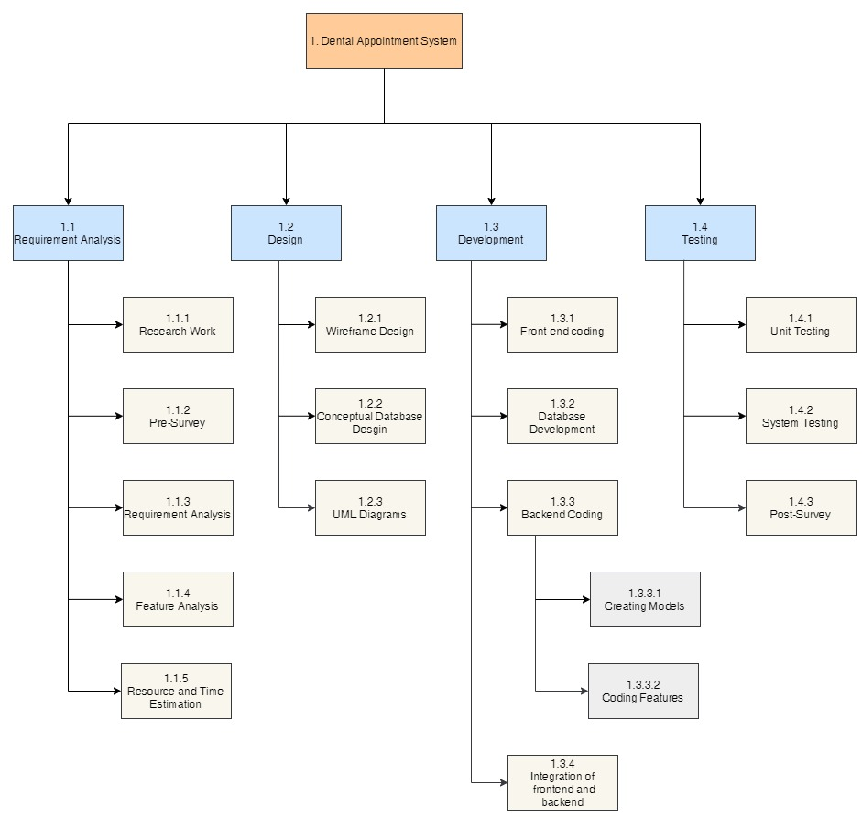

Figure 290: Work Breakdown Structure

### 7.6.4 Algorithms and Flowcharts

**7.6.4.1 Algorithm**

In computer programming terms, an algorithm is a set of well-defined instructions to solve a particular problem. It takes a set of input and produces a desired output. (Programiz, 2022) In this application, the bubble sort algorithm has been used to sort the data that has been used to display in the table. The algorithm was used to sort the details of the doctor, appointment, report, services and users data to display.

Bubble sort is a very simple algorithm that used for sorting. This sorting algorithm is comparison-based algorithm in which each pair of adjacent elements is compared and the elements are swapped if they are not in order.  (TutorialsPoint, 2022)

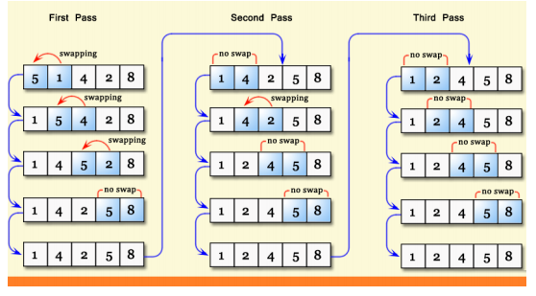

Figure 291: Bubble Sort Algorithm

The image above shows how the bubble sort algorithm works. It repeatedly swaps the adjacent elements if they are in wrong order and keeps on doing it until the elements are in correct order.

The pseudocode for the bubble sort algorithm is given below:

procedure bubbleSort( list : array of items )

loop = list.count;

for i = 0 to loop-1 do:

swapped = false

for j = 0 to loop-1 do:

/* compare the adjacent elements */

if list[j] > list[j+1] then

/* swap them */

swap( list[j], list[j+1] )

swapped = true

end if

end for

/*if no number was swapped that means

array is sorted now, break the loop.*/

if(not swapped) then

break

end if

end for

end procedure return list

**7.6.4.2 Flowchart**

Flowcharts are simply graphical representations of data or algorithms for a better visual comprehension of the code.  It shows how to solve an issue, algorithm, or procedure step by step. It is a pictorial way of representing steps that are preferred by most beginner-level programmers to understand algorithms of computer science, thus it contributes to troubleshooting the issues in the algorithm. (Mukherjee, 2021)

The overall flowchart diagram based only on the user side experience is given below:

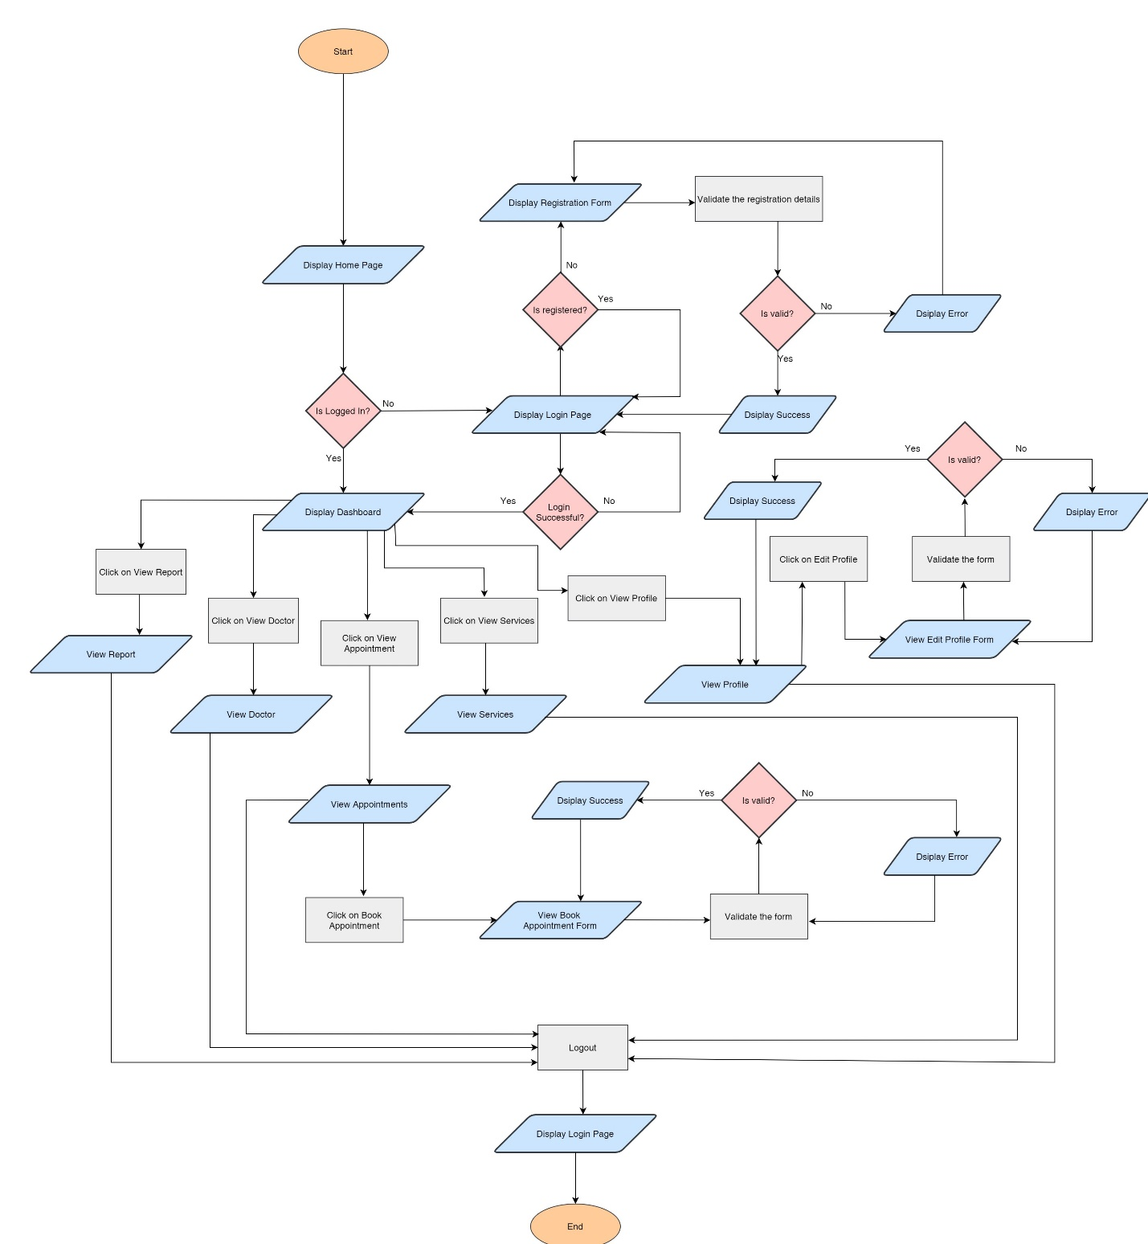

Figure 292: Flowchart of the overall system

### 7.6.5 ER Diagram Creation Process

The ERD creation process is elaborated below:

**1. Possible Entities**

The possible entities for Dental Appointment System as:

i. User – To store information about the users/admin for authentication.

ii. patientUser – To store additional information about the users.

iii. Appointments – To store the details about the appointment done by user.

iv. Services – To store the details about the services available.

v. Doctors – To store the details about the doctor.

vi. Report – To store the report of the appointment.

**2. Relationship Between Entities**

i. User and patientUser:

All the patientUser must be a User but a User can either be a patientUser or not. They can also be an admin who does not have extra fields. So, the relation between User and patientUser will be one mandatory to one optional. The entity along with relation is shown below:

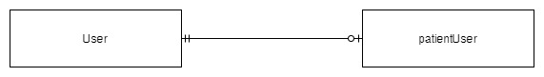

Figure 293: User-patientUser Relation

ii. patientUser and Appointment:

A user can have multiple appointment but an appointment can only belong to one patientUser. So the relation between patientUser and Appointment is One Mandatory to Many.

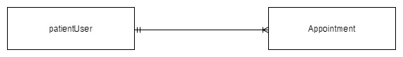

Figure 294: patientUser-Appointment Relation

iii. Report and Appointment:

A report can only belong to one appointment and an appointment can only have one report. So, the relation between report and appointment will be one mandatory to one mandatory.

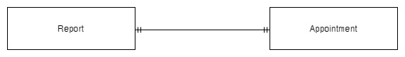

Figure 295: Report-Appointment Relation

iv. Doctor and Appointment

A doctor can oversee many appointments but an appointment can only have one doctor. So, the relation between Doctor and Appointment will be one mandatory to many.

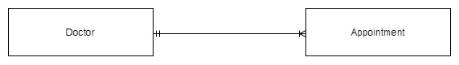

Figure 296: Doctor-Appointment Relation

v. Service and Appointment

An appointment can only be made for one services but a service can have multiple appointments. So, the relation between Services and Appointment will aslo be one mandatory to many.

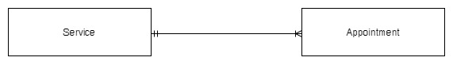

Figure 297: Service-Appointment Relation

**3. Attributes**

i. User

|  |  |  |
| --- | --- | --- |
| **Attributes** | **Data Type** | **Others** |
| ID | Integer | Primary Key, Not Null, Auto Increment |
| First_name | Varchar(150) | Not Null |
| Last_name | Varchar(150) | Not Null |
| Email | Varchar(254) | Not Null, Unique |
| Username | Varchar(150) | Not Null, Unique |
| Password | Varchar(128) | Not Null |

Table 81: User Attributes

ii. patientUser

|  |  |  |
| --- | --- | --- |
| **Attributes** | **Data Type** | **Others** |
| ID | Integer | Primary Key, Not Null, Auto Increment |
| Date_of_birth | Date | Not Null |
| Phone_number | Varchar(15) | Not Null |
| Profile_picture | Varchar(100) | Not Null, Default="img/defaultuser.png" |
| User_id | Integer | Foreign Key, Unique |

Table 82: patientUser Attributes

iii. Doctor

|  |  |  |
| --- | --- | --- |
| **Attributes** | **Data Type** | **Others** |
| ID | Integer | Primary Key, Not Null, Auto Increment |
| Full_name | Varchar(100) | Not Null |
| Qualification | Varchar(50) | Not Null |
| Date_of_birth | Date | Not Null |
| Email | Varchar(100) | Not Null |
| Phone_number | Varchar(15) | Not Null |
| Address | Varchar(50) | Not Null |
| Experience | Varchar(10) | Not Null, Default="1 year" |
| Profile_picture | Varchar(100) |  |

Table 83: Doctor Attribute

iv. Service

|  |  |  |
| --- | --- | --- |
| **Attributes** | **Data Type** | **Others** |
| ID | Integer | Primary Key, Not Null, Auto Increment |
| Service_name | Varchar(50) | Not Null |
| description | Text | Not Null |
| Cost | Integer | Not Null |

Table 84: Service Attribute

v. Appointment

|  |  |  |
| --- | --- | --- |
| **Attributes** | **Data Type** | **Others** |
| ID | Integer | Primary Key, Not Null, Auto Increment |
| Date | Date | Not Null |
| Time | Time | Not Null |
| Description | Text | Not Null |
| Doctor_id | BIGINT | Foreign Key, Not Null |
| patient ser_id | BIGINT | Foreign Key, Not Null |
| Service_id | BIGINT | Foreign Key, Not Null |
| Status | Integer | Not Null, Default="1" |

Table 85: Appointment attribute

vi. Report

|  |  |  |
| --- | --- | --- |
| **Attributes** | **Data Type** | **Others** |
| ID | Integer | Primary Key, Not Null, Auto Increment |
| Problems | Text | Not Null |
| Prescription | Text | Not Null |
| Other_details | Text | Not Null |
| Appointment_id | BIGINT | Foreign Key, Not Null, Unique |

Table 86: Report attribute

**Final ERD**

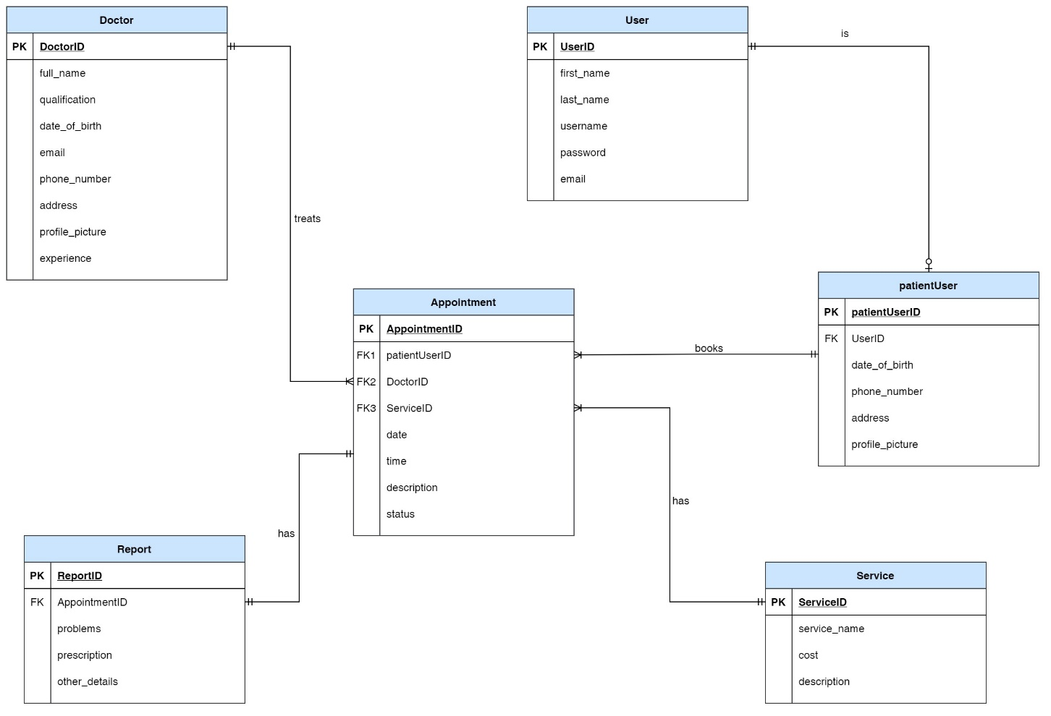

Figure 298: Final ERD:

Here, we can see User is a default database table of Django which has limited fields. So, to extend it, we created a new table called patientUser i.e. all patientUser must be a user but a user can either be a patientUser or an admin. There is Doctor and services table. The appointment table takes patientUser, services and doctor as a foreign key. A doctor treats more than one appointment but an appointment can only belong to one doctor. Similarly, a patientUser can book many appointment but an appointment can only belong to one patientUser. An appointment also has one service but a service can have multiple appointment. The report then takes appointment as a foreign key. A report can belong to only one appointment and an appointment can only have one report.

### 7.6.6 Creation of Use Case Diagram

Use case diagram shows the functionality and the actors which uses the functionality in a system. When creating a use case, an active verb or noun is used. When creating a use case diagram, the actor and the use case that the actor requires are defined.

* **System**

The project that we plan to build is called System. The method is defined by a rectangular shape in the use case diagram. It establishes the overall system's reach. The name of the system is always shown at the top.

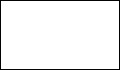

Figure 299: Rectangle which represents System

* **Actors**

In the use case diagram, the actor is portrayed by a human stick picture. The device users of the software system are referred to as actors. Actors are always kept outside the system. Primary and Secondary actors are the two groups of actors. The system's primary actors are the system's creators. It makes direct requests to the machine. Whereas secondary actors communicate less with the system and only responds to the primary actors.

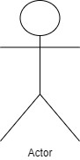

Figure 300: Human stick figure which represents Actor

* **Use Case**

It is the list of tasks that are performed by the system. It is usually done in logical order. It is represented by oval.

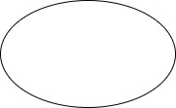

Figure 301: Oval which represents Use Case

* **Relation between actor and use case**

The relation between actor and use case is demonstrated by a solid line. It is called association relationship.



Figure 302: Solid line which represents the relation between actor and use case

* **Relationships**

**1. Include Relation**

It is the relation which is performed immediately. Use case that is auto executed with base use is include relation. The arrow points to the use case that includes it. It is represented by the following diagram:



Figure 303: Include Relation

**2. Extend Relation**

It is used to indicate that one use case extends the functionality of another use case. The arrow points to the base use case. It is represented by the following diagram:



Figure 304: Extend Relation

**3. Generalisation Relation**

It is the inheritance relation. Generalisation relation is the relation between parent and child.

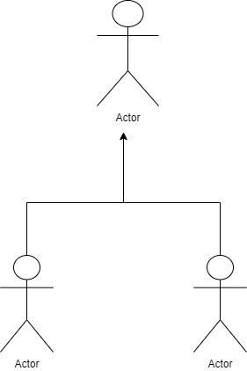

Figure 305: Generalisation Relation

Click here to see the overall use case diagram of the system.

### 7.6.7 Class Diagram

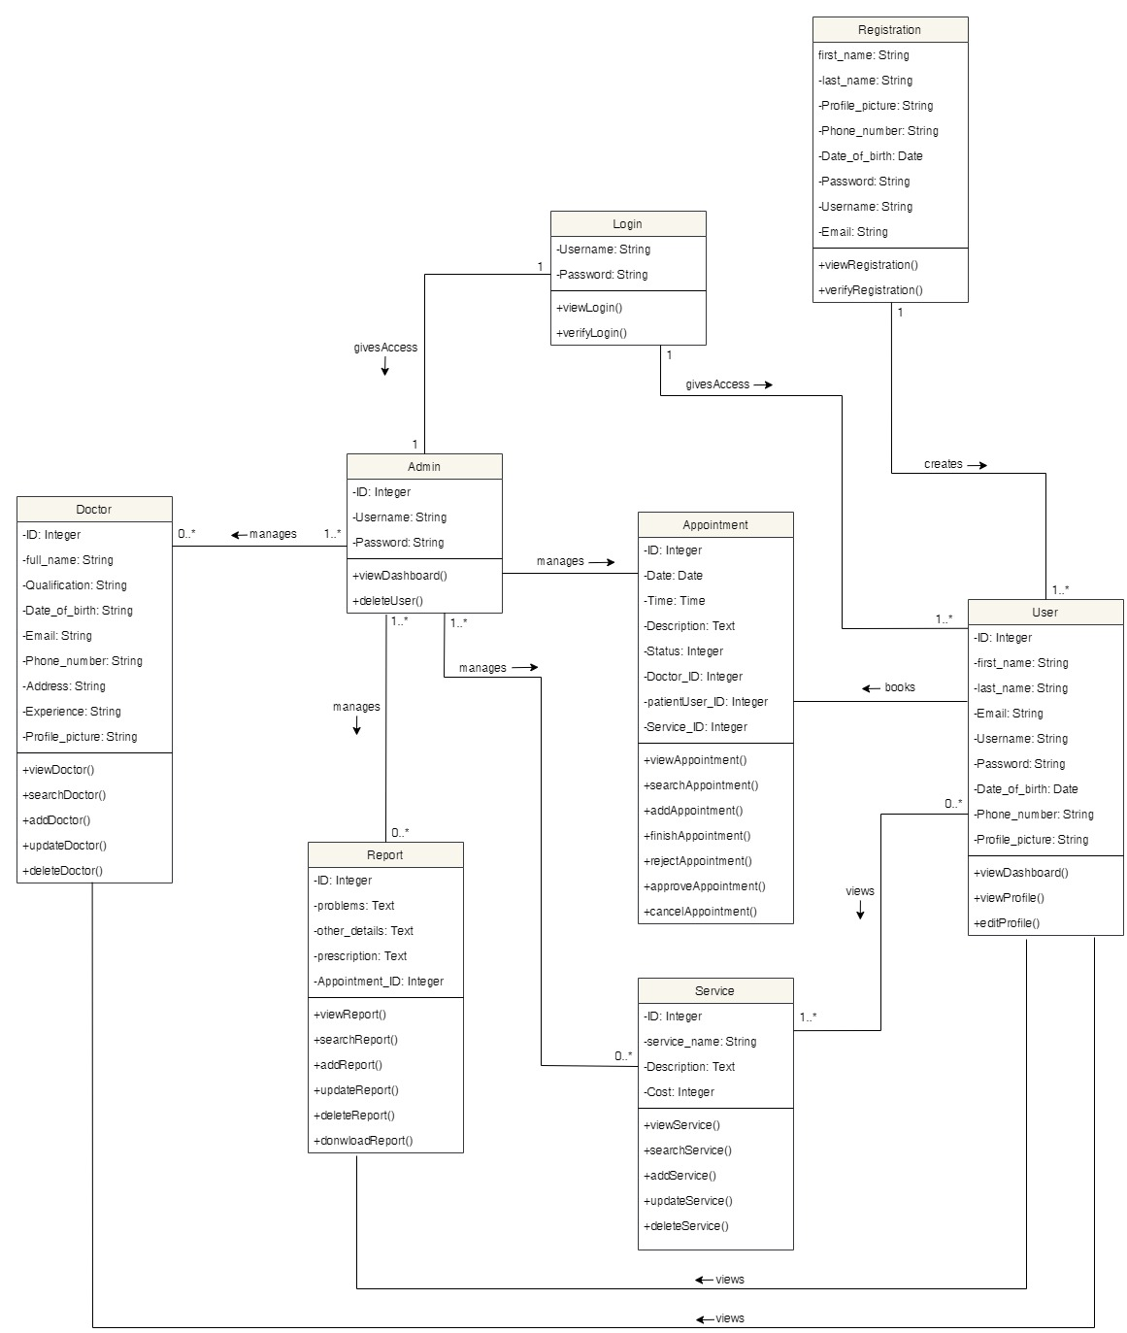

Figure 306: Class Diagram

### 7.6.8 Software Requirement Specification (SRS)

**7.6.8.1 Introduction**

**Project**: Dental Appointment System

**Category**: Web Application

**7.6.8.1.1 Purpose**

The primary purpose of this document is to provide a full description of the Dental Appointment System. It will explain the system's goal and characteristics, as well as the system's interfaces, what the system will perform, and the limitations under which it must operate. It provides a thorough explanation of the system's objectives, functionality, and user interface. It outlines how the application (system) will operate. This paper is designed for both system users and system developers.

**7.6.8.1.2 Intended Audience**

The intended audience for this system is the general public. Everyone has their dental needs that to be treated or cleaned. But not everyone has the time to go to the clinic and wait in line for hours. So, this system in intended for those people who do not wish to wait for hours for their check-up rather be more convenient and visit the clinic when they have the appointment time,

The SRS (Software requirement specification) is intended for:

* Client/User
* Developer
* Tester

**7.6.8.1.3 Project Scope**

The primary goal of this system is to manage users' appointments and to build a user-friendly application for booking appointments. This program assists users in connecting to a database server and logging into the system. Above all, we believe in providing excellent service at a reasonable cost. This application will help to schedule an appointment and manage the work efficiently It is a booking system that the user uses to schedule an appointment. The user can also view the doctors and services available along with the costs of services and the details of the doctors. Furthermore, users can view their report after their visit to the clinic. This helps avoid the loss of report that will be useful for the next meeting. This application is intended for a particular clinic only i.e. Phulchowki Dental Clinic.

The terms present in the documentations are:

* Admin: The person who is responsible for managing the whole system.
* User: A person who is using the application with limited privilege.
* Database: A server for the storing information of this system.

**7.6.8.2 Overall Description**

**7.6.8.2.1 System Perspective**

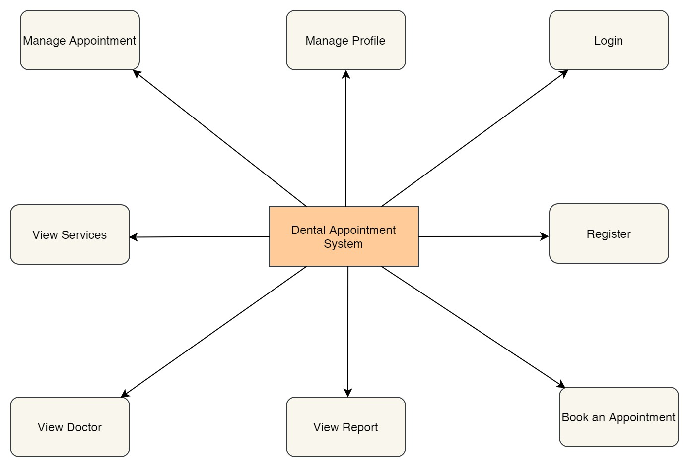

Figure 307: System Perspective Diagram

The features of the web based application are as mentioned below:

SP1: Register

SP2: Login

SP3: Book an appointment

SP4: View Report

SP5: View Doctor

SP6: View Services

SP7: Manage Appointment

SP8: Manage Profile

**Use Case of the Overall System**



Figure 308: Overall Use Case of the System

**7.6.8.2.2 System Features**

**SF1: Register**

**Description:** New users who have not yet been registered to the system registers into it using the web browser. The registration details entered by the user is then verified by the system.

**SF2: Login**

**Description:** Registered Users can proceed to login to the system to use the features using the web browser. The login details entered by the customer is then verified by the system.

**SF3: Book an Appointment**

**Description:** Users can book an appointment for their dental requirements. The appointment is then reviewed by the admin.

**SF4: View Report**

**Description:** Users can view the report for their appointment only after it has been finished.

**SF5: View Doctor**

**Description:** Users can view the list of doctors available in the clinic along with their description and select the one they want to book an appointment with.

**SF: View Services**

**Description:** Users can view the list of services available in the clinic along with the cost and description of it.

**SF7: Manage Appointment**

**Description:** Users can view the list of their appointments and cancel their pending as well confirmed appointment if the need arises to.

**SF8: Manage Profile**

**Description:** Users can view their profile and edit their details that they previously entered while registering. However, they cannot change their username.

**7.4.5.2.3 User Class and Characteristics**

The following are the classes for users who will be using the Dental Appointment System application with their roles:

**UC1: Patient User**

**UC1.1**: Book an appointment for their dental requirements

**UC1.2**: Browse doctors available in the clinic

**UC1.3**: View services available in the clinic

**UC1.4**: Manage their appointment

**UC1.5**: Manage their profile

**UC1.6**: View the reports of their appointment visit

**UC2: Admin User**

**UC2.1**: Manage appointments booked by the patient users like approving, rejecting, finishing and cancelling the appointments of the users.

**UC2.2**: Manage the reports of the user's appointments like adding, updating and deleting.

**UC2.3**: Manage the doctors in the clinic like adding new doctors, updating and deleting the existing ones if the need arises.

**UC2.4**: Manage the services in the clinic like adding new services, updating and deleting the existing ones if the need arises.

**UC2.5**: Manage users and deleting them if needed.

**UC3: Client**

**UC3.1**: Requirement analysis and finalization

**UC3.2**: Check whether the requirements are met or not at the time of delivery

**UC3.3**: Provide funding, resources and further information if needed

**UC4: Developer**

**UC4.1**: Check for errors and fix the bugs

**UC4.2**: Add additional features

**UC4.3**: Provide progress to the client

**UC4.4**: Manage the databases

**7.6.8.2.4 Operating Environment**

**OE1:** Currently the dental appointment system web application is available in any web browser like Google Chrome, Microsoft Edge, Mozilla Firefox, etc. In the near future, the application will also run on other platforms such as Android and iOS.

**7.6.8.2.5 Design and implementation constraints**

**CO1:** Only registered users can book the appointment.

**CO2:** Reports can only be made of appointments that are marked as finished by the admin.

**CO3:** User can only view their appointment, report and profile.

**CO4:** User can view all the doctors and services.

**CO5:** User cannot access the admin's panel.

**CO6:** User can only cancel their pending and confirmed appointments.

**CO7:** Only admin can approve, reject and finish the user's appointments.

**CO8:** Only admin can manage the doctor, reports and services

**CO8:** The appointment can only be taken from 9am – 5pm any day of the week.

**7.6.8.2.6 Assumptions and Dependencies**

**AS1**: This application is target mainly for those who have to visit dental clinic for their dental check-ups.

**AS2**: The application will be connected with the database.

**AS3**: The documentation and reports of the system are only accessible to limited people like the client and developers.

**AS4**: The users can book any number of appointment they may like to. However, they may only choose one service at a time but can include other services at the same time by mentioning in the description.

**7.6.8.3 Functional Requirement**

**7.6.8.3.1 Login Feature**

|  |  |  |  |
| --- | --- | --- | --- |
| **Req.ID** | **Requirement Description** | **Priority** | **Complexity** |
| **FR1** | All users will be able to access the login page   |  |  | | --- | --- | | **System Requirement** | | | **SR1** | On opening the application, the user will be directed to the home/landing page. | | **SR2** | When the user click the ‘Login’ button, they will be directed to the login page | | **SR3** | The user needs to enter their login details i.e. username and password in order to log in to the application. If the credentials are correct, they will be redirected towards the user dashboard page. | | Most | High |

Table 87: Functional Requirement 1

**7.6.8.3.2 Register Feature**

|  |  |  |  |
| --- | --- | --- | --- |
| **Req.ID** | **Requirement Description** | **Priority** | **Complexity** |
| **FR2** | All users will be able to access the register page   |  |  | | --- | --- | | **System Requirement** | | | **SR4** | When the user click the ‘Register' button, they will be directed to the register page | | **SR5** | The user needs to fill the registration form. The details are then verified by the system and the user will be registered in to the system. The user can then log in using their username and password. | | Most | High |

Table 88: Functional Requirement 2

**7.6.8.3.3 Booking an appointment and manage appointment**

|  |  |  |  |
| --- | --- | --- | --- |
| **Req.ID** | **Requirement Description** | **Priority** | **Complexity** |
| **FR3** | All users who are registered and logged in will be able to use this feature.   |  |  | | --- | --- | | **System Requirement** | | | **SR6** | After logging in, the users will be directed to their dashboard page. | | **SR7** | When the user clicks the ‘Book Appointment’ button, they will be directed to the book appointment page. | | **SR8** | The user needs to fill the form and click submit. If the details are valid, the appointment is then viewed by admin for approval. | | Most | High |
| **FR4** | All users who have at least one appointment can use this feature.   |  |  | | --- | --- | | **System Requirement** | | | **SR9** | When the user clicks the ‘View Appointment’ button, they will be directed to the view appointment page. | | **SR10** | The user can cancel their pending or confirmed appointment by clicking the 'cancel' button. | | Most | High |

Table 89: Functional Requirement 3

**7.6.8.3.4 View Report**

|  |  |  |  |
| --- | --- | --- | --- |
| **Req.ID** | **Requirement Description** | **Priority** | **Complexity** |
| **FR5** | The user must have at least one appointment marked as finished to view the reports.   |  |  | | --- | --- | | **System Requirement** | | | **SR11** | After logging in, the users will be directed to their dashboard page. | | **SR12** | When the user clicks the ‘View Report’ button, they will be directed to the view report page. | | **SR13** | The user will be able to view the report details of the appointment that they have finished. The admin upload the report and the user can view it. | | Most | High |

Table 90: Functional Requirement 4

**7.6.8.3.5 View Doctor**

|  |  |  |  |
| --- | --- | --- | --- |
| **Req.ID** | **Requirement Description** | **Priority** | **Complexity** |
| **FR6** | The user must be registered and logged in to view this feature.   |  |  | | --- | --- | | **System Requirement** | | | **SR14** | After logging in, the users will be directed to their dashboard page. | | **SR15** | When the user clicks the ‘View Doctor' button, they will be directed to the view doctor page. | | **SR16** | The user will be able to view the doctors along with their details. | | Most | Normal |

Table 91: Functional Requirement 5

**7.6.8.3.6 View Services**

|  |  |  |  |
| --- | --- | --- | --- |
| **Req.ID** | **Requirement Description** | **Priority** | **Complexity** |
| **FR7** | The user must be registered and logged in to view this feature.   |  |  | | --- | --- | | **System Requirement** | | | **SR17** | After logging in, the users will be directed to their dashboard page. | | **SR18** | When the user clicks the ‘View Services' button, they will be directed to the view services page. | | **SR19** | The user will be able to view the services along with their details. | | Most | Normal |

Table 92: Functional Requirement 6

**7.6.8.3.7 Manage Profile**

|  |  |  |  |
| --- | --- | --- | --- |
| **Req.ID** | **Requirement Description** | **Priority** | **Complexity** |
| **FR8** | The user must be registered and logged in to view this feature.   |  |  | | --- | --- | | **System Requirement** | | | **SR20** | After logging in, the users will be directed to their dashboard page. | | **SR21** | When the user clicks the ‘View Profile' button, they will be directed to the view profile page. | | **SR22** | The user will be able to view their details. | | Most | Medium |
| **FR9** | The user must be registered and logged in to view this feature.   |  |  | | --- | --- | | **System Requirement** | | | **SR23** | When the user clicks the ‘Edit Profile' button, they will be directed to the view services page. | | **SR24** | When the user clicks the ‘View Profile' button, they will be directed to the edit profile page. | | **SR25** | The user will be able to update their details and if the details are valid, the details of the users will be updated. | | Most | High |

Table 93: Functional Requirement 7

**7.6.8.4 External Interface Requirement**

**7.6.8.4.1 User Interfaces**

The project's user interface will be intended to be clean and simple to use. Simple phrases will be used, and page titles will be assigned based on the objective of the page. The application will make use of appropriate colour schemes and fonts. Similarly, the photos in the program will be retained in order to deliver a relevant message to the users. User testing will be done on a regular basis to ensure maximum effort and happiness.

The home page was made as a one page website. The screenshot of the home page UI is shown below:

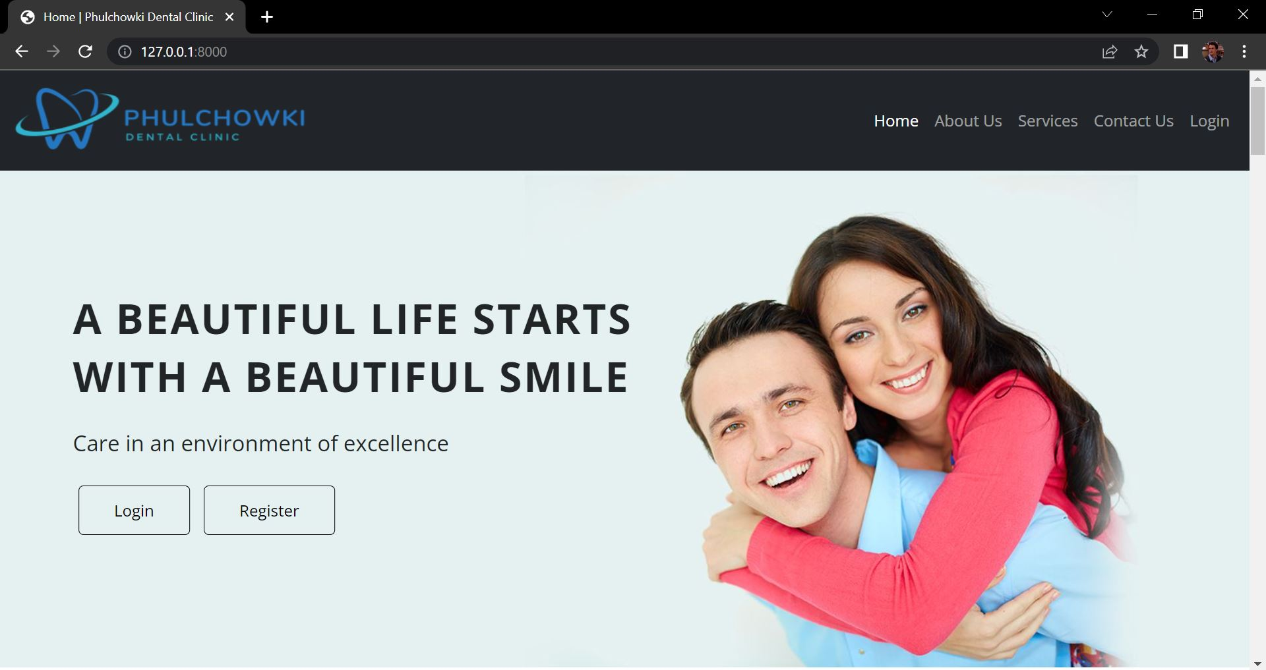

Figure 309: UI of Home Page 1

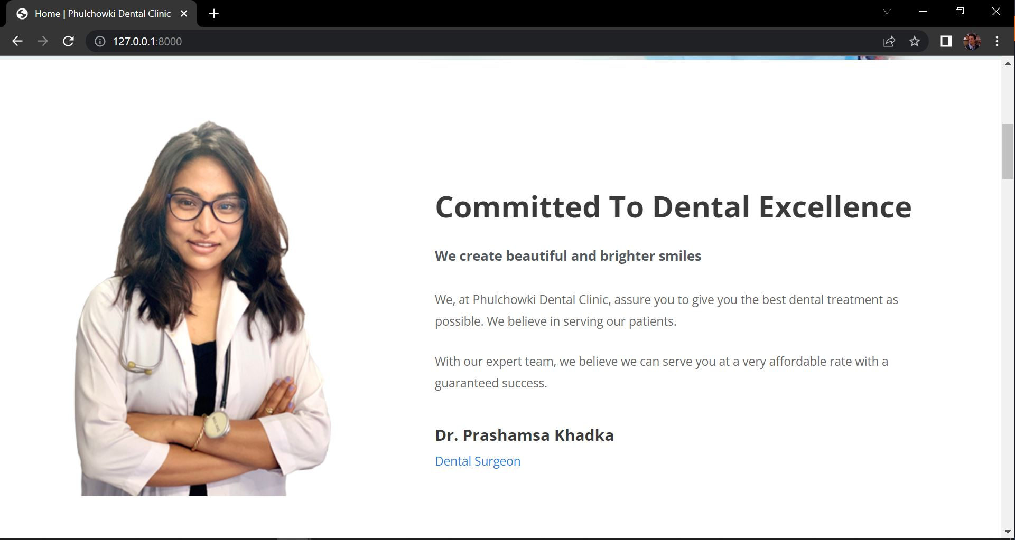

Figure 310: UI of Home Page 2

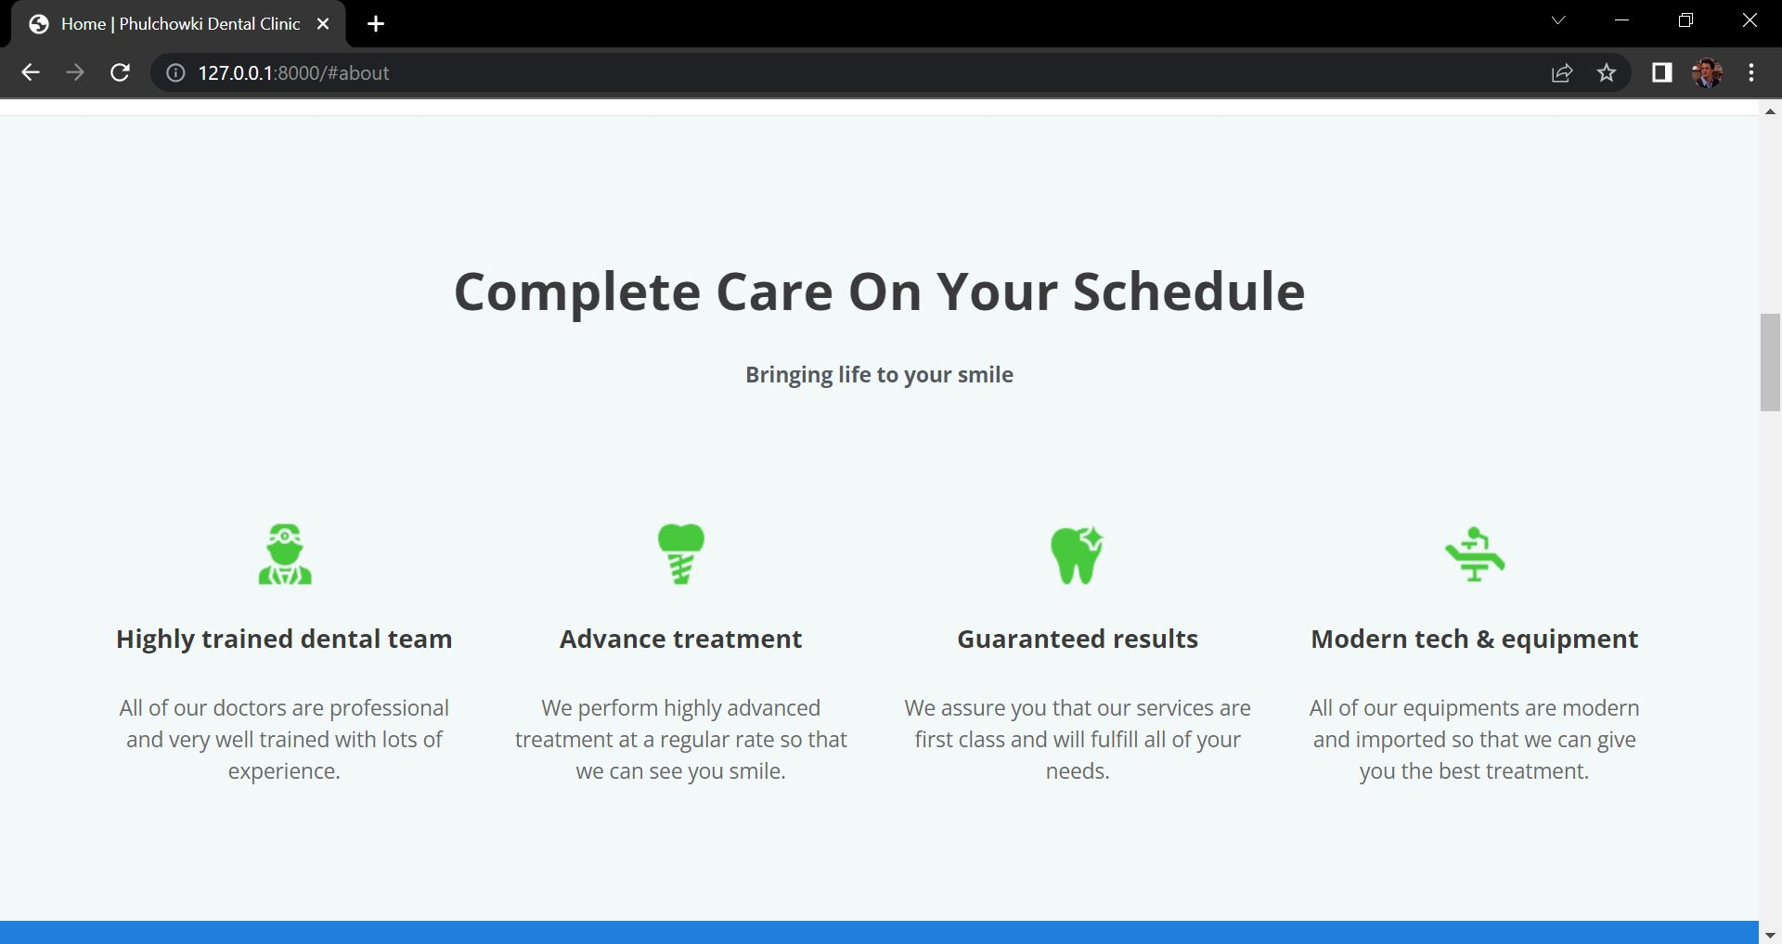

Figure 311: UI of Home Page 3

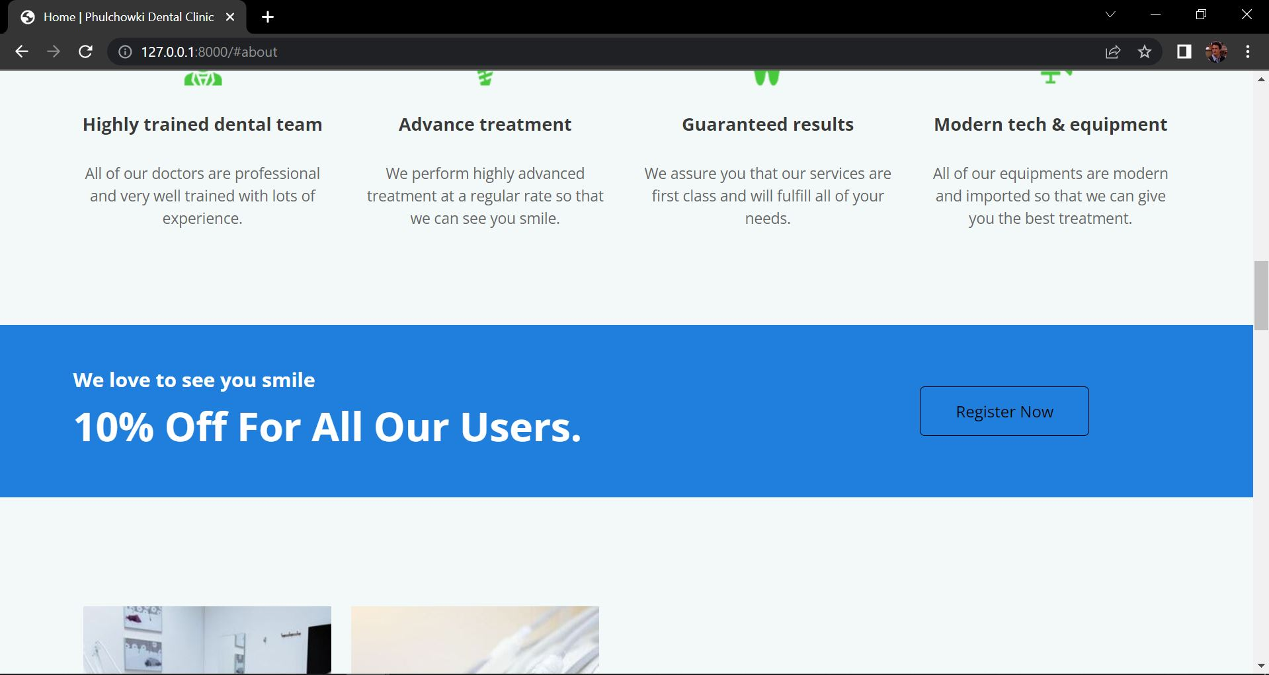

Figure 312: UI of Home Page 4

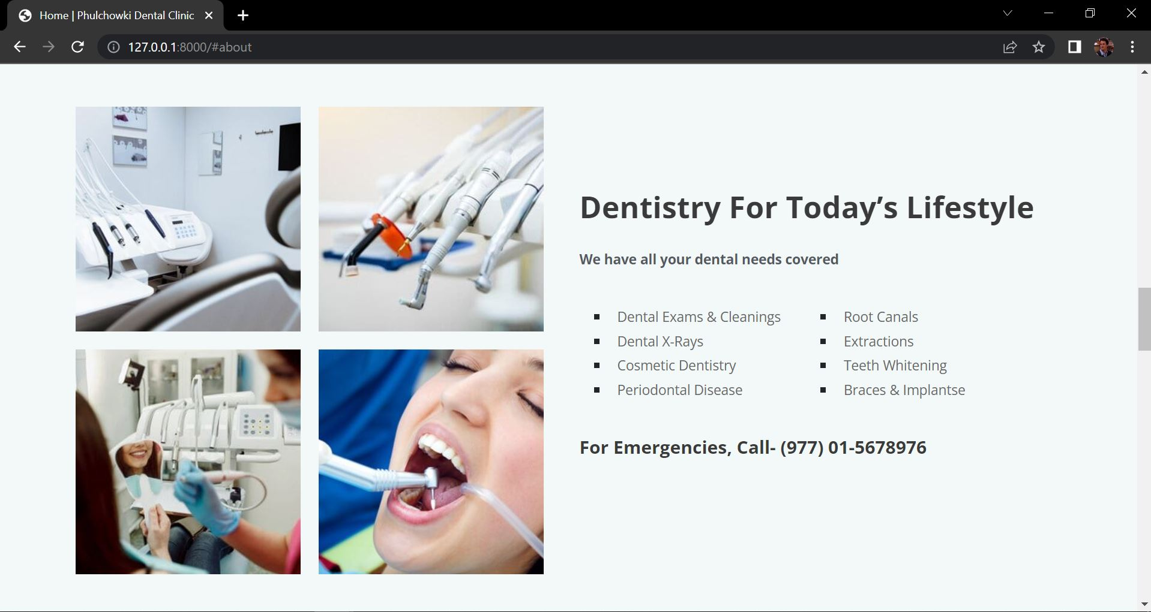

Figure 313: UI of Home Page 5

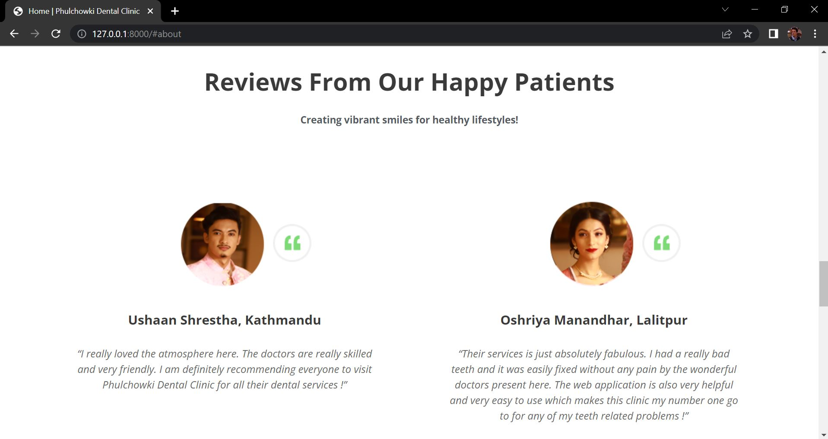

Figure 314: UI of Home Page 6

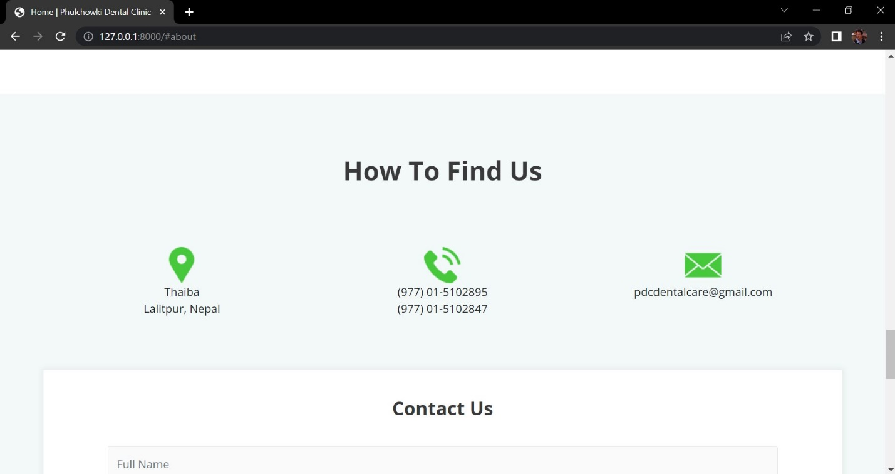

Figure 315: UI of Home Page 7

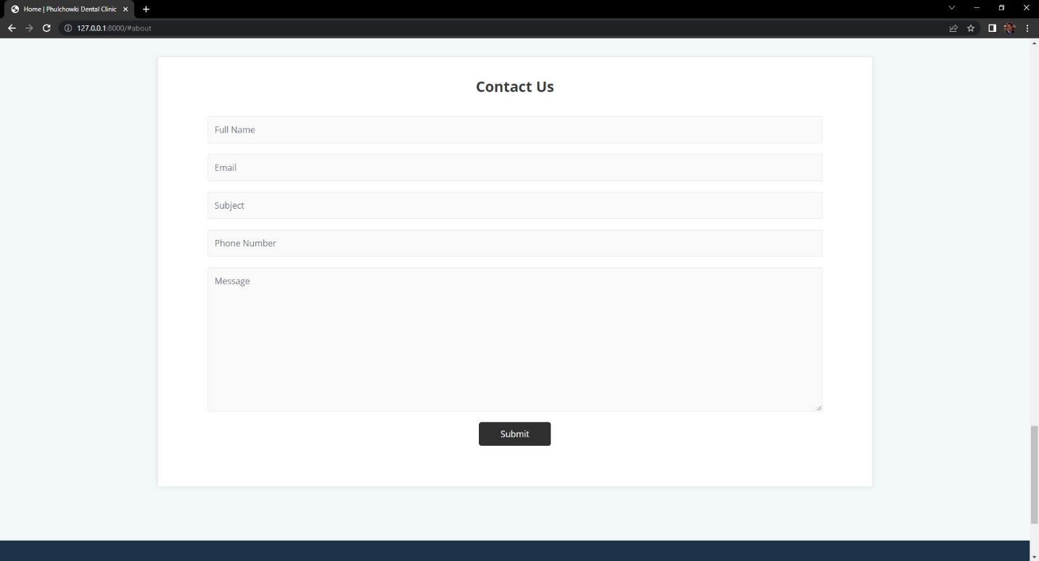

Figure 316: UI of Home Page 8

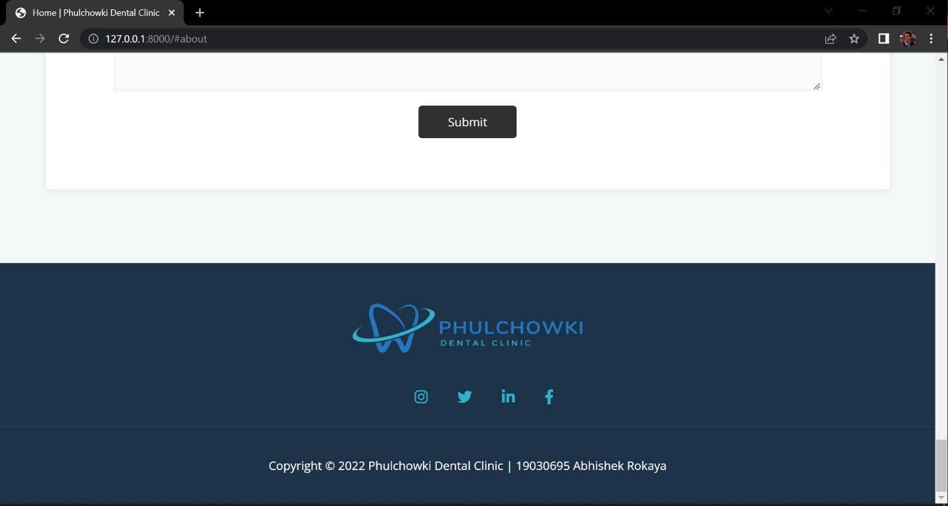

Figure 317: UI of Home Page 9

**7.6.8.4.2 Hardware Interfaces**

Since this is a web application, there are no such hardware requirements. This application can be executed on any functional machine with an internet connection.

**7.6.8.4.3 Software Interfaces**

The software interface for the application is as mentioned below:

* **Programming Language**: Python
* **Framework**: Django
* **IDE**: Visual Studio Code
* **Database**: SQLite3

**7.6.8.4.4 Communication Interfaces**

This system's communication interface will use the HTTP protocol for internet communication and the TCP/IP protocol suite for intranet communication.

**7.6.8.5 Non-Functional Requirements**

Non-functional requirements are those that are used to assess the application's quality. This section contains a comprehensive description of the application's non-functional needs.

**7.4.5.5.1 Performance Requirements**

|  |  |  |  |
| --- | --- | --- | --- |
| **Req. ID** | **Requirement Description** | **Priority** | **Complexity** |
| **PR1** | The system should be fast and easy to use. | Should | Medium |
| **PR2** | The system should be reliable meaning the function should work properly. | Should | Normal |
| **PR3** | The system should be user friendly. | Should | Normal |

Table 94: Performance Requirement

**7.6.8.5.2 Safety Requirements**

|  |  |  |  |
| --- | --- | --- | --- |
| **Req. ID** | **Requirement Description** | **Priority** | **Complexity** |
| **SR1** | The program shall not install any type of malware or spyware in the background without notifying the users. | Should | Medium |
| **SR2** | The system must keep track of the session to guarantee that the login and logout are secure. | Should | High |
| **SR3** | A user category must not have access to the profiles of other user categories, i.e. a user (patient) must not be able to access the admin panel. | Should | Medium |

Table 95: Safety Requirement

**7.6.8.5.3 Other Software Quality Attributes**

|  |  |  |  |
| --- | --- | --- | --- |
| **Req. ID** | **Requirement Description** | **Priority** | **Complexity** |
| **SQA1** | The system must be scalable, which means that it should be able to incorporate new features in the future. | Could | Medium |
| **SQA2** | All users must be able to quickly access the program. | Should | Normal |
| **SQA3** | The system must be user-friendly, and even non-technical users should be able to utilize it with ease. | Should | Normal |
| **SQA4** | The program must be interoperable, which means it must act consistently across browsers. | Could | Normal |

Table 96: Other Software Quality Attributes

### 7.6.9 Wireframes

A wireframe is a schematic or blueprint that is useful for helping you, your programmers and designers think and communicate about the structure of the software or website you're building. (Guilizzoni, 2022) The wireframes are created using Balsamiq. It is a desktop application that is used to create various kinds of wireframes for different web as well as mobile based applications. Wireframes are needed in a software development. It creates a blueprint for the application we are developing. It helps in the development phase to create a design by looking at the wireframes.

The wireframes for the dental appointment system application are as follows:

1. Home Page (Landing Page)

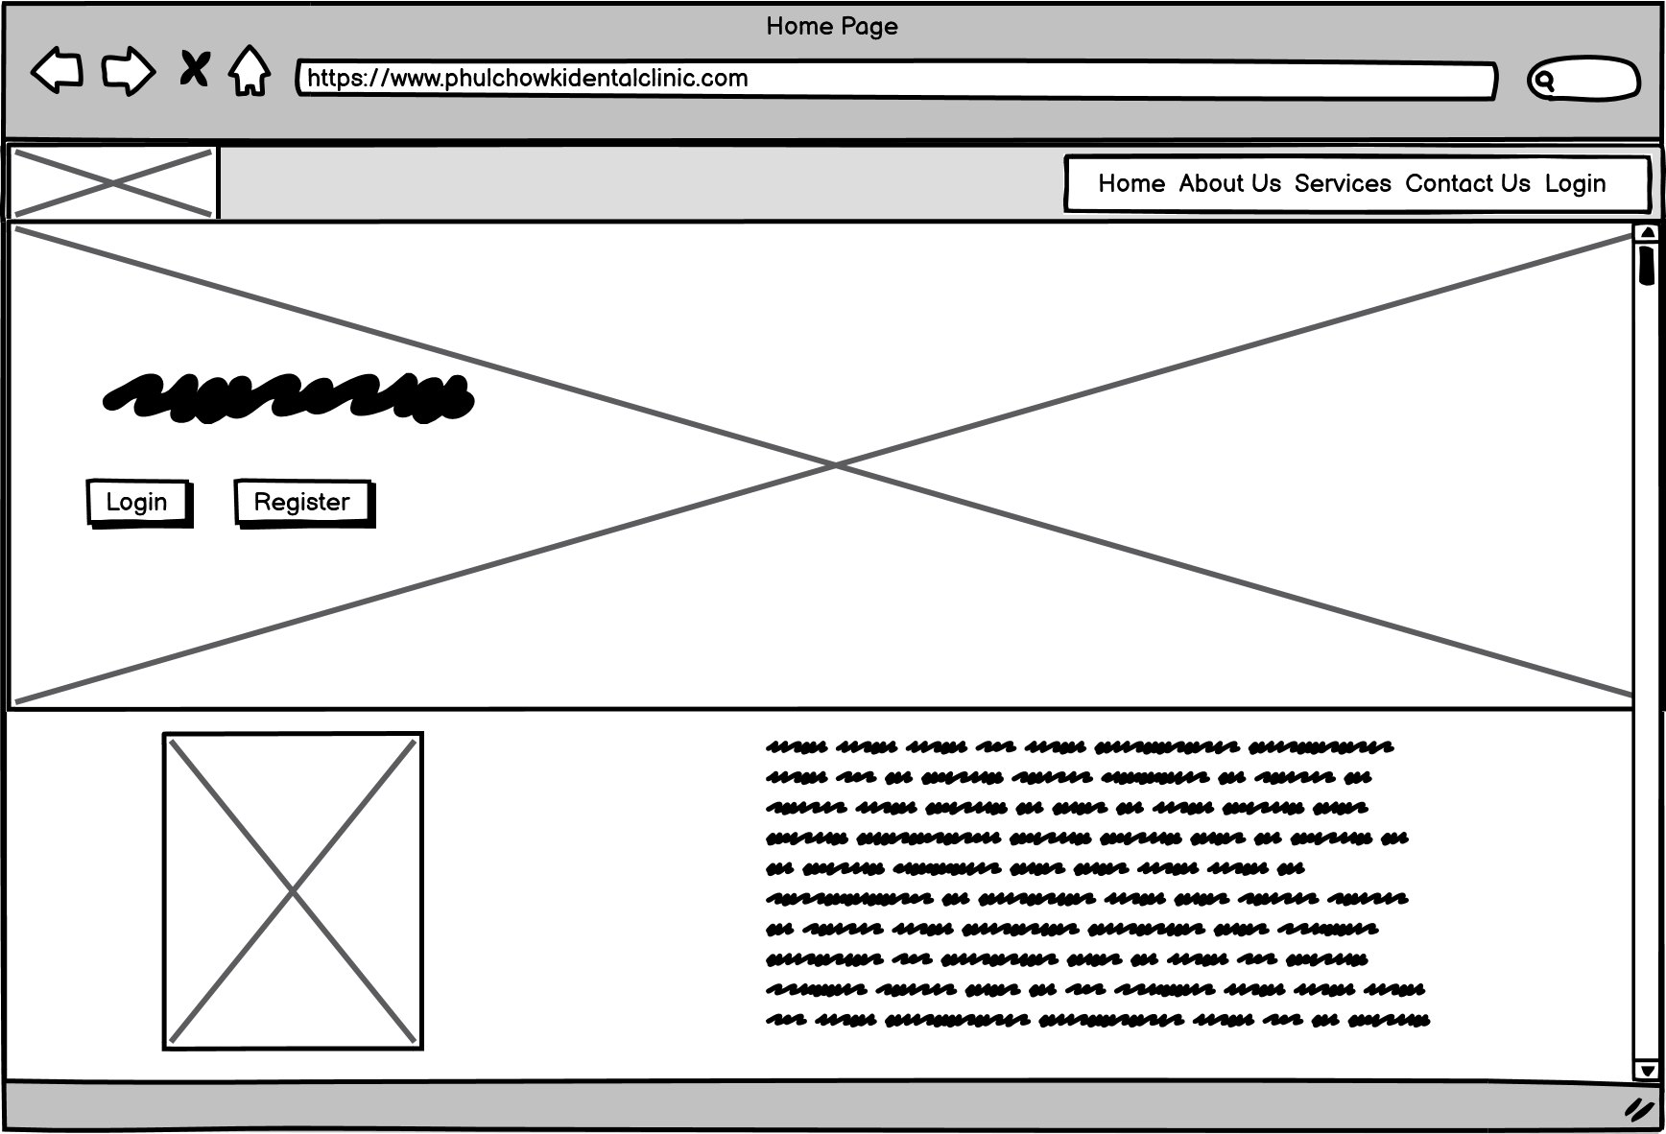

Figure 318: Wireframe - Home Page

2. User Registration Page

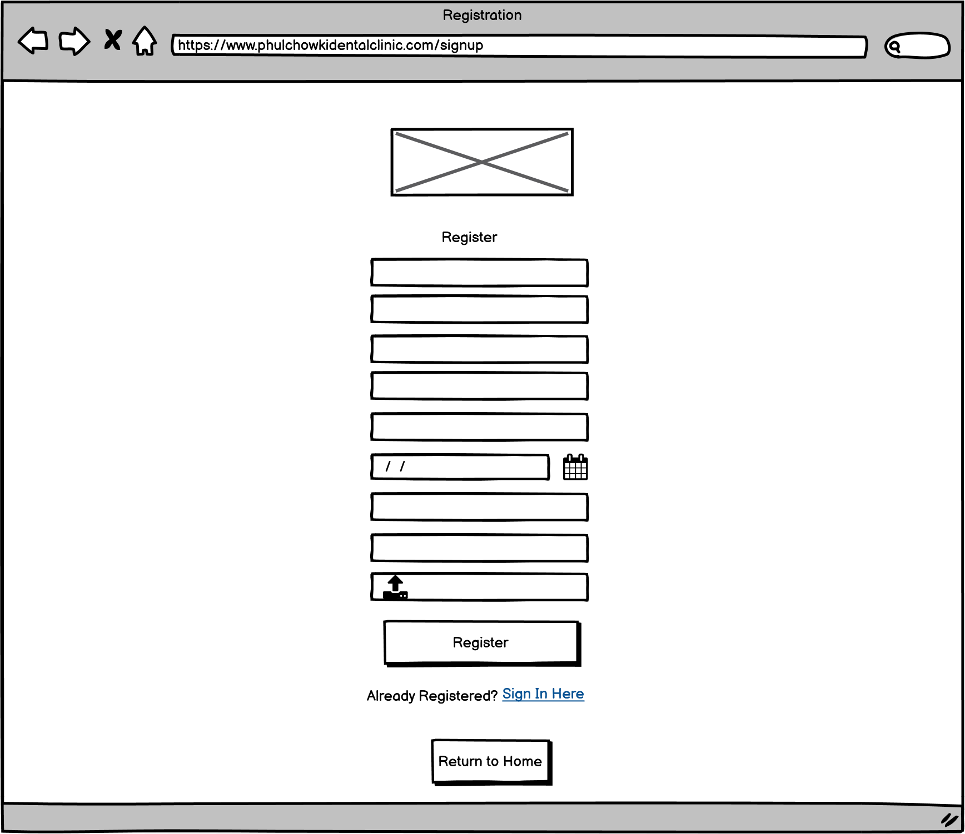

Figure 319: Wireframe - User Registration

3. User Login Page

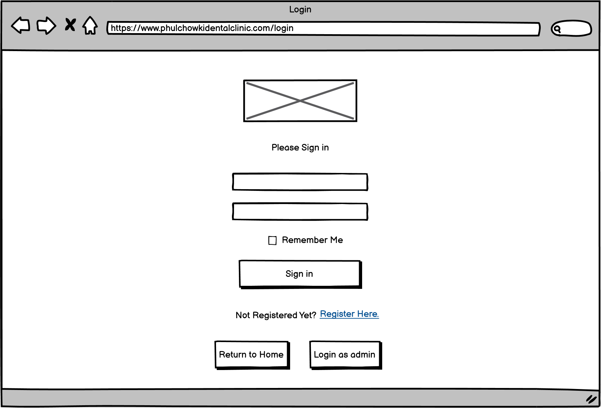

Figure 320: Wireframe - User Login

4. Admin Login Page

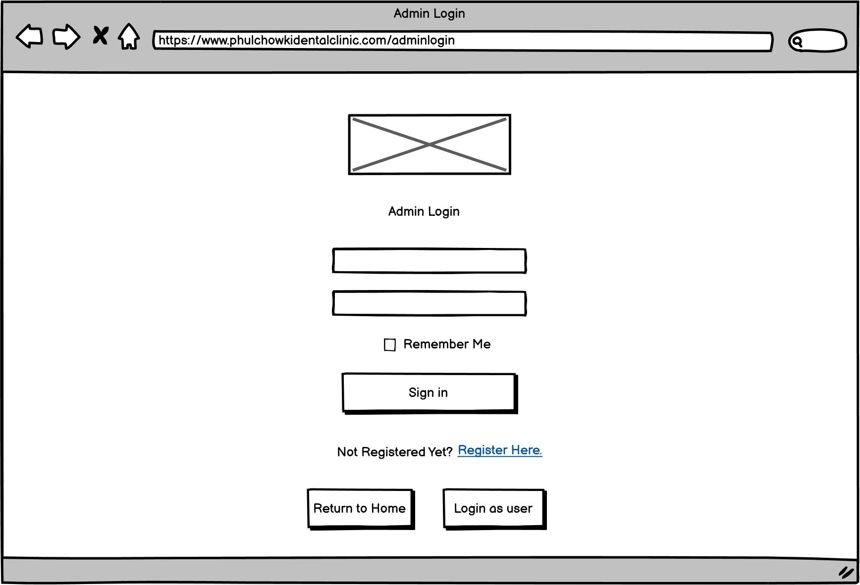

Figure 321: Wireframe - Admin Login

5. User Dashboard Page

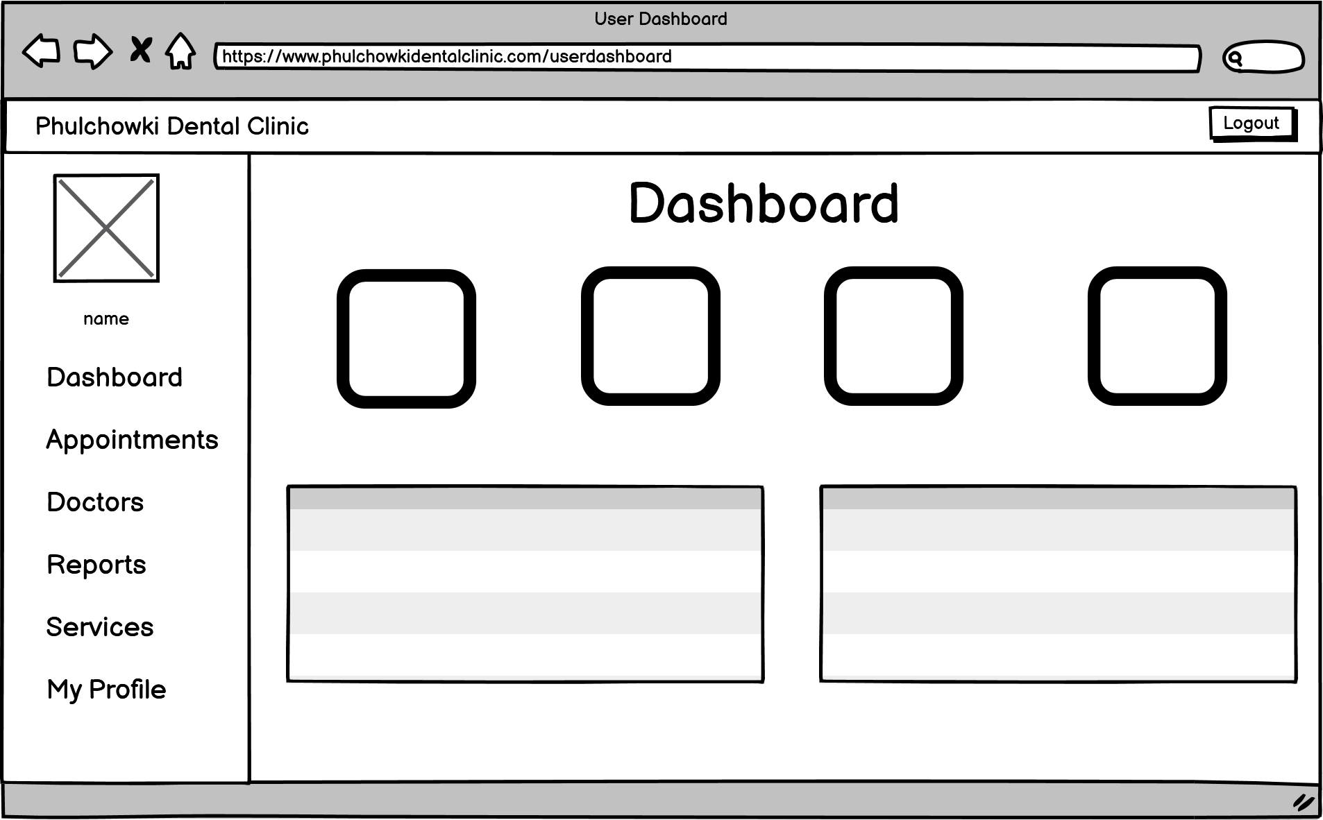

Figure 322: Wireframe - User Dashboard

6. User View Appointment Page

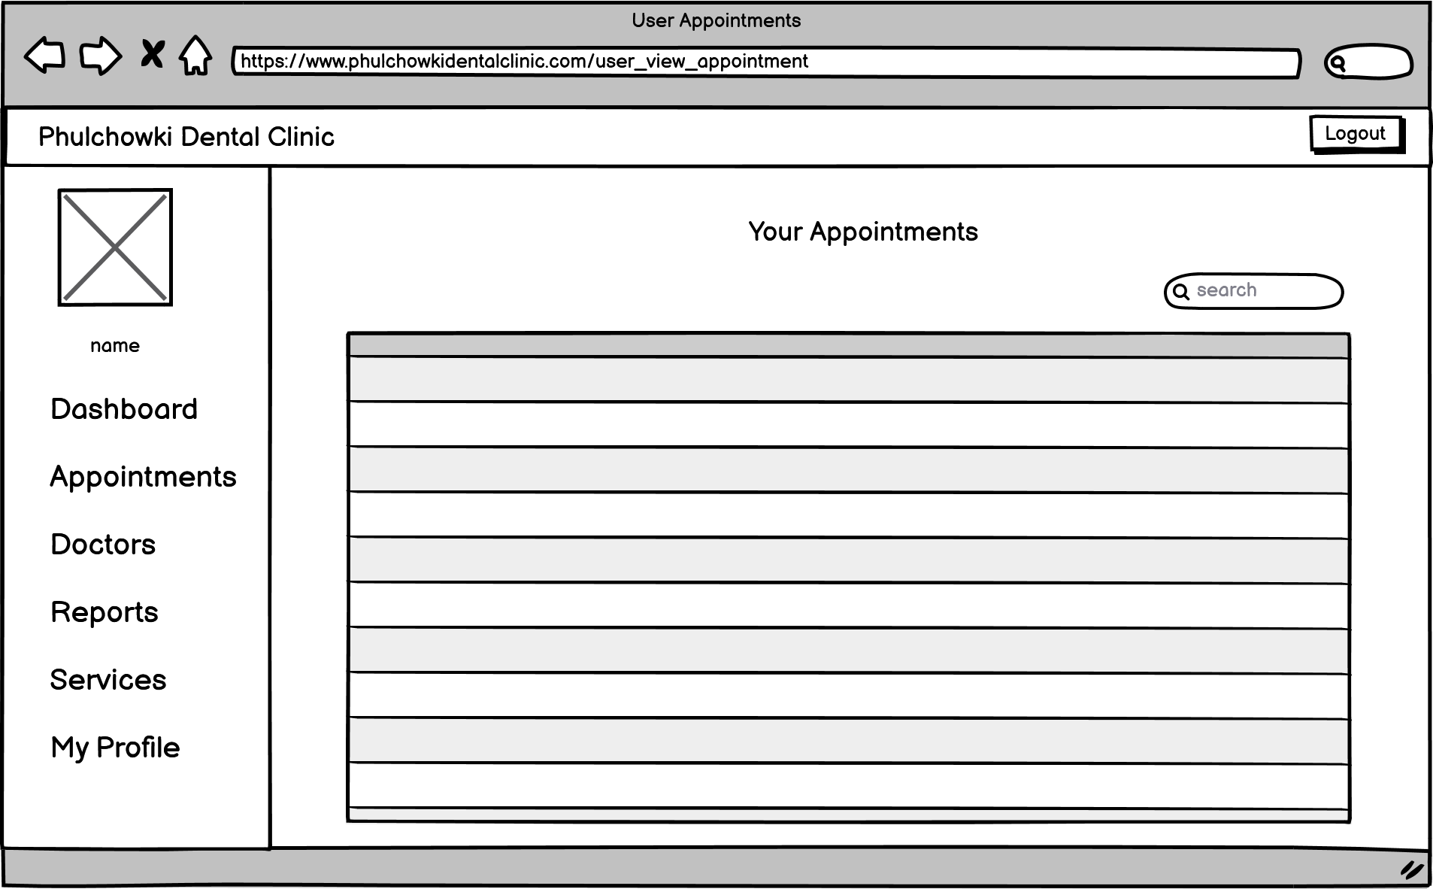

Figure 323: Wireframe - User View Appointment

7. User Book Appointment Page

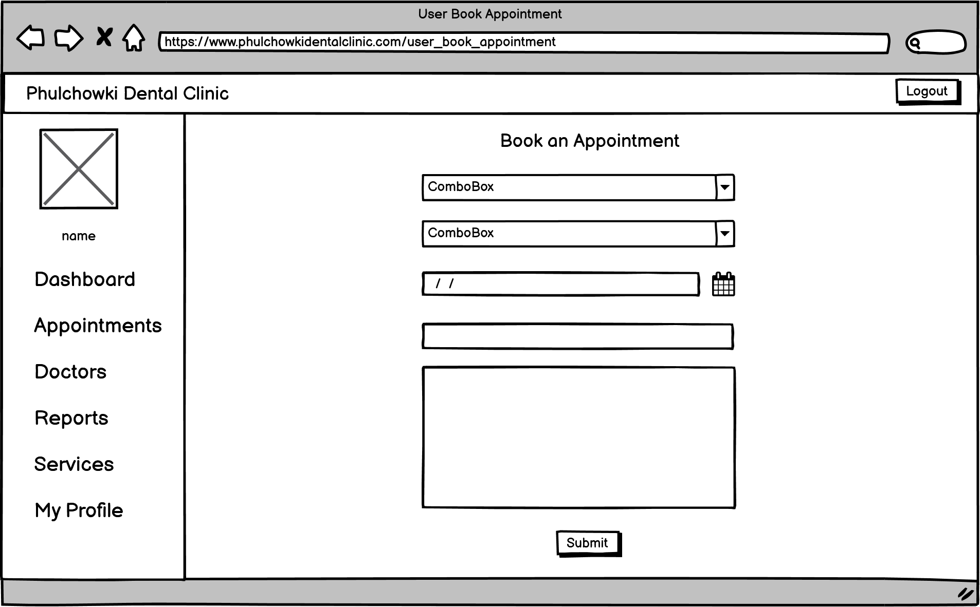

Figure 324: Wireframe - User Book Appointment

8. User View Doctor Page

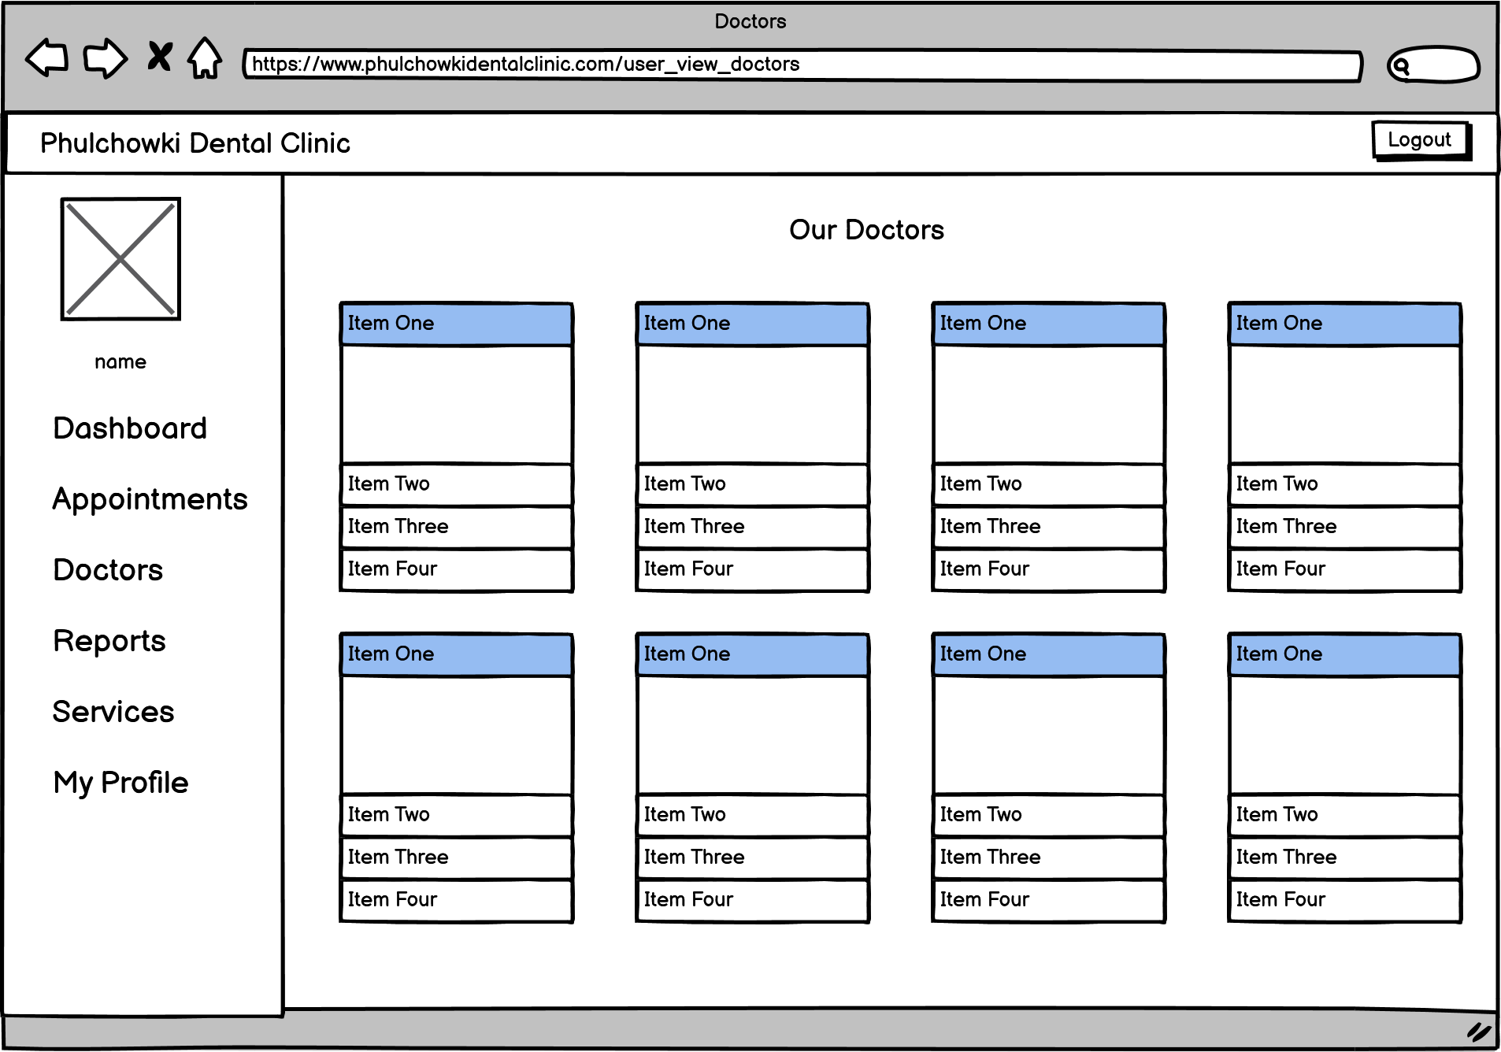

Figure 325: Wireframe - User View Doctor

9. User View Report Page

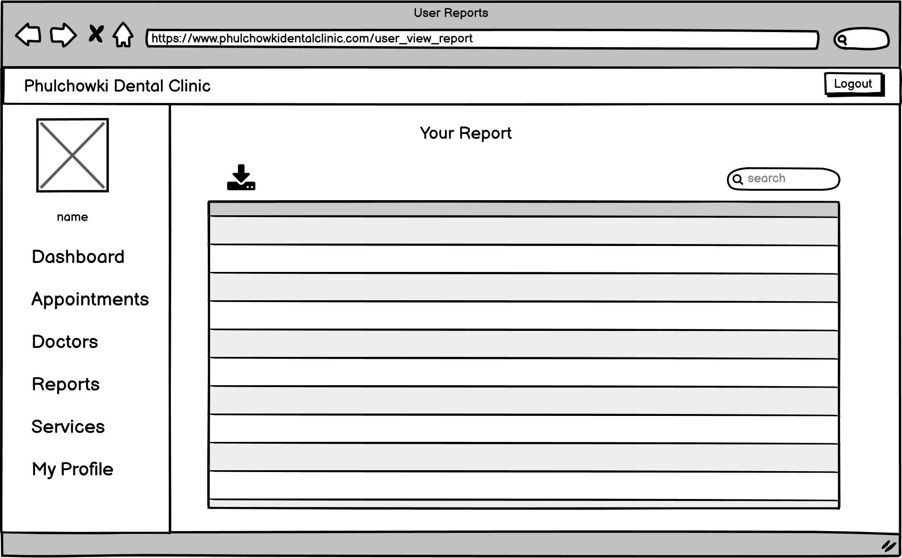

Figure 326: Wireframe - User View Report

10. User View Service Page

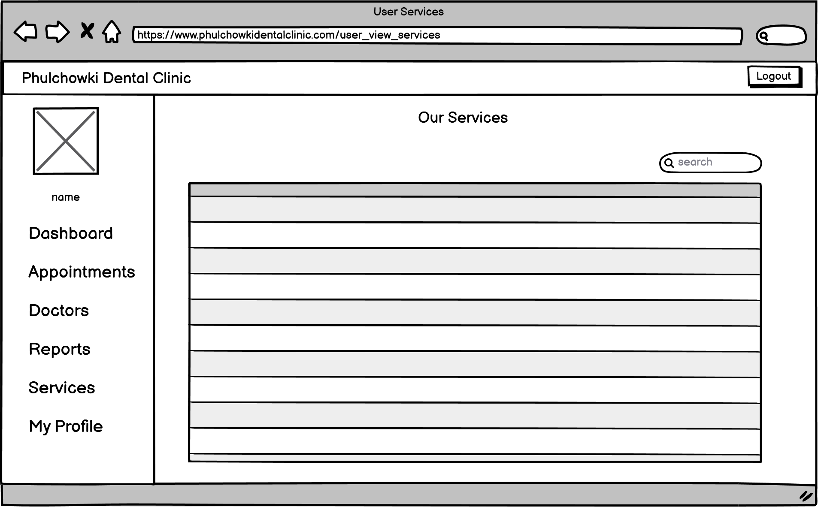

Figure 327: Wireframe - User View Service

11. User View Profile Page

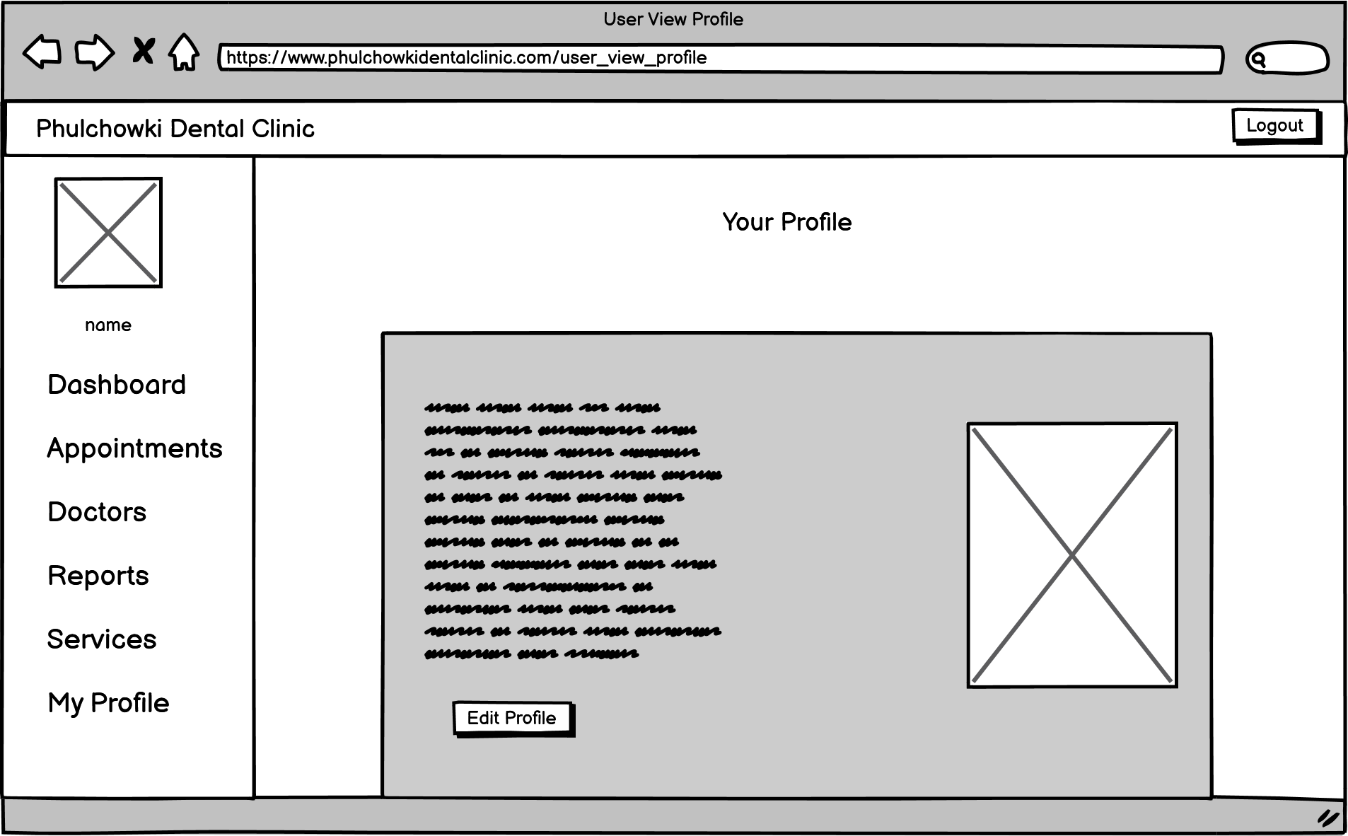

Figure 328: Wireframe - User View Profile

12. User Edit Profile Page

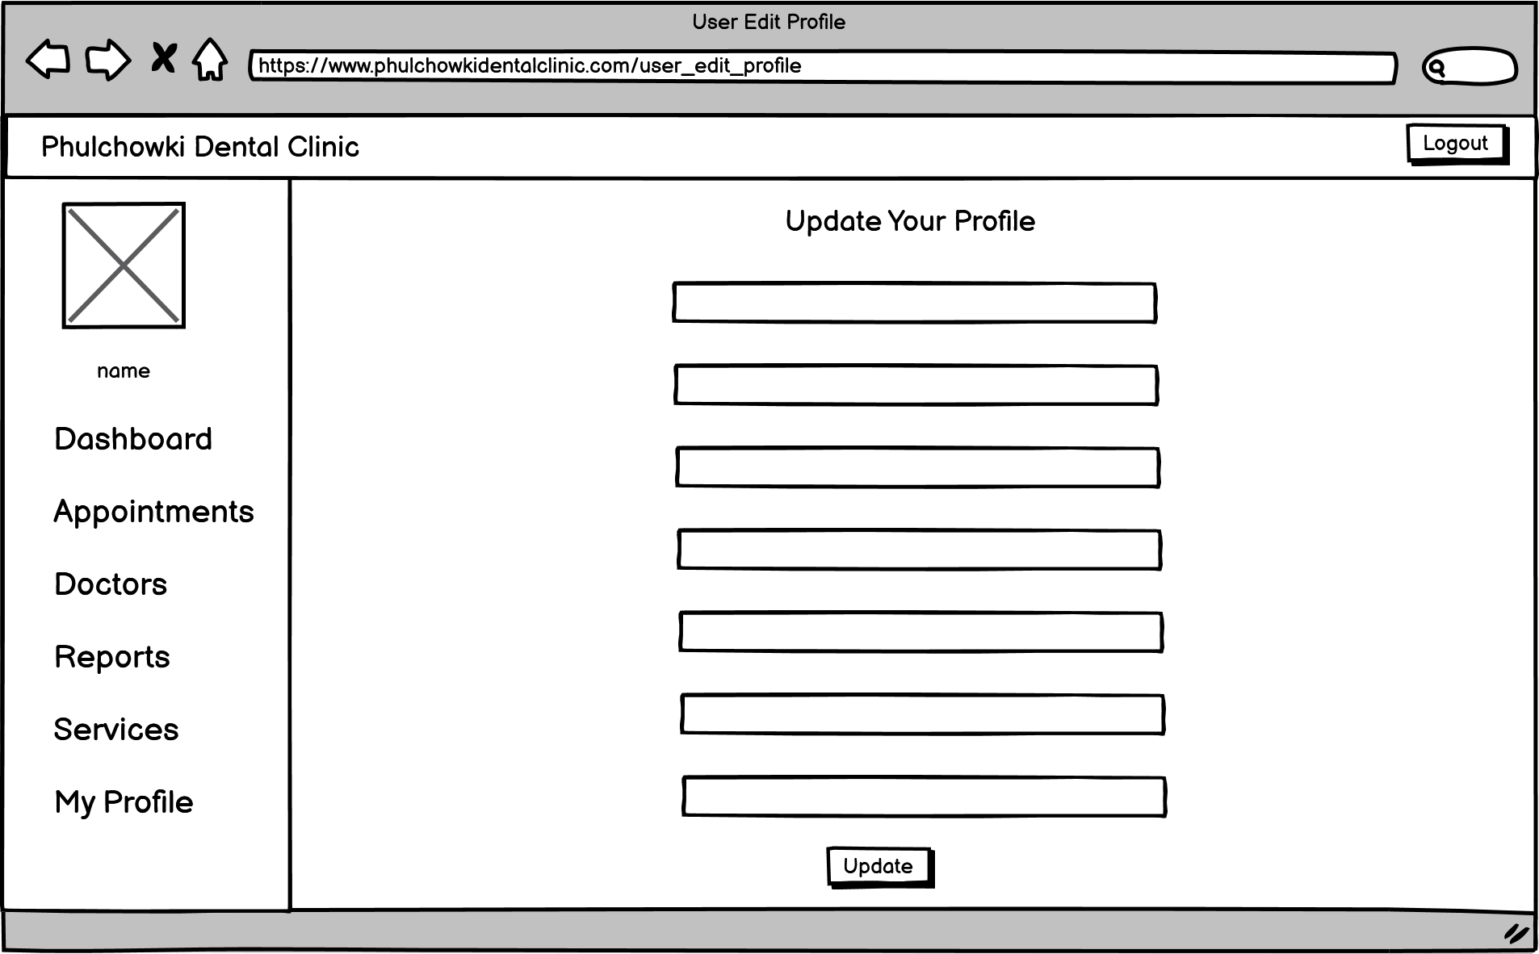

Figure 329: Wireframe - User Edit Profile

13. Admin Dashboard Page

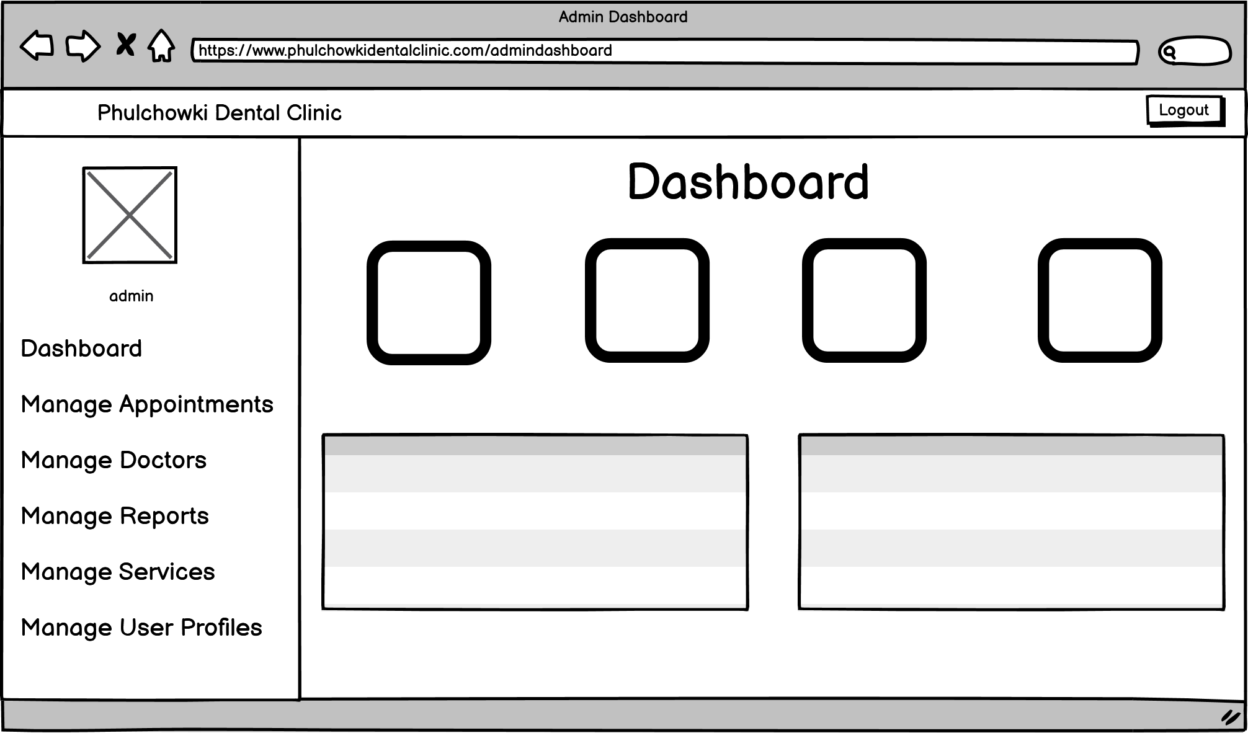

Figure 330: Wireframe - Admin Dashboard

14. Admin View Appointment Page

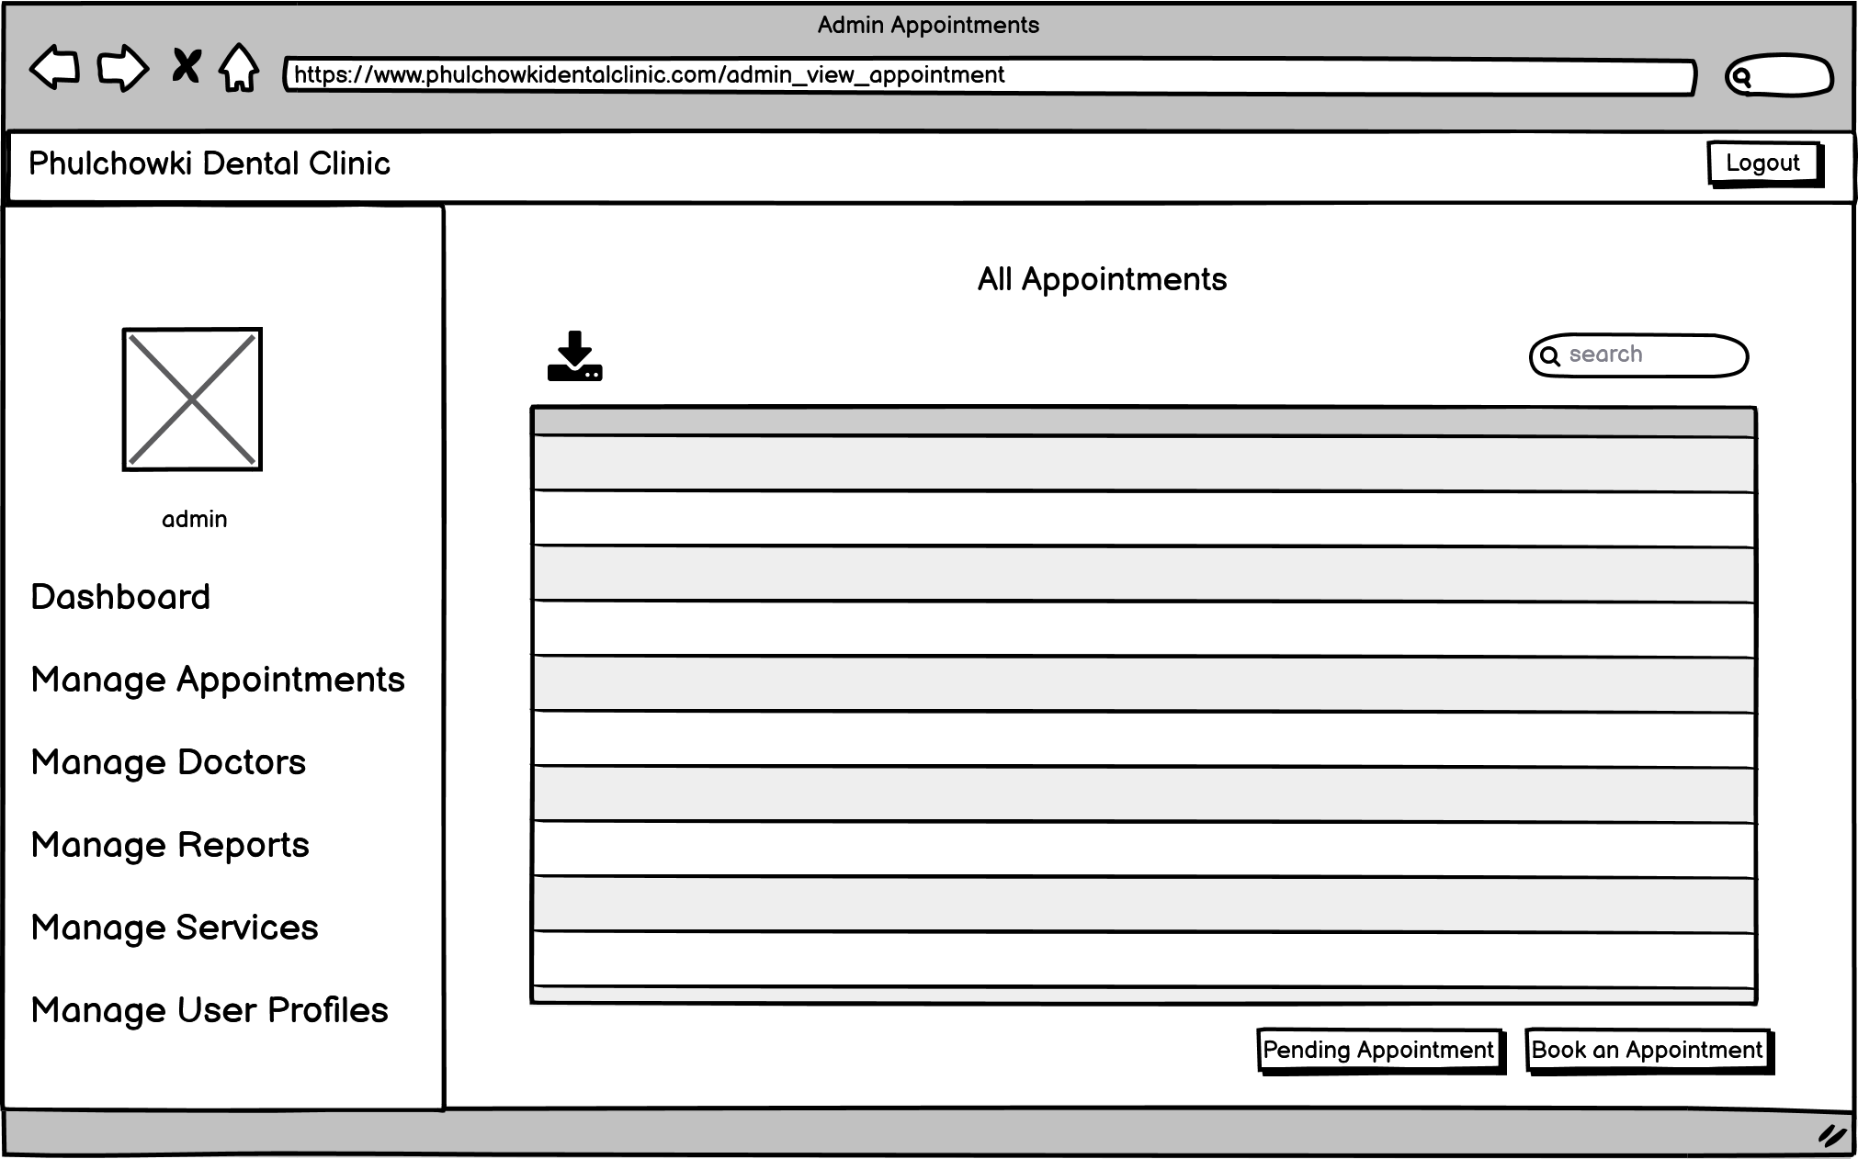

Figure 331: Wireframe - Admin View Appointment

15. Admin Approve Appointment Page

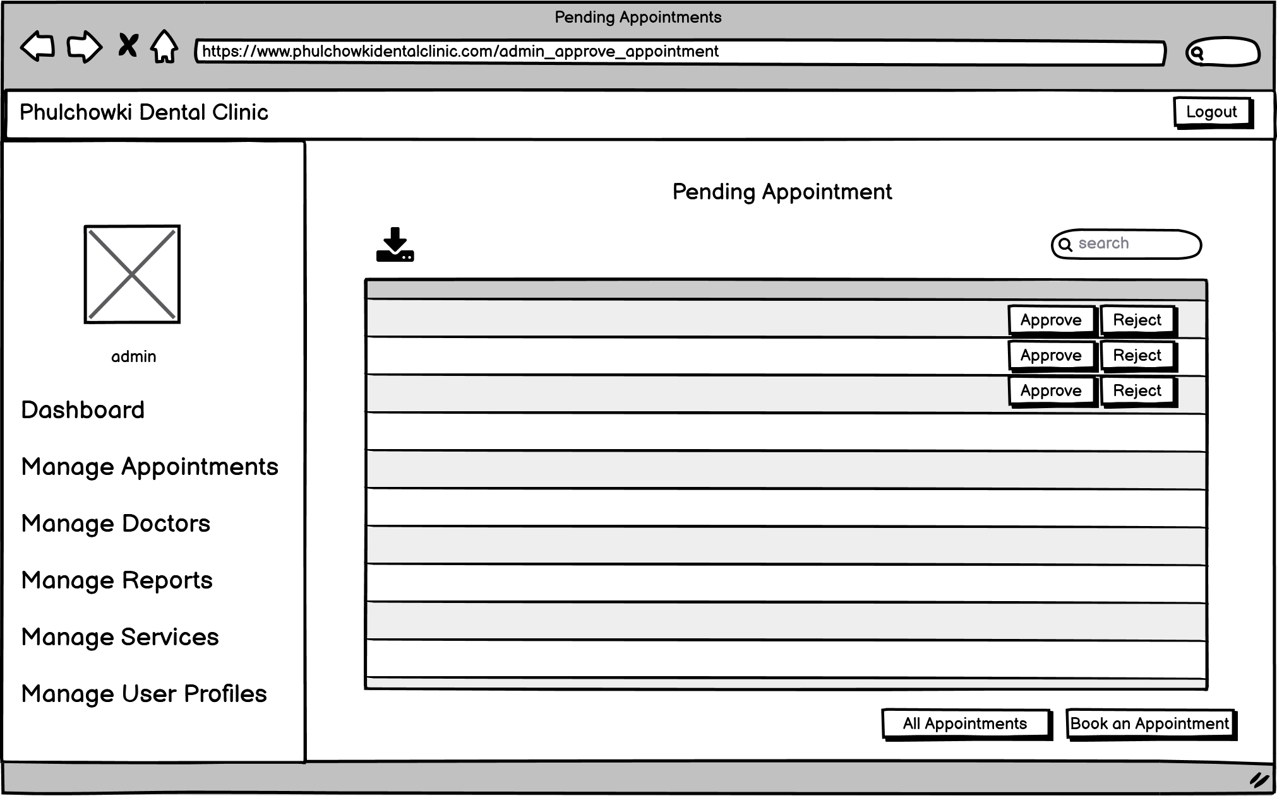

Figure 332: Wireframe - Admin Approve Appointment

16. Admin Book Appointment Page

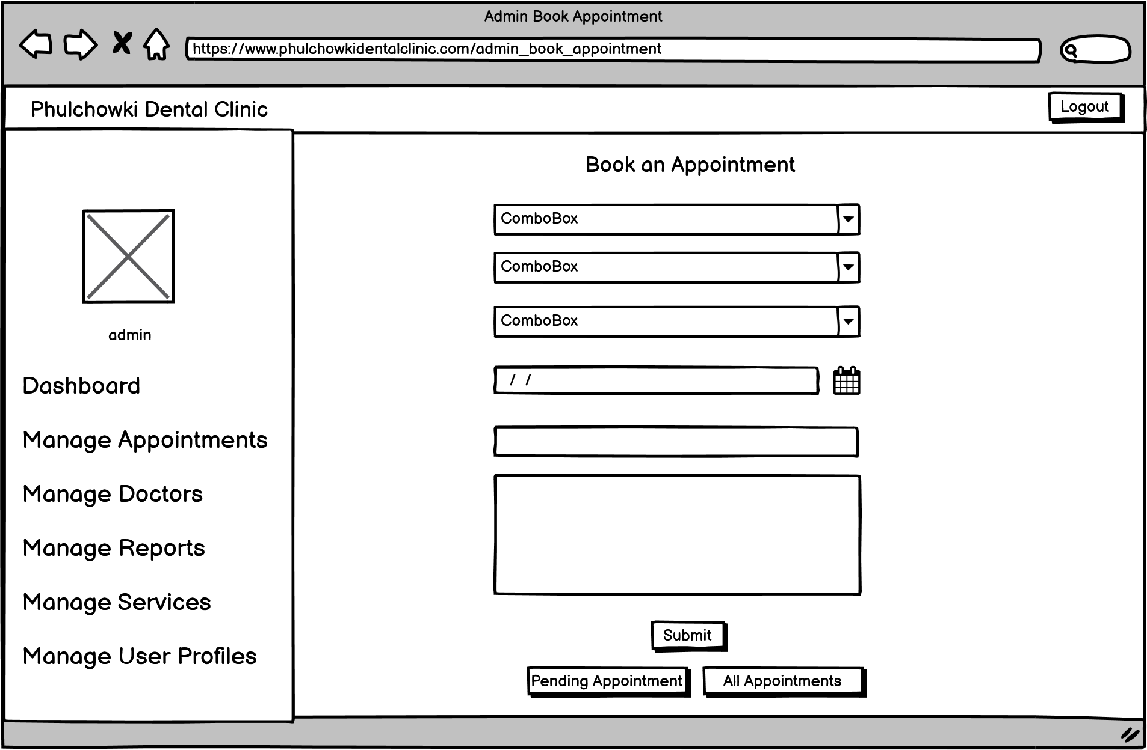

Figure 333: Wireframe - Admin Book Appointment

17. Admin View Doctor Page

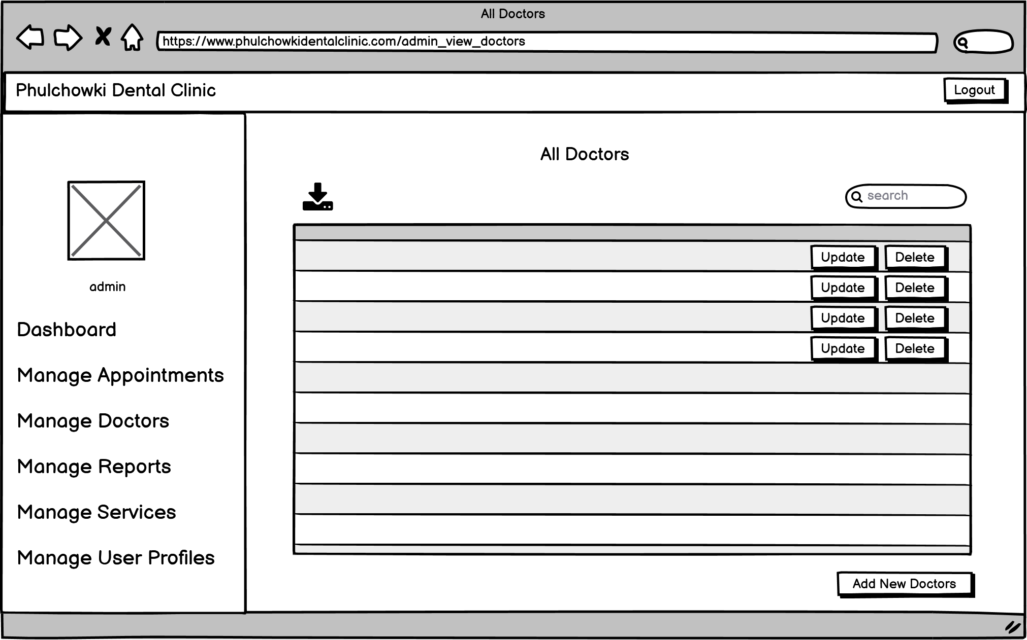

Figure 334: Wireframe - Admin View Doctor

18. Admin Add Doctor Page

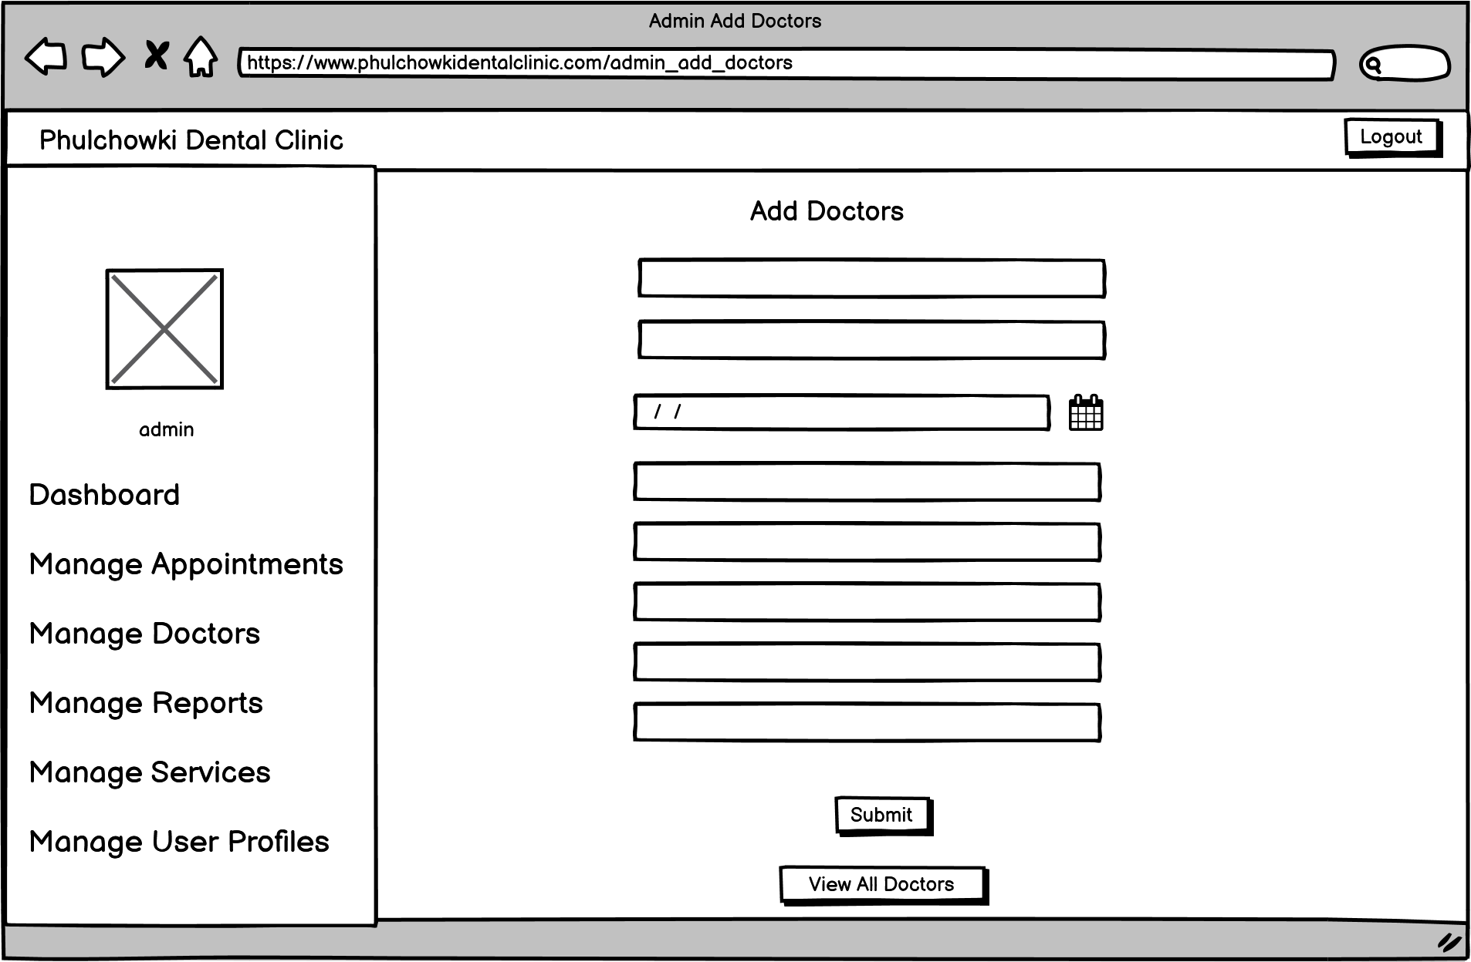

Figure 335: Wireframe - Admin Add Doctor

19. Admin View Report Page

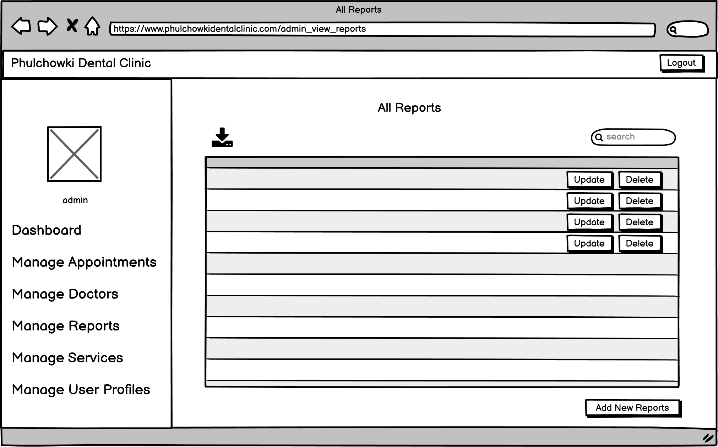

Figure 336: Wireframe - Admin View Report

20. Admin Add Report Page

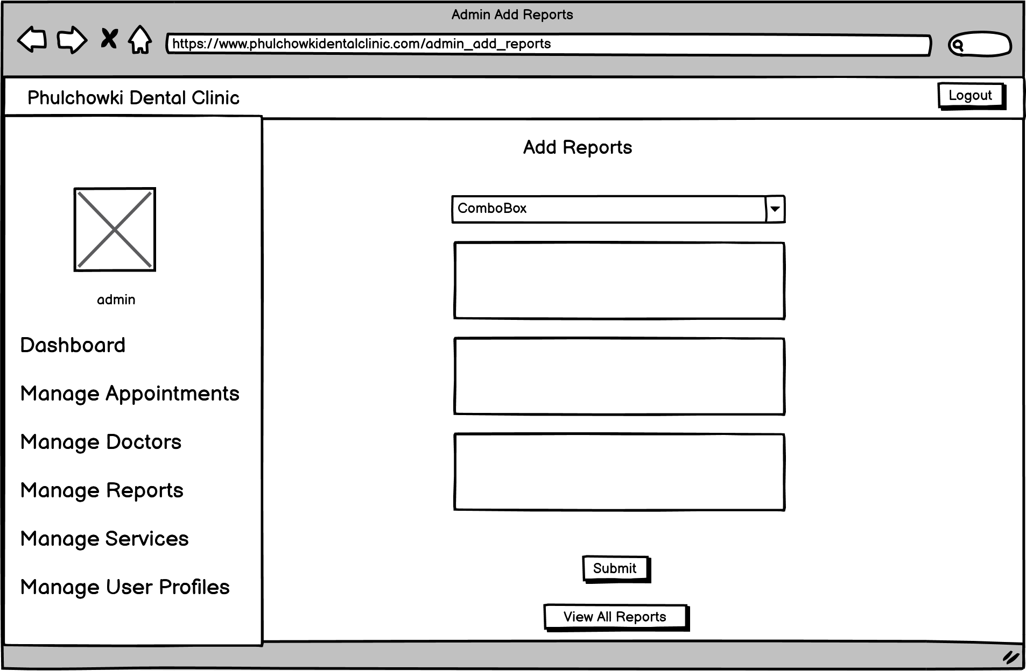

Figure 337: Wireframe - Admin Add Report

21. Admin View Service Page

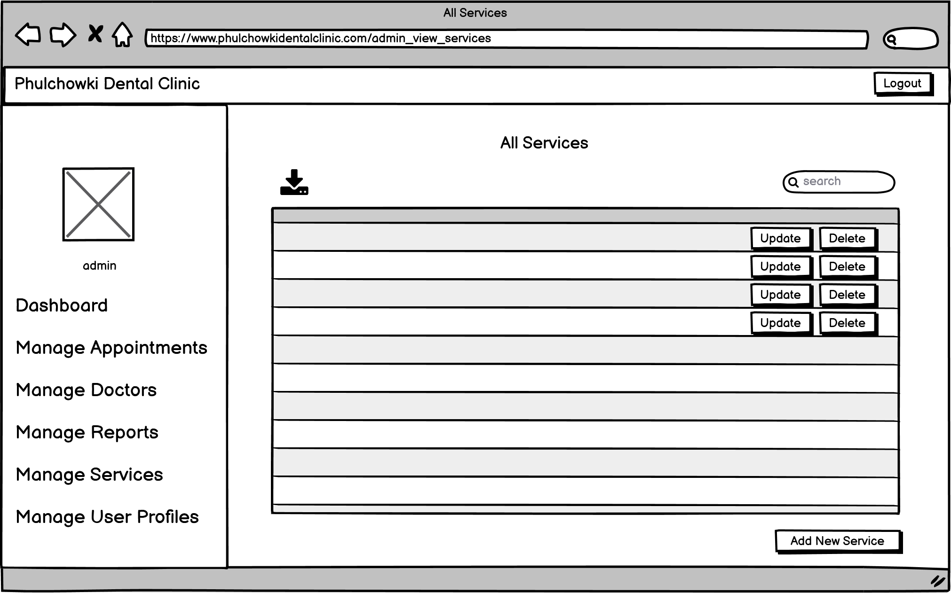

Figure 338: Wireframe - Admin View Service

22. Admin Add Service Page

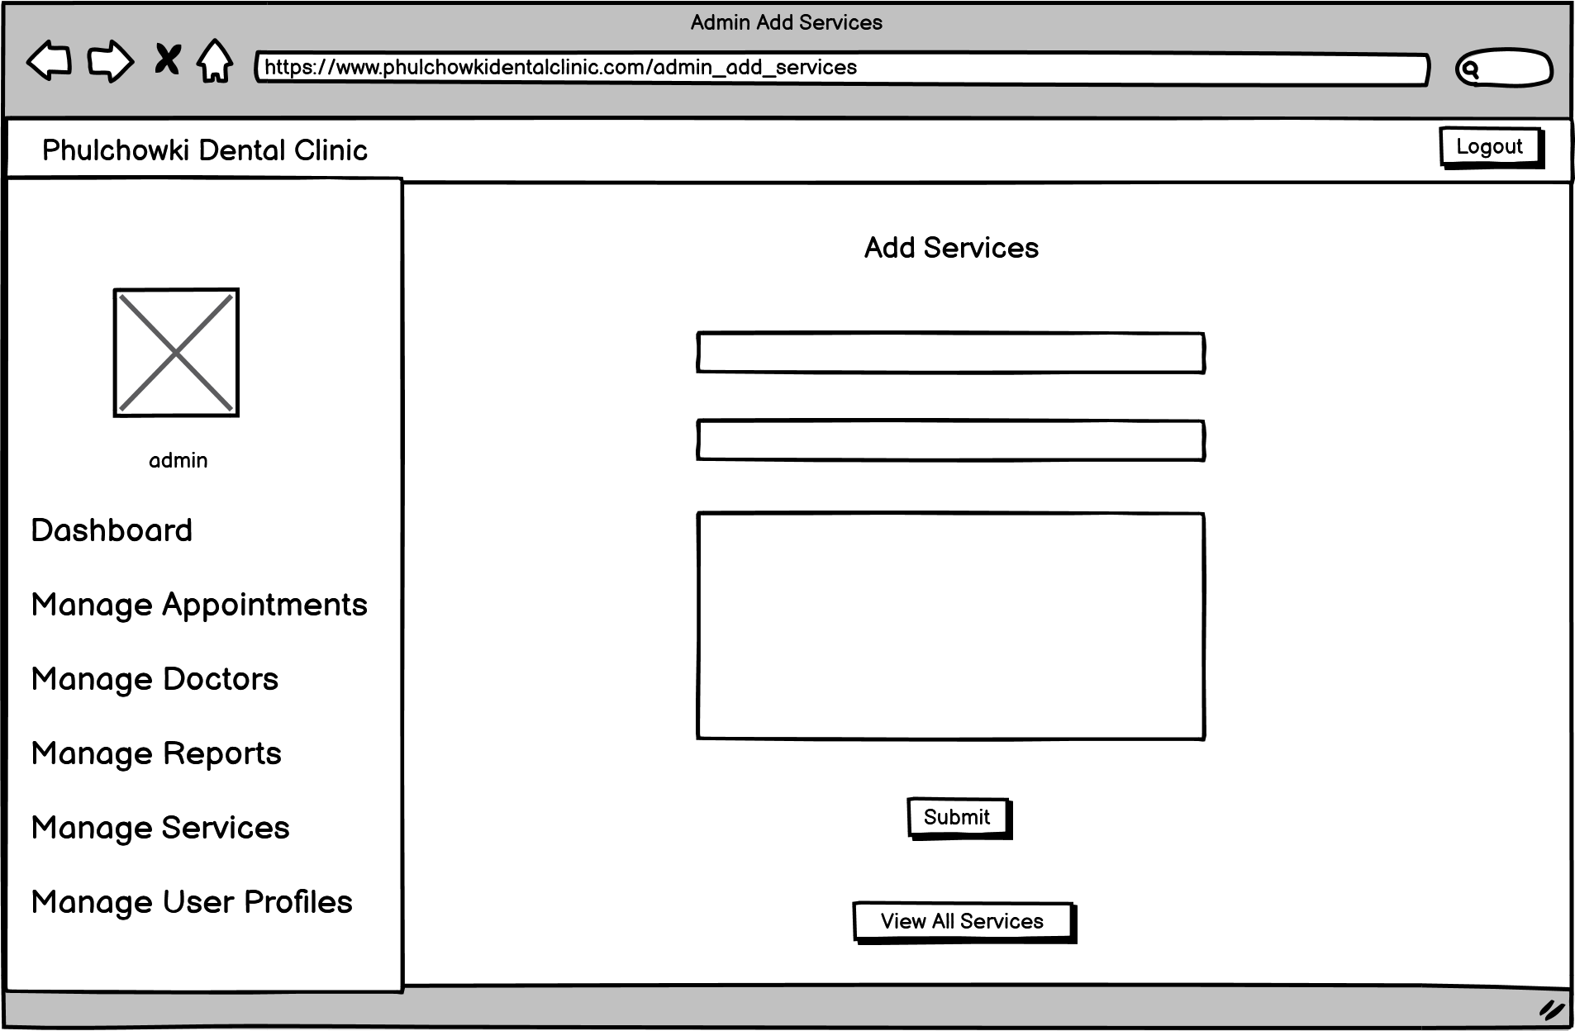

Figure 339: Wireframe - Admin Add Service

23. Admin View Users Page

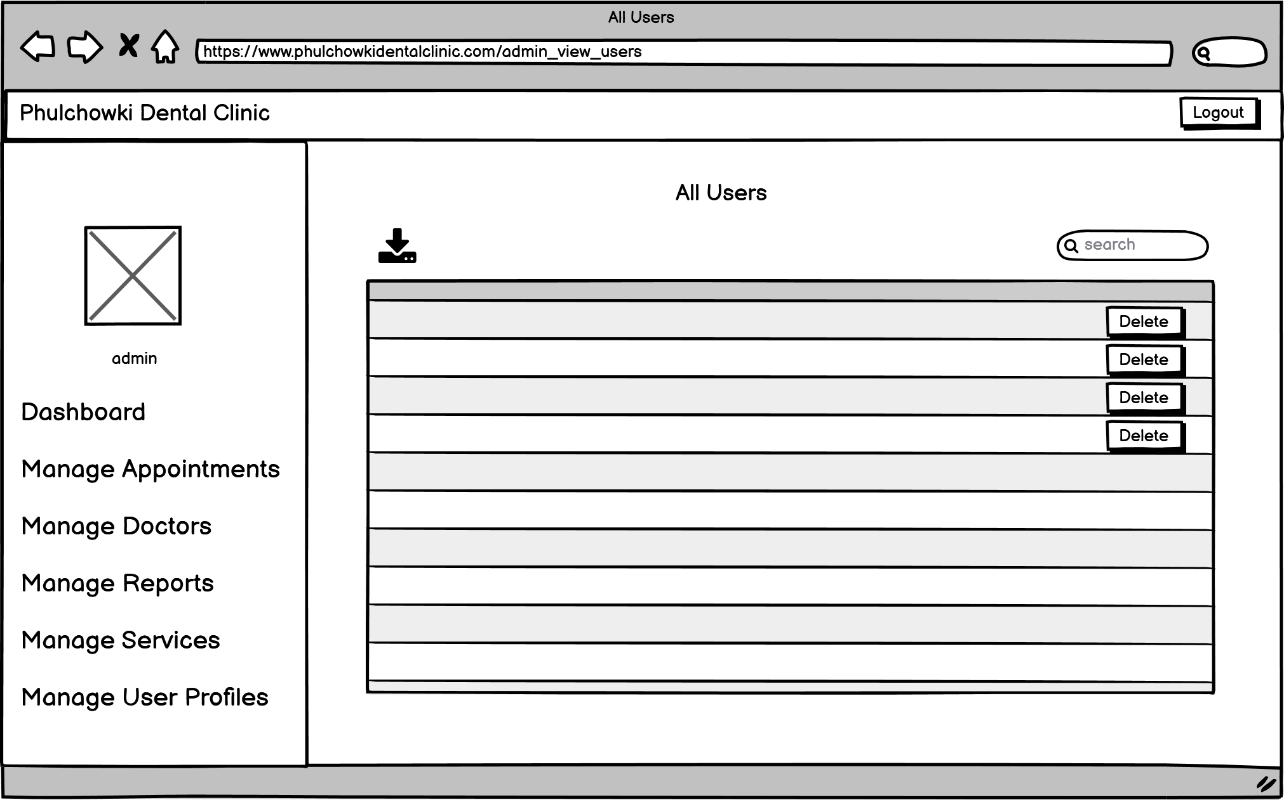

Figure 340: Wireframe - Admin View Users

## 7.7 Appendix G: Testing

### 7.7.1 Black Box Testing

Continued from here

|  |  |
| --- | --- |
| **Test No.5** | |
| Objective | To view user's report by the user. |
| Action | The 'View Report' button was clicked in the side bar. |
| Expected Output | Only current user's reports would be shown. |
| Actual Output | All user's reports was shown. |
| Result | The test was unsuccessful. |

Table 24: Black Box Test 5 (Unsuccessful)

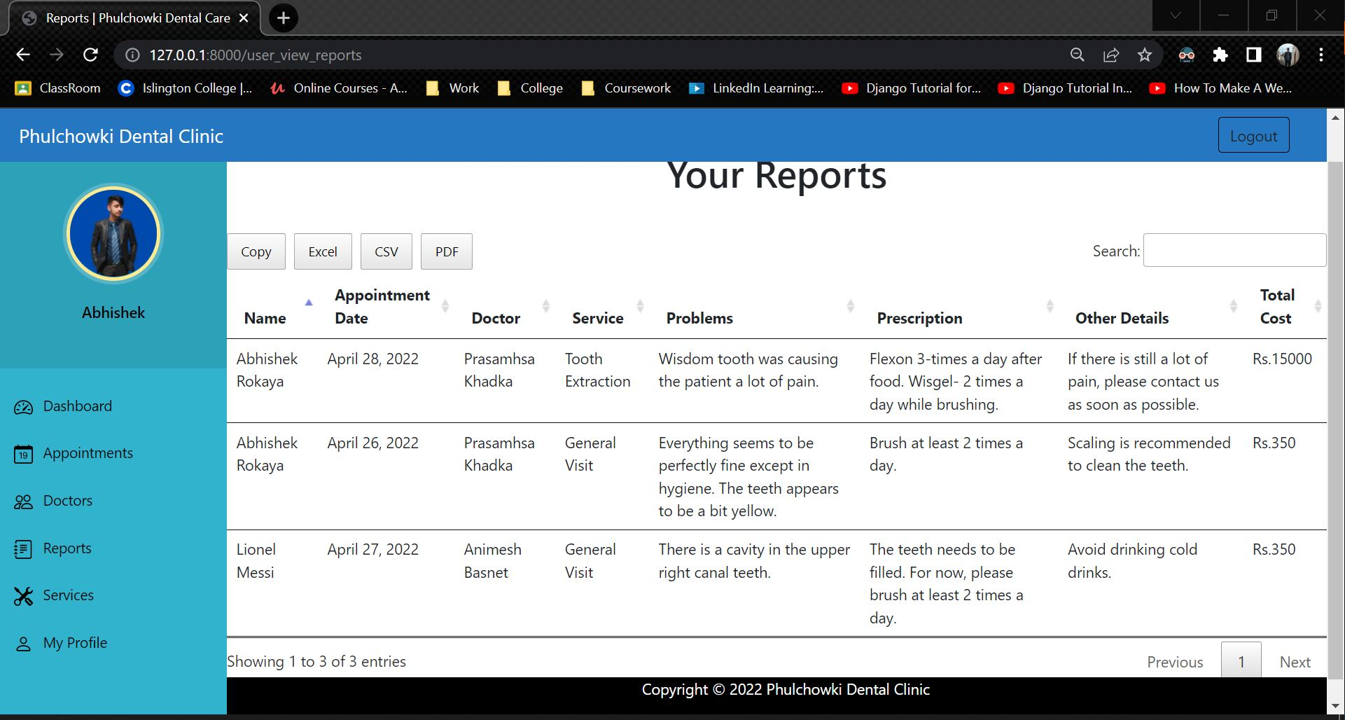

Figure 341: Black Box Test 5 (Unsuccessful)

**Code that caused the error:**

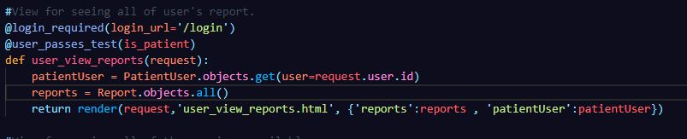

Figure 342: Black Box Test 5 - Error Code

**Fixing the code:**

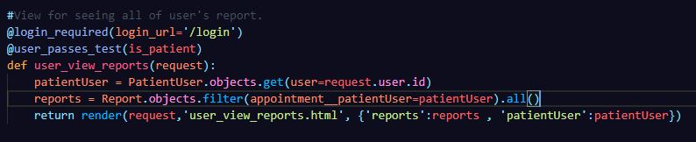

Figure 343: Black Box Test 5 - Fixed Code

|  |  |
| --- | --- |
| **Test No.5** | |
| Objective | To view user's report by the user. |
| Action | The 'View Report' button was clicked in the side bar. |
| Expected Output | Only current user's reports would be shown. |
| Actual Output | Only current user's reports was shown. |
| Result | The test was successful. |
| Cause of Error | The report was not filtered according to current user ID. |

Table 25: Black Box Test 5 (Successful)

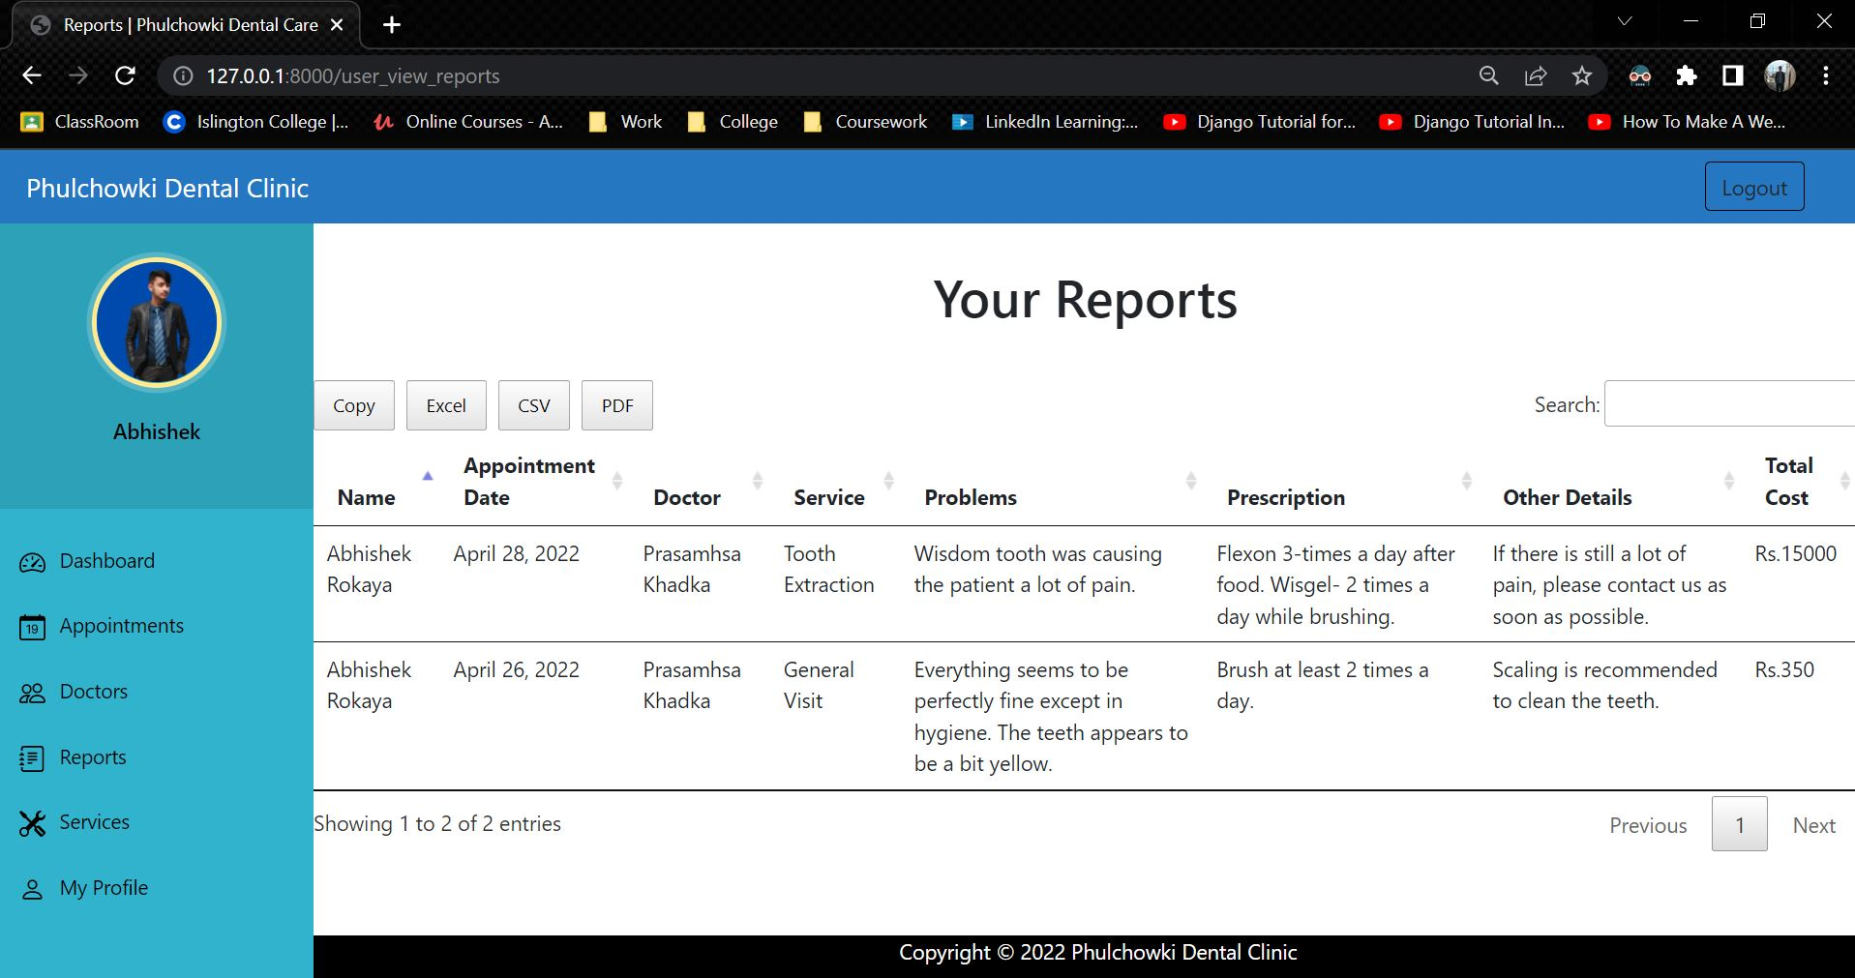

Figure 344: Black Box Test 5 (Successful)

|  |  |
| --- | --- |
| **Test No.6** | |
| Objective | To book an appointment outside the clinic time. |
| Action | The booking form was filled with 4am as the booking time and the form was submitted by the user. |
| Expected Output | The booking would not be done and the error would be shown. |
| Actual Output | The booking was done and error was not shown. |
| Result | The test was unsuccessful. |

Table 26: Black Box Test 6 (Unsuccessful)

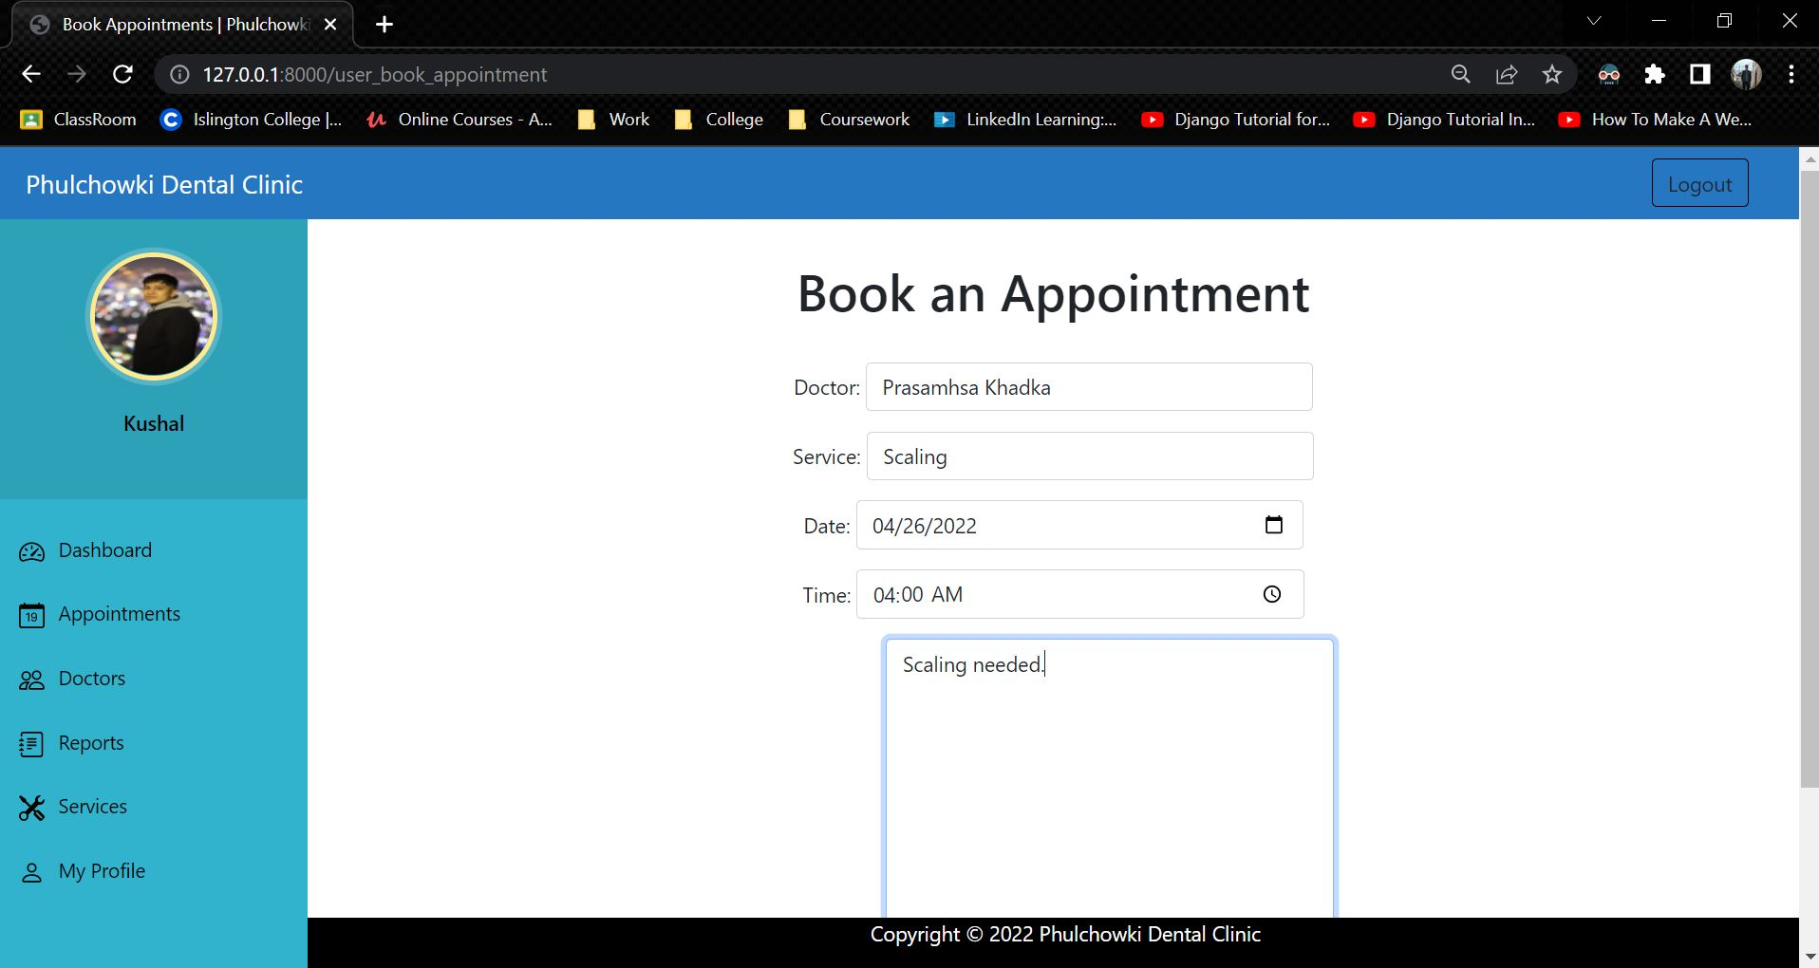

Figure 345: Black Box Test 6 (Unsuccessful) - 1

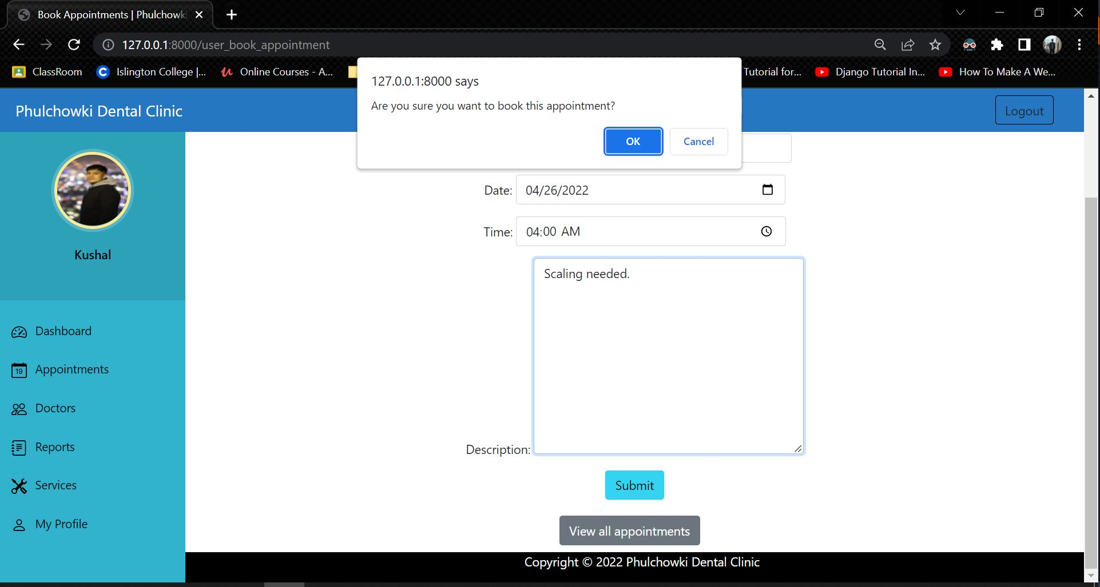

Figure 346: Black Box Test 6 (Unsuccessful) - 2

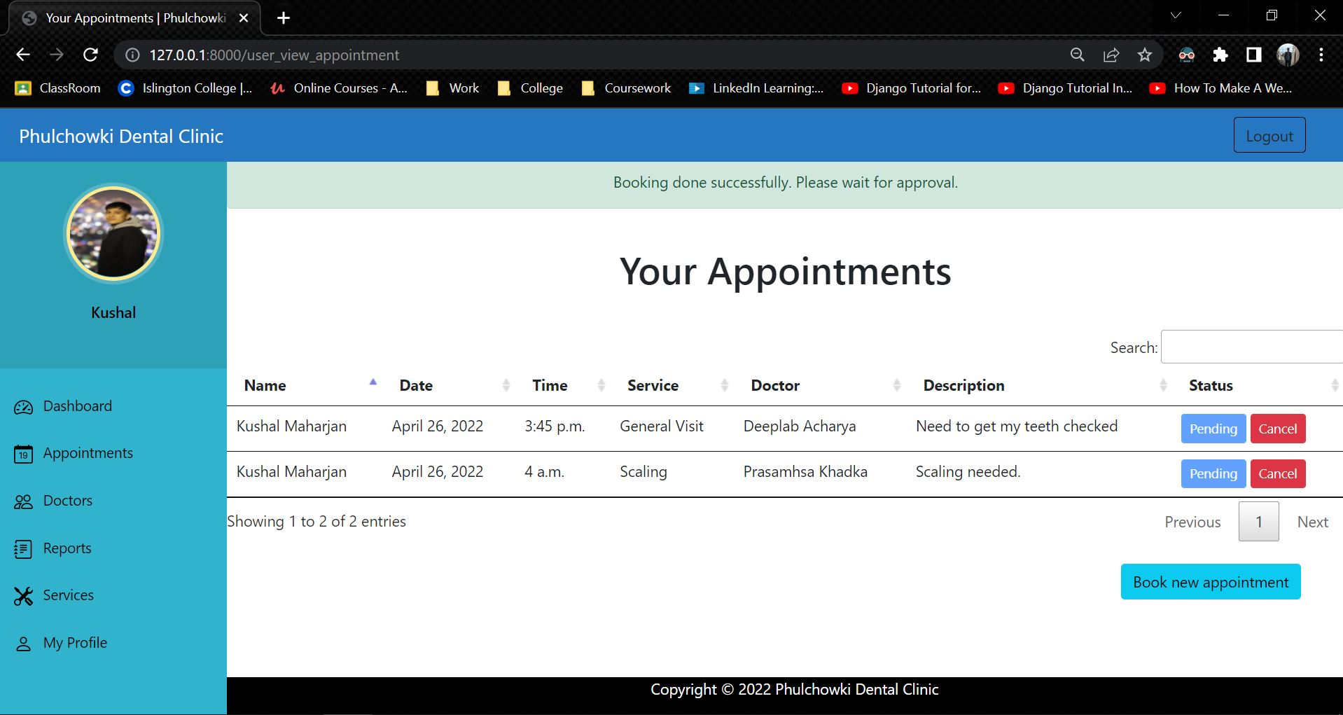

Figure 347: Black Box Test 6 (Unsuccessful) – 3

**Code that caused the error:**

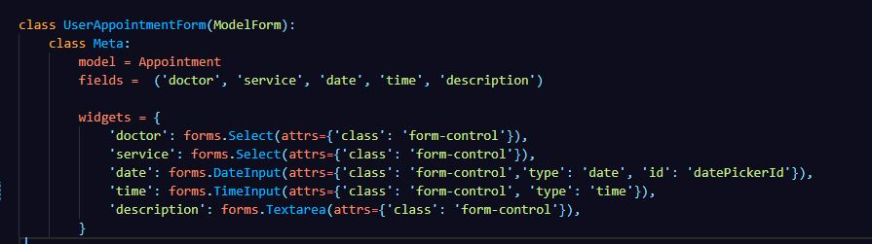

Figure 348: Black Box Test 6 - Error Code

**Fixing the code:**

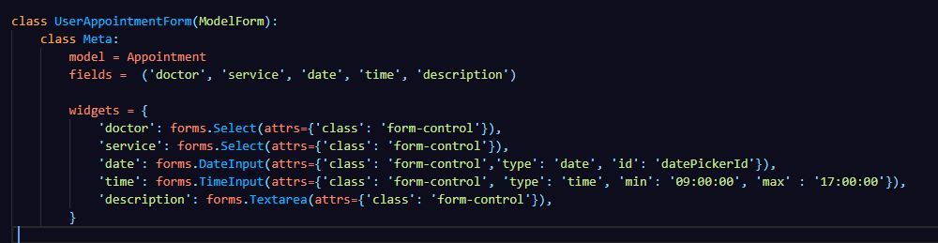

Figure 349: Black Box Test 6 - Fixed Code

|  |  |
| --- | --- |
| **Test No.6** | |
| Objective | To book an appointment outside the clinic time. |
| Action | The booking form was filled with 4am as the booking time and the form was submitted by the user. |
| Expected Output | The booking would not be done and the error would be shown. |
| Actual Output | The booking was not done and error was shown. |
| Result | The test was successful. |
| Cause of Error | The mix and min value was not decalred. |

Table 27: Black Box Test 6 (Successful)

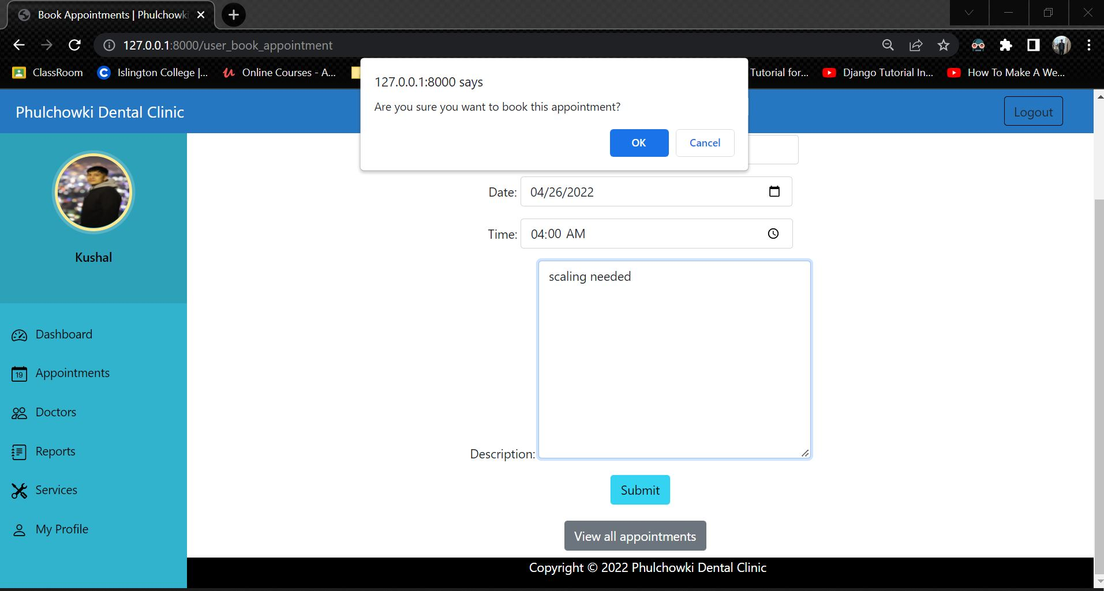

Figure 350: Black Box Test 6 (Successful) - 1

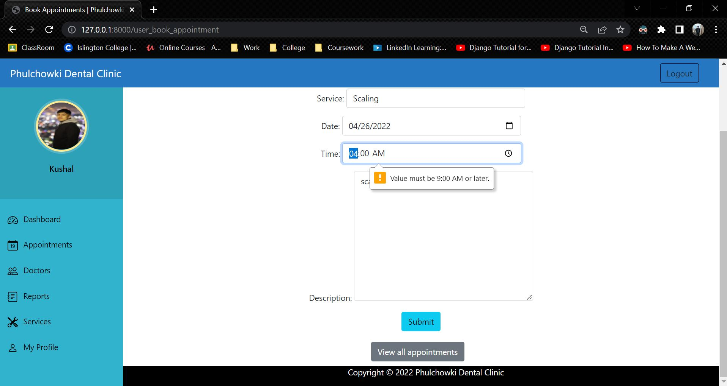

Figure 351: Black Box Test 6 (Successful) – 2

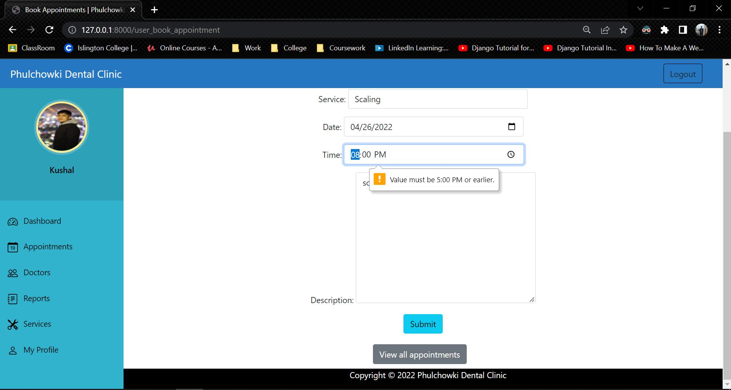

Figure 352: Black Box Test 6 (Successful) - 3

Here, the clinic time is 9am-6pm so the booking can only be done from 9am to 5pm.

|  |  |
| --- | --- |
| **Test No.7** | |
| Objective | To view pending appointment by the admin. |
| Action | The 'Approve Appointment' button was clicked in the admin panel. |
| Expected Output | The list of pending appointments would be shown. |
| Actual Output | All the appointments which has been approved/rejected was also shown. |
| Result | The test was unsuccessful. |

Table 28: Black Box Test 7 (Unsuccessful)

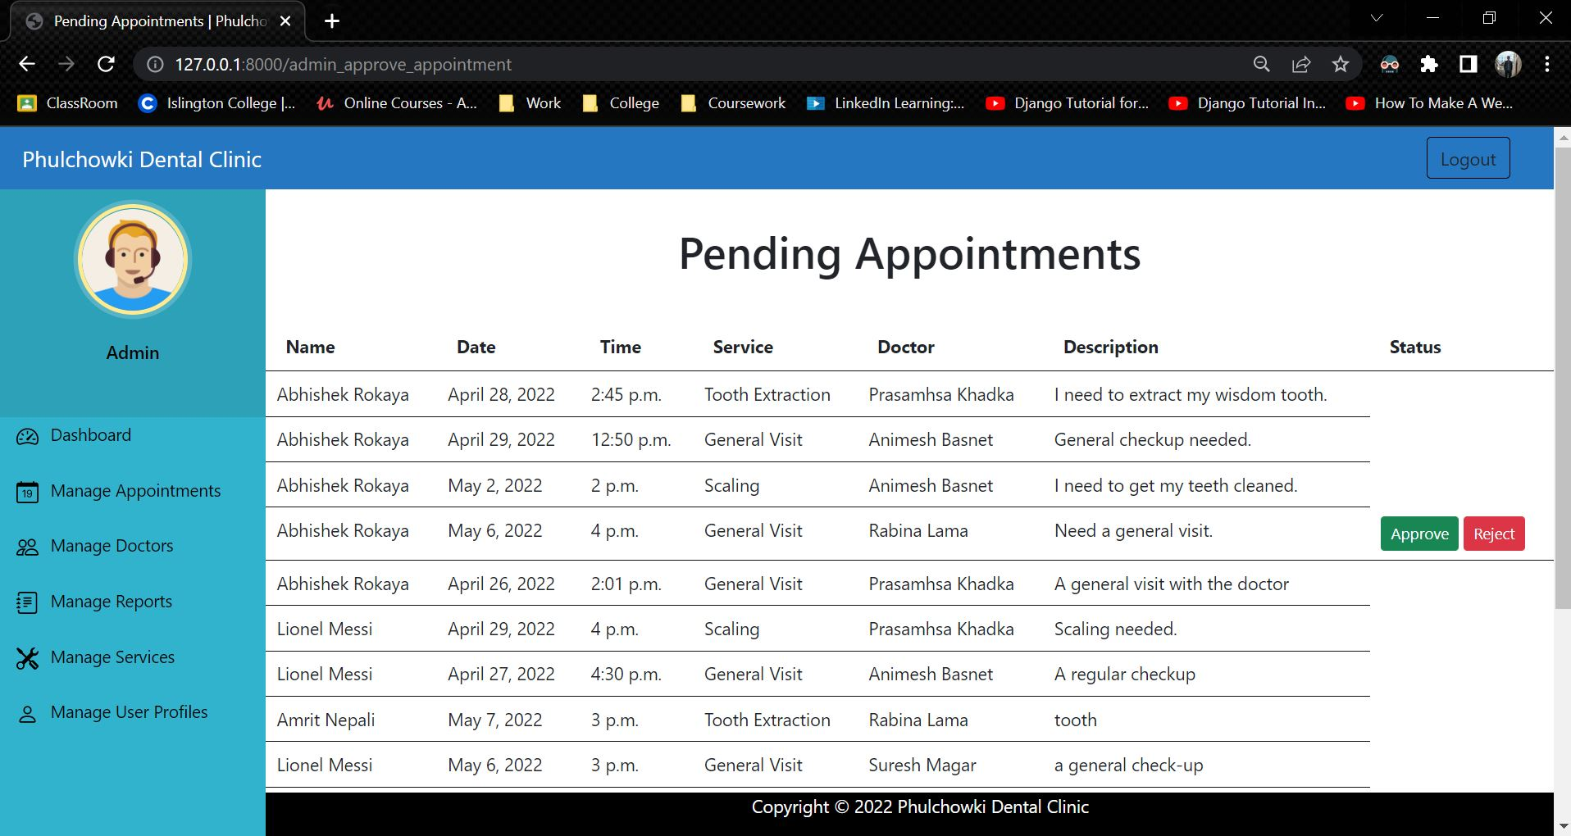

Figure 353: Black Box Test 7 (Unsuccessful)

**Code that caused the error:**

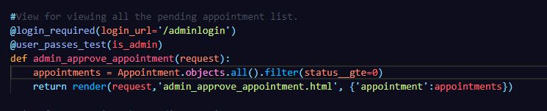

Figure 354: Black Box Test 7 - Error Code

**Fixing the code:**

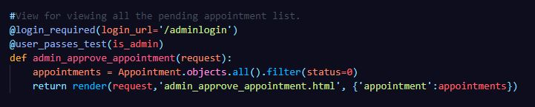

Figure 355: Black Box Test 7 - Fixed Code

|  |  |
| --- | --- |
| **Test No.7** | |
| Objective | To view pending appointment by the admin. |
| Action | The 'Approve Appointment' button was clicked in the admin panel. |
| Expected Output | The list of pending appointments would be shown. |
| Actual Output | The list of only pending appointments was be shown. |
| Result | The test was successful. |
| Cause of Error | The status was shown of greater than 0 but should be 0. |

Table 50: Black Box Test 7 (Successful)

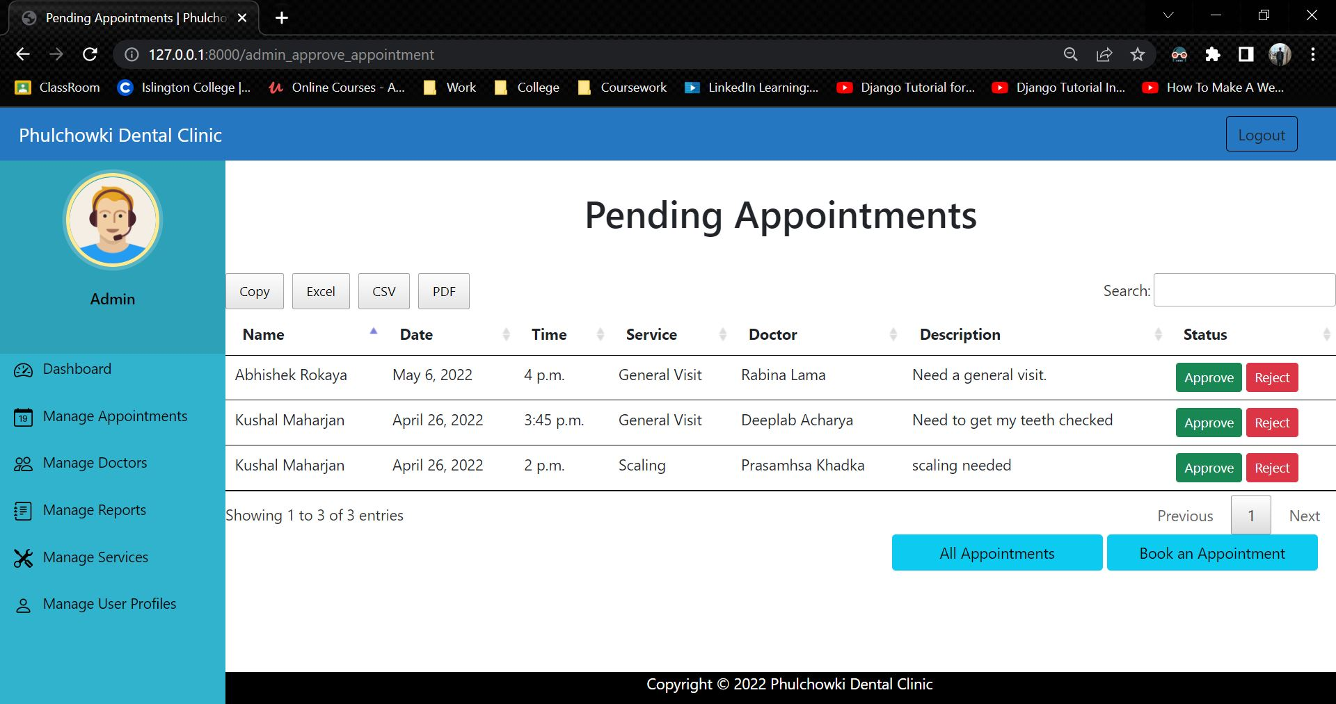

Figure 356: Black Box Test 7 (Successful)

|  |  |
| --- | --- |
| **Test No.8** | |
| Objective | To delete user from the system by the admin. |
| Action | The delete button of the user to be deleted was clicked. |
| Expected Output | The user would be deleted. |
| Actual Output | An error was shown and the user was not deleted. |
| Result | The test was unsuccessful. |

Table 30: Black Box Test 8 (Unsuccessful)

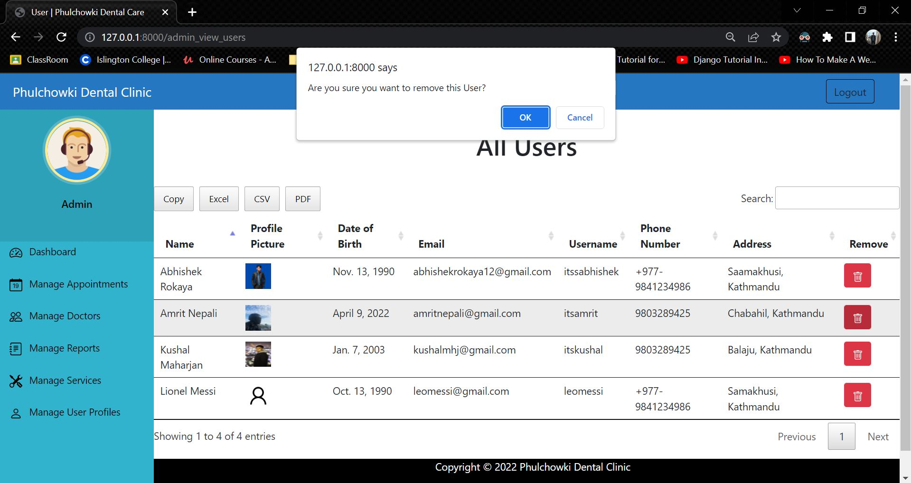

Figure 357: Black Box Test 8 (Unsuccessful) - 1

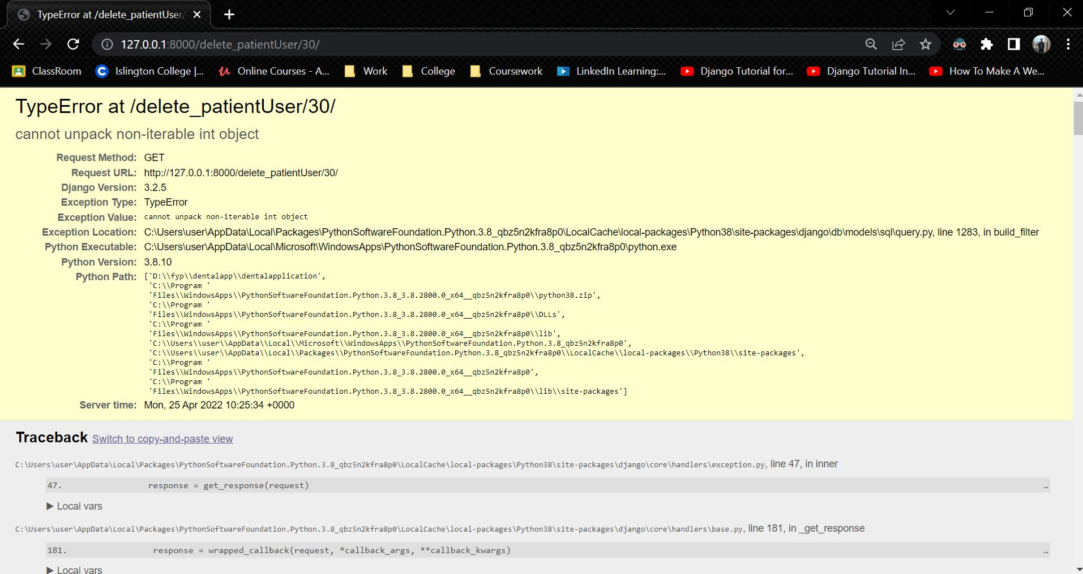

Figure 358: Black Box Test 8 (Unsuccessful) – 2

**Code that caused the error:**

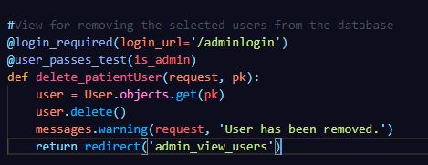

Figure 359: Black Box Test 8 - Error Code

**Fixing the code:**

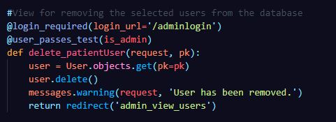

Figure 360: Black Box Test 8 - Fixed Code

|  |  |
| --- | --- |
| **Test No.8** | |
| Objective | To delete user from the system by the admin. |
| Action | The delete button of the user to be deleted was clicked. |
| Expected Output | The user would be deleted. |
| Actual Output | The user was deleted. |
| Result | The test was successful. |
| Cause of Error | The id was not specified for deleting which caused error in deleting the selected user. |

Table 31: Black Box Test 8 (Successful)

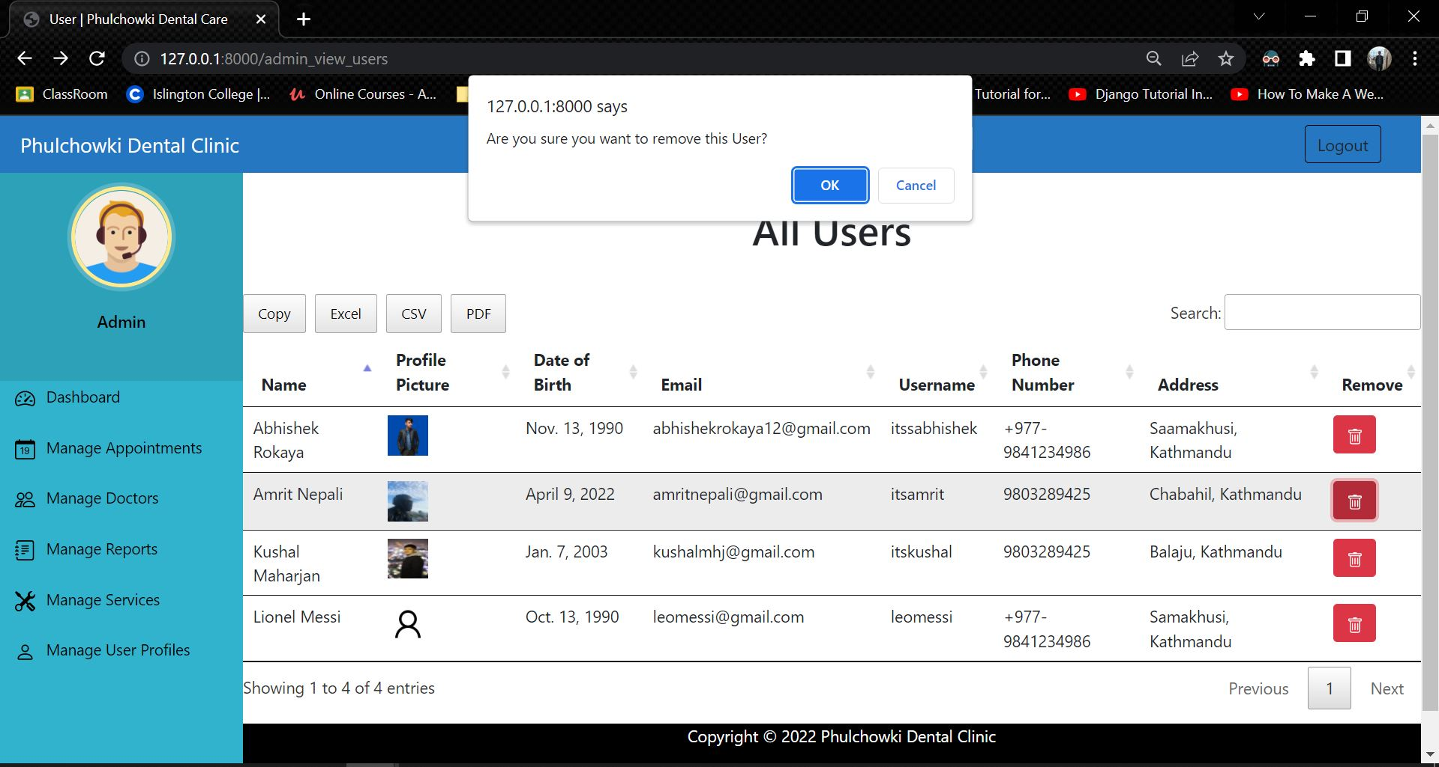

Figure 361: Black Box Test 8 (Successful) - 1

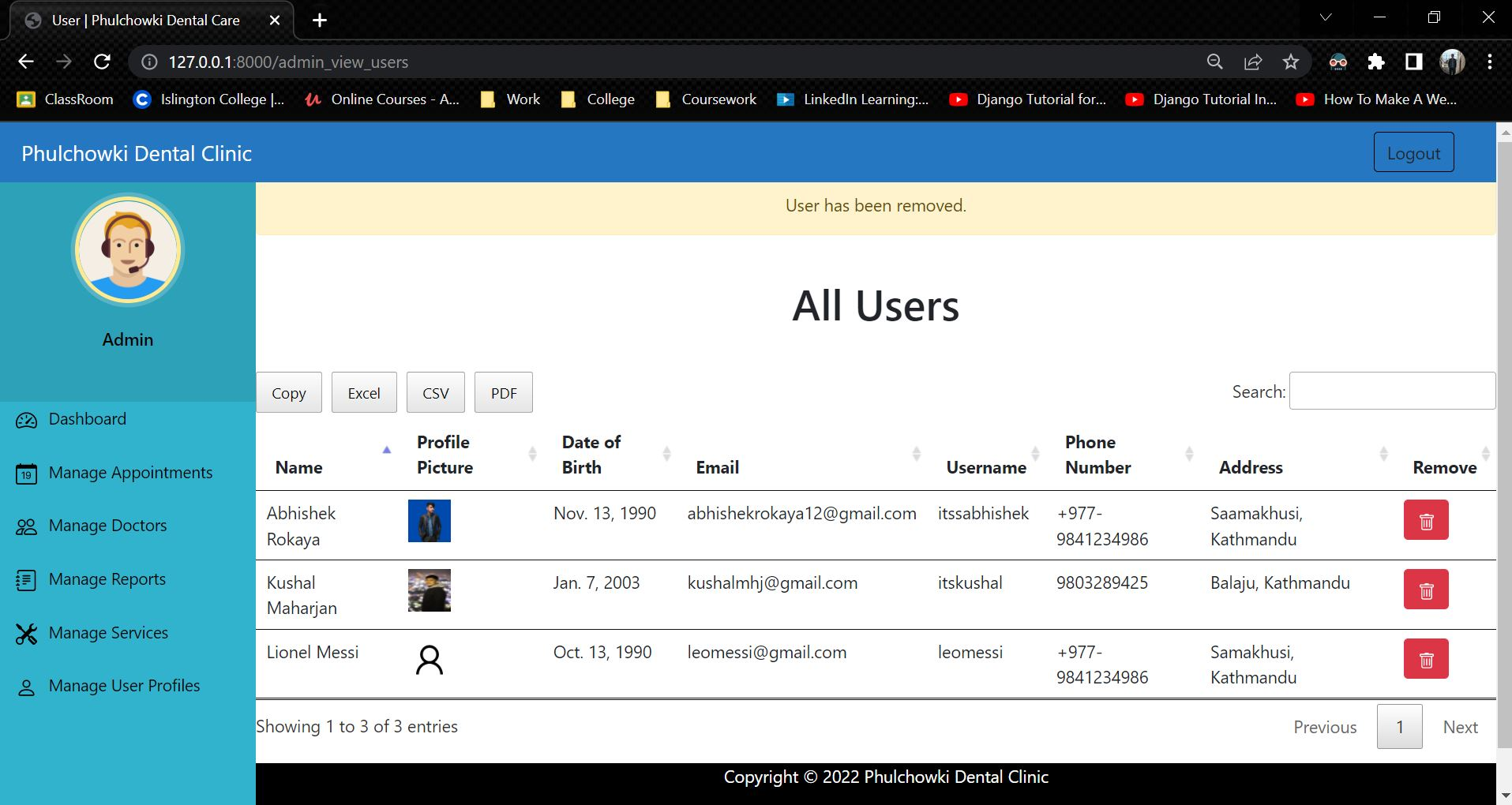

Figure 362: Black Box Test 8 (Successful) - 2

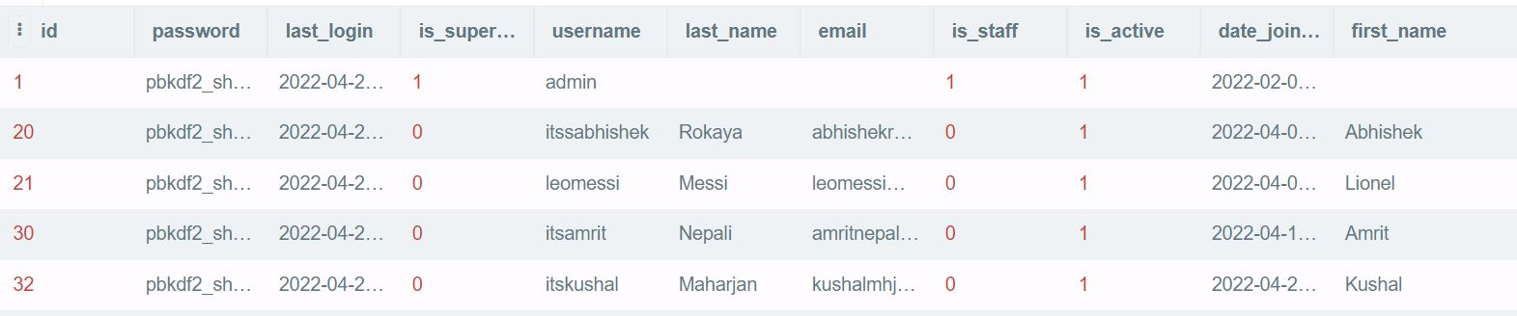

Figure 363: Black Box Test 8 - Database before

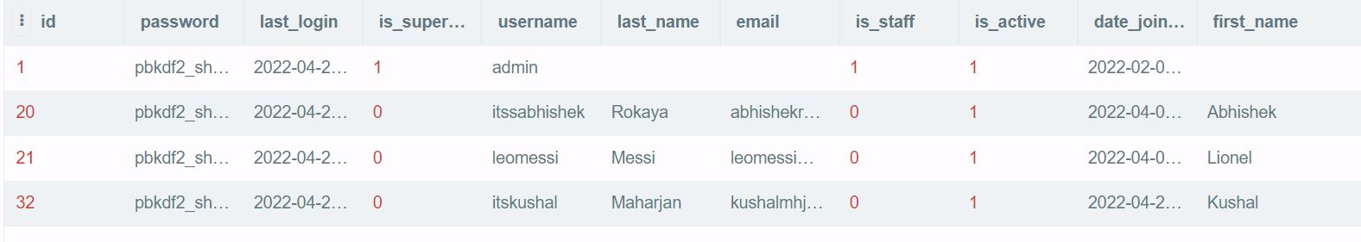

Figure 364: Black Box Test 8 - Database after

View the rest of the Black Box Testing Here.

View the test plan for the Black Box Testing Here.

### 7.7.2 White Box Testing

Continued from here

|  |  |
| --- | --- |
| **Test No.6** | |
| Objective | To view doctor by user. |
| Action | The 'Doctors' button in the sidebar was clicked. |
| Expected Output | The user would see the available doctors with their details. |
| Actual Output | The user saw the available doctors with their details. |
| Result | The test was successful. |

Table 58: White Box Test 6

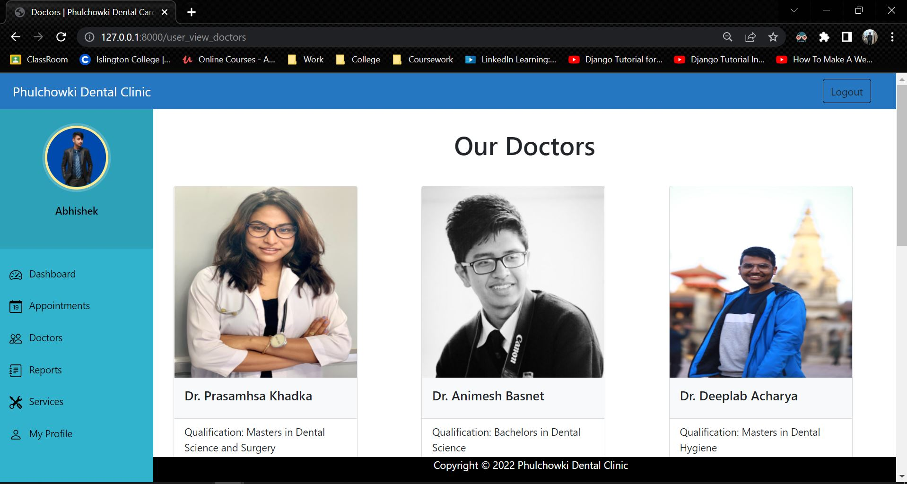

Figure 365: White Box Test 6 - 1

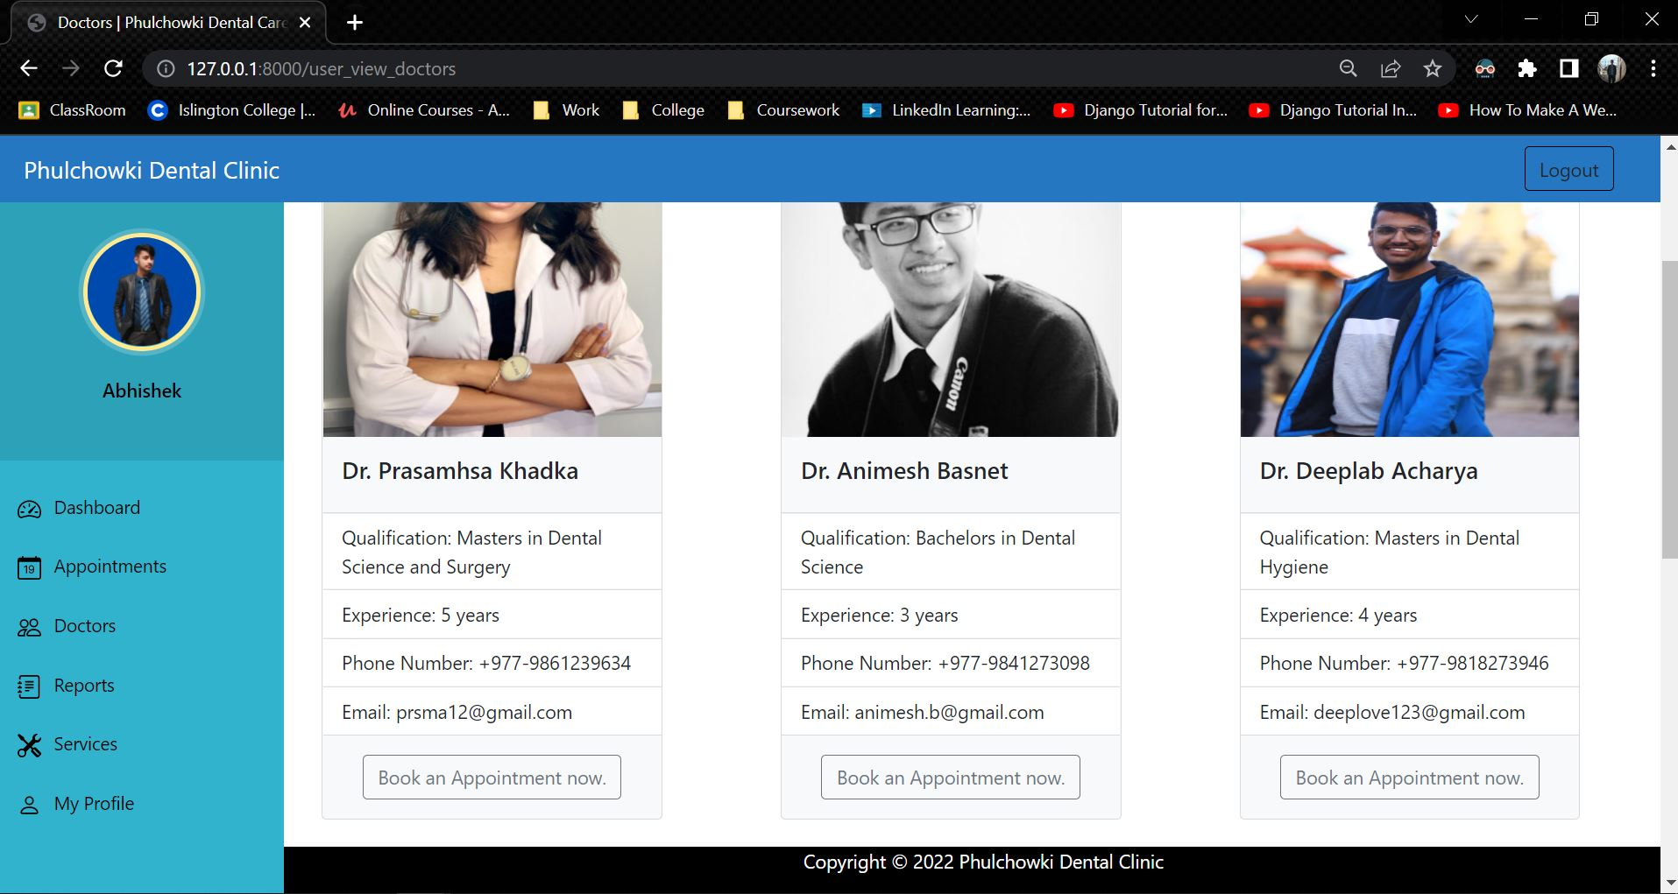

Figure 366: White Box Test 6 – 2

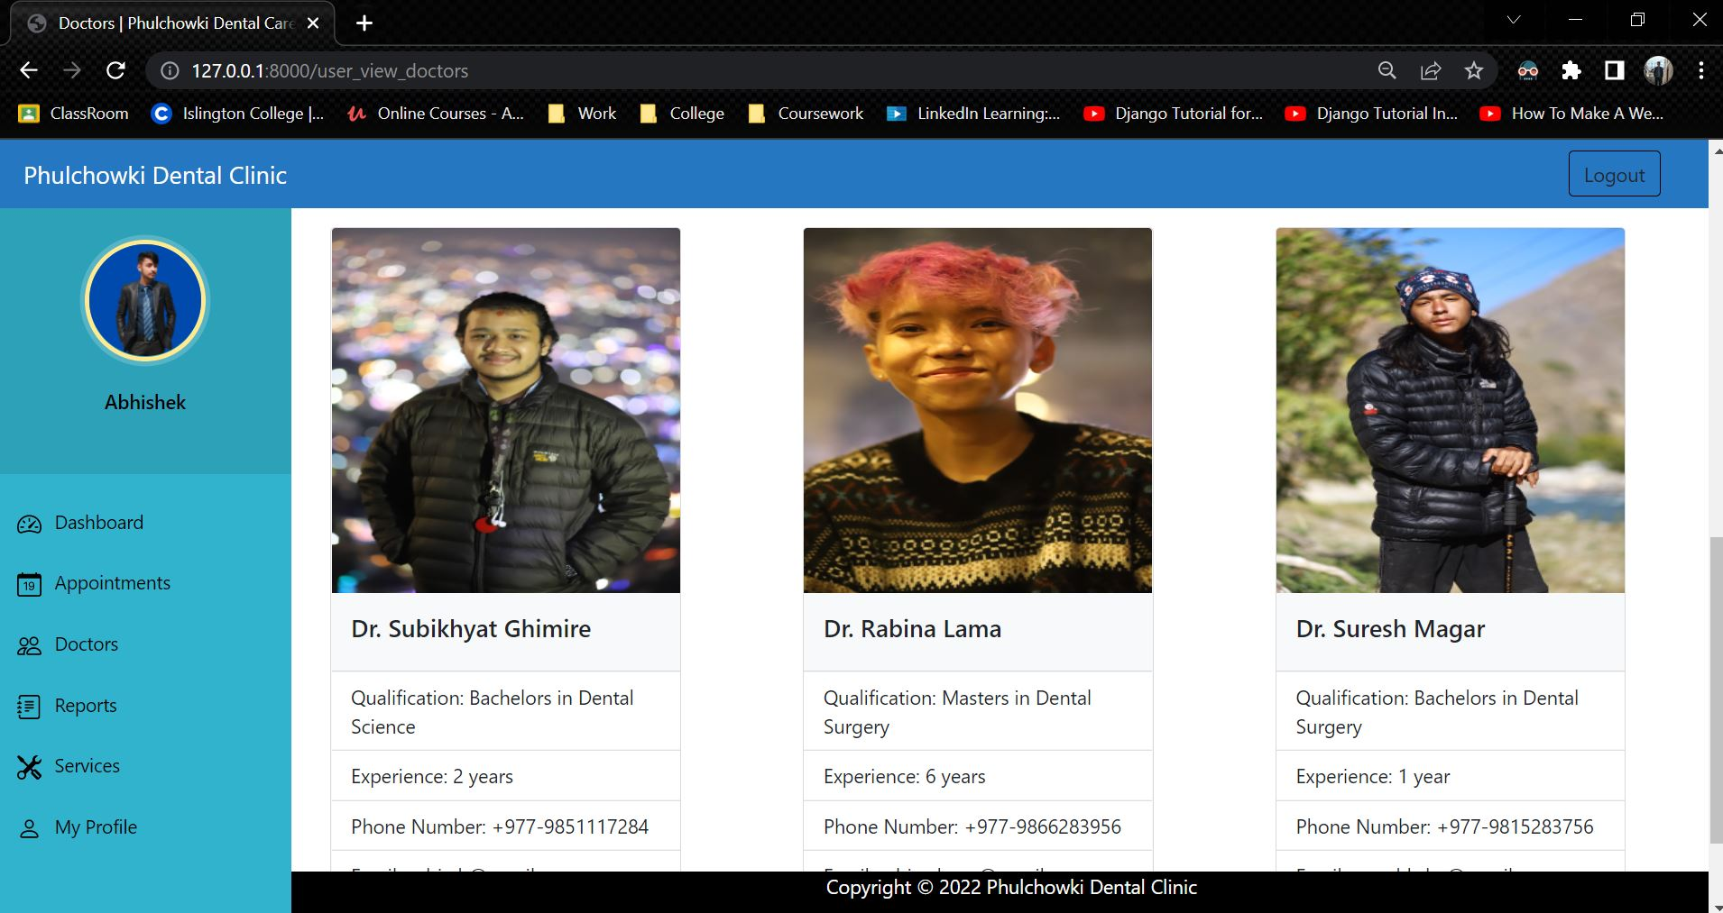

Figure 367: White Box Test 6 - 3

|  |  |
| --- | --- |
| **Test No.7** | |
| Objective | To view service by user. |
| Action | The 'Service' button in the sidebar was clicked. |
| Expected Output | The user would see the available services with their details. |
| Actual Output | The user saw the available services with their details. |
| Result | The test was successful. |

Table 59: White Box Test 7

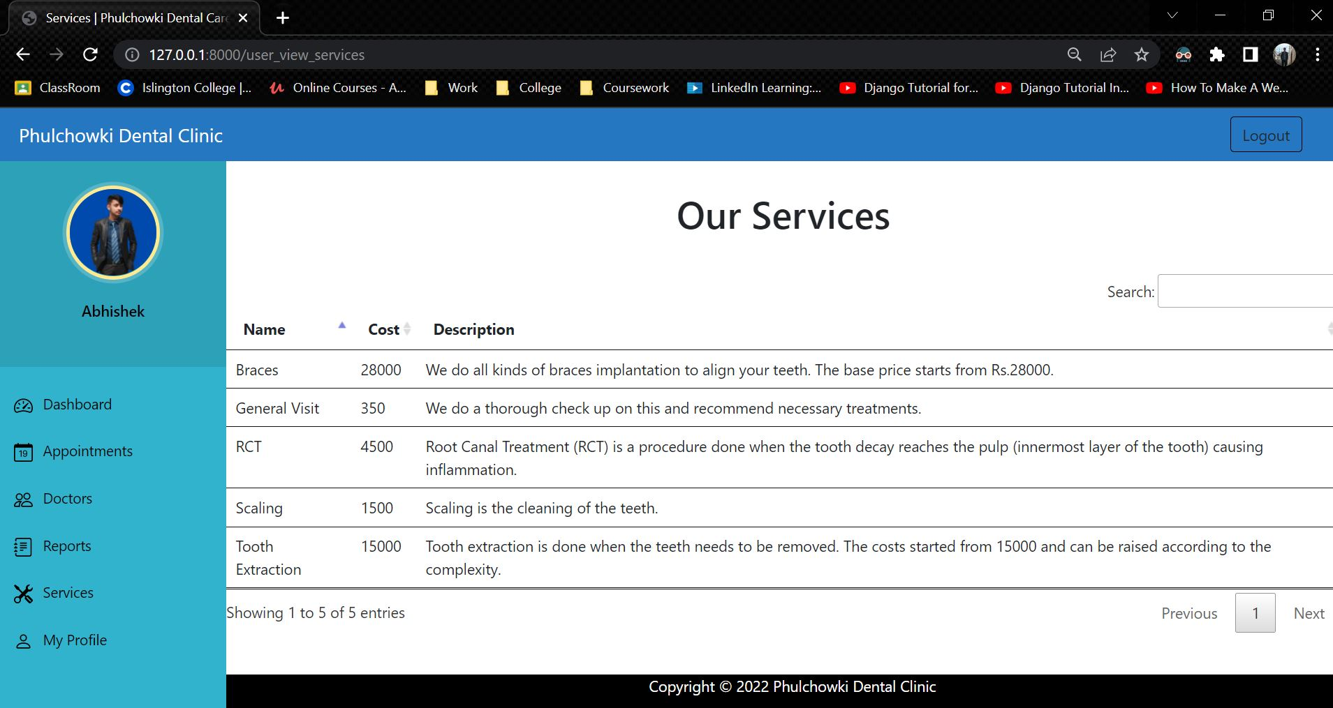

Figure 368: White Box Test 7

|  |  |
| --- | --- |
| **Test No.8** | |
| Objective | To download the report in pdf by the user. |
| Action | The 'Report' button in the sidebar was clicked to view the reports. Then the 'PDF' button was clicked. |
| Expected Output | The reports would be downloaded. |
| Actual Output | The reports was downloaded. |
| Result | The test was successful. |

Table 60: White Box Test 8

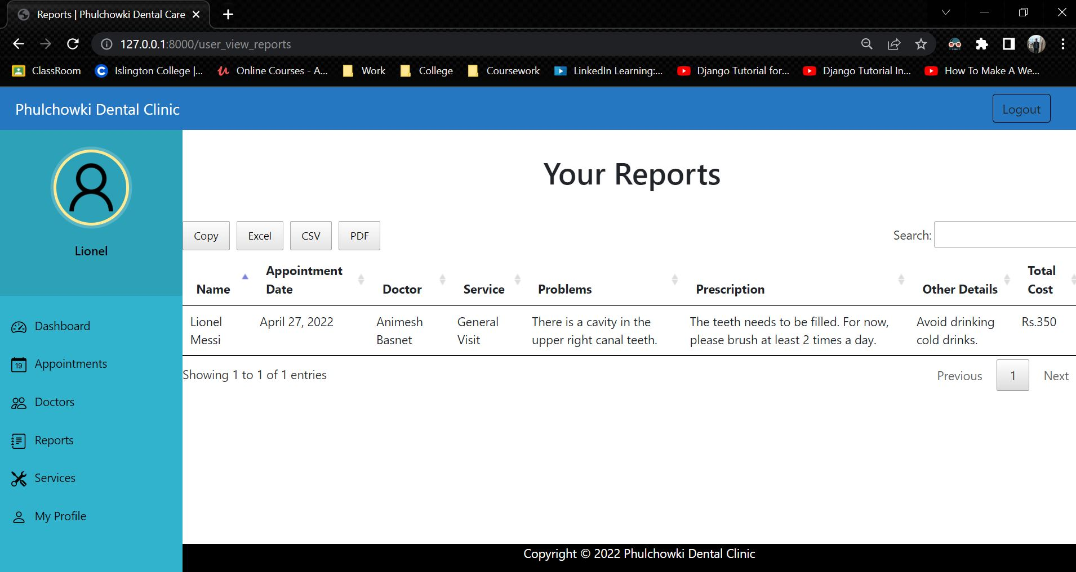

Figure 369: White Box Test 8 - 1

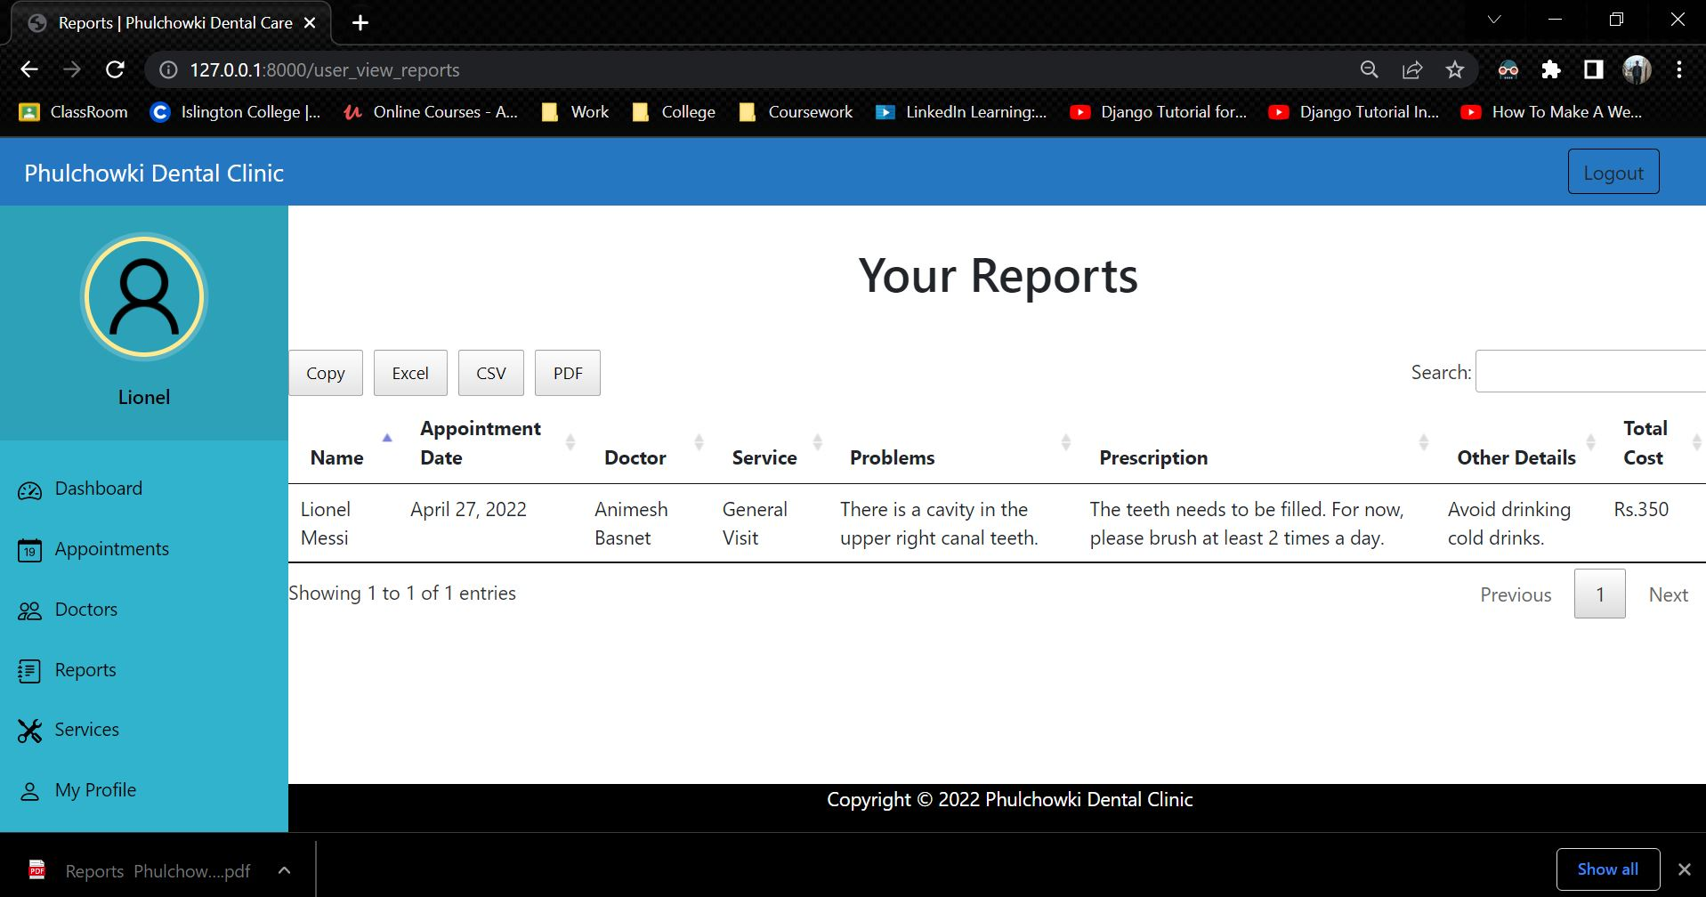

Figure 370: White Box Test 8 – 2

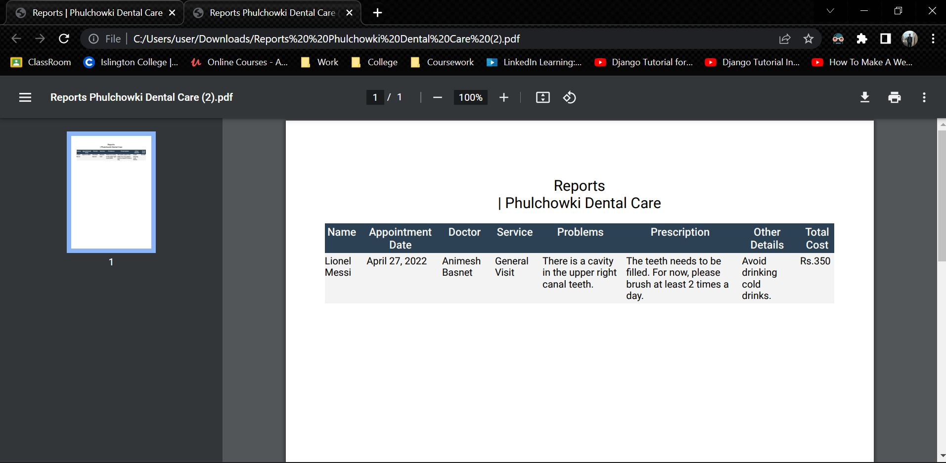

Figure 371: White Box Test 8 - 3

|  |  |
| --- | --- |
| **Test No.9** | |
| Objective | To sort the appointment according to the date. |
| Action | The 'Appointment' button was clicked in the sidebar to view all appointments. Then the 'Appointment date' header of the table was clicked to sort it according to date. |
| Expected Output | The appointments would be sorted according to date. |
| Actual Output | The appointments was sorted according to date. |
| Result | The test was successful. |

Table 61: White Box Test 9

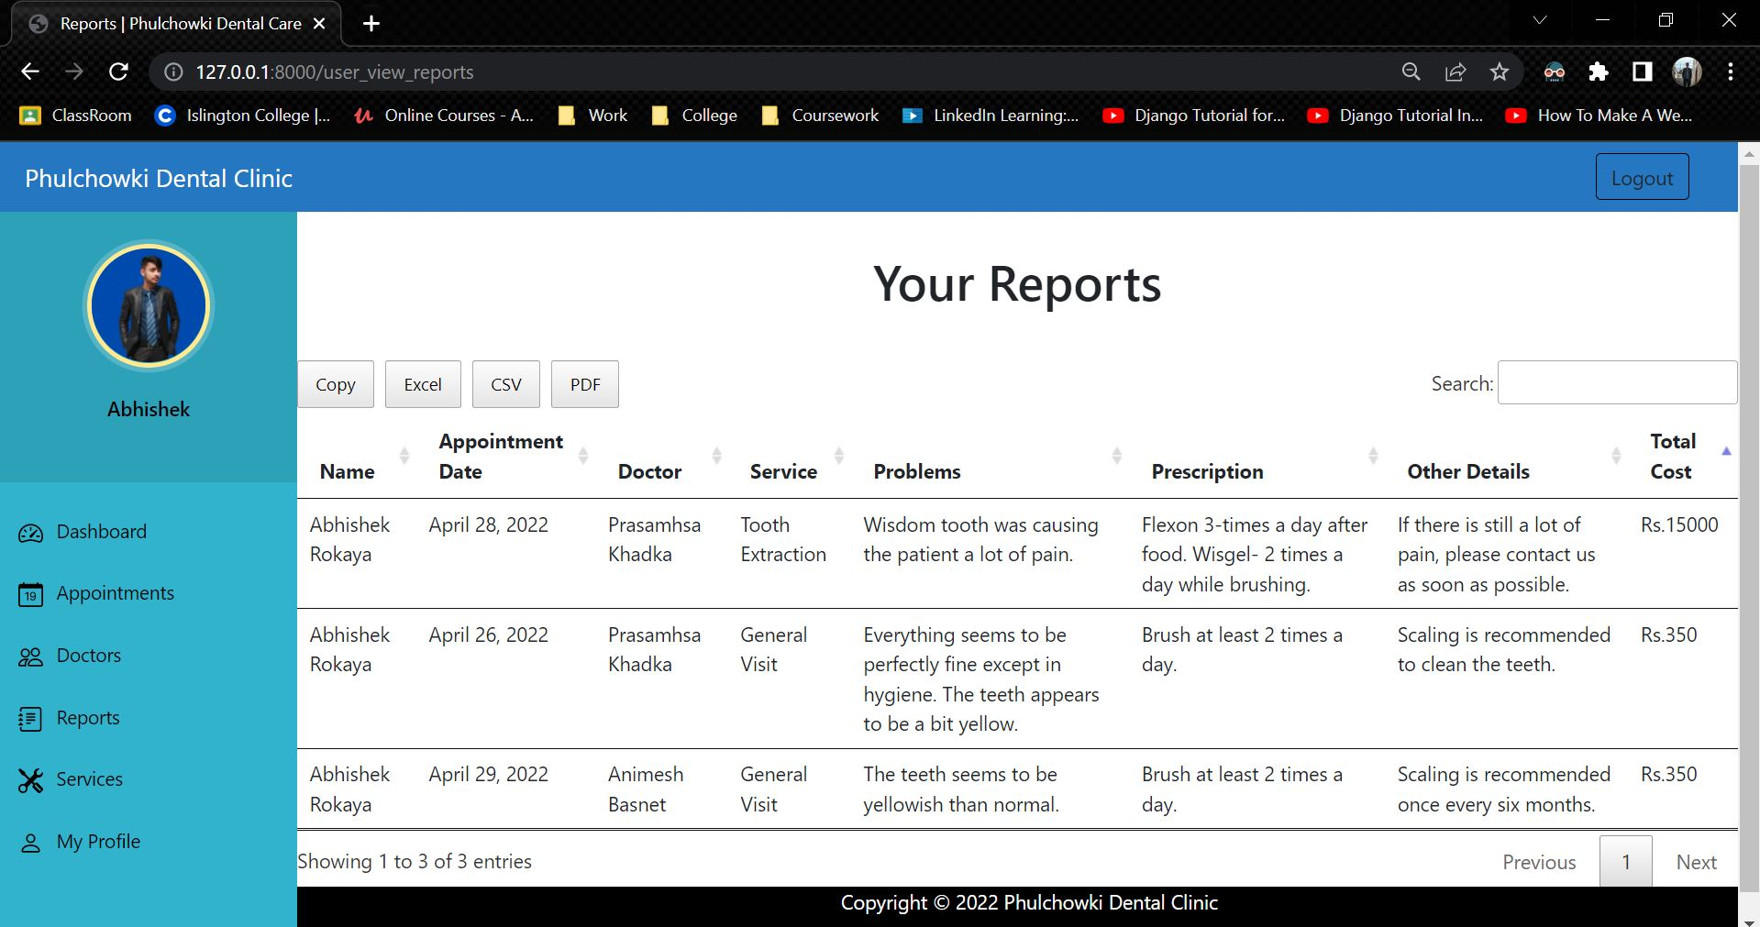

Figure 372: White Box Test 9 - 1

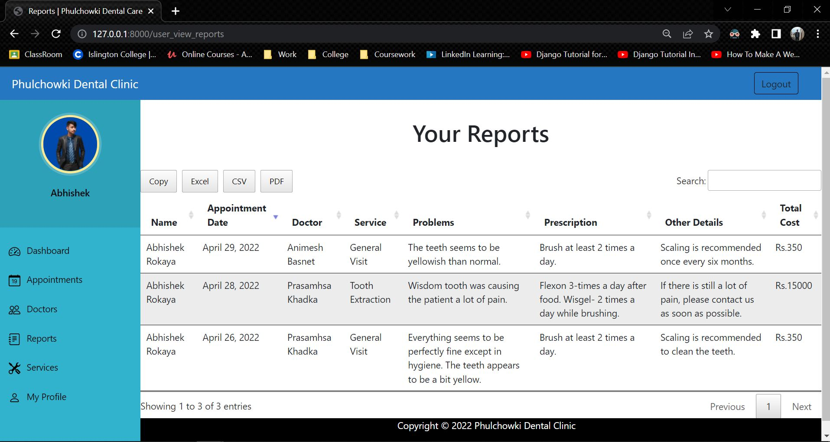

Figure 373: White Box Test 9 - 2

|  |  |
| --- | --- |
| **Test No.10** | |
| Objective | To search the report. |
| Action | The 'Report' button in the sidebar was clicked to view the reports. Then 'April 29 ' was entered to filter the report list of April 29 only. |
| Expected Output | The reports would be filtered. |
| Actual Output | The reports was filtered. |
| Result | The test was successful. |

Table 62: White Box Test 10

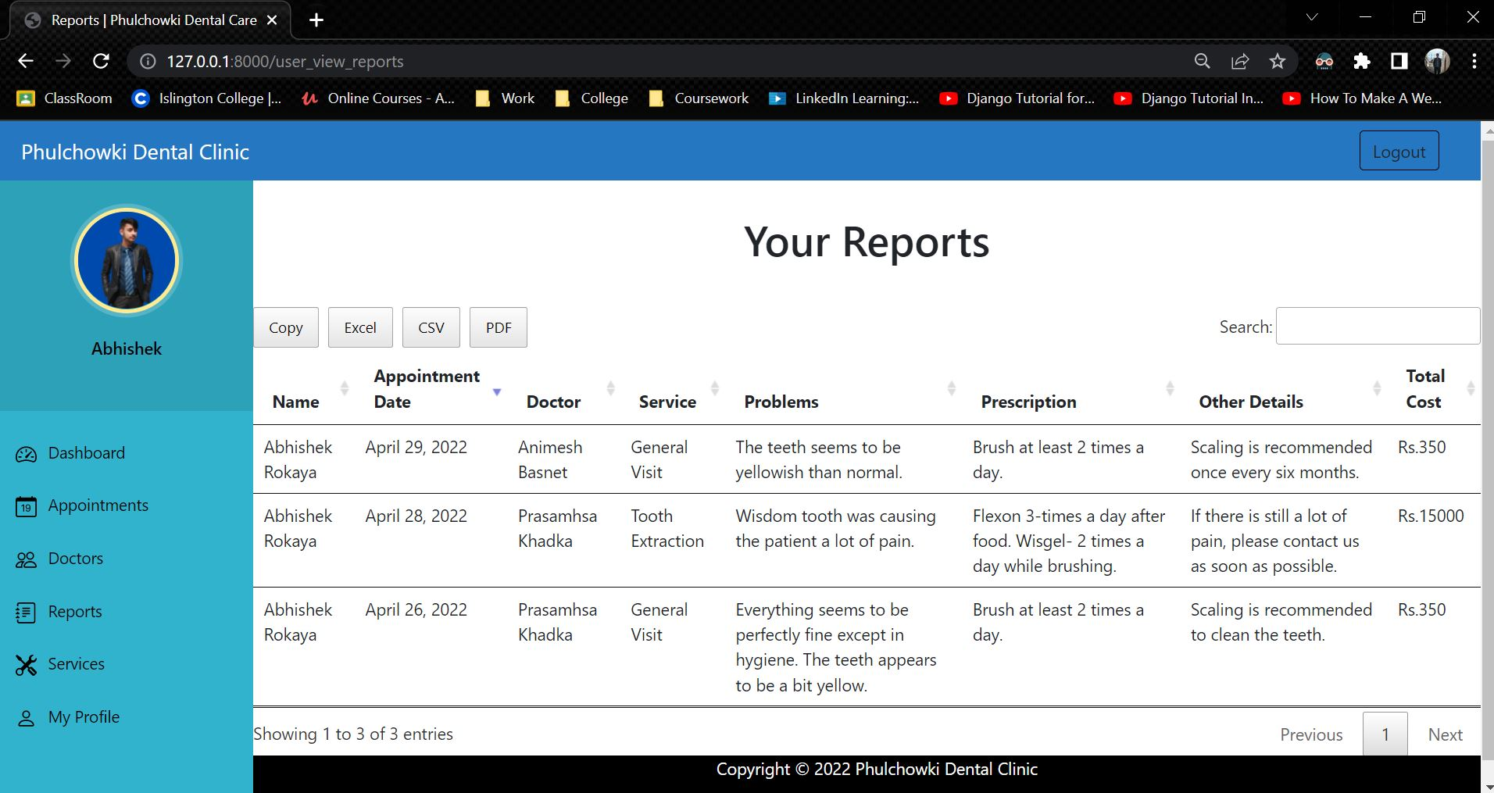

Figure 374: White Box Test 10 - 1

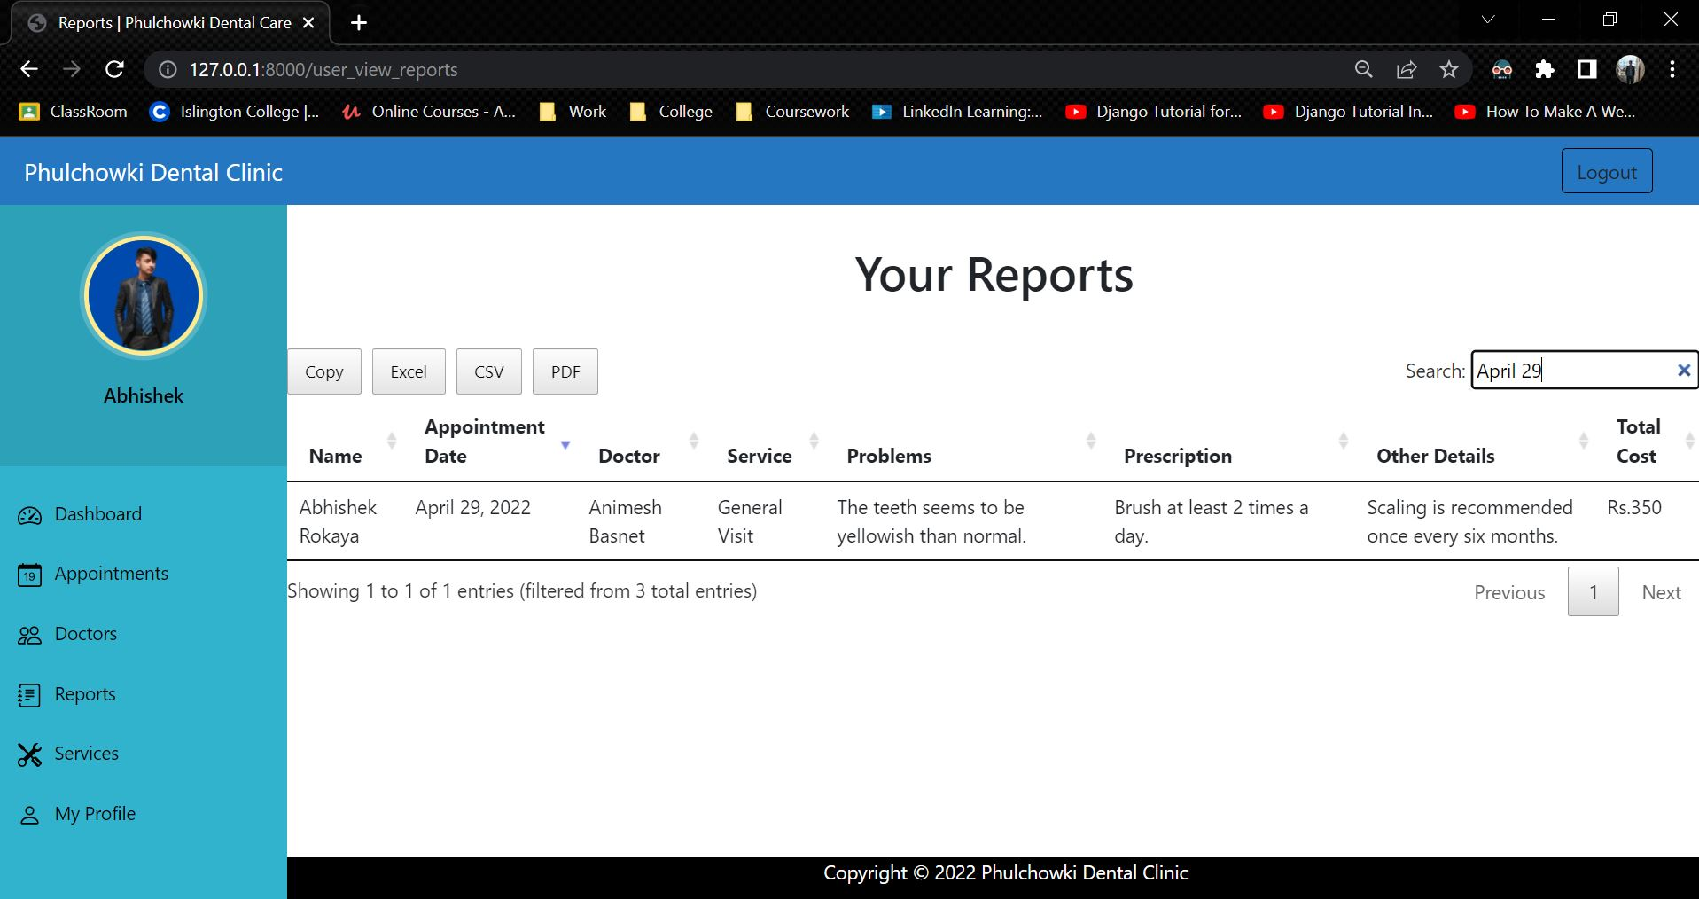

Figure 375: White Box Test 10 - 2

|  |  |
| --- | --- |
| **Test No.11** | |
| Objective | To view user's profile. |
| Action | The 'My Profile' button in the sidebar was clicked. |
| Expected Output | The user's profile with the logged in user's data would be shown. |
| Actual Output | The user's profile with the logged in user's data was shown. |
| Result | The test was successful. |

Table 63: White Box Test 11

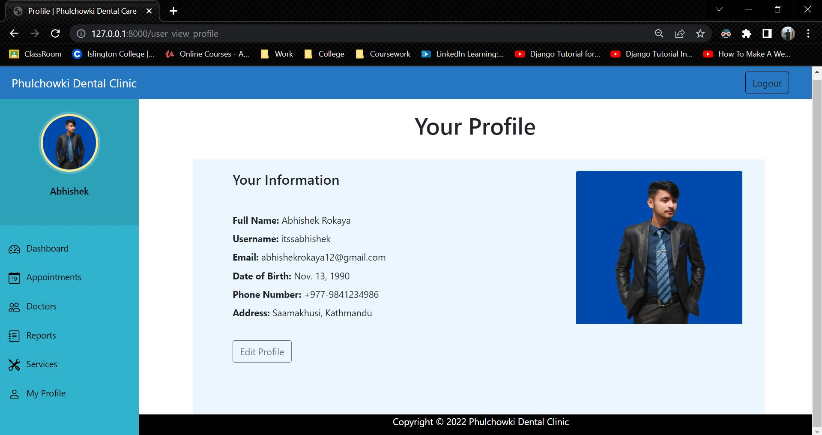

Figure 376: White Box Test 11

|  |  |
| --- | --- |
| **Test No.12** | |
| Objective | To logout. |
| Action | The 'logout' button in the top right was clicked. |
| Expected Output | The user would be logged out. |
| Actual Output | The user was logged out. |
| Result | The test was successful. |

Table 64: White Box Test 12

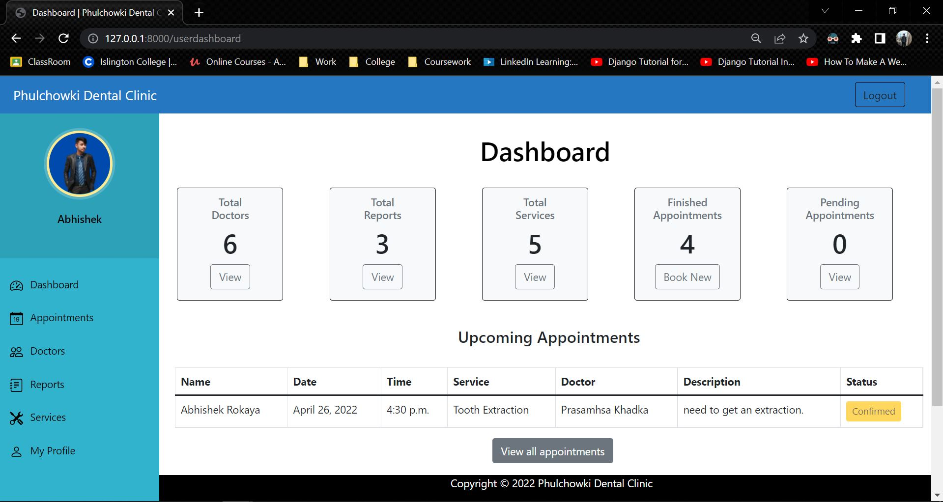

Figure 377: White Box Test 12 - 1

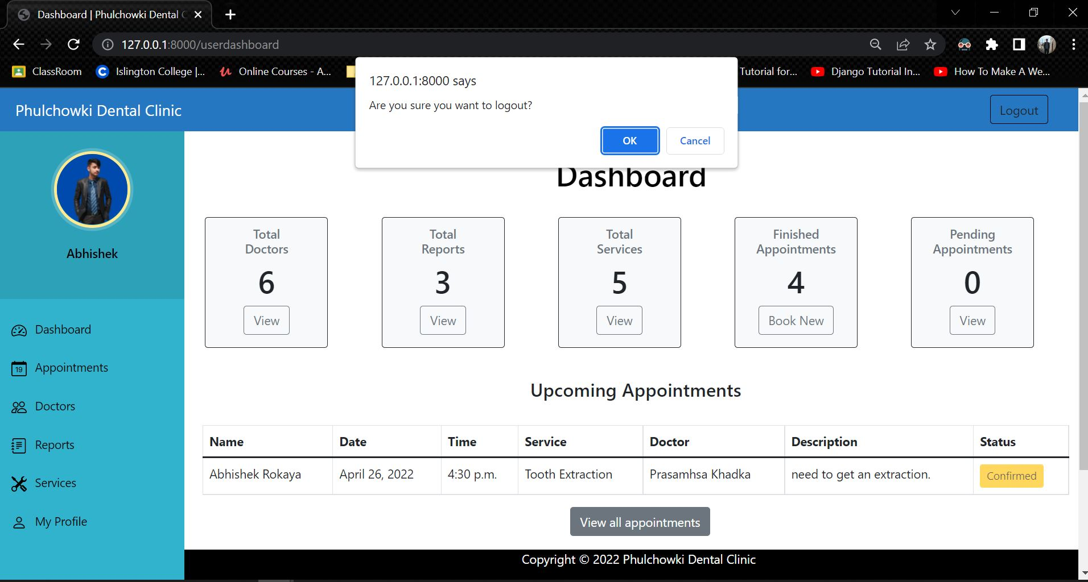

Figure 378: White Box Test 12 – 2

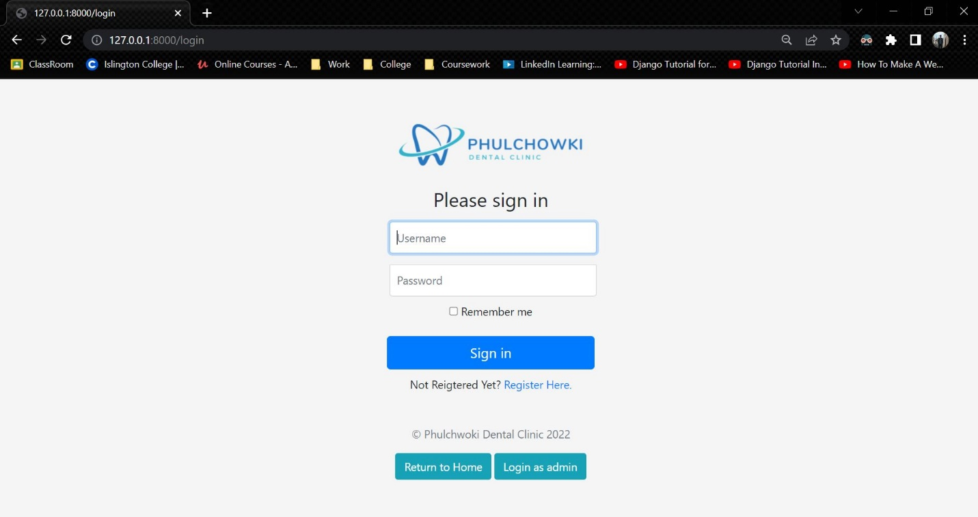

Figure 379: White Box Test 12 - 3

|  |  |
| --- | --- |
| **Test No.13** | |
| Objective | To approve appointment of the user by the admin. |
| Action | The 'approve' button was clicked in the pending appointment list. |
| Expected Output | The appointment would be approved. |
| Actual Output | The appointment was approved. |
| Result | The test was successful. |

Table 65: White Box Test 13

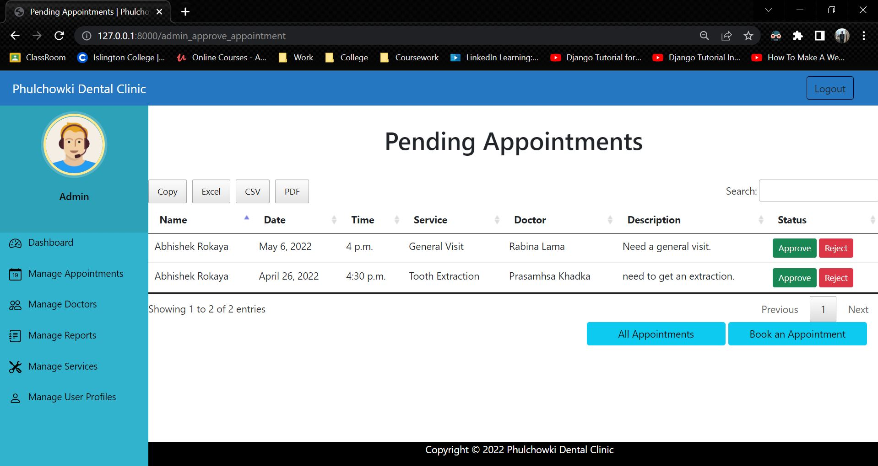

Figure 380: White Box Test 13 - 1

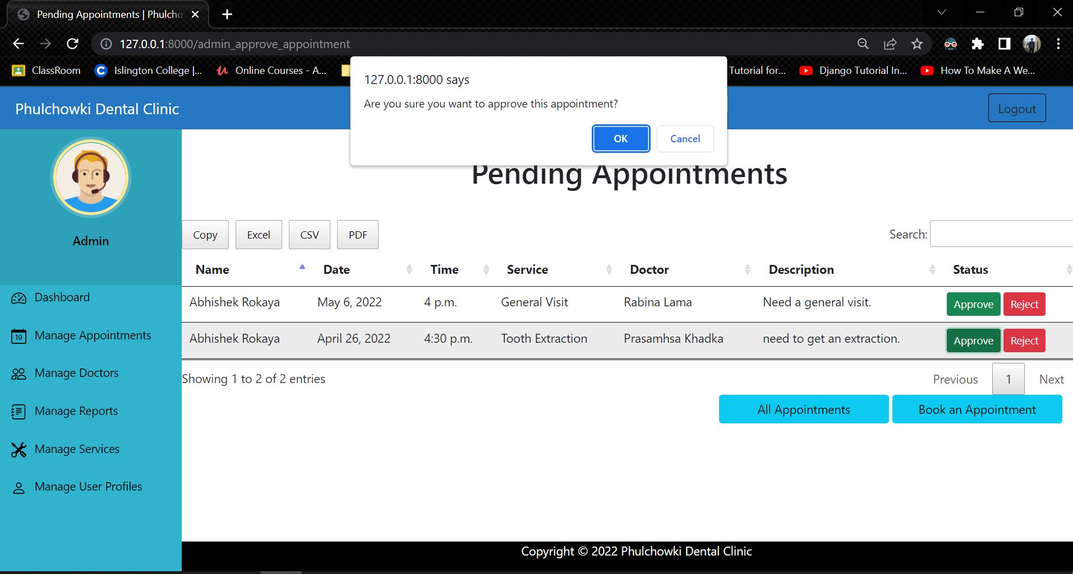

Figure 381: White Box Test 13 – 2

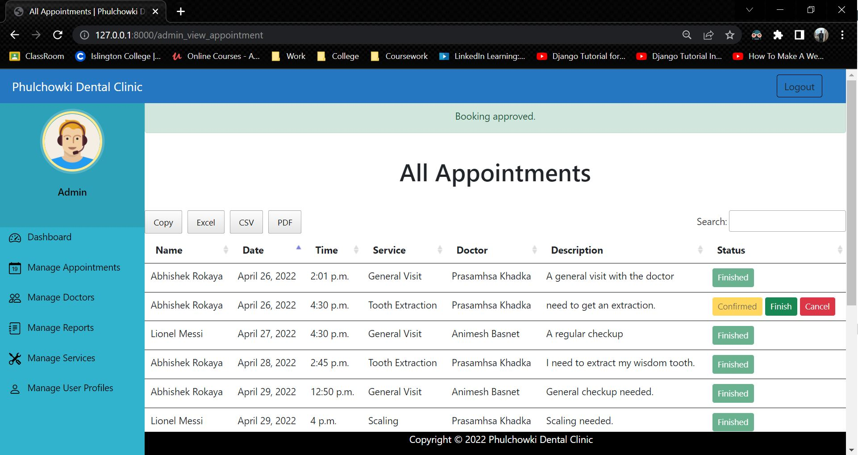

Figure 382: White Box Test 13 - 3

|  |  |
| --- | --- |
| **Test No.14** | |
| Objective | To reject appointment of the user by the admin. |
| Action | The 'reject' button was clicked in the pending appointment list. |
| Expected Output | The appointment would be rejected. |
| Actual Output | The appointment was rejected. |
| Result | The test was successful. |

Table 66: White Box Test 14

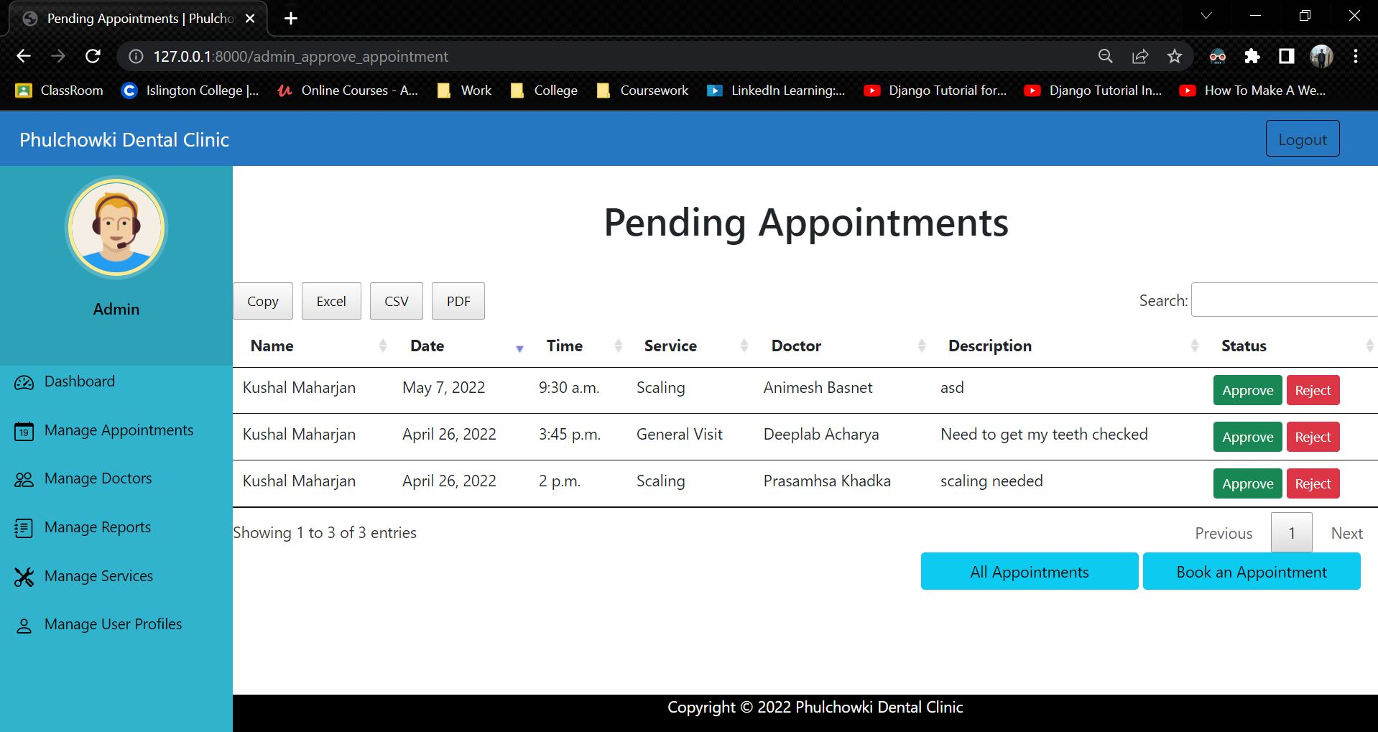

Figure 383: White Box Test 14 - 1

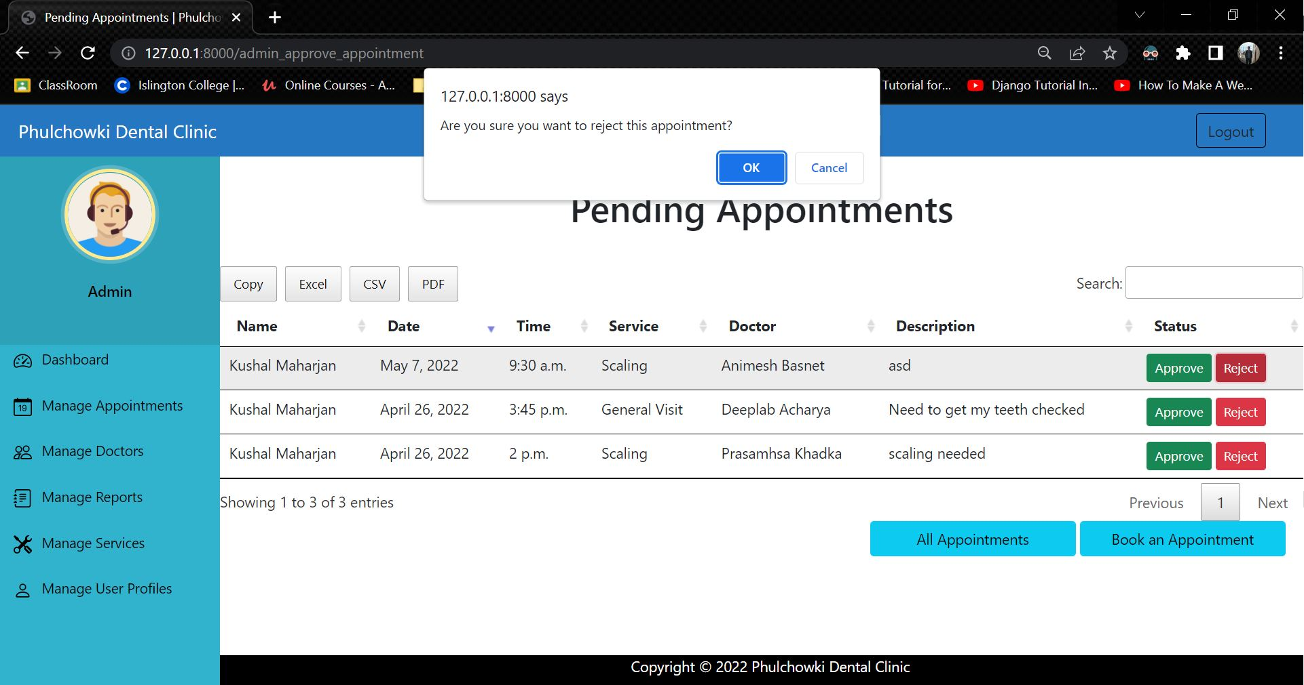

Figure 384: White Box Test 14 – 2

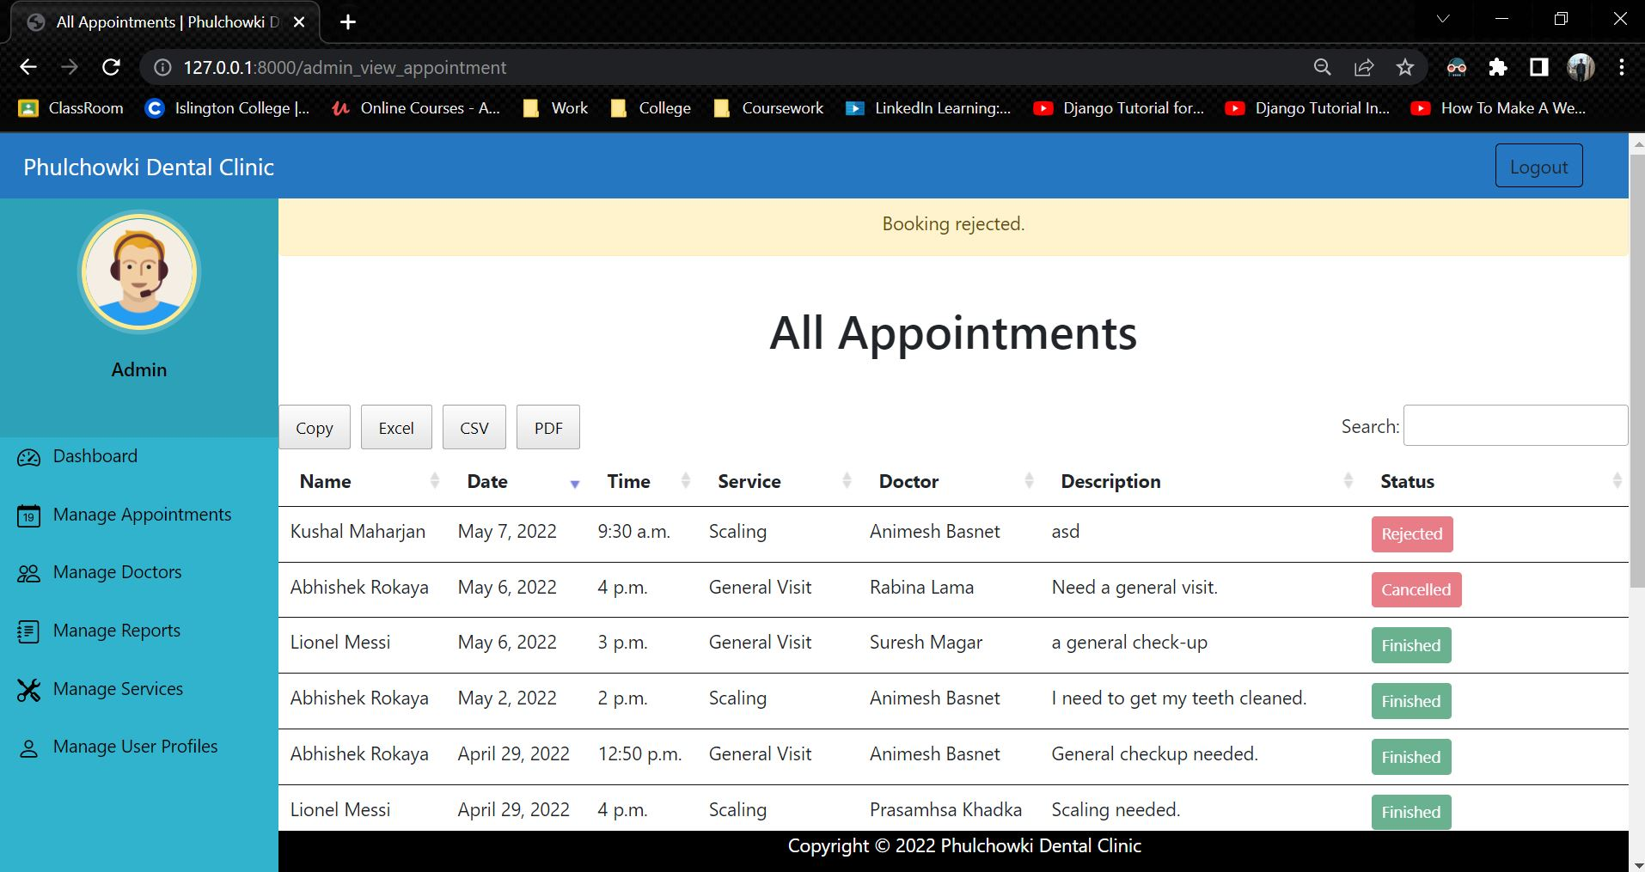

Figure 385: White Box Test 14 – 3

|  |  |
| --- | --- |
| **Test No.15** | |
| Objective | To cancel the confirmed appointment of the user by the admin. |
| Action | The 'cancel' button was clicked in the appointment list. |
| Expected Output | The appointment would be cancelled. |
| Actual Output | The appointment was cancelled. |
| Result | The test was successful. |

Table 67: White Box Test 15

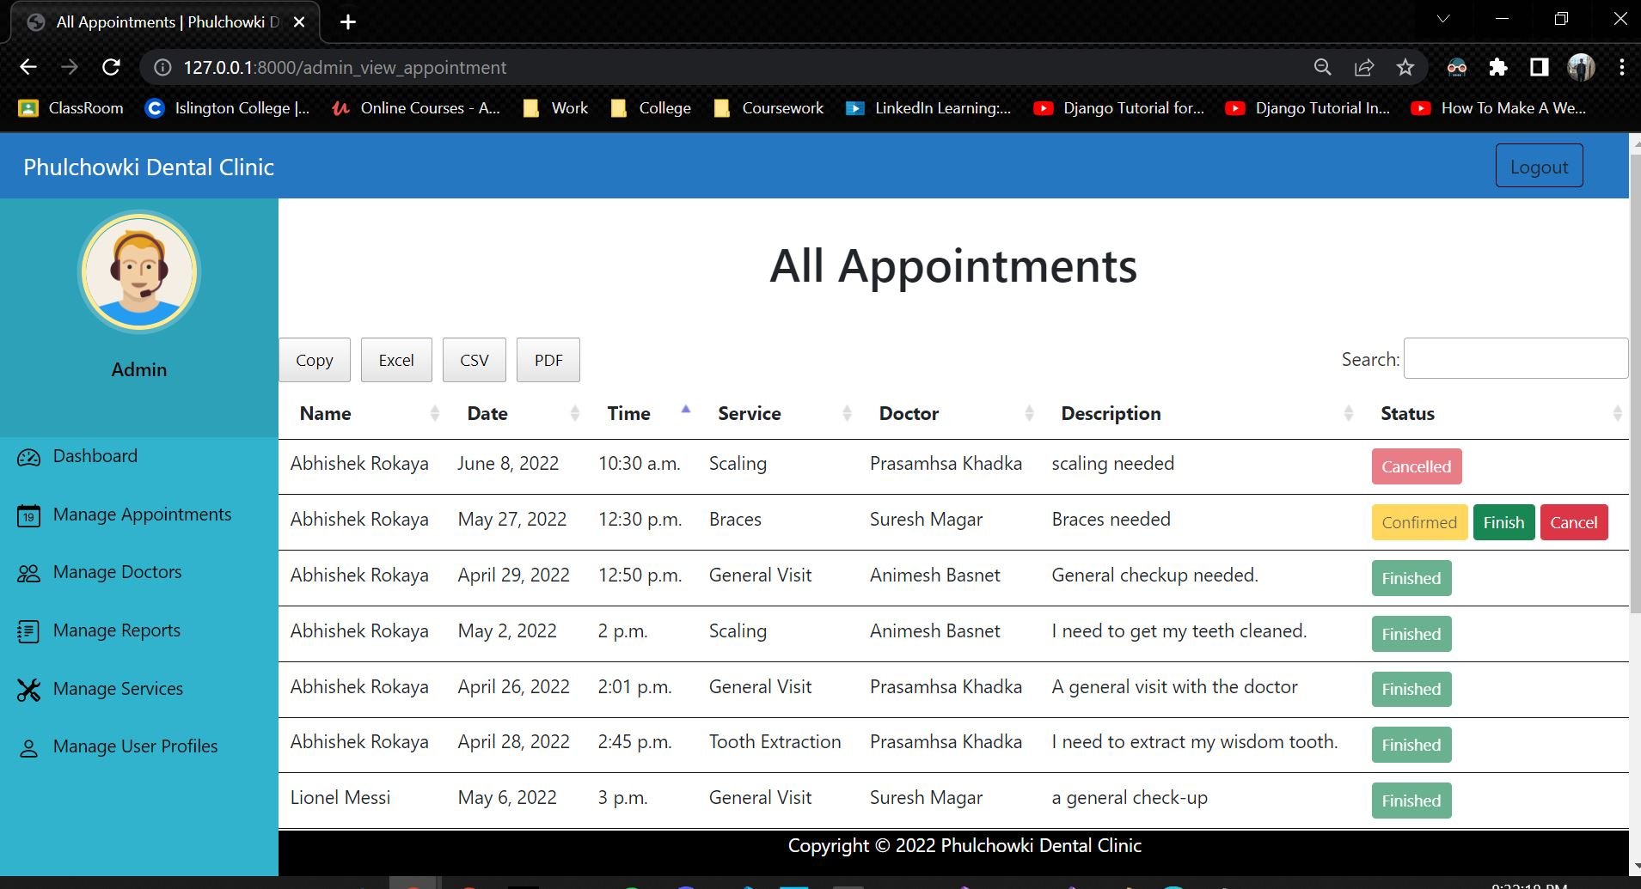

Figure 386: White Box Test 15 - 1

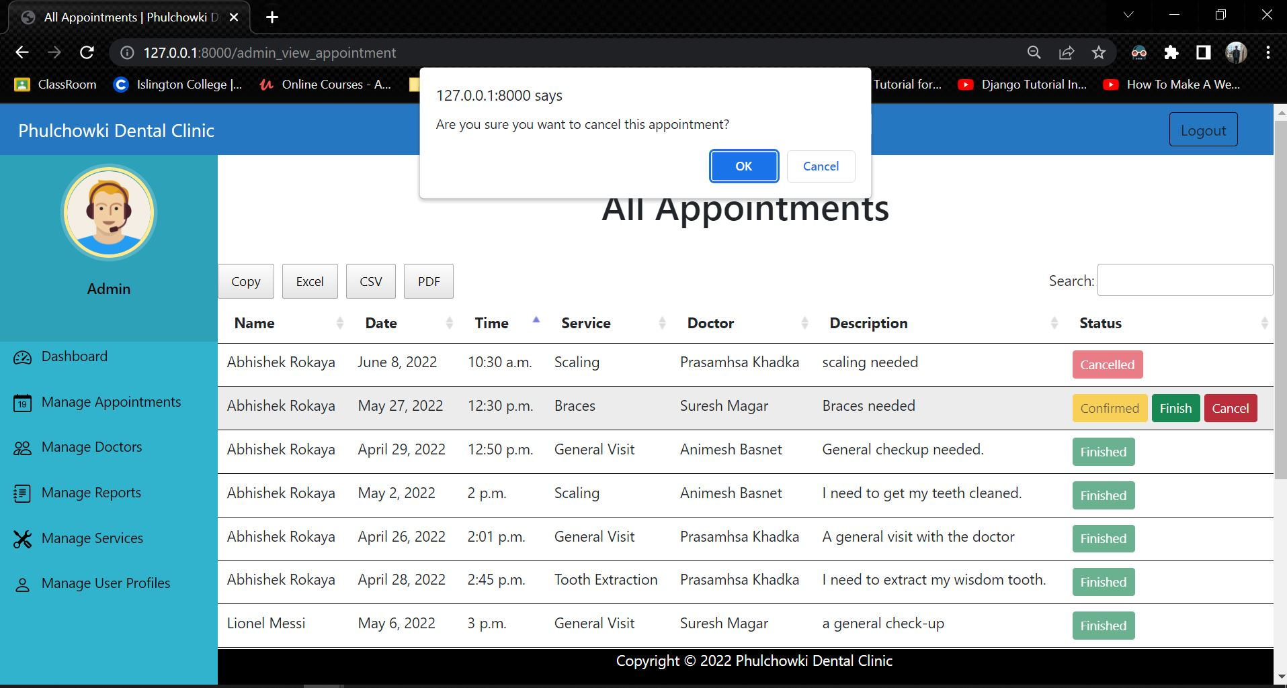

Figure 387: White Box Test 15 – 2

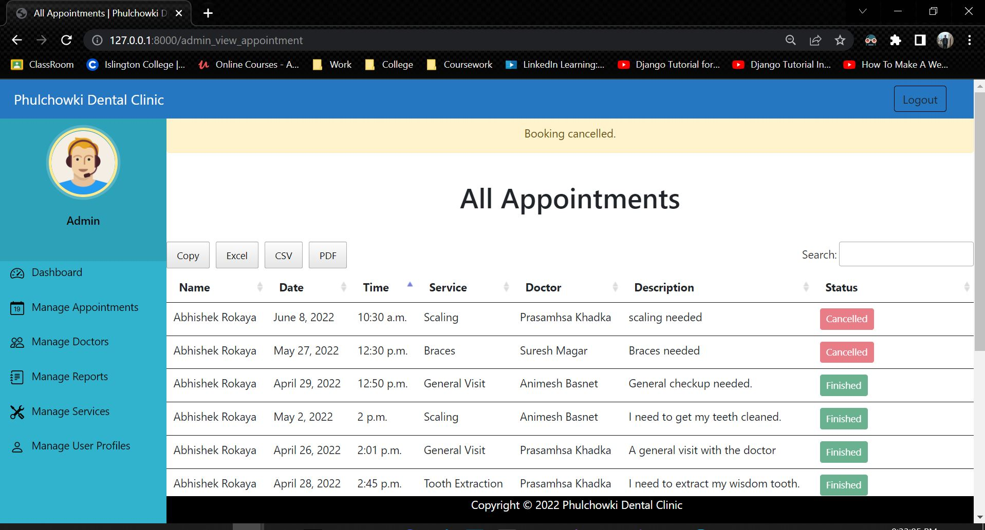

Figure 388: White Box Test 15 – 3

|  |  |
| --- | --- |
| **Test No.16** | |
| Objective | To finish the appointment of the user by the admin. |
| Action | The 'finish' button was clicked in the appointment list. |
| Expected Output | The appointment would be finished. |
| Actual Output | The appointment was finished. |
| Result | The test was successful. |

Table 68: White Box Test 16

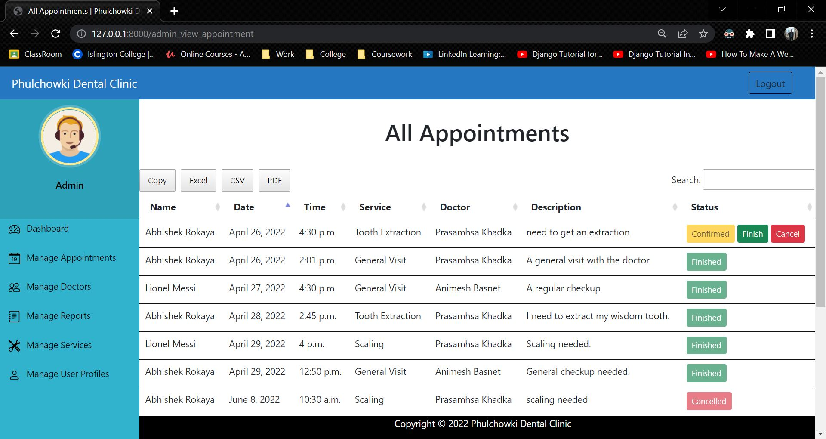

Figure 389: White Box Test 16 - 1

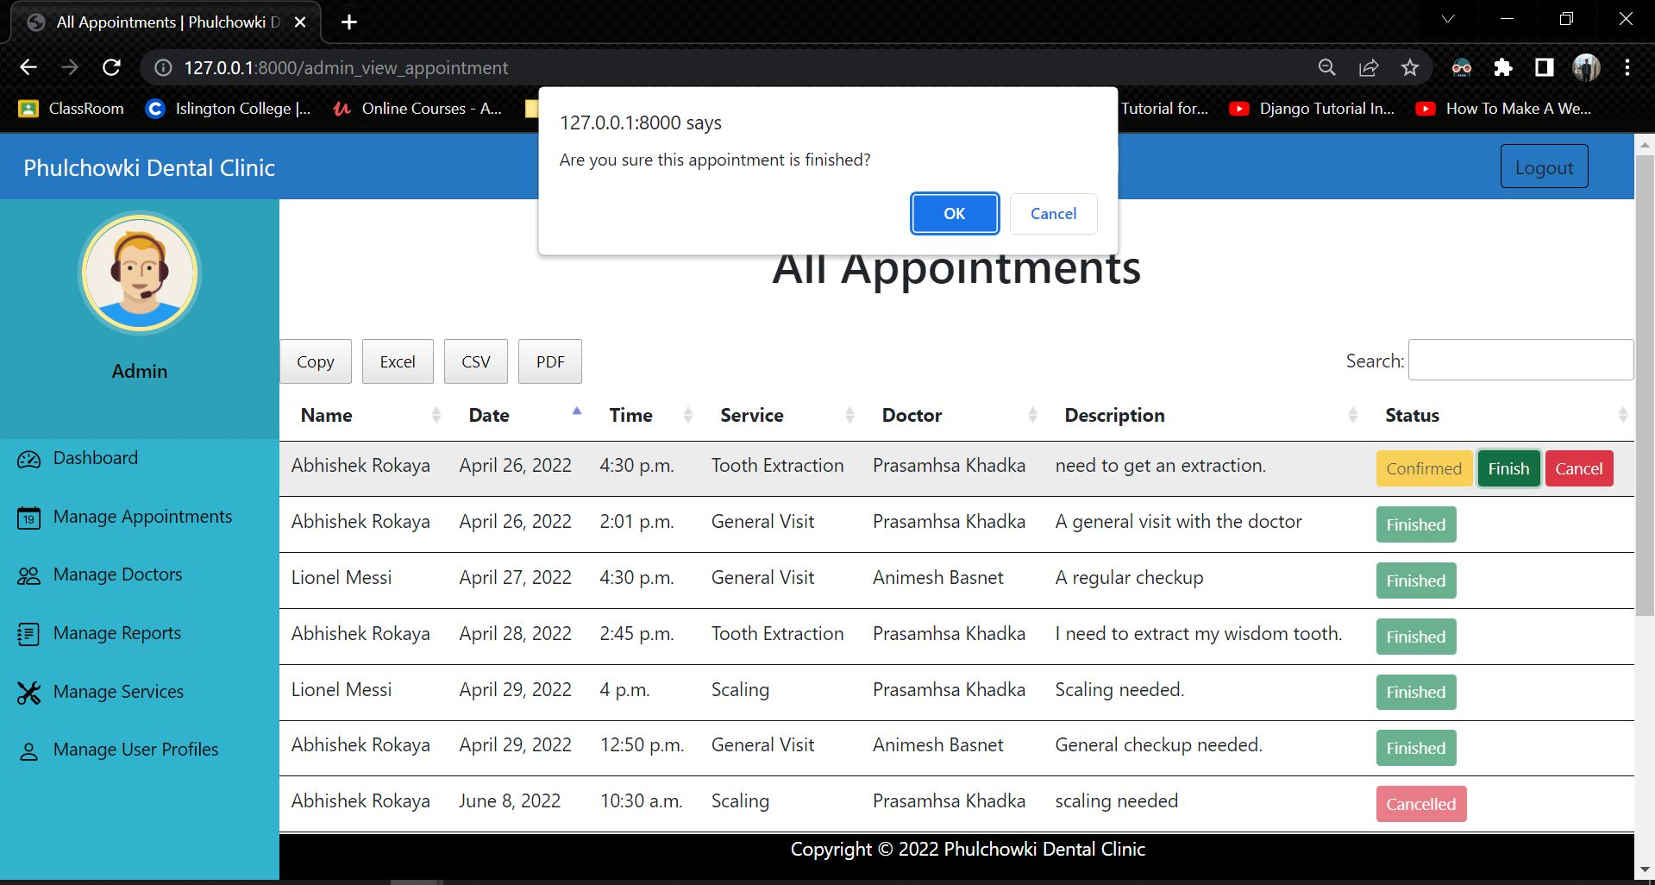

Figure 390: White Box Test 16 - 2

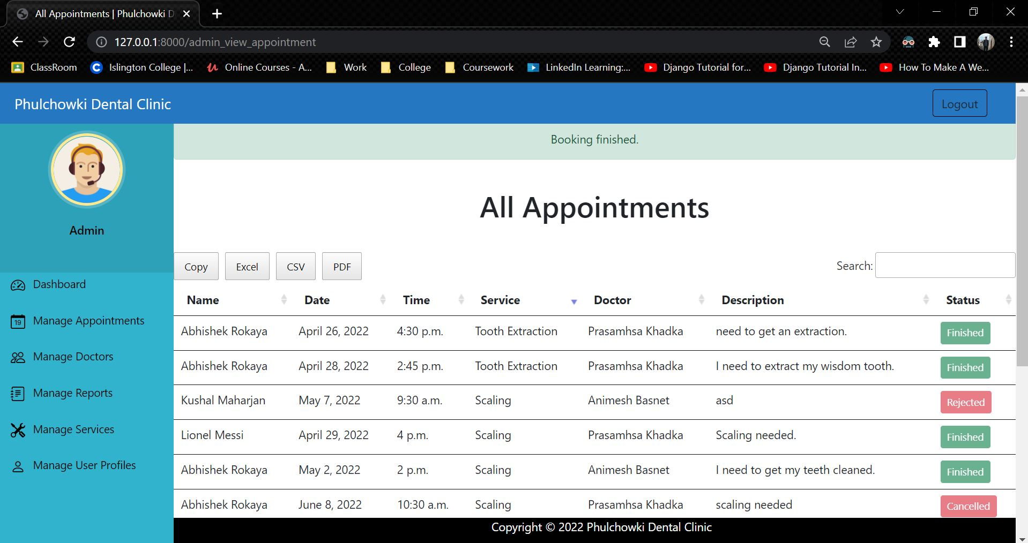

Figure 391: White Box Test 16 - 3

|  |  |
| --- | --- |
| **Test No.17** | |
| Objective | To add another report of the same appointment. |
| Action | The report form was filled and the appointment which already had an report was selected and submitted. |
| Expected Output | An error would be shown. |
| Actual Output | An error was shown. |
| Result | The test was successful. |

Table 69: White Box Test 17

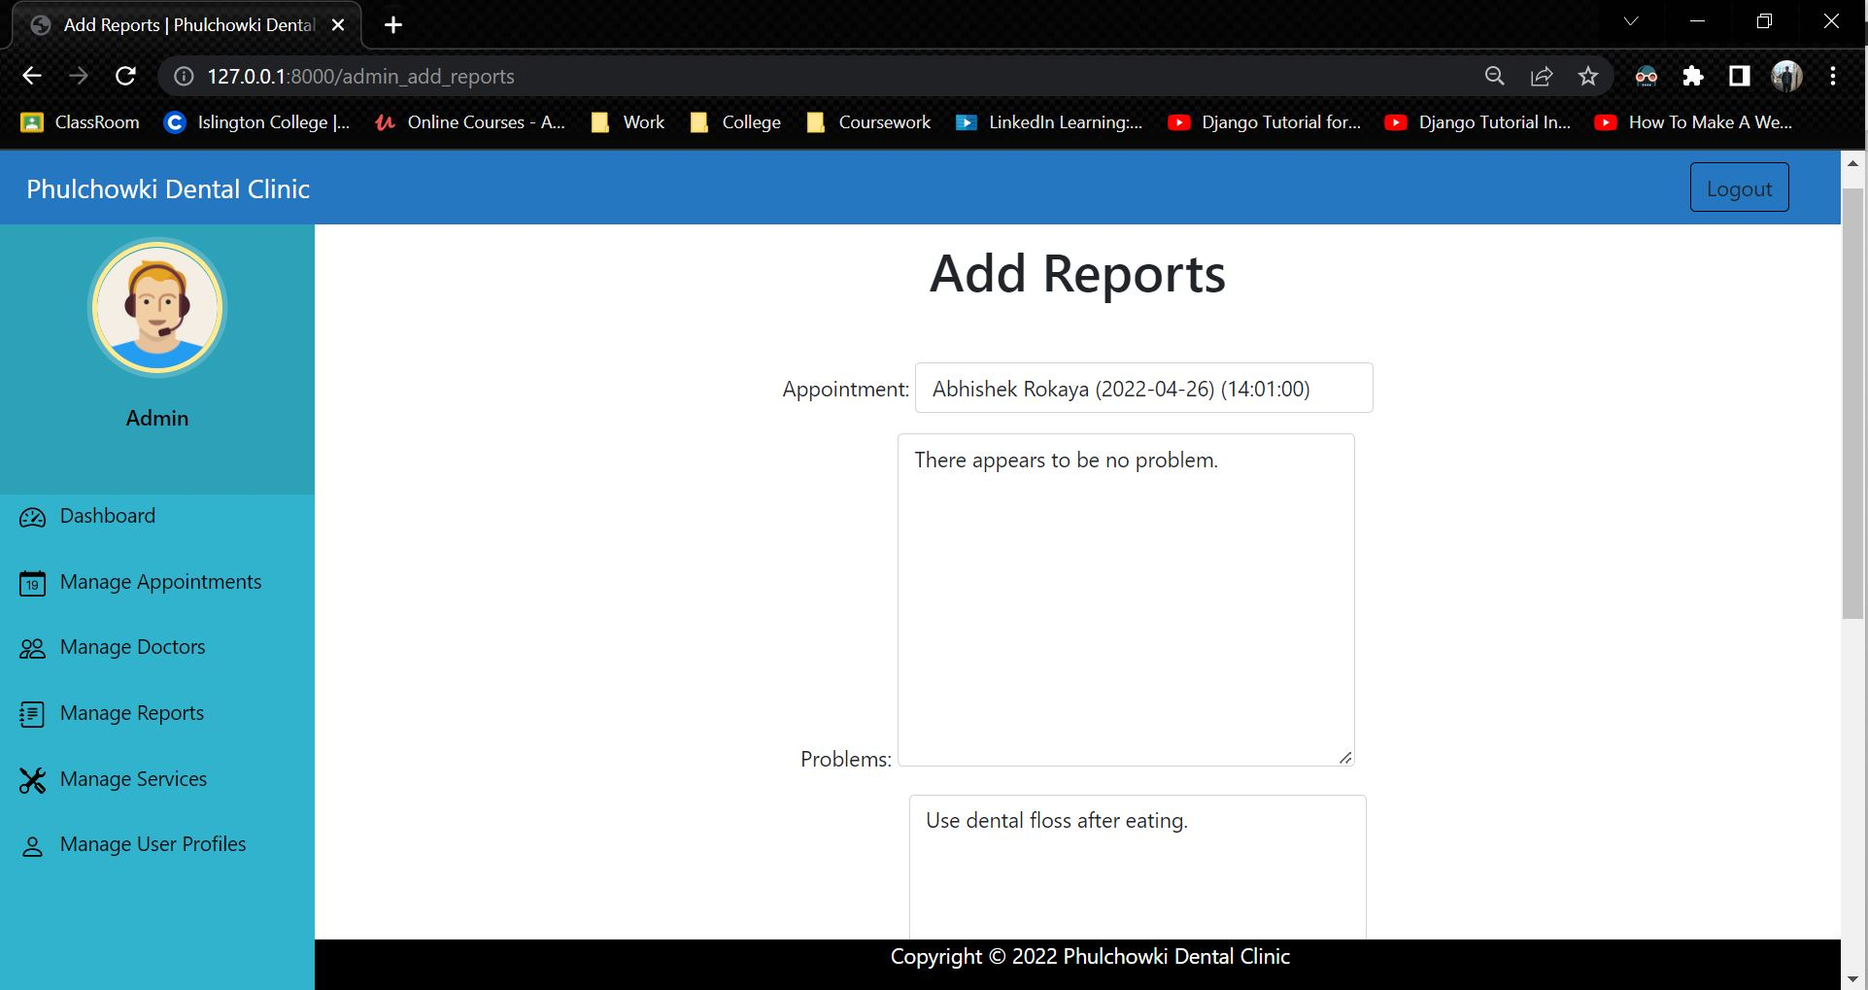

Figure 392: White Box Test 17 - 1

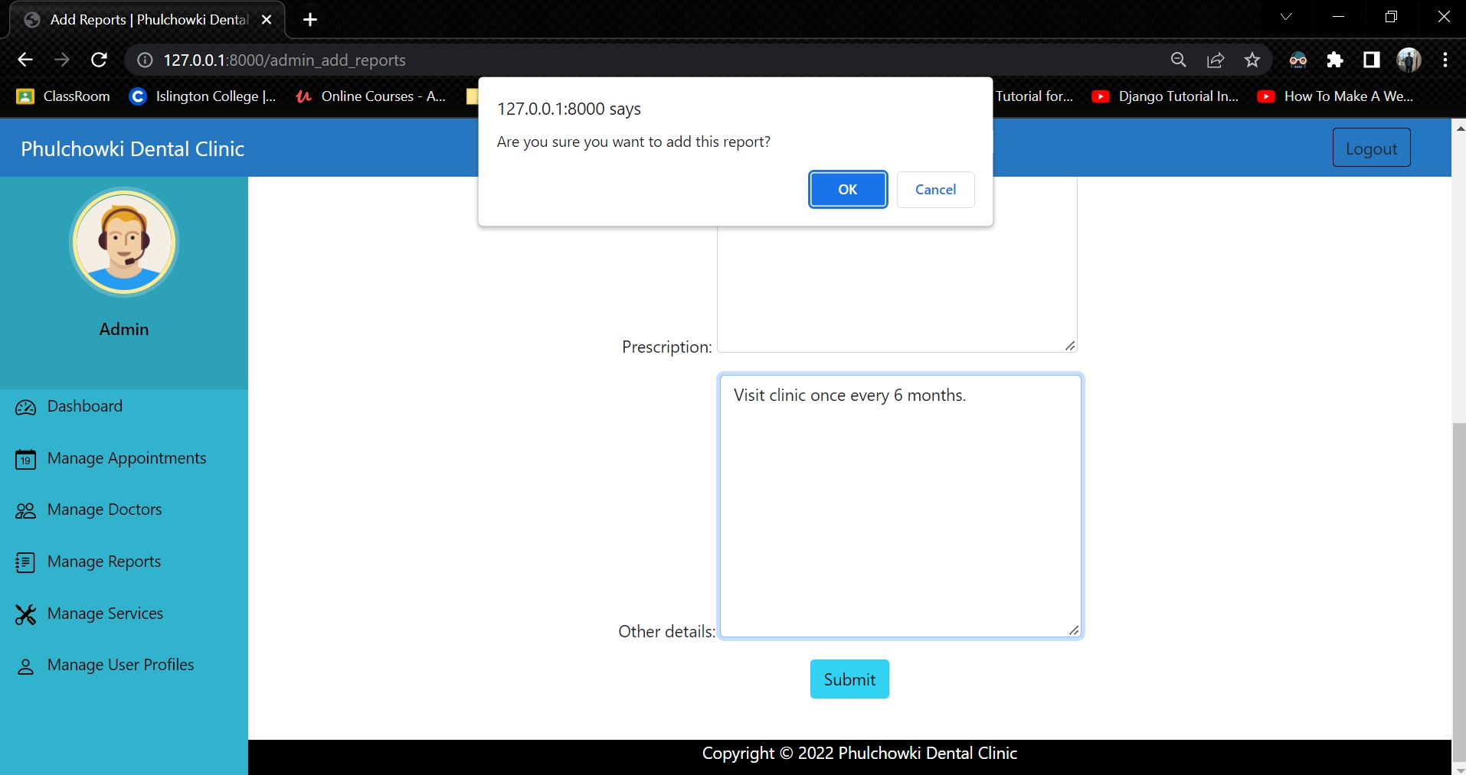

Figure 393: White Box Test 17 - 2

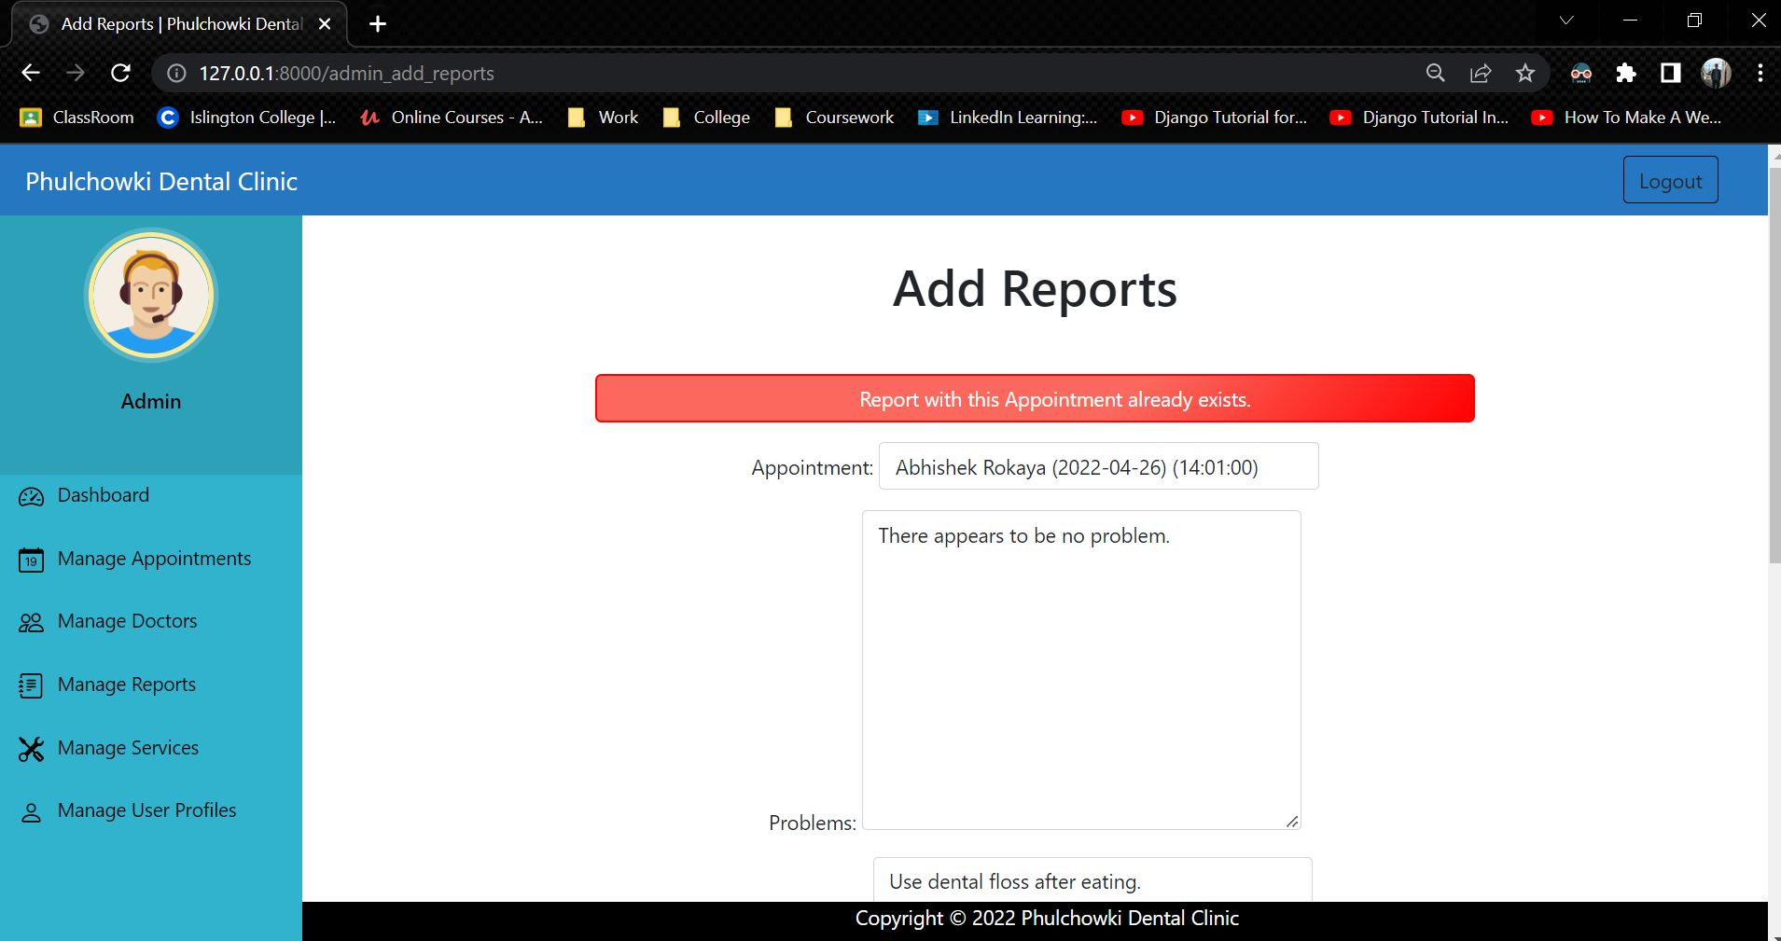

Figure 394: White Box Test 17 - 3

View the rest of the White Box Testing Here.

View the test plan of the White Box Testing here.

## 7.8 Appendix H: Screenshots of the System

**Landing Home Page**



















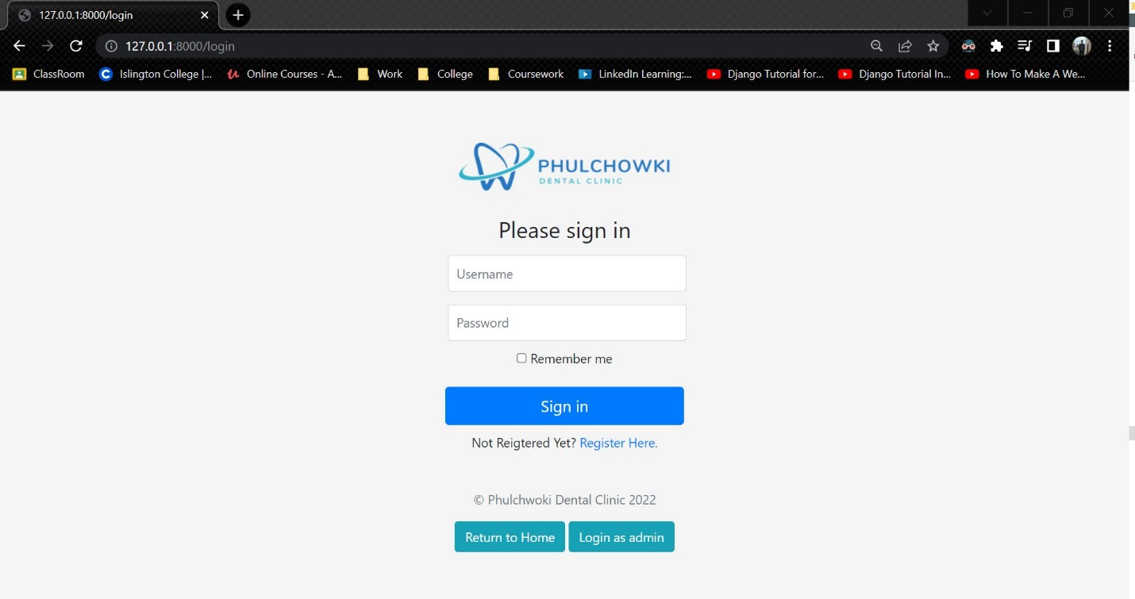

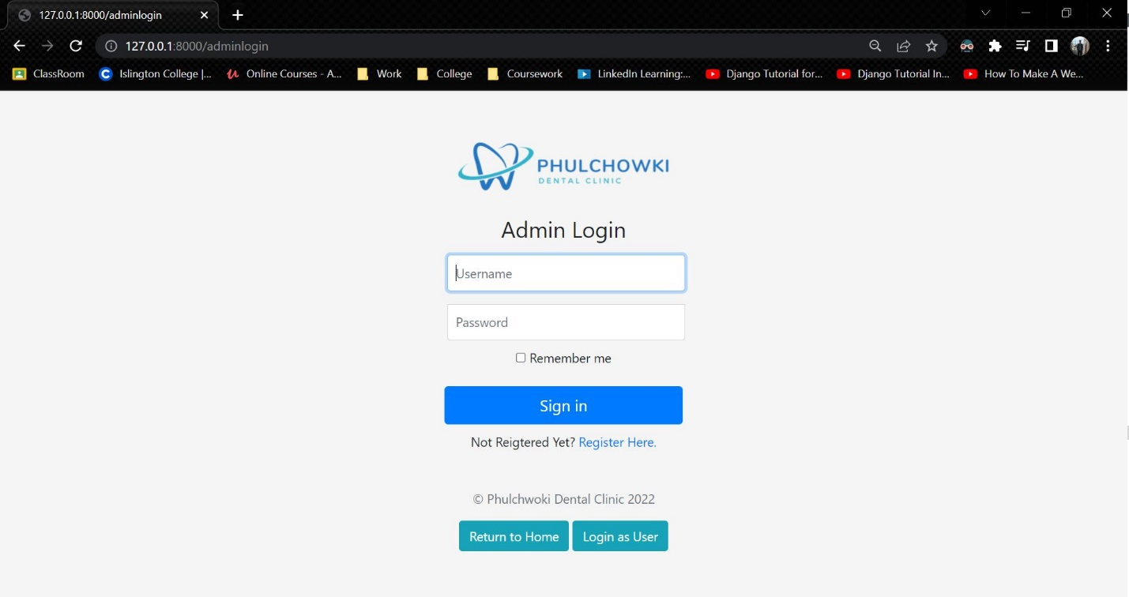

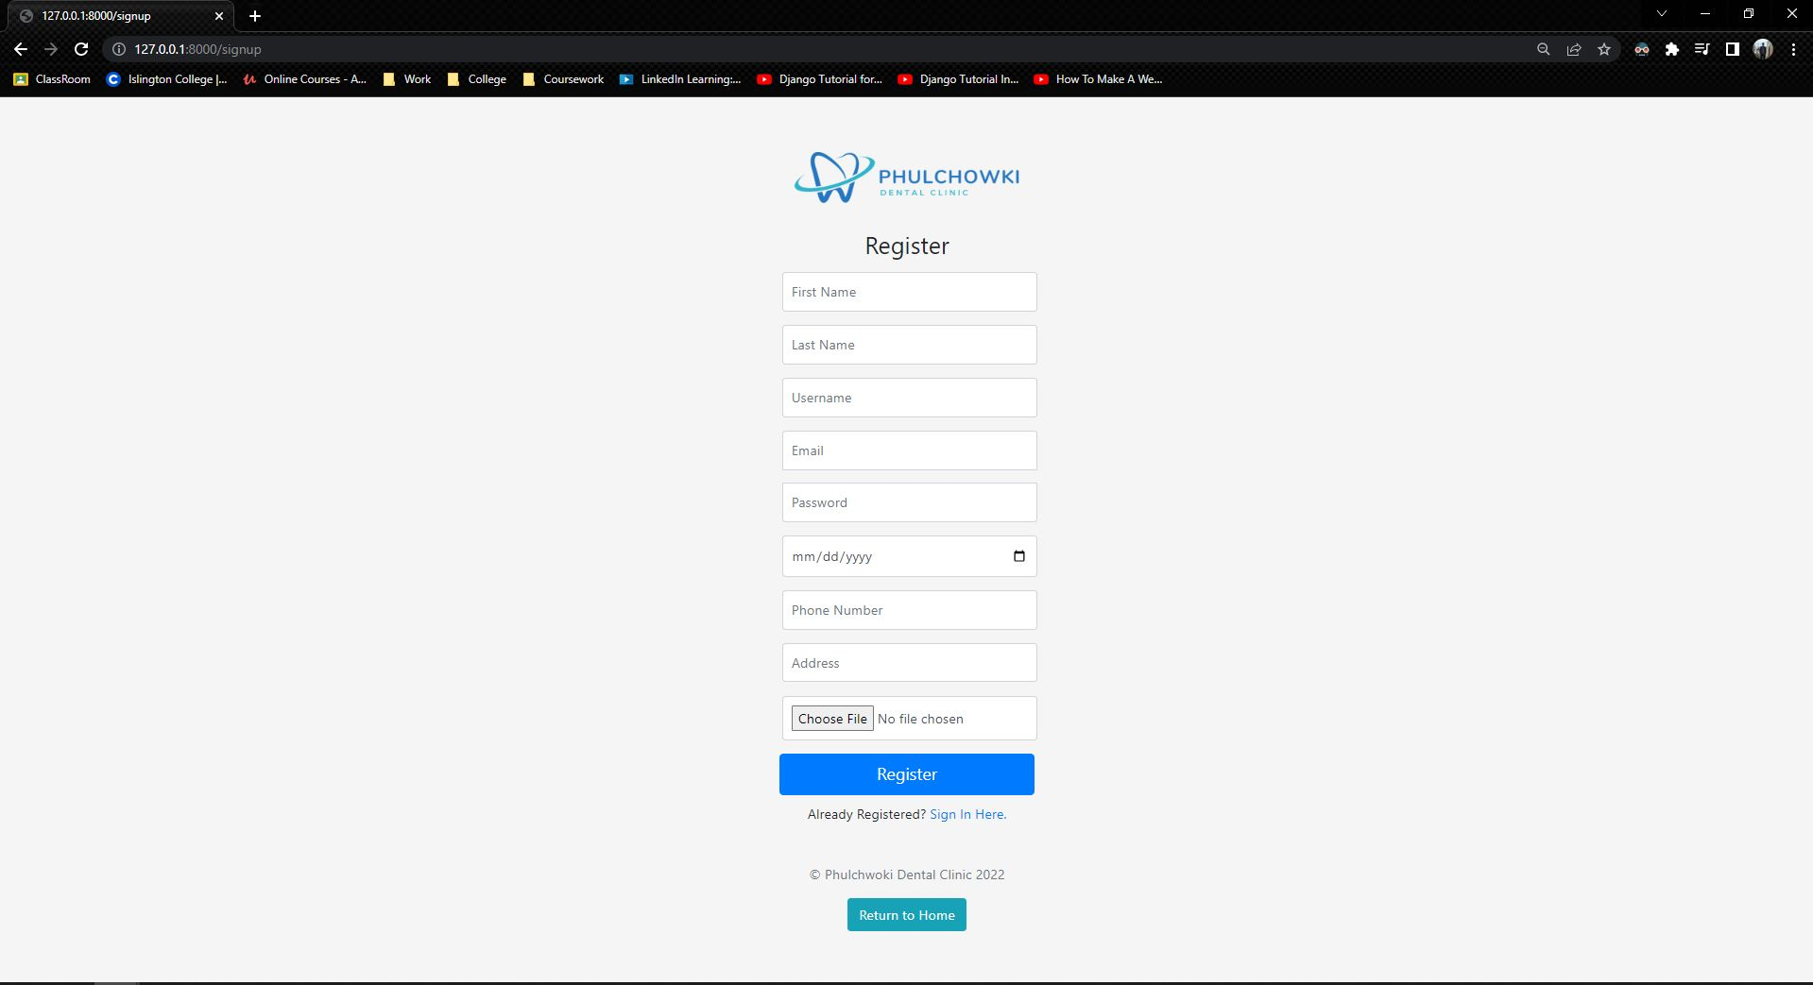

**User Side UI**

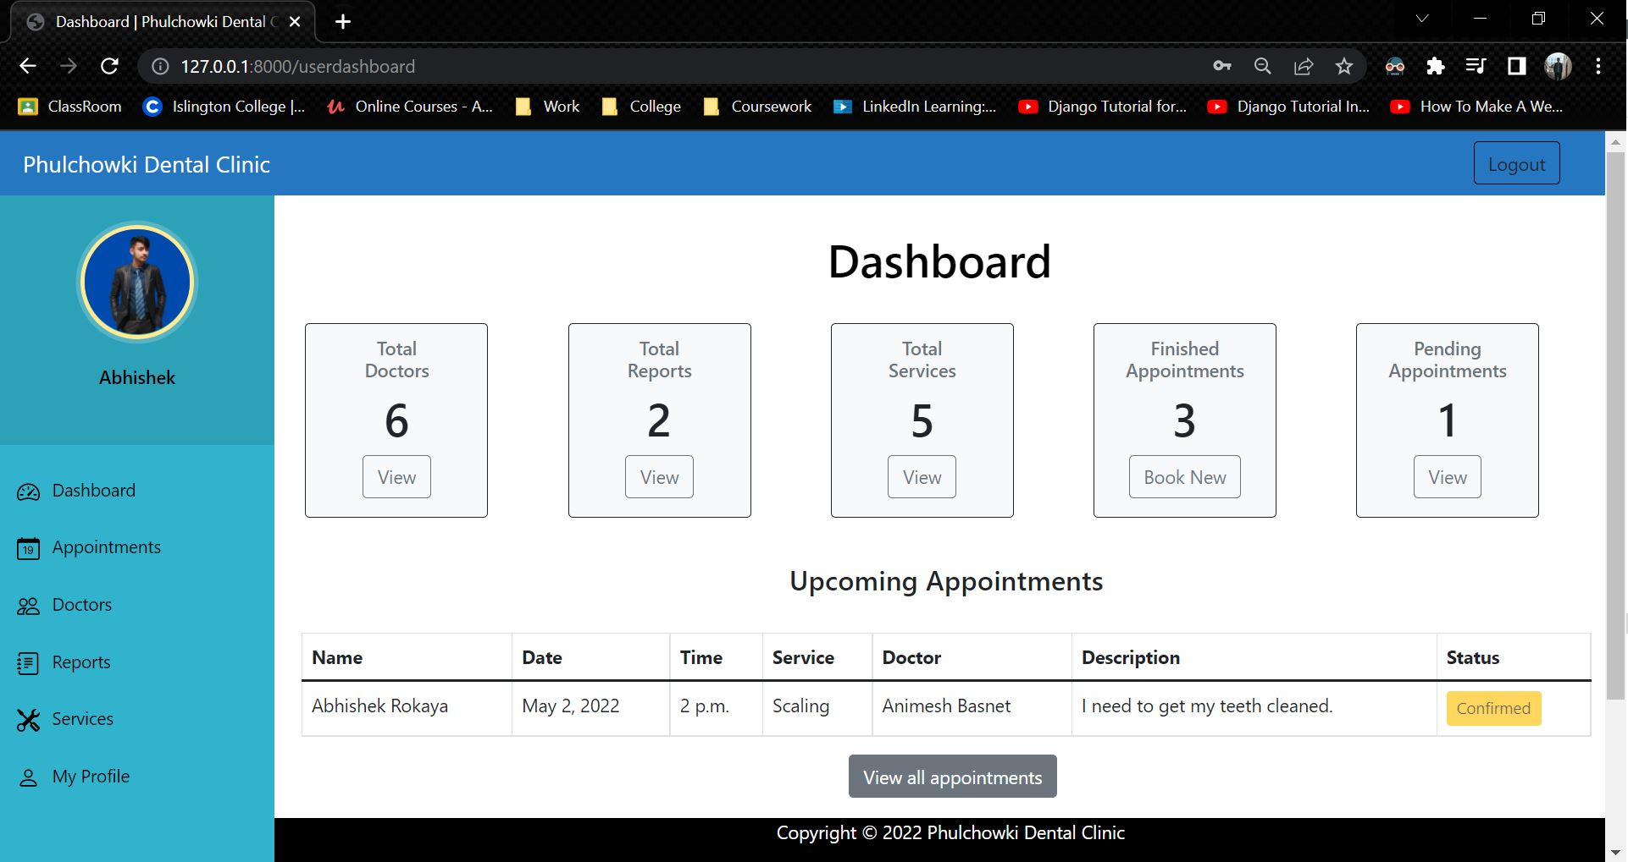

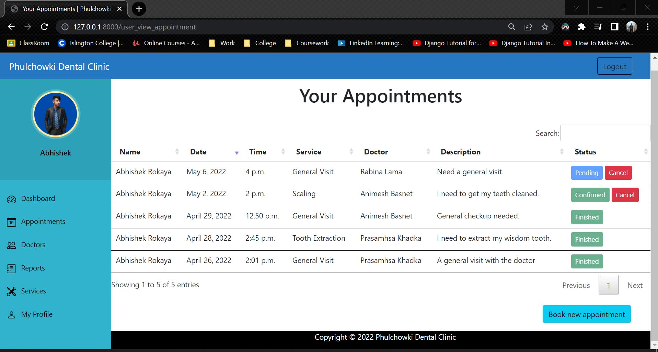

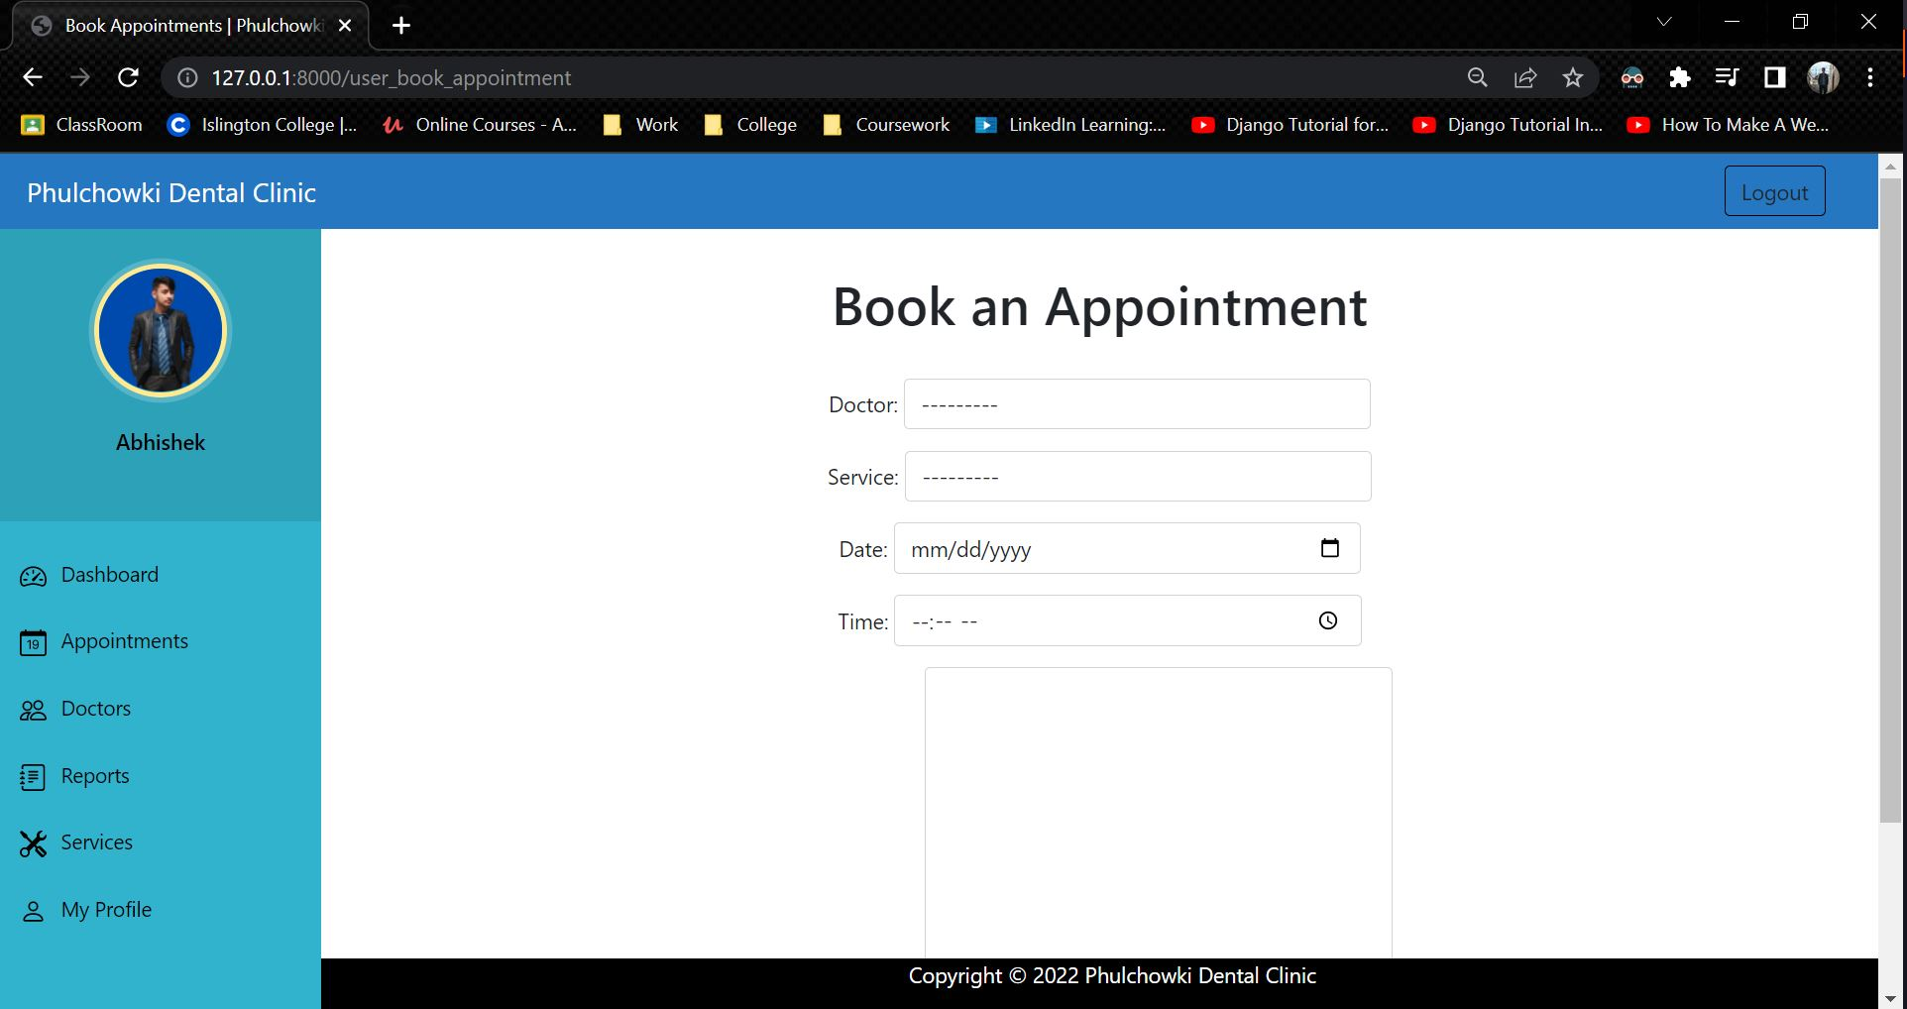

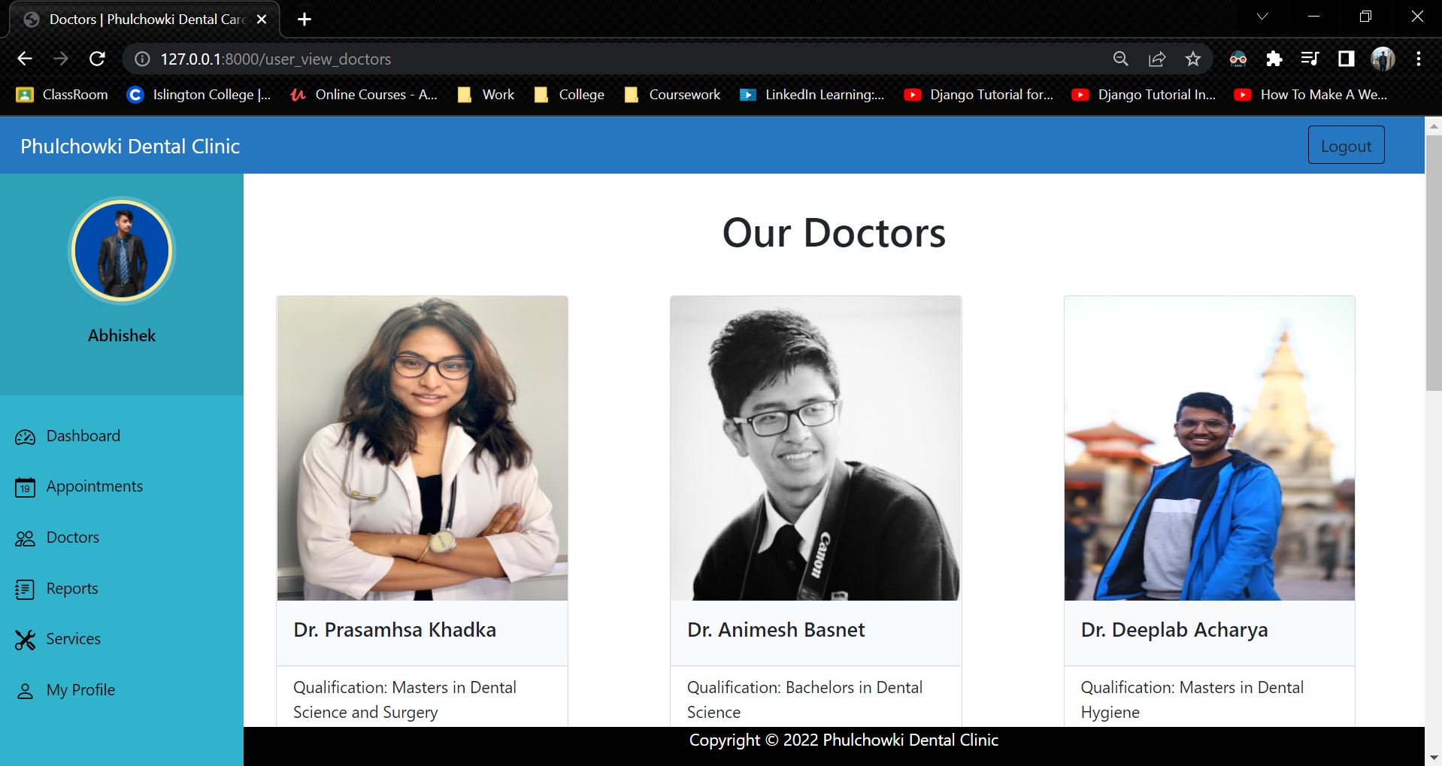

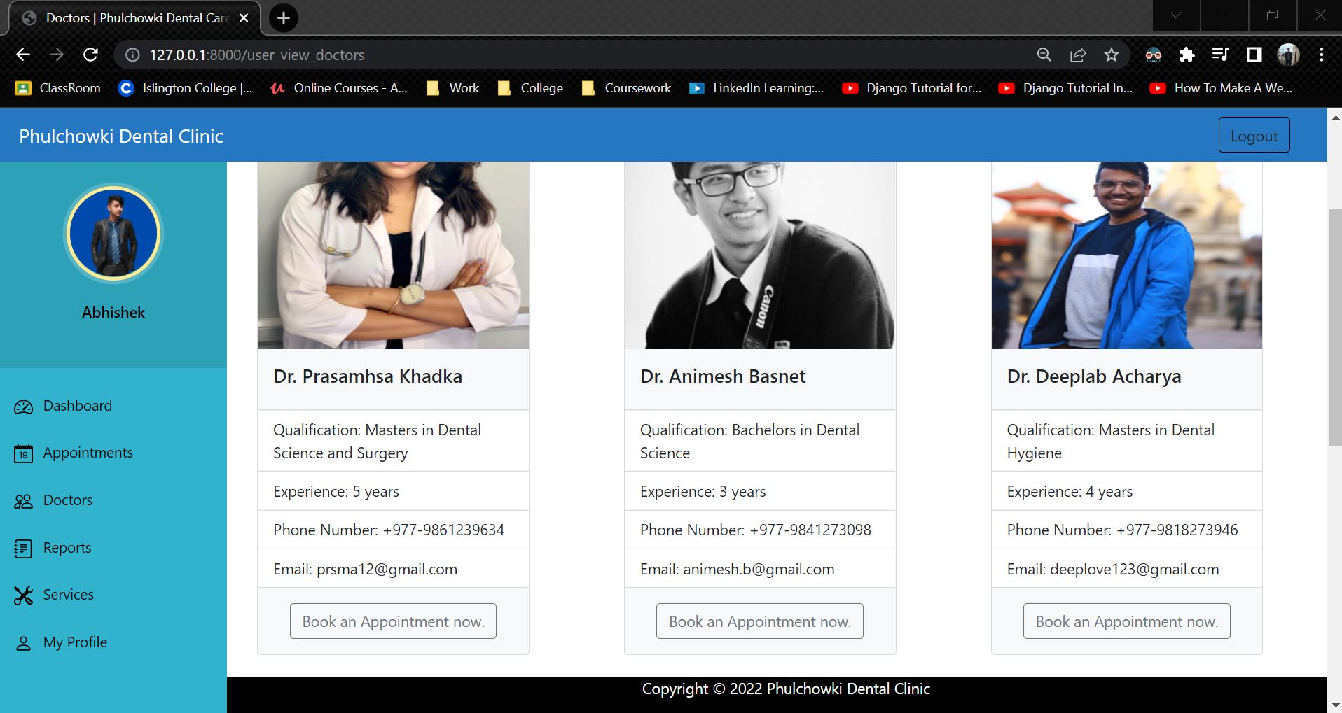

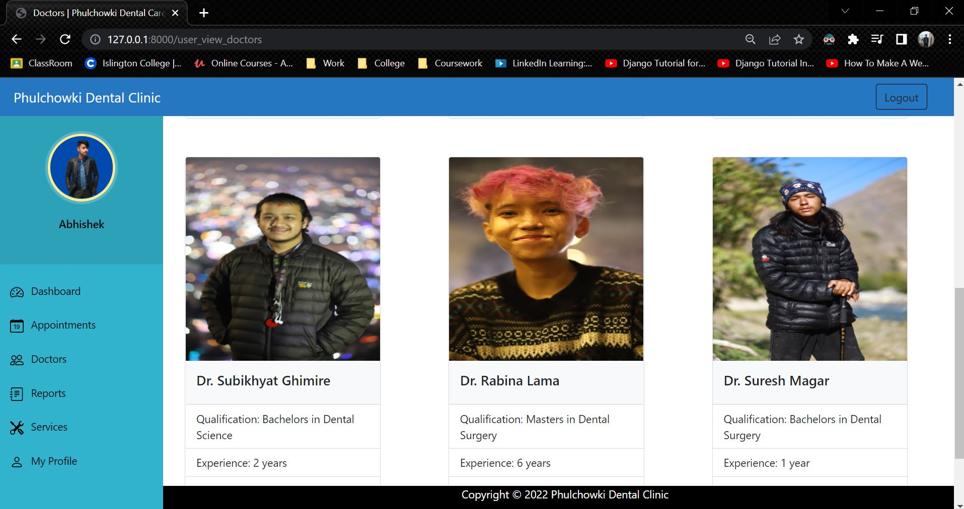

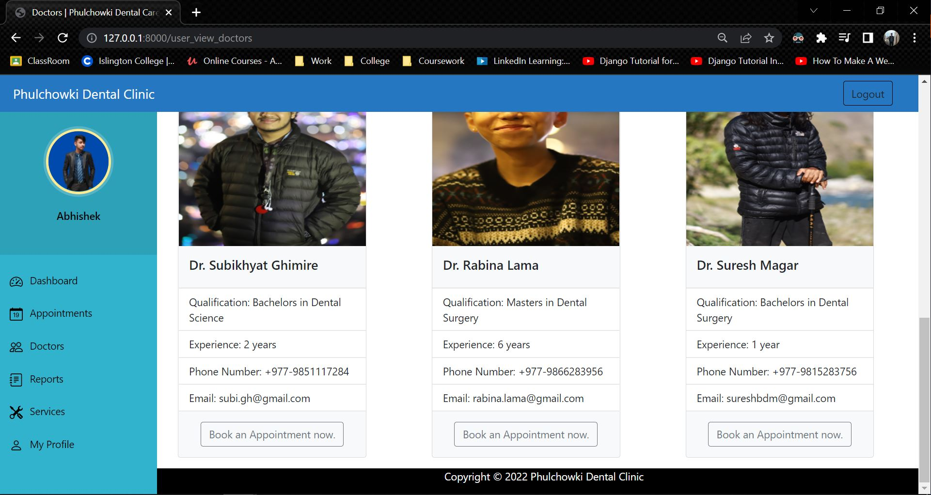

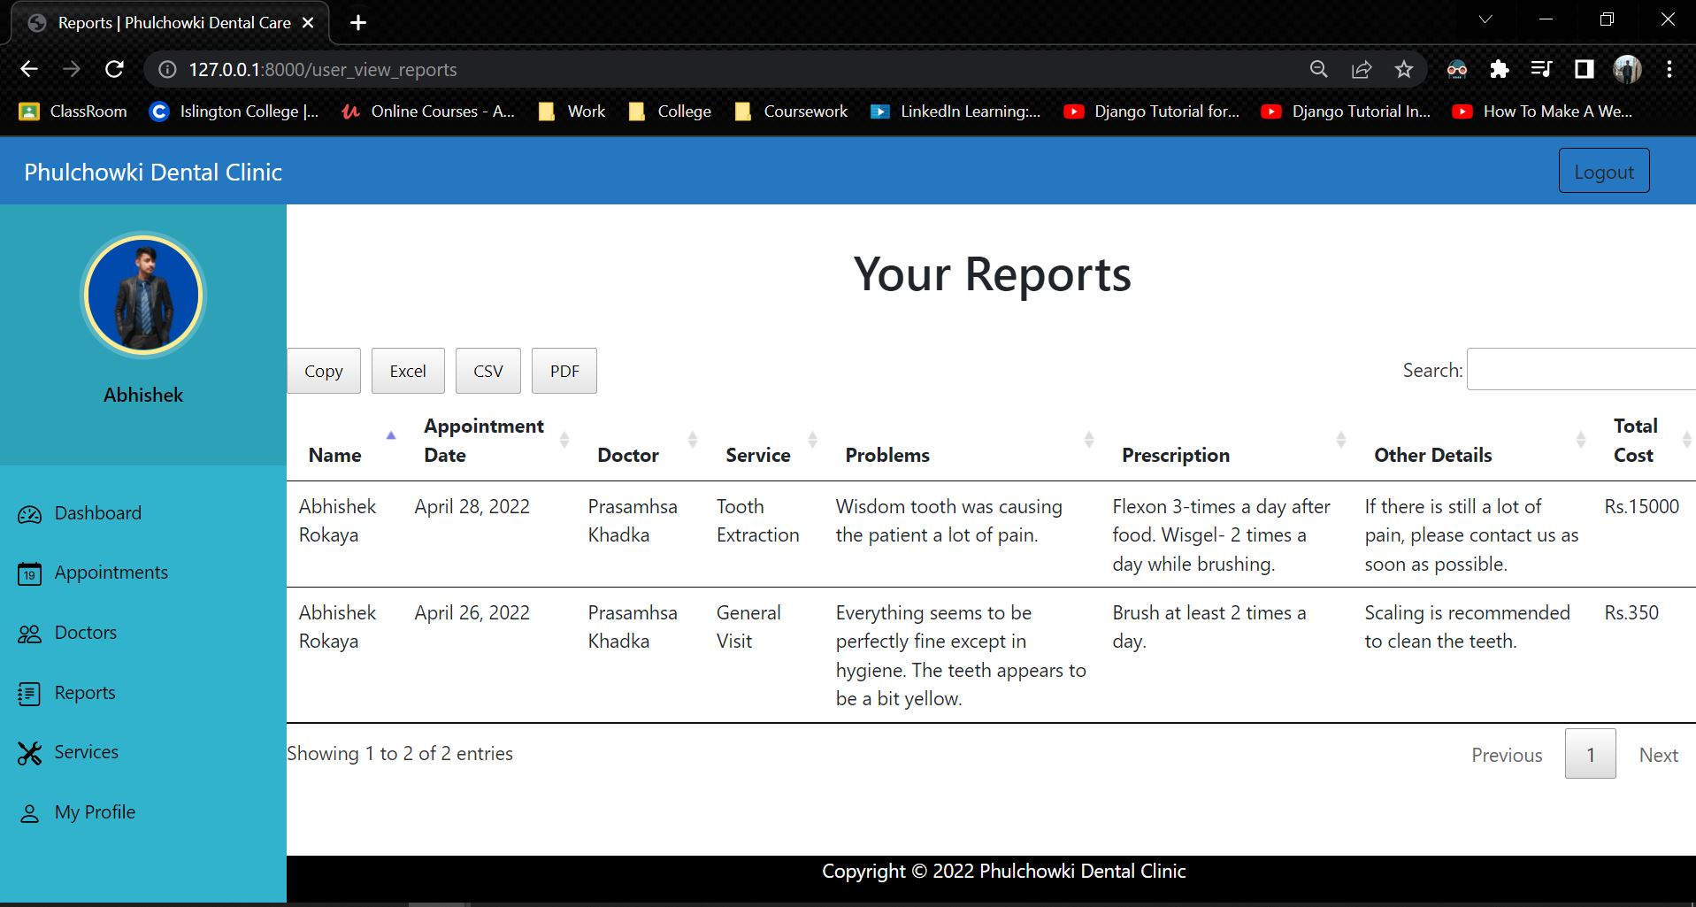

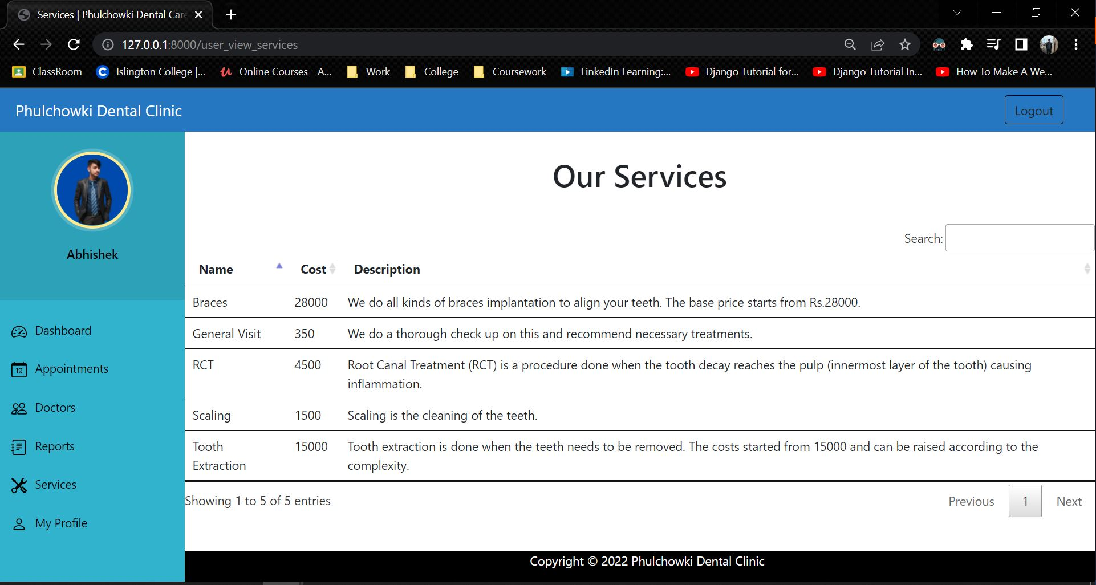

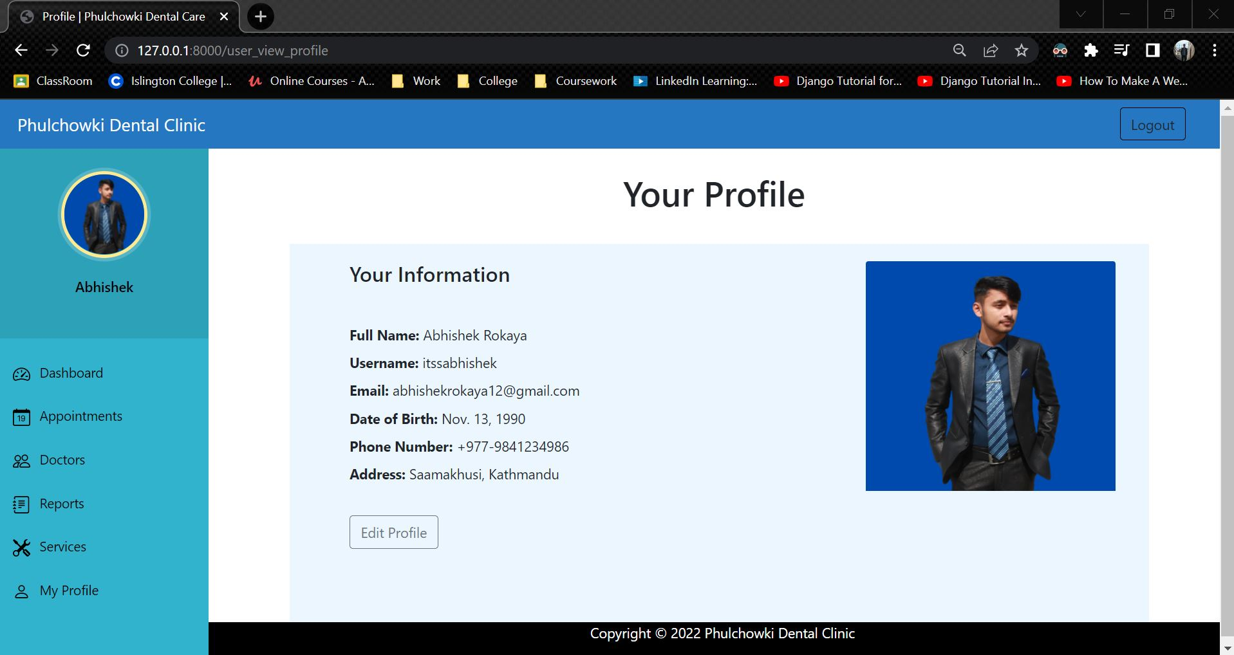

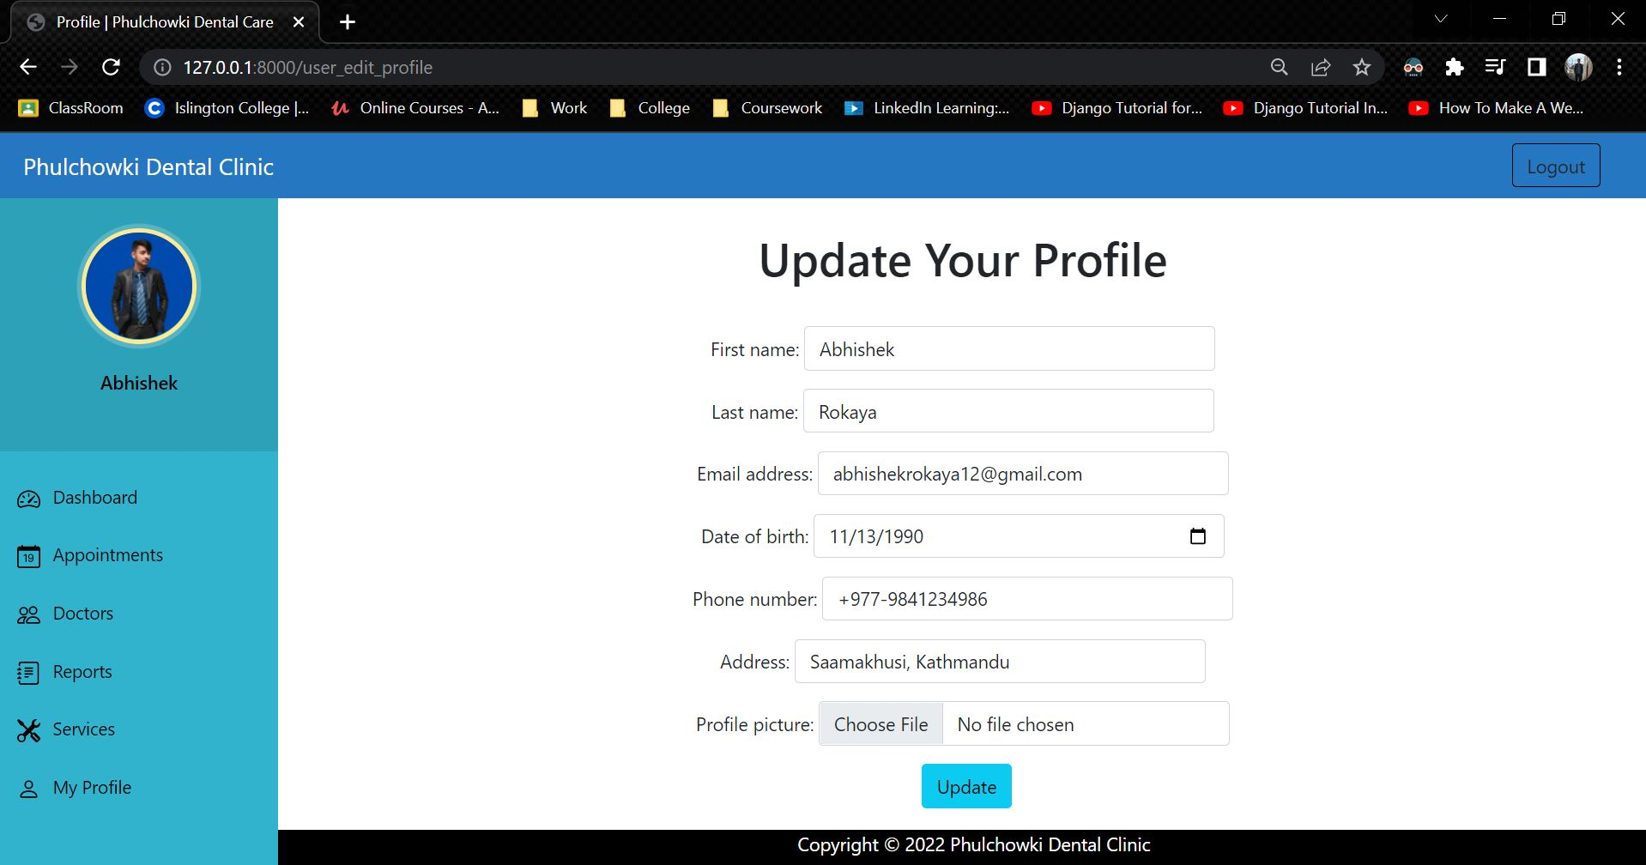

**Admin Side**

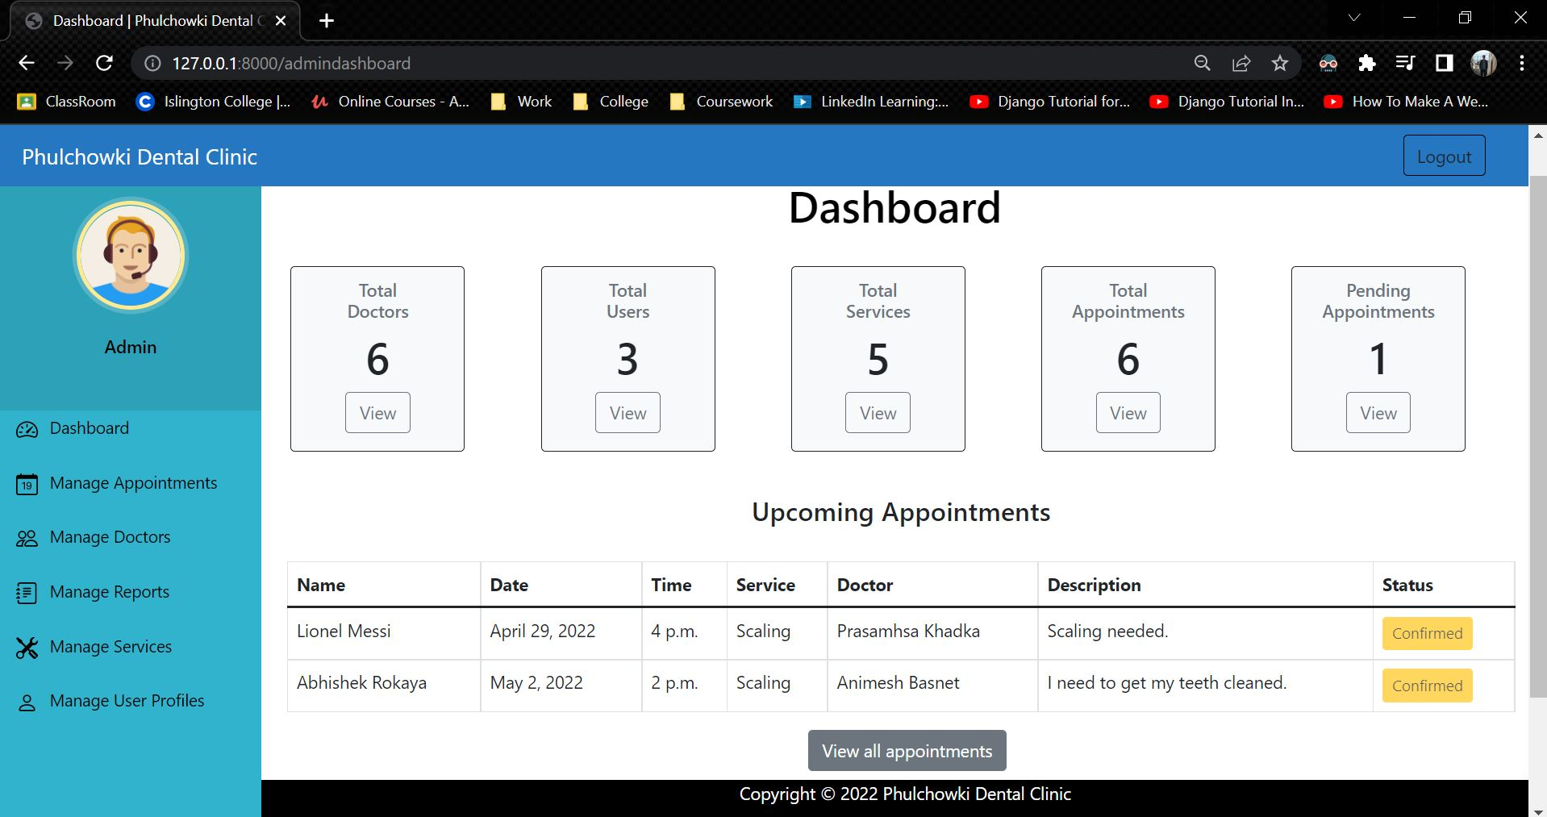

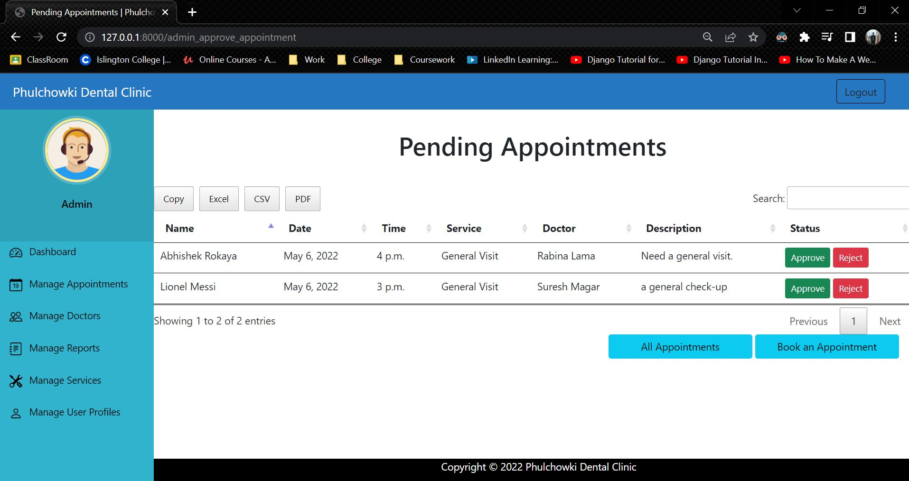

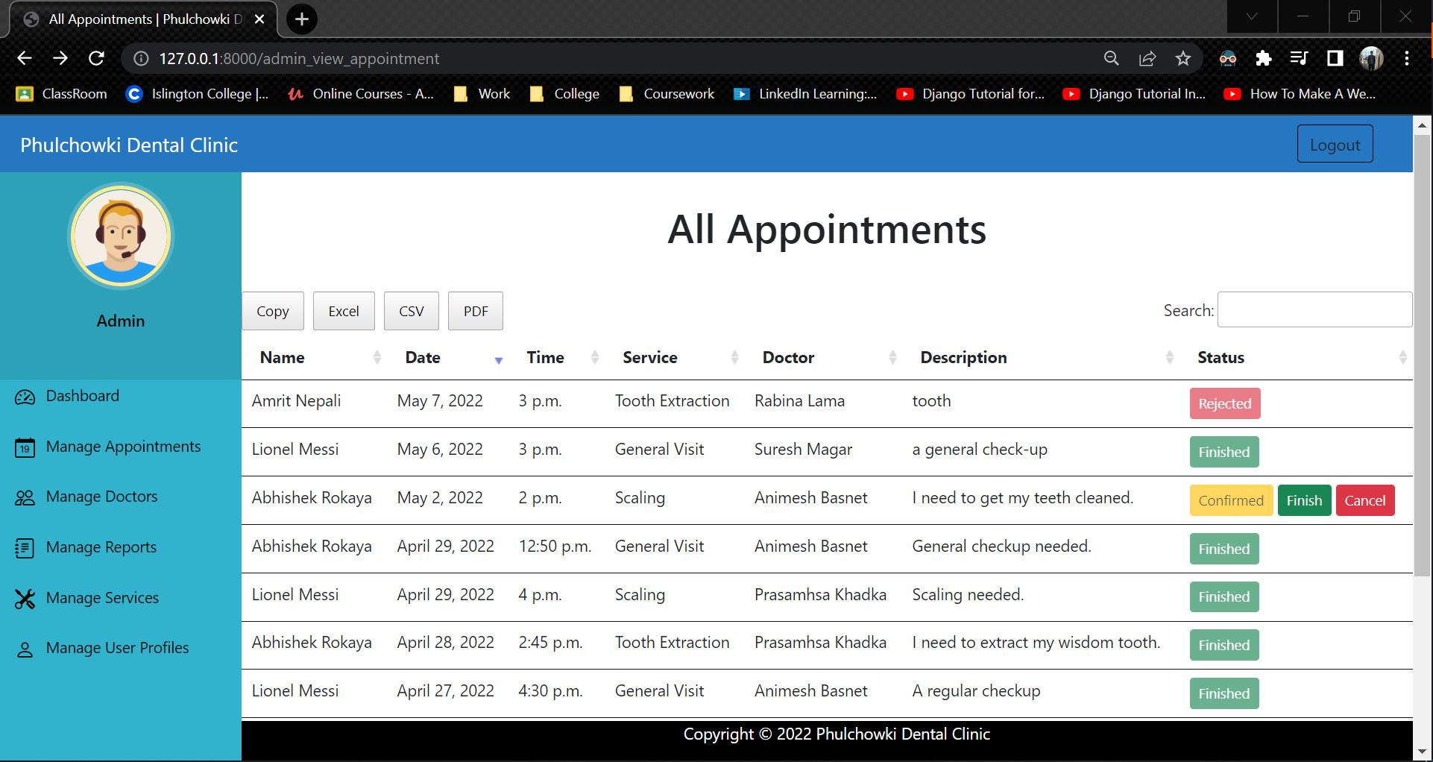

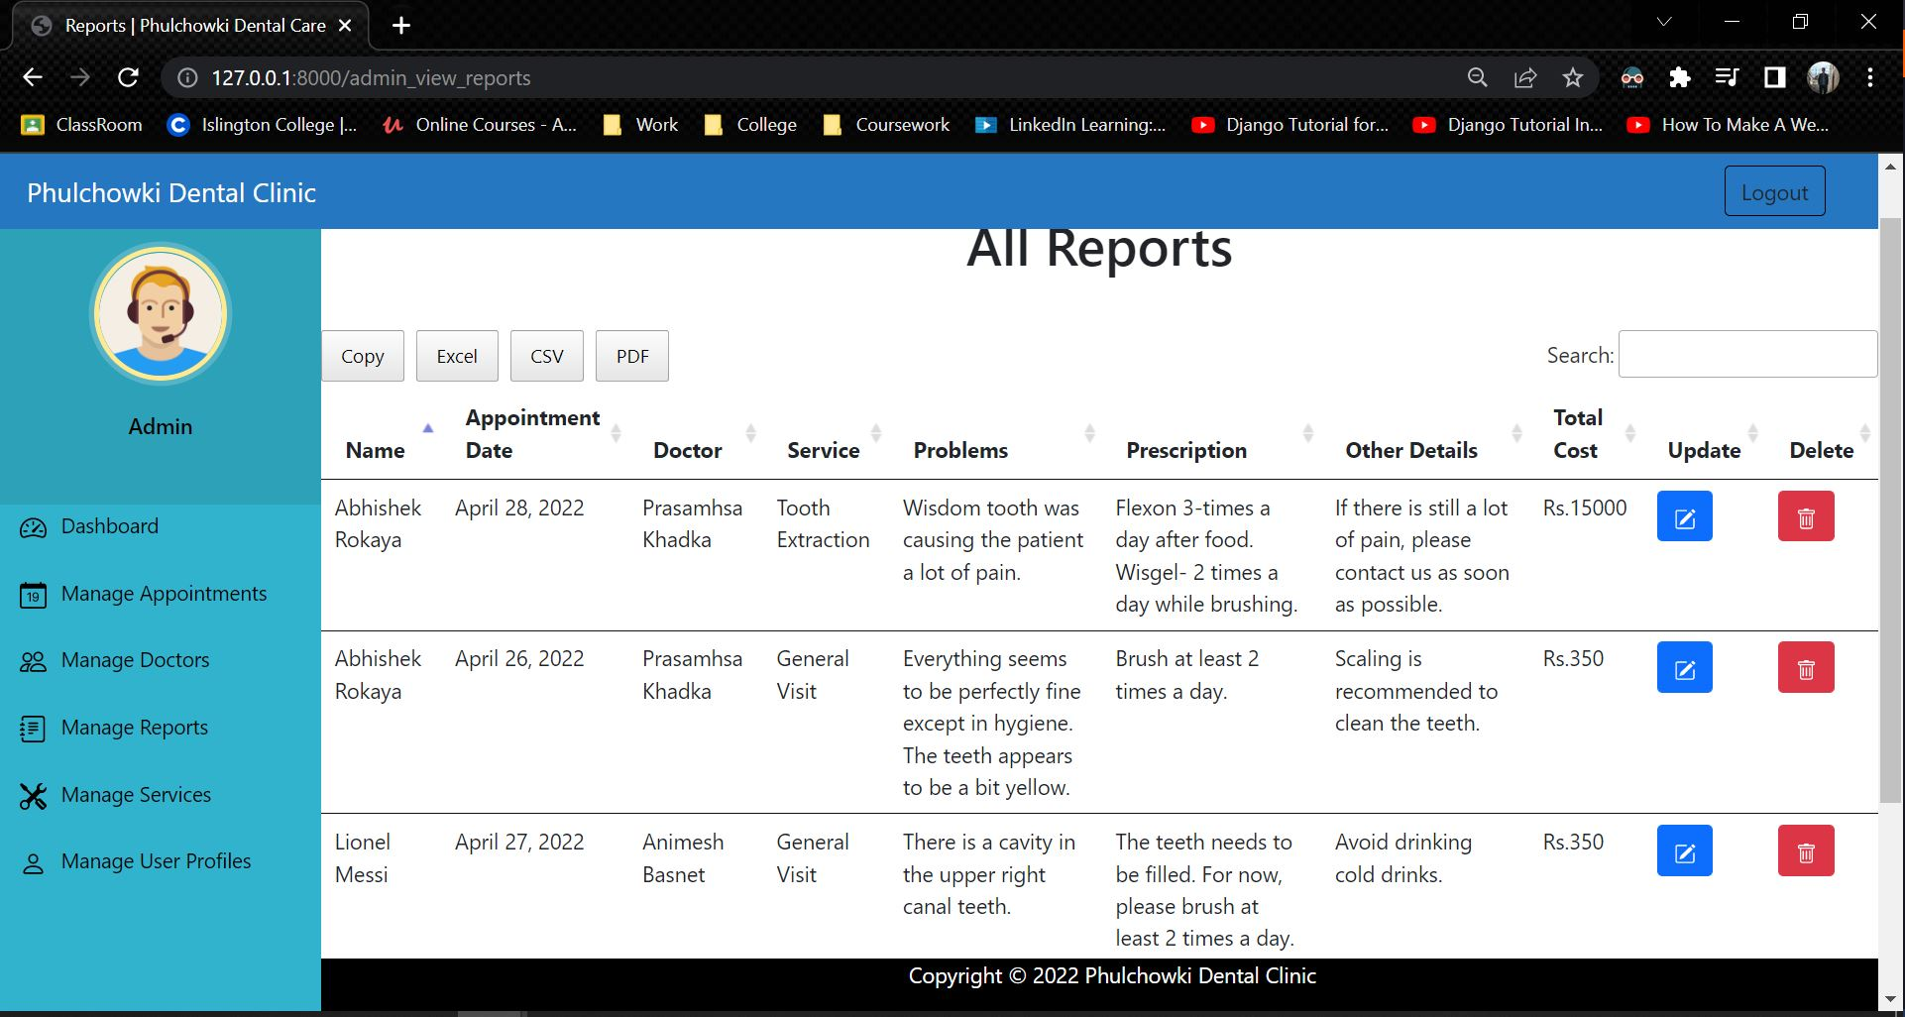

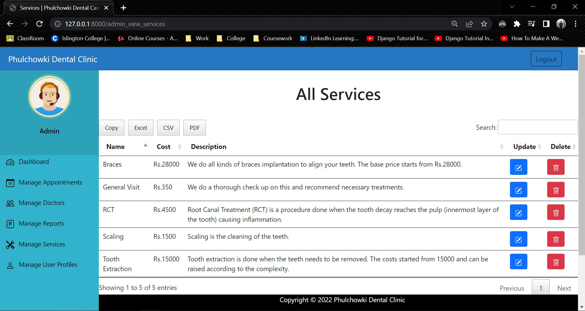

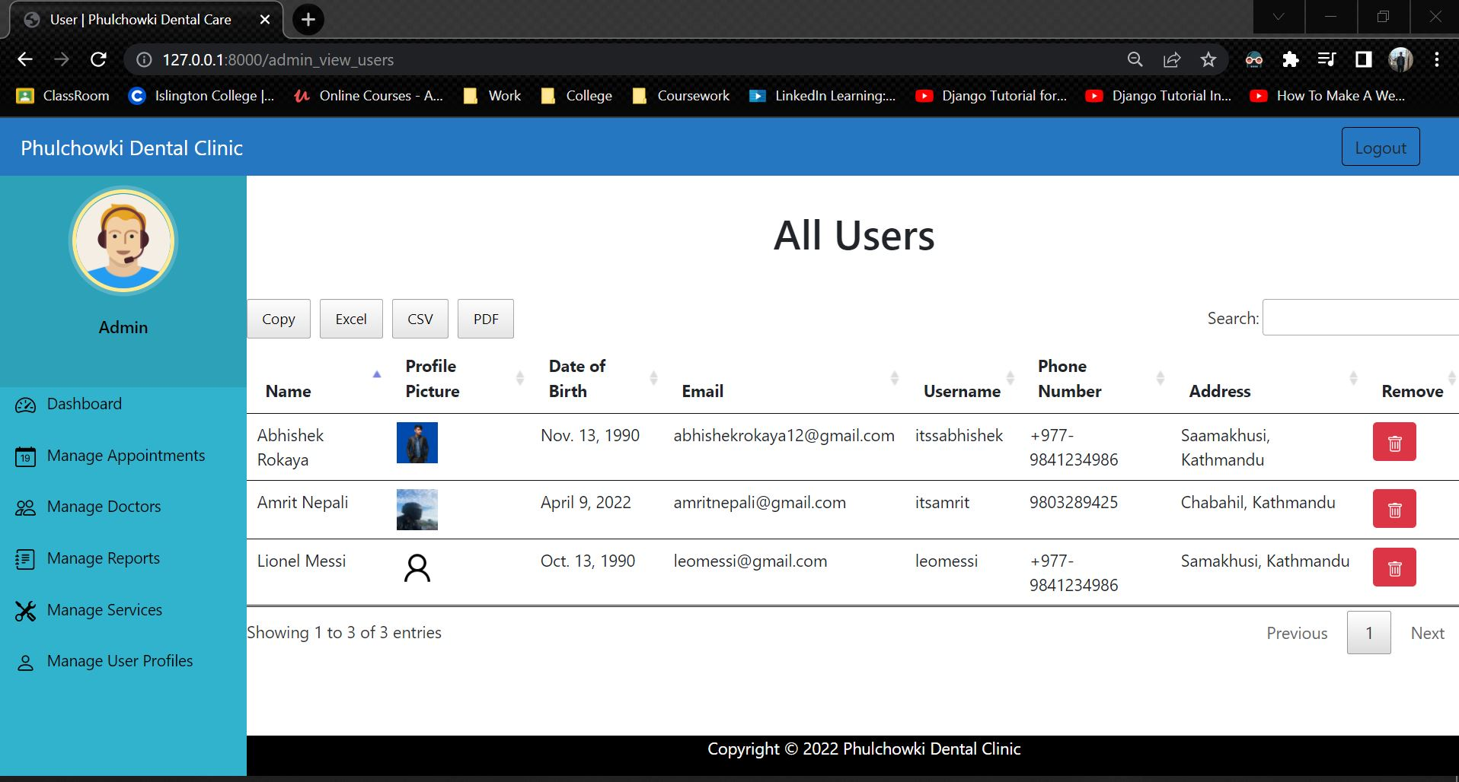

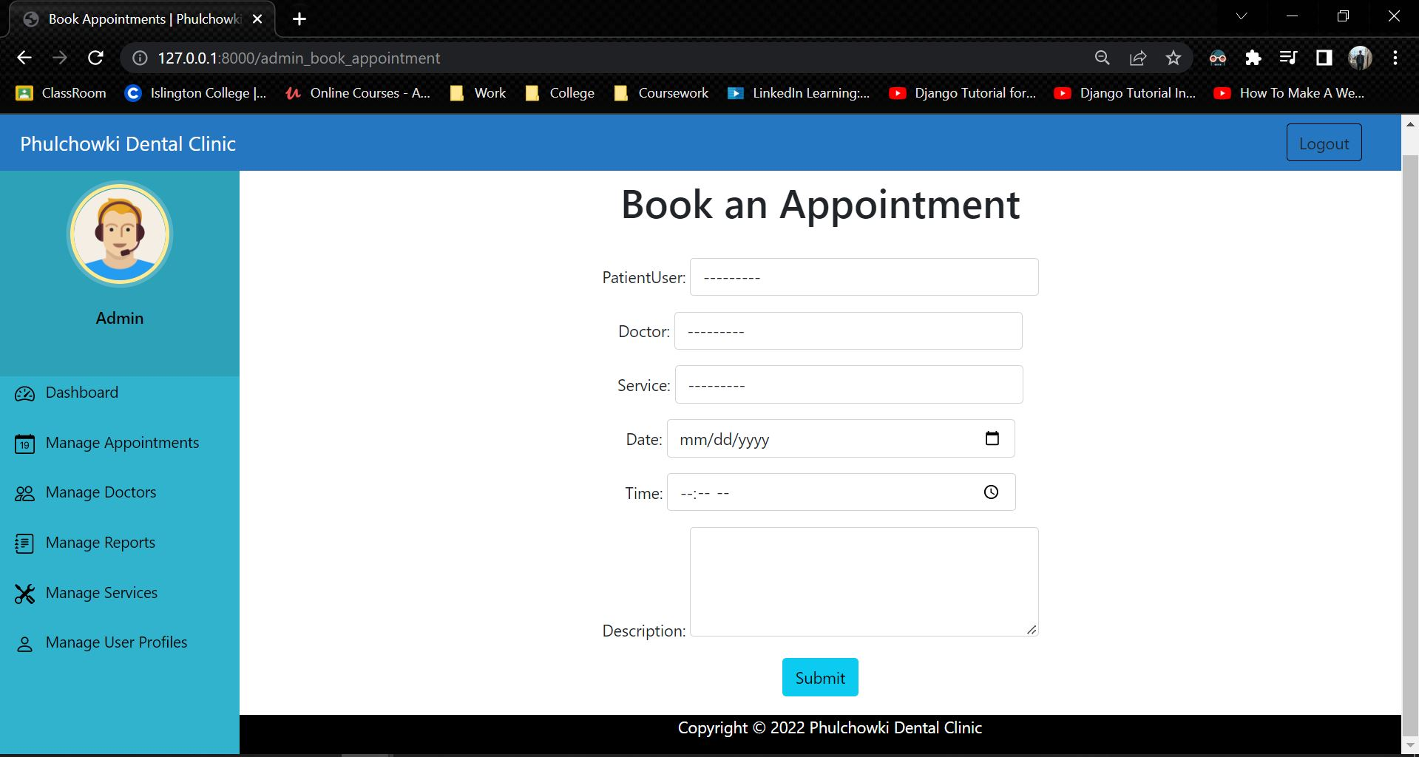

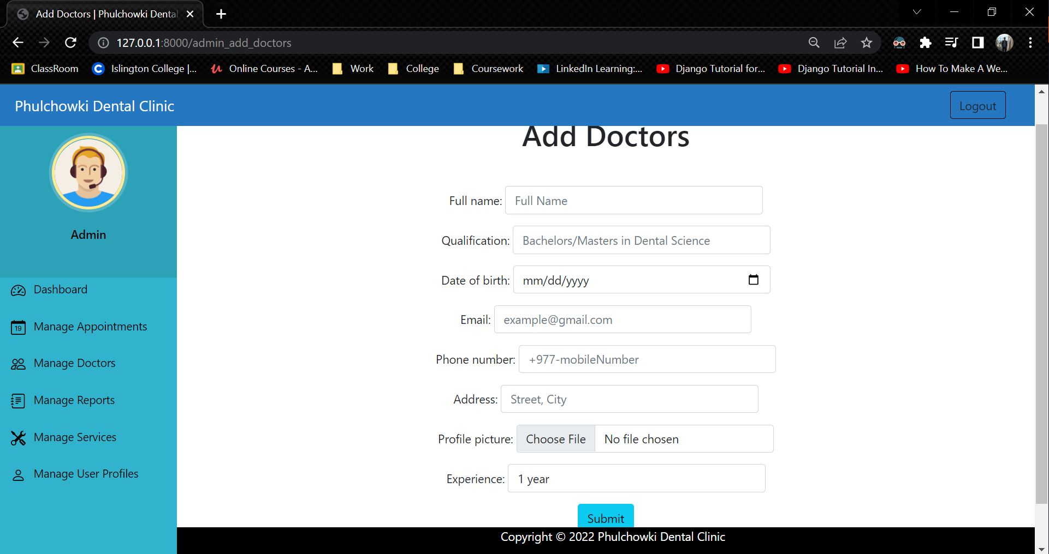

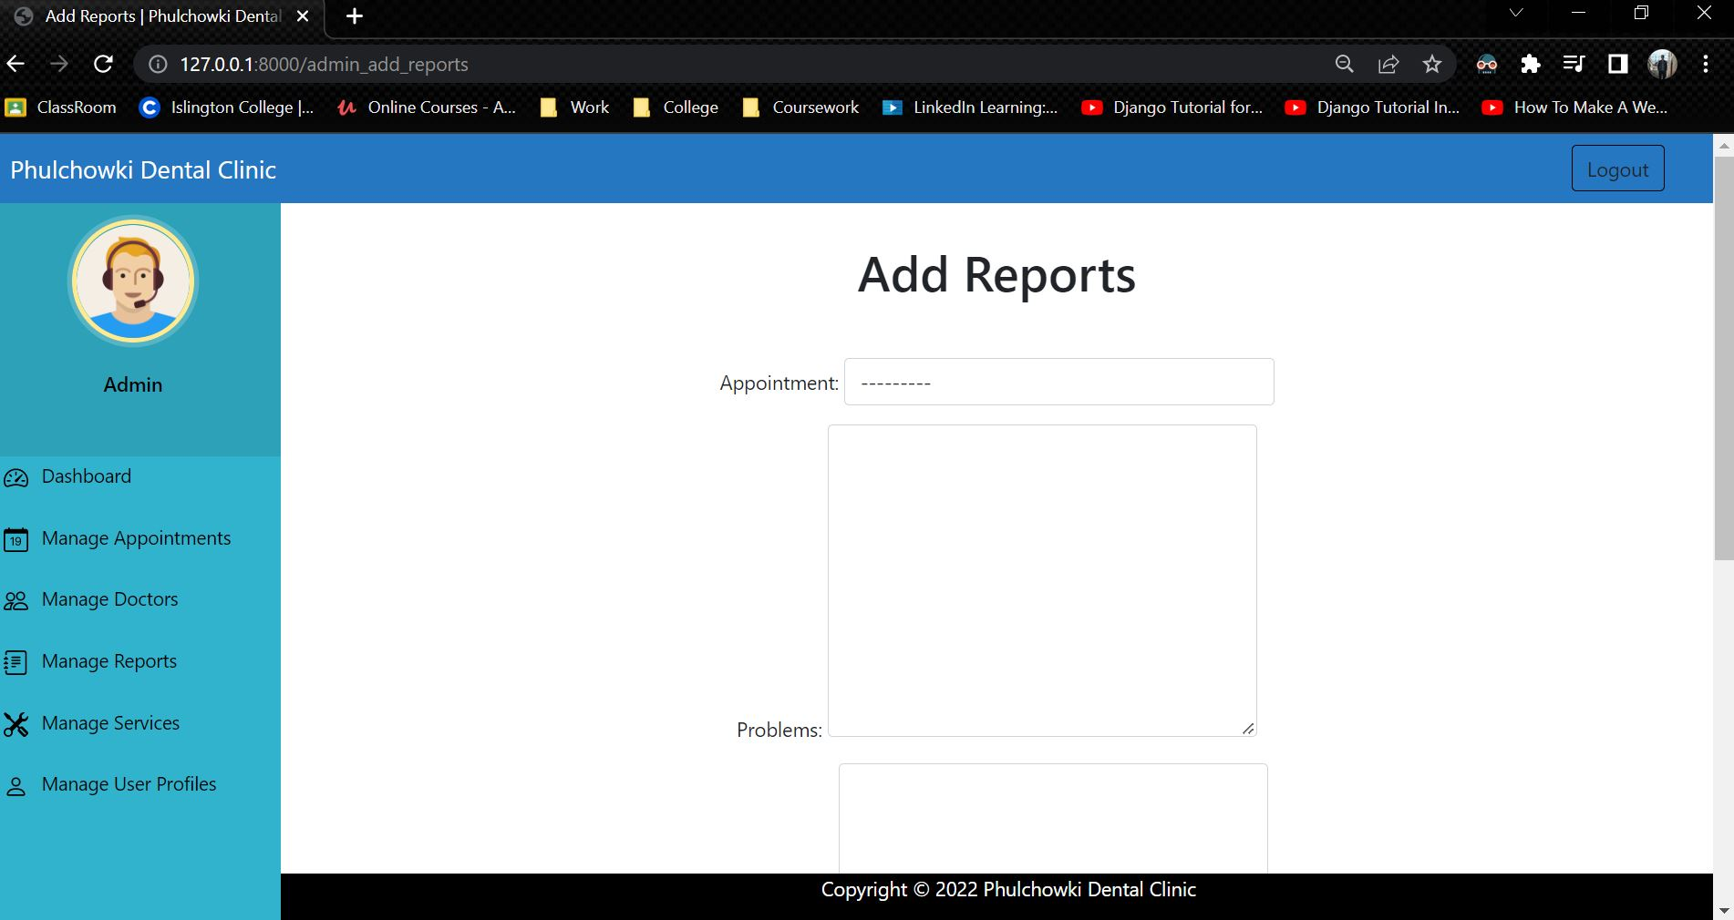

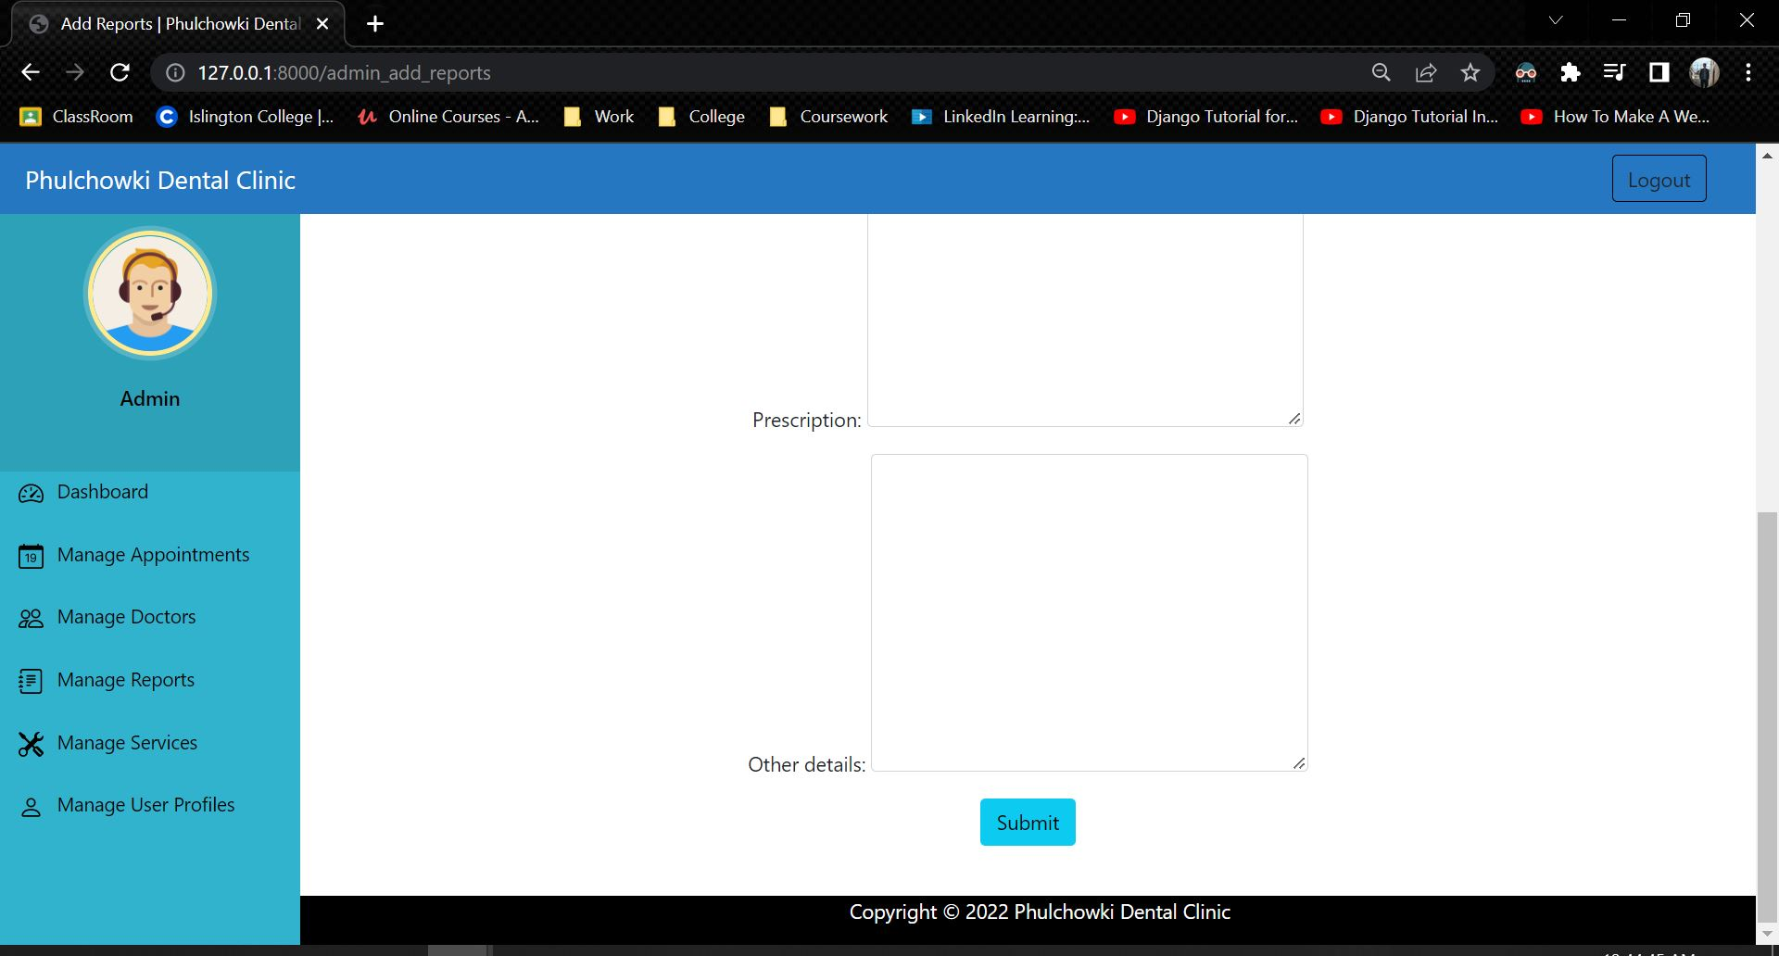

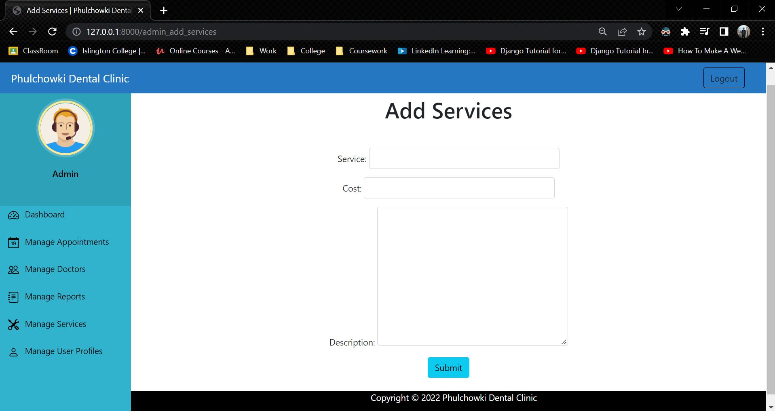

## 7.9 Appendix I: User Feedback

### 7.9.1 User Feedback Form

### 7.9.2 Sample of Filed User Feedback Forms

## 7.10 Appendix J: Future Work

### 7.10.1 Readings for future work